Aurora — Project Creation via Salesforce
How the business team requests a project, and how supplemental alpha codes are raised.
Detailed guide · Guide 2 of 2 · Guide 1 covers projects created directly in Aurora

OVERVIEW
When to use this route, and what it does.
A project reaches Aurora by one of two routes. You create it directly in Aurora, which Guide 1 covers, or the business team requests one through Salesforce. Both routes work and neither replaces the other.
This guide covers the Salesforce route, used when the business team wants projects created for them. It also covers a separate route, the supplemental alpha code, used when the engagement already exists and only an extra alpha code is needed.
Route 1 — New engagement. An engagement is created in Salesforce from a won opportunity. This produces a new alpha code and a new project. Parts 1 to 3 cover it.
Route 2 — Supplemental alpha code. A second alpha code is raised under an engagement that already exists. This is a ServiceNow form and does not involve Salesforce. Part 4 covers it.
Five systems carry the work between them. Each step below names the system it happens in.
System | What it does here
Salesforce | Where the engagement is set up from a won opportunity. Captures the billing information and the services required, and generates the engagement code.
CASE | Issues the alpha code and holds the time engagement. One step here is manual and the chain waits on it.
ServiceNow (Smartflow Hosting) | Holds the project setup record, runs the provisioning playbook and raises the supplemental alpha code request.
Relativity | Where the review workspace is created.
Data Warehouse | Final sync. The project is not visible downstream until this has run.
Aurora sits alongside these as the platform the finished project appears in. The business team creates projects directly in Aurora as well, so not every request travels through Salesforce.
The worked example used throughout is engagement FullService015, engagement code 240016-422621, alpha code U00052 and ServiceNow record SFPS0017920, raised from the opportunity Aurora v3.0 - F.A.T. Testing 02 - Full. Substitute your own values.

PART 1 — CREATING THE ENGAGEMENT
Steps 1 to 6. From a won opportunity to a saved engagement.
EMAIL

1. Send the request
The business team sends an email to the job setup team setting out the projects needed and what they are for. A single request covers several projects at once.
SALESFORCE

2. Open the opportunity
Open the opportunity the engagement will be created from. The opportunity holds the client region, client contact, pipeline category and subcategory, lead source and pricing type, and it must sit at a stage of Closed Won before an engagement can be set up.
Check the opportunity name, because it carries through to the engagement setup screen and identifies which project is being created.
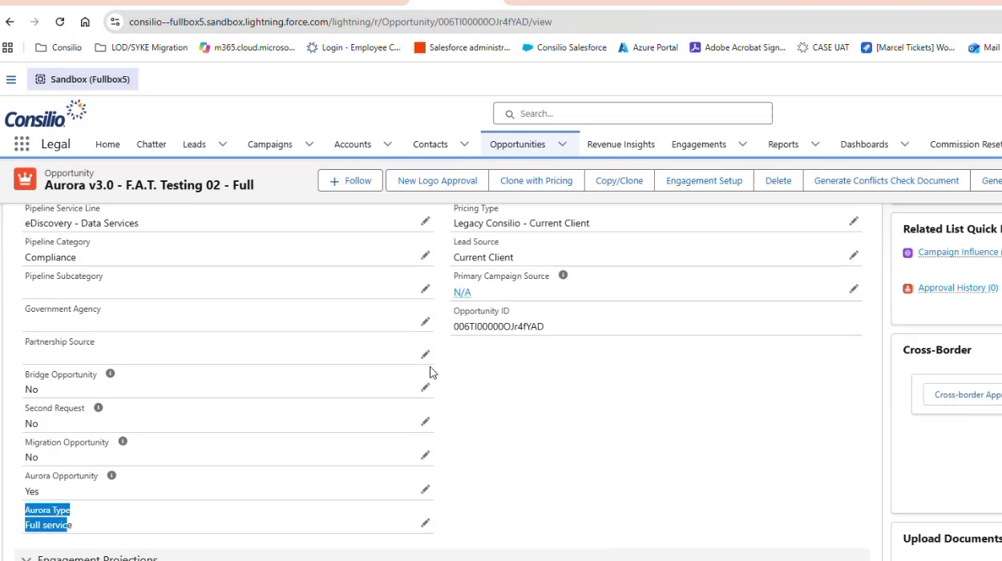
The opportunity record, with Engagement Setup in the action bar.
SALESFORCE

3. Start the engagement setup
Open Engagement Setup. Choose New Engagement to create a fresh engagement, or Link to Existing Engagement where the work belongs under one that already exists. The form displays the opportunity name at the top for reference.
The engagement code stays blank at this point. Saving the engagement generates it.
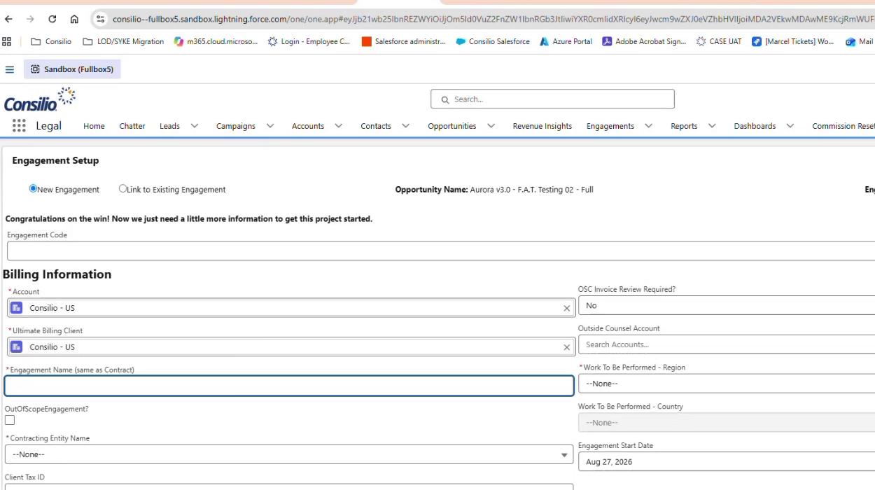
Engagement Setup, with the engagement code still blank.
SALESFORCE

4. Complete the billing information
Work through the Billing Information section.
Account — The account the engagement sits under, for example Consilio - US.
Ultimate Billing Client — The client ultimately billed for the work.
Engagement Name (same as Contract) — The name of the engagement as it appears on the contract. This becomes the project name downstream, so it must match what was requested.
Contracting Entity Name — The legal entity contracting the work, selected from the list of group entities.
Client Tax ID — Where the entity requires one.
ESC Invoice Review Required — Yes or No.
Outside Counsel Account — Where an outside counsel firm is involved.
Work To Be Performed — Region and Country — Where the work will be carried out.
Engagement Start Date — The date the engagement begins.
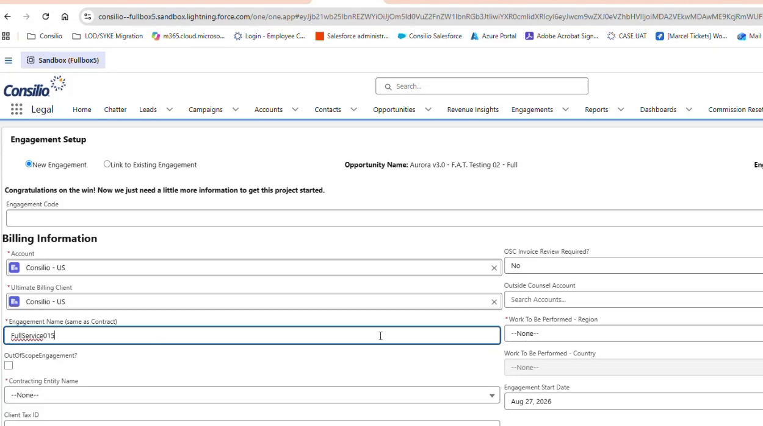
Billing Information, with the engagement name entered.
SALESFORCE

5. Complete the service information
Below the billing section, set out what the engagement covers.
Services Provided — Move the required services from Available to Chosen. The options include Forensics, Paper/Copy/Scan, Risk Management, Staffing, Hosting, Processing and Review. This selection determines what gets provisioned later.
Hosting Platform — The platform the workspace will sit on, for example Relativity.
Hosting Location — Where the workspace is hosted.
Processing Workflow — For example Consilio Aurora Default.
Engagement requires a second workspace — Set this where more than one workspace is needed, and give the name of the second workspace.
Billing Frequency — For example Monthly.
Expected SOW Signed Date, Signed SOW, Part of a MSA — Contract details for the engagement.
Time Entry Consent Mandatory, Virtual Wall, Data Privacy Restrictions — Compliance settings. Complete these according to the engagement terms.
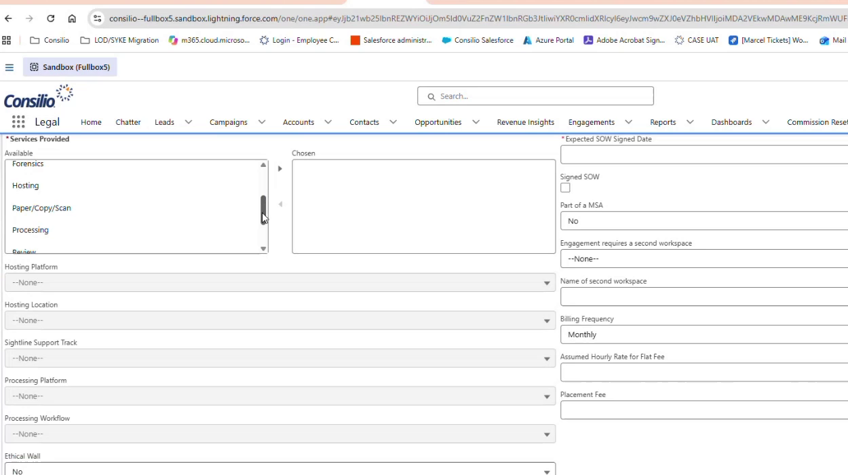
Services Provided, hosting and processing selections.
SALESFORCE

6. Save the engagement
Save the form. A success message confirms the engagement, and the engagement code appears at the top of the record with an engagement status of Active.
Check the saved record before moving on. The engagement code shown here is the number that ties this engagement together across every downstream system.
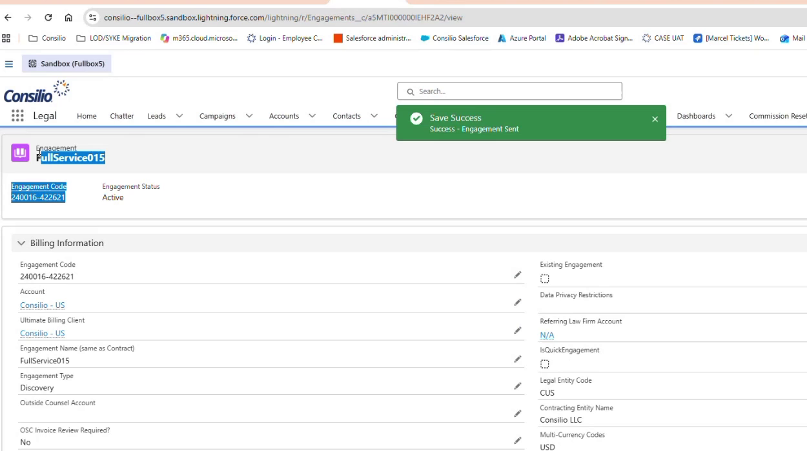
The saved engagement, showing engagement code 240016-422621 and a status of Active.

PART 2 — PROVISIONING
Steps 7 to 14. From the project setup record through to a usable project.
Saving the engagement in Salesforce starts an automated chain. Where the project sits under a master engagement, the master engagement clones to a child engagement, a sync goes to CASE, and CASE creates the corresponding record in ServiceNow.
SERVICENOW

7. Open the project setup queue
Open the Smartflow Hosting workspace and select the Open Smartflow Project Setup queue for the relevant workflow. Engagements created in Salesforce appear under the Standard Workflow queue, and requests raised for a child engagement appear under the Aurora Workflow queue.
The list shows each request with its number, state, assignee, project setup type and ultimate client. A request that nobody has picked up shows a state of Pending with no assignee. Once actioned, the state changes to Submitted and the assignee fills in.
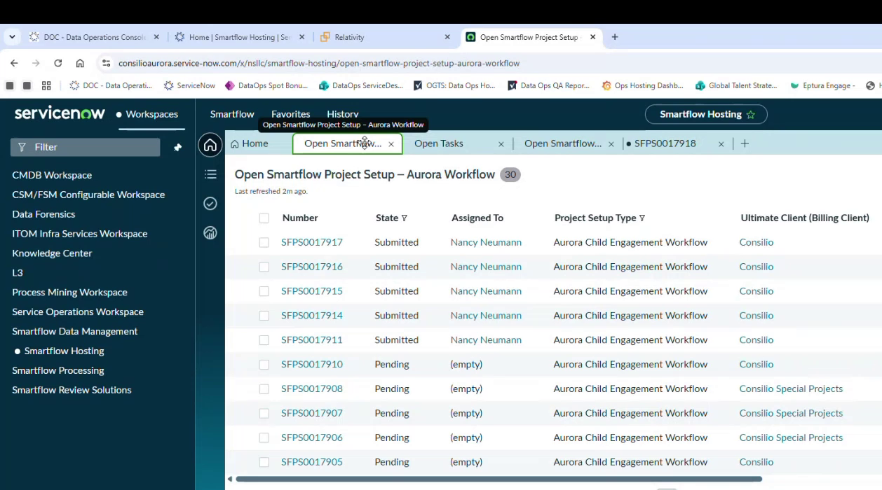
The Aurora Workflow queue, showing Pending and Submitted records.
SERVICENOW

8. Open the project setup record and check the details
Select the record number to open it. The header holds the record number, its state, the project setup type and the assignee, along with the engagement selection and the code returned from CASE.
Work down the Details tab and confirm the information carried across correctly from Salesforce. Engagement Information holds the engagement name and number, the ultimate client for billing, the engagement data centre location, any data privacy restrictions, the vertical, the services provided and whether a second workspace is required. The engagement name matches the project name exactly. Processing Platform Information follows, covering the processing workflow and the processing platform. Hosting Platform Information sits below that, covering the hosting platform, the workspace name, the infrastructure location, the hosting template, the database location and the resource pool.
Correct anything that looks wrong before the record is submitted, because these values are what the provisioning chain acts on.
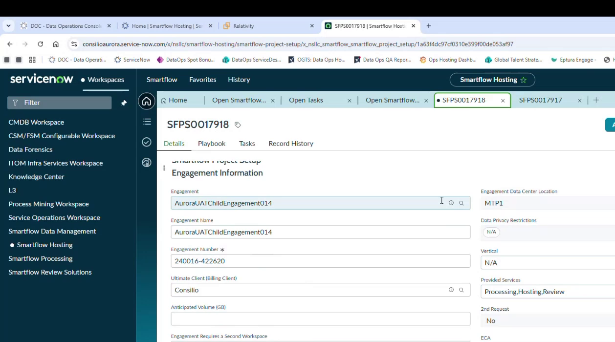
The Details tab, with Engagement Information carried through from Salesforce.
Values seen on the record during testing:
Section | Field | Example value
Engagement Information | Engagement / Engagement Name | FullService015
Engagement Information | Engagement Number | 240016-422621
Engagement Information | Ultimate Client (Billing Client) | Consilio
Engagement Information | Engagement Data Center Location | MTP1
Engagement Information | Data Privacy Restrictions / Vertical | N/A
Engagement Information | Provided Services | Processing, Hosting, Review
Engagement Information | 2nd Request | No
Processing Platform | Processing Workflow / Platform | Consilio Aurora Default / Nuix
Hosting Platform | Hosting Platform | Relativity
Hosting Platform | Workspace Name | Matches the engagement name
Hosting Platform | Project Infrastructure Location | LVS UAT
Hosting Platform | Selected Hosting Template | Relativity Consilio Default
Hosting Platform | Relativity DB Location / Resource Pool | LVSVUDSQL11 / Default
Relativity DB Location shows Loading briefly while the database server is selected. That is expected.
SERVICENOW

9. Submit the record
Hosting operations submits the record. Submitting starts the provisioning chain. Until it happens nothing downstream runs and the record sits in the queue as Pending.
SERVICENOW

10. Follow the playbook
Select the Playbook tab to track progress. The stages run in order, beginning with Alpha Code Creation. A green tick marks a completed step, and the step currently running is highlighted. Steps that wait on another system sit in place for a short time, which is expected rather than a fault.
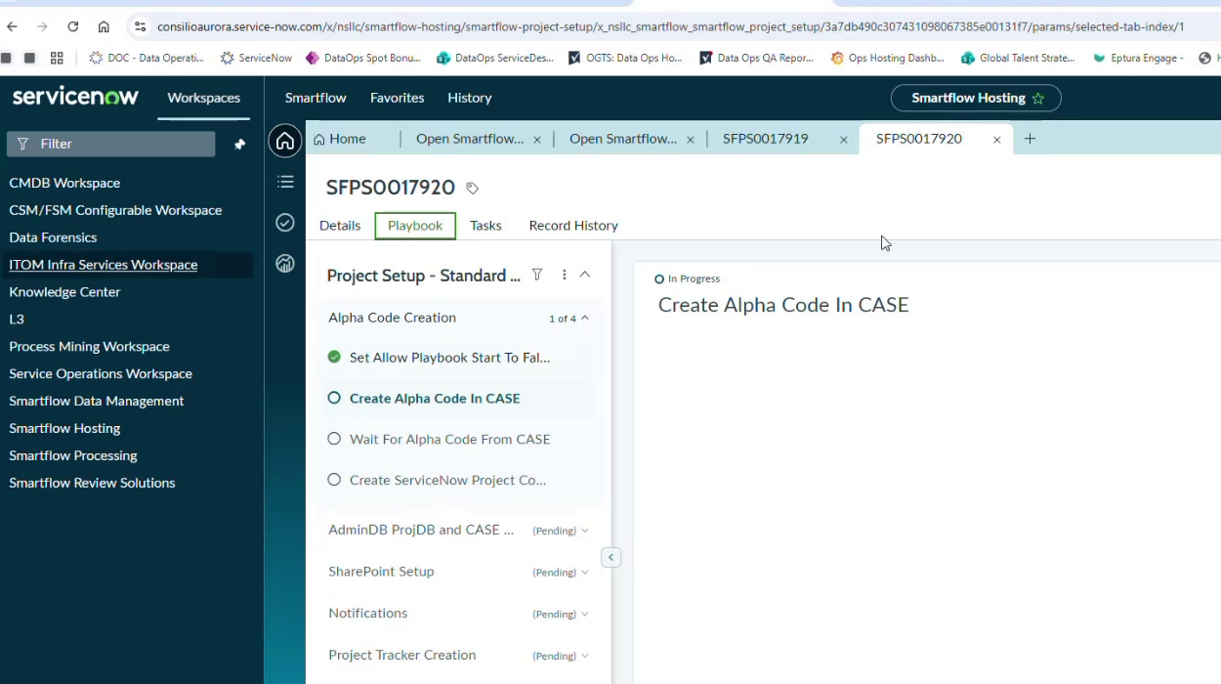
The Playbook tab, with Create Alpha Code In CASE running.
The stages, in order:
Stage | Steps it runs | What done looks like
Alpha Code Creation | Set Allow Playbook Start To False; Create Alpha Code In CASE; Wait For Alpha Code From CASE; Create ServiceNow Project Code; Update the SmartFlow record | An alpha code is returned from CASE and written to the record.
AdminDB ProjDB and CASE | Wait For Infrastructure Information; Send Workspace Request Info To CASE | Infrastructure details received and the workspace request dispatched.
SharePoint Setup | Wait For Sharepoint URL to be populated | A SharePoint URL is populated on the engagement record.
Notifications | Automated notifications to the project team | Stage marked Complete.
Project Tracker Creation | Creates the project tracker | Stage marked Complete.
Project Share Creation | Skipped in UAT | Bypassed. The Processing team creates the share manually.
Workspace Creation | Five steps that build the Relativity workspace and send the workspace information onward | Workspace visible and Active in Relativity.
CASE

11. Create the time engagement
The playbook pauses on Wait For Time Engagement From CASE. This step is manual and the chain does not continue until someone completes it.
In CASE, open the engagement and select Create The Engagement. The Create Time Engagement form opens with the client and engagement details already populated.
Client Details — Client name, client code and industry, carried from the engagement.
Engagement Name — The engagement created in Salesforce.
Time Engagement Name — Required. The name for the time engagement.
Engagement Status — Active.
Contracting Entity — For example Consilio LLC (CUS).
Time Engagement Type — For example Discovery.
Is Billable — Yes or No.
Expected Contract Sign Date — Carried from the engagement.
Currency, Hosting Status, Billing Type — Complete as the engagement requires.
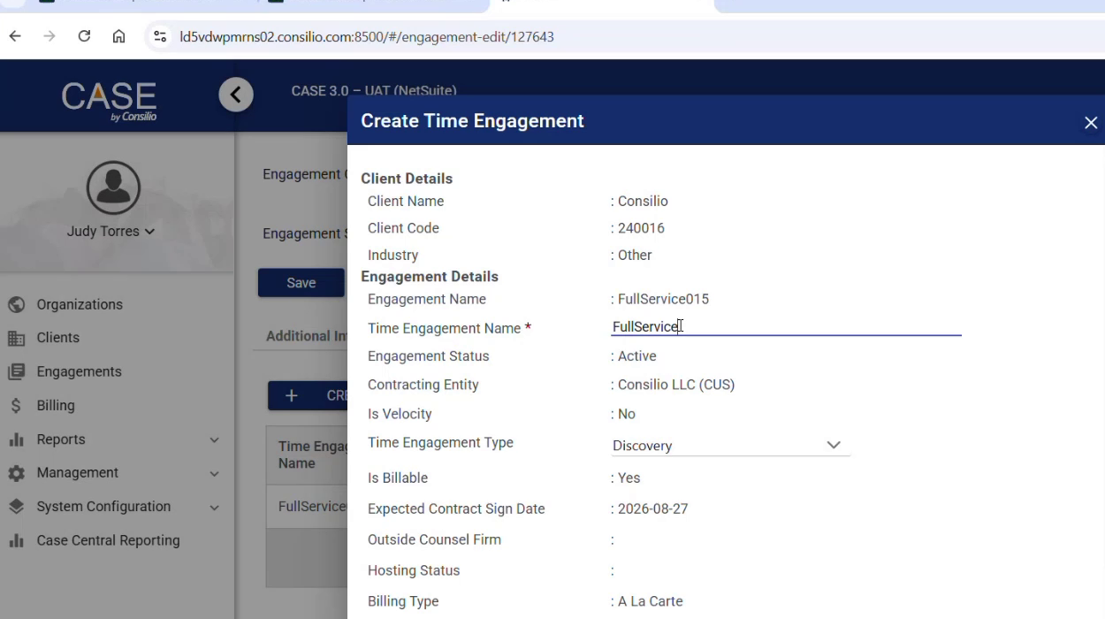
The Create Time Engagement form, populated from the engagement.
Save the form. The time engagement then appears against the engagement with its name, code, type, currency and workspace code. Edit Time Engagement reopens it where a value needs changing.
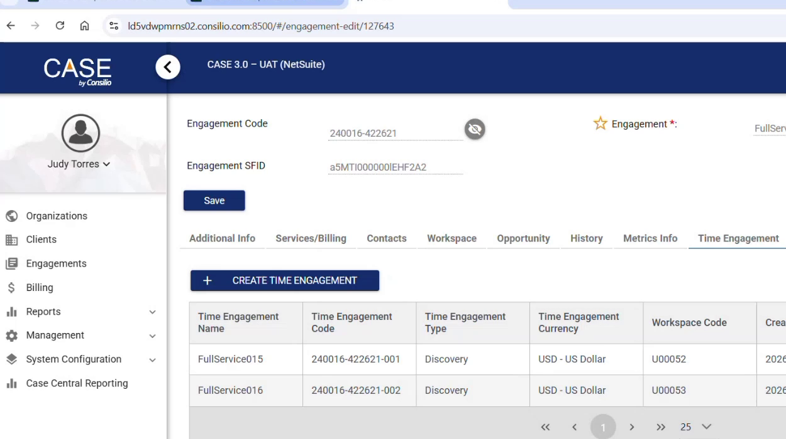
The saved time engagement listed against engagement code 240016-422621.
SERVICENOW

12. Confirm the chain continues
Once the time engagement exists, the playbook resumes. The later steps send the workspace request information to CASE and then send the Relativity workspace information onward.
The Record History tab shows each value as it arrives, including the time engagement code, the workspace request ID and the alpha code returned from CASE. That is the quickest way to see what the chain has and has not received.
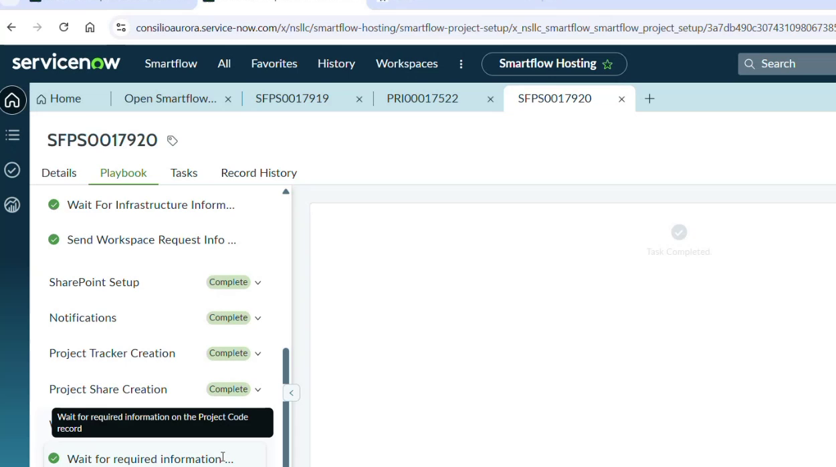
Later playbook stages completing after the time engagement is created.
SERVICENOW

13. Check the tasks
Select the Tasks tab. Tasks are raised as the playbook progresses, so the list grows during the run. A task shows a state of New with no assignee until operations picks it up.
Where the tab shows no records, the playbook has not yet reached the point where a task is created. Refresh and check again shortly.
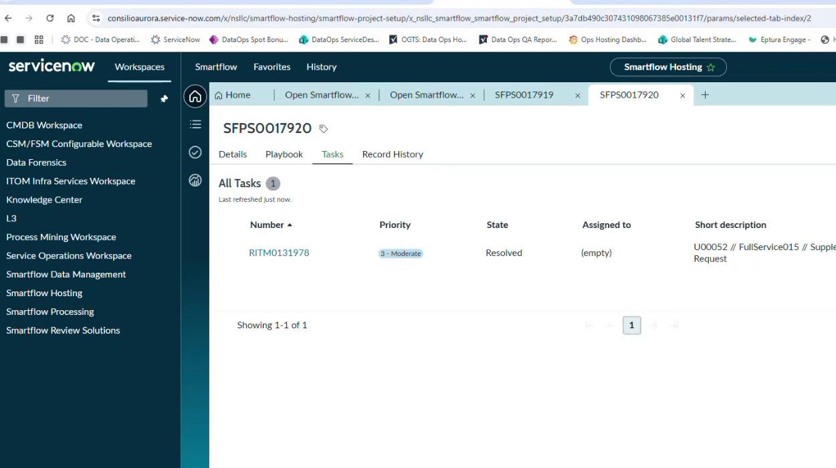
The Tasks tab early in the run, with a single task raised.
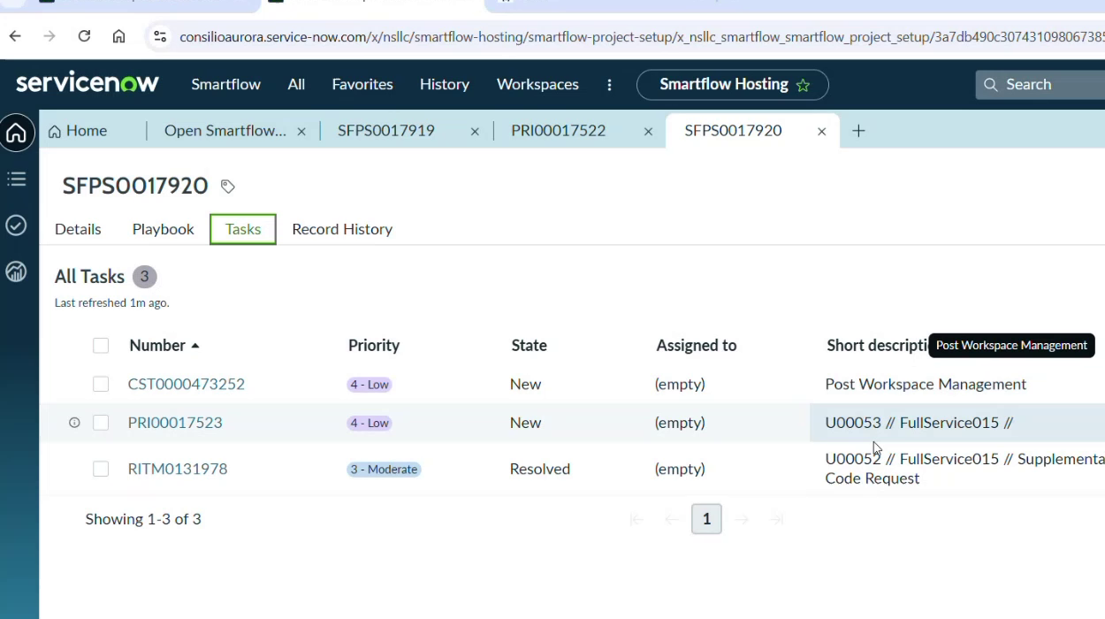
The same tab later, with three tasks against the record.
RELATIVITY

14. Check the workspace
Once workspace creation completes, the workspace appears in Relativity. Open Relativity, go to Workspaces, and filter on the alpha code.
The workspace is listed as the alpha code and project name together. Check the client name, matter name, matter number, case artifact ID and database location against the ServiceNow record. The database location in particular matches the one shown in the hosting platform section of the project setup record.
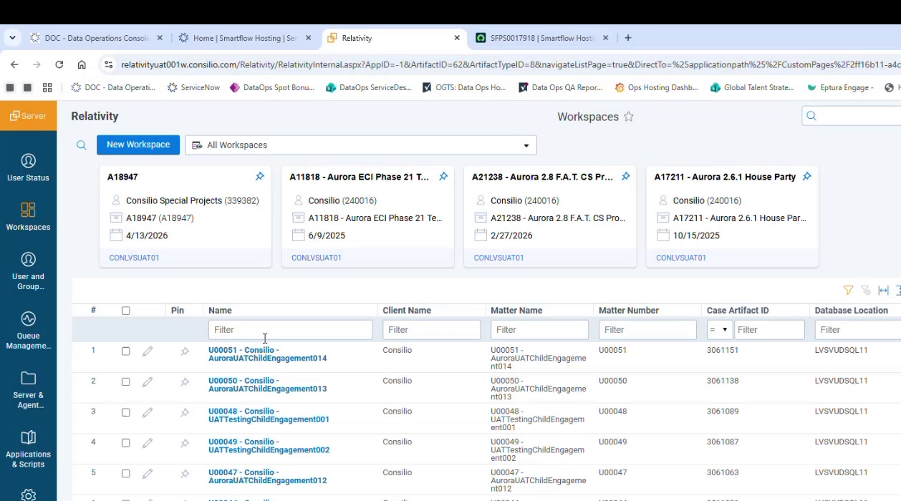
The workspace in Relativity, filtered on the alpha code.

PART 3 — FINISHING UP
Steps 15 and 16. The manual share and the final sync.
PROCESSING TEAM

15. Arrange the project share
The project share is not created automatically. Contact the Processing team, who run a script to create it. Do this as soon as the project exists rather than waiting until the share is needed. The playbook shows the stage as skipped, which is expected and not a failure.
DATA WAREHOUSE

16. Wait for the sync
The project syncs to the Data Warehouse on a scheduled job that runs on 10 and 30 minute cycles. The project stays invisible downstream until a cycle has run, so allow up to 30 minutes.
This is the slowest step in the chain and a delay here is normal rather than a fault. Once the sync has run, the project is complete and available to use. Check that the alpha code matches the one issued in ServiceNow and Relativity.
Timings from the UAT runs, each a single observation rather than an average:
Stage | Observed | Note
Infrastructure creation | A little over 1 minute | Excluding the workspace.
Infrastructure including workspace | About 2 minutes
Full provisioning chain | Under 3 minutes in the fastest run | 16 to 21 minutes is the more usual figure.
Data Warehouse sync | 10 to 30 minutes | Runs on a scheduled cycle. The slowest step.
For context, the same work took around half a day before the process was automated.

PART 4 — SUPPLEMENTAL ALPHA CODE
Steps 17 to 20. A separate route, used when the engagement already exists.
Use this route for a second alpha code under an engagement that already exists, either for media storage or to create an additional workspace. Rather than requesting a whole new project, you raise a form in ServiceNow that adds another alpha code to what is already there.
This does not go through Salesforce. It is a service catalog request, and it creates an entry in the standard workflow as long as the engagement it is raised against was itself set up with a standard workflow.
When to use it. The engagement exists and you need an additional alpha code or workspace under it.
When not to use it. No engagement exists yet. In that case request a new project through Part 1.
SERVICENOW

17. Open the Supplemental Alpha Code Request form
Open the service catalog and search for Supplemental. Select Supplemental Alpha Code Request from the results.
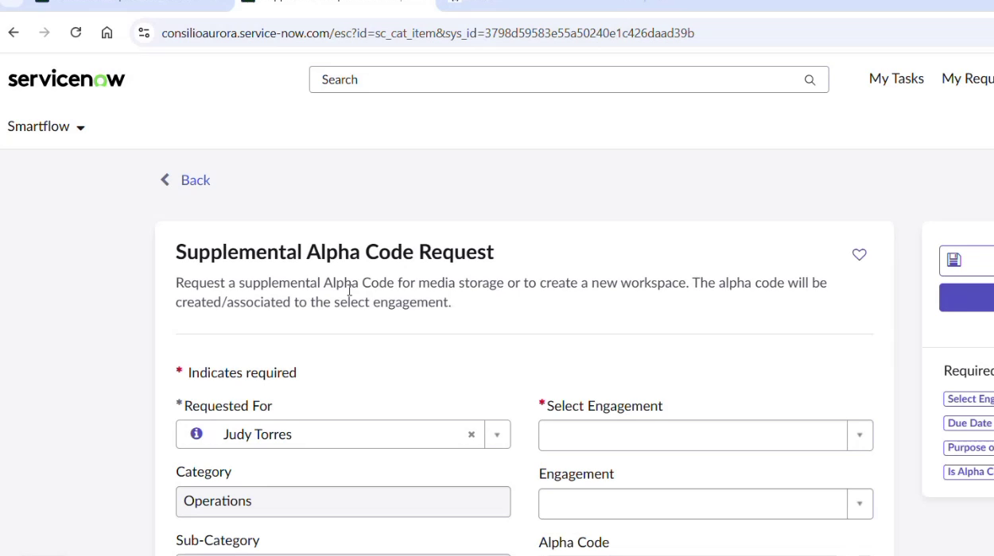
The Supplemental Alpha Code Request catalog item.
SERVICENOW

18. Complete the request details
The top of the form identifies who is asking and what for. A red asterisk marks a required field.
Requested For — The person the request is raised for.
Select Engagement — Required. Start with an engagement number or an existing alpha code. To search on an alpha code, begin with EU followed by the number. To match a value in the middle of a field, begin with an asterisk. Selecting the engagement fills in the engagement name, alpha code and ultimate billing client automatically.
Category and Sub-Category — Operations and Hosting.
Item — Supplemental Alpha Code Request.
Priority — For example 3 - Moderate.
Vertical and Workspace Sensitivity — Carried from the engagement where already set.
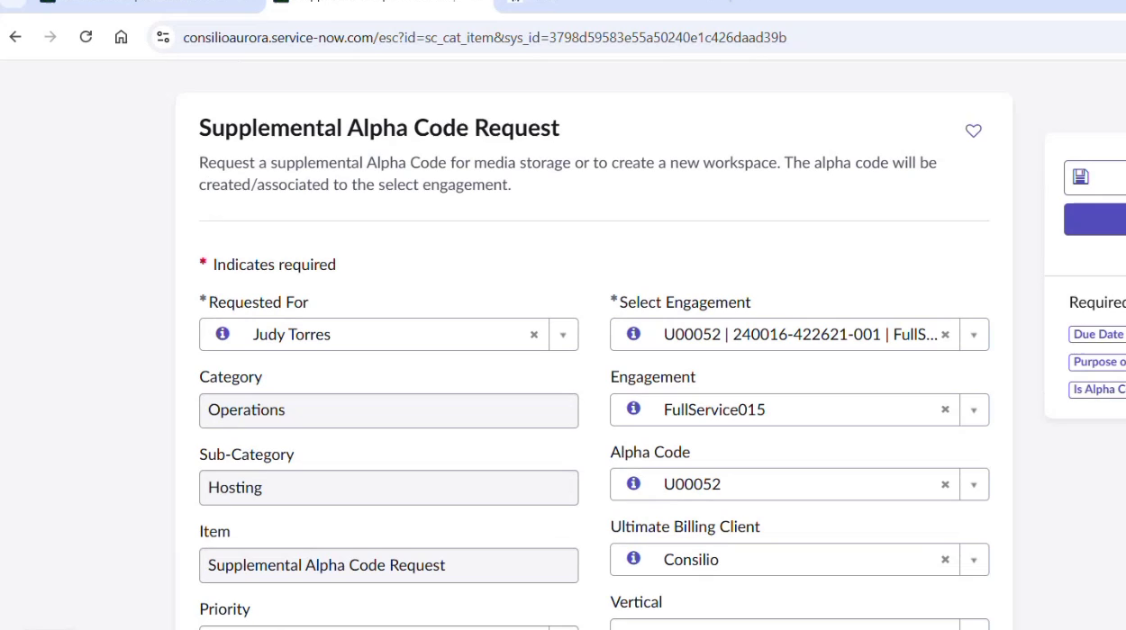
Request details, with the engagement selected and its values filled in.
SERVICENOW

19. Complete the scheduling and notification details
Due Date & Time — When the alpha code is needed by.
Processing Data Ops Lead — Where applicable.
Watchlist — The people copied on notifications and alerted when the request is resolved. This links to Active Directory, so each person must exist in the system.
Watchlist Distribution List — A distribution list serves instead. Distribution lists do not sync to Active Directory and go unvalidated, so check the address carefully.
Subject — Generated automatically from the alpha code and engagement, in the form U00052 // FullService015 // Supplemental Alpha Code Request.
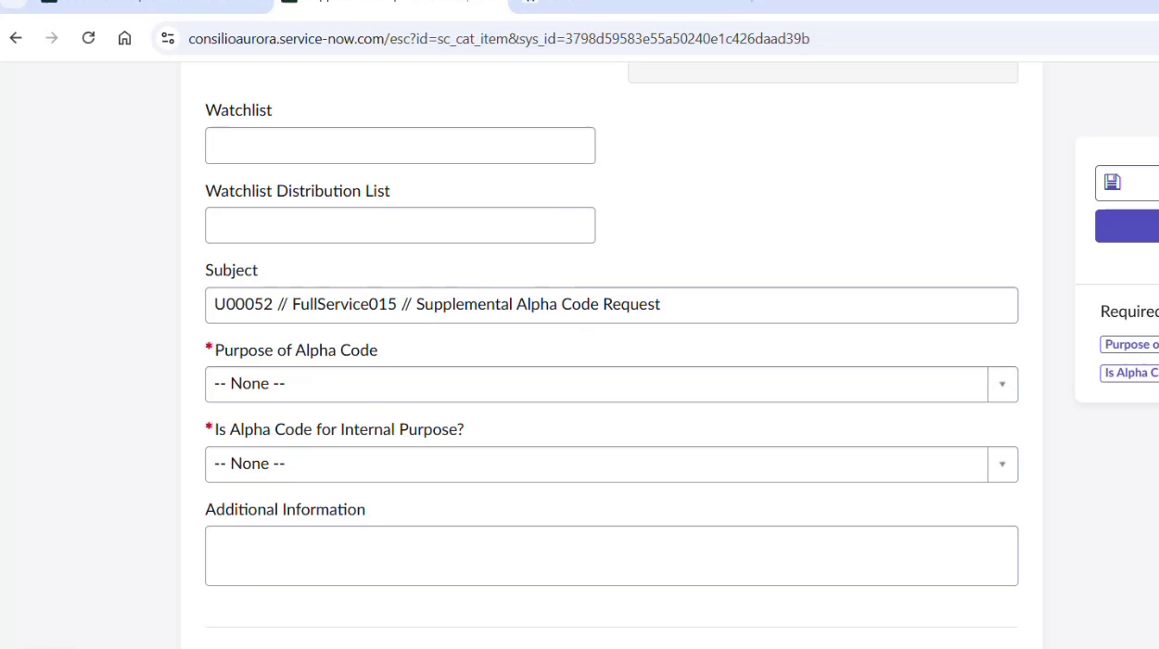
Watchlist and the automatically generated subject line.
SERVICENOW

20. Complete the workspace details and submit
Purpose of Alpha Code — Required. Choose Storage or Add Workspace. Storage covers an alpha code needed without infrastructure and routes the request to a different queue, outside the standard and non-standard workflows.
Is Alpha Code for Internal Purpose? — Required. Yes or No.
Add Workspace Name — Required where a workspace is being added. The name of the new workspace.
Anticipated Volume — Required. Less than 1TB, Between 1TB and 5TB, Between 5TB and 10TB, or Greater than 10TB.
Add Workspace Hosting Platform — Required. For example Relativity.
Add Workspace Sensitivities — Required. An engagement holds several workspaces with different sensitivities, though most have only one. Where the form shows a single option, that sensitivity is already confirmed for the engagement. A setting of Not applicable means anyone can work on the project.
Add Workspace Location — Required. The infrastructure location, for example LVS UAT.
Is Storage/Add Workspace Billable? — Required. Yes or No.
Additional Information and attachments — Anything else the job setup team needs.
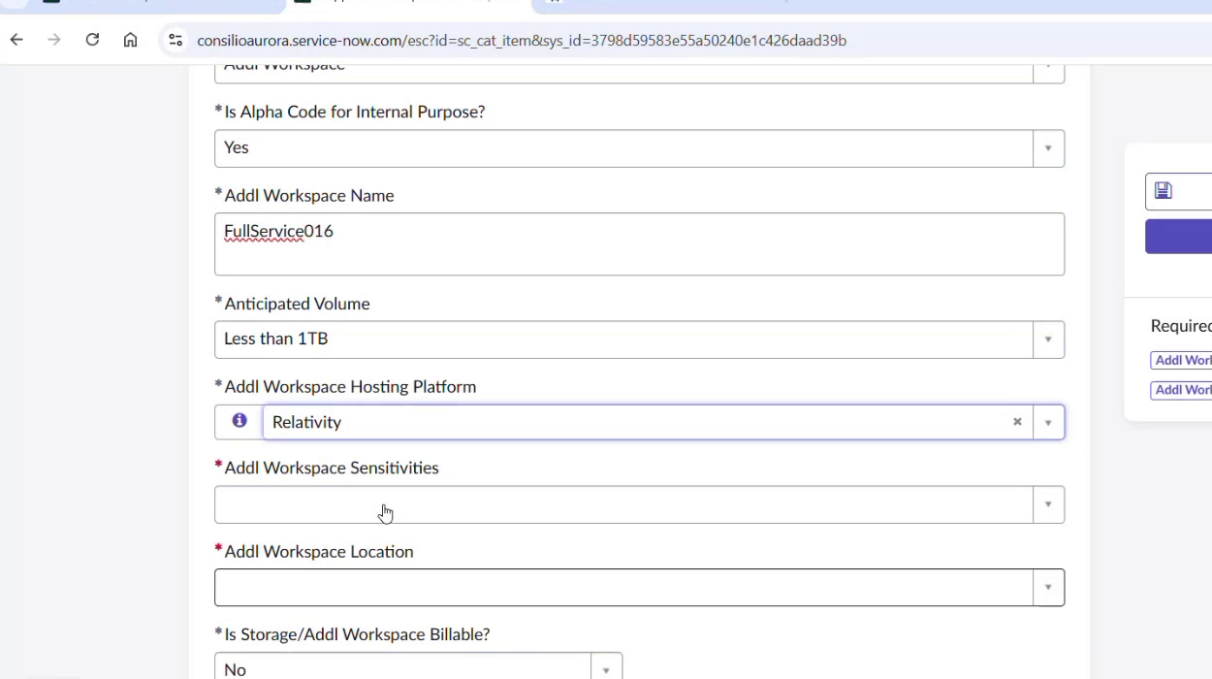
Workspace details for the supplemental request.
Submit the form. A request number is generated and the request appears with its activity, attachments and additional details. From this point it follows the same provisioning path as any other alpha code, so steps 10 to 16 apply.
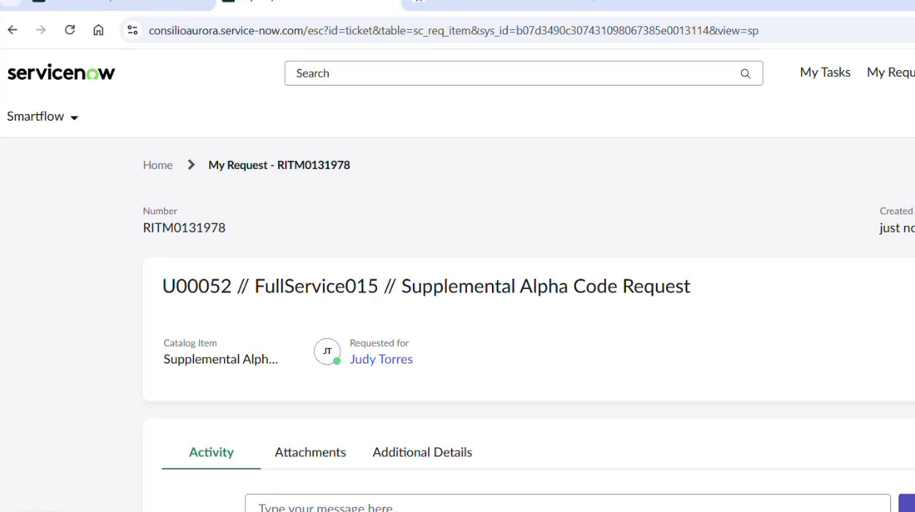
The submitted request, RITM0131978.

NOTES AND KNOWN ISSUES
Points to be aware of when running this process.
No email is sent from UAT. Watchlist entries receive no notifications in UAT. The field still records who to alert once the process moves to production.
The project share is not created automatically. The workflow skips project share creation in UAT. Contact the Processing team, who run a script to create it.
The time engagement is a manual step. The playbook waits on the time engagement being created in CASE. Nothing downstream moves until it exists.
The Data Warehouse sync runs on a cycle. The sync job runs on 10 and 30 minute cycles, and the project stays invisible downstream until a cycle has run. Allow a full cycle before investigating further.
Progress tracker scope. The staged progress tracker runs only for projects initiated from Aurora child engagements. It does not run for self-service or full-service projects, so its absence there is expected and needs no report.
Safe ID reruns. Where a job needs a rerun and a folder from a previous attempt still exists, the job does not start. Delete the existing folder first, then retry.
Two ways to obtain an alpha code. Either create a new engagement, which requires a new alpha code, or raise a supplemental alpha code under an existing engagement. The supplemental route needs no involvement from the Salesforce team.
Availability in UAT2. Release 3.2 is not yet deployed to UAT2, so the new project creation and the integrated Data Warehouse link are unavailable there. Deployment follows the production release. Aurora points at a single Data Warehouse, so once deployed the projects appear in both UAT1 and UAT2. Flag new projects intended for UAT2 when creating them.

