Supplemental Alpha Code Request
How DevOps raises an additional alpha code under an existing engagement.

OVERVIEW
When to use this route, and what it does.
This guide covers the supplemental alpha code route, which is used when an engagement already exists and an additional alpha code is required. This process is initiated through a ServiceNow form and does not involve Salesforce. DevOps runs this route.
Use this route for a second alpha code under an engagement that already exists, either for media storage or to create an additional workspace. Rather than requesting a whole new project, you raise a form in ServiceNow that adds another alpha code to what is already there.
This does not go through Salesforce. It is a service catalog request, and it creates an entry in the standard workflow as long as the engagement it is raised against was itself set up with a standard workflow.
When to use it. The engagement exists and you need an additional alpha code or workspace under it.
When not to use it. No engagement exists yet. In that case a new project is requested through the Project Creation via Salesforce guide.
Four systems work together to raise, provision, and synchronize the alpha code. Each step in this guide identifies the system in which the activity takes place.
System | What it does here
ServiceNow (Smartflow Hosting) | Holds the project setup record, runs the provisioning playbook and raises the supplemental alpha code request.
CASE | Issues the alpha code and holds the time engagement. One step here is manual and the chain waits on it.
Relativity | Where the review workspace is created.
Data Warehouse | Final sync. The project is not visible downstream until this has run.
Aurora sits alongside these as the platform the finished project appears in.

WHO TO CONTACT
The checkpoints that depend on someone acting.
Most of the process runs automatically, but progress depends on a few key checkpoints. Three of them require manual action, while the Data Warehouse sync runs on a scheduled cycle. If a request appears stalled, check the stages below.
Step | What is needed | Team | Contact
Project setup submission | The SmartFlow Project Setup record has to be submitted in ServiceNow before the provisioning chain will start. | Hosting operations | Nancy Neumann  nneumann@consilio.com
Time engagement creation | The CASE time engagement must be created manually. The provisioning playbook pauses and cannot continue until this step is completed. | CASE / Job Setup Team | CASE Operations Team
Project share creation | The project share is created manually by running a script. Data cannot be processed in Aurora without it. | Processing | Brett Turner  Brett.Turner@consilio.com
Data Warehouse sync | Runs on a schedule. Can be looked at if the project has not appeared after a full cycle. | Data Warehouse | Joe  Joseph.Femino@consilio.com

PART 1 — RAISING THE REQUEST
Steps 1 to 4. From the service catalog to a submitted request.
SERVICENOW

1. Open the Supplemental Alpha Code Request form
Open the service catalog and search for Supplemental. Select Supplemental Alpha Code Request from the results.
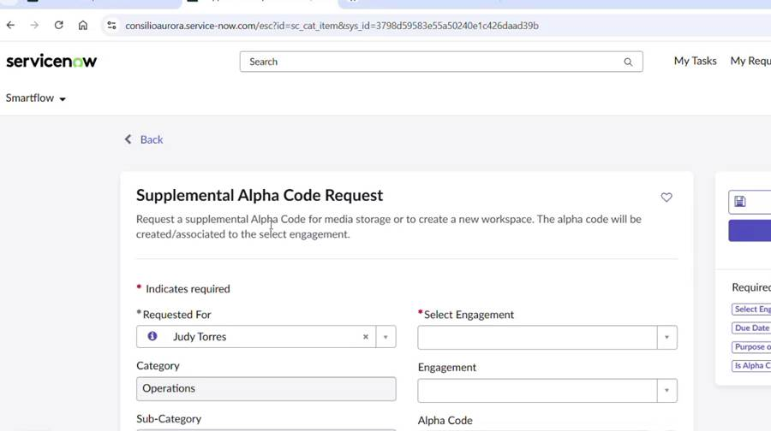
The Supplemental Alpha Code Request catalog item.
SERVICENOW

2. Complete the request details
The top of the form identifies who is asking and what for. A red asterisk marks a required field.
Requested For — The person the request is raised for.
Select Engagement — Required. Start with an engagement number or an existing alpha code. To search on an alpha code, begin with EU followed by the number. Selecting the engagement fills in the engagement name, alpha code and ultimate billing client automatically.
Category and Sub-Category — Operations and Hosting.
Item — Supplemental Alpha Code Request.
Priority — Specifies the urgency level of the request. For example 3 - Moderate.
Vertical and Workspace Sensitivity — Carried from the engagement where already set.
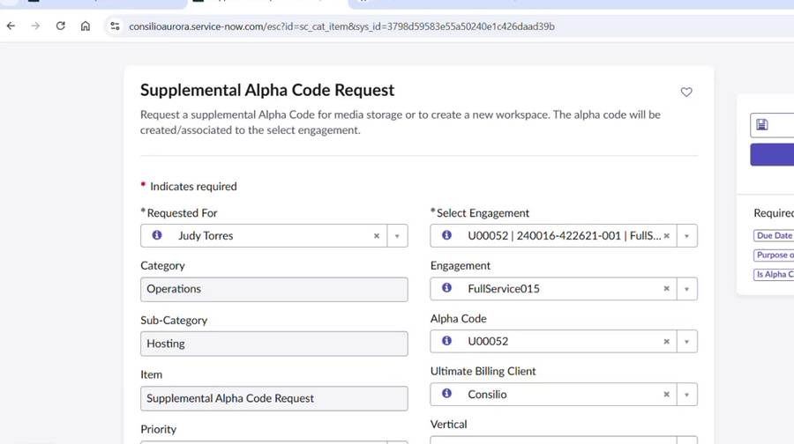
Request details, with the engagement selected and its values filled in.
SERVICENOW

3. Complete the scheduling and notification details
Due Date & Time — When the alpha code is needed by.
Processing Data Ops Lead — Where applicable.
Watchlist — The people copied on notifications and alerted when the request is resolved. This links to Active Directory, so each person must exist in the system.
Watchlist Distribution List — A distribution list serves instead. Distribution lists do not sync to Active Directory and go unvalidated, so check the address carefully.
Subject — Generated automatically from the alpha code and engagement.
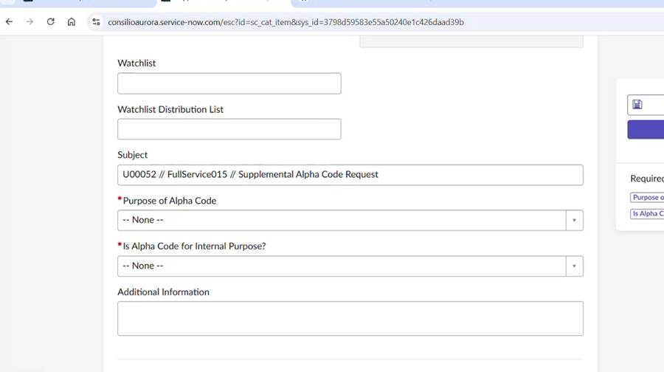
Watchlist and the automatically generated subject line.
SERVICENOW

4. Complete the workspace details and submit
Purpose of Alpha Code — Required. Select Storage or Add Workspace. Storage requests do not require infrastructure provisioning.
Is Alpha Code for Internal Purpose? — Required. Select Yes or No.
Add Workspace Name — Required when adding a workspace. Enter the new workspace name.
Anticipated Volume — Required. Select the expected data volume range.
Add Workspace Hosting Platform — Required. Select the hosting platform, such as Relativity.
Add Workspace Sensitivities — Required. Select the workspace sensitivity level. Not Applicable means no sensitivity restrictions.
Add Workspace Location — Required. Select the infrastructure location, such as LVS UAT.
Is Storage/Add Workspace Billable? — Required. Select Yes or No.
Additional Information and Attachments — Provide any supporting details or documents needed by the Job Setup team.
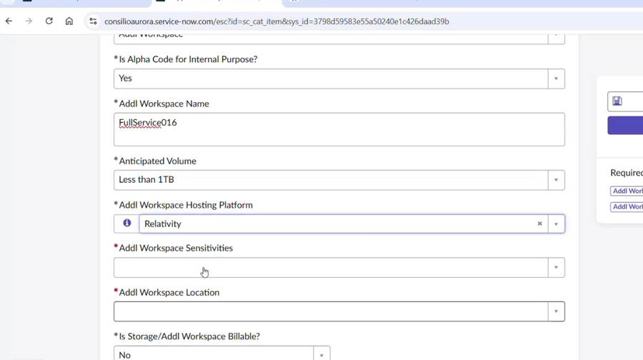
Workspace details for the supplemental request.
Submit the form. A request number is generated and the request appears with its activity, attachments and additional details.
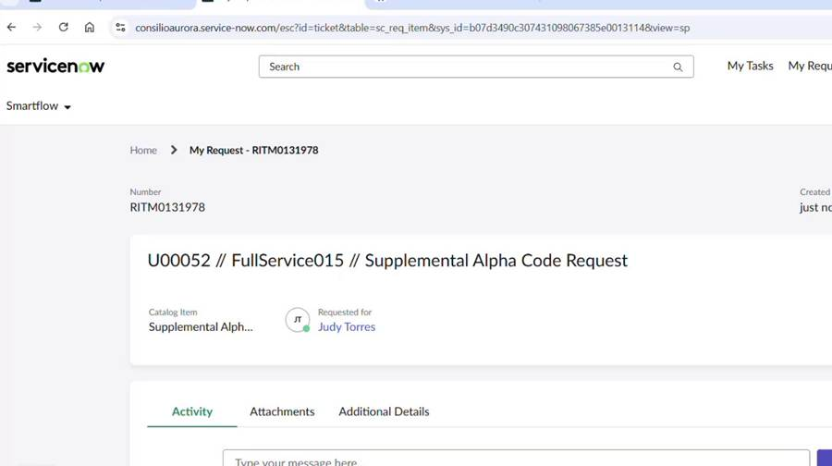
The submitted request, RITM0131978.

PART 2 — PROVISIONING
From the project setup record through to a usable alpha code.
Submitting the request creates an entry in the standard workflow, and from this point the alpha code follows the same provisioning path as any other. CASE creates the corresponding record in ServiceNow.
SERVICENOW

SmartFlow Project Setup record creation (FYI)
A SmartFlow Project Setup record is created in ServiceNow automatically and populated with the information synchronized from the engagement. It holds the Engagement Information, the Processing Platform Information and the Hosting Platform Information, and it waits in the Open SmartFlow Project Setup queue until Hosting Operations submits it.
The workspace name is expected to match the project name exactly to ensure successful downstream processing and workspace creation. Relativity DB Location shows Loading briefly while the database server is selected, which is expected.
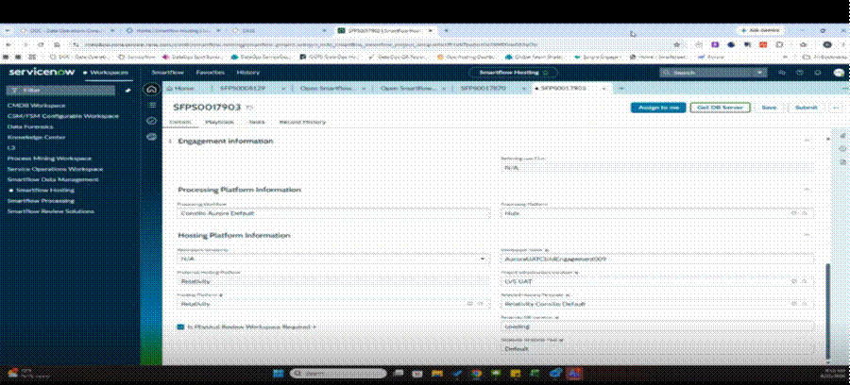
The project setup record before submission, showing the processing and hosting platform information.
SERVICENOW

5. Hosting ops submits the project setup
Hosting Operations opens the SmartFlow Project Setup record in ServiceNow, completes any required fields, and selects Submit. Submitting the record initiates the provisioning workflow; no downstream processes will begin until this step is completed. Allow approximately 16 to 21 minutes for the provisioning chain to finish.
WHO TO CONTACT Nancy Neumann — Hosting operations · nneumann@consilio.com
Ask for the SmartFlow Project Setup record to be submitted. Quote the record number (SFPS…) and the project name.
SERVICENOW

Playbook progress tracking (FYI)
As part of the automated provisioning process, the Playbook tab displays the status of each provisioning step. A green check mark indicates a completed step, while bold text identifies the step currently in progress.
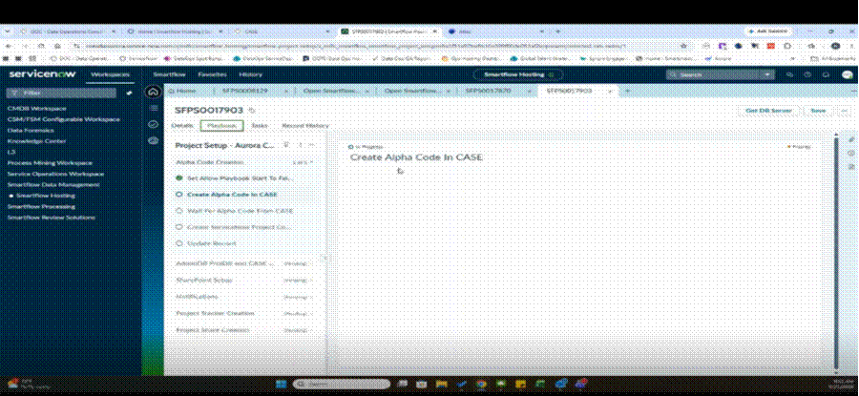
The Playbook tab, with Create Alpha Code In CASE in progress.
The stages, in order:
Stage | Steps it runs | What done looks like
Alpha Code Creation | Disables automatic playbook execution, creates an Alpha Code in CASE, waits for CASE to return the Alpha Code, generates the ServiceNow project code and updates the SmartFlow record | An alpha code is returned from CASE and written to the record.
AdminDB ProjDB and CASE | Wait For Infrastructure Information; Send Workspace Request Info To CASE | Infrastructure details received and the workspace request dispatched.
SharePoint Setup | Wait For Sharepoint URL to be populated | A SharePoint URL is populated on the engagement record.
Notifications | Automated notifications to the project team | Stage marked Complete.
Project Tracker Creation | Creates the project tracker | Stage marked Complete.
Project Share Creation | Skipped in UAT | Bypassed. The Processing team creates the share manually.
Workspace Creation | Five steps that build the Relativity workspace and send the workspace information onward | Workspace visible and Active in Relativity.
CASE

6. Create the time engagement
The playbook pauses on Wait For Time Engagement From CASE. This step is manual and the chain does not continue until someone completes it.
In CASE, open the engagement and select Create The Engagement. The Create Time Engagement form opens with the client and engagement details already populated.
Client Details — Client name, client code and industry, carried from the engagement.
Engagement Name — The engagement created in Salesforce.
Time Engagement Name — Required. The name for the time engagement.
Engagement Status — Active.
Contracting Entity — For example Consilio LLC (CUS).
Time Engagement Type — Indicates the category of work being performed. For eg., Discovery.
Is Billable — Yes or No.
Expected Contract Sign Date — Carried from the engagement.
Currency, Hosting Status, Billing Type — Complete as the engagement requires.
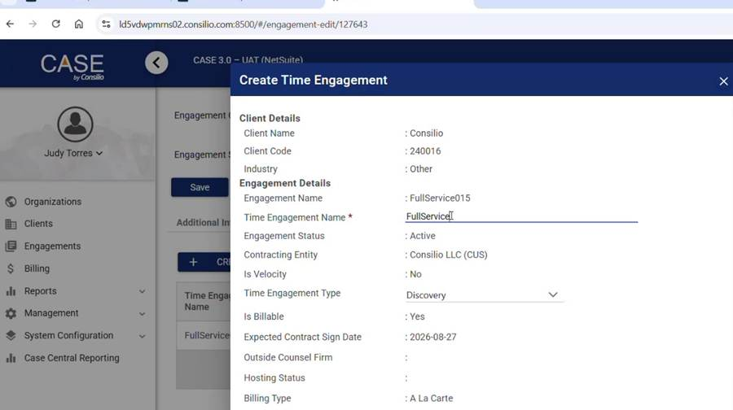
The Create Time Engagement form, populated from the engagement.
Save the form. The time engagement then appears against the engagement with its name, code, type, currency and workspace code. Edit Time Engagement reopens it where a value needs changing.
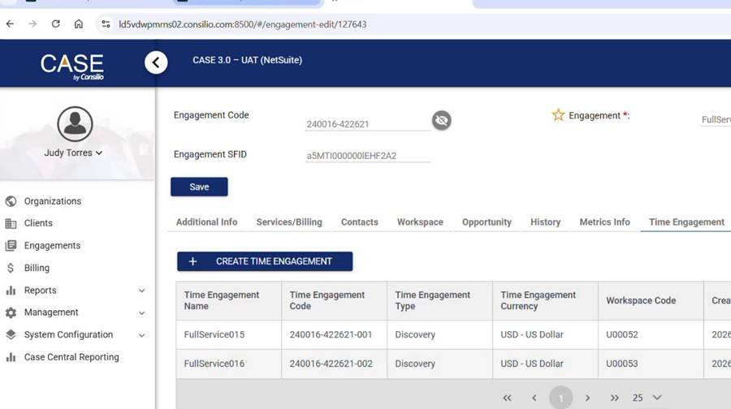
The saved time engagement listed against engagement code 240016-422621.
WHO TO CONTACT CASE Operations Team — Job setup
SERVICENOW

Confirm the chain continues
Once the time engagement exists, the playbook resumes. The later steps send the workspace request information to CASE and then send the Relativity workspace information onward.
The Record History tab shows each value as it arrives, including the time engagement code, the workspace request ID and the alpha code returned from CASE. That is the quickest way to see what the chain has and has not received.
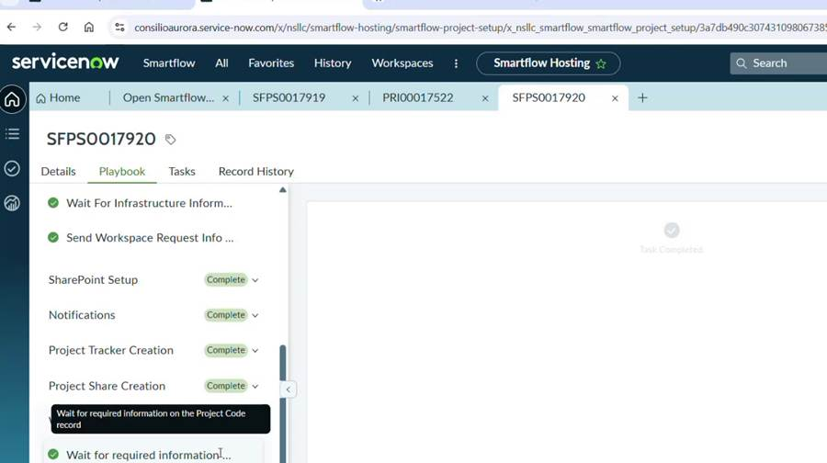
Later playbook stages completing after the time engagement is created.
SERVICENOW

Project Initiation task creation (FYI)
As part of the provisioning process, a Project Initiation task is automatically created in ServiceNow. The task includes the project alpha code and project name in the Short Description field. When initially created, the task is expected to have a status of New and will remain unassigned until it is picked up by Operations.
Where the tab shows no records, the playbook has not yet reached the point where a task is created. Refresh and check again shortly.
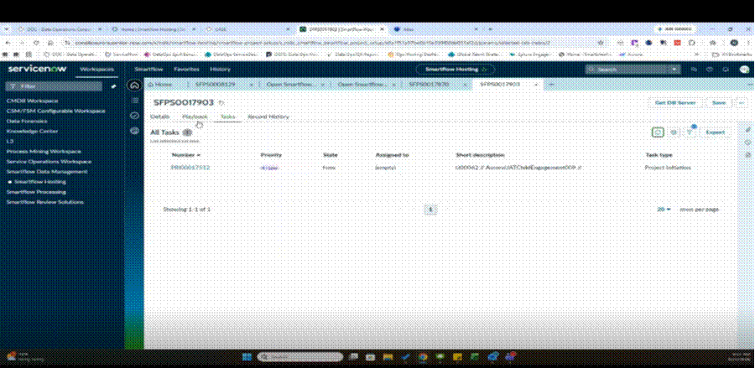
The Tasks tab, with the Project Initiation task raised and unassigned.
SERVICENOW

Provisioning completion status (FYI)
The provisioning playbook progresses through a series of automated stages until all applicable stages reach a status of Complete. The Workspace Creation stage is typically the longest-running stage and displays its own progress indicator while processing.
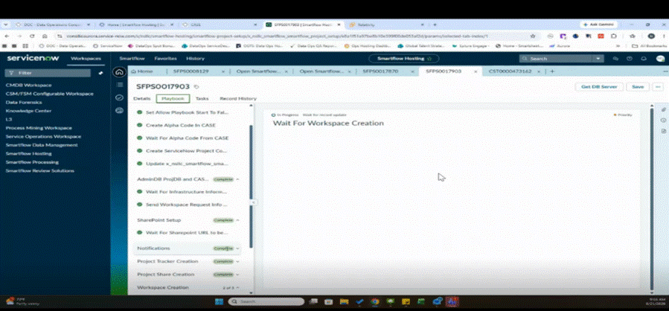
The stages complete, with Workspace Creation still in progress.
RELATIVITY

Check the workspace
Once workspace creation completes, the workspace appears in Relativity. Open Relativity, go to Workspaces, and filter on the alpha code.
The workspace is listed as the alpha code and project name together. Check the client name, matter name, matter number, case artifact ID and database location against the ServiceNow record. The database location in particular matches the one shown in the hosting platform section of the project setup record.
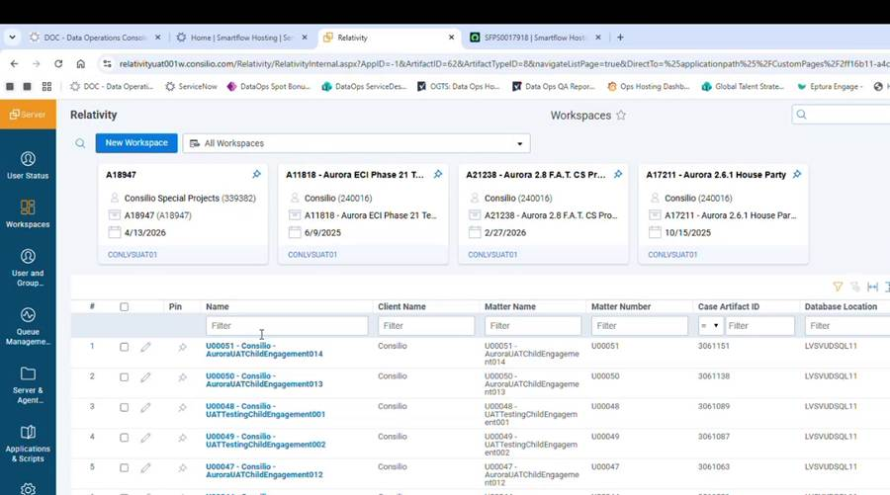
The workspace in Relativity, filtered on the alpha code.

PART 3 — FINISHING UP
Steps 7 and 8. The manual share and the final sync.
PROCESSING TEAM

7. Arrange the project share
A project share is required for data processing within Aurora. In UAT environments, the Project Share Creation stage is typically skipped because project shares are created manually rather than by the playbook. If this stage is skipped, the Processing team must create the project share before data processing can continue in Aurora.
WHO TO CONTACT Brett Turner — Processing · Brett.Turner@consilio.com
When requesting project share creation, provide the project name and the alpha code. The Processing team will create the project share and run the required script.
DATA WAREHOUSE

8. Wait for the sync
The project syncs to the Data Warehouse on a scheduled job that runs on 10 and 30 minute cycles. The project stays invisible downstream until a cycle has run, so allow up to 30 minutes.
Once the sync has run, the project is complete and available to use. Check that the alpha code matches the one issued in ServiceNow and Relativity.
WHO TO CONTACT Joe — Data Warehouse · Joseph.Femino@consilio.com
Contact only where the project has not appeared after a full cycle.

NOTES
Points to be aware of when running this process.
The project share is not created automatically. The workflow skips project share creation in UAT. Contact the Processing team, who run a script to create it.
The time engagement is a manual step. The playbook waits on the time engagement being created in CASE. Nothing downstream moves until it exists.
The Data Warehouse sync runs on a cycle. The sync job runs on 10 and 30 minute cycles, and the project stays invisible downstream until a cycle has run. Allow a full cycle before investigating further.
Progress tracker scope. The staged progress tracker runs only for projects initiated from Aurora child engagements. It does not run for self-service or full-service projects, so its absence there is expected and needs no report.
Safe ID reruns. Where a job needs a rerun and a folder from a previous attempt still exists, the job does not start. Delete the existing folder first, then retry.
Two ways to obtain an alpha code. Either create a new engagement, which requires a new alpha code, or raise a supplemental alpha code under an existing engagement.

