AIM:

To design a system for a game that displays and increments score by 1, whenever a football hits a desired target out of 4 targets.

CIRCUIT DIAGRAM

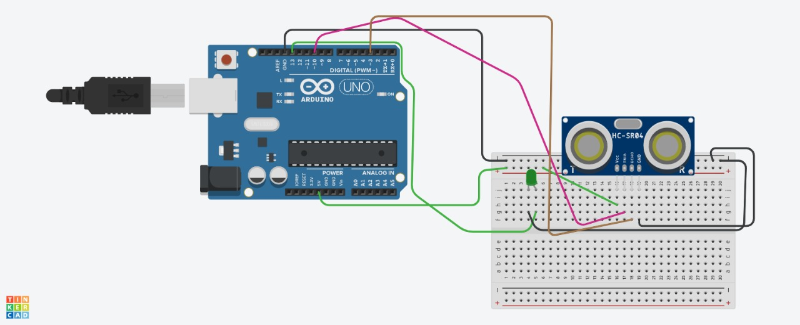

THEORY:

In this experiment we have to design a circuit type of game in which if a football hits the desired target out of 4 given targets the first time , then the circuit or the game should display a score 1 as it hit the target, and if it again hits the target second time then it should display and increment the previous score by one.

LEARNING AND OBSERVATION:

1. To provide knowledge of different Smart System applications.

2. To familiarize students with Arduino as IDE, programming language & platform.

3. To provide knowledge of Arduino boards and basic components.

4. Develop skills to design and implement various smart system application

PROBLEM AND TROUBLESHOOTING:

1. trouble in coding

2. trouble making the circuit

3. trouble understanding the question given.

PPRECAUTIONS:

1. if the connecting wires are loosely connected then the LED’s will not glow

2. Do not make any errors while coding, if error occurs then the program will not run in arduino

3. Components should properly work, if not there may be trouble in the working of the circuit.

LEARNING OUTCOMES:

1. Familiar with Arduino environment and its applications.

2. Able to understand Arduino programming.

3. Able to Design Smart systems applications.

4. Learn and understand about any new IDE, compiler, and MCU chip in Arduino compatible boards or similar types.