

BILKENT UNIVERSITY

DEPARTMENT OF COMPUTER SCIENCE

CS 201: FUNDAMENTAL STRUCTURES OF

COMPUTER SCIENCE I

**HOMEWORK 2 DISCUSSIONS**

**&**

**C++ CODES**

BERAT BİÇER - 21503050 - SECTION 2

EXPERIMENT 1

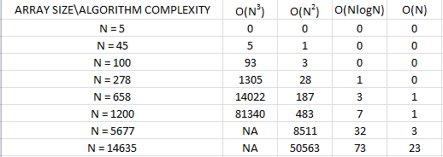

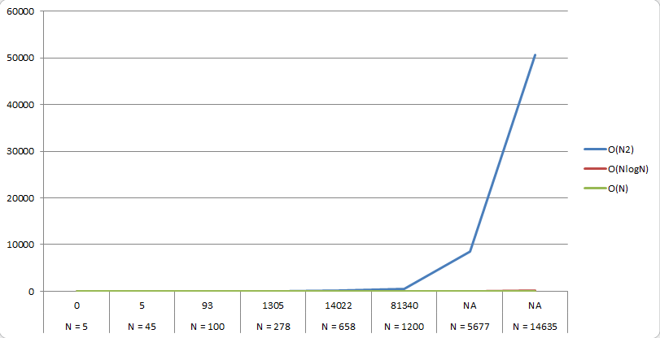

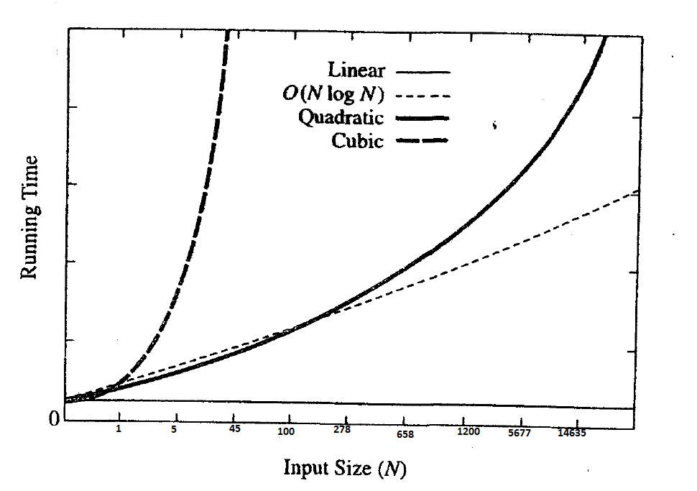

EXPERIMENT 2

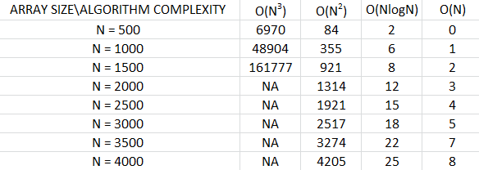

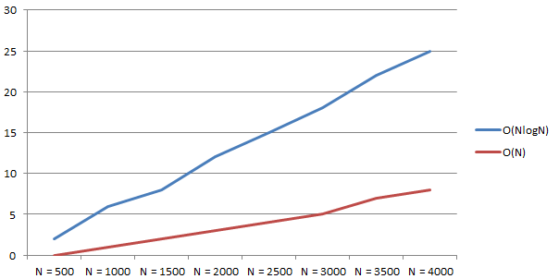

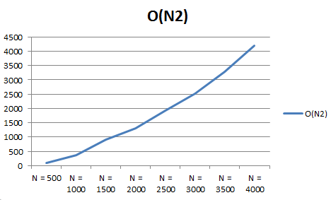

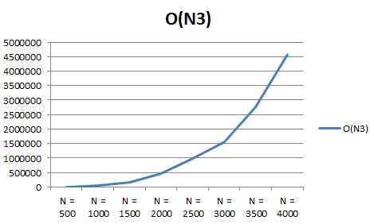

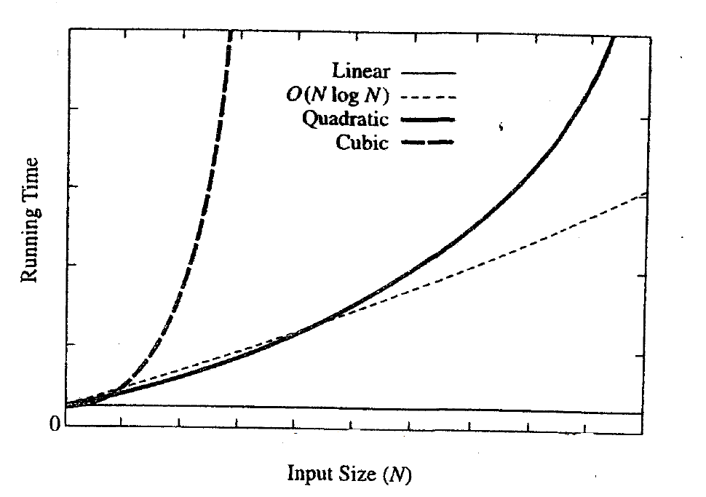

Figure : Expected Graph

**DISCUSSION**

In both cases as the array size gets bigger, I observed that time required to run a specific algorithm becomes larger. Since algorithms have different rate of growth, their growth are different as expected. To be more specific,

* We know algorithm 1 has growth rate O(n^3) and algorithm 4 has growth rate O(n). From the graphs above, we see that our theoretical calculations are correct since algorithm 1 works the slowest whereas algorithm 4 works the fastest.
* We can observe that
  + Algorithm 3 and 4 are quite close to each other eventhough size of the input N grows larger. This implies that these algorithms work similarly and their efficiency are similar as well.
  + Eventhough algorithm 1 and 2 are similar in theory that is, their growth rate is relatively close to each other, in practice they are quite different: algorithm 1 becomes larger faster that algorithm 2 in very small time intervals.
  + For large data, it’s wise to use the most efficient algorithm to work with because it saves time and resources. However, for small data, the difference between these algorithms isn’t quite clear and any one of them can be chosen to work with.
* It is also worth mentioning that for different computer systems and CPU’s, these results may vary and therefore it’s important to note my computer’s specifications: Intel Core i7-4510u CPU @ 2.00-2.60 GHz, 8 GB RAM with Windows 7 64 bit OS.

**C++ CODES**

**MAIN – 1:**

#include <iostream>

#include <ctime>

#include<vector>

using namespace std;

int maxSubSum1(const vector<int> & a);

int maxSubSum2(const vector<int> & a);

int maxSumRec(const vector<int> & a, int left, int right);

int max3(int a, int b, int c);

int maxSubSum3(const vector<int> & a);

int maxSubSum4(const vector<int> & a);

int maxSubSum1(const vector<int> & a) {

int maxSum = 0;

for(size_t i = 0; i < a.size(); i++)

for (size_t j = i; j < a.size(); j++) {

int thisSum = 0;

for (size_t k = i; k <= j; k++)

thisSum += a[k];

if (thisSum > maxSum)

maxSum = thisSum;

}

return maxSum;

}

int maxSubSum2(const vector<int> & a) {

int maxSum = 0;

for (size_t i = 0; i < a.size(); i++) {

int thisSum = 0;

for (size_t j = i; j < a.size(); j++) {

thisSum += a[j];

if (thisSum > maxSum)

maxSum = thisSum;

}

}

return maxSum;

}

int maxSumRec(const vector<int> & a, int left, int right) {

if (left == right)

if(a[left] > 0)

return a[left];

else

return 0;

int center = (left + right) / 2;

int maxLeftSum = maxSumRec(a, left, center);

int maxRightSum = maxSumRec(a, center + 1, right);

int maxLeftBorderSum = 0, leftBorderSum = 0;

for (int i = center; i >= left; i--) {

leftBorderSum += a[i];

if (leftBorderSum > maxLeftBorderSum)

maxLeftBorderSum = leftBorderSum;

}

int maxRightBorderSum = 0, rightBorderSum = 0;

for (int j = center + 1; j <= right; j++) {

rightBorderSum += a[j];

if (rightBorderSum > maxRightBorderSum)

maxRightBorderSum = rightBorderSum;

}

return max3(maxLeftSum, maxRightSum, maxLeftBorderSum + maxRightBorderSum);

}

int max3(int a, int b, int c) {

int max = 0;

if (a > b)

max = a;

else

max = b;

if (c > max)

max = c;

else

max = max;

return max;

}

int maxSubSum3(const vector<int> & a) {

return maxSumRec(a, 0, a.size() - 1);

}

int maxSubSum4(const vector<int> & a) {

int maxSum = 0, thisSum = 0;

for (size_t j = 0; j < a.size(); j++) {

thisSum += a[j];

if (thisSum > maxSum)

maxSum = thisSum;

else if (thisSum < 0)

thisSum = 0;

}

return maxSum;

}

int main() {

int base = 0;

//int a[5];

//int b[45];

//int c[100];

//int d[278];

//int e[658];

//int f[1200];

//int g[5677];

int h[14635];

/*for (int i = 0; i < 5; i++) {

a[i] = ((base*base + 7) / 5) + 8;

base++;

}*/

/*for (int i = 0; i < 45; i++) {

b[i] = ((base*base + 7) / 5) + 8;

base++;

}*/

/*for (int i = 0; i < 100; i++) {

c[i] = ((base*base + 7) / 5) + 8;

base++;

}*/

/*for (int i = 0; i < 278; i++) {

d[i] = ((base*base + 7) / 5) + 8;

base++;

}*/

/*for (int i = 0; i < 658; i++) {

e[i] = ((base*base + 7) / 5) + 8;

base++;

}*/

/*for (int i = 0; i < 1200; i++) {

f[i] = ((base*base + 7) / 5) + 8;

base++;

}*/

/*for (int i = 0; i < 5677; i++) {

g[i] = ((base*base + 7) / 5) + 8;

base++;

}*/

for (int i = 0; i < 14635; i++) {

h[i] = ((base*base + 7) / 5) + 8;

base++;

}

//vector<int> v(a, a + sizeof a / sizeof a[0]);

//vector<int> v(b, b + sizeof b / sizeof b[0]);

//vector<int> v(c, c + sizeof c / sizeof c[0]);

//vector<int> v(d, d + sizeof d / sizeof d[0]);

//vector<int> v(e, e + sizeof e / sizeof e[0]);

//vector<int> v(f, f + sizeof f / sizeof f[0]);

//vector<int> v(g, g + sizeof g / sizeof g[0]);

vector<int> v(h, h + sizeof h / sizeof h[0]);

// Store the starting time

double duration;

clock_t startTime = clock();

// Code block

int x = maxSubSum4(v);

//Compute the number of milliseconds that passed since the starting time

duration = 1000 * double(clock() - startTime) / CLOCKS_PER_SEC;

cout << "Execution took " << duration << " milliseconds." << endl;

int q;

cin >> q;

}

**MAIN – 2:**

#include <iostream>

#include <ctime>

#include<vector>

using namespace std;

int maxSubSum1(const vector<int> & a);

int maxSubSum2(const vector<int> & a);

int maxSumRec(const vector<int> & a, int left, int right);

int max3(int a, int b, int c);

int maxSubSum3(const vector<int> & a);

int maxSubSum4(const vector<int> & a);

int maxSubSum1(const vector<int> & a) {

int maxSum = 0;

for(size_t i = 0; i < a.size(); i++)

for (size_t j = i; j < a.size(); j++) {

int thisSum = 0;

for (size_t k = i; k <= j; k++)

thisSum += a[k];

if (thisSum > maxSum)

maxSum = thisSum;

}

return maxSum;

}

int maxSubSum2(const vector<int> & a) {

int maxSum = 0;

for (size_t i = 0; i < a.size(); i++) {

int thisSum = 0;

for (size_t j = i; j < a.size(); j++) {

thisSum += a[j];

if (thisSum > maxSum)

maxSum = thisSum;

}

}

return maxSum;

}

int maxSumRec(const vector<int> & a, int left, int right) {

if (left == right)

if(a[left] > 0)

return a[left];

else

return 0;

int center = (left + right) / 2;

int maxLeftSum = maxSumRec(a, left, center);

int maxRightSum = maxSumRec(a, center + 1, right);

int maxLeftBorderSum = 0, leftBorderSum = 0;

for (int i = center; i >= left; i--) {

leftBorderSum += a[i];

if (leftBorderSum > maxLeftBorderSum)

maxLeftBorderSum = leftBorderSum;

}

int maxRightBorderSum = 0, rightBorderSum = 0;

for (int j = center + 1; j <= right; j++) {

rightBorderSum += a[j];

if (rightBorderSum > maxRightBorderSum)

maxRightBorderSum = rightBorderSum;

}

return max3(maxLeftSum, maxRightSum, maxLeftBorderSum + maxRightBorderSum);

}

int max3(int a, int b, int c) {

int max = 0;

if (a > b)

max = a;

else

max = b;

if (c > max)

max = c;

else

max = max;

return max;

}

int maxSubSum3(const vector<int> & a) {

return maxSumRec(a, 0, a.size() - 1);

}

int maxSubSum4(const vector<int> & a) {

int maxSum = 0, thisSum = 0;

for (size_t j = 0; j < a.size(); j++) {

thisSum += a[j];

if (thisSum > maxSum)

maxSum = thisSum;

else if (thisSum < 0)

thisSum = 0;

}

return maxSum;

}

int main() {

int base = 0;

int a[500];

int b[1000];

int c[1500];

int d[2000];

int e[2500];

int f[3000];

int g[3500];

int h[4000];

for (int i = 0; i < 500; i++) {

a[i] = ((base*base + 7) / 5) + 8;

base++;

}

for (int i = 0; i < 1000; i++) {

b[i] = ((base*base + 7) / 5) + 8;

base++;

}

for (int i = 0; i < 1500; i++) {

c[i] = ((base*base + 7) / 5) + 8;

base++;

}

for (int i = 0; i < 2000; i++) {

d[i] = ((base*base + 7) / 5) + 8;

base++;

}

for (int i = 0; i < 2500; i++) {

e[i] = ((base*base + 7) / 5) + 8;

base++;

}

for (int i = 0; i < 3000; i++) {

f[i] = ((base*base + 7) / 5) + 8;

base++;

}

for (int i = 0; i < 3500; i++) {

g[i] = ((base*base + 7) / 5) + 8;

base++;

}

for (int i = 0; i < 4000; i++) {

h[i] = ((base*base + 7) / 5) + 8;

base++;

}

//vector<int> v(a, a + sizeof a / sizeof a[0]);

//vector<int> v(b, b + sizeof b / sizeof b[0]);

//vector<int> v(c, c + sizeof c / sizeof c[0]);

//vector<int> v(d, d + sizeof d / sizeof d[0]);

//vector<int> v(e, e + sizeof e / sizeof e[0]);

//vector<int> v(f, f + sizeof f / sizeof f[0]);

//vector<int> v(g, g + sizeof g / sizeof g[0]);

vector<int> v(h, h + sizeof h / sizeof h[0]);

// Store the starting time

double duration;

clock_t startTime = clock();

// Code block

int x = maxSubSum4(v);

//Compute the number of milliseconds that passed since the starting time

duration = 1000 * double(clock() - startTime) / CLOCKS_PER_SEC;

cout << "Execution took " << duration << " milliseconds." << endl;

int q;

cin >> q;

}