List of edits:

* Significant grammatical and syntactical improvements as suggested and guided by recommended principles throughout the first five sections
* Removal of alcohol-related traffic fatalities as a percentage of traffic fatalities due to realized disassociation with our model
* State budget deficits measured per capita rather than raw
* Included a results and conclusion section of the paper
* Changed the regression methodology to highlight the effects of control variables and fixed effects

The High Cost of a Cold One:

The Link Between Beer Taxes and Traffic Fatalities

Ben Bankston

Class of 2025

Bradford Bush

Class of 2025

**Prepared for Economics 203**

**Washington and Lee University**

**April 11, 2023**

1. **Introduction**

As alcohol culture has shifted nationwide over the past 20 years, states are beginning to truly penalize drunk drivers. According to data from 2020, the share of traffic fatalities in the United States attributed to drunk drivers was 30%, down from 38% in 2000 (NHTSA). This fall in percentage may not seem large, but it represents a decrease of almost 2,000 deaths per year caused by drunk driving. While this may only represent a trend of increased criticism of drunk drivers, there are likely other factors that affect one’s choice to drive after drinking. On the level of public policy, the most prevalent approach against drunk driving has been sin taxes, a type of tax levied to deter people from engaging in harmful activities, like smoking cigarettes or drinking alcohol. While there is a federal sin tax, sin taxes also vary by state. There has been much debate on how beer sin taxes affect drunk driving fatalities (Levitt and Porter 2001).

The research we propose here specifically examines the relationship between sin taxes and alcohol related traffic fatalities. Namely, do sin taxes on alcohol, specifically beer, affect alcohol-related traffic fatalities?

As taxes increase, demand in alcohol is expected to decrease due to an increase in price. If there are fewer people purchasing alcohol, the number of alcohol-related traffic fatalities would be expected to decrease.

There are a number of other factors associated with changes in alcohol-related fatalities that vary by state demographics, such as the police presence within a given state. With more officers, one is less likely to drive drunk knowing there is a greater likelihood of repercussions for their actions (Levitt and Porter 2001). Young adults between ages 18-24 exhibit riskier behavior than older adults, including getting behind the wheel after they drink (Levitt and Porter 2001). Unemployed individuals are less likely to drink at a bar where prices are higher than buy alcohol at the store and drink at home. With a higher unemployment rate, alcohol-related fatalities are expected to be lower. For simplicity, we will group these factors into a group dubbed state demographics.

We also thought it would be relevant to add the total number of miles driven on the interstate. Here, we are measuring the driving culture within a state. If there is a strong driving culture measured in vehicle miles, one is then more likely to drive after drinking.

Next, it is important to look at the alcohol culture within the state. If there is a strong alcohol culture, people are more likely to allow individuals to drive after drinking. Culture is difficult to quantify, so we have incorporated multiple variables to measure a state’s alcohol culture. For instance, a state incentivizing ID scanners for alcohol purchases is a measure of states’ attitudes towards underage drinking. Additionally, implementation of scanners would reduce the risk-taking behavior that is common in young adults. Open container laws state that drivers of noncommercial vehicles cannot have an open alcohol container in the front seats of their vehicle, passenger seat or otherwise. As this is increasingly implemented over time, drinking and driving rates would be expected to decrease. We also included ignition interlock laws, where one cannot start their vehicle without first doing a breathalyzer test. We found this to be a strong proxy for alcohol culture because of the objective extremity of the law. We us all of these variables to isolate the effects of alcohol sin taxes on alcohol-related traffic fatalities.

F = f(BTst, Dst, Vst, Ast)

We present our basic model above, where BT is the focal point of this paper – the state’s beer tax, D represents factors regarding state demographics, V is seen as the driving culture for a state, and A is the alcohol culture for a given state.

1. **Literature Review**

We found four primary papers that helped us better understand this topic. Levitt and Porter (2001) find that not only are drunk drivers are at higher risk of collision than their sober counterparts, but they also find key demographics that relate to one’s likelihood to crash. Levitt and Porter look at age groups, gender, and finally, how costly a drunk driver is. While this paper was a good start for our literature review, our main issue was the outdated nature of the study. Alcohol culture has rapidly evolved since 2001, leading us to believe that the effect of alcohol culture was underestimated in the study compared to its effects on drunk driving today.

Shrestha and Markowitz (2016) focused on the effects of beer taxes on retail prices. The study finds that a $0.10 tax increase on a six pack of beer is associated with an increase of retail beer prices of $0.17 at a state level. This allows us to look at the clinical significance of our study holistically, considering the way increases in beer taxes affect ultimate beer prices.

Hoke and Cotti (2014) look at the effects of purchasing large container beers on alcohol-related traffic fatalities. It finds that increases in these purchases significantly raises the probability of fatal alcohol-related accidents. This once again reinforces the relationship between purchases of alcohol and drunk-driving fatalities.

Lastly, Chang (2011) demonstrates the relationship between beer taxes and drunk driving. This paper investigates the effectiveness of alcohol policies on drunk driving and presents interesting empirical results regarding the relationship between beer taxes and drunk driving fatalities. Chang’s research also highlights public policies and beer taxes as highly effective tools for reducing alcohol-related vehicle fatalities. This helped us to better understand control variables that were necessary to include in our study.

1. **Data Explanation**

Beer Taxes are the explanatory variable used in our model. The data on beer taxes was taken from a database maintained by the Federation of Tax Administrators, describing the dollars per gallon tax on beer in each state since 2000. Despite the availability of other-alcohol tax data, we chose to investigate beer because of its prevalence and general ease of access across the country (Alcohol.org). Unlike wine or distilled spirits, citizens, underage or otherwise, often look first to beer before other forms of alcohol, making it the best beverage to study drunk driving. The average beer tax among our sample was $0.29 with some as high as $1.29 and as low as $0.02 between our sample years of 2000-2019. A boxplot (Figure 1) included below demonstrates a far-right tail but with a median of $0.19, values are heavily concentrated to the left.

The state demographic control variables are unemployment rate, percentage of the population between 18-24, and police per capita. We took state population data from US Census Bureau estimates used in per capita calculations. Included state demographic variable are percent of the population between ages 18-24, police per capita, and unemployment rates. The data for the proportion of the state population between the ages 18-24 was taken from the Kids Count Data Center and ranges by 11% with a standard deviation of 1.32%. They cite all of their data to the population estimates published by the US Census Bureau. Police presence in each state was taken from the Federal Bureau of Investigation, originating from local and state police departments. Divided by the total state population, we are using police per capita as a proxy for police presence. On average, in a given year, a state will have about 3 police officers per 1000 people. Unemployment rates were found on Iowa State University’s Iowa Community Indicators Program website. This was cited as being adapted from the Bureau of Labor Statistics, the government agency responsible for keeping track of employment data throughout the United States. The unemployment rate ranges by about 11.5%, the average is about 5.5% suggesting an upward skew, but only with a standard deviation of 2%.

Total vehicle miles is our exclusive predictor of driving culture. Vehicle miles is defined by the total number of miles driven (in millions) on all highways in a state. We see this variable as a strong predictor of the total amount of driving occurring in a state. The standard deviation of vehicle miles is greater than the mean but is sensible because of the range of state sizes and drivers in those states.

Alcohol culture in a state may best be predicted by statewide surveys or alcohol-related legislation. Due to a lack of survey data, we decided to dedicate ourselves exclusively to alcohol-related legislation regarding scanners, ignition interlocks, and open containers. Both open container and scanner legislation was taken from a database maintained by the Alcohol Policy Information System, a mission of the National Institutes of Health. Scanner is a binary variable that equals one in years that a state provides incentives to retailers who use electronic scanners to check valid identification to purchase alcohol. This was the best available proxy for prevalence of underage drinking in a state following the intuition that as states implement scanners, underage drinking in a state will decrease due to lack of availability. The proportion of observations representing scanner implementation was 0.19. Over time, adoption of open container laws increases, with an average of 0.5; about half of our observations include an open container law. Ignition interlock is a self-made dataset created using acclimation of state judicial codes and law-focused sources. It tracks when a state implements an ignition interlock installation requirement after a first drunk driving offense for offenders with a BAC above 0.08. The methods for creation of this dataset were consistent, only drawing conclusions when supporting judicial codes were found. We found this to be a strong predictor of a state’s attitudes towards drunk driving. Figure 2 includes a bar graph demonstrating the increase in the adoption of ignition interlock over time.

Alcohol-related traffic fatalities was our dependent variable; the National Highway and Traffic Safety Administration reports the total number of people killed in an accident for accidents where the highest BAC of an involved driver was at least 0.08. When unknown, alcohol involvement is estimated. This estimation may contribute to small inaccuracies in the data, but overall should be considered reliable based on heavy police involvement with fatal car accidents (Levitt and Porter, 2001). It was decided not to include alcohol-related traffic fatalities as a percentage of vehicular fatalities as we felt our instrumental variable was more relevant when measuring alcohol-related traffic fatalities on a per capita basis. We focused exclusively on drunk driving fatalities as an overall proportion of the population. This variable was calculated by dividing the number of alcohol-related vehicle fatalities by the state population. A boxplot to show this data distribution is included in Figure 3.

1. **Data Analysis**

We intend to use a two-stage least squares regression or 2SLS for our estimation strategy. The 2SLS regression allows us to solve for issues of reverse causality between our independent and dependent variables. For the 2SLS we use an exogenous variable (instrumental variable) that has two requirements: 1) it has no relation to the error term and 2) that there is a correlation between this instrumental variable and our independent variable. With no correlation with the error term, the only way the instrumental variable can affect Y is through X. We then regress the instrumental variable on X to measure the exogenous variation of X outside of variation with Y. From this we predict terms based on this regression then regress Y on X to find the relationship between X and Y. Because we are looking at the relationship of the exogenous variation of X and Y, there is no longer an issue of endogeneity.

We have reason to believe that beer taxes have an effect on alcohol-related traffic fatalities (Chang, 2011). However, we could also imagine that an increase of alcohol-related traffic fatalities would result in an increase in beer taxes, leading to reverse causality. In order to solve this issue of reverse causality, we conducted a 2SLS regression with state budget deficits as our instrumental variable. States often increase their taxes to make up for their deficits, and there is little relationship between state deficits and alcohol-related fatalities, this made them an ideal instrumental variable. State budget deficits were divided by population to better interpret them relatively between states. This was also better in line with other per capita measures throughout our other variables. Deficit data was found from the Census but data was originally collected by the Annual Survey of State Government Finances.

**VI. Results**

We first regressed alcohol-related traffic fatalities on beer taxes. This is the raw representation of the relationship between the explanatory and dependent variable. We find little relationship between the two. Only 0.7% of the change in alcohol-related traffic fatalities is explained by beer taxes alone. This emphasizes the need to include control variables.

After adding control variables, the relationship between beer taxes and alcohol-related traffic fatalities improves. This shows the efficacy of the control variables used. The positive sign of the beer taxes coefficient is unexpected. We attribute this to a lack of inclusion of state fixed-effects and time-fixed effects. The distribution of our data has a positive relationship as seen in Figure 4. However, when we look at this relationship on a state-by-state basis, we find a negative relationship. Because the effect of beer taxes does not vary between states, we find negative parallel lines between states despite the positive overall trend. Through state fixed-effects, we can explore the effects of beer taxes, irrespective of state differences, such as alcohol or driving culture, within a state. Time fixed-effects also contribute to our model. Through time fixed-effects, we can control for inflation and other changes in federal policy regarding beer taxes or traffic fatalities.

Our third regression incorporates these state and time fixed-effects. Highlighted in Table 1, we find a significantly higher R-squared value (0.874). We can control for significantly more variation of alcohol-related traffic fatalities per capita with the addition of fixed-effects. The coefficient of beer taxes yields a negative sign, suggesting a negative relationship between beer taxes and alcohol-related traffic fatalities. However, there is a low magnitude in the relationship between the dependent and explanatory variable, suggesting an increase of $1 in beer taxes per gallon correlates to a 0.12% decrease in alcohol-related traffic fatalities per capita.

While these are encouraging results, as mentioned above, there is an issue of reverse causality. Therefore, incorporating the state budget deficit instrumental variable will resolve this problem. We conduct a second set of similar regressions that incorporate modified beer tax.

For the first 2SLS regression, we find similar results. While the R-squared is improved through the 2SLS regression, there is still little relationship between beer taxes and alcohol-related traffic fatalities. Therefore, incorporating control variables is important to better understand this relationship.

The second 2SLS regression improves the relationship between beer taxes and alcohol-related traffic fatalities, but it again needs state fixed-effects and time-fixed effects. There is still a positive sign for the relationship between beer taxes and alcohol-related traffic fatalities. This is again attributed to the distribution of the raw data. It is important to note that the use of an instrumental variable significantly improves the predictability of the model.

The third and last 2SLS regression incorporates the fixed effects. As a result, the sign of the beer taxes coefficient changes and the magnitude of the relationship also improves. From this, we can see a 22% decrease in alcohol-related traffic fatalities per capita for a $1 increase in beer taxes. While there is a slightly lower R-squared in the regression compared to Regression (3), we find that since the issue of reverse causality is resolved, this is not an issue.

The magnitude of the coefficient for beer taxes is especially large. However, an average change of beer taxes is $0.30, therefore a realistic decrease in alcohol-related traffic fatalities per capita is about 6.6%. This is still a large effect, indicating the clinical significance of our findings. In summary, our results point to a strong relationship between beer taxes and alcohol-related traffic fatalities.

**VII. Conclusion**

The importance of mitigating alcohol-related traffic fatalities has never been greater. Increased scrutiny both legally and culturally of drunk drivers has helped in reducing these fatalities. Even with these shifts, drunk driving is still a highly relevant issue with more than 10,000 drunk driving deaths country-wide in 2020. However, potential methods for further reducing drunk driving fatalities are still being researched

In this paper, we investigate one potential method for reducing alcohol-related traffic fatalities: increasing beer taxes. Through increasing beer taxes, we suggest that alcohol-related traffic fatalities will fall. With controls for alcohol culture, driving culture and state demographics, we investigate this relationship between beer taxes and alcohol-related traffic fatalities. We also felt it relevant to include state fixed effects and time fixed effects for our analysis. Additionally, we include state budget deficits per capita as an instrumental variable, controlling for reverse causality between our explanatory and response variable. From our regressions, we found a statistically significant relationship between increases in beer taxes and decreases in alcohol-related traffic fatalities per capita with an adjusted R-squared of 0.860. As such, we recommend the use of beer taxes to further mitigate the number of alcohol-related traffic fatalities.

Driving culture is something very prevalent in certain parts of the United States. Therefore, a potential shortcoming of this study is a lack of control variables that fully encompass this driving culture. We believe that including additional control variables for driving culture would further improve our empirical results.

We believe researching this topic in countries or regions outside of the United Stated would be an optimal next step. Through this, we can learn how varying cultures affect the relationship between beer taxes and alcohol-related traffic fatalities. The analysis presented in this paper suggests that even with a difference in cultures, beer taxes will still be highly effective in reducing alcohol-related traffic fatalities.

Works Cited:

Levitt, Steven D., and Jack Porter. “How Dangerous Are Drinking Drivers?” *Journal of Political Economy*, vol. 109, no. 6, 2001, pp. 1198–1237., <https://doi.org/10.1086/323281>.

Shrestha, Vinish, and Sara Markowitz. “The Pass-through of Beer Taxes to Prices: Evidence from State and Federal Tax Changes.” *Economic Inquiry*, vol. 54, no. 4, 2016, pp. 1946–1962., <https://doi.org/10.1111/ecin.12343>.

Hoke, Omer, and Chad Cotti. “The Impact of Large Container Beer Purchases on Alcohol-Related Fatal Vehicle Accidents.” *Contemporary Economic Policy*, vol. 33, no. 3, 2014, pp. 477–487., <https://doi.org/10.1111/coep.12089>.

Chang, Koyin, et al. “The Effectiveness of Alcohol Control Policies on Alcohol-Related Traffic Fatalities in the United States.” *Accident Analysis & Prevention*, vol. 45, 2012, pp. 406–415., <https://doi.org/10.1016/j.aap.2011.08.008>.

Editorial Staff. “Beer & Wine Production and Consumption Rates.” *Alcohol.org*, 17 Jan. 2023, <https://alcohol.org/guides/beer-wine-production-consumption-worldwide/>.

Appendix.

Figure 1: Boxplot showing distribution of all instances of beerTax

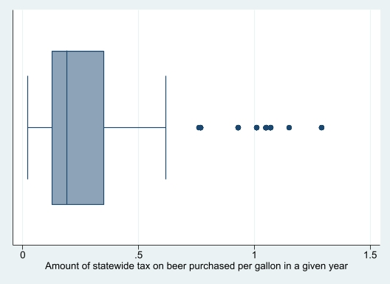

Figure 2: Proportion of states requiring Ignition interlock from 2000-2019

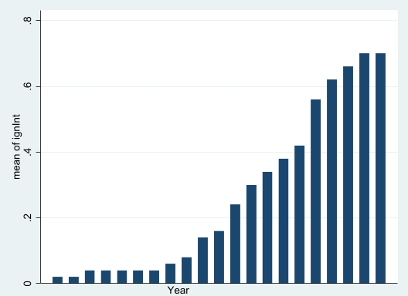

Figure 3: Box plots describing dependent variables

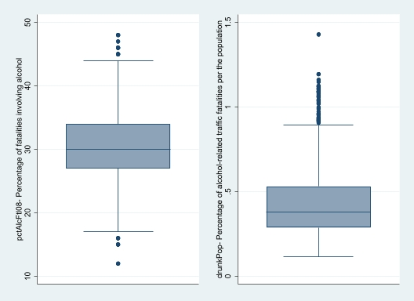

Figure 4: Representation of raw Beer Taxes against Alcohol-Related Traffic Fatalities as a Percentage of the Population

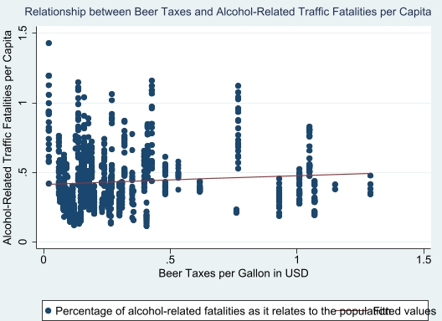

Table 1: Regression results for drunk Pop

