Software Requirements Specification

for

SMIL Messaging Service
Version 1.0 approved
Prepared by Brian Santisi
Team 1
March 9th, 2011

Table of Contents

Table of Contents 2
1.Document Information 4
1.1. Prepared By 4
1.2. Document Responsibilities 4
1.3. Revision History 4
2.Introduction 5
2.1. Purpose 5
2.2. Scope 5
2.3. Definitions, Acronyms, and Abbreviations 5
2.4.References 5
2.5. Overview 5
3.Overall Description 6
3.1. Product Perspective 6
3.2. Product Functions 6
3.3. User Characteristics 6
3.4. General Constraints 6
3.5. Assumptions and Dependencies 6
4.Specific Requirements 6
4.1. External Interface Requirements 6
4.1.1.User Interfaces 6
4.1.2.Hardware Interfaces 8
4.1.3.Software Interfaces 8
4.1.4.Communication Interfaces 8
4.2. Functional Requirements 8
4.2.1.Overall Activity Diagram 8
4.2.2.Use Case Diagram 8
4.2.3.Detailed Activity Diagram 8
4.3. Performance Requirements 8
4.4. Design Constraints 8
4.5. Software System Attributes 8
4.6. Other Requirements 8
5.Project Management 9
5.1. Project Estimation 9
5.2. Risk Assessment 9
6.Future System Improvements 9
7.Meeting Agenda and Minutes 10

Document Information

Prepared By
Brian Santisi

Document Responsibilities
Documentation: Brian Santisi
MS Project Document: Benjamin Baxter
Use Case Diagram: Spencer Egart
Overall Activity Diagram: ????
Detailed Activity Diagram: ????
Other: ????

Revision History

Name | Date | Reason For Changes | Version
Brian Santisi | 03/11/11 | First Draft | 0.1
Jason Niklas | 03/18/11 | Added agendas and minutes  Added application screen shots  Update various sections | 0.2

Introduction

Purpose
The purpose of this document is to define the project requirements for the program design and implementation.

Scope
The program will allow a user to generate, play, send, and receive SMIL format messages from cellular phones running Google’s Android mobile platform.

Definitions, Acronyms, and Abbreviations
SMIL – Synchronized Multimedia Integration Language
Éclair – Android version 2.0/2.1
Froyo – Android 2.2
Gingerbread – Android 2.3
Honeycomb – Android 3.0

References
http://www.w3c.org
http://developer.android.com

Overview
Messages can be edited using a drag and drop interface and saved for later editing or sent immediately. Once sent, messages will be saved in the Outbox. Received messages will be saved in the Inbox for later viewing. Messages that have been saved but not yet sent (drafts) will be saved in the Drafts folder.

Drag and drop interface will consist of a canvas and several buttons. The user will choose a file to place on the canvas and drag it to the desired location. The types of files users can choose from are limited to text, picture, video, and sound clip. Once all files are added a SMIL message will be generated specifying when and where each file will appear in the message during playback.

Overall Description

Product Perspective
SMIL messages allow users to create and view multimedia messages very simply through a mobile interface. Users can create reasonably complex messages on the go with virtually no prior video editing knowledge.

Product Functions
This application has a large set of features and functionality, but there are three(3) main functions:

- SMIL Player – Allows user to play a specified SMIL message
- SMIL Composer – Allows user to create a new SMIL message
- SMIL Browser – Allows user to browse a list of all SMIL messages

NOTE: The ability to send and receive SMIL messages is incorporated into all three of these functions.

User Characteristics
Android 2.1 and up user.

General Constraints
Constrained by limitations of the Android operating system, memory and clock speed of Android phones, data transfer rate of phone to cloud/cloud to phone.

Assumptions and Dependencies
Assume that messages will be sent/received at any time of day, user is familiar with drag and drop functionality, simple touch screen interfaces.
Dependent on cloud storage up and running and able to receive and send data.

Specific Requirements

External Interface Requirements

User Interfaces
The user interface will include a number of windows. The application will start from a main page and depending on the user's actions, other windows will be displayed accordingly. For example, from the main window, the user has the ability to create a new message. The new message window would then be displayed.

Please see below for a brief overview of supported windows:
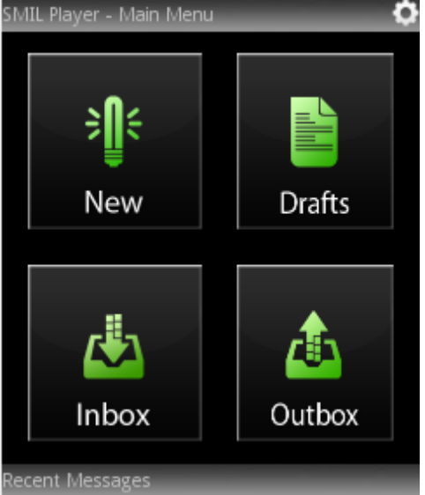
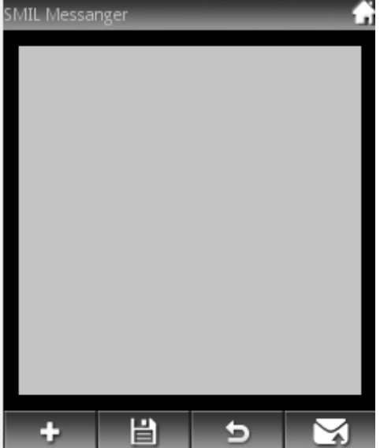
Main Composer

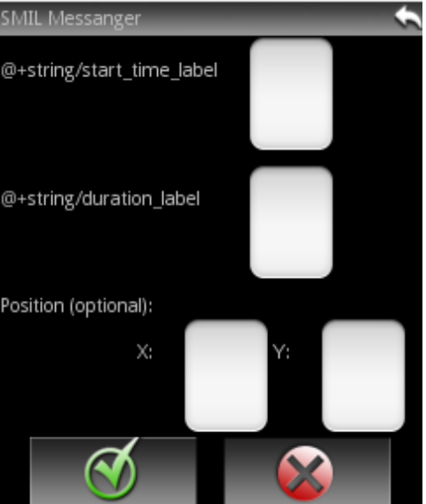
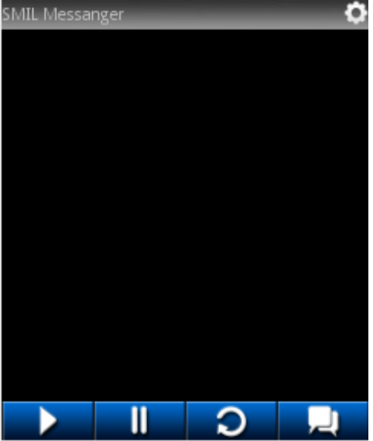
Player Media Properties

Hardware Interfaces
960 x 640 Touchscreen

Software Interfaces
SMIL generator, SMIL interpreter

Communication Interfaces
Multimedia files must be stored in the Cloud. The SMIL composer sends the links of multimedia files with the text to the player. The SMIL player retrieves the multimedia files from the Cloud.

Functional Requirements

Overall Activity Diagram
[diagram here]

Use Case Diagram
[diagram here]

Detailed Activity Diagram
[diagram here]

Performance Requirements
Application must be able to send, receive, generate, and play SMIL messages in a timely manner. Optimal time for begin playback: < 1 second.

Design Constraints
Bandwidth usage is limited by phone internet speeds. Storage for files limited to phone hard drive size. Limited time for development.

Software System Attributes
Generate, play, send, receive SMIL messages. Save sent and received messages and messages saved for later editing. Allow users to create message in a user-friendly manner.

Other Requirements
Allow support for future versions of Android.

Project Management

Project Estimation
Applications slated for production release: April 27th 2011

Risk Assessment
Time, catastrophic hardware failure.

Future System Improvements
Undo functionality in message creator.

Appendix:
- Task Partition
Project Manager: Benjamin Baxter
Developer: Corry Dringenburg
(Section unfinished)
- Work Schedule
[MS Project file here]
- Weekly Meeting Agenda and Minutes
Copy/paste minutes?
- Other Communication Records
- Software Configuration Management

Meeting Agenda and Minutes
CSC 440/540
Team 2 Meeting Agenda

Date: 1/18 Primary Facilitator: Curtis
Start: 5:15 P.M. Timekeeper: Jason
End: 6:00 P.M. Minute Taker: Brian
Room: Steely Library 3rd Floor

1. Objective
Establish team management, organization, and project details so we can begin working together in an efficient manner.

2. Status [Allocated Time: 10 minutes]
Everyone: Are we all on the same page about where we stand and how we move forward? Two members changed teams.

3. Discussion Items [Allocated Time: 30 minutes]
3.1 Assign member roles
3.2 Confirm language and platform we will use in development
3.3 Confirm group communication mechanism
3.4 What cloud service will we use? (Amazon EC2, Microsoft Azure, Google App)
3.5 What comm type will we use between the device and cloud? (FTP, HTTP, etc)
3.6 What will we work on during the first week?
3.7 Who is responsible for which part of the system?

4. Wrap up [Allocated Time: 5 minutes]
4.1 Review and assign new action items
4.2 Meeting critique

CSC 440 Team 2 Minutes

Date: 1/18/11 Primary Facilitator: Curtis LaBoiteaux
Start: 5:15pm Timekeeper: Jason Niklas
End: 6:15pm Minute Taker: Brian Santisi
Room: Frank Steely Library 3rd Floor

- Objective
(from agenda)

- Status
All members have Android SDK installed without issue.
Decided to wait on assigning roles/tasks until all group members are present in the group.
All members will be Implementers and Testers
Assigned research to be done.

- Discussion
We were all able to get the Eclipse IDE and Android SDK/PlugIns installed without any major problems. Because two team members dropped over the weekend, were are waiting until the next meeting to assign individual roles to our group members. We are also holding off assigning specific project tasks to individual group members until next meeting. Every group member will be Implementor and Tester. Curtis is looking into Google Groups and the ability to use it for communication, document control, and source control. Jason and Brian are looking into Google App Engine. All group members are looking into the Android API and tutorials.

- Wrap Up
Team members will look into details on using Google cloud storage and Google Groups. All team members will research Android SDK tutorials. Awaiting more information on the technical details of the project. Also awaiting new team members to assign roles.
CSC 440/540
Team X Meeting Agenda

Date: 1/26 Primary Facilitator: Benjamin
Start: 5:00 P.M. Timekeeper: Brian
End: 5:45 P.M. Minute Taker: Curtis
Room: Student Lounge 3rd Floor

1. Objective
Allow each team member to discuss research findings. Finalize member roles. Assign first round of development tasks.

2. Status [Allocated Time: 10 minutes]
2.1 Jason – Report status/findings with regards to Google App Engine and first round requirements document.
2.2 Brian – Report status/findings with regards to Google App Engine
2.3 Curtis – Report status/findings with regards to Google Groups
  - All members report research status on Android programming techniques

3. Discussion Items [Allocated Time: 30 minutes]
3.1 Bring any new members up to speed and assign member roles
3.2 What will we work on during the next week?

4. Wrap up [Allocated Time: 5 minutes]
4.1 Review and assign new action items
4.2 Meeting critique

CSC 440/540
Team 2 Meeting Minutes

Date: 1/26 Primary Facilitator: Benjamin
Start: 5:00 P.M. Timekeeper: Brian
End: 5:45 P.M. Minute Taker: Curtis
Room: Student Lounge 3rd Floor Attending: Ben, Corry, Curtis, Brian, Spencer, Jason

1. Objective
Allow each team member to discuss research findings. Finalize member roles. Assign first round of development tasks.

2. Status
2.1 Jason – Sent out requirements document to the group.
2.2 Brian – Was able to get eclipse up and running with Android SDK
2.3 Curtis – Google groups account setup, CSCteamX@googlegroups.com members have been invited.
  - Members have Android SDK setup in Eclipse

3. Discussion
3.1 Team needs a system for source code management and code
Proposals: 1) Use kosh account at NKU 2) Utilize Google Code
Resolution: Team will utilize Google Code using the subversion plugin for eclipse

3.2 What will we work on next week?
Resolution: Get more familiar with the Android SDK and get a primitive schedule together

4. Wrap up
AI[1] For: All members.
Get a standard “Hello World” example up and running from the Android SDK. Then, make a variation of the program experimenting with changing values, such as color, size of the text, using an input box for a name, etc.

AI[2] For: Jason and Corry
Setup Google Code account for the group.
CSC 440/540
Team X Meeting Agenda

Date: 2/4 Primary Facilitator: Benjamin
Start: 5:30 P.M. Timekeeper: Corry
End: 6:15 P.M. Minute Taker: Spencer
Room: Student Lounge 3rd Floor

1. Objective
All members should be able to access the Google Code SVN repository. Improvements and refinements should be made to the requirements and design specifications, and some basic UI layouts should be discussed.

2. Status [Allocated Time: 10 minutes]
2.1 Everyone – go over access to SVN with Eclipse
2.2 Everyone – set up SVN if not already set up

3. Discussion Items [Allocated Time: 30 minutes]
3.1 Project Requirements – refine and go over the requirements for the project
  - Design – start establishing a design for the project, including UI layout
  - Establish coding standards, using other established standards as a basis

4. Wrap up [Allocated Time: 5 minutes]
4.1 Review and assign new action items
4.2 Meeting critique

CSC 440/540
Team 1 Meeting Minutes

Date: 2/2 Primary Facilitator: Benjamin
Start: 5:30 P.M. Timekeeper: Corry
End: 6:15 P.M. Minute Taker: Spencer
Room: Student Lounge 3rd Floor

1. Objective
Allow each team member to discuss research findings. Members will display advances in learning the Android Eclipse environment.

2. Status
Corry and Ben worked on getting a basic tabbed interface up and running through Eclipse
Curtis demoed a similar tabbed interface with inbox/outbox/draft tabs

3. Discussion Items
Group discussed various tutorials and help available on the Android developers site.
Corry set up SVN server on Google Code and connected to it via the Eclipse SVN plugin.
Group went over basic UI options like tabs.
Ben suggested a “chat bubble” interface like many messaging services have today.

4. Wrap-up
Established a meeting time for Friday at 5:30 – future meetings will be at this time.
Assigned Corry to create a simple “how-to” on connecting to SVN via Eclipse.
Generated discussion items for next meeting.

CSC 440/540
Team 2 Meeting Minutes

Date: 2/11 Primary Facilitator: Ben
Start: 5:30 P.M. Timekeeper: Spencer
End: 6:30 P.M. Minute Taker: Spencer
Room: Calculus Lab Attending: Ben, Spencer, Brian, Corry

1. Objective
- UML and UI
- Coding standards
  - Eclipse standard
- Brian/Jason – useful eclipse hotkeys
- Curtis – test videos and images
- Ben – SVN structure
- Corry – admin of Google Group and Google Project
- Spencer – look up APIs for file searching

2. Status
- Discussed status of group members
- Discussed objective items from last week

3. Discussion
- Went over example layout for GUI
- Assigned button job to Curtis
- Assigned GUI example application to Brian and Corry
- Discussed UML as applied to the current project
  - Separated into composer and player aspects
    - State UML Diagram
    - Activity UML
    - Sequence UML
    - Use-case diagram
- Assigned dynamic file choosing drag to Corry and Spencer
- Assigned menu to Corry
- Discussed Drag-n-Drop
  - Single click vs Long-touch
    - Single-click
      - Pros
        - Easy
        - Smooth
        - Responsive
        - Many features
      - Cons
        - Not in the initial design requirements
        - Not currently dynamic (assigned to Corry)
    - Long-touch
      - Pros
        - In our initial required specifications
      - Cons
        - Lots of code
        - Unfinished
        - Buggy
        - Pictures hard-coded
        - Z-layers hard-coded
        - Movement icon?
- Debugging
  - android.util.*;
  - Log.i(Tag, Msg)
  - Log.d(Tag, Msg)
  - Log.v(Tag, Msg)
  - Log.w(Tag, Msg)
  - platform-tools/adb.exe logcat
  - String final TAG_WE = “Class_Name”;
  - IDVW/TAG ___________

4. Wrap up
- Next week
  - Coding standards if members present
  - UML Diagrams
  - Go into depth with UI
  - Assign UI construction
- CSC 440/540
- Team 1 Meeting Minutes

- Date: 2/18 Primary Facilitator: Benjamin
- Start: 5:30 P.M. Timekeeper: Curtis
- End: 6:40 P.M. Minute Taker: Curtis
- Room: Student Lounge 3rd Floor Attending: Ben, Corry, Curtis, Spencer, Jason

- 1. Objective
- Update progress on user interface ideas and prototype implementation.

- 2. Status
- 2.1 Corry – Update on experimenting with drag and drop functionality. Partially working with bugs.
- 2.2 Jason – Requirements document started up and distributed.
- 2.3 Curtis – Prototype image for main app page and various icons created for UI

- 3. Discussion
- 3.1 Team discussed the UML state diagram for the composer, and navigation to and from the main menu.

- 3.2 Properties discussed for how the team would like the user interface of the composer to function. Properties for an added object with include defaults for x and y coordinate position, start time, duration, and height and width. Text will include an input field, and an option to define text size. Audio and video will have a “repeat” check box. Each object will have the option for manually inputted x and y coordinates for screen position.

- 3.3 Team will use ArgoUML for our various UML documentation.

- 4. Wrap up
- AI[1] For: Curtis.
- Put together images for the properties windows of each object type. Create buttons for “back” and “home”. Create image for type selection when user elects to add an object to a message.

- AI[2] For: Corry
- Continue to work on drag and drop functionality prototyping. Include the main menu page with functioning “new” button for the prototype, that takes the user to the composer layout.

- AI[3] For: Spencer
- Create an ArgoUML setup document for the team detailing how to setup and use.

- AI[4] For: Ben
- Update the Microsoft Projects file.

- AI[5] For: Ben
- Create the UML state diagram for the composer, discussed during the meeting.

- AI[6] For: Jason
Create a properties file for Eclipse.
CSC 440/540
Team 1 Meeting Agenda

Date: 2/25 Primary Facilitator: Benjamin
Start: 5:30 P.M. Timekeeper: Curtis
End: 6:30 P.M. Minute Taker: Jason
Room: Student Lounge 3rd Floor

1. Objective
Review requirements documentation and UI direction.

2. Status [Allocated Time: 25minutes]
2.1 Curtis – Report status on images displaying the team’s direction for UI components: properties windows for various object types following the user’s selection.
2.2 Spencer – Report status/findings with regards to ArgoUML
2.3 Ben – Report status on the UML state diagram for the composer
  - Corry – report status on drag and drop functionality and navigation from main menu to composer
  - Jason – report status on the Eclipse properties document

3. Discussion Items [Allocated Time: 30 minutes]
3.1 Discuss requirements documentation direction and assign roles for their creation
3.2 What will we work on during the next week?

4. Wrap up [Allocated Time: 5 minutes]
4.1 Review and assign new action items
4.2 Meeting critique

CSC 440/540
Team 2 Meeting Minutes

Date: 2/25 Primary Facilitator: Benjamin
Start: 5:30 P.M. Timekeeper: Spencer
End: 7:00 P.M. Minute Taker: Brian
Room: Student Lounge 3rd Floor Attending: Benjamin, Corry, Spencer, Brian

1. Objective
Outline SRS Document

2. Status
Went over main points for a draft of SRS doc, assigned tasks

3. Discussion
Outlined main points for each category of Spec Sheet – 1 hr
Assigned tasks – ½ hr

4. Wrap up
Skeleton for SRS document drawn up, following tasks were assigned:
Benjamin – update MS Project Doc
Corry – drag and drop
Spencer – research SMIL format, player
Brian – write rough draft of SRS document

CSC 440/540
Team 1 Meeting Minutes

Date: 03/02 Primary Facilitator: Benjamin
Start: 6:00 P.M. Timekeeper: Curtis
End: 7:00 P.M. Minute Taker: Jason
Room: Student Lounge 3rd Floor Attending: Ben, Curtis, Spencer, Jason

1. Objective
Get Curtis and Jason caught up and assign more tasks and get status of assigned tasks.

2. Status
2.1 Corry – Working on refining Drag-n-Drop functionality.
2.2 Jason – Looking into Player Activity to play SMIL file, no status to report.
2.3 Curtis – Further developing various UI components.
  - Spencer – Currently working on File Browser/Chooser using Plug-In
  - Brian – Working on requirements document.

3. Discussion
3.1 File Chooser Plug-In identified by Spencer appears to be a viable solution and we agreed to keep moving forward with integrating this Plug-In into our application.

3.2 There was some discussion about the manner in which the data content would get sent from one client to another and how multimedia files would handled in the cloud. This discussion served mainly to get Jason brought up to speed.

4. Wrap up
AI[1] For: Curtis.
Develop UI portion of requirements document/specification and work with Brian on getting content into his version of the document..

AI[2] For: Curtis.
Work on unified Properties page including Inbox and Outbox images.

AI[3] For: Jason
Develop SMIL Player Activity proof of concept. Get media from Curtis to create message. Make .smil file and play it for demo.

AI[4] For: Jason
Get ahold of Cory and get status of Cloud. Create proof of concept/demo that is capable of uploading multimedia files to the Cloud from PC and possibly Android test application.

AI[5] For: Spencer
Create File Chooser proof of concept to demo for meeting on Friday 3/11.

AI[6] For: Ben
Update the Microsoft Projects file.

AI[7] For: Ben
Look into Activity stack and the ability to move back to previous Activities. Is this an automatic or manual process?

AI[8] For: Corry
Keep working on Drag-n-Drop.

AI[9] For: Ben & Corry
Work on Composer Activity.

AI[10] For: Brian
Keep working on Requirements Document.

