
Mobile SMIL in the Cloud

Version 1.1

Revisions
Version | Primary Author(s) | Description of Version | Date Completed
1.0 | Benjamin | Initial document | 04/10/2011
1.1 | Curtis | Spelling/Grammar/Readability changes | 4/13/2011
Contents
1 Introduction 1
1.1 System Overview 1
1.2 high level entities 1
1.3 Low level design 1
2 Design Considerations 2
2.1 Assumptions 2
2.2 Environment Considerations 2
3 Architecture 8
3.1 Overview 3
3.2 Strategies 3
3.2.1 Backwards-compatibility Requirements 3
3.2.2 Security Requirements 3
3.2.3 Scalability 3
3.2.3 Performancey 3
3.2.3 Reliability 3
3.2.3 Efficiency 3
3.2.3 Understandability 3
3.2.3 Maintainlability 3

- Introduction
  - System Overview
As technology evolves, it is becoming easier to share media such as pictures, text, and videos with others around the world. To better utilize the diversity of this multi-media, we are building an application that can compose a SMIL message capable of integrating all of these pieces. The application will be capable of playing SMIL messages, as well as composing them on the fly. The sending and receiving of SMIL messages will also be possible. This application will be able to be used by anyone who would like to develop a multi-media SMIL message on their phone. Having this mobile application will enable the user to create and watch SMIL messages without the need of a computer.

  - High Level Entities
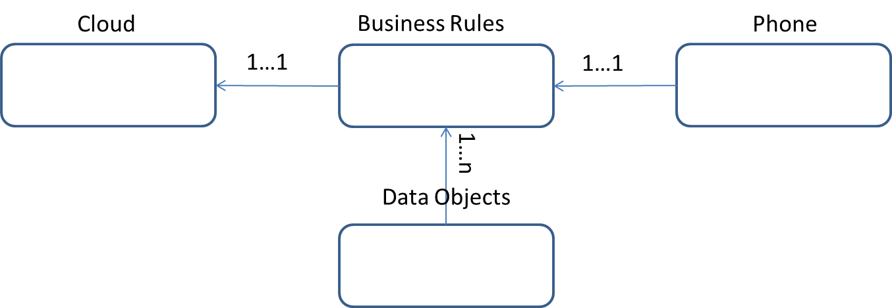
The application will use services provided by a cloud. We will use Google’s App Engine for our cloud provider. The cloud the actual SMIL XML files as well as the media objects embedded in the message.
The application will also rely on services provided by the phone. We will use the SMS service of the phone to transfer a recipient notification to the receiver, as well as the file name of the sent SMIL file.
The business rules will decide how the phone will interact with the cloud and the corresponding data objects. Note that multiple data objects may be used for any one business rule.
The data objects will range from utilities, such as reading and writing to a SMIL file, to services such as uploading and downloading from the cloud. These objects will assist the business rules.

  - Low Level Design

Audio Video Text Image
| | | |
|
|
SmilComponent [source, start, duration, region]

Since the entire application revolves around the ability to create and play SMIL messages, it makes sense to start with the objects that make up the SMIL message. The SmilComponent class is an abstract class that contains the main functions of a media element in a SMIL message. It holds the file name and path, along with the tag name, region, and begin/end times. There are four sub classes of the SmilComponent class: SmilAudioComponent, SmilImageComponent, SmilTextComponent, and SmilVideoComponent. Each of these components will contain information that is mutually exclusive to their properties per the SMIL specifications.
We will create a list of SmilComponents that the user can add, edit, or delete from. This list will represent the contents of the SMIL message. A SmilComponent will contain a special tag to map it from the list to the View that will be displayed on the canvas. Once the user is happy with their message, they can send it to another user.
In order for our phone to transfer the media files along with the xml file, we must use services provided by the cloud. We will encrypt the file name of the SMIL message as we send it over the cloud. The key for the file name is the sender’s phone number plus a time stamp as to when the message was sent. By appending the time stamp, we ensure uniqueness for each SMIL file. It’s probably not the most secure, but it will be a random bunch of numbers that do not look like anything to a user. However, this will enable us to know who sent a message and when the message was sent without the use of an expensive database. Once the user decides to send their message, we will generate the SMIL file with the appropriate file name. Then we will upload the file to the cloud and send a notification text message at the same time. The file name will be embedded in the text message. When the text message is received, our application will parse the message and extract the file name. With the unique file name, we can begin downloading from the cloud.
What does uploading and downloading entail? Glad you asked! To upload to the cloud, we need to make several requests. An HTTP GET request will be made to our cloud application and we will receive another URL that contains the address to where we can store our files. Using the provided Blob Store from Google’s App Engine, we can make a POST request to the receive URL and the Blob Store will now store the file. To download, we make a GET request to our cloud application with the requested file name. Then, we stream the contents of the file and write the bytes to a local file.
How is this supposed to be used? We will have a list of SmilComponents from the composer. We can embed text into the SMIL file so we do not need to make a text file for each text message. Under this assumption, we then examine each element of the list and if it is not an instance of SMILTextComponent, we then upload the file to the cloud. We take the newly named SMIL file and upload it as well. Now that uploading covered, how do we handle downloading? The file names of the media objects are embedded in the SMIL File. So, as we parse through the file, we will download the media content from the cloud.
Now that we have the media content, how to we play the SMIL file? We have a SmilView which extends android.view.SurfaceView and implements SurfaceHolder.Callback. This SmilView will contain a SmilThread class which will be used to control each SmilComponent. There is a master thread that monitors all the other threads and tells them when to start and stop playing. The SmilView will tell each component where to be positioned on the screen to recreate the final product that was saved on the canvas.

- Design Considerations
  - Assumptions
We have several assumptions in place, but there are several risks associated with our application model as well.
- Assumptions
  - A unique file name will be given to each SMIL file.
- Risks
  - An outside listener can intercept the SMIL file and gather a lot of information from the file name and the contents.
  - In the player, we have multiple threads running but we have not determined a strategy for handling hung threads. If our application produces hung threads, then it will be up to the user to handle restarting our application to clear any hung threads. However, a user may not know about hung threads and thus might not be equipped with the knowledge as to how to handle our application when it crashes.
  - If the cloud experiences any downtime, our application will be effectively unusable until it is back up and running.

  - Environment Considerations
We will need “branch” directory in subversion for two new projects to be created called SMIL Project and Web Handler. The SMIL Project will contain the android source code while the Web Handler will contain the code for the Cloud application. Upon completion of the code, we will need to add these projects to the “trunk” directory and merge with any other changes.
Since a mobile device is not like a server, where an application can be hosted in one central location, each team member will be limited to only using the emulator provided from the android SDK plug-in for eclipse. The down side of this limitation is that if team members start to see discrepancies between each other’s application behavior, then we will lose time and resources to fix the problem and sync the applications back up again. Unfortunately, we cannot deploy a team member’s phone to be the host of our application.
However, the cloud application can run in a centralized location. This will enable us to test, debug, and develop in an environment that will be uniform across all interfaces. There will be a test application deployed on the cloud as well to verify the basic principles of the services provided by the cloud.
Since we are utilizing the services provided by the cloud, we expect the simple assumptions and considerations to be handled on Google’s side; 24 hour availability, to provide an example. However, if a problem does occur, we will need to consult our environment administrator to diagnose and resolve any issues caused by our application.

- Architecture
  - Overview
We wish to design an elegant application. However, we must first weigh the trade-offs. We realize that this is an application for a user with no technical skills. This means that we must increase our usability. This will affect our functionality in that we will not be able to offer as many features or tasks that a user may desire because we have to spend so many resources focusing on usability. For example, we would love to have an undo option, but there are not enough resources to incorporate that task.
Another aspect we will rely on is portability over efficiency. It is important to have an application that can be run on either an Android OS of 2.1 or better. However, if at any time we need make changes to our cloud application, then we should be able to make the necessary modifications without affecting the mobile part of the application. Our efficiency will decrease, as we will experience more over head in setting up interfaces that enable us to modulate our application. However, this will serve to complete the portability described in the initial requirements specification.
With modulation comes reusability. We are making reusable packages for functions that range from uploading and downloading from the cloud to reading and writing a SMIL file. However, this will produce a high cost to create the overhead interfaces when these packages are to be used again.

  - Strategies
There are several strategies that need to be addressed. Even though a strategy enables a more elegant design, several risks are exposed from them as well.
    - Backward-compatibility
We would want every release with all of its new features and enhancements to be able to still support the functions that were evident from the previous versions. We can handle this from our modulation approach. If we want to add a feature to just the composer, then we can make the modification in the application tier, and make corresponding changes to the presentation tier without having to worry about the model tier.

    - Security
One big design aspect is security. With the resources available, we do not have the ability to create an enhanced security system that can validate a user. This leaves us at risk with how we approach our mobile to mobile communications. Also, we do not make https connections to the cloud. Because we do not have control over the server, it will be harder to accomplish creating self-signed certificates and incorporate them into our mobile application for communicating with the cloud. With more resources at our disposal, we would investigate this approach.

    - Scalability
We will account for scalability in two aspects. On the phone, we must be able to support a large number of phones running the application. On the mobile level, the scalability only affects the total number of phones that have downloaded and installed our application. The other aspect is the cloud. Can our cloud handle a scalable size increase of users uploading and downloading from the cloud? In the initial design, we will ignore this point, but still be cognizant of the benefits of scalability. In this way, when we modulate our code we will design for scalability. At the present time, though, it is not necessary and is outside of the scope in the early stages of this application.

    - Performance
We will take into account the overall performance of the application. However, we do not have the resources at this initial step to undergo a full regression and performance test. We will account for performance, but because of all the modulation our performance will decrease given the overhead interface connections.

    - Reliability
We will test and create a test plan for the functions and requirements defined in the requirements specification document. We may have errors and exceptions in our code but as long as the Android OS does not recognize them, then we will not segregate resources to fix them in this initial phase. An example is the thread class. When java released its latest version, it deprecated the thread class’ stop method. Now, whenever stop is invoked, a runtime error is thrown. As long as the program functions and a user does not notice a decrease in performance because of this, then we will push this task to a later phase. To ensure reliability on the cloud, we will have a system support team to monitor the performance and reliability of the cloud. If at any time a problem occurs on the cloud from our application, they will be consulted to diagnose and resolve the issue. If at any time any part of the application is down, then we will need a way to notify the user and apologize for any inconvenience.

    - Efficiency
We must take into account efficiency because this can seep into other key components of our application, such as performance. If a search is necessary, then we must choose the best search algorithm for the occasion. We should try to minimize poor performance algorithms. When an algorithm is to be used, it should be documented and packaged for reuse.

    - Understandability
We will make efforts for our code to be readable by creating classes, variables, and methods with sentence like structure. We do not want a jumbled mess inside each class, so a structure of where to define methods and variables will be declared. We also want the traceability of the requirements to be evident.

    - Maintainability
By having readable code, it will reduce the cost of maintenance. By using modules, we can lower the cost for maintainability by removing the need to develop and test for every aspect of the application. We will have test applications that will test the basic functions of our application. If any functions or requirements change, we will need to maintain the test applications as well.

