User Interface Requirements Specification
for
SMIL Messaging Service
Version 1.0
Prepared by Curtis LaBoiteaux
Team 1
March 17th, 2011

Table of Contents
1. Document Information 1
1.1. Prepared By 1
1.2. Revision History 1
2. Introduction 1
2.1. Purpose 1
2.2. Audience 1
3. Specific Requirements 2
3.1. Home Screen 2
3.1.1. Home Screen Image 2
3.1.2. GUI Elements 2
3.1.3. Additional Page Messages 3
3.2. Composer Screen 3
3.2.1. Composer Screen Image 3
3.2.2. GUI Elements 3
3.3. Player Screen 4
3.3.1. Player Screen Image 4
3.3.2. GUI Elements 4
3.3.3. Additional Page Messages 5
3.4. Text Properties Screen 5
3.4.1. Text Properties Image 5
3.4.2. Text Properties Fields 5
3.4.3. GUI Elements 6
3.5. Audio Properties Screen 6
3.4.1. Text Properties Image 6
3.4.2. Text Properties Fields 6
3.4.3. GUI Elements 7
3.6. Image Properties Screen 7
3.4.1. Text Properties Image 7
3.4.2. Text Properties Fields 7
3.4.3. GUI Elements 8
3.7. Video Properties Screen 8
3.4.1. Text Properties Image 8
3.4.2. Text Properties Fields 8
3.4.3. GUI Elements 9

Document Information

Prepared By
Curtis LaBoiteaux

Revision History
Name | Date | Reason For Changes | Version
Curtis LaBoiteaux | 3/17/11 | First Draft | 0.1

Introduction

Purpose
The goal of these screens is to show how a user will use and navigate the areas of our application.

Audience
The primary audience for this UI Specification are the team members who will be responsible for the development of the user interface for our application.

Specific Requirements

Home Screen

Home Screen Image
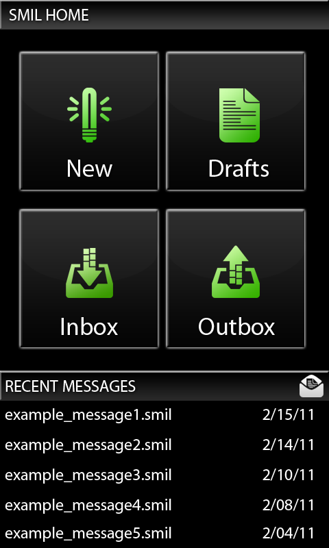

GUI Elements
Item: Label | Action | Dynamic Behavior
Button: New | Touch | Sends the user to the Composer screen to create a message
Button: Drafts | Touch | Opens the file chooser for the Drafts folder to select unfinished messages.
Button: Inbox | Touch | Opens the file chooser for the Inbox folder to select received messages.
Button: Outbox | Touch | Opens the file chooser for the Outbox folder to select previously sent messages
Button: Recent_Message[5] | Touch | The 5 most recent messages received are displayed, selecting one will open it in the Player screen.

Additional Page Messages
Scenario | Message | Notes
User returns to the main screen after successfully sending a message | “Message successfully sent.” | This messages pops up in the form of a toast.

Composer Screen

Composer Screen Image
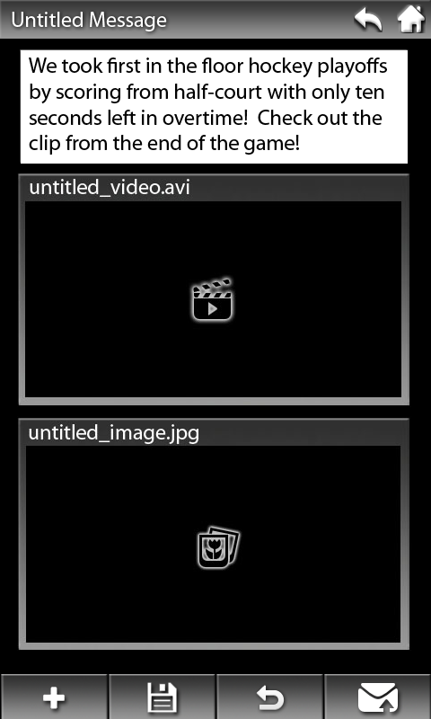

GUI Elements
Item: Label | Action | Dynamic Behavior
Button: Return | Touch | Sends the user back to the previous screen. A toast will pop up to confirm.
Button: Home | Touch | Sends the user to the Home screen. A toast will pop up to confirm.
Button: Add | Touch | Opens a spinner where the user will choose to add an Audio, Text, Image or Video component to the message. Selecting one (other than text) will open up the gallery. After a file is chosen, the user will be directed to the properties page for that object.
Button: Save | Touch | Opens pop-up for the user to name their message to be saved in the drafts folder.
Button: Undo | Touch | Reverses the user’s previous action.
Button: Send | Touch | Opens pop-up with options to select message title and recipients.
Placed Object: file title or text | Touch | Opens the properties page for that specific object
Placed Object: file title or text | Touch and Hold | Object will now follow the user’s finger as he/she drags it across the screen

Player Screen
    - Player Screen Image
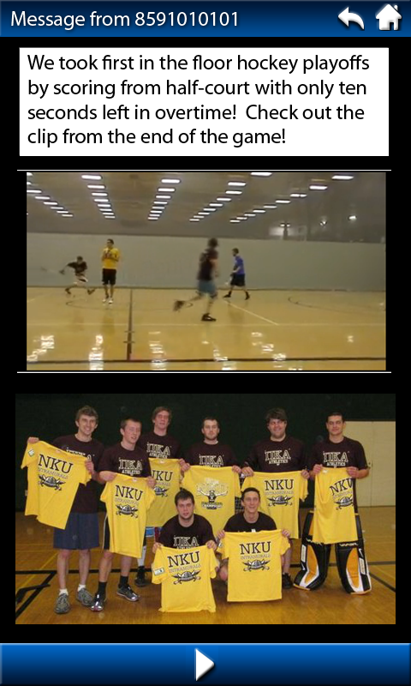

    - GUI Elements

Item: Label | Action | Dynamic Behavior
Button: Return | Touch | Sends the user back to the previous screen. A toast will pop up to confirm.
Button: Home | Touch | Sends the user to the Home screen. A toast will pop up to confirm.
Button: Play | Touch | Starts the message. While playing, the play button will be replaced by the pause button.
Button: Pause | Touch | Pauses the message. While stopped, the pause button will revert back to the play button.

    - Additional Page Messages
Scenario | Message | Notes
The message reaches the end of its running time. | A pop-up window displaying “Would you like to play the message again?” | The window has three buttons to choose from. Restart message, Reply to sender, and the Return button to take the user back to the previous screen.

Text Properties Screen
    - Text Properties Image
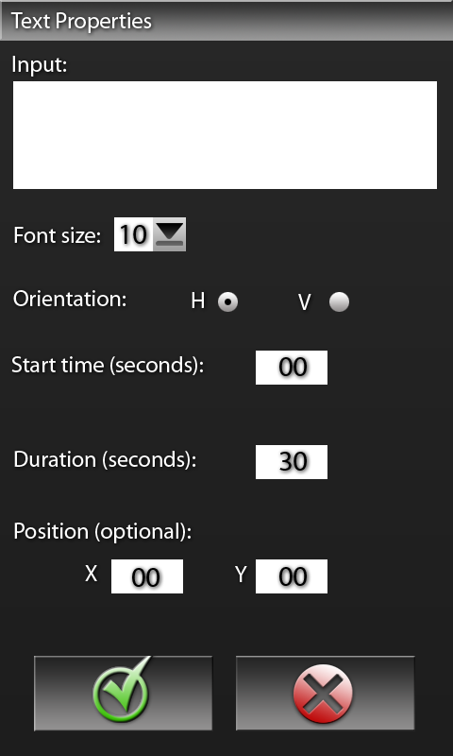

    - Text Properties Fields

Label | Screen Format | Validation | Default Values
Input | Text box
Start time | Text box | Must be a positive integer. | 00
Duration | Text box | Must be a positive integer. | 30
X Position | Text box | Must be between 0 and the width of the work area. | 00
Y Position | Text box | Must be between 0 and the height of the work area. | 00

3.4.3. GUI Elements
Item: Label | Action | Dynamic Behavior
Drop Down Menu: Font size | Touch | Allows the user to select the size of the font from a list of options.
Radio Buttons: H, V | Touch | Defines whether text will be represented horizontally or vertically. The default is horizontal.
Button: OK | Touch | Accepts the provided values and returns the user to the composer screen.
Button: Cancel | Touch | Aborts the creation of the object and sends the user back to the composer screen.

Audio Properties Screen
    - Audio Properties Image
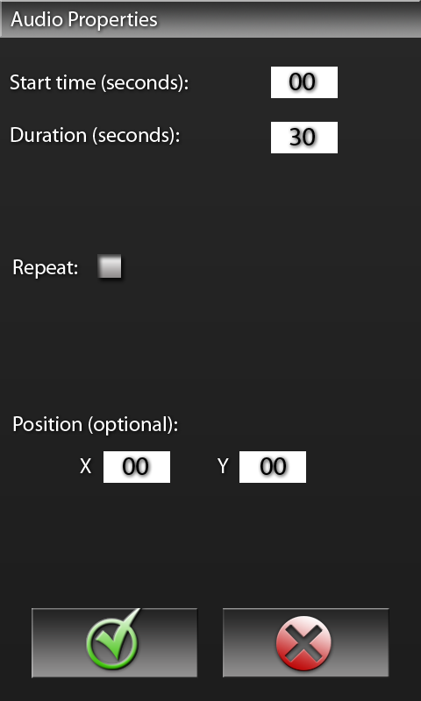

    - Audio Properties Fields

Label | Screen Format | Validation | Default Values
Start time | Text box | Must be a positive integer. | 00
Duration | Text box | Must be a positive integer. | 30
X Position | Text box | Must be between 0 and the width of the work area. | 00
Y Position | Text box | Must be between 0 and the height of the work area. | 00

3.4.3. GUI Elements
Item: Label | Action | Dynamic Behavior
Check Box: Repeat | Touch | Defines whether or not to repeat the audio until the end of the message.
Button: OK | Touch | Accepts the provided values and returns the user to the composer screen.
Button: Cancel | Touch | Aborts the creation of the object and sends the user back to the composer screen.

Image Properties Screen
    - Image Properties Image
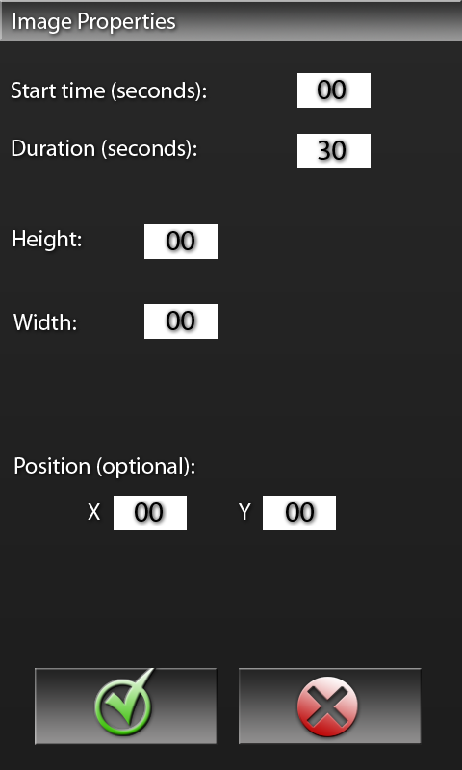

    - Image Properties Fields

Label | Screen Format | Validation | Default Values
Start time | Text box | Must be a positive integer. | 00
Duration | Text box | Must be a positive integer. | 30
Height | Text box | Must be a positive integer. | 00
Width | Text box | Must be a positive integer. | 00
X Position | Text box | Must be between 0 and the width of the work area. | 00
Y Position | Text box | Must be between 0 and the height of the work area. | 00

3.4.3. GUI Elements
Item: Label | Action | Dynamic Behavior
Button: OK | Touch | Accepts the provided values and returns the user to the composer screen.
Button: Cancel | Touch | Aborts the creation of the object and sends the user back to the composer screen.

Video Properties Screen
    - Video Properties Image
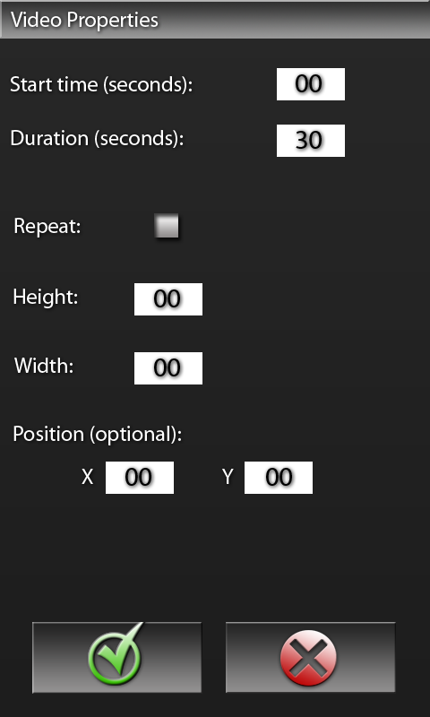

    - Video Properties Fields

Label | Screen Format | Validation | Default Values
Start time | Text box | Must be a positive integer. | 00
Duration | Text box | Must be a positive integer. | 30
Height | Text box | Must be a positive integer. | 00
Width | Text box | Must be a positive integer. | 00
X Position | Text box | Must be between 0 and the width of the work area. | 00
Y Position | Text box | Must be between 0 and the height of the work area. | 00

3.4.3. GUI Elements

Item: Label | Action | Dynamic Behavior
Check Box: Repeat | Touch | Defines whether or not to repeat the video until the end of the message.
Button: OK | Touch | Accepts the provided values and returns the user to the composer screen.
Button: Cancel | Touch | Aborts the creation of the object and sends the user back to the composer screen.

