Software Requirements Specification

for

SMIL Messaging Service

Version 1.0 approved

Prepared by Brian Santisi

Team 1

March 9th, 2011

Table of Contents

1. Document Information 1

1.1. Prepared By 1

1.2. Document Responsibilities 1

1.3. Revision History 1

2. Introduction 1

2.1. Purpose 1

2.2. Scope 1

2.3. Definitions, Acronyms, and Abbreviations 1

2.4. References 2

2.5. Overview 2

3. Overall Description 2

3.1. Product Perspective 2

3.2. Product Functions 2

3.3. User Characteristics 2

3.4. General Constraints 2

3.5. Assumptions and Dependencies 2

4. Specific Requirements 3

4.1. External Interface Requirements 3

4.1.1. User Interfaces 3

4.1.2. Hardware Interfaces 3

4.1.3. Software Interfaces 3

4.1.4. Communication Interfaces 3

4.2. Functional Requirements 3

4.2.1. Overall Activity Diagram 3

4.2.2. Use Case Diagram 3

4.2.3. Detailed Activity Diagram 3

4.3. Performance Requirements 3

4.4. Design Constraints 3

4.5. Software System Attributes 4

4.6. Other Requirements 4

5. Project Management 4

5.1. Project Estimation 4

5.2. Risk Assessment 4

6. Future System Improvements 4

# Document Information

## Prepared By

Brian Santisi

## Document Responsibilities

Documentation: Brian Santisi

MS Project Document: Benjamin Baxter

Use Case Diagram: Spencer Egart

Overall Activity Diagram: ????

Detailed Activity Diagram: ????

Other: ????

|  |  |  |  |
| --- | --- | --- | --- |
| **Name** | **Date** | **Reason For Changes** | **Version** |
| Brian Santisi | 3/11/11 | First Draft | 0.1.1 |
| Benjamin Baxter | 3/17/11 | Added screen shot of project | 0.1.2 |
|  |  |  |  |
|  |  |  |  |

## Revision History

# Introduction

## Purpose

Program will generate, play, send, and receive SMIL format messages from cellular phones running Google’s Android mobile platform.

## Scope

Android operating system, SMIL format, cloud storage/computing

## Definitions, Acronyms, and Abbreviations

SMIL – Synchronized Multimedia Integration Language

Éclair – Android version 2.0/2.1

Froyo – Android 2.2

Gingerbread – Android 2.3

Honeycomb – Android 3.0

## References

<http://www.w3c.org>

<http://developer.android.com>

## Overview

Messages can be edited using a drag and drop interface and saved for later editing or sent immediately. Once sent, messages will be saved in the Outbox. Received messages will be saved in the Inbox for later viewing. Messages that have been saved but not yet sent (drafts) will be saved in the Drafts folder.

Drag and drop interface will consist of a canvas and several buttons. The user will choose a file to place on the canvas and drag it to the desired location. The types of files users can choose from are limited to text, picture, video, and sound clip. Once all files are added a SMIL message will be generated specifying when and where each file will appear in the message during playback.

# Overall Description

## Product Perspective

SMIL messages allow users to create and view multimedia messages very simply through a mobile interface. Users can create reasonably complex messages on the go with virtual no prior video editing knowledge.

## Product Functions

Generate, playback, save, send, and receive SMIL format files. (SMIL message)

## User Characteristics

Android 2.1 and up user.

## General Constraints

Constrained by limitations of the Android operating system, memory and clock speed of Android phones, data transfer rate of phone to cloud/cloud to phone.

## Assumptions and Dependencies

Assume that messages will be sent/received at any time of day, user is familiar with drag and drop functionality, simple touch screen interfaces.

Dependent on cloud storage up and running and able to receive and send data.

# Specific Requirements

## External Interface Requirements

### User Interfaces

Canvas display with buttons to add files. Tabs up above for inbox, outbox, drafts.

### Hardware Interfaces

960 x 640 Touchscreen

### Software Interfaces

SMIL generator, SMIL interpreter

### Communication Interfaces

Cloud communication

## Functional Requirements

### Overall Activity Diagram

[diagram here]

### Use Case Diagram

[diagram here]

### Detailed Activity Diagram

[diagram here]

## Performance Requirements

Application must be able to send, receive, generate, and play SMIL messages in a timely manner. Optimal time for begin playback: < 1 second.

## Design Constraints

Bandwidth usage is limited by phone internet speeds. Storage for files limited to phone hard drive size. Limited time for development.

## Software System Attributes

Generate, play, send, receive SMIL messages. Save sent and received messages and messages saved for later editing. Allow users to create message in a user-friendly manner.

## Other Requirements

Allow support for future versions of Android.

# Project Management

## Project Estimation

Applications slated for production release: April 27th 2011

## Risk Assessment

Time, catastrophic hardware failure.

# Future System Improvements

Undo functionality in message creator.

Appendix:

1. Task Partition

Project Manager: Benjamin Baxter

Developer: Corry Dringenburg

(Section unfinished)

1. Work Schedule
2. 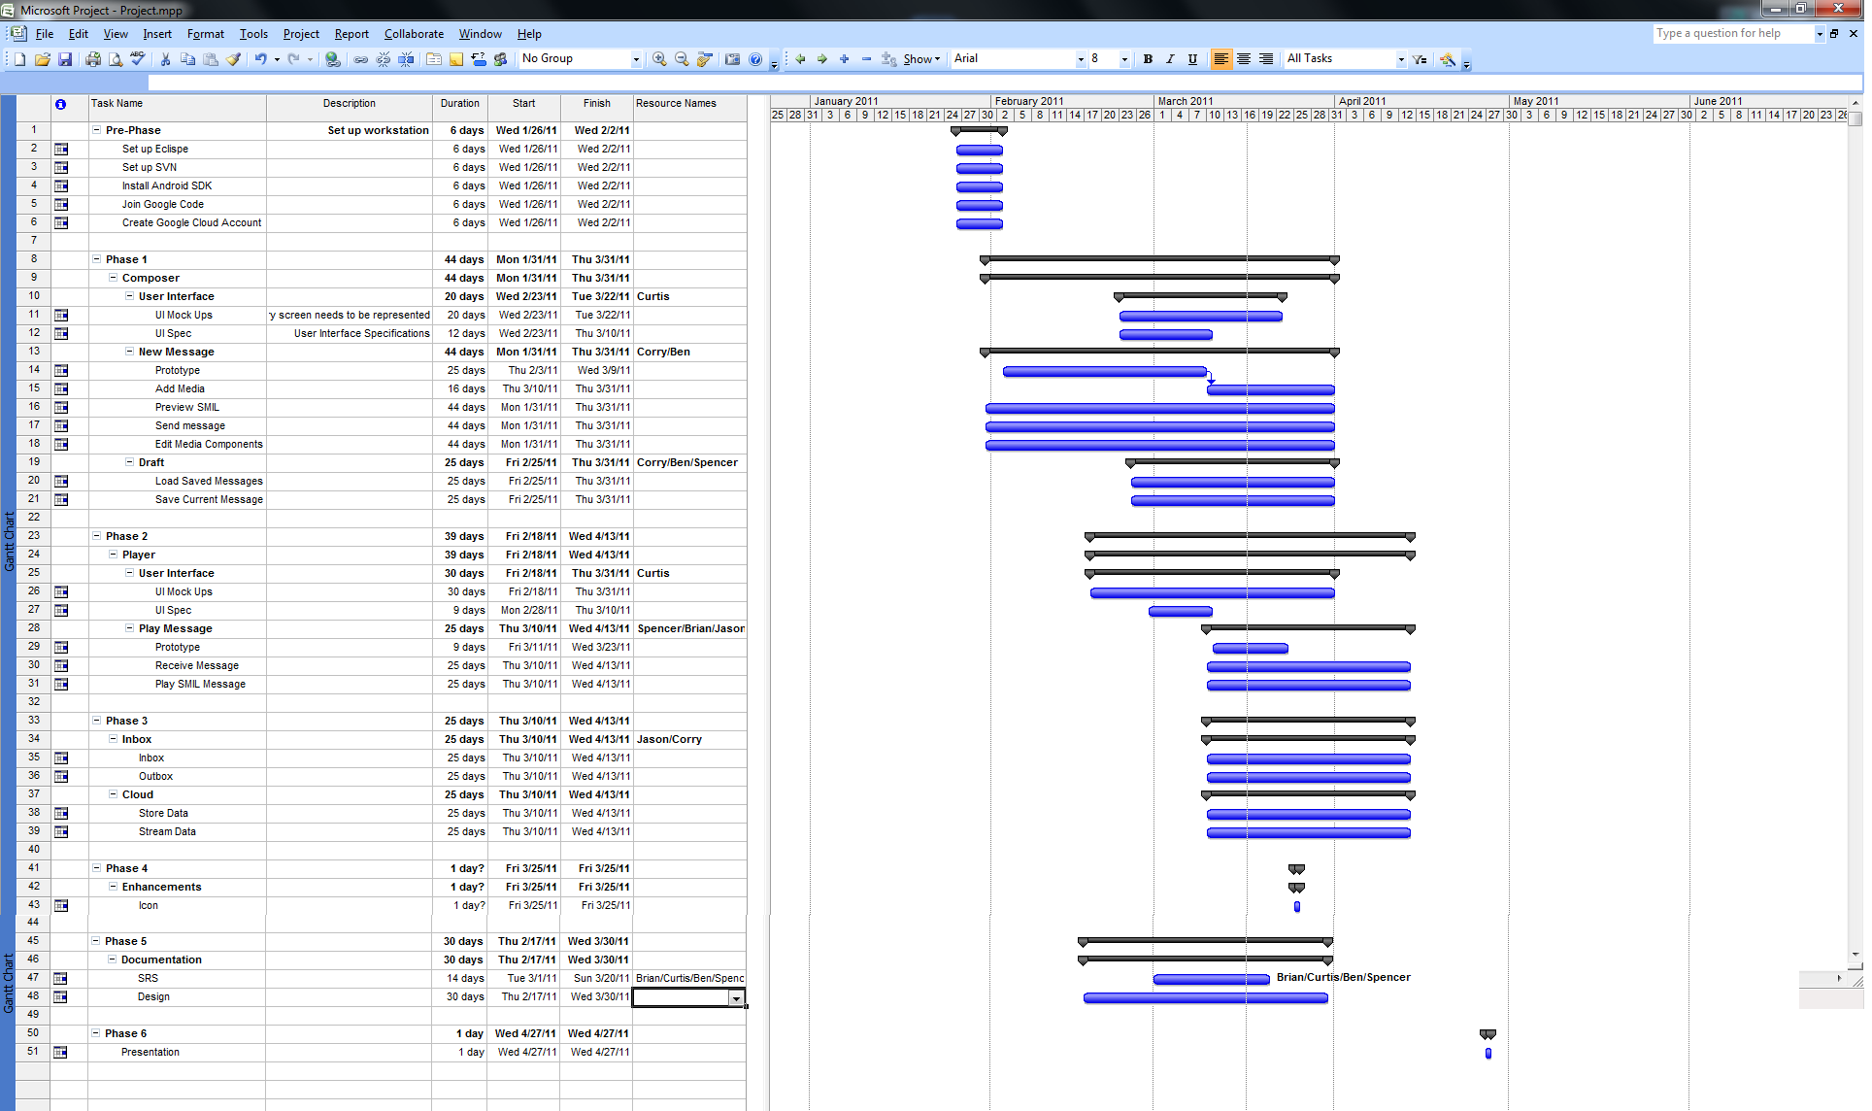Weekly Meeting Agenda and Minutes

Copy/paste minutes?

1. Other Communication Records
2. Software Configuration Management