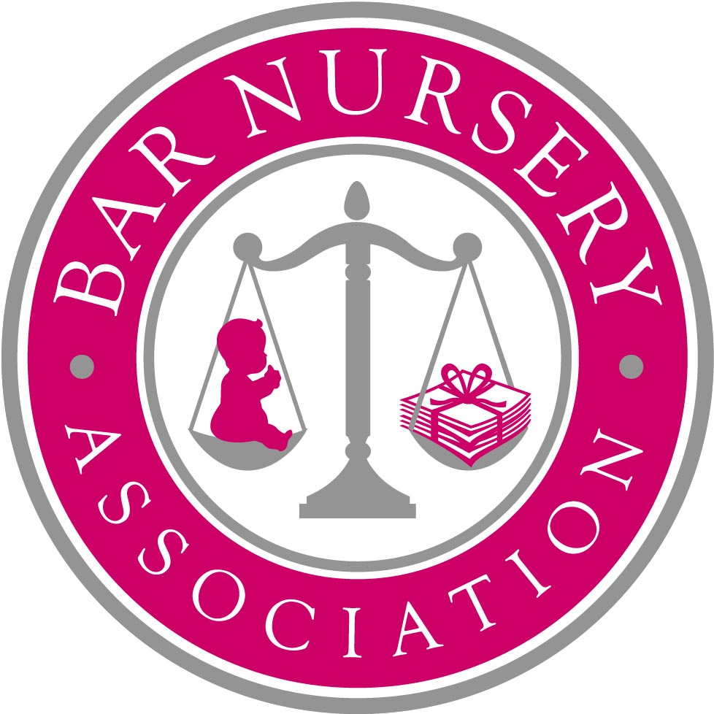

BAR NURSERY ASSOCIATION

____________

RULES
____________

- Name The Association shall be called the Bar Nursery Association (“the Association”).

- Objects The objects of the Association are:
  - To arrange for the provision of facilities for the care of children of barristers, employees of barristers’ chambers and employees of organisations associated with the Bar.
  - To promote the recruitment and retention of women barristers at the Bar.

- Membership Membership shall be open to all barristers, employees of barristers’ chambers and employees of organisations associated with the Bar.

- Election of members The election of members shall be vested in the Committee. A person who wishes to become a member shall notify the Committee in writing.

- Resignation of members A member may resign from the Association by informing the Committee in writing of his intention to do so.

- Suspension and expulsion of members The Committee shall have the power to suspend for a period not exceeding 12 months or to expel a member who infringes any of these rules or whose conduct is in the opinion of the Committee renders him unfit for membership. No person shall be suspended or expelled without first being summoned before the Committee and full opportunity afforded to him to advance a defence nor unless three-quarters of the Committee then present shall vote for his suspension or expulsion.

- Officers of the Association The Association shall have the following honorary officers, who shall hold office for a period of two years: a Secretary and a Treasurer. Such officers shall be elected at an AGM. Upon expiry of their term of office, they may offer themselves for re-election.

- Management of the Association The management and control of the affairs of the Association shall be vested in an executive committee of members (“the Committee”). The Committee shall consist of the Chairperson, the Secretary, the Treasurer and other members who shall number not less than two and not more than seven. The Committee shall meet as and when appropriate. A quorum for meetings of the Committee shall be three members. Meetings of the Committee shall be chaired such member as the Committee may determine. The chair of any Committee meeting shall have a casting vote in addition to his ordinary vote.

- Board of Patrons The Committee shall invite suitable candidates to become members of the Board of Patrons. Such candidates shall include but not be limited to senior members of the Bar. The Board of Patrons shall consist of not more than forty members. The function of the Board of Patrons shall be to provide guidance and non-binding advice to the Committee on such issues as it or the Committee considers appropriate. The Board of Patrons shall meet as and when appropriate. Any member of the Committee may attend such meetings. A quorum for meetings of the Board of Patrons shall be three members. The chair of any such meeting (who shall be appointed by consensus at the start of each meeting) shall have a casting vote in addition to his ordinary vote.

- Annual General Meeting The Annual General Meeting (“AGM”) of the Association shall be held in January of each year for the purpose of receiving the reports of the Committee, any sub-committee and the Treasurer in respect of the Association’s activities since the previous AGM, receiving and, if thought fit, approving the accounts in respect of the preceding financial year; electing the officers of the Association; and for the transaction of the general business of the Association. All members shall receive 7 days’ notice in writing of the date of such meeting by email.

- Quorum and voting at meetings A general meeting may proceed to business if five members are present within half an hour after the time fixed for the meeting; otherwise the meeting shall stand adjourned to the same time in the following week, save that the adjourned meeting may proceed to business whatever the number of members present. The chair of the meeting shall have a casting vote in addition to his ordinary vote. Any motion to be carried shall require a simple majority of those entitled to vote and present at the meeting.

- Amendment of the rules These rules may be added to, altered or revoked by members at an AGM.

- Dissolution of the Association In the event that the members pass a resolution to dissolve the Association, any property belonging to the Association shall not be distributed to the members if there is a surplus of assets over liabilities, but will be given or transferred to the National Association of Citizens Advice Bureaux or such other association having similar objects as the members of the Association may decide upon.

