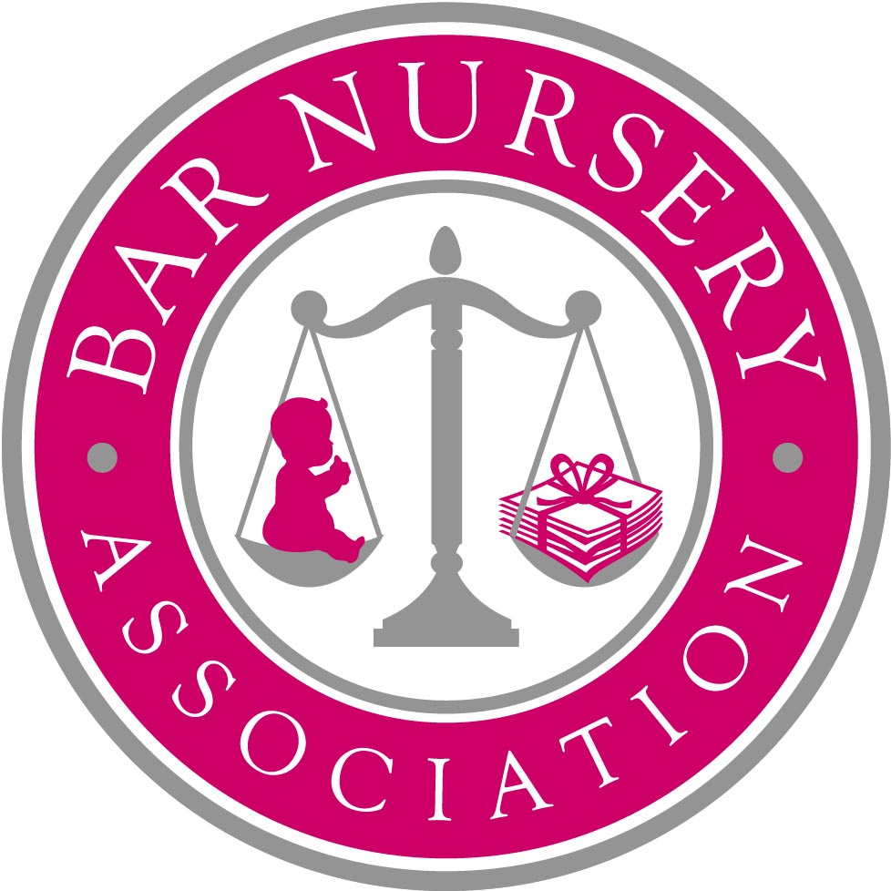

Proposal to Middle Temple for the establishment of a Bar Nursery in the premises currently occupied by St Clement’s Cafe

April 2010

Introduction

Maternity absence from chambers, return to practice and work life balance thereafter are still presenting insuperable problems for many women. The Bar Nursery Association was established in 2007 with aim of finding practical solutions to these problems. Central to its objectives is the provision of suitable childcare facilities for babies and young children in the Inns of Court, for the benefit of male and female barristers.

The Bar Nursery Association received statements of support from all four Inns of Court in 2008 as well as the Attorney General and Lord Chief Justice. It has been working since then to identify suitable premises in which to establish a nursery. Potential locations have been considered but have not proved viable. The Middle Temple cafe premises are the ideal location.

In this proposal, the Bar Nursery Association sets out:

- Costed proposals for a Bar Nursery on the Middle Temple cafe site
- Evidence of demand for a Bar Nursery on the Middle Temple cafe site based on these financial proposals

Summary

The contents of this proposal can be summarised as follows:

- Women are leaving the independent Bar in disproportionate numbers after having children. This is a matter of real concern, not only as regards equal access to and diversity of the Bar, but also for the achievement of those aims in the Judiciary. (See Annex A for further details).

- This is a problem which could be alleviated by childcare provision within or near the Inns of Court.

- This is an idea which has been discussed in the past. It is now ripe for action. It is a proposal which can deliver real changes.

- This is a financially feasible proposition. Two nursery providers produced proposals for the BNA to establish and run a profit-making nursery for around 40 children on the St Clement’s site.

- There is a demonstrated demand for a Bar Nursery which opens between 7am and 7pm, and takes children aged 0 to 5 years. This has been proven by a survey in 2008 carried out by the Bar Nursery Association, to which more than 400 barristers and their employees responded (see Annex C) and a further survey in April 2010 (see Annex D).

- The April 2010 survey was based on costed proposals and has shown considerable support for the nursery. In the first week of the survey being publicised, 93 people stated that they were ‘extremely’ or ‘very’ likely to take up a full or part-time place for their child, and a further 120 said they would be ‘extremely’ or ‘very’ likely to make use of the nursery on an emergency basis.

- The proposal to establish an Inn-based nursery has the enthusiastic support of its Patrons – the Lord Chief Justice, Baroness Hale, Lord Mance, Lady Justice Arden, Lord Walker, Mrs Justice Cox and Edwin Glasgow QC together with the Bar Council Equality & Diversity Committee, the Young Bar Committee, the Association of Women Barristers and members of approximately 40 sets of chambers (both civil and criminal).

- Inner Temple has shown its commitment to the scheme by offering the use of part of its gardens for the children to play in.

- The Bar Nursery Association has started a fundraising campaign seeking financial pledges to support the proposed nursery. All money raised would be donated directly to Middle Temple and would compensate the Inn for the limited rent that can be obtained from a nursery as compared to use of the space as offices. The Bar Nursery Association aims to raise £200,000 in pledges.

- In those circumstances, the Bar Nursery Association makes the following proposal:

  - That Middle Temple approves a lease of the cafe premises to Newpark Childcare on the basis set out in its proposal (Annex B) for a term of 15 years and at a rent of £23 per square foot exclusive of VAT and inclusive of business rates.

Evidence of a demand for childcare facilities

In late 2007, an internet-based survey was conducted among London barristers and chambers’ employees (see Annex C). In total 426 people responded, of whom 346 were barristers and 80 were employees. Roughly three quarters of respondents had children under the age of 5, or were hoping to have children in the next three years.

98.5% of the respondents- 420 individuals - said that they supported the idea of an Inns-based nursery facility. 207 respondents said that they would be interested in using such a facility in the next three years for regular childcare. 277 respondents said they would be interested in using such a facility for emergency childcare.

Most recently, an online survey was conducted in April 2010 based on a nursery on the Middle Temple cafe site opening in January 2011 and priced according to the proposal by Newpark Childcare (Annex B).

This survey is still being carried out, but the preliminary results show substantial interest in the proposed nursery. In the first week of the survey being publicised, 170 people responded.

  - 20 said they would be extremely likely (90% or higher) to take up a full time place for one or more children during 2011.
  - 24 said they would be extremely likely to take up a part-time place for one or more children during 2011.
  - A further 50 people said they would be very likely (70% or higher) to take up a full or part-time place for one or more children during 2011.
  - 120 people said they would be extremely or very likely to make use of emergency places at the nursery during 2011.

These figures show that the nursery could expect to reach full occupancy (35-45 places) in a significantly shorter time than a standard community nursery. There truly is a high level of demand for this facility in the Inns of Court.

Many respondents also indicated that although they did not currently have children, they would be very likely to use the nursery in the future when they started a family.

Some of the comments made by respondents to the surveys are set out below.

- I think this is a fantastic idea that could make a real difference to the ability of parents to juggle family commitments and a career at the bar. It might hopefully help address some of the issues surrounding the retention of women at the senior bar.
- I think this is a fantastic idea, and a real step towards making a career at the Bar and a family (especially for women) non mutually exclusive options.
- It is a concrete example of how the Inns can make our working lives easier and make it more feasible for working mothers.
- I think that this is an arrangement that is not only extremely desirable, but frankly essential if Chambers are going to participate in the modern world.
- As a father of 3, 2 from a former marriage to a barrister and one in a second marriage to a barrister I have tried a number of different child care arrangements. None, even the stay at home professional woman giving up work to be a full time mother, is perfect. I think a proximate nursery, and one tailored to our peculiar demands, is an excellent idea and moves us into the late 20th Century at least. In Chambers we spend time and effort recruiting and educating pupils. We do so not least because we want long term tenants. It is very much in our interest we retain those tenants. That is not simple altruism. Much time and effort is spent on their recruitment and in developing their practices, because it benefits Chambers and therefore the individual. To not try to retain those tenants is to run a poor business. They are chambers assets. On a personal level that so many women, who have been friends for years, are forced to leave to employed work or lost to the profession completely is a matter of deep regret.

Comments received from Patrons of the BNA include:

- “a most desirable project” (Lord Walker of Gestingthorpe)
- “this is just the sort of support the Inns should be offering their members” (Baroness Hale of Richmond)
- “an excellent initiative…If there is one practical step which could really help women at the Bar, this is it! I am not surprised at the level of enthusiasm for it.” (Cox J)

The provision of nursery facilities in or near the Inns of Court is a vital element in helping to retain women at the Bar and to enable barristers with families to better manage their competing priorities. A decision by Middle Temple to enable such provision would enjoy the strong support of the majority of members of the Bar, as well as the particular support of the substantial minority who would directly avail themselves of those facilities.

Developments since the Bar Nursery Association was established in 2007

In 2008, all four Inns of Court confirmed that they supported the objectives of the Bar Nursery Association. Inner Temple has offered use of part of its gardens as an outdoor play area for the children.

The Bar Nursery Association has tried over the past two years to locate suitable premises for the nursery. A number of potential locations have been investigated, including the old BBC nursery near Holborn, vacant office space on Tudor Street, and buildings within Middle and Inner Temple. None has been suitable, for various reasons including lack of planning consent, proximity to the Inns of Court, access to outside space, amount of ground floor space, cost of refurbishment, security arrangements, and capacity.

There is clearly an extremely limited number of premises within the Inns of Court which could be converted to use as a financially viable nursery and which could comply with the criteria set down by OFSTED, leaving aside the question of them becoming vacant in the near future. The experience of the Bar Nursery Association over the past two years is that finding suitable premises is exceptionally difficult – this has been the main stumbling block to the creation of a nursery.
The Middle Temple cafe site is the first location that has become available in over two years that is suitable for the nursery. The site is more than suitable: it is ideal. It has all the features required for a successful Bar Nursery:

- Located within the Inns of Court
- All on one level
- Disabled access
- Existing kitchen facilities
- Space for additional bathroom and laundry facilities
- Able to be kept secure
- Sufficient space to enable a profit-making nursery to be run
- Safe and convenient access to Inner Temple gardens
- Relatively little work required to convert the premises
- Pleasant outlook

The Bar Nursery Association and its supporters strongly believe that this is the best opportunity to establish a nursery that is likely to arise in the medium term, and that if the proposal is rejected by Middle Temple, the prospects of there being a Bar Nursery in the next 10 years are remote.

Costed proposals for a nursery on the Middle Temple cafe site

The Bar Nursery Association obtained two costed proposals for the cafe site, one from a national nursery provider, and one from a smaller London-based company. The Bar Nursery Association has considered the proposals in detail and selected the smaller company as the preferred provider, based on their flexibility, childcare ethos, and commitment to the project. The company is called Newpark Childcare and its proposal is at Annex B.

The proposal is put forward on the basis that the nursery provider takes all risk and does not require ongoing subsidy or support. In order for this to be commercially viable, the providers would require a relatively long lease of 15 years.

It is the intention that places at the Bar Nursery could be offered in a number of different ways. Some larger sets might hold one or two places for the joint use of their members, other places would taken on a full or part-time basis by individual barristers directly, and any excess capacity would be available for emergency childcare provision (for example to provide cover when a nanny calls in sick, or a day off turns into a day in court).

Members of Middle Temple could be given priority for places in recognition of Middle Temple’s support in agreeing to lease the premises to the nursery. It may also be possible to agree a discount on fees for Middle Temple members. The Bar Nursery Association considers that this would be very likely to encourage membership of Middle Temple in preference to other Inns, both among existing members of the Bar and students.

The Bar Nursery Association is also running a fundraising campaign gathering pledges of financial support from individual barristers, chambers, and other supporters. The fundraising target is £200,000. The pledges are conditional on Middle Temple’s support of this proposal, and the money raised would be paid directly to Middle Temple once work on the nursery begins. The Bar Nursery Association envisages that Middle Temple would use these funds to defray the cost to it of supporting the nursery, namely the reduction in rent that could otherwise be obtained.

The Bar Nursery Association is also intending to meet representatives of the other three Inns to seek their support for the proposal and to establish what tangible contribution they might make. This proposal will be updated with further details of the fundraising campaign and support from the other Inns in due course.

Conclusion

The idea of an Inns-based nursery has been discussed in the past, however in light of the evidence presented above it is now ripe for action. The Bar Nursery Association has spent more than 2 years of searching for suitable premises without success. The Middle Temple cafe premises would provide an ideal location for a nursery. If this proposal is not approved, the prospects for a Bar Nursery being established in the near future are remote.

This is a proposal which will deliver real changes to barristers in their working lives. It will make a significant contribution to the achievement of equality and diversity at the Bar. It will provide Middle Temple with a long-term source of income, reduce its dependency on one type of tenant, and encourage membership of the Inn. We invite you to support it.

Contacts

For further information please contact:
Victoria Butler-Cole at 39 Essex Street Chambers (vb@39essex.com) or
Cara Guthrie at Outer Temple Chambers (cara.guthrie@outertemple.com)
Annex A

The Need for a Bar Nursery

In recent years, the number of women training to be barristers has equalled or exceeded the number of men. But while the proportion of women barristers at the junior end of the Bar is improving, at the senior end, women are significantly under-represented. Many women barristers leave the Bar when they have a family, finding it impossible to balance the demands of work with their responsibilities as mothers.

In 2001, the then Chair of the Association of Women Barristers, Helene Pines Richmond, said that ‘more and more women are being forced to make a choice between family and career. Men never have to make that choice. Right now to be a woman and make it to the Bar’s senior ranks, you need a very supportive husband.’

Sadly, the situation has not improved to any significant extent. In November 2007, the Honourable Mrs Justice Cox DBE, President of the Association of Women Barristers and Patron of the Bar Nursery Association, wrote in that organisation’s newsletter ‘It must be a matter of real concern to everyone that so many women are leaving the profession each year, after several years of practice, because they are finding the demands of practice unacceptable and so wholly incompatible with family life…Maternity absence from chambers, return to practice and work life balance thereafter are still presenting insuperable problems for many women. Whilst so many sets of chambers now boast comprehensive maternity and equality policies, the reality on the ground seems rather different.’

The difficulty in retaining women barristers has long been recognised as a serious problem for the Bar. The report of the Entry to the Bar Working Party chaired by Lord Neuberger of Abbotsbury summarised the position thus:

Whilst the number of women barristers has increased significantly in the last three decades, so that men and women now graduate from the BVC in roughly equal numbers, women are still being lost to the profession in greater numbers during their early years of practice. A Bar Council study of barristers ceasing self-employed practice found that the proportion of women who began a tenancy between the years 1988 and 1998, and who ceased to practise between the sixth and tenth years of call was nearly twice that of men. The fact that there are significantly more women than men in employed practice, also suggests that self-employed practice may present particular obstacles for women. Anecdotal evidence strongly supports this. This means that one cannot assume that the simple fact that there is now a greater number (and proportion) of women entering the profession will necessarily result in a greater number, or at least a corresponding increase in the number, (or proportion) of women practising at senior levels in future decades.

The data available to us indicate that level of income and the uncertainty over future income are significant factors in relation to retention, as is a desire to spend more time with family. Women in particular consider that having children produces an adverse effect on their careers at the Bar, especially where their practice requires frequent appearances in court.

The problem of retaining women at the Bar also has consequential knock-on effects on the issue of Judicial Diversity. The encouragement of diversity within the legal professions was identified as an important part of the Strategy for Diversity announced by the Lord Chancellor in May 2006. As stated by the Lord Chancellor in November 2005:

We need diversity in order to ensure our judicial decision-making reflects the community as a whole. For example: 51 per cent of the population is female - yet women hold fewer than 20 per cent of judicial posts.

Rather than continuing to lament this state of affairs, the Bar Nursery Association believes that practical steps must be taken to help women return to work after having children, and to achieve the difficult balance between work and family life, a challenge also faced by male members of the Bar.

One obvious solution is the provision of suitable childcare facilities for babies and young children in the Inns of Court. High-quality childcare near their place of work would be a real benefit to barristers concerned about not seeing their children during the day, who cannot afford to employ a full-time nanny, or who need the flexibility of a nursery run by people who understand the particular demands of work at the Bar, including the need to have access to a childcare facility which opens early and closes late, to accommodate barristers’ court and other professional commitments.

The objectives of the Bar Nursery Association

The Bar Nursery Association is an unincorporated association established in 2007 which aims to:
- Encourage the retention of women barristers at the Bar in the interests of equality and diversity
- Promote the establishment childcare facilities in or near the Inns of Court
- Improve the quality of life of barristers with young families

Annex B: Proposal from Newpark Childcare

Please see attached document.

Annex C: Summary of 2008 survey results

Please see attached document.

Annex D: Summary of 2010 survey results

Please see attached document.

The Bar Nursery Association is fundraising to contribute towards the difference between this rent and a commercial office rent.
The Barrister, #9 11th June 2001, ‘Where women fear to tread’.
Dated November 2007
http://www.dca.gov.uk/publications/reports_reviews/judicial_diversity_strat.pdf
Increasing judicial diversity: the next steps Commission for Judicial Appointments - Institute of Mechanical Engineers, London 2 November 2005

