**An Analysis on Mark-18A Target Irradiation History and Inventory of Plutonium and Heavy Curium**

Benjamin Austin1, W. Cade Brinkley1, Jennifer Jeffcoat1,2, Jacob Weinberg1, Benjamin Beeler1,3, Tara Smith4, Tracy Stover4

1North Carolina State University

2South Carolina State University

3Idaho National Laboratory

4Savannah River National Laboratory

**Abstract**

From 1969 to 1979, the Savannah River Site (SRS) produced and managed heavy isotopes as directed by the DOE. This was accomplished by exposing 86 highly enriched Pu-242 Mk-18A Outer Housing (OH) targets to high neutron fluxes in the K-Reactor with the initial intent to produce Cf-252 [1]. Although this directive was abandoned just over a year later, the plutonium targets continued their exposure in an effort to produce Pu-244 for the duration of the decade. After decommissioning, 21 of the targets were transferred to Oak Ridge National Laboratory (ORNL) to extract the accumulated Cf-252. The remaining 65 Mk-18A targets remained in water basin storage located at SRS. The purpose of this study is to model the irradiation history of the core and the decay of isotopes to approximate the inventory of each individual target.

# Introduction

The high flux Californium I irradiation campaign began August 11, 1969 and ended November 8, 1970. During this time, 86 Mk-18A targets with high enriched Pu-242 were exposed to a high neutron flux in an effort to produce Cf-252 [1]. Californium is a synthetic radioisotope produced in reactors via multiple neutron capture reactions, which is a highly sought-after neutron source. With a half-life of 2.6 years and a 3% natural fission decay rate, it has uses in medicine, reactor startup [2], metal detectors [3], etc. There are only 2.625 grams of Cf-252 produced annually worldwide [4]. Figure 1 shows the rationality behind using enriched Pu-242 instead of natural uranium for the campaign, in that the number of neutrons required to produce a single atom of Cf-252 is greatly reduced.

|  |
| --- |
|  |
| *Figure 1: Production chain of Californium 252 from Uranium 238 (Public Domain).* |

Between 1972 and 1973, 21 of the 86 Mark 18-A targets were processed to recover Cf-252, heavy curium, and plutonium. The extraction of these isotopes was applied to industrial applications and the discovery of new transactinides. Savannah River Site (SRS) currently houses the majority of the world’s heavy curium and plutonium in the remaining 65 targets. The supply of these isotopes from the 21 processed targets is expected to deplete by 2030 [1].

In 2012, SRS was appointed to address the disposal or recovery of the remaining 65 Mark 18-A targets. This study assessed seven alternatives for the disposition of the Mark-18A: five unique choices for recuperation of the materials for later use, a fractional recuperation choice, and a possibility for disposing of the Mark-18A material as waste. The investigation recommended that the targets be processed to recover the essential Pu-244 and heavy curium and move the materials to ORNL for capacity and future advantageous use. [5]

In this work the contents of the remaining 65 targets will be analyzed by utilizing a computational method to determine the mass concentration of the Pu 244 and heavy curium. The results will be used to elucidate which assemblies should be processed first by SRS to recover Pu 244 and heavy curium. As the specifications of the Mark 18A targets are classified, the computational model is made with calculated and assumed variables, such as flux profile, enrichment, and geometric assumptions. As such, this study is not meant to provide exact quantitative predictions of isotopic concentrations. However, the qualitative assessments of isotopic concentrations will be utilized by SRS to determine processing schedule and priority for the various target assemblies.

# Computational Methods

The K-reactor core consists of a hexagonal lattice of annular driver assemblies as shown in figure 2 [6]. It is cooled/moderated with heavy water and its 6 coolant loops enable high neutron fluxes (ideal for isotope production) by dissipating approximately 18 MW per assembly of thermal energy [7].

|  |
| --- |
|  |
| *Figure 2: Face Map of the K-reactor located at SRS [3].* |

Many design specifics of the K-reactor are classified. The enrichment of the drivers, geometry and location of the 90 assemblies used [8], peaking factors, fuel to moderator ratio, and other parameters that are necessary when modeling a full reactor core can only be known to a best estimate using declassified material. Because of this, irradiation histories were modeled one assembly at a time in an effort to mitigate any sources of error that may propagate throughout the model. A consequence of this method is the need to develop a flux distribution function. This was achieved assuming a sinusoidal radial distribution, a radial peaking factor of 1.35, and equations 1 and 2:

|  |  |
| --- | --- |
|  | (1) |
|  | (2) |

Since the dimensions of the core were unknown and the placement of the targets was provided in cartesian coordinates, the x and y indices (Appendix A) were utilized (and normalized to ) resulting in equation 1 becoming:

|  |  |
| --- | --- |
|  | (3) |

and equation 2 becoming:

|  |  |
| --- | --- |
|  | (4) |

Figure 3 shows the general shape of the flux profile using this method. This distribution function was utilized to assign power levels to each assembly in each cycle for the duration of the irradiation time.

|  |
| --- |
|  |
| *Figure 3: Assumed shape of the K-Reactor’s flux profile with exaggerated amplitude for visualization.* |

|  |
| --- |
|  |
| *Figure 4: Sketches of MK-14 and 16 Tubes that were used in later irradiation cycles after the Cf production campaign [9].* |

The model assumes that each assembly consists of three inner concentric uranium-aluminum alloy annuli that are 6 ft tall, referred to as the drivers (as seen in figure 4), and a single plutonium-aluminum alloy annulus, referred to as the target, around the middle four feet of the drivers [10]. The drivers are assumed to share dimensions with 2, 2.5, and 3-inch schedule 10 aluminum pipe while the target is assumed to share the dimensions of a 3.5-inch schedule 40 aluminum pipe. Additionally, the initial amounts of the activated isotopes in the target and the amount of fuel in the three driver rings throughout their lifetimes is known. This is used to find the isotopic density of the relevant material with the known geometries as shown in equation 5.

|  |  |
| --- | --- |
|  | (5) |

The Mk-18A drivers used in the first irradiation cycle contained a nominal amount of 180 grams of U-235. The subsequent cycles utilized Mk-14 (1500 g/assembly U-235), Mk-16 (3000 g/assembly U-235), and Mk-22 (3400 g/assembly U-235) drivers [11].

SCALE is a code system developed by the reactor and nuclear systems division of ORNL. SCALE is widely used for a variety of purposes including nuclear safety analysis, radiation shielding, reactor physics, and activation analysis. Some main computational modules are three Monte Carlo transport solvers and three deterministic solvers. SCALE also contains multiple data libraries to support these solving capabilities. SCALE was developed to combine each of these capabilities into a robust, easy to use platform [12].

SCALE’s t-depl depletion sequence within the TRITON module is used for the model. Compositions for each material were defined using densities and isotopic percentages of the three materials: U-Al drivers, the Pu target, and the heavy water moderator. A geometry was then defined in a 2-dimensional mesh. To account for the different assemblies used throughout the irradiation, a timetable block was used to change the uranium densities in the driver annuli. This approximation accounts for the different number of driver annuli present in the MK-22 assemblies (figure 5) used during some cycles. The irradiation itself was defined using a burndata block consisting of the dissipated assembly power and the number of days exposed.

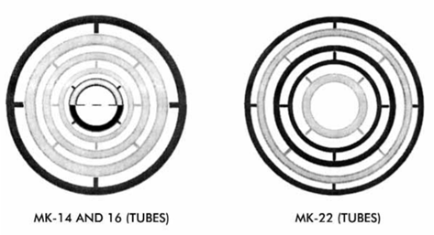

*Figure 5: Sketch of MK-22 Tubes that were used in later irradiation cycles after the Cf production campaign [2]*

# Results

A unique input file was generated for each of the sixty-five assemblies, each with a unique flux history. The accumulated masses of specific isotopes were monitored over the lifetime of operation in-reactor (approximately 10 years), as well as after the shut-down period of the K-reactor. The shut-down period was modeled using two points of time: the first when the reactor shut down, and the second as 15,000 days (41.1 years) after that event. After production, depletion, and decay, the mass concentrations of key isotopes were analyzed, including Pu-244, Cm-242, Cm-243, Cm-244, Cm-245, Cm-246, Cm-247, Cm-248, and Cm-250.

As the primary objective of this study was to determine which assemblies produced the most Pu-244 following their initial exposure, the first isotope investigated was Pu-244 (the total accumulation of all tracked isotopes in each assembly is provided in Appendix A). The overall trend of the Pu-244 concentration in assembly 1 as a function of time is shown in Fig. 6. Initially, there were 227.3 mg of Pu-244 in the assembly. In the first few months of operation, the plutonium concentration in assembly 1 decreased before rising to a maximum of 227.7 mg. This maximum occurs 1.14 yrs into the irradiation history. The Pu concentration subsequently decreased until the K-reactor shut down. Expectedly, the SCALE simulation calculated no change in the Pu-244 concentration following the K-reactor shutdown due to the long-lived half-life of Pu-244 (T1/2= 80 million years). To better understand how the Pu concentration varies between the assemblies, the assemblies with the most and least Pu-244 during reactor operation and shutdown are displayed in Table 1. After the storage decay time, assembly 46 had the largest quantity of Pu-244 (226.6 mg) and assembly 36 had the smallest quantity of Pu -244 (224.9 mg). The Pu-244 production as a function of time for both assembly 46 and 36 are visualized below in Fig. 7. It is apparent that regardless of the final inventory in the assemblies, the Pu-244 concentration in assembly 36 and 46 reached their respective maximums approximately 1 year into the irradiation history (227.66 mg and 227.67 mg, respectively). Following the maximums, the Pu-244 concentrations decreased to their respective saturation levels. The mass concentration in assembly 36 decreased at a faster rate compared to assembly 46; therefore, assembly 36 possesses the smallest amount of Pu-244. However, it should be emphasized that there is less than a 0.1% difference between the maximum and minimum residual Pu-244 concentrations for the given 65 assemblies.

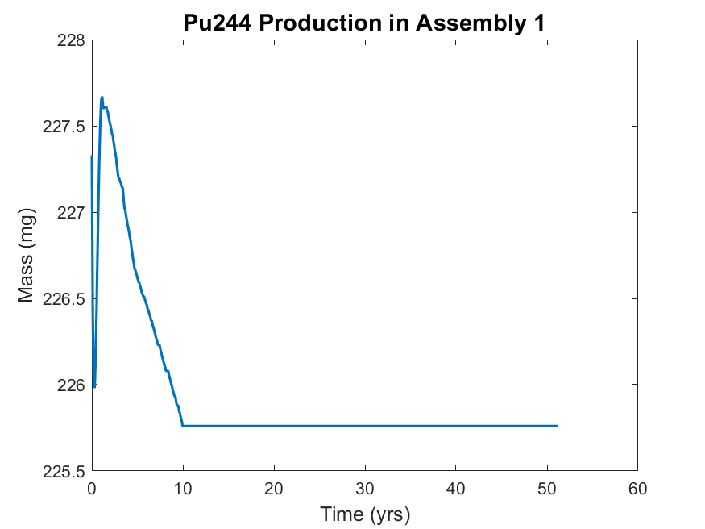

*Figure 6. The production of Pu-244 in assembly 1. The assembly was irradiated for approximately 10 years before being put into storage for roughly 40 years.*

|  |  |  |  |
| --- | --- | --- | --- |
| **Most Remaining** | | **Least Remaining** | |
| **Assembly No.** | **Mass (mg)** | **Assembly No.** | **Mass (mg)** |
| 46 | 226.6 | 36 | 224.9 |

*Table 1. Tabulated values for the Pu-244 masses in the assemblies that currently contain the most and least remaining Pu-244 by mass.*

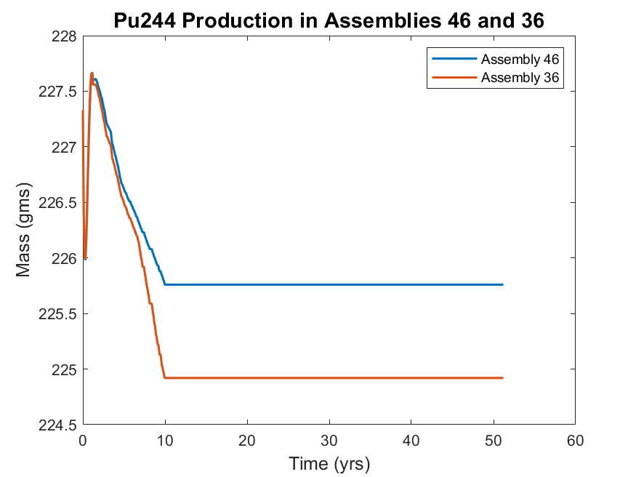

*Figure 7. Plutonium production during reactor operation and shutdown in assembly 46 and 36. The reactor was shut down at approximately t = 10 yrs.*

The different levels of production of Pu-244 are investigated by considering the production of Cf-252, a strong neutron source [13]. Assembly 46, which was found to have the highest amount of Pu-244 after the simulated decay time, was found to produce the least amount of Cf-252 among all assemblies (considering peak Cf-252 production). Contrarily, assembly 36 produced the least amount of Pu-244 and produced the highest amount of Cf-252 among all assemblies. Further, leading up to the reactor shut down the amount of Cf-252 in assembly 36 increased by approximately 0.15 mg while there was no significant increase in Cf-252 in assembly 46. The production and decay of Cf-252 in assembly 36 and 46 can be seen below if Fig. 8. As expected, all of the Cf-252 decayed away by the simulation end.

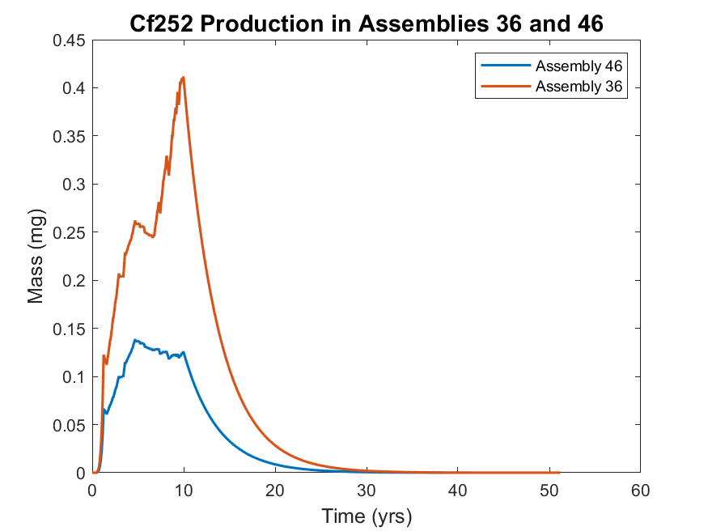

*Figure 8. Production of Cf-252 in assemblies 36 and 46. There are local maximums after roughly 5 years and 10 years. The remaining Cf-252 at shutdown quickly decays away (T1/2 = 2.6 yrs).*

Curium is another key element of interest, and specifically heavy-curium (Cm-246, Cm-247, Cm-248). The isotopes of Cm that were found to have the highest mass concentrations were Cm-244, Cm-245, and Cm-246. The per-assembly masses of Cm-250 are significantly smaller than the other isotopes listed and are not included in the following analysis. The assembly that has the highest heavy Cm inventory is assembly 39, while assembly 46 produced the least amount of heavy curium. As previously shown, assembly 46 was also found to contain the most Pu-244. The assemblies that currently possess the least and most Cm are displayed in Table 2.

|  |  |  |  |  |
| --- | --- | --- | --- | --- |
|  | **Most Remaining Cm** | | **Least Remaining Cm** | |
| **Isotope** | **Assembly** | **Mass (mg)** | **Assembly** | **Mass (mg)** |
| **Cm-242** | 14 | 0.0031 | 36 | 0.0014 |
| **Cm-243** | 32 | 0.2376 | 42 | 0.1503 |
| **Cm-244** | 57 | 5458 | 30 | 5319 |
| **Cm-245** | 56 | 949.0 | 39 | 930.3 |
| **Cm-246\*** | 39 | 3460 | 46 | 2613 |
| **Cm-247\*** | 39 | 100.2 | 46 | 67.30 |
| **Cm-248\*** | 39 | 56.23 | 46 | 29.55 |
| **Cm-250** | 36 | 1.128 E-5 | 46 | 4.940 E-6 |

*Table 2.* *Tabulated inventories of all tracked curium isotopes for the assemblies where the maximum and minimum isotopic accumulation were observed. Assembly 39 contained the most heavy curium and assembly 46 contained the least amount of heavy curium. (* Isotopes considered part of heavy curium)*

Of the three heavy curium isotopes, Cm-246 is the most prevalent (approximately 96% by mass of the total heavy-curium inventory). Figure 9 compares the production of Cm-246 in assemblies 39 and 46. The concentration of Cm-246 in these assemblies diverged approximately one year into the irradiation history. As expected, the mass concentrations remained unchanged following the shutdown of the reactor due to the long half-life of these isotopes. The difference in the final masses of heavy-curium between assembly 39 and 46 is approximately 900 mg, or approximately 33%.

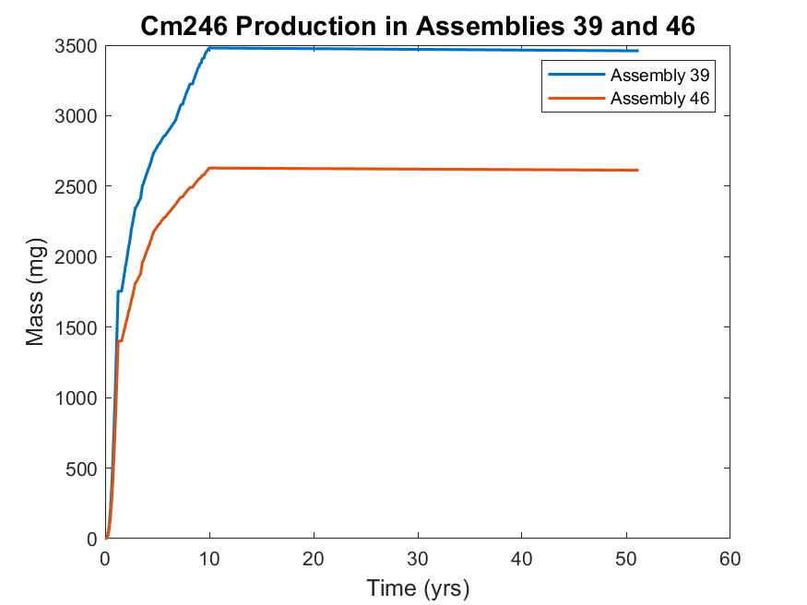

*Figure 9. Cm-246 production in assemblies 39 and 46. Assembly 39 produced the most Cm-246 and assembly 46 produced the least amount of Cm-246. There is no calculated change in the mass concentration after reactor shutdown at 10 yrs.*

An analysis of key isotopic concentrations yielded a correlation between heavy-curium isotope and Pu-244. Figure 10 shows the residual Pu-244 mass as a function of the Cm-246 mass. There exists a very tight negative correlation between the masses of these two actinides, in that as Pu-244 residual mass decreases, the Cm-246 mass increases. It was also shown earlier that the peak isotopic production of Cf-252 was inversely proportional to the Pu-244 mass.



Figure 10. The mass of Cm-246 as a function of the mass of Pu-244 in each individual assembly.

# Discussion

In order to more concisely analyze the isotopic production data, a statistical summary of the individual isotopes of heavy curium and Pu-244 are tabulated in Table 3. Including all 65 assemblies, a total of 196.8 g of heavy-curium was produced. The average amount of heavy-curium per assembly was 3026.9 mg, with a standard deviation of 229.7 mg. The distribution of heavy curium among the assemblies is shown in a histogram in Fig. 11. It can be seen that most of the assemblies produced between 2880 mg and 3150 mg of heavy curium (interquartile range is 269.6 mg). While the range of the data is small (0.91 g), the distribution shows that production was not uniform among all assemblies, where a minority of assemblies possess a statistically large amount of heavy curium.

|  |  |  |  |  |  |
| --- | --- | --- | --- | --- | --- |
|  | Mean Inventory (mg) | Median Inventory (mg) | Min. Inventory (mg) | Max. Inventory (mg) | Standard Deviation (mg) |
| Pu-244 | 226.1 | 226.2 | 224.9 | 226.6 | 0.4226 |
| Cm-246 | 2910.7 | 2851.9 | 2613 | 3460 | 214.8 |
| Cm-247 | 78.39 | 75.98 | 67.30 | 100.2 | 8.27 |
| Cm-248 | 37.81 | 35.75 | 29.55 | 56.22 | 6.67 |

*Table 3. Statistical summary for Pu-244, Cm-246, Cm-247, and Cm-248. The median Pu-244 is within one σ of its maximum while all other median values are at least 2 σ from their respective maximums.*

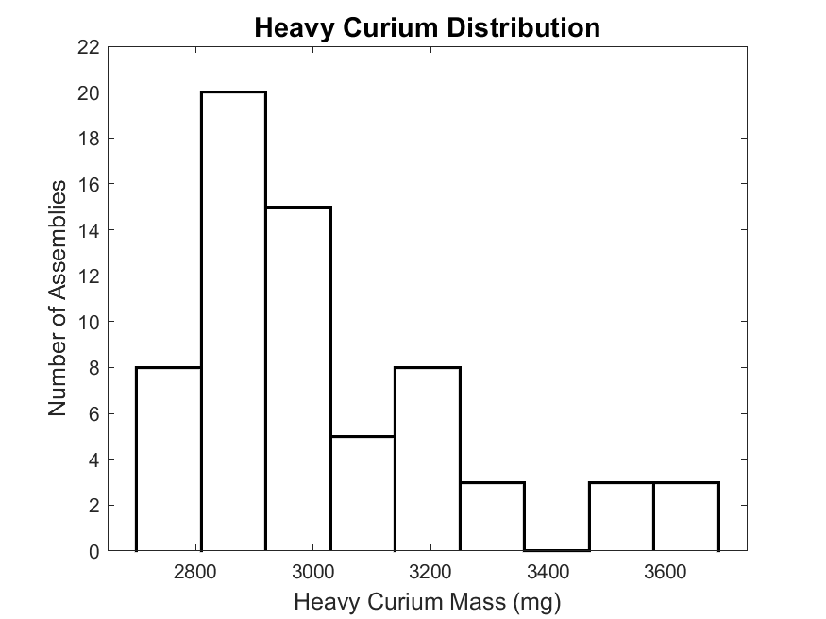

*Figure 11. Histogram of the assembly contribution to total heavy curium mass. The distribution is skewed right with some outliers existing on the upper-end of the distribution.*

It was previously shown that assemblies with smaller amounts of heavy curium would contain larger amounts of Pu-244. Further, a link between the maximum amount of Cf-252 produced and Pu-244 emphasizes that there are underlying factors in this relationship. Figure 12 visualizes the 65 assemblies (in no spatially significant order) and their respective current concentrations of Pu-244, heavy-curium, Cm-245, Cf-252 (maximum produced), Cm-242, and Cm-243, along with the average power applied to each assembly. The trends observed show that a larger amount of Pu-244 corresponds to a smaller amount of heavy-curium (illustrated in Fig. 10), Cf-252, and Cm-243. This relationship could be explained by the Cf-252 production chain. Upon the creation of Pu-243, beta decay (T1/2 = 4.95 hr) transforms the isotope into Am-243. Continuing the production chain with neutron absorption, the heavy-curium isotopes are produced and eventually, Cf-252. Pu-243 does have a thermal neutron cross section (σγ = 90 b), creating the Pu-244 isotope. This event significantly reduces the possibility of creating Cf-252 because Pu-244 has an extremely long half-life and alpha decays into U-240. In the event the Pu-244 isotope captures a neutron, the decay chain of Pu-245 (T1/2 = 10.5 hr) first decays to Am-245 (T1/2 = 2.05 hr), which decays to Cm-245 (T1/2 = 8500 yr). To verify this production chain, an examination of the Cm-245 production as a function of Pu-244 was undertaken. This showed a statistically significant positive correlation between Cm-245 and Pu-244 production, confirming this production chain pathway. The heat map of Cm-242 and Cm-243 appear to follow the same relationship as heavy-curium and Pu-244, respectively. Cm-244 shows no statistically significant correlation with either Pu-244 or heavy-curium production, but is present in the highest quantities among any isotope tracked. Cm-244 has been proposed as an alternative power source for generators.

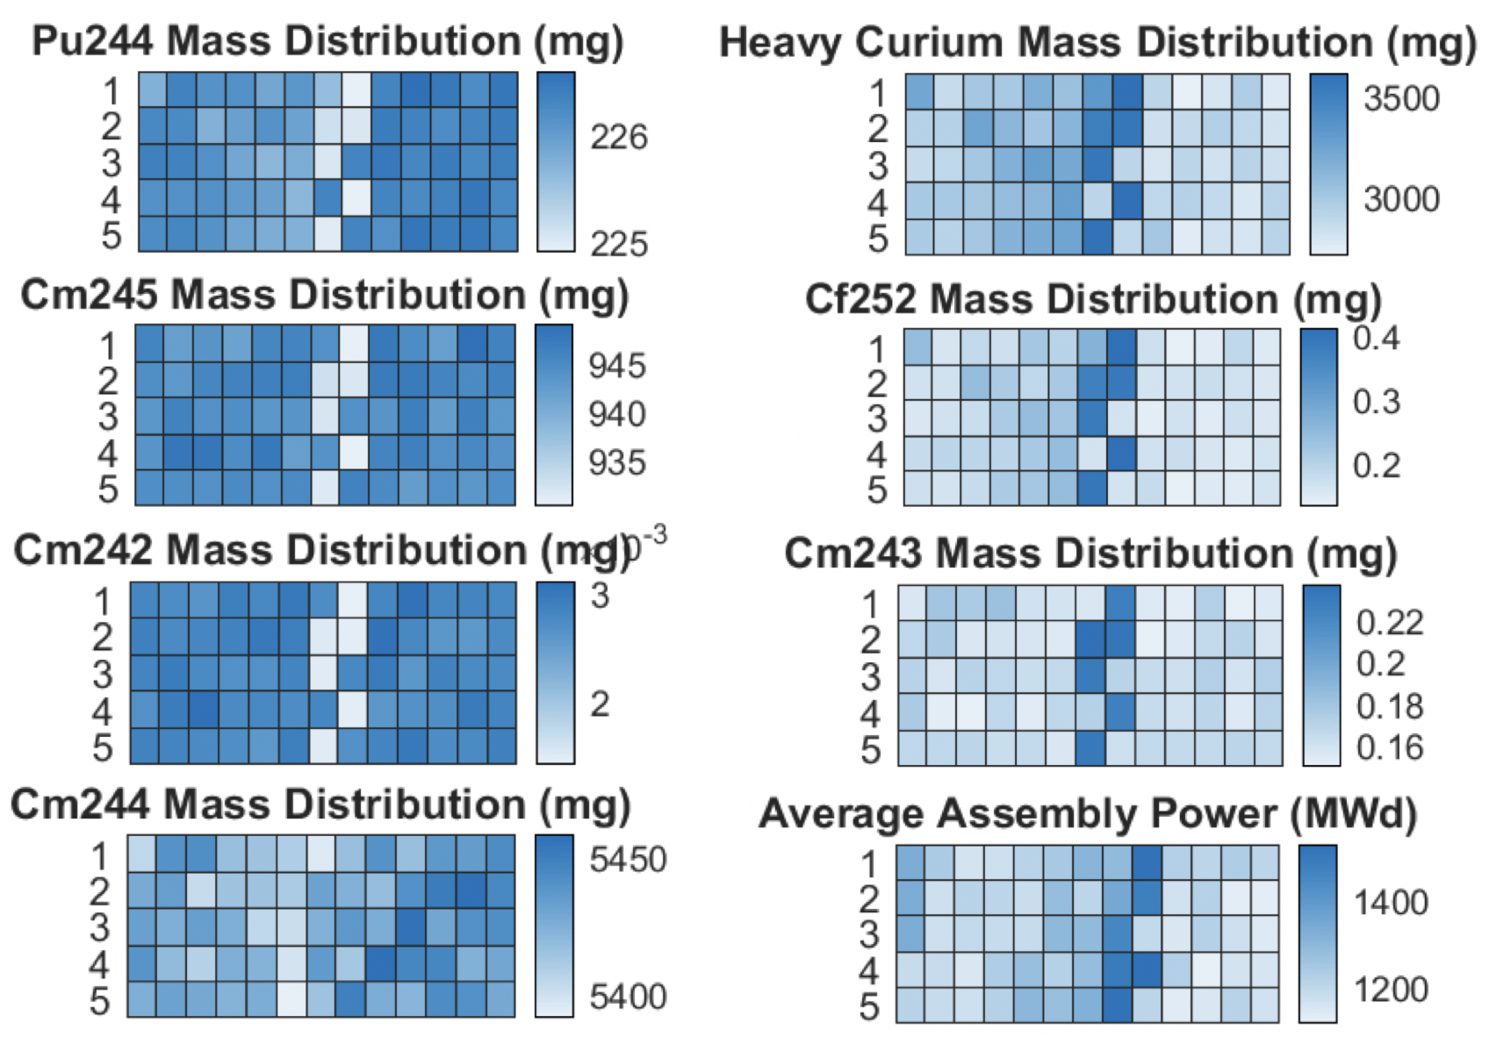

*Figure 12. Heat map of Pu-244, heavy curium, Cm-245, Cf-252, Cm-242, Cm-243, Cm-244, and the average assembly power. Each square represents an assembly but there is no significance in the order of the squares.*

The irradiation history for each assembly is unique and therefore, could reveal underlying trends in the simulations. For each assembly, the total power was calculated and plotted with the corresponding final Pu-244 inventory mass in Fig. 9. There is a very loose correlation between high power and low Pu-244 content, but this is not a statistically significant trend. A trendline is overlaid onto the data in Fig. 9 to demonstrate the lack of linear correlation of Pu-244 mass to power. There are also groupings of assemblies where power is generally high (approximately assemblies 36-42, 44), only one of which shows a reduced mass accumulation of Pu-244. The non-correlation between the total power and mass indicates that there are other factors that influence isotope production. An analysis was also performed analyzing Pu-244 content as a function of peak power, however, this also yielded no discernible trends between peak power and isotope production. Thus, neither total power or peak power days can be utilized to ascertain the production of key isotopes in these targets.



*Figure 9. The final Pu-244 inventory as a function of the total power plotted for each assembly. Each data point represents an individual assembly.*

# Conclusion

From 1969 to 1970, a Cf-252 production campaign was conducted at SRS. Following the processing of 21 assemblies, the remainder of the targets were exposed in the K-reactor and subsequently put into storage after 10 years of irradiation. This study was done to determine the current inventories of key isotopes and investigate the trends in their production. Using SCALE, 65 individual simulations were performed to analyze and estimate the isotopic production and decay in each assembly. An analysis was then conducted on each assembly dataset to determine which assemblies produced the most Cf-252, Pu-244, and heavy curium. It was found that the more Cf-252 an assembly produced, the less Pu-244 and heavy curium was present at the end of simulation. Assembly 46 is calculated to contain the most Pu-244 and heavy curium and assembly 36 and 39 were found to have the least Pu-244 and heavy curium. The results lend to a strategy of tracking one isotope, such as Cf-252, in order to predict which assemblies will contain more Pu-244 or heavy curium, which can significantly reduce computational time and logistical costs associated with processing these Mk-18A targets.

# Acknowledgments

This project is supported by Dr. Tracy Stover and Ms. Tara Smith from the Savannah River National Laboratory and advised by Dr. Benjamin Beeler from North Carolina State University. SCALE was acquired through the Radiation Safety Information Computational Center at ORNL. SCALE computations are completed through the Reactor Dynamics Fuel Modeling Group High Performance Cluster at North Carolina State University.

# References

1. SHARON ROBINSON & BRAD PATTON, *“Mark-18A Target Materials Recovery Study”,* Oak Ridge National Laboratory, 2015

2. O'NEIL, MARYDALE J.; HECKELMAN, PATRICIA E.; ROMAN, CHERIE B., eds. (2006). The Merck Index: An Encyclopedia of Chemicals, Drugs, and Biologicals (14th ed.). Merck Research Laboratories, Merck & Co. ISBN 978-0-911910-00-1.

3. OSBORNE-LEE, I. W.; ALEXANDER, C. W. (1995). "Californium-252: A Remarkable Versatile Radioisotope". Oak Ridge Technical Report ORNL/TM-12706. doi:10.2172/205871.

4. National Research Council (U.S.). Committee on Radiation Source Use and Replacement (2008). Radiation Source Use and Replacement: Abbreviated Version. National Academies Press. ISBN 978-0-309-11014-3.

5. S. M. Robinson et al., Evaluation of Disposition Options for Mark-18A (Mk-18A) Target Materials, ORNL/TM-2013/148R1, 2014.

6. WADE BICKFORD, “*Estimate of Fission Products in the Mark-18A OH Targets”*, Westinghouse Savannah River Company, 2003

7. DPSTM-18-51-P, Technical Manual Californium Physics, 7/1/69, Savannah River Laboratory, Aiken, SC

8. DPSOP-134, SRP Reactor Assemblies, page 2204, Mark 18A, Savannah River Laboratory, Aiken, SC

9. WILLIAM P. BEBBINGTON, “*History of Du Pont at the Savannah River Plant”*, E. I. du Pont de Nemours and Company, 1990

10. DPSTM-18-51-P, Technical Manual Californium Physics, 7/1/69, Savannah River Laboratory, Aiken, SC

11. DPSOP-134, SRP Reactor Assemblies, page 2204, Mark 18A, Savannah River Laboratory, Aiken, SC

12. Weiselquist, William A. “SCALE Overview.” Oak Ridge National Laboratory, www.ornl.gov/scale/overview.

13. 1. SHARON ROBINSON & BRAD PATTON, *“Mark-18A Target Materials Recovery Study”,* Oak Ridge National Laboratory, 2015

# 

# Appendix A (Cumulative Results Projection for January 1, 2025 [g])

|  |  |  |  |  |  |  |  |  |  |  |
| --- | --- | --- | --- | --- | --- | --- | --- | --- | --- | --- |
|  | Cf-252 | Pu-244 | Cm-242 | Cm-243 | Cm-244 | Cm-245 | Cm-246 | Cm-247 | Cm-248 | Cm-250 |
| 1 | 4.43E-09 | 2.26E-01 | 2.83E-06 | 1.56E-04 | 5.40E+00 | 9.46E-01 | 3.10E+00 | 8.53E-02 | 4.29E-02 | 8.04E-09 |
| 2 | 3.40E-09 | 2.26E-01 | 2.89E-06 | 1.67E-04 | 5.43E+00 | 9.45E-01 | 2.81E+00 | 7.46E-02 | 3.47E-02 | 6.17E-09 |
| 3 | 3.24E-09 | 2.26E-01 | 2.85E-06 | 1.70E-04 | 5.43E+00 | 9.43E-01 | 2.75E+00 | 7.24E-02 | 3.31E-02 | 5.74E-09 |
| 4 | 3.77E-09 | 2.26E-01 | 2.68E-06 | 1.75E-04 | 5.44E+00 | 9.44E-01 | 2.87E+00 | 7.68E-02 | 3.64E-02 | 6.39E-09 |
| 5 | 3.54E-09 | 2.26E-01 | 2.88E-06 | 1.67E-04 | 5.43E+00 | 9.45E-01 | 2.85E+00 | 7.61E-02 | 3.58E-02 | 6.44E-09 |
| 6 | 3.37E-09 | 2.26E-01 | 2.73E-06 | 1.79E-04 | 5.44E+00 | 9.42E-01 | 2.76E+00 | 7.27E-02 | 3.34E-02 | 5.83E-09 |
| 7 | 3.54E-09 | 2.26E-01 | 2.77E-06 | 1.75E-04 | 5.43E+00 | 9.43E-01 | 2.82E+00 | 7.50E-02 | 3.50E-02 | 6.24E-09 |
| 8 | 3.21E-09 | 2.26E-01 | 2.96E-06 | 1.58E-04 | 5.43E+00 | 9.46E-01 | 2.78E+00 | 7.32E-02 | 3.37E-02 | 5.95E-09 |
| 9 | 3.49E-09 | 2.26E-01 | 2.96E-06 | 1.52E-04 | 5.42E+00 | 9.48E-01 | 2.88E+00 | 7.68E-02 | 3.63E-02 | 6.70E-09 |
| 10 | 3.39E-09 | 2.26E-01 | 2.86E-06 | 1.67E-04 | 5.43E+00 | 9.45E-01 | 2.80E+00 | 7.42E-02 | 3.44E-02 | 6.02E-09 |
| 11 | 3.88E-09 | 2.26E-01 | 2.63E-06 | 1.76E-04 | 5.44E+00 | 9.44E-01 | 2.89E+00 | 7.75E-02 | 3.69E-02 | 6.43E-09 |
| 12 | 4.45E-09 | 2.26E-01 | 2.83E-06 | 1.56E-04 | 5.40E+00 | 9.46E-01 | 3.11E+00 | 8.56E-02 | 4.31E-02 | 8.12E-09 |
| 13 | 3.73E-09 | 2.26E-01 | 2.76E-06 | 1.71E-04 | 5.43E+00 | 9.44E-01 | 2.88E+00 | 7.71E-02 | 3.66E-02 | 6.47E-09 |
| 14 | 3.39E-09 | 2.26E-01 | 3.13E-06 | 1.51E-04 | 5.41E+00 | 9.48E-01 | 2.88E+00 | 7.68E-02 | 3.63E-02 | 6.76E-09 |
| 15 | 3.75E-09 | 2.26E-01 | 2.77E-06 | 1.69E-04 | 5.43E+00 | 9.44E-01 | 2.89E+00 | 7.76E-02 | 3.69E-02 | 6.77E-09 |
| 16 | 3.62E-09 | 2.26E-01 | 2.94E-06 | 1.82E-04 | 5.42E+00 | 9.41E-01 | 2.88E+00 | 7.69E-02 | 3.63E-02 | 6.88E-09 |
| 17 | 4.00E-09 | 2.26E-01 | 2.87E-06 | 1.59E-04 | 5.42E+00 | 9.46E-01 | 3.00E+00 | 8.13E-02 | 3.97E-02 | 7.29E-09 |
| 18 | 4.34E-09 | 2.26E-01 | 2.67E-06 | 1.67E-04 | 5.42E+00 | 9.45E-01 | 3.03E+00 | 8.27E-02 | 4.09E-02 | 7.37E-09 |
| 19 | 3.97E-09 | 2.26E-01 | 2.77E-06 | 1.67E-04 | 5.43E+00 | 9.45E-01 | 2.96E+00 | 7.99E-02 | 3.86E-02 | 6.99E-09 |
| 20 | 4.27E-09 | 2.26E-01 | 2.71E-06 | 1.63E-04 | 5.42E+00 | 9.45E-01 | 3.03E+00 | 8.25E-02 | 4.07E-02 | 7.42E-09 |
| 21 | 4.23E-09 | 2.26E-01 | 2.81E-06 | 1.60E-04 | 5.41E+00 | 9.46E-01 | 3.04E+00 | 8.29E-02 | 4.10E-02 | 7.53E-09 |
| 22 | 3.56E-09 | 2.26E-01 | 2.99E-06 | 1.58E-04 | 5.42E+00 | 9.47E-01 | 2.90E+00 | 7.76E-02 | 3.68E-02 | 6.77E-09 |
| 23 | 4.77E-09 | 2.26E-01 | 2.69E-06 | 1.63E-04 | 5.40E+00 | 9.43E-01 | 3.15E+00 | 8.71E-02 | 4.43E-02 | 8.34E-09 |
| 24 | 4.05E-09 | 2.26E-01 | 2.79E-06 | 1.54E-04 | 5.42E+00 | 9.48E-01 | 2.99E+00 | 8.12E-02 | 3.97E-02 | 7.28E-09 |
| 25 | 4.60E-09 | 2.26E-01 | 2.58E-06 | 1.66E-04 | 5.43E+00 | 9.44E-01 | 3.07E+00 | 8.44E-02 | 4.22E-02 | 7.70E-09 |
| 26 | 3.65E-09 | 2.26E-01 | 3.01E-06 | 1.59E-04 | 5.41E+00 | 9.46E-01 | 2.93E+00 | 7.87E-02 | 3.76E-02 | 7.10E-09 |
| 27 | 4.01E-09 | 2.26E-01 | 2.92E-06 | 1.56E-04 | 5.41E+00 | 9.47E-01 | 3.01E+00 | 8.18E-02 | 4.01E-02 | 7.44E-09 |
|  | Cf-252 | Pu-244 | Cm-242 | Cm-243 | Cm-244 | Cm-245 | Cm-246 | Cm-247 | Cm-248 | Cm-250 |
| 28 | 4.38E-09 | 2.26E-01 | 2.85E-06 | 1.66E-04 | 5.40E+00 | 9.44E-01 | 3.09E+00 | 8.47E-02 | 4.23E-02 | 8.07E-09 |
| 29 | 4.77E-09 | 2.26E-01 | 2.73E-06 | 1.67E-04 | 5.40E+00 | 9.42E-01 | 3.16E+00 | 8.74E-02 | 4.45E-02 | 8.52E-09 |
| 30 | 4.38E-09 | 2.26E-01 | 2.93E-06 | 1.57E-04 | 5.39E+00 | 9.45E-01 | 3.12E+00 | 8.58E-02 | 4.32E-02 | 8.41E-09 |
| 31 | 4.84E-09 | 2.26E-01 | 2.73E-06 | 1.56E-04 | 5.40E+00 | 9.44E-01 | 3.19E+00 | 8.85E-02 | 4.55E-02 | 8.76E-09 |
| 32 | 7.84E-09 | 2.25E-01 | 1.51E-06 | 2.38E-04 | 5.43E+00 | 9.33E-01 | 3.37E+00 | 9.65E-02 | 5.28E-02 | 1.06E-08 |
| 33 | 8.18E-09 | 2.25E-01 | 1.48E-06 | 2.30E-04 | 5.42E+00 | 9.32E-01 | 3.41E+00 | 9.82E-02 | 5.44E-02 | 1.09E-08 |
| 34 | 3.38E-09 | 2.26E-01 | 2.81E-06 | 1.71E-04 | 5.44E+00 | 9.44E-01 | 2.79E+00 | 7.37E-02 | 3.41E-02 | 5.91E-09 |
| 35 | 8.30E-09 | 2.25E-01 | 1.49E-06 | 2.31E-04 | 5.42E+00 | 9.31E-01 | 3.44E+00 | 9.92E-02 | 5.53E-02 | 1.12E-08 |
| 36 | 8.65E-09 | 2.25E-01 | 1.42E-06 | 2.28E-04 | 5.42E+00 | 9.30E-01 | 3.46E+00 | 1.00E-01 | 5.62E-02 | 1.13E-08 |
| 37 | 8.24E-09 | 2.25E-01 | 1.46E-06 | 2.34E-04 | 5.42E+00 | 9.32E-01 | 3.41E+00 | 9.83E-02 | 5.44E-02 | 1.10E-08 |
| 38 | 3.38E-09 | 2.26E-01 | 2.80E-06 | 1.70E-04 | 5.44E+00 | 9.44E-01 | 2.79E+00 | 7.37E-02 | 3.41E-02 | 5.86E-09 |
| 39 | 8.57E-09 | 2.25E-01 | 1.46E-06 | 2.26E-04 | 5.41E+00 | 9.30E-01 | 3.46E+00 | 1.00E-01 | 5.62E-02 | 1.12E-08 |
| 40 | 3.41E-09 | 2.26E-01 | 2.69E-06 | 1.62E-04 | 5.45E+00 | 9.46E-01 | 2.78E+00 | 7.34E-02 | 3.39E-02 | 5.70E-09 |
| 41 | 3.35E-09 | 2.26E-01 | 2.81E-06 | 1.55E-04 | 5.44E+00 | 9.48E-01 | 2.79E+00 | 7.38E-02 | 3.42E-02 | 5.82E-09 |
| 42 | 2.96E-09 | 2.26E-01 | 3.09E-06 | 1.50E-04 | 5.42E+00 | 9.47E-01 | 2.73E+00 | 7.14E-02 | 3.24E-02 | 5.69E-09 |
| 43 | 2.96E-09 | 2.26E-01 | 2.97E-06 | 1.64E-04 | 5.43E+00 | 9.44E-01 | 2.69E+00 | 7.00E-02 | 3.14E-02 | 5.37E-09 |
| 44 | 3.51E-09 | 2.26E-01 | 2.60E-06 | 1.65E-04 | 5.46E+00 | 9.46E-01 | 2.78E+00 | 7.36E-02 | 3.41E-02 | 5.62E-09 |
| 45 | 3.64E-09 | 2.26E-01 | 2.86E-06 | 1.66E-04 | 5.43E+00 | 9.45E-01 | 2.88E+00 | 7.71E-02 | 3.65E-02 | 6.55E-09 |
| 46 | 2.65E-09 | 2.27E-01 | 3.09E-06 | 1.53E-04 | 5.42E+00 | 9.45E-01 | 2.61E+00 | 6.73E-02 | 2.96E-02 | 4.94E-09 |
| 47 | 3.27E-09 | 2.26E-01 | 2.80E-06 | 1.56E-04 | 5.44E+00 | 9.47E-01 | 2.76E+00 | 7.28E-02 | 3.35E-02 | 5.70E-09 |
| 48 | 3.51E-09 | 2.26E-01 | 2.61E-06 | 1.62E-04 | 5.46E+00 | 9.47E-01 | 2.79E+00 | 7.38E-02 | 3.42E-02 | 5.75E-09 |
| 49 | 3.56E-09 | 2.26E-01 | 2.69E-06 | 1.61E-04 | 5.45E+00 | 9.47E-01 | 2.82E+00 | 7.51E-02 | 3.51E-02 | 6.07E-09 |
| 50 | 2.83E-09 | 2.27E-01 | 3.00E-06 | 1.66E-04 | 5.42E+00 | 9.42E-01 | 2.65E+00 | 6.86E-02 | 3.05E-02 | 5.23E-09 |
| 51 | 3.08E-09 | 2.26E-01 | 2.81E-06 | 1.73E-04 | 5.44E+00 | 9.42E-01 | 2.69E+00 | 7.01E-02 | 3.16E-02 | 5.32E-09 |
| 52 | 3.66E-09 | 2.26E-01 | 2.62E-06 | 1.66E-04 | 5.45E+00 | 9.46E-01 | 2.83E+00 | 7.54E-02 | 3.54E-02 | 6.01E-09 |
| 53 | 3.09E-09 | 2.26E-01 | 2.88E-06 | 1.72E-04 | 5.43E+00 | 9.42E-01 | 2.71E+00 | 7.08E-02 | 3.20E-02 | 5.58E-09 |
| 54 | 3.37E-09 | 2.26E-01 | 2.70E-06 | 1.69E-04 | 5.45E+00 | 9.44E-01 | 2.76E+00 | 7.28E-02 | 3.35E-02 | 5.69E-09 |
| 55 | 3.17E-09 | 2.26E-01 | 2.75E-06 | 1.67E-04 | 5.44E+00 | 9.44E-01 | 2.71E+00 | 7.10E-02 | 3.22E-02 | 5.45E-09 |
|  | Cf-252 | Pu-244 | Cm-242 | Cm-243 | Cm-244 | Cm-245 | Cm-246 | Cm-247 | Cm-248 | Cm-250 |
| 56 | 3.51E-09 | 2.26E-01 | 2.84E-06 | 1.51E-04 | 5.44E+00 | 9.49E-01 | 2.85E+00 | 7.60E-02 | 3.58E-02 | 6.26E-09 |
| 57 | 3.52E-09 | 2.26E-01 | 2.57E-06 | 1.70E-04 | 5.46E+00 | 9.45E-01 | 2.78E+00 | 7.34E-02 | 3.40E-02 | 5.61E-09 |
| 58 | 3.43E-09 | 2.26E-01 | 2.77E-06 | 1.60E-04 | 5.44E+00 | 9.47E-01 | 2.80E+00 | 7.43E-02 | 3.45E-02 | 5.98E-09 |
| 59 | 2.87E-09 | 2.27E-01 | 2.98E-06 | 1.56E-04 | 5.42E+00 | 9.45E-01 | 2.67E+00 | 6.94E-02 | 3.10E-02 | 5.40E-09 |
| 60 | 3.06E-09 | 2.26E-01 | 2.78E-06 | 1.68E-04 | 5.44E+00 | 9.43E-01 | 2.68E+00 | 6.99E-02 | 3.14E-02 | 5.27E-09 |
| 61 | 2.95E-09 | 2.27E-01 | 2.80E-06 | 1.55E-04 | 5.44E+00 | 9.46E-01 | 2.66E+00 | 6.91E-02 | 3.09E-02 | 5.18E-09 |
| 62 | 3.12E-09 | 2.26E-01 | 2.75E-06 | 1.58E-04 | 5.45E+00 | 9.46E-01 | 2.70E+00 | 7.07E-02 | 3.20E-02 | 5.45E-09 |
| 63 | 3.25E-09 | 2.26E-01 | 2.75E-06 | 1.73E-04 | 5.44E+00 | 9.43E-01 | 2.73E+00 | 7.17E-02 | 3.26E-02 | 5.47E-09 |
| 64 | 3.42E-09 | 2.26E-01 | 2.85E-06 | 1.71E-04 | 5.43E+00 | 9.44E-01 | 2.81E+00 | 7.44E-02 | 3.46E-02 | 6.16E-09 |
| 65 | 3.38E-09 | 2.26E-01 | 2.89E-06 | 1.67E-04 | 5.43E+00 | 9.45E-01 | 2.81E+00 | 7.44E-02 | 3.45E-02 | 6.10E-09 |