Defect cluster and non-equilibrium gas bubble associated growth in irradiated UMo fuels – a cluster dynamics and phase field model

Shenyang Hu¹, Wahyu Setyawan¹, Benjamin W. Beeler^{2,3}, and Douglas E Burkes¹
¹Pacific Northwest National Laboratory, 902 Battelle Blvd., Richland, WA 99352, USA
² Idaho National Laboratory, PO Box 1625, MS 3740, Idaho Falls, ID 83415, USA
³ North Carolina State University, 2500 Stinson Dr, Raleigh, NC 27607, USA

Abstract: Irradiation examination shows that gas bubble swelling kinetics are much faster after irradiation-induced recrystallization than that prior to recrystallization in UMo fuels. It implies that gas bubbles in coarse grains and small recrystallized grains have different growth behavior. In this work, a phase-field model of gas bubble evolution integrating microstructure dependent cluster dynamics has been developed, for the first time, to study the gas bubble swelling behavior in the recrystallization zone of UMo fuels. Generation, diffusion, reaction, sink, emission and clustering of vacancies and interstitials are described by the cluster dynamics model while a phase-field model is used to describe the evolution of non-equilibrium gas bubbles including nucleation and growth. With the coupled model, the effect of defect generation rate, clustering rate, interstitial emission and sink rates on grain boundaries on the gas bubble evolution are systematically simulated. A set of model parameters (defect generation rate, clustering rate, interstitial emission and sink rates) is determined by comparing measured and simulated gas bubble swelling kinetics. The results demonstrate that interstitial clustering is one of the important physical mechanisms which results in fast gas bubble swelling kinetics in the recrystallization zone. The developed model can also be extended to study the associated growth of defect and second phase precipitates often observed in irradiated materials.

Introduction
U-10 wt% Mo alloys (UMo), with less than 20 wt% ²³⁵U enrichment, are considered a candidate for replacing highly enriched ²³⁵U fuels currently used in high performance research and test reactors in the USA. Irradiation examination of UMo monolithic fuels showed that irradiation-induced recrystallization dramatically speeds up the gas bubble swelling kinetics¹⁻⁶. Recrystallization refines grain sizes from several micrometer coarse grains to 200-300 nm fine grains. It implies that the gas bubbles in coarse grains and small recrystallized grains have different growth behavior. As we know, fission reactions continuously generate fission gas atoms, vacancies, interstitials, and their clusters. Gas bubble growth requires both gas atoms and vacancies. Gas bubbles grow with absorption of vacancies and shrink with absorption of interstitials. Therefore, vacancy and interstitial concentrations affect the gas bubble growth kinetics. In coarse grains, experiments and modeling show that nano-sized gas bubbles form a face-centered cubic (fcc) superlattice⁷⁻⁹. The gas bubble density is about 1-~4×1024/m3. Atomistic simulations of equation of states for gas bubbles in UMo fuels show that internal pressure inside the nano-sized Xe gas bubbles is on the order of a few GPa^{10,11} and the gas bubble superlattice generates a compressive stress in the matrix⁹. The formation of interstitials and interstitial loops causes volume expansion of lattices. A compressive stress is not energetically favored for interstitial accumulation and interstitial loop growth. The compressive stress associated with dense nano-sized gas bubbles prevents interstitial accumulation and interstitial loop growth which largely reduces the vacancy concentration. The low vacancy concentration causes slow gas bubble growth kinetics in coarse grains. On the other hand, the grain size in the recrystallization zone is about 200-300nm⁵. Inside these small grains, the gas bubble superlattice collapses, and gas bubbles with uniform distribution and low density form in the recrystallization zone¹². The small grain size and low gas bubble density may release the stress in the matrix. Therefore, our hypothesis for the faster gas bubble growth in recrystallization zone is that interstitial clustering is energetically favored which results in more vacancies available for the gas bubble growth.

Since gas bubbles are sinks for vacancies and interstitials, the evolution of gas bubbles (such as nucleation and growth) changes the sink strength while defect concentrations affect the gas bubble evolution. Therefore, to describe the gas bubble evolution in irradiated UMo fuels, the model needs to take the defect clustering and gas bubble associated growth into account. In this work, we extended the cluster dynamics model to a microstructure-dependent cluster dynamics model for taking into account both steady-state and evolving sinks. The generation, diffusion, reaction, sink, emission and clustering of vacancies and interstitials in a polycrystalline structure with evolving gas bubbles are described by a microstructure-dependent cluster dynamics model. A phase-field model was used to describe the gas bubble nucleation and growth^{13,14}. The information of defect clusters, defect fluxes and fission gas atom flux obtained from cluster dynamics modelling is fed into the phase-field model of gas bubble evolution while the gas bubble structures from phase-field modelling are used to update the sinks in the cluster dynamics model. Integrating these two models enables us to study the effect of defect cluster evolution on gas bubble growth and swelling mechanisms. The model can also be extended to study the associated growth of defect and second phase precipitates often observed in irradiated materials¹⁵⁻¹⁹.

Microstructure-dependent cluster dynamics and phase-field model of gas bubble evolution

To describe the gas bubble evolution in the recrystallization zone, two sets of field variables are used to describe the microstructure. One set is the order parameters $η_{m }(x,t)$ and $χ(x,t)$. $η_{m }(x,t)$ describes the grain orientations and $χ(x,t)$ describes the gas bubbles. $η_{m }(x,t)$ is equal to 1 inside grain m, and 0 outside the grain m. It varies from 0 to 1 across the grain boundaries. The order parameter $χ(x,t)$ is equal to 1 inside gas bubbles and 0 outside gas bubbles, and varies from 0 to 1 across the interface between gas bubble and matrix. The other set of field variables is defect concentrations $C_{li }(m,x,t)$ and $C_{g}(x,t)$. $C_{li }(n,x,t)$ which describe the concentrations of vacancy and interstitial clusters; $li$ denotes a cluster with defect $i$ which could be vacancy or interstitial, $n$ is the number of defect $i$ in the cluster $li$, $C_{g}(x,t)$ describes the concentration of fission gas atoms, and $x,t$ are coordinate and time, respectively.
A phase-field model of grain growth¹³ is used to generate polycrystalline structures. The grain boundaries are defined by a shape function $η\left(x,t\right)=2\sum_{m=1}^{m_{0}}{{\left(1-η_{m}\right)}^{2}}$ which has the value of 0 inside the grains and continuously varies to 1 at the center of grain boundaries. Grain boundaries and gas bubbles are structural defects which are sinks for vacancies and interstitials. The spatial distribution of sinks can be defined by $θ\left(x,t\right)=η\left(x,t\right)+χ^{2}(x,t)$. Figure 1(a) shows the polycrystalline structure with cylindrical grains and distributed gas bubbles. At sinks of defects, when the defect concentration is larger than the equilibrium concentration, the defect will be emitted. In conventional rate theory the emitted defects will be used to update the overall defect concentration inside grains. This means that the emitted defects are uniformly distributed in the matrix. However, in reality, for a given simulation time increment, the distance of defect migration can be estimated by $∆l=\sqrt{D∆t}$ , where D is diffusivity of defect and $∆t$ is the time increment in the simulation. So, if $∆l$ is much smaller than the grain size, uniformly redistributing the emitted defects inside the grains is incorrect. The emission rate in the polycrystalline structure should be non-uniform. In this work, to calculate defect emission, we define a defect emission zone near sinks. We first calculate the total amount of defects during the time increment $∆t,$ which will be emitted from sinks: $dC_{i}=\iint_{Sink}{\left[C_{i}-C_{i_{def}}^{eq1}\right]dV}$ where $C_{i}$ is concentration of defect $i$, and $C_{i_{def}}^{eq1}$ is the equilibrium concentration of defect $i$ on the sink. The integration is on sinks. After that, the emission zone is defined where the minimum distance to sinks is less than $∆l$, and the total lattice of the emission zone, $N_{tot}$, is calculated. Then, the emitted defects are uniformly distributed in the emission zone by ${\dot{ξ}}_{i,def}=dC_{i}/∆tN_{tot}$. Figure 1(b) shows the sinks including grain boundaries, gas bubbles and the emission zone on the plane A in Figure 1(a). The red lines represent grain boundaries, red circles for gas bubbles, and the yellow regions are the emission zones. The sinks change with the evolution of gas bubbles and grain boundaries.
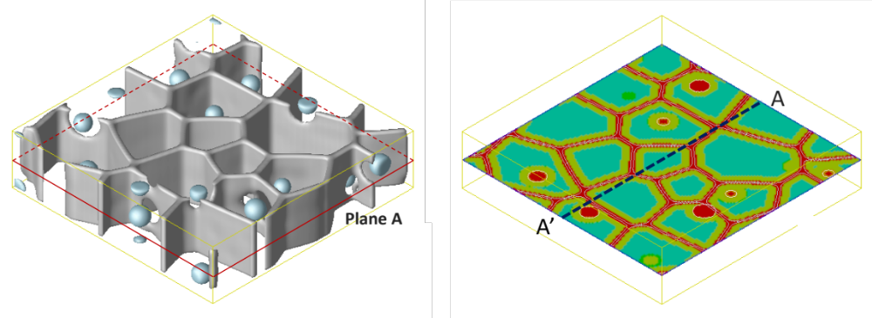
- (b)
Figure 1. (a) Polycrystalline structure with distributed gas bubbles, and (b) different regions on plane A: grain boundaries (red lines); gas bubbles (red circles); and emission zone (yellow).
With this description of defects and microstructures, next we present the cluster dynamics and phase-field models.

Microstructure dependent cluster dynamics
In UMo fuels, ²³⁵U fission generates high energy neutrons and fission fragments which cause radiation damage. The cluster dynamics model describes the evolution of gas atoms, vacancies, interstitials and their clusters in polycrystalline structures with distributed gas bubbles. The generation of gas atoms, vacancies and interstitials are calculated with the fission product (FP) yields and the kinetic energy distribution of the fission products. The details of defect generation are described in next section. Grain boundaries, gas bubbles and dislocations are treated as sink and emission sites of defects. According to the kinetic rate theory, with the assumption that 1) only single interstitial, vacancy, and gas atom are mobile, and 2) mobile gas atoms only interact with existing gas bubbles, the evolution of defect concentrations can be written as²⁰⁻²³:

$$\frac{dC_{i}\left(x,t\right)}{dt}=∇\left[D_{i}∇C_{i}\left(x,t\right)+D_{i}C_{i}\left(x,t\right)∇U_{i}/k_{B}T\right]+{\dot{G}}_{i}-αC_{i}\left(x,t\right)C_{j}\left(x,t\right)+K_{j}^{li}\left(2\right)C_{j}\left(x,t\right)C_{2i}\left(x,t\right)+\sum_{m=3}^{M_{I}}{\left[γ_{i}^{li}\left(m\right)-K_{i}^{li}\left(m\right)C_{i}\left(x,t\right)\right]C_{li}\left(x,t\right)-}K_{i}^{li}\left(2\right)C_{i}\left(x,t\right)C_{2i}\left(x,t\right) -K_{i}^{li}\left(1\right)C_{i}^{2}\left(x,t\right)-\sum_{m=3}^{M_{V}}{\left[γ_{j}^{li}\left(m\right)-K_{j}^{li}\left(m\right)C_{i}\left(x,t\right)\right]C_{lj}\left(x,t\right)-}K_{i}^{li}\left(2\right)C_{i}\left(x,t\right)C_{2j}\left(x,t\right)-{\dot{S}}_{i,gb}\left(η,C_{i}\left(x,t\right)\right)-{\dot{S}}_{i,g}\left(χ,C_{i}\left(x,t\right)\right)-{\dot{S}}_{i,dis}\left(ρ_{dis},C_{i}\left(x,t\right)\right)+{\dot{ξ}}_{i,gb}\left(η,C_{i}\left(x,t\right),C_{i_{gb}}^{eq1}\left(x,t\right)\right)+{\dot{ξ}}_{i,g}\left(η,C_{i}\left(x,t\right),C_{i_{g}}^{eq1}\left(x,t\right)\right), i≠j=I and V$$

$$\frac{dC_{li}\left(m,x,t\right)}{dt}=K_{i}^{li}\left(m-1\right)C_{i}\left(x,t\right)C_{li}\left(m-1,x,t\right)+γ_{j}^{li}\left(m-1\right)C_{li}\left(x,t\right)-\left[K_{i}^{li}\left(m\right)C_{i}\left(x,t\right)+K_{j}^{li}\left(m\right)C_{j}\left(x,t\right)+γ_{j}^{li}\left(m\right)\right]C_{li}\left(m,x,t\right)+K_{j}^{li}\left(m+1\right)C_{j}\left(x,t\right)C_{li}\left(m+1,x,t\right)-{\dot{S}}_{li,g}\left(m\right), m=2,3,…,M$$
$$i≠j=I and V, li=a cluster m with defects i, M=M_{I} or M_{V} \left(2\right)$$

$\frac{dC_{g}\left(x,t\right)}{dt}=∇\left[D_{g}∇C_{g}\left(x,t\right)+D_{g}C_{g}\left(x,t\right)∇U_{g}\right]+{\dot{G}}_{g}-{\dot{S}}_{g,g} (3)$

$\frac{dρ}{dt}=2πv_{li}S_{BH}-ρτ_{li}^{-1}+2π\sum_{m≥2}{r_{m}C_{li}\left(m\right)τ^{-1}\left(m\right), i=I}$ (4)

where $C_{i }\left(r,t\right)=C_{li }\left(1,r,t\right)$ is the concentration of single defect $i$, $i=V$for single vacancy, $i=I$for single interstitial, and , $i=g$for gas atom. $D_{i }$is the diffusivity of defect $i$; $U_{i}$is the interaction energy between sink and defect $i$ or chemical potential of defect on sinks; $G_{i}$ denotes generation rate of vacancy, interstitial and gas atom by fission reaction; $C_{lj }\left(m,x,t\right)$is the concentration of defect cluster$lj$; $α$ is a rate constant for the recombination between single vacancies and single interstitials;$K_{i}^{lj}$ is the capture coefficient of mobile defect $i$ by defect cluster $lj$; $γ_{i}^{lj}\left(m\right)$ is the emission coefficient of mobile defect $i$ by cluster $m$ of defect $j$; ${\dot{S}}_{i,def}$ is the sink rate of defect $i$ on sinks ($def$) including grain boundary ($gb$), gas bubble interface ($g$), and dislocation network (dis); and $C_{i_{def}}^{eq1}$ is the equilibrium concentration of defect $i$ on sinks ($def$); ${\dot{ξ}}_{i,def}$ is the emission rate of defect $i$ from sink ($def$); $ρ$ is the dislocation density. The evolution of the dislocations is described by a model similar to the one developed by Stoller^{24,25}; $M_{I}$and $M_{V}$ are the largest allowable sizes of interstitial and vacancy clusters, respectively. Defect equilibrium concentration $C_{i_{def}}^{eq1}$ is calculated by $exp(E_{i_{def}}^{f}/k_{B}T){ }$ where $E_{i_{def}}^{f}$ is the formation energy of defect $i$ on defect$def$; the rate constant $α=Z_{iv}\left(D_{I}+D_{V}\right)/a^{2}$ where $a$ is the lattice constant, and $Z_{iv}$ is the combinatorial factor of vacancy and interstitial; rate constant $K_{i}^{lj}(m)={4πr}_{i,lj}Z_{lj}^{i}D_{i}/Ω$ where $Ω$ is the atom volume, $r_{i,lj}$ is the capture radius between defect $i$ and cluster$lj$; emission rate $γ_{i}^{lj}(m)=K_{i}^{lj}\left(m-1\right)exp⁡(-E_{b}^{i}(lj)/k_{B}T)$ where $E_{b}^{i}(lj)$ is the binding energy between defect $i$ and cluster$lj$. The capture radius $r_{i,lj}$ is estimated by $r_{i,lj}={\left(n_{lj}\right)}^{1/3}r_{at}+r_{at}$ where $n_{lj}$is the total number of vacancies/interstitials in cluster $lj$ and $r_{at}$ is the atom radius. ${\dot{S}}_{li,g}$is the sink rate of cluster $lj$ at gas bubbles. The defect diffusivity $D_{i }$and the chemical potential $U_{i }$of defect $i$ on grain boundaries and/or gas bubbles are different from those in matrix. The spatially dependent thermodynamic property of defect $i$ is described as
$Φ_{i}=Φ_{0i}+{∆Φ}_{i_{def}}θ\left(η_{m},χ\right)$. (5)
where $Φ_{0i}$ is the property of defect $i$ inside the grains, and ${∆Φ}_{i_{def}}θ\left(η_{m},χ\right)$ is the difference of the property of defect $i$ on the structural defect from that inside grains.

In conventional rate theory and cluster dynamics models the sink strength of defect $i$ on a structural defect is estimated by calculating the diffusion flux of defect $i$ to an isolated structural defect in matrix. The sink strength is only correct for the system with a low density of structural defects so that the diffusion field around the structural defects doesn’t overlap. In current model, the structural defects such as grain boundaries and gas bubbles have spatial distribution. The diffusion field of defect $i$ is solved in the system with distributed defects. Therefore, the sink rate can be calculated by ${\dot{S}}_{i,def}=Z_{i,def}^{s}D_{i}/a^{2}\left[c_{i}\left(x,t\right)-C_{i_{def}}^{eq1}\right]θ\left(η_{m},χ\right)$ with the diffusion field. $θ\left(η_{m},χ\right)$is not zero only inside the structural defects according to its definition. The emission rate can be calculated by ${\dot{ξ}}_{i,def}=∆C_{i}/(∆tN_{tot})$ which is described in the previous section.

Phase-field model of gas bubble evolution
Gas bubbles in irradiated nuclear fuels may not reach equilibrium. This means that the gas concentration inside gas bubbles may be larger or smaller than the equilibrium concentration. For example, the gas bubbles may become voids if the matrix has high vacancy concentration. In contrast, the gas bubble might be over-pressurized if the vacancy concentration is low in matrix. To describe the non-equilibrium gas bubbles, we assume that gas bubbles are energetically favored sinks for vacancies and gas atoms, and are energetically unfavored sinks for interstitials. Once vacancies and gas atoms reach gas bubbles they are absorbed immediately by gas bubbles while interstitials are partially absorbed or emitted by gas bubbles. Two field variables, i.e., vacancy $C_{gV}$ and order parameter $χ$ are used to describe the gas bubbles in the phase-field model of non-equilibrium gas bubble evolution. $C_{gV}$ is the vacancy concentration which is different from $C_{V}$ in the cluster dynamics model. Vacancies, interstitials and their clusters sinking to gas bubbles, which are described by ${\dot{S}}_{i,g} and {\dot{S}}_{lj,g}$ in the cluster dynamics model, generate a net change of vacancies inside the gas bubbles. $C_{gV}$ accounts for the net vacancy concentration inside gas bubbles. A KKS model is used to describe the thermodynamics and kinetics of UMo with gas bubbles. According to the KKS model²⁶, the total free energy density of a system with vacancies can be written as
$G=p\left(χ\right)f^{b}\left(c_{v}^{b}\right)+\left(1-p\left(χ\right)\right)f^{m}\left(c_{v}^{m}\right)+wg\left(χ\right)$ (6)
where $χ$ is the order parameter, which is zero in matrix and unity in bubbles, $p\left(χ\right)=χ^{3}(10-15χ+6χ^{2})$ is a monotonously changing function from $p\left(0\right)=0$ to $p\left(1\right)=1$, $g\left(χ\right)=30χ^{2}{(1-χ)}^{2}$ is a double well potential, $w$is the height of the double well potential. $f^{m}$ and $f^{b}$ are the bulk free energy density of the matrix and bubble phase, respectively. They are set to be $f^{m}=A_{m}{(c_{v}^{m}-1)}^{2}$ and $f^{b}=A_{bv}{(c_{v}^{b}-c_{v}^{eq})}^{2}$.
The total free energy $F\left(C_{gV},χ\right)$of the system includes chemical free energy and interfacial energy. It is defined as
$F\left(C_{gV},χ\right)=\int_{Ω}{\left[G\left(C_{gV},χ\right)+\frac{κ}{2}{\left\lceil ∇χ\right\rceil }^{2}\right]dΩ}$ (7)
where $κ$ is a gradient coefficient. Two model parameters $w$ and $κ$ can be determined by the interfacial energy $σ$ and interface thickness $λ$ ¹⁴.
Following the KKS model, the concentration of vacancies is written as follows
$C_{gV}=p\left(χ\right)c_{v}^{b}+(1-p\left(χ\right))c_{v}^{m}$ (8)
At each point in the system, local thermodynamic equilibrium is assumed
$\frac{{∂f}^{b}\left(c_{v}^{b}\right)}{∂c_{v}^{b}}=\frac{{∂f}^{m}\left(c_{v}^{m}\right)}{∂c_{v}^{m}}$ (9)
The evolution equations of gas bubbles are written as follows.
$$\frac{∂C_{gV}}{∂t}=∇\left[\frac{D_{gV}}{G_{C_{gV}C_{gV}}}\left(G_{χC_{gV}}∇χ+G_{C_{gV}C_{gV}}∇C_{gV}\right)\right]+{\dot{S}}_{V,g}-{\dot{S}}_{I,g}$$
$+\sum_{m=2}^{M_{V}}{m{\dot{S}}_{lv,g}(m)}-\sum_{m=2}^{M_{I}}{m{\dot{S}}_{li,g}(m)}$ (10)
$\frac{∂χ}{∂t}=L\left[-\frac{∂}{∂χ}\left(\frac{κ}{2}{\left\lceil ∇χ\right\rceil }^{2}\right)+p^{'}\left(χ\right)\left(f^{m}\left(c_{v}^{m}\right)-f^{b}\left(c_{v}^{b}\right)-\left(c_{v}^{m}-c_{v}^{b}\right)\frac{∂f^{m}\left(c_{v}^{m}\right)}{∂c_{v}^{m}}\right)+wg^{'}\left(χ\right)\right]$ (11)
where $D_{gV}$ are diffusivity of vacancies and $L$ is the interface mobility. ${\dot{S}}_{V,g}$ and${\dot{S}}_{I,g}$ are sink rates of vacancies and interstitials at gas bubbles, respectively. ${\dot{S}}_{lv,g}$ and ${\dot{S}}_{li,g}$ are the sink rates of vacancy and interstitial clusters at the gas bubbles. It is assumed that all gas atom, vacancy, and vacancy and interstitial clusters are absorbed by gas bubbles when they reach the gas bubbles. The sink rate is calculated by ${\dot{S}}_{i,g}=S_{i}{m_{i}C}_{i}χ/∆t, i=V,g,lI, and lV$. $m_{i}$ is the number of defect cluster $i$. For interstitials, when their concentration on the gas bubble interface is larger than their equilibrium concentration, the interstitials are emitted as described in cluster dynamics model.
The gas phase inside gas bubbles is treated as a solution phase. The free energy density of the gas phase is described as
$G_{1}=A_{bg}{\left(C_{gg}-C_{gg}^{eq}\right)}^{2}$ (12)
where $C_{gg}^{eq}$ is the equilibrium concentration of gas atoms which is set to 0.45¹¹. The evolution of gas atom concentration is given
$\frac{∂C_{gg}\left(x,t\right)}{∂t}=∇\left[D_{gg}∇\frac{{∂G}_{1}}{∂C_{gg}}\right]+{\dot{S}}_{g,g}$ (13)
where $D_{gg}$is the diffusivity of gas atoms, and ${\dot{S}}_{g,g}$is the sink rate of gas atoms calculated in cluster dynamics model. For large gas bubbles it is reasonable to assume that gas atoms are confined inside gas bubbles once they are absorbed by the gas bubbles. To apply this assumption in the model, $D_{gg}$ is defined as $D_{gg}=D_{gg0}χ^{2}$. $D_{gg}$is equal to $D_{gg0}$inside the gas bubble, and equal to zero in the matrix. $D_{gg0}$is the diffusivity of gas atoms inside gas bubbles which should be much larger than that in the matrix.

Nucleation of gas bubbles
The concentration distributions of vacancies, interstitials and their clusters are nonuniform because of inhomogeneous grain and gas bubble structures. With the increase of local net vacancy concentration (single vacancy, single interstitial, and their clusters), the defects will collapse and form a void. Based on this assumption, a statistical method is used to introduce the nuclei of gas bubbles. To do so, the total vacancy population, $c_{{tot}_{M}}\left(x,t\right)$is calculated by integrating all the defects (single vacancy, single interstitial, and their clusters) at every $N_{1}$ simulation steps. With $c_{{tot}_{M}}$the number of potential nucleation sites, $N_{2}$, is determined. Then, position $x_{i}, (i=1,2,…{, N}_{2})$ is chosen randomly; the total vacancy $c_{{tot}_{1}}$ at $x_{i}$by integrating $c_{{tot}_{M}}\left(x,t\right)$in a sphere with radius $r_{1}$; and a spherical nucleus with radius $r_{c}$ is introduced if the total vacancy $c_{{tot}_{1}}$is larger than the critical value $c_{crt}$. Inside the nucleus, the order parameter $χ$ is set to be 1.0, the radius $r_{c}$ is calculated by ${\left[3c_{{tot}_{1}}/(4π)\right]}^{1/3}$. $N_{1}$, $c_{crt}$ and$r_{1}$ are model parameters. For given model parameters, $r_{1}$ is estimated by $\sqrt{D_{V}N_{1}∆t}$. In the simulations, $N_{1}$ and $c_{crt}$ are set to be 5000 and 1.0, respectively.

Flow chart of cluster dynamics and phase field model of gas bubble evolution

Figure 2 shows the flow chart of cluster dynamics and phase field model of non-equilibrium gas bubble evolution. It shows that the cluster dynamics model and phase field model exchanges information through the simulation. Defect concentrations and the absorption of defects at gas bubbles from the cluster dynamics simulation are used in nucleation and growth of gas bubbles in the phase-field model. The gas bubble structures obtained from phase-field modeling is used to update the sink as well as defect concentrations in the cluster dynamics model. The integrated model enables one to simulate defect and gas bubble associated growth.

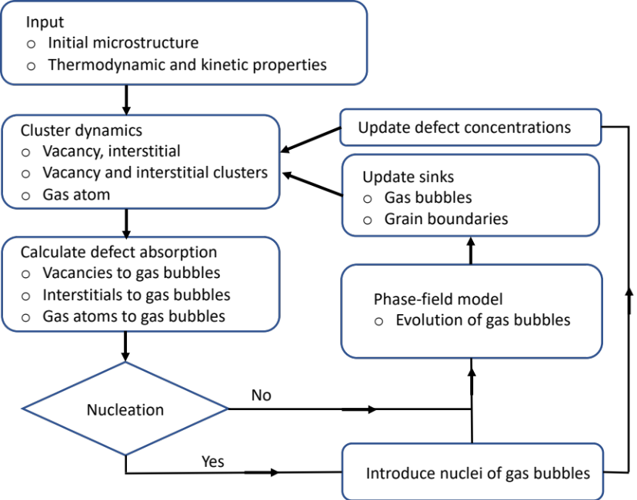

Figure 2. Flow chart of the integrated cluster dynamics and phase-field model.

Model parameters

Calculation of defect generation during fission
To calculate the defect generation ${\dot{G}}_{i}$, we need to know the fission product (FP) yields and the kinetic energy distribution of the fission products. Fission product yields depend on the fissioning nuclide and the energy of the neutron causing the fission. Here, we evaluate the model for fission from 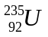 due to thermal neutrons (neutron energy=0.0253 eV), which is applicable for light-water reactors (LWRs). Based on our previous work ²⁷, we take the independent fission product yield (iFPY) from the JEFF 3.3 library to calculate the defect generation in this work. The distribution of the fission products and kinetic energies (E_{tot}) as a function of atomic number can be found in the reference ²⁷. There are 18 elements that make up almost 100% of the distribution. Every fission creates 2 FPs, one light FP and one heavy FP. The mass of the most probable isotope in each element is taken as the mass of the element.
Using E_{tot} and the mass of the most probable isotope, SRIM simulations are performed to obtain the portion of the energy lost due to electronic stopping (E_{electronic}) and the energy that effectively causes damage via displacement cascade (E_{damage}), for each FP. For SRIM simulations, the displacement threshold energy (E_{d}) of 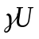 from MD cascade simulations ²⁸ and the material density of pure are used. The NRT formula of 0.4*E_{damage}/E_{d} is used to estimate the Frenkel pair generation per fission. The results show that one fission generates about 14,825 Frenkel pairs in . Since we do not have the cascade data of U10Mo, the defect generation calculated in is used in the simulations. Table 1 summarizes the E_{tot}, E_{electron}, E_{damage}, and the number of Frenkel pairs for each FP.

Table 1. The most probable isotopes of fission products from due to thermal neutrons, the independent fission product yield (iFPY), total kinetic energy (E_{tot}), electronic loss (E_{electron}), and E_{damage} = E_{tot} – E_{electron} used in SRIM simulations to estimate the number of Frenkel pairs in with displacement threshold energy E_{d}=35.6eV at 800K.

Element iFPY E_{tot}(MeV) E_{electron}(MeV) E_{damage}(MeV) Frenkel pairs
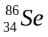 | 0.042 | 101.3 | 98.362 | 2.938 | 1376.9
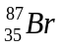 | 0.051 | 101.2 | 98.117 | 3.083 | 1751.6
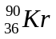 | 0.164 | 101.5 | 98.333 | 3.167 | 5829.3
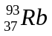 | 0.112 | 101.2 | 97.840 | 3.360 | 4216.0
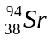 | 0.209 | 101.1 | 97.766 | 3.334 | 7816.4
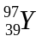 | 0.114 | 101.3 | 97.792 | 3.508 | 4504.4
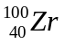 | 0.180 | 101.4 | 97.536 | 3.864 | 7824.6
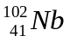 | 0.073 | 101.8 | 97.728 | 4.072 | 3319.2
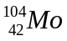 | 0.041 | 101.2 | 97.172 | 4.028 | 1847.3
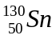 | 0.041 | 81.5 | 75.928 | 5.572 | 2555.1
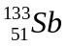 | 0.073 | 78.8 | 73.052 | 5.748 | 4685.4
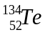 | 0.180 | 77.5 | 71.641 | 5.859 | 11864.3
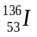 | 0.114 | 74.6 | 68.582 | 6.018 | 7726.5
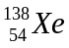 | 0.209 | 71.9 | 66.289 | 5.611 | 13154.9
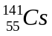 | 0.112 | 68.2 | 61.898 | 6.322 | 7931.9
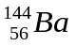 | 0.164 | 64.8 | 58.330 | 6.470 | 11908.0
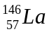 | 0.051 | 62.6 | 56.049 | 6.551 | 3721.8
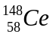 | 0.042 | 60.2 | 53.491 | 6.709 | 3144.7
SUM 1.969
iFPY-weighted sum of Frenkel pairs = 14825

Thermodynamic and kinetic properties of defects
Table 2 lists the model parameters used in the simulations. The diffusivity $D_{i}$ and chemical potential $U_{i}$ of mobile defects including single vacancy, single interstitial and gas atoms in matrix are different from those at structural defects such as grain boundaries and gas bubbles. The inhomogeneous thermodynamic and kinetic properties are described by equation (5). Most parameters such as the diffusivity of vacancy and Xe in irradiated UMo fuels, fission rates and rate constants are assessed and adopted from the previous papers.²⁹ The diffusivity of vacancies and gas atoms inside gas bubbles is set up to be large so that the concentrations of vacancy and gas atoms quickly become uniform inside gas bubbles after the absorption at the gas bubble interface. In the simulations, $D_{Vg}=100D_{V}$ and $D_{gg0}=100D_{g}$ were used. The chemical potential of vacancy, interstitial and gas atom inside the gas bubbles depends on the ratio of gas atom and vacancy or gas concentration $C_{gg}$. Generally speaking, vacancies and gas atoms should have lower chemical potentials inside gas bubbles than those in the matrix which drives vacancies and gas atoms diffusing to gas bubbles. Interstitials should have a higher chemical potential inside a pressured gas bubble than that in matrix which prevents interstitials diffusing to gas bubbles. For gas bubbles with low pressure or voids, interstitials, like vacancies, should have lower chemical potential inside voids than that in the matrix. Since the chemical potential data is lacking, the chemical potentials are assumed to be $U_{V}/k_{B}T=\left[-2.eV/k_{B}T\right]χ^{2}$,$U_{g}/k_{B}T=\left[-2.eV/k_{B}T\right]χ^{2}$and $U_{VI}/k_{B}T=\left[2.eV/k_{B}T\right]χ^{2}$ in the simulations. For more quantitative $U_{i}$, the elastic interaction between defects and gas bubbles should be calculated.

Table 2. Model parameters in the cluster dynamics model

Parameter | Value | Parameter | Value
$$T_{0}$$ | $$180℃$$ | $$Z_{IV}$$ | $$50$$
$$r_{at}$$ | $$1.5A$$ | $$Z_{I,dis}$$ | $${1.25ρ_{dis}D}_{I}$$
$$Ω$$ | $$4πr_{at}^{3}/3$$ | $$Z_{V,dis}$$ | $${ρ_{dis}D}_{V}$$
$$a$$ | $$3.48A$$ | $$M_{I}$$ | $$30$$
$$D_{V}$$ | $$1.83×{10}^{-19}m^{2}/s$$ | $$M_{V}$$ | $$10$$
$$D_{I}$$ | $$1.42×{10}^{-18}m^{2}/s$$ | $$E_{b}^{I}(lI)$$ | $$0.5$$
$$D_{g}$$ | $$1.83×{10}^{-20}m^{-2}$$ | $$E_{b}^{V}(lI)$$ | $$0.8$$
$$ρ_{0}$$ | $$1.0×{10}^{14}m^{-2}$$ | $$E_{b}^{I}(lV)$$ | $$0.5$$
$$C_{I_{gb}}^{eq1}$$ | $$1.28×{10}^{-8}$$ | $$E_{b}^{V}(lV)$$ | $$0.8$$
$$C_{V_{gb}}^{eq1}$$ | $$2.41×{10}^{-8}$$ | $$σ$$ | $$1.0 J/m^{2}$$
$$D_{0}$$ | $$1.42×{10}^{-18}m^{2}/s$$ | $$l_{0}$$ | $$12nm$$
$${\dot{f}}_{0}$$ | $$3.29×{10}^{22}fission/s{/m}^{3}$$ | $$λ$$ | $$3l_{0}$$
$$A_{m}$$ | $$10.75k_{B}T$$ | $$A_{bv}$$ | $$0.91k_{B}T$$
$$A_{bg}$$ | $$0.91k_{B}T$$ | $$∆t$$ | $$0.101s$$

Results
The simulations start from a polycrystalline structure with cylindrical grains and distributed gas bubbles as shown in Figure 1. The simulation cell has dimensions of ${128l}_{0}×128l_{0}×32l_{0}$. The use of cylindrical grains is to save the simulation cost while capturing grain boundary effect. To solve the equations (1-4, 10, 11, and 13), time, length, and energy are normalized by $t^{*}=t/(D_{0}/l_{0}^{2}),$ $x^{*}=x/l_{0}$, and $k_{B}T_{0}$, respectively. $D_{0}$ is the largest diffusivity of $D_{i}$, $l_{0}$ is the characteristic length, and $T_{0}$ is the absolute temperature. The average grain size is about 300 nm which is similar to that observed in the recrystallization zone in UMo. The initial size distribution and density of gas bubbles are set to have the volumetric swelling $1.32\%$ at fission density $f_{d}=$2.6E+27(fission/m³) to mimic the gas bubble microstructure just after the recrystallization. Besides the given model parameters and properties listed in Table 2, there are some thermodynamic and kinetic properties which are unknown or have large uncertainty, for example, the defect generation rate, clustering rate and the defect emission rate. In section 2.5.1 the generation of Frenkel pairs per ${}_{}^{235}U$ fission in $γU$ is estimated. It is about 14,825. However, most generated Frenkel pairs annihilate during a very short period (few ps). The defect and microstructure evolution modeling consider a much large time scale from seconds to years. The generation rate of defects can be calculated by ${\dot{G}}_{I}={\dot{G}}_{V}=G{\dot{f}}_{0}$, where ${\dot{f}}_{0}$ is the fission rate. $G$ is the number of survived Frenkel pairs per fission during the simulation time increment $∆t$, which is unknown. The generation rate of gas atoms is calculated by ${\dot{G}}_{g}=0.25{\dot{f}}_{0}$ which means four fissions generate one gas atom. Emission, sink and clustering rates of defects depend on the interaction energies among defects. The knowledge of the interaction energies in the UMo system is lack. Therefore, parametric studies for the unknown model parameters are carried out in the simulations. Table 3 lists the parameters used in the case studies.

Table 3 Model parameters used in the case studies
Cases | $$G$$ | $$Z_{i,gb}^{s*}$$ | $$Z_{i,g}^{e*}$$ | $$Z_{lj}^{i*}$$
Defect generation rate | $$1000$$  $$2000$$  $$3000$$ | 3.0 | 0.025 | 0.333
Interstitial emission rate | $$3000$$ | 3.0 | 0.035  0.025  0.020  0.015 | 0.333
Defect sink rate | $$3000$$ | 0.1  0.3  1.0  3.0 | 0.025 | 0.333
Defect clustering rate | $$3000$$ | 3.0 | 0.025 | 0.167  0.333  0.667  1.000

Effect of defect generation rate on gas bubble swelling
For a given generation rate, $G{\dot{f}}_{0}$, of Frenkel pairs per fission with $G=2000$ and the rest of the parameters shown in the first row in Table 3, the evolution of gas bubbles $χ\left(x,t\right)$ and $C_{Vg}\left(x,t\right)$, the concentrations of interstitial $C_{I}(x,t)$, vacancy $C_{V}(x,t)$, and total concentration of gas atoms ${C_{g}\left(x,t\right)+C}_{gg}\left(x,t\right)$ on the plane A shown in the Figure 1(a) are presented in Figure 4(a-d), respectively. The gray color in Figure 4(a) represents grain boundaries and the light blue shows the iso-surface of vacancy concentration, $C_{Vg}\left(x,t\right)$, representing gas bubbles. The color bar in Figure 4(a-d) presents the concentration of defects. The change in gas bubble number and size show the nucleation, growth and coalesce of gas bubbles. Concentrations $C_{I}(x,t)$ and $C_{V}(x,t)$ in the matrix is not uniform. Interstitial concentration in the interior of grains increases then decreases while vacancy concentration increases with time. Both $C_{I}(x,t){ and C}_{V}(x,t)$ inside gas bubbles are almost zero because they recombine with vacancies $C_{Vg}(x,t)$. The white circles show the interface of gas bubbles. It can be seen that there is a depletion zone of interstitials and vacancies near the gas bubbles. Inside gas bubble $C_{Vg}(x,t)$ is equal to 1 and gas atom concentration $C_{gg}(x,t)$ has a general tendency to decrease with time. The color shows that the largest $C_{gg}(x,t)$ is about 0.8 which is associated with the nucleation stage of gas bubbles. $C_{gg}(x,t)$ in large gas bubbles is also larger than that inside small gas bubbles. These results demonstrated that the developed model reasonably captures the defect-gas bubble associated growth in UMo fuels, i.e., dynamic interaction between evolving gas bubbles (sinks) and defects.

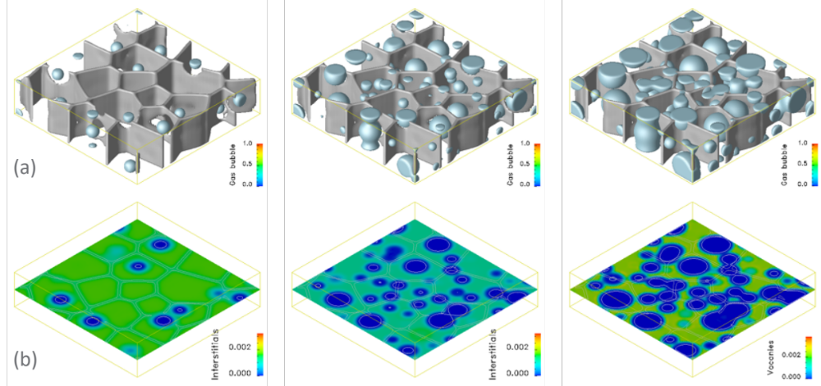
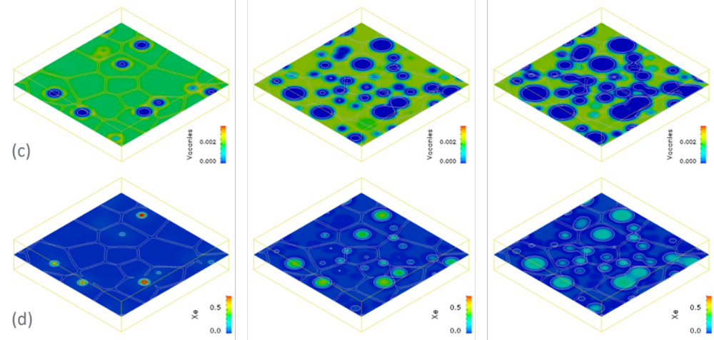

$f_{d}=$2.6E+27(fission/m³) $f_{d}=$5.02E+27 (fission/m³) $f_{d}=$8.04E+27(fission/m³)

Figure 3. Evolution of defects and gas bubble. (a) gas bubble $C_{Vg}\left(x,t\right)$, (b) interstitials $C_{I}(x,t)$, (c) vacancy $C_{V}(x,t)$ and (d) gas atom ${C_{g}\left(x,t\right)+C}_{gg}\left(x,t\right)$. $f_{d}$ is the fission density (fission/m³).

The gas bubble swelling is calculated by
$S_{gb}(t)=\int_{Ω}{χ\left(x,t\right)}dΩ/V_{0}$ (14)
where the integration is over the simulation cell, and $V_{0}$ is the volume of simulation cell. The effect of defect generation rates on gas bubble swelling is plotted in Figure 4. The experimental data points¹ are shown by red circles in the Figure. As expected, the gas bubble swelling kinetics increase as the generation rate of Frenkel pairs per fission increases because there are more vacancies available for gas bubble growth. However, the predicted gas bubble swelling kinetics are much slower than measured swelling kinetics even using a large defect generation rate (3000 Frenkel pairs per fission). So other thermodynamic and kinetics should play an important role in gas bubble swelling in the recrystallization zone.

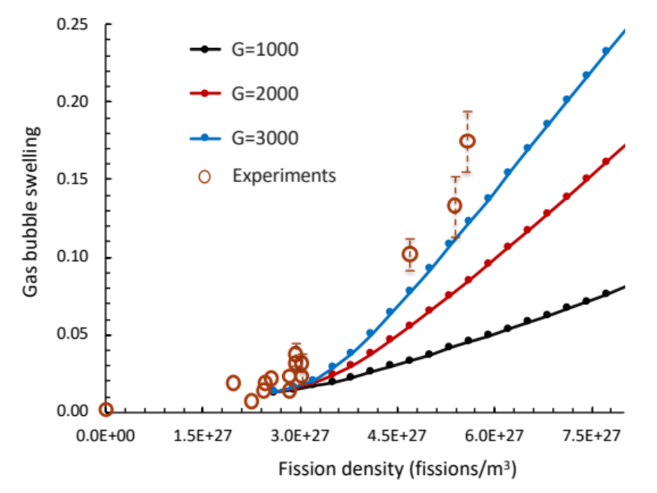

Figure 4. Effect of defect generation rates on gas bubble swelling.

Effect of interstitial emission rate on gas bubble swelling
Normalized emission rate is described as
${\dot{ξ}}_{i,def}^{*}\left(η,C_{i}\left(x,t\right),C_{i_{def}}^{eq1}\left(x,t\right)\right)=Z_{i,def}^{e}*\frac{D_{i}\left(C_{i}-C_{i_{def}}^{eq1}\right)χ\left(x,t\right)/a^{2}}{D_{0}/l_{0}^{2}}$
$=Z_{i,def}^{e*}D_{i}^{*}\left(C_{i}-C_{i_{def}}^{eq1}\right)χ(x,t)$ (15)
where $D_{i}^{*}=D_{i}/D_{0}$ and $Z_{i,def}^{e*}=Z_{i,def}^{e}l_{0}^{2}/a^{2}$ are normalized model parameters. $Z_{i,def}^{e*}$ is a coefficient for the interstitial emission strength from gas bubble interfaces. Figure 5 shows the effect of interstitial emission rate on gas bubble swelling. Increasing the emission rate results in more emission of interstitials from the gas bubble interface. As a result, the interstitial concentration near the gas bubble decreases with the increase of $Z_{i,def}^{e*}$, and less vacancies are recombined with interstitials, hence, increasing the vacancy absorption by gas bubbles, the gas bubble growth, and swelling kinetics. When $Z_{i,def}^{e*}$ reaches $0.025$, further increasing $Z_{i,def}^{e*}$ doesn’t affect the swelling kinetics. It indicates that all interstitials arriving at gas bubbles are emitted and the interstitials have an equilibrium concentration near the gas bubbles. The results show that for the given model parameters listed in the second row in Table 3 increasing the interstitial emission rate on gas bubble interface couldn’t produce the measured swelling kinetics.
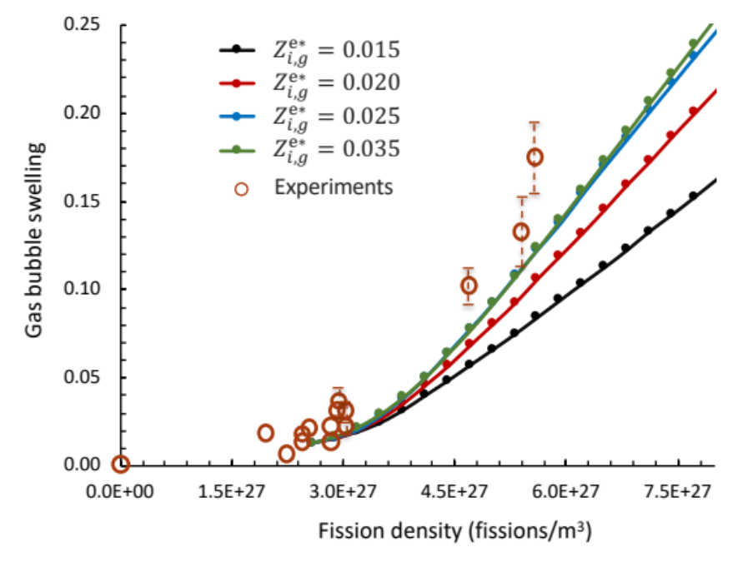
Figure 5. Effect of interstitial emission rate from gas bubbles on gas bubble swelling.

Effect of interstitial and vacancy sink rates on gas bubble swelling
Interstitial and vacancy sink to grain boundaries. The sink rate is calculated by
${\dot{S}}_{i,def}=\frac{Z_{i,def}^{s}D_{i}l_{0}^{2}}{a^{2}D_{0}}\left[c_{i}\left(x,t\right)-C_{i_{def}}^{eq1}\right]θ\left(η_{m},χ\right)$
$=\frac{Z_{i,def}^{s}l_{0}^{2}}{a^{2}}D_{i}^{*}\left[c_{i}\left(x,t\right)-C_{i_{def}}^{eq1}\right]θ\left(η_{m},χ\right)={Z_{i,def}^{s*}D}_{i}^{*}\left[c_{i}\left(x,t\right)-C_{i_{def}}^{eq1}\right]θ\left(η_{m},χ\right)$ (16)
where $Z_{i,def}^{s*}=Z_{i,def}^{s}l_{0}^{2}/a^{2}$ is the normalized sink rate coefficient, and $def=gb$ which means grain boundaries. Figure 6 shows the effect of sink rate at grain boundaries on gas bubble swelling. It is interesting to find that that when $Z_{i,def}^{s*}<1.0$ the gas bubble swelling kinetics is independent of $Z_{i,def}^{s*}$. But the gas bubble swelling kinetics deviate from measured swelling kinetics with the increase of the sink rate $Z_{i,def}^{S*}$. Therefore, adjusting the sink rate on grain boundaries couldn’t produce the measured gas bubble swelling kinetics.

Interstitials and vacancies sinking to grain boundaries change their concentrations on grain boundaries as well as in matrix. We assume that interstitials and vacancies on grain boundaries recombine immediately. Thus, if more interstitials than vacancies are absorbed by grain boundaries, it leads to grain growth. In contrast, if more vacancies than interstitials are absorbed by grain boundaries, that may result in the formation of voids. The defect concentration absorbed by grain boundaries can be calculated by
$c_{IV,gb}=\int_{0}^{t}{\left[{\dot{S}}_{I,gb}-{\dot{S}}_{V,gb}\right]dt}$ (17)
where $t$ is the time. Figure 7(a) shows the distribution of $c_{IV,gb}$ on the plane A for the case $Z_{i,gb}^{S*}=3.0$ at fission density$f_{d}=$8.04E+27(fission/m³). It can be seen that $c_{IV,gb}$ on grain boundaries is larger than zero. A positive value of $c_{IV,gb}$ means that more interstitials than vacancies are absorbed by grain boundaries. The effect of sink rates on $c_{IV,gb}$ along the line AA’ on the plane A are plotted in Figure 7(b). Since the sink rate ${\dot{S}}_{i,gb}$is proportional to the diffusivity $D_{i}$, it is understandable that $c_{IV,gb}$ increases with the increase of ${\dot{S}}_{i,gb}$i . As more interstitials sink to dislocations and grain boundaries, it is expected that more vacancies are left in the matrix. A high vacancy concentration should speed up the gas bubble swelling. The results in Figure 6 show an opposite tendency. Notice the fact that the sink rate ${\dot{S}}_{i,gb}$is also proportional to local defect concentration $c_{i}\left(x,t\right)-C_{i_{gb}}^{eq1}$. In the matrix, vacancy concentration is much higher than that of interstitials. Increasing sink rate coefficient $Z_{i,gb}^{S*}$ also increases the sink strength of vacancies on the grain boundaries. As a consequence, both interstitial and vacancy concentrations in the matrix decrease with the increase of sink rate coefficient $Z_{i,gb}^{S*}$. The decrease of the gas bubble swelling kinetics shown in Figure 7 is attributed to the decreasing vacancy concentration.

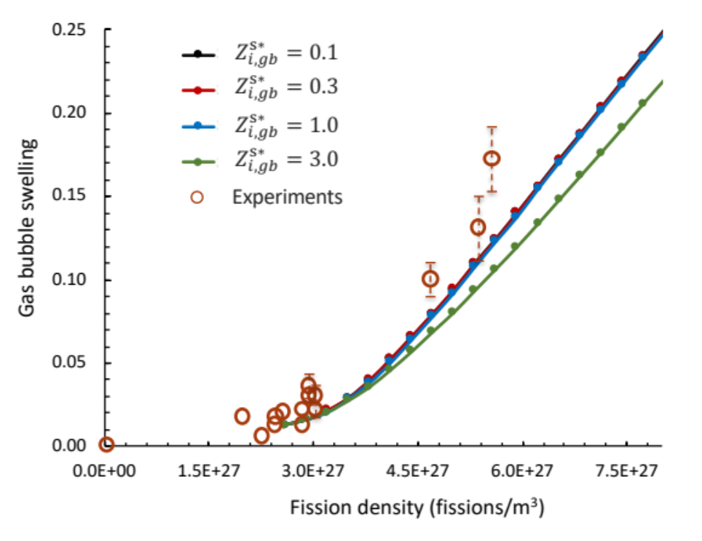

Figure 6. Effect of interstitial and vacancy sink rate on grain boundaries on gas bubble swelling.

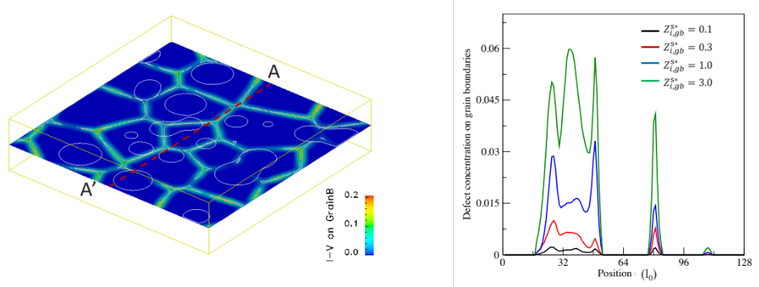
- (b)
Figure 7. (a) concentration $c_{IV,gb}$ of interstitial and vacancy absorbed on grain boundaries, and effect of sink rate coefficient on $c_{IV,gb}$ along the AA’ line shown in Figure 7(a).

Effect of interstitial clustering on gas bubble swelling
Interstitials and vacancies form clusters which reduces the concentrations of mobile vacancies and interstitials in the matrix. As a result, the defect clustering affects the gas bubble nucleation and growth. The capture coefficients of clusters depend on the interaction energy between defect $i$ and defect cluster $lj$. The normalized capture coefficient of mobile defect $i$ by defect cluster $lj$ is calculated by
$K_{i}^{lj*}\left(m\right)=\frac{{4πr}_{at}Z_{lj}^{i}D_{i}l_{0}^{2}}{ΩD_{0}}\left[{\left(n_{lj}\right)}^{\frac{1}{3}}+1\right]=\frac{{4πr}_{at}Z_{lj}^{i}l_{0}^{2}}{Ω}D_{i}^{*}\left[{\left(n_{lj}\right)}^{\frac{1}{3}}+1\right]=Z_{lj}^{i*}D_{i}^{*}\left[{\left(n_{lj}\right)}^{\frac{1}{3}}+1\right]$ (18)
where $Z_{lj}^{i*}={4πr}_{at}Z_{lj}^{i}l_{0}^{2}/Ω$ is a normalized parameter. The effect of capture coefficient of clustering on swelling kinetics is plotted in Figure 8. It can be seen that with the increase of $Z_{lj}^{i*}$ the gas bubble swelling kinetics increases and converges to measured swelling kinetics. If the interstitial clusters have a large clustering rate or growth rate, the predicted gas bubble swelling kinetics is in agreement with the measured swelling kinetics. Compared the effect of other thermodynamic and kinetic properties on the swelling kinetics, we conclude that the defect clustering plays an important role in fast gas bubble swelling kinetics in recrystallization zone in UMo fuels.
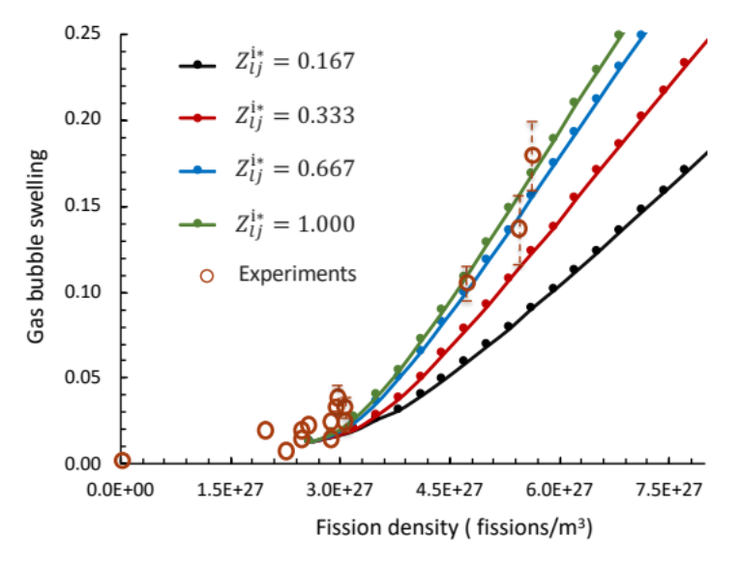
Figure 8. Effect of interstitial and vacancy clustering rate on gas bubble swelling.

Figure 9(a, b, c) show the temporal evolution of gas bubble structures including gas bubble density, average gas bubble size, and average ratio of Xe and vacancy inside the gas bubbles, respectively. In Figure 9a, it can be seen that the gas bubble density increases due to the gas bubble nucleation, and then decreases with gas bubble coalescence as the fission density increases. Experiments do show a wide distribution of gas bubble size (100nm ~ 300nm)². This implies gas bubble nucleation and coalescence take place. Figure 9b shows that the average gas bubble size increases with the fission density increase. The drop of average gas bubble size around $f_{d}=$3.0E+27(fission/m³) is because of rapid increase of gas bubble density associated with gas bubble nucleation. For different defect clustering rates, the average gas bubble size at high fission density has a slight difference. The predicted average gas bubble sizes, about 160nm at $f_{d}=$7.0E+27(fission/m³), is in reasonable agreement with the average intergranular gas bubble size². Figure 9c shows the average Xe concentration inside the gas bubbles. The Xe concentration is the same as the ratio of Xe and vacancy inside the gas bubbles. It is clear that average Xe concentration inside the gas bubble is much lower than the equilibrium value (0.45), and decreases with the increase of fission density as well as the increase of clustering rate. The average ratio of Xe and vacancy inside gas bubbles is about 1:10 at $f_{d}=$7.0E+27(fission/m³). It implies that the gas bubbles become voids. All the information of gas bubble structure evolution can be extracted from the simulations. However, systematic experimental results of gas bubble structure evolution are required to validate the model.

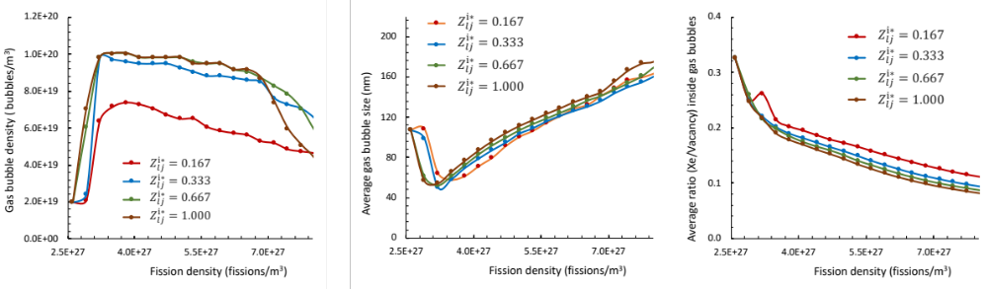
Figure 9. Evolution of gas bubble structures for different clustering rates. (a) gas bubble density, (b) average gas bubble size in diameter, and (c) the average ratio of Xe and vacancy inside the gas bubbles.

Gas bubble swelling is calculated by equation (14) which should be equivalent to the volume increase associated with absorbed interstitials induced grain growth, the formation of interstitial and vacancy clusters, and dislocation climb by absorbing defects. The absorbed interstitials on grain boundaries shown in Figure 7(a) has a concentration which is much higher than thermal equilibrium concentration. If the absorbed interstitials cause grain growth the volumetric swelling associated with the grain growth can be calculated by integrating the absorbed interstitial on the gain boundary. Figure 10 shows the effect of sink rates and clustering rates on grain growth induced swelling. It is found that the swelling rate associated with grain growth gradually reach zero for all cases. This means that absorbed interstitials decrease with the fission density increase or the increase of gas bubble and interstitial density. For the cases that predicted gas bubble swelling kinetics in agreement with experiment ($Z_{lj}^{i*}>0.667)$, the total swelling associated with grain growth is less than 0.002 which is much smaller than gas bubble swelling (0.25 at $f_{d}=$7.0E+27(fission/m³)). Therefore, in the recrystallization zone grain growth-induced the volumetric swelling is negligible compared with volumetric swelling associated with gas bubble and interstitial clustering. In other words, the defect clustering is one of main mechanisms which results in a fast gas bubble swelling kinetics in the recrystallization zone.
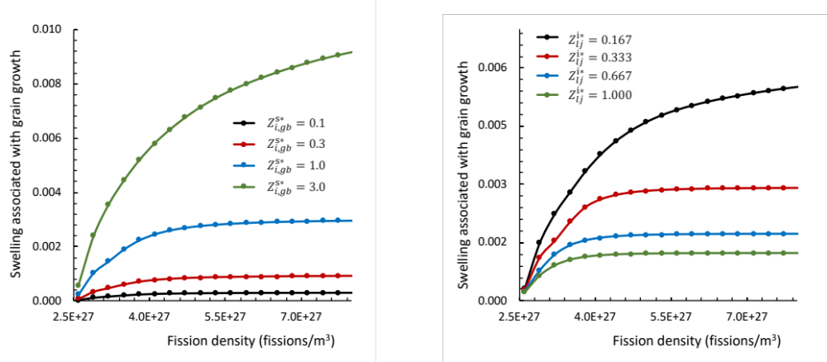
- (b)
Figure 10. Effect of defect kinetic properties on swelling associated with grain growth. (a) defect sink rate coefficient $Z_{i,gb}^{S*}$ on grain boundaries, and (b) defect clustering rate coefficient $Z_{lj}^{i*}$

Conclusions
In this work, we, for the first time, developed a mesoscale model of defect cluster and gas bubble associated growth by integrating phase-field and cluster dynamics approaches for investigating the effect of defect clustering on gas bubble swelling in polycrystalline UMo under irradiation. With the model, the effect of defect generation rate, clustering rate, interstitial emission and sink rates on gas bubble evolution were systematically simulated. It is found that 1) gas bubble swelling kinetics increases with the increase of defect generation rate, interstitial emission rate from gas bubble interfaces, and defect clustering rate, but decreases with the increase of defect sink rate on grain boundaries; 2) swelling associated with grain growth is negligible compared with gas bubble swelling; 3) compared with the sink and emission of defects from grain boundaries and interfaces, interstitial clustering and growth is the key mechanism for the rapid gas bubble growth observed in irradiated UMo. From the simulations a set of model parameters is determined, i.e., G=3000, $Z_{i,def}^{s*}<1.0$, When $Z_{i,def}^{e*}>0.25$ , and $Z_{lj}^{i*}>0.667$. With this set of model parameters, predicted gas bubble swelling kinetics in the recrystallization zone is in good agreement with the experimental results. The evolution of gas bubble structures including gas bubble density, gas bubble size, and the ratio of Xe and vacancy inside gas bubble are also analyzed. The gas bubble structures are in reasonable agreement with existing experimental data. However, more experimental data are required for validating the model. In summary, the simulations demonstrate the capability of the developed model to study the effect of thermodynamic and kinetic properties on defect cluster and gas bubble associated growth, gas bubble structure evolution, and gas bubble swelling kinetics in polycrystalline UMo, and explore the swelling mechanisms. Defect and second phase precipitate associated growth are often observed in irradiated materials. For example, voids form and grow on evolving precipitates. The developed model can be extended to study defect and second phase associated growth in irradiated materials.

Acknowledgement
This work was supported by the U.S. Department of Energy, for the Office of Material Management and Minimization, National Nuclear Security Administration under DE-AC07-05ID14517. PNNL is a multi-program national laboratory operated by Battelle Memorial Institute for the US DOE under DE-AC05-76RL01830.

Reference
1 Kim, Y. S. & Hofman, G. L. Fission product induced swelling of U-Mo alloy fuel. J Nucl Mater 419, 291-301, doi:DOI 10.1016/j.jnucmat.2011.08.018 (2011).
2 Rest, J. Evolution of fission-gas-bubble-size distribution in recrystallized U-10Mo nuclear fuel. J. Nucl. Mater. 407, 55-58, doi:DOI 10.1016/j.jnucmat.2010.07.009 (2010).
3 Meyer, M. et al. Preliminary Report on U-Mo Monolithic Fuel for Research Reactors. Report No. INL/EXT-17-40975, (2017).
4 Meyer, M. K. et al. Irradiation Performance of U-Mo Monolithic Fuel. Nuclear Engineering and Technology 46, 169-182 (2014).
5 Kim, Y. S., Hofman, G. L. & Cheon, J. S. Recrystallization and fission-gas-bubble swelling of U-Mo fuel. J Nucl Mater 436, 14-22, doi:DOI 10.1016/j.jnucmat.2013.01.291 (2013).
6 Hu, S. Y., Burkes, D., Lavender, C. A. & Joshi, V. Effect of grain morphology on gas bubble swelling in UMo fuels - A 3D microstructure dependent Booth model. J Nucl Mater 480, 323-331 (2016).
7 Gan, J. et al. Thermal stability of fission gas bubble superlattice in irradiated U-10Mo fuel. J Nucl Mater 464, 1-5, doi:10.1016/j.jnucmat.2015.04.023 (2015).
8 Gan, J. et al. Irradiated microstructure of U-10Mo monolithic fuel plate at very high fission density. J Nucl Mater 492, 195-203, doi:https://doi.org/10.1016/j.jnucmat.2017.05.035 (2017).
9 Hu, S. Y. et al. Formation mechanism of gas bubble superlattice in UMo metal fuels: Phase-field modeling investigation. J Nucl Mater 479, 202-215 (2016).
10 Xiao, H. X., Long, C. S., Tian, X. F. & Li, S. J. Atomistic simulations of the small xenon bubble behavior in U-Mo alloy. Materials & Design 74, 55-60, doi:10.1016/j.matdes.2015.02.005 (2015).
11 Hu, S. Y., Setyawan, W., Joshi, V. V. & Lavender, C. A. Atomistic simulations of thermodynamic properties of Xe gas bubbles in U10Mo fuels. J Nucl Mater 490, 49-58 (2017).
12 Miao, Y. B. et al. High-energy synchrotron study of in-pile-irradiated U-Mo fuels. Scripta Materialia 114, 146-150 (2016).
13 Chen, L. Q. Phase-field models for microstructure evolution. Annual Review of Materials Research 32, 113-140, doi:DOI 10.1146/annurev.matsci.32.112001.132041 (2002).
14 Li, Y. L., Hu, S. Y., Sun, X. & Stan, M. A review: applications of the phase field method in predicting microstructure and property evolution of irradiated nuclear materials. npj Computational Materials 3, doi:10.1038/s41524-41017-40018-y (2017).
15 Maziasz, P. J. & Mchargue, C. J. Microstructural Evolution in Annealed Austenitic Steels during Neutron-Irradiation. Int Mater Rev 32, 190-219 (1987).
16 Brailsford, A. D. & Bullough, R. Rate Theory of Swelling Due to Void Growth in Irradiated Metals. J Nucl Mater 44, 121-+ (1972).
17 Odette, G. R. & Stoller, R. E. A Theoretical Assessment of the Effect of Microchemical, Microstructural and Environmental Mechanisms on Swelling Incubation in Austenitic Stainless-Steels. J Nucl Mater 122, 514-519 (1984).
18 Mansur, L. K. Theoretical Evaluation of a Mechanism of Precipitate-Enhanced Cavity Swelling during Irradiation. Philos Mag A 44, 867-877 (1981).
19 Brager, H. R. & Straalsund, J. L. Defect Development in Neutron-Irradiated Type-316 Stainless-Steel. J Nucl Mater 46, 134-158 (1973).
20 Mansur, L. K. Theory and experimental background on dimensional changes in irradiated alloys. J Nucl Mater 216, 97-123, doi:https://doi.org/10.1016/0022-3115(94)90009-4 (1994).
21 Brimbal, D., Fournier, L. & Barbu, A. Cluster dynamics modeling of the effect of high dose irradiation and helium on the microstructure of austenitic stainless steels. J Nucl Mater 468, 124-139, doi:https://doi.org/10.1016/j.jnucmat.2015.11.007 (2016).
22 Kohnert, A. A. & Wirth, B. D. Cluster dynamics models of irradiation damage accumulation in ferritic iron. II. Effects of reaction dimensionality. Journal of Applied Physics 117, doi:Artn 154306, 10.1063/1.4918316 (2015).
23 Kohnert, A. A. & Wirth, B. D. Cluster dynamics models of irradiation damage accumulation in ferritic iron. I. Trap mediated interstitial cluster diffusion. Journal of Applied Physics 117, doi:Artn 154305, 10.1063/1.4918315 (2015).
24 Stoller, R. E. Modeling dislocation evolution in irradiated alloys. Metallurgical Transactions A 21, 1829-1837, doi:10.1007/bf02647229 (1990).
25 Bardeen, J. & Herring, C. in Imperfections in Nearly Perfect Crystals (eds W. Shockley, J. H. Hollomon, R. Maurer, & F. Seitz) 261 (John Wiley and Sons, Inc, 1952).
26 Kim, S. G., Kim, W. T. & Suzuki, T. Phase-field model for binary alloys. Physical Review E 60, 7186-7197, doi:DOI 10.1103/PhysRevE.60.7186 (1999).
27 Setyawan, W. et al. Atomistic model of xenon gas bubble re-solution rate due to thermal spike in uranium oxide. J Appl Phys 124 (2018).
28 Beeler, B., Zhang, Y., Okuniewski, M. & Deo, C. Calculation of the displacement energy of α and γ uranium. J Nucl Mater 508, 181-194, doi:https://doi.org/10.1016/j.jnucmat.2018.05.039 (2018).
29 Was, G. S. Fundamentals of Radiation Materials Science, Metal and Alloys. (Springer, 2007).

