We thank the reviewers for their comments. The comments helped identify and rectify the shortcomings of the initially submitted manuscript.

Our choice of equation of states (EOSs) for MD and BCA simulations had not been explained well enough in the original manuscript. While we employed an EOS described by Beeler et al. in our MD simulations, the van der Waals EOS is used for all BCA simulations. This choice was based on multiple factors, which we summarize below:

1. The EOS used in our MD simulations has also been calculated using MD. Therefore, using the equilibrium bubble pressure prescribed by that EOS ensured that the NVE ensemble in our MD simulations was not under compressive/tensile stress.

2. Salvato et al. utilized the Ronchi EOS to investigate the state of Xe inside the bubbles. They could not conclude whether the nanobubbles contain solid Xe with certainty, and suggested further investigation. Later MD studies by Beeler et al. found that the bubble pressure might reach a plateau for smaller bubbles. Thus, there is considerable uncertainty in the equilibrium pressure predicted by different EOSs for very small bubbles, as shown in Figure R1.
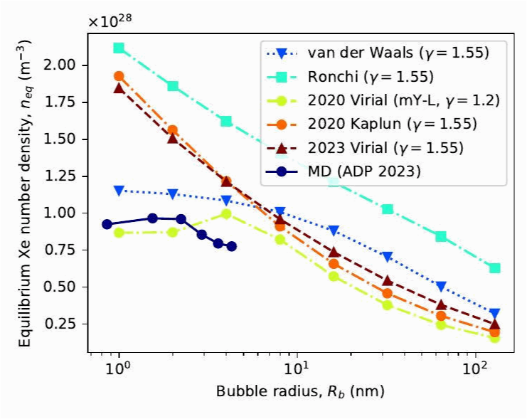
Figure R1: Predicted equilibrium Xe number density for different equations of state.

3. In our BCA simulations, we employ a number density threshold to distinguish between solid and gaseous matter, and the mean free path model depends on that distinction. We did not find it reasonable to simulate two different states of Xe, especially when the EOSs predict different states with large uncertainty.

4. Previous re-solution studies of nuclear fuels, such as UC and U-Zr, used the van der Waals EOS to derive equilibrium bubble pressure. Comparison of re-solution among related nuclear fuels is thus made easy by adopting the same EOS.

5. We have explored the effect of bubble pressure separately in our manuscript. Thus, one can readily calculate the re-solution rate for Xe gas bubbles at non-equilibrium pressure. Therefore, using the simple van der Waals EOS does not hamper the utility of the results in any way.

We added a few sentences in Section 3.3.3 justifying our choice of the van der Waals EOS. However, we do not go into the full details of our choice of EOS since we think it detracts from the original purpose of the manuscript. A detailed description of the differences of various EOSs on smaller bubbles and any possible reconciliation should be a separate study altogether.

--------------------------------------------------
Reviewer #1: This manuscript combines binary collision approximation (BCA) and molecular dynamics (MD) simulations with the two-temperature model (TTM) to quantitatively evaluate the re-solution mechanism of Xe bubbles in U-10Mo nuclear fuel. The manuscript is generally well organized, and the computational work appears substantial. However, the authors need to provide more adequate justification for the boundary conditions of several core physical assumptions and for the selection of key simulation parameters. In addition, there are several minor issues related to formatting, figures, and wording that should be corrected.

(1) The manuscript selects only 97Y and 136I as representative light and heavy fission fragments (FFs). Although these isotopes correspond to the peaks of the fission yield distribution, the fission product spectrum is broadly distributed. The authors should discuss whether using only these two isotopes may introduce a significant systematic error into the re-solution rate (b) obtained from the integral in Eq. (7), and whether this simplification adequately captures the representativeness of the fission-fragment energy and mass distributions.

>> We have selected two isotopes as representative light and heavy FFs to manage computational complexity. This enabled us to study the effect of the selected FFs on re-solution in great detail. The masses of ⁹⁷Y and ¹³⁶I are near the means of that of light and heavy FFs, and their initial kinetic energies of 101.3 MeV and 74.6 MeV are also close to the means of the kinetic energies of light and heavy FFs. Thus, Eq. (7) underestimates the effect of some FFs on re-solution while overestimating others. These errors are expected to cancel out and leave negligible systematic error into the final re-solution rate (b). This approach has also been used in Mao and colleagues' work on U-Zr. We have added a few sentences in Sections 3.1 and 3.3.1 discussing the choice of isotopes and its implications.

(2) In calculating the equilibrium Xe number density inside the bubbles, the authors employ a simple van der Waals equation of state. Given that fission gas in nanobubbles is typically under extremely high pressures on the order of several GPa, the simple van der Waals equation may underestimate the gas density. The authors should clarify the possible deviation under high-temperature and high-pressure conditions and discuss how this may affect the calculated re-solution rate or whether any correction is needed.

>> To our knowledge, the bubble pressure reported in the literature has considerable uncertainty. As such, it is not exactly clear whether the van der Waals EOS underestimates or overestimates the pressure. Section 3.3.6 already establishes a way to calculate the re-solution rate for bubble pressures deviating from the equilibrium value. As long as Xe in the bubble remains in the gaseous state, our model should be able to predict re-solution behavior. However, since BCA cannot take into account temperature effects (Section 2.1), model correction for temperature variations is not possible. Nevertheless, our proposed re-solution model should be suitable for the operational conditions of the U-10Mo fuel.

(3) The BCA method assumes the material to be an amorphous and disordered medium, whereas U-10Mo is in fact a bcc alloy, meaning that the body-centered cubic crystal structure is neglected. In an actual crystal, primary knock-on atoms may undergo pronounced channeling along low-index crystallographic directions, thereby increasing their penetration depth.

>> We have acknowledged in Section 2.1 that BCA simulations assume an amorphous material, neglecting crystal structure, and the channeling of PKAs or their recoils is also mentioned in the introduction. Additionally, we discuss how the channeling phenomenon makes MD unfeasible. Even with periodic boundary conditions, there are issues with subcascade interactions. On the other hand, performing MD simulations of a full energy fission fragment would require a supercell with trillions of atoms. Therefore, MD is not suited for homogeneous re-solution. To our knowledge, all homogeneous re-solution studies in the literature employed BCA on materials with a defined crystalline structure, and we have mentioned this in the introduction. However, we have not shied away from utilizing MD whenever possible, as exemplified by our heterogeneous re-solution work. Thus, we believe that we have utilized the best methods to address the given problem and that these methods are consistent with the existing state-of-the-art literature on this phenomenon.

(4) Before introducing the thermal spike, the system was equilibrated for only 10 ps under an NPT ensemble at 400 K. Considering that inserting 330 Xe atoms into a vacuum cavity (with a Xe/vacancy ratio of 0.2) may generate substantial local stress, the authors should clarify whether 10 ps is sufficient for the U-10Mo-Xe-bubble interfacial structure to reach full thermodynamic equilibrium.

>> We have not seen any indication of any substantial local stress in our simulations. However, 10 ps is indeed short for equilibration of such a system. Thus, we reran our simulations with a 100 ps equilibration time, and we found 100 ps to be sufficient enough for full thermodynamic equilibrium.

(5) The manuscript states that the TTM parameters, such as the thermal diffusion coefficient and specific heat, were adopted from pure U or U-5 at.% Mo and assumed to be applicable to U-10Mo. Since these parameters were not validated specifically for U-10Mo, the authors should provide a brief but convincing justification showing that reasonable variations or minor adjustments of these parameters would not alter the central conclusion that re-solution in U-10Mo is inactive under electronic stopping.

>> Since re-solution is heavily dependent on the amount of energy transferred to the Xe atoms, the value of thermal conductivity may dictate the validation concerns. We have thus performed non-equilibrium MD simulations with the TTM parameters and found the thermal conductivity of the system to be about 37.5 W/m/K at 1200 K, which is close to the literature range of 32--36 W/m/K. The calculated thermal conductivity value and its comparison with literature are added in section 2.2. Since we did not observe any re-solution even at an electronic stopping power of 30 keV/nm, we think slight variations in TTM parameters (and in turn thermal conductivity) should not alter the conclusion. This argument has been made in the last paragraph of Section 3.2.

(6) For the legends in Figures 7 and 9, the horizontal axes are plotted on logarithmic scales. Please check whether the font size of the axis labels is consistent with that in the main text and ensure that the labels remain clearly readable in the printed version.

>> The figures generated in this manuscript use a single matplotlib stylesheet, where a 10 pt font size is specified for a figure dimension of 3.5' x 2.625'. This is to make sure that the font size of the figure labels is the exact same as the font size of the main text in the final camera-ready version. The figures are also provided in a vectorized format. Changes can be made, if necessary, in the processing stage but we thank the reviewer for the consideration here.

(7) For the error bars in Figure 10, the span is very large for the 2 nm bubble. Please briefly explain in the main text that this is due to the small cross section of the bubble and the resulting Monte Carlo statistical fluctuation, and clarify whether 5000 BCA simulations are sufficient to ensure convergence for such small bubbles.

>> We have added the suggested explanation to the main text in Section 3.3.3. As for convergence, we calculated χ after every 1000 simulations to keep track of relative changes. For the smallest bubbles (1 nm radius), 5000 simulations ensure that the relative change in χ over the last 1000 runs is less than 0.2. For larger bubbles, the relative change is lower than 0.05. Thus, we considered 5000 simulations sufficient enough for the calculation of ξ
since we also propagate the standard deviation of χ. This helped us keep the computational expense manageable.

(8) Figure 11 is very helpful for understanding the calculation scheme of ξ. It is recommended that the caption explicitly state that (Am) denotes the projected area, and that the physical meaning of the δ region also be marked clearly, so that the figure corresponds more precisely to Eq. (13) in the main text.

>> The figure caption now includes definitions of A_m and δ.

--------------------------------------------------
Reviewer #2: Review of the Manuscript
"Xe gas bubble re-solution in U-10Mo nuclear fuel" by ATM Jahid Hasan, Linu Malakkal, Mathew Swisher, Benjamin Beeler

The re-solution of gas from radiation-induced bubbles formed in nuclear fuel during irradiation is one of the most important mechanisms affecting the change in the microstructure of the fuel during irradiation, which at the macro level manifests itself in fuel swelling and deterioration of its thermal conductivity. The peer-reviewed paper presents the results of a theoretical analysis of the features of the re-solution of Xe atoms from bubbles in a promising monolithic fuel U-10Mo. The results obtained are not only of independent interest for this type of fuel, but when implemented in fuel codes, they can enhance their predictive ability in comparison with semi-empirical correlations. Thus, the subject of the article meets the requirements of Journal of Nuclear Materials.

The paper considers both the main mechanisms of re-solution. Heterogeneous mechanism was analyzed in the frame work of common MD simulations coupled with the two-temperature model. Homogeneous re-solution was considered in the framework of BCA approximation. It was demonstrated (for the first time for U-10Mo) that thermal spikes generated by electronic stopping make a negligible contribution to the overall re-solution rate. Therefore the authors focused on the careful numerical simulation of the homogeneous mechanism. As a result, the re-solution rate was calculated for different bubble sizes and pressures; a simple interpolation dependence on the bubble size and gas density was proposed.

All stages of the re-solution rate calculation, including reference fission fragment simulations, fission fragment interactions with bubbles and the fraction of the re-solved atoms, were described in detail and well illustrated. Therefore the paper can be recommended for publication with of minor improvements to make the paper more readable for a wider range of readers.

1. Eq (1). The right-hand side of the equation of the two-temperature model usually includes the term to balance the energy lost by the atomic system due to electronic stopping (see, for example, the papers cited in [21], [31]). It may be worth explaining why this term is excluded from consideration in this paper.

>> In the MD/TTM simulations we performed, the kinetic energy of ions is well below 9 eV,
which is double the cohesive energy of U-U. As a result, we omitted the term for electronic stopping from the equation. A sentence has been added in section 2.2 explaining the omission.

2. Fig. 1. What is the uncertainty in the calculated stopping power profiles? It can be estimated by comparing, for example, with calculations of a smaller number of ion-material simulations.

>> Shaded regions representing 2 sigma deviation from the mean have now been added to the stopping power profiles.

3. Eqs. (8), (9). The van der Waals equation of state was used to simulate Xe-bubble interactions. Meanwhile, a more accurate for U-Mo equation was used in the MD calculations (Section 3.2). It would be appropriate to clarify the choice of van der Waals EOS.

>> The rationale behind different EOSs is described in the beginning of this document. We have also clarified our choice of the van der Waals EOS in Section 3.3.3.

4. Lines 169-170. It is advisable to explain how the values of Tspike are related to electronic stopping powers.

>> We have now clarified how the electronic stopping powers were calculated. By integrating the electronic specific heat (C_e = C_1 T_e) over the system, one can find the extra energy deposited due to the introduction of T_spike. This energy deposition is interpreted as the electronic stopping power.

5. Fig. 6. It would be useful to specify the temperature value for which the curve is given.

>> The temperature value (400 K) has been added to the caption of Figure 6. A reference to the temperature has also been added to the main text.

6. Subsection 3.3.6. If we assume that atoms are knocked out from a boundary region with a thickness of several interatomic distances, then the number of re-solved atoms would be proportional to n^(2/3). The invariance of the number of atoms found in the calculations may mean that thickness of the boundary region decreases with increasing pressure. This can be verified by analyzing the initial positions in the bubble of the knocked-out atoms.

>> We tested the assumption of a boundary region with 20,000 simulations of a 64 nm radius bubble and incident ⁹⁷Y with 5 MeV kinetic energy. We varied the Xe number density from 0.8 n_{eq} to 1.4 n_{eq}. Following the reviewer’s suggestion, we analyzed the initial positions of the re-solved atoms. The red histograms in Figure R2 depict the initial positions in two bubbles with different Xe number density. A distinct boundary region cannot be identified from these distributions.

(a)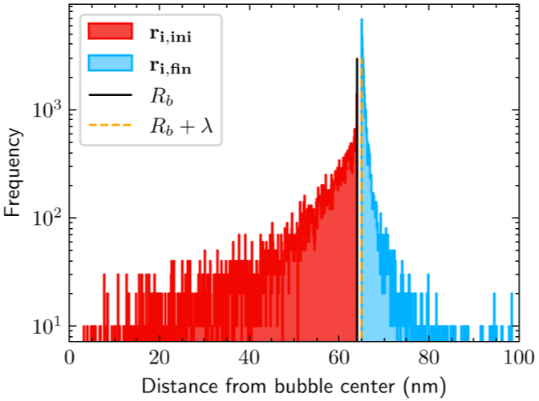 | (b)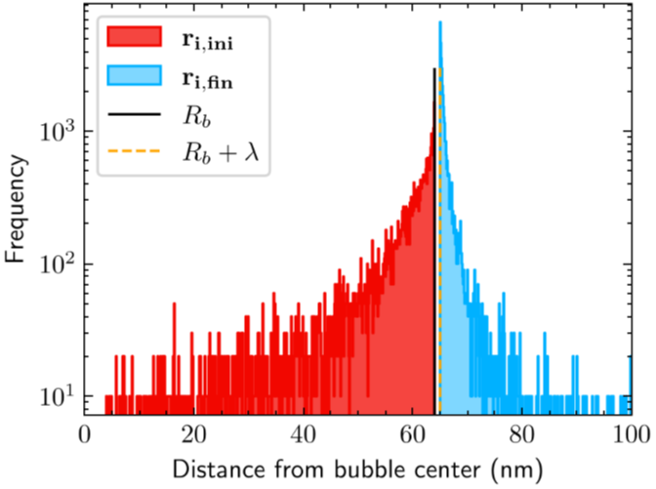
Figure R2: Histogram showing the distribution of the initial and final positions of re-solved Xe recoils for (a) 0.8 n_{eq} and (b) 1.4 n_{eq} Xe number density in a 64 nm radius bubble. The incident ion is a 5 MeV ⁹⁷Y isotope.

We also looked at the average initial positions of the re-solved atoms as a proxy for boundary thickness (t). The obtained data is then tested against t = constant and t = 1/n. However, as can be seen from Figure R3, the standard deviation of the average initial position is too large to allow any conclusion.

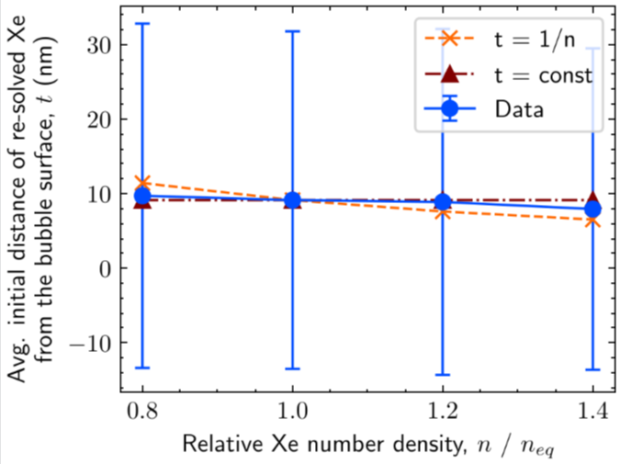
Figure R3: Average initial distance of the re-solved Xe atoms from the bubble surface against Xe number density in the bubble.

What we have found is that the total number of Xe recoils increases with the Xe number density in the bubble, as shown in Figure R4. This is expected since higher Xe density increases the interaction probability. Also, the mean free path of Xe recoils is observed to be inversely proportional to the Xe number density. These two competing phenomena combined explain the invariance of the number of re-solved Xe atoms. We have updated the main text to state the new explanation.

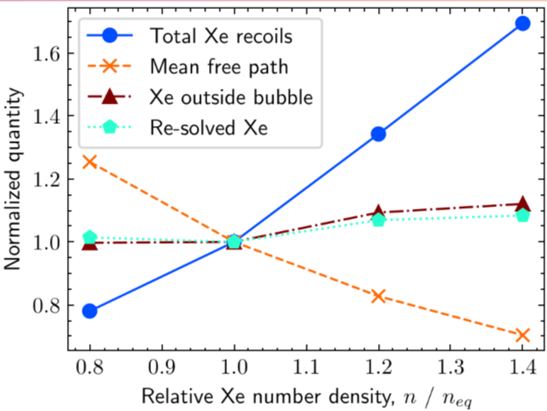
Figure R4: Normalized total number of Xe recoils, their mean free path, number of Xe outside the bubble and number of re-solved Xe as a function of relative Xe number density. Normalization is done against values at n_{eq}.

