We would like to thank the reviewers for their time and for their constructive feedback. We believe that we have strengthened and clarified certain aspects of this paper, in accordance with the suggestions of the reviewers. Full responses to the reviewer comments are listed below in blue. A marked manuscript is included in the submission which shows the revisions made.

Reviewer #1: The manuscript can be a good addition to the Journal of Nuclear Materials. However, the authors need to fully address the following issues before I recommend publication of this work.  
  
1. Section 2.1. I am not sure I understand the sentence "The size of the systems..., with small variations due to compositional variance"

This comment is addressed by removing the sentence of interest and ending the previous sentence with: “… with a system comprising of 200, 198, 199, 195, 196 and 198 atoms, respectively.” Thus, we are now expressing the exact number of atoms in each system. The number of molecules changes as a function of the composition, but the total number of atoms remains approximately constant.

2. Section 2.1. What are the pseudo-potentials in use? To increase the reproducibility, the number of valance electrons in each atom type should be provided.

The reproducibility has been enhanced by changing the sentence “The electronic optimization criterion was 10-4 eV and the cutoff energy was 300 eV” to “Due to this, the electronic optimization criterion was selected to be 10-4 eV and the projector augmented wave PBE pseudopotential cutoff energy was 300 eV for the Na_pv (p6s1 19Sep2006), Mg (s2p0 13Apr2007) and Cl (s2p5 06Sep2000).” The exact pseudopotentials used are now given to enhance reproducibility. Also the version of VASP that was used was stated after VASP was introduced.

3. Section 2.1.  The electronic optimization criterion of 10^-4 eV seems to be pretty large. A tighter criterion may need to be tested.

To ensure that an electronic optimization criterion of 10-4 eV is sufficiently accurate a study was conducted with five simulations at a criterion of 1E-4, 1E-5, and 1E-6 eV with a simulation length of 2000 time steps where the first 400 timesteps are ignored. The average of the five simulations and their standard deviation can be seen below in Tables 1 and 2. What can be observed is that the values for both pressure and energy are within the standard deviation and that there is no discernible trend for increasing the threshold criteria. The combination of both would suggest that 1E-4 eV is a sufficient criterion for electronic optimization. A brief discussion along these lines has been included in the manuscript.

Table 1: Average pressure and standard deviation for different electronic optimization criterion.

|  |  |  |
| --- | --- | --- |
| Criteria | Average Pressure | Standard deviation |
| 1E-4 eV | 0.077 | 0.493 |
| 1E-5 eV | 0.049 | 0.488 |
| 1E-6 eV | 0.391 | 0.275 |

Table 2: Average potential energy and standard deviation for different electronic optimization criterion.

|  |  |  |
| --- | --- | --- |
| Criteria | Average Potential Energy | Standard deviation |
| 1E-4 eV | -317.823 | 0.829 |
| 1E-5 eV | -317.283 | 0.591 |
| 1E-6 eV | -318.230 | 0.496 |

4. Section 2.1. What is the distance cutoff for the D3 correction?

This comment is addressed by adding the cutoff radius value into the Ab Initio Molecular Dynamics subsection. The new sentence now says, “Additional verification of the applicability of the vdW-DF2 functional was performed in this investigation, with comparisons to the DFT-D3 [29] method with the default cut-off radius of 50.2 Angstrom and to density functional theory (DFT) without dispersion.”

5. Section 2.1. If I understood correctly, for each system (composition), at least five volumes (so, five densities), and for each of such density, five independent simulations were performed to determine the pressure. How long was each simulation? How well did the pressure converge?

That is correct each composition has a pressure as a function of volume curve with at least 5 unique volumes and each of these volumes contain a minimum of 5 simulations. Simulation length was addressed by adding the sentence “Each of these simulations was 5 ps long and the pressure is averaged over the last 4 ps.” The pressure is well converged for each of the different volumes. Below is an example of one of the eutectic NaCl-MgCl­2 simulations at 1200K. The orange line shows the running average for the pressure (skipping the first 1 ps) and the blue is the pressure at each time step. The standard deviation of the 5 averaged pressures for this example system is 0.49 kBars. Thus, each individual simulation is quite well converged, the scatter in the data across different simulations, while real, is not excessive. 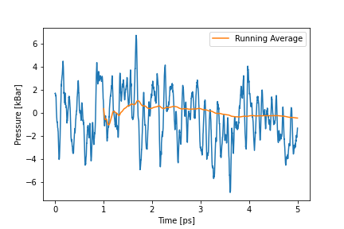

Fig 1: Pressure as a function of time for 1200 K eutectic NaCl-MgCl2

6. Section 3.3. Both the heat capacity and the thermal expansion coefficient are temperature dependent. But it seems to me that the reported values are constants over a temperature range, please explain this.

While there may be minor fluctuations in the heat capacity or thermal expansion as a function of temperature, this work indicates an essentially constant value over the temperature range explored. A finer mesh of temperatures may indicate more intricate variances as a function of temperature, but the data, considering the entire temperature range, expresses a constant value for each of these quantities. It should be noted that the coefficient of thermal expansion matches the other AIMD study very well and the CTE for liquids is often shown as a constant over a temperature range, such as in Bottinga [1]. In their study on silicate liquids, they showed the CTE as a constant over temperature, similar to what was found here. There is an additional example of such a phenomenon being observed in NaCl-UCl3, the manuscript of which is currently under review.

[1] Y. Bottinga, P. Richet, D. Weill, Calculation of the density and thermal expansion coefficient of silicate  
liquids, Bulletin de Min ́eralogie 106 (1) (1983) 129–138.  
  
Reviewer #2: This paper reports an ab initio molecular dynamics study of the thermophysical properties of molten NaCl-MgCl2, an important system for molten salt reactors. Properties such as density, heat capacity, compressibility, enthalpy of mixing, and thermal expansion coefficient have been predicted over a wide temperature and composition range, and good agreement between modeling and experiments have been achieved.

Since NaCl-MgCl2 is used as a coolant in molten salt reactors, knowledge of its viscosity and thermal conductivity will be critical for understanding its heat transfer via convection and conduction. Both thermophysical properties are however not included in the present study. With recent advancement in computational materials science, viscosity and thermal conductivity of molten salts can now be calculated using ab initio molecular dynamics. See, for example, the following two new references:  
  
[1] Tingrui Xu et al., In-depth explorations on the microstructural, thermodynamic and kinetic characteristics of MgCl2-KCl eutectic salt, Journal of Molecular Liquids 347 (2022) 118275.  
[2] Xuejiao Li et al., Unrevealing the thermophysical properties and microstructural evolution of MgCl2-NaCl-KCl eutectic: FPMD simulations and experimental measurements Solar Energy Materials & Solar Cells 210 (2020) 110504  
  
It is the reviewer's opinion that this paper should be revised by including the predictions of viscosity and thermal conductivity before considering it for publication in Journal of Nuclear Materials.

We are in agreement with the reviewer that both viscosity and thermal conductivity are important properties for a heat transfer medium. But we believe that the time period of the current study, which is 5 ps, is insufficient to capture those properties. Also, we are currently working on a study to extract the transport properties from both NaCl-MgCl2 along with LiCl-KCl. What we have determined from that study is that the minimum time of each simulation should be 50 ps which is an order of magnitude larger than the 5 ps of the present study. Nguyen et al. used a production run time of 45 ps in their study to calculate the transport properties of molten salts which is in agreement with our preliminary results [2]. Below in Fig. 2 & 3 are some preliminary results from the LiCl-KCl transport study. Fig. 2 shows the diffusion coefficient of 1200 K eutectic LiCl-KCl. The legend is comprised of 2 numbers A/B, A is the number of atoms (we were testing if 200 atoms was required or if 100 atoms was sufficient), and B is the length of the time increments (25ps, 50ps, or 100ps simulations), with a total time of 200ps. This was conducted in a sequential manner where the end of the one simulation would be the start of the following one until the total simulation time was 200 ps. From that, we determined that 100 atoms is sufficient, that 25 ps is not sufficient, and the total simulation window required should be above 100 ps. This can be seen on the Li diffusivity plot in Fig. 2 as there is a large amount of scattering over the first 75 ps. Due to this, we believe that a minimum time increment of 50 ps should be used to calculate transport properties. With these preliminary results, we believe that the transport properties, while important, are not suited for inclusion in this manuscript, and deserve to be presented separately in a molten salt transport property manuscript. We believe this is important to demonstrate the capability of AIMD to reach a diffusive regime, while some argue that only classical MD simulations can probe the diffusive regime.

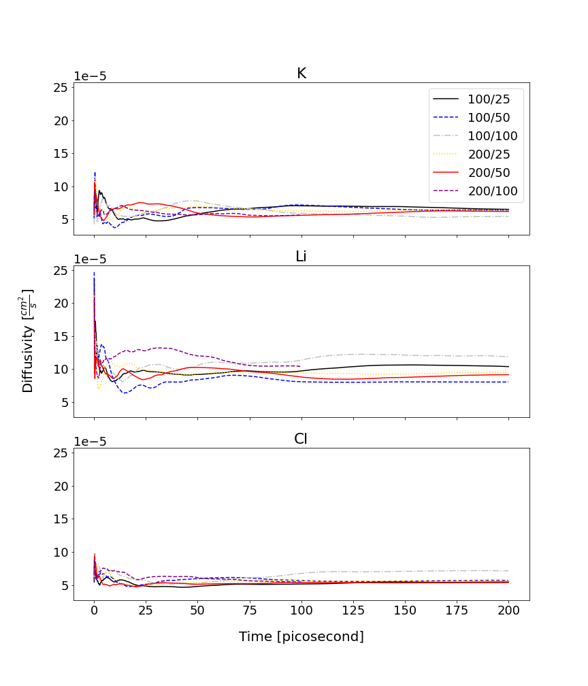

Figure 2: Diffusion coefficient for LiCl-KCl eutectic at 1200 K for 100 atoms vs 200 atom with different time increments of 25, 50 and 100 ps for sequential simulations with a total time of 200 ps.

[2] M.-T. Nguyen, V.-A. Glezakou, J. Lonergan, B. McNamara, P. D. Paviet, R. Rousseau, Ab initio molecular dynamics assessment of thermodynamic and transport properties in (k, li) cl and (k, na) cl molten salt mixtures, Journal of Molecular Liquids 326 (2021) 115262.