Ace Live Pre-deployment Workflow

This workflow steps you through the creation of business groups, reports, and capture files.
A business group allows you to classify traffic by ip address subnet, domains, AS, data center, application, etc. A business group is a user defined group that defines traffic. The ace live appliance monitors traffic in, out, and between business groups. Business groups are helpful in understanding an organizations traffic patterns and application flows.
A capture keys or triggers on important or significant traffic that can be saved on the appliance and removed later via tcp dump or backup and restore. That file can be viewed with ethereal, wire shark, etc.
A report is created from the ace live java console, but viewed in the web browser on the appliance. There are canned reports that come with the appliance and you can create custom reports as well.

Equipment List: 1 each Cisco roll cable- to connect to console
1 each Ethernet crossover cable (only needed if no switch available) - to
facilitate network connection to appliance.
1 each keyboard, monitor, and mouse or a laptop- to connect to
appliance console

- You will need to connect to the appliance via the java applet/cli interface to create reports, captures, or business groups.
- Connecting to Appliance: There are multiple ways to connect to the appliance.
- Connect a Cisco roll cable from laptop db-9 to appliance db-9. You will need to setup a vty 100, baud 9600, 8 bits, no parity, 1 stop bit with some type of terminal emulation software i.e: hyper term, secure crt, procomm, etc.
- You could also connect the monitor, keyboard, and mouse to the appliance.
- The third method would be to establish ip connectivity by placing your laptop on same subnet as appliance with Ethernet crossover or plug into same switch on vlan. You will need to change the laptop subnet to the same subnet as the appliance. You will need to ssh to the host address o the appliance.

- make a connection to the field appliance using one of the methods in steps 1 to 4. Login.

- From the java interface:
Open a web browser to x.x.x.x:8080

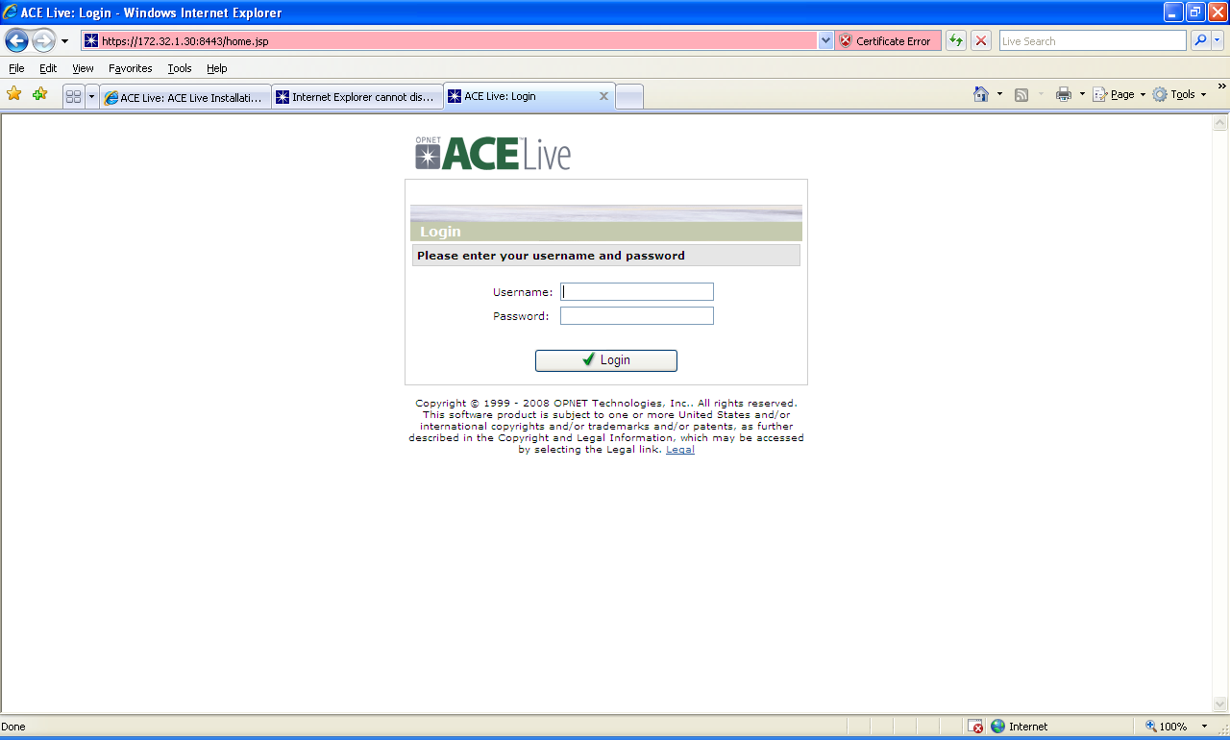

- type in the login id and password.
- Next go to Launch>ace live console and you will get the java pop-up shown below:
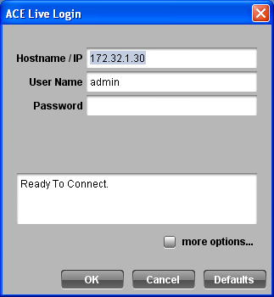

After typing in logon credentials, you should see:

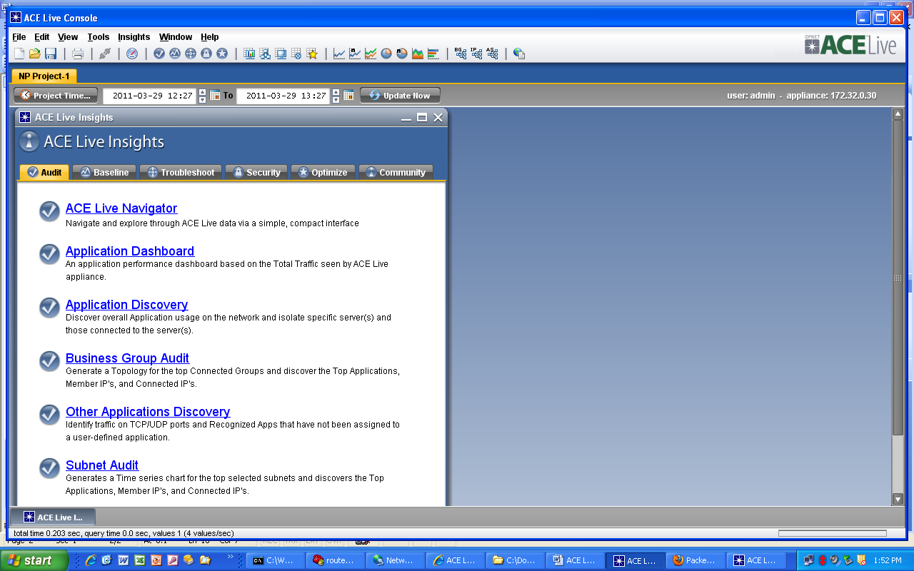

- We will start by creating business groups
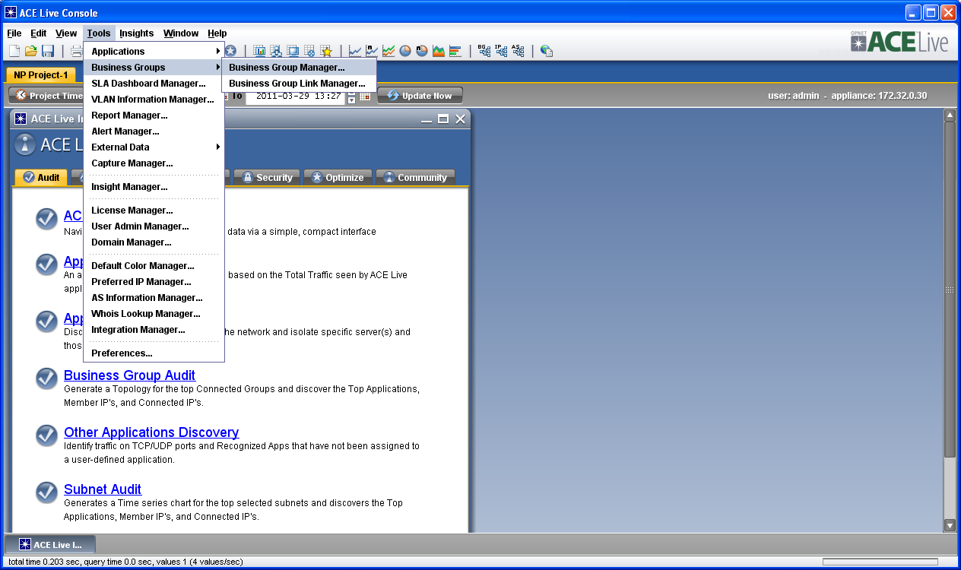

- Select Tools>business group> business group manager
You should see the following screen:
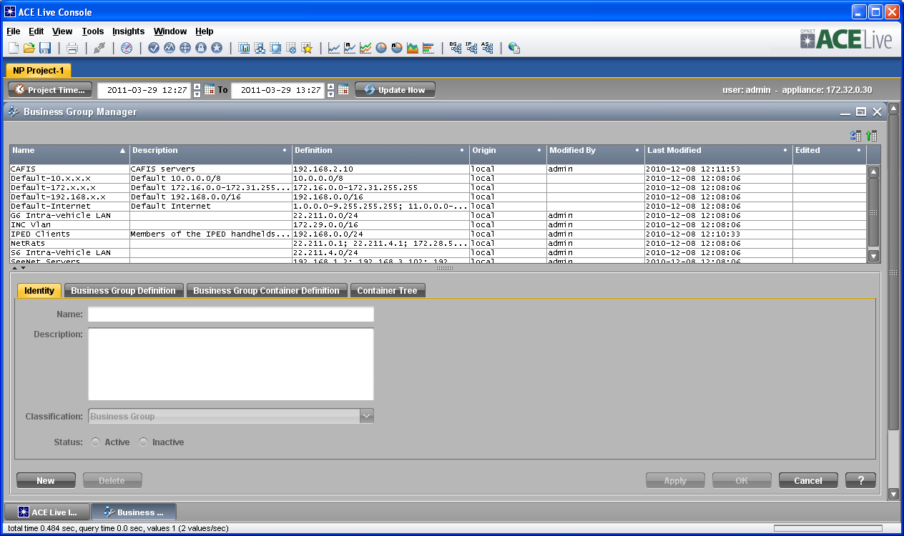

- From here you’ll see the default business groups.
- To create your own select >new> identity
You will want to give your business group a name, define traffic, etc, make it active

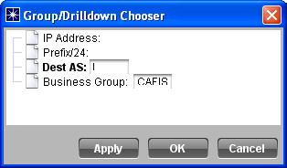

Creating capture files
- You will need to log into the cli java again or remain logged in if already in.

- Once logged in select Tools> capture manager>
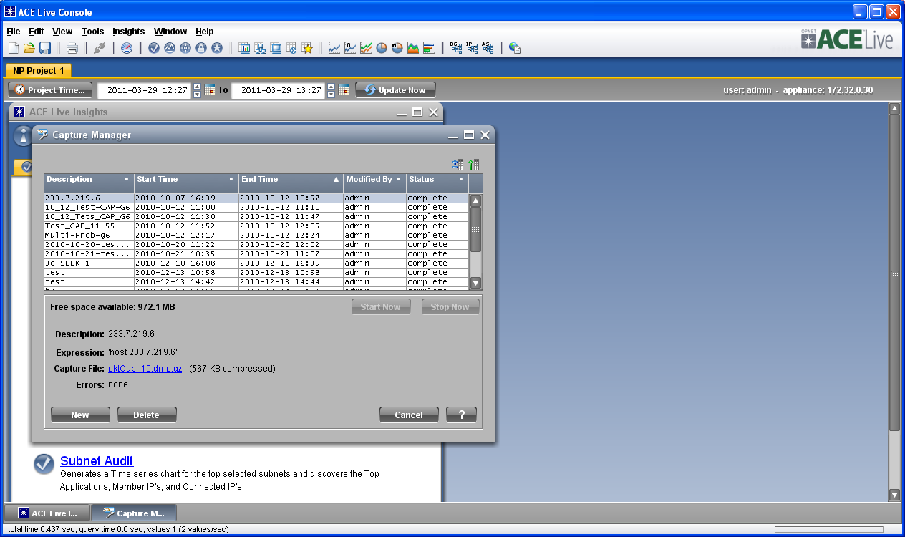

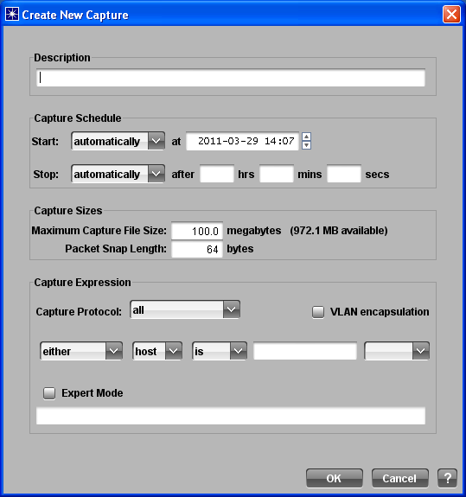

- From here you can type a name for the capture, the frequency and duration, capture size limit, capture expression tabs, or you can create captures manually using expert mode
- once you click ok, you should see the capture you created in the capture manager screen similar to picture below
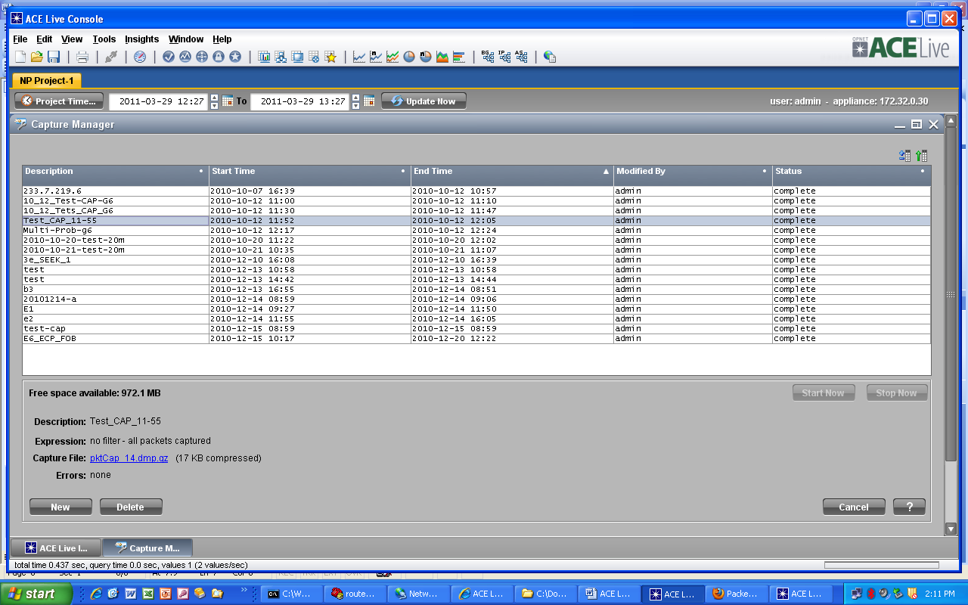

Creating Reports
- If you have logged off the java gui, you want to log back into the appliance
- From the ace live console select tools> report manager
You should see a display with the canned reports defined but most or none active
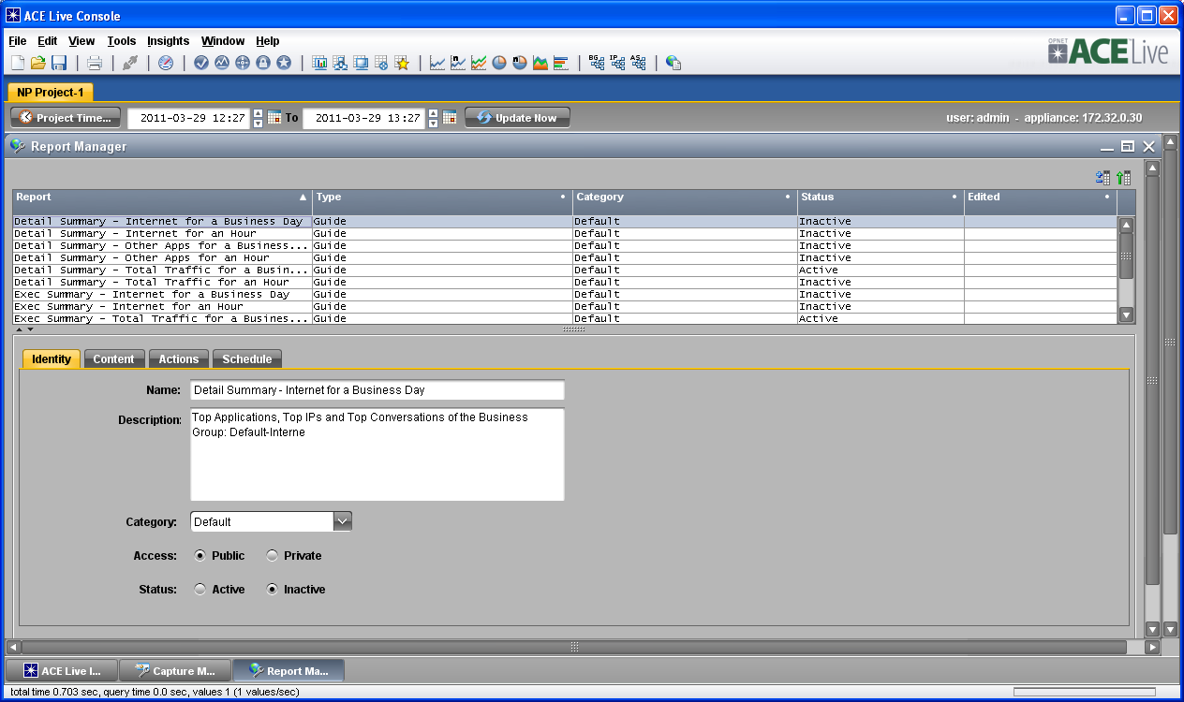

- From the bottom left hand corner select new
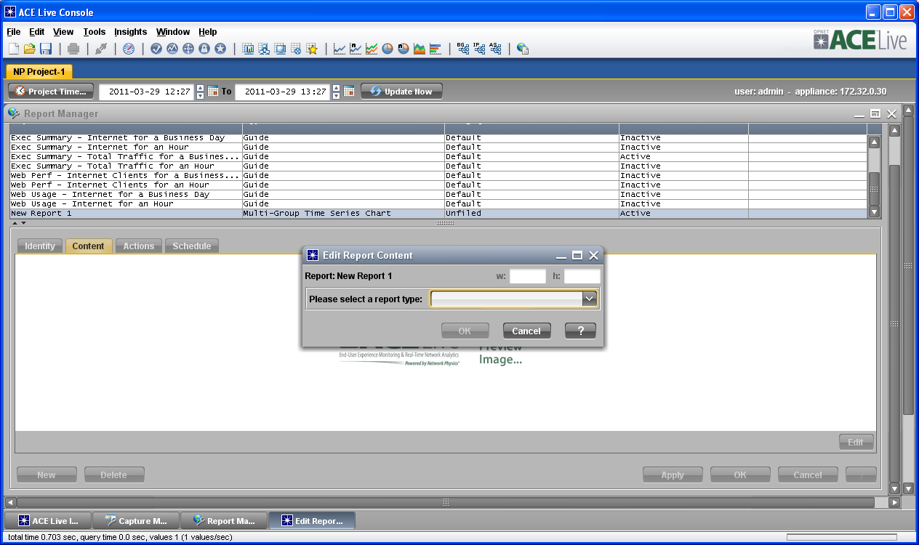

- Select the drop down tab for the type of report you would like to create
- You need to set up the desired action for the report
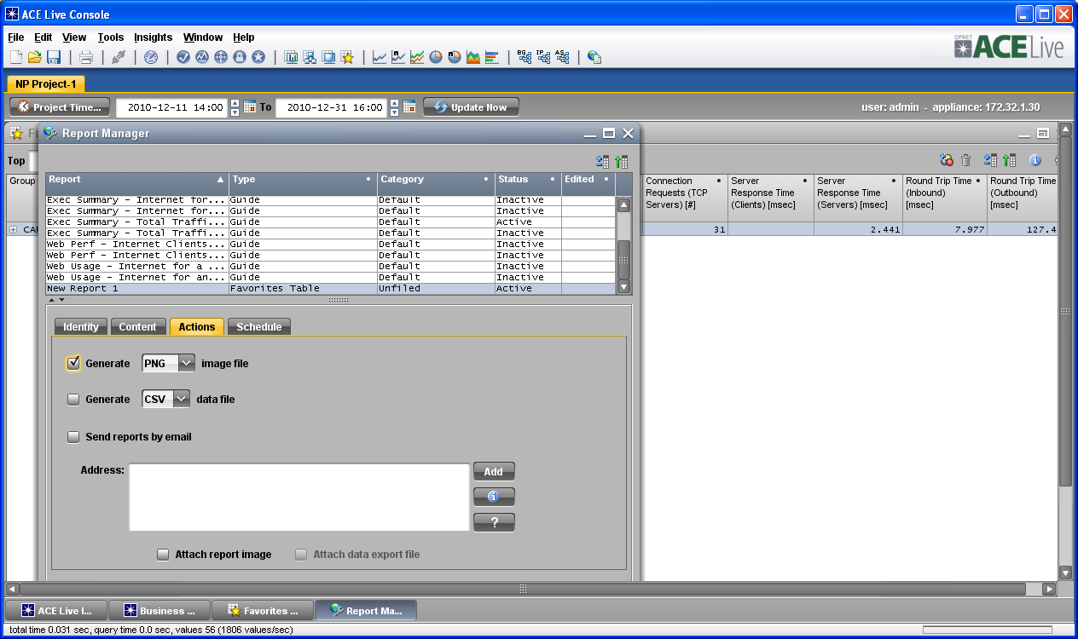

- Next you can set up the schedule:
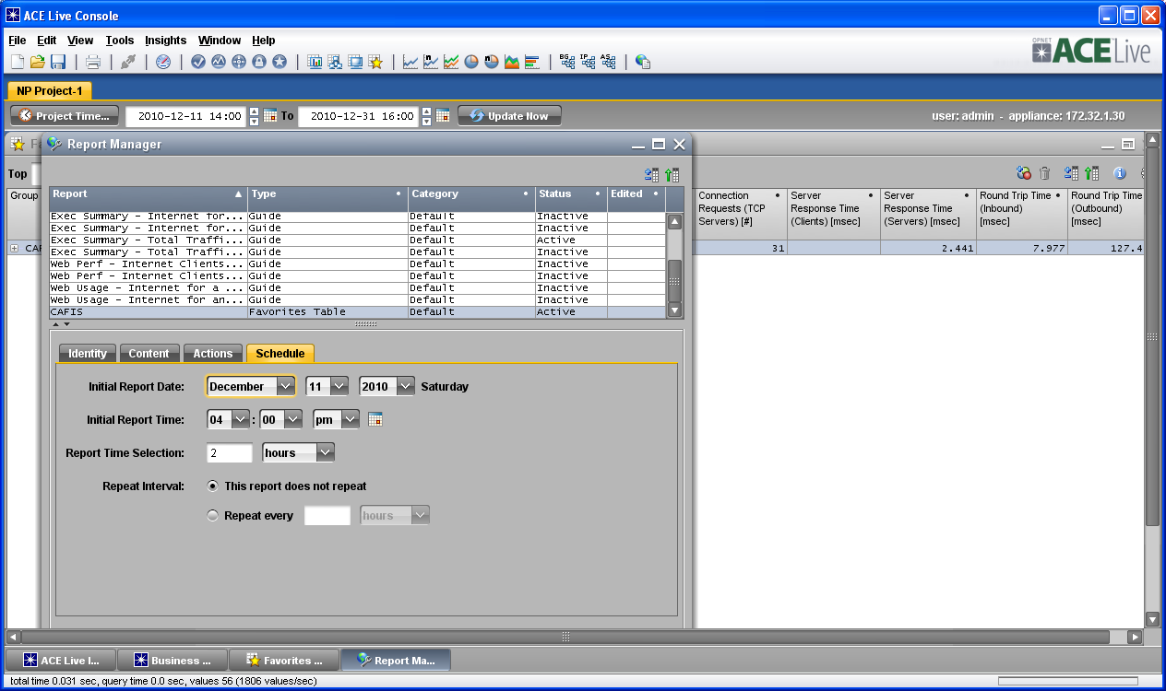
- Select apply and ok:
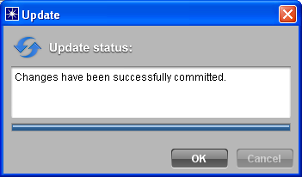
- Once you have finished you should see the report listed in the report manager screen
- There is an alternative way to create reports as well.
- From the favorites table, select a line of interest, right mouse and scroll down to publish
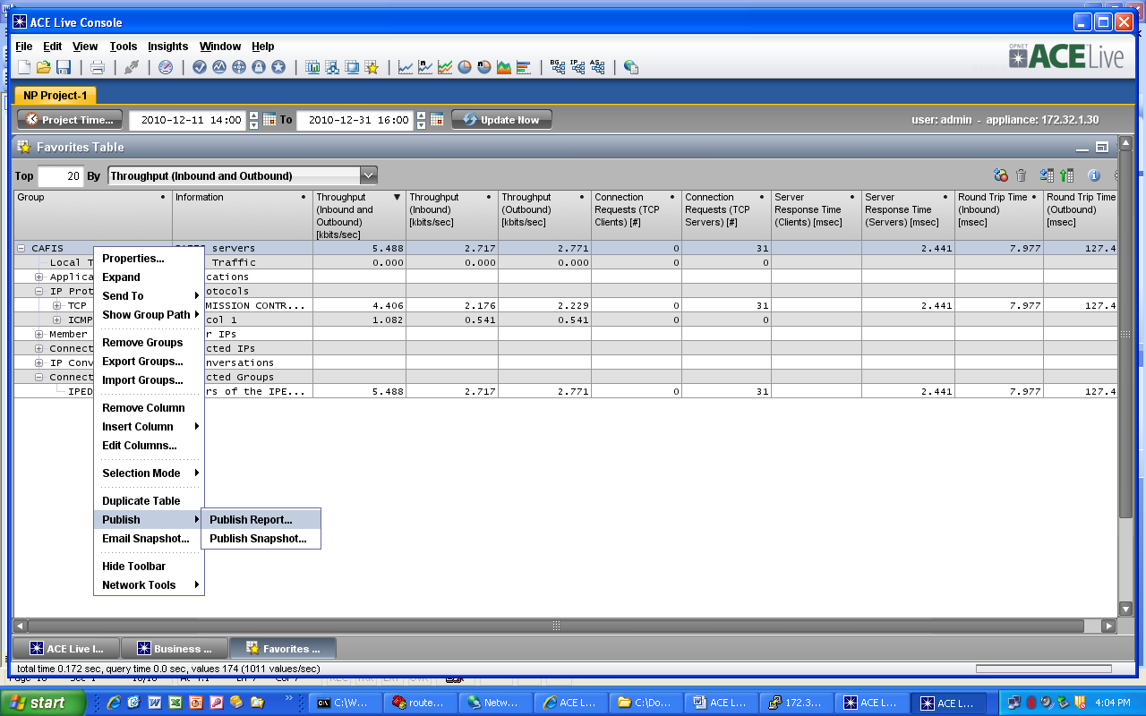

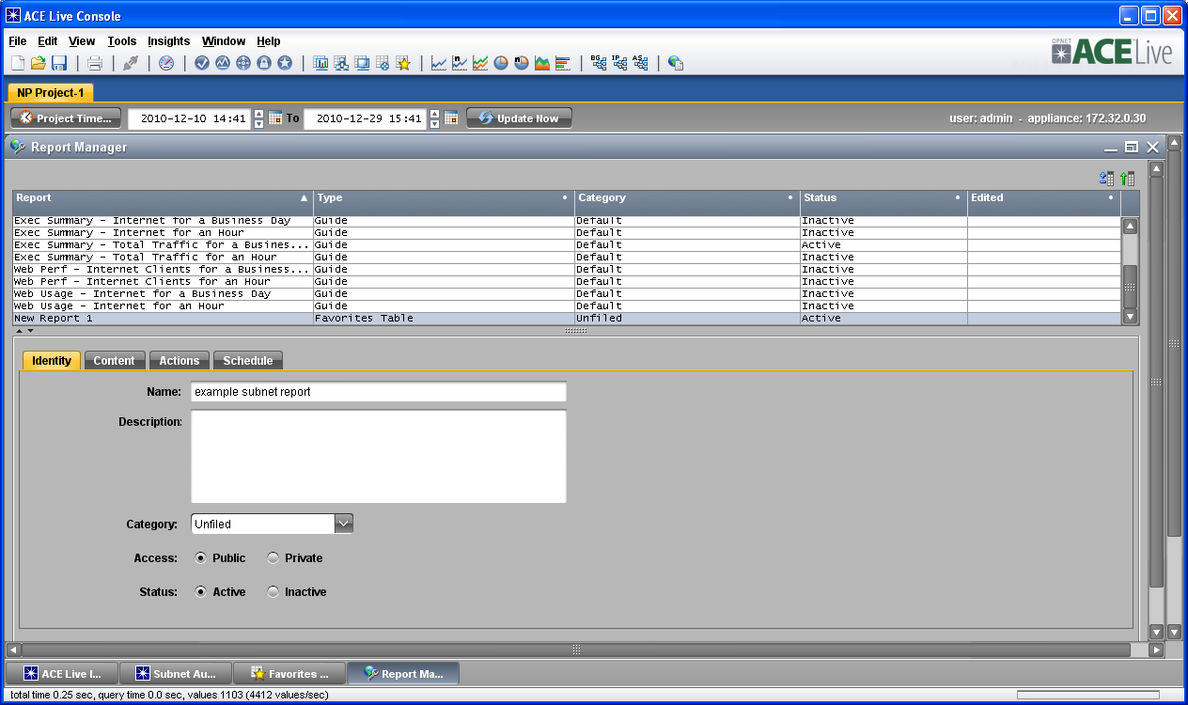

- This brings you to a familiar previous step where you can then finish defining the report with identity, content, actions, and schedule.
- Once you have the reports defined and made active in report manager, the appliance begins creating the reports.
Note: Reports can only be viewed from the time created and forward; you can’t go back in time.
- In the next section Ace Live Operational Workflows, we will examine how to
Verify that our defined reports are working.

