Ace Live Operational Workflow

In this workflow we will verify that our reports and captures are working as we defined them in the pre-deployment workflow.

- We will need to connect to the field appliance via the web browser.
- Open up a browser to http://x.x.x.x:8080 and login
You should see:
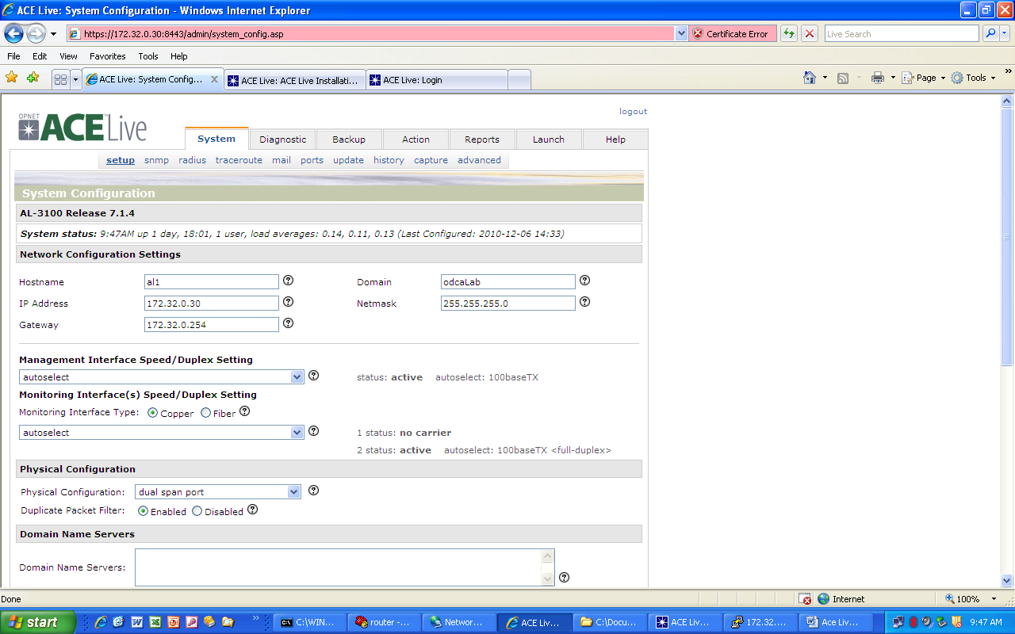
- Select the Reports tab and you will see a display of the created reports:
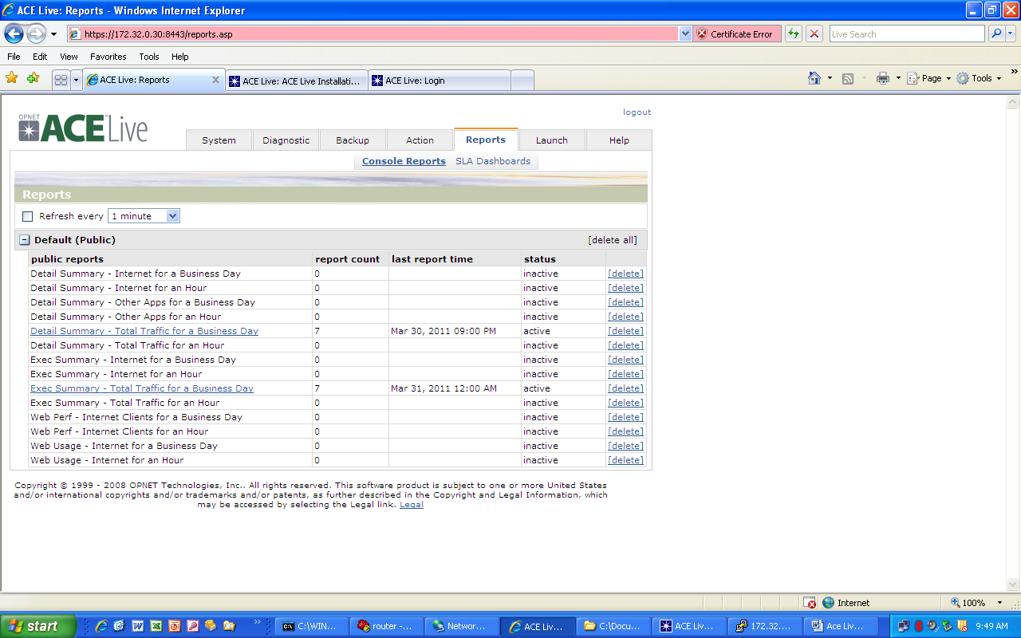
- You should see the reports you created and the last report time, active, and how many have been created so far
.
Note: Remember they will only be from the time the appliance comes online forward; nothing in the past

- You may want to drill down and see if they look the way you want them to and are capturing the data you anticipated.
- If necessary you can go back into the java GUI and make the appropriate adjustments.

I n this section, we want to verify that our captures are working as we defined them in our pre-deployment workflow.
1. We will need to login to the java GUI:

2. From the web interface select launch> ace live console>
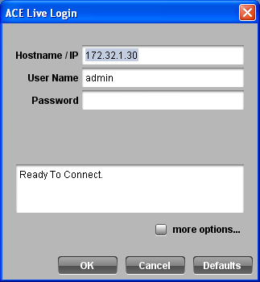

3. Here you will put in the correct appliance ip address and login credentials.
4. Once you are in select Tools> Capture Manager>
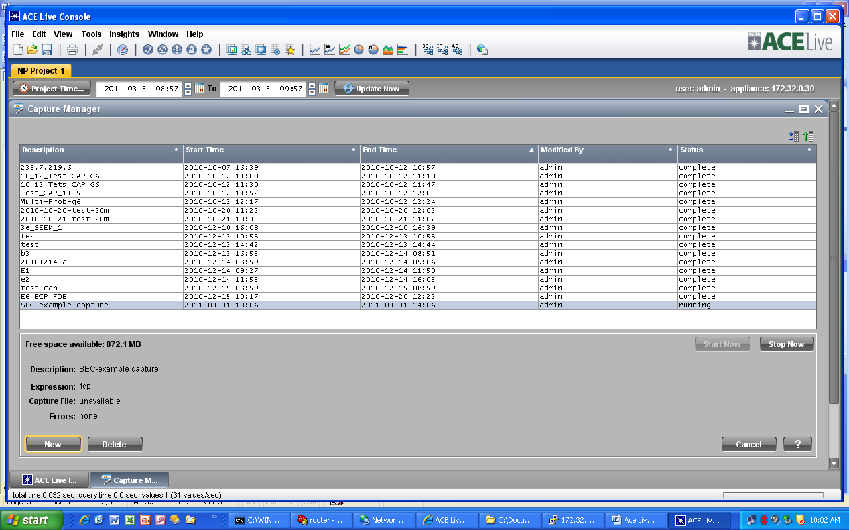

5. Depending on how long the appliance has been online, and how long the capture has been set to run for determines the status shown.
In the above picture all the captures are showing complete except the last one I created “SEC-example capture” This particular one shows that it is running
- From here your appliance should be collecting the data you setup in the pre-deployment workflow.
- As you did in the prior procedure make any adjustments you think are necessary

