Missouri university of science & technology
Using Neural Networks to Predict Telephone Marketing
Final Report
Prepared for Dr Singh
Systems Engineering 378
Bennie Blunt, Jr
12/3/2012

Table of Contents
1.0 Introduction 3
2.0 Problem Statement 3
2.0 Methodology 5
3.0 Results and Discussion 5
5.0 Conclusions 8
6.0 References 9

Introduction
The project is based on a paper written on a direct marketing campaign and a methodology titled CRoss Industry Standard Process for Data Mining (CRISP-DM). CRISP-DM is a popular data mining methodology that supposes increase to the success of direct marketing campaigns. Two of the common metrics used are the confusion matrix and the receiver operating curve (ROC). [3] The campaign was based on a Portuguese bank's marketing data. The goal was to determine the criteria for a successful marketing campaign to determine if contacts would purchase the bank certificate of deposit. In addition to predicting a yes no answer, the authors also used sensitivity analysis to determine the top five input influences. [1] This paper and experiment in particular is focused on predicting the success of the respondents based on the input characteristics.

2.0 Problem Statement
The purpose of the experiment is to analyze data set from the University of California, Irvine Machine Learning Repository. [4] The data set consists of two sets of data bank and bank_full. They are 4.521 records and 45,521 records respectively. The expected outcome is to predict the total number of yes responses from the larger record set. Below is a sample of the characteristics of the client data sets.
Table 1 sample 1 of client records
age | job | marital | education | default | balance | housing | loan
58 | management | married | tertiary | no | 2143 | yes | no
44 | technician | single | secondary | no | 29 | yes | no
33 | entrepreneur | married | secondary | no | 2 | yes | yes
47 | blue-collar | married | unknown | no | 1506 | yes | no
33 | unknown | single | unknown | no | 1 | no | no
35 | management | married | tertiary | no | 231 | yes | no
28 | management | single | tertiary | no | 447 | yes | yes
42 | entrepreneur | divorced | tertiary | yes | 2 | yes | no
58 | retired | married | primary | no | 121 | yes | no
43 | technician | single | secondary | no | 593 | yes | no
41 | admin. | divorced | secondary | no | 270 | yes | no
29 | admin. | single | secondary | no | 390 | yes | no
53 | technician | married | secondary | no | 6 | yes | no
58 | technician | married | unknown | no | 71 | yes | no
57 | services | married | secondary | no | 162 | yes | no
51 | retired | married | primary | no | 229 | yes | no

Table 2 sample 2 of client records
contact | day | month | duration | campaign | pdays | previous | poutcome | y
unknown | 5 | may | 261 | 1 | -1 | 0 | unknown | no
unknown | 5 | may | 151 | 1 | -1 | 0 | unknown | no
unknown | 5 | may | 76 | 1 | -1 | 0 | unknown | no
unknown | 5 | may | 92 | 1 | -1 | 0 | unknown | no
unknown | 5 | may | 198 | 1 | -1 | 0 | unknown | no
unknown | 5 | may | 139 | 1 | -1 | 0 | unknown | no
unknown | 5 | may | 217 | 1 | -1 | 0 | unknown | no
unknown | 5 | may | 380 | 1 | -1 | 0 | unknown | no
unknown | 5 | may | 50 | 1 | -1 | 0 | unknown | no
unknown | 5 | may | 55 | 1 | -1 | 0 | unknown | no
unknown | 5 | may | 222 | 1 | -1 | 0 | unknown | no
unknown | 5 | may | 137 | 1 | -1 | 0 | unknown | no
unknown | 5 | may | 517 | 1 | -1 | 0 | unknown | no
unknown | 5 | may | 71 | 1 | -1 | 0 | unknown | no
unknown | 5 | may | 174 | 1 | -1 | 0 | unknown | no
unknown | 5 | may | 353 | 1 | -1 | 0 | unknown | no

Each client record contained elements such as age, sex, marital status, occupation, and several others. There are seventeen elements total in each record. The responses varied depending on the particular client. There are 38 possible answers across the seventeen elements. The last column, marked y, contains a yes or no. The smaller data set had answers for this column.
The data sets were mixed with character and numerical data. The character data had to be converted to numerical values for processing purposes.

Methodology
The original goal was to apply two separate training algorithms to the data sets and compare their accuracy. The first experiment consisted of applying the feedforward and radial basis algorithms to the data sets. The feed forward network processed the data very fast, but never achieved accuracy beyond 51%. The radial basis function, newrb, required over 24 hours of training on the training data set. It created 4,521 neurons; it created one for each input record. It never got the gradient descent lower than .21. Based on the amount of time it took just for the training data set, it was decided to not process the full data set of 45,521 records.
The second approach was to try the patternet algorithm, but I was unsure of its use. It was recommended by Dr Singh, and subsequently achieved much better results, which are discussed in the next section.
The data preprocessing consisted of removing some unwanted characters and placing the record elements into individual cells. This enabled them to put into vector inputs more easily. All of the character data was converted to binary values with only one bit set. The decimal numerical values were left in decimal. The smaller data set (4.521 records) used the default training/testing/validation of 70%/15%/15%. All data sets were processed with the neural network tool box. [5]
I decided to use four different training algorithms traingdm (Gradient Descent with Momentum), trainlm (Levenberg-Marquardt), trainbr (Bayesian Regularization), and trainscg (scaled conjugate gradient).
The goal was to compare the accuracy of the four training algorithms in classifying the data sets. Each method was applied to the exact same data sets one at a time. The final output vector values were rounded to ones and zeros for a positive (yes) or negative (no) answer respectively.

Results and Discussion

Table 3 Results of the used algorithms
Patternnet: | Traingdm | Trainlm | trainbr | trainscg
Number of neurons | 20 | 20 | 20 | 20
epochs | 2000 | 76 | 2000 | 335
accuracy | 88.4% | 91.4 | 97.5% | 91%
Yes versus no | 3571/41,640 | 118/45,093 | 33,895/11,316 | 33176/12,035

The above table, table 3, shows the results of three training algorithms used on the data sets. The Bayesian regularization training algorithm indicated the most accuracy at 97.5% and it predicted the most positive (yes) answers at 33,895. The lowest predictor was the Levenberg-Marquardt algorithm with 88.4% accuracy and 3,571 positive answers. The large difference in positive values for the output responses elicits some questions about the results. In addition, all the tabular results were taken from the confusion matrices and an output data spreadsheet.

Below are the results of the confusion matrices for each training algorithm used:

Figure 1 Bayesian regularization (trainbr)
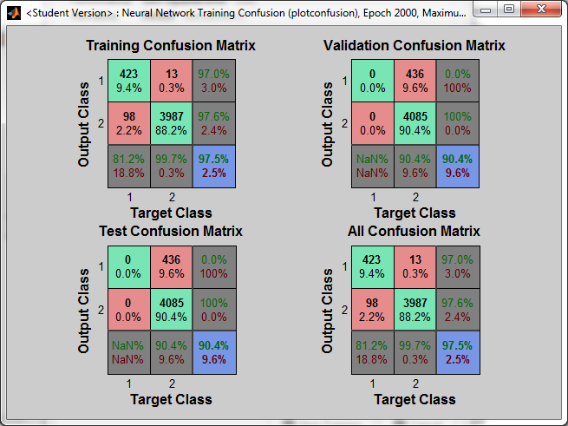
Figure 2 Levenberg-Marquist (trainlm)
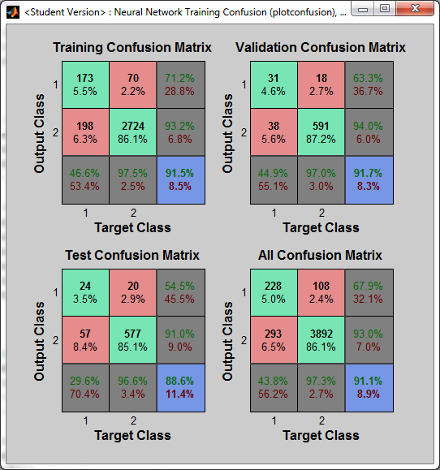

Figure 3 Gradient descent with momentum (traingdm)
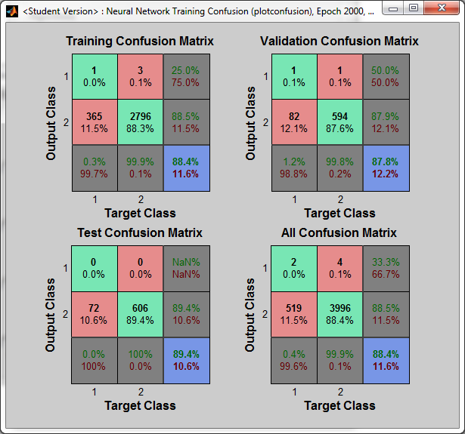

Figure 4 scaled conjugate gradient (trainscg)
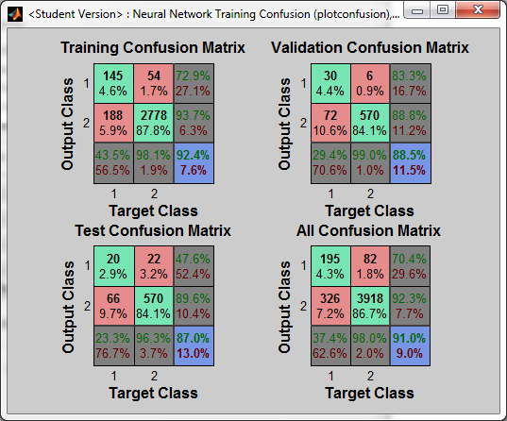

After comparing the results between the different training algorithms, I decided to try and determine why there was such a large difference in the amount of positive (yes) values. The experiments used all of the default bias and weight values generated by the NN toolbox. According to the neural network toolbox user guide purelin is the default output transfer function. Another area considered was the rounding of the output vector. The round function from matlab was used on all experiments.

5.0 Conclusions
Although the network performance was almost 90% in each of the four training algorithms, it is unclear why there is such a large difference in the number of yes responses. That is an area that requires more experimentation possibly with metrics. One method that was tried is increasing the number of neurons. The neurons were increased to 400 with the trainlm algorithm to see if it made a difference in the number of yes responses.
In order for these experiments to be used for business intelligence, it would require much more work. There is definite value in neural networks for application in other areas of engineering and science. One area I would like to experiment with is using neural networks in my MANET routing research for the Army's tactical networks.

6.0 References

- Moro, Sérgio, Raul Laureano, and Paulo Cortez. "Using data mining for bank direct marketing: an application of the CRISP-DM methodology." (2011).
- Beale, Mark, and Howard Demuth. "Neural network toolbox." For Use with MATLAB, User's Guide, The Math Works, Natick (1998).
- Chapman, Pete, et al. "CRISP-DM 1.0 Step-by-step data mining guide." (2000).
- Frank, A. & Asuncion, A. (2010). UCI Machine Learning Repository [http://archive.ics.uci.edu/ml]. Irvine, CA: University of California, School of Information and Computer Science.
- © 1994-2012 The MathWorks, Inc

