Technical Standard Operating Procedures (SOPs) for Capture Viewer in support of ADCCP



Version 1.0
5 June 2012

CECOM-SEC/RDECOM-CERDEC
Discovery Team

Bennie Blunt, Jr (Bennie.Blunt.civ@mail.mil)
Thomas Trinh (thomas.t.trinh.civ@mail.mil)

History of Changes
Version # | Change # | Date | Changed By | Change Descriptions/Remarks
1.0 | 1 | 5 June 2012 | Bennie Blunt, Jr | Initial Document.

Overview
This document provides detailed step by step procedures to run Opnet’s capture viewer tool for downloading packet captures from Application Response Xpert (ARX) 4100 appliances to obtain server information.
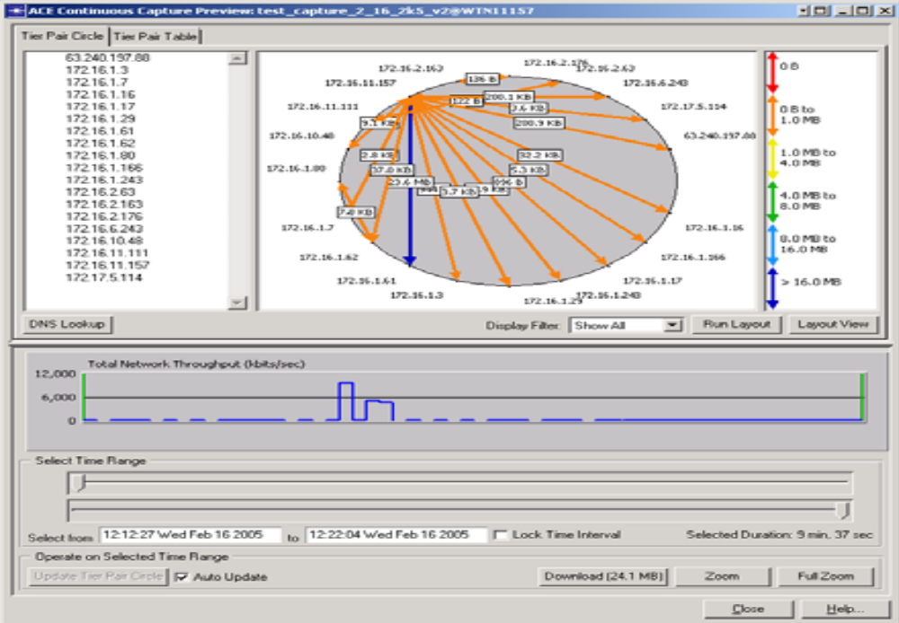
User will need to have a valid Opnet support account with maintenance and an established login id . Where to download: https://enterprise1.opnet.com/support/product/alcv/146PL3
Capture viewer user guide: https://enterprise1.opnet.com/tsts/Lic_Priv/support/updates/alcv/ALCV.pdf

Once capture viewer has been downloaded, it will be needed to be unzipped and installed on the computer with ip connectivity to the appliance or appliances desired to download packet data. It is most simple to accept all the defaults during the installation.
This section provides detailed steps for capture viewer use.
- Start the capture viewer GUI by going to the start>programs>Opnet capture viewer
You should see below window: The first time you launch the GUI, there will be no appliances in the view
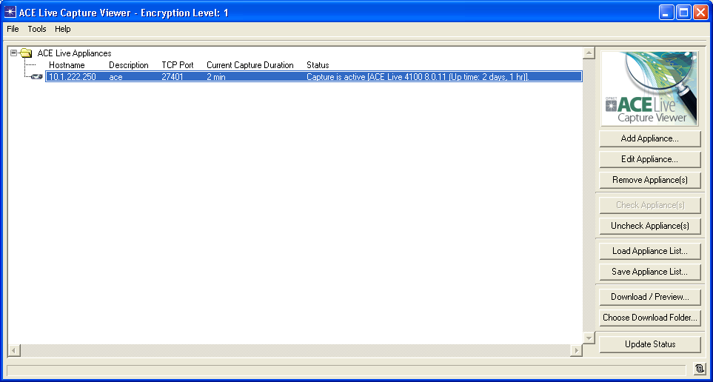

- Select add appliance:
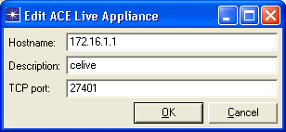

- Type ip address of appliance you are adding
- tcp port is auto populated as 27401
- description can be anything
- select okay
- The appliance should appear under ACE Live Appliance in the GUI
- Next you want to select Choose download folder on the right hand side of the
This will allow you to select the desired directory to store the packet captures on
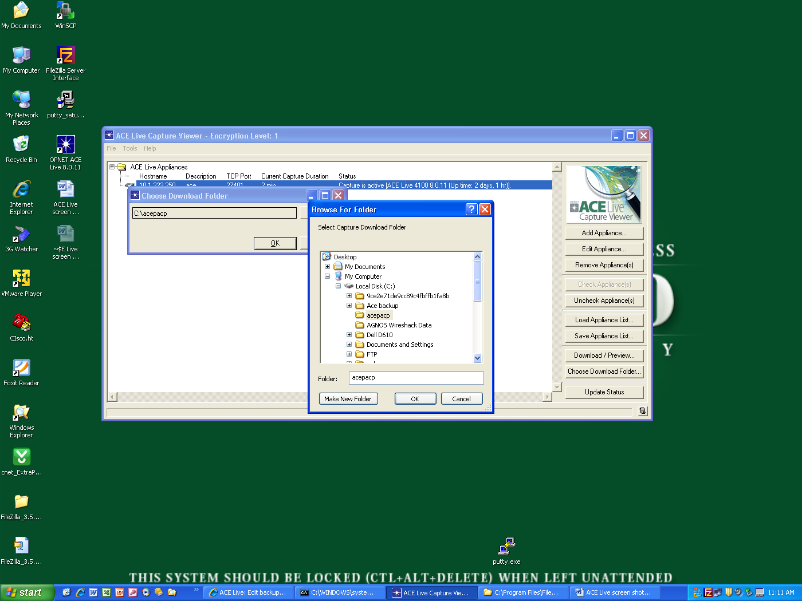
- Highlight the appliance just added
- On the right hand side of the GUI select: Download/preview
You should see a screen that allows you to select and filter the packet capture data by date and time.
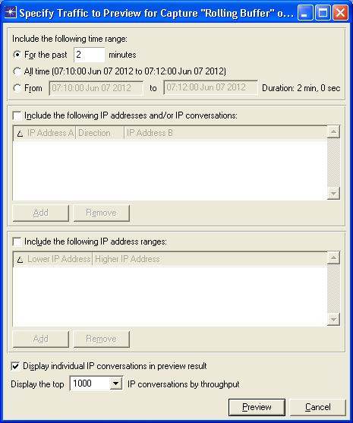

- Once you have selected the time range, ip address filters or ranges of ip addresses, select preview
You will see the packet data selected and be presented with the option to download it
- The best way to accomplish this task is create smaller chunks that can be easily digested and parsed usually around 2GB max.

