FINAL REPORT

EVALUATION OF THE FEASIBILITY OF

THE NORTHERN LIGHTS EXPRESS

COMMUTER RAIL SYSTEM

UNIVERSITY OF MINNESOTA DULUTH

COMP 3130

David Marcaccini

Ben Boldt

**Table of Contents**

List of Illustrations 3

Executive Summary 4

Introduction 5

Solution Criteria 6

Transit Time 7

Fuel Efficiency 11

Conclusions 13

Recommendations 14

List of References 15

Appendix 16

**List of Illustrations**

Figures:

Figure A. 79 mph Speed/Distance 8

Figure B. 110 mph Speed/Distance 9

Figure C. 125 mph Speed/Distance 10

Figure D. Station Dwell Time 11

Figure E. Total Passenger Miles 12

Figure F. BTUs per Passenger Mile 12

**Executive Summary**

We have conducted a study of the proposed Northern Lights Express rail line. The Northern Lights Express is a train of the future. We think it is important to be as modern as possible. It is not worth spending millions of dollars on technology of the twentieth century for a twenty-first century project.

This study was conducted to investigate the factors that would make this a popular rail line. With more ridership the rail line will prosper to the point that it can be considered a success. Our main points of transit time and fuel efficiency are two factors that will maximize ridership by saving passengers time and money.

For transit time, this study focused on the benefits and shortcomings of three general categories, cruising speed, acceleration, and dwell time. These are three significant factors that contribute to the transit time of a rail line trip. The cruising speed is the top speed of the train. A minimum cruising speed of 110 mph is needed to viably compete with automobiles in terms of transit time. If a full grade separation is installed between the tracks and crossing roads, the trains may be able to achieve cruising speeds of up to 150 mph. This would make the rail line a faster alternative to automobile travel.

Starts and stops along the way will cause the train to have to slow down and speed up over a long distance, thus slowing the average speed of the train. Adding a full grade separation into the tracks would reduce the frequency of these slow-downs since the train would not cross roadways.

An added benefit would be to install special short dwell time entrance ways at the train stations so the passengers could board the trains faster. This would reduce the dwell time that the train has to sit idle at the station while passengers get off and on.

For fuel efficiency, the study is focused on the benefits of using intercity rail over other forms of transportation. Intercity rail uses less energy per passenger-mile at just over 2500 BTUs than automobiles do at approximately 3500 BTUs. More efficient locomotives would add even more benefit to the rail line. Regenerative braking would allow the train to channel its kinetic energy into an electric battery when it breaks to slow down.

These are our recommendations:

1. Build a full grade separation between the tracks and roads and use trains that would travel at cruising speeds of 150 mph. This will allow the train to easily be faster than automobile traffic even though it must make intermediate stops. A fast train will lure more riders.
2. Install trains that use modern technology like regenerative braking and hybrid drive systems. This would make for a modern rail line that could compete on a 21st century level.

With both of these recommendations are combined, an added environmental benefit will be increased. The energy consumption of the train will be divided across more passengers and the carbon footprint of all the riders will be reduced. We recommend that the people of Minnesota install a high speed modern rail line that will benefit everyone.

**Introduction**

**Background**

The cost of oil is rising while the supply is running out. Efficiency and alternative fuels are becoming necessary. Old methods of transportation are not only becoming more expensive, but also more time-consuming as roads become more congested. This is a serious problem that will not correct itself it left alone. Trains offer a feasible alternative to the current, most popular forms of transportation. This can help reduce fuel usage and prolong the life of the finite supply.

**Purpose and Scope**

The Northern Lights Express aims to improve efficiency of transportation to reduce the use of foreign fuels and also reduce emissions. It also provides a safer, arguably faster alternative to other forms of transportation.

We have evaluated the train speed first, as this seemed to be a definite issue. People would be deterred from riding the train if it was considerably slower than other methods available, even if they are at a higher cost. Trains are very massive and have a considerable amount of inertia, so they do not start and stop as quickly as a car or bus. We researched acceleration and deceleration times, and also have plotted the speed over the course of the entire proposed length of rail. To find the total time of the trip, one must simply integrate to find the area beneath this curve.

Next we evaluated train fuel consumption compared to other forms of transportation. Trains are not the most efficient, outdone by vanpools and motorcycles, but it is significantly better than any other form of transportation. Reducing consumption immediately saves money from being spent on foreign fuel, and in the long run, it also helps the environment and the movement toward reduction in overall use of oil.

We also looked into hybrid powered train engines, which increase efficiency even more by reclaiming energy when slowing down. There are also engines capable of running on renewable fuel.

**Methodology**

After choosing to research train speeds and fuel efficiency, we found some reliable sources from which we could pull information. The TEMS report was very useful, providing a lot of information specific to the Northern Lights Express project. We found several other sources that provided other general information about trains. For example, there were documents that detailed fuel consumption of commuter trains compared to other forms of transportation.

We used this information to compare the project to current forms of transportation and see the advantages and disadvantages of each. This allowed us to assess the feasibility of the project.**Organization**

The report is made of two main sections, assessment of train speed and assessment of fuel efficiency.

Train speed consists of point-to-point times of the train compared to other vehicles. It also discusses maximum speed, acceleration, deceleration, and waiting times at each stopping point.

Fuel efficiency consists of comparisons in fuel consumption of the train compared to other vehicles. It also consists of the possibility of a hybrid engine and/or alternative fuels.

**Feasibility of the Northern Lights Express Project**

This section discusses our evaluation criteria, which is the speed and fuel efficiency of the train compared to current forms of transportation.

**The Importance of Speed**

Time is money. People need to get to their destination on a schedule, and it may not be worth it to them to lose time to an alternate form of transportation. Travel speed must be sufficient for many people to even consider changing their current methods of travel. If speed is too slow, more people will continue to pay more to drive their own vehicles even at the greater costs from fuel, maintenance, parking, and any other related expenses.

The success of the Northern Lights Express lies in their ability to demonstrate to potential riders that the speed is sufficient to balance their other associated costs and savings.

**Fuel Efficiency**

The amount of fuel consumed by the train directly affects the cost to ride, which is a major factor in people’s choice to ride. Reducing fuel consumption reduces dependency on foreign oil and also helps the environment by reducing factors that contribute to global warming. Hybrid engines and alternative energies are also discussed.

**Solution Criteria**

We are evaluating the proposed rail line on a basis of overall transit time and fuel efficiency. These are two separate aspects of evaluation but together they carry a significant amount of weight when determining whether or not the train will be successful. For this reason we have decided to focus on these two areas when determining our recommendations.

1. **Transit Time** – constitutes 50% of recommendation.

The train will be competing with other forms of transportation. The main other form of transportation is automobiles. Drivers on I-35 can drive at approximately 70 mph between Duluth and the Twin Cities. They also have the ability to drive directly to their destination without making intermediate stops. If the transit time of the train is too long, many drivers may not consider it worth it to use the rail line. Our analysis will calculate the transit time of the rail, including intermediate stops and extra distance. This will help determine whether or not the proposed rail line is a viable alternative to other modes of transportation.

1. **Fuel Efficiency** – constitutes 50% of recommendation.

Fuel efficiency is an important part of any mode of transportation. Fossil fuels are a limited resource and their price is prone to fluctuation. Travelers are generally concerned with the expense of the fuel it takes to travel. It is good to do more with less. Moving more people with less fuel per person contributes to an overall benefit in fuel consumption. This also reduces the carbon footprint of each person that would’ve otherwise used more fuel by another mode of transportation. A fuel efficient train will greatly contribute to its practicality.

**Transit Time**

There are several components that contribute to transit time. The most obvious attribute is the train cruising speed. This is the maximum speed the train travels at. Another important attribute is acceleration. Trains accelerate and decelerate over a considerably long distance. This reduces the train’s average velocity and plays an important factor in the overall transit time. A third and very important factor in the overall transit time is station dwell time. This is the time that the train sits idle at a station waiting for passengers to get off and on. If there are several intermediate stops on a traveler’s route, their overall transit time will be greatly increased.

1. **Cruising Speed:** The current track system is shared with freight trains and allows passenger trains to travel up to 79 mph. The TEMS report indicates at this speed, the rail line would not be able to compete with automobile travel in terms of speed. Upgrading the rail line to 110 mph would be the minimum speed at which the train could compete with automobiles. Upgrading the rail to 125 mph would create large improvement costs due to FRA regulations requiring a full grade separation of public and private crossings for speeds above 124 mph. A full grade separation would mean that regular roads would have to cross tracks either by bridging over or tunneling under. If the extra price is paid to install full grade separation, it would be sensible to upgrade to 150 mph which is the fastest speed achievable by diesel locomotives. 110 mph seems to be the optimal speed after all the trade-offs are weighed.
2. **Acceleration:** Different trains also have different acceleration rates. It takes several miles for certain trains get up to top speed. These factors were used to determine that a 125 mph train would only be on average 10 minutes faster than a 110 mph train. To maximize ridership, several trains need to be running each day. A frequency of 4 trains per day is optimal for 79mph track. The TEMS report indicates that 79 mph track is only competitive with automobiles for stops located off of the I-35 corridor such as Minneapolis to Cambridge. Train frequencies of 4 to 8 trains per day are optimal for 110 mph to 125 mph track. If the track is capable of handling 110 mph trains, locomotives that are able to perform at that speed will need to be used. It is also necessary to increase the number of trains as not to have too much unused empty track.

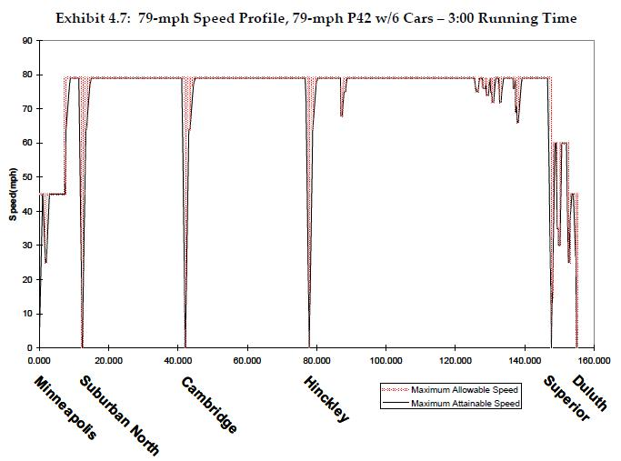

Figure A – 79 mph Speed/Distance – (TEMS, Inc. SRF Consulting Group Inc. 2007)

The above graph shows the train speeds over the entire distance of the rail line for a 79 mph train. One can easily observe that in areas near the endpoints of Duluth and the Twin Cities, the train does not even achieve top speed. There are also several intermediate stops as well as points along the line where the train must slow from its cruising speed. All these slow-downs increase the overall transit time of a trip.

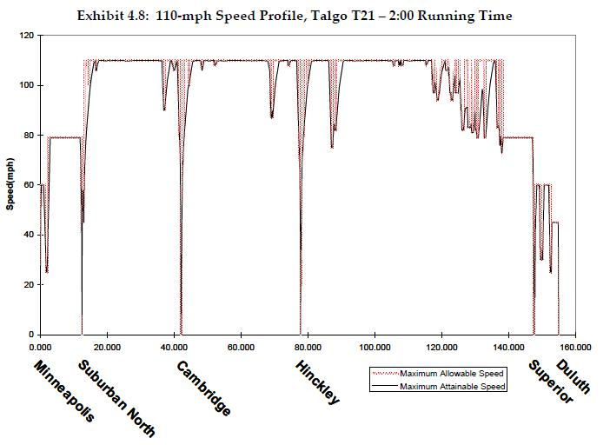

Figure B – 110 mph Speed/Distance – (TEMS, Inc. SRF Consulting Group Inc. 2007)

In the above graph, a 110 mph train is charted against distance. Like the previous graph, there are only a few points along the route where the train is at full speed. In this case, there are even less full speed miles. This is due to the fact that even a short distance with a limitation on speed causes the train to have to decelerate over a long distance and accelerate over an even longer distance. With all these fluctuations in speed, the average speed of the train is considerably lower than the top speed listed for the rail line. The changes in speed also tend to cause passenger discomfort due to the forces required in changing the massive train’s velocity.

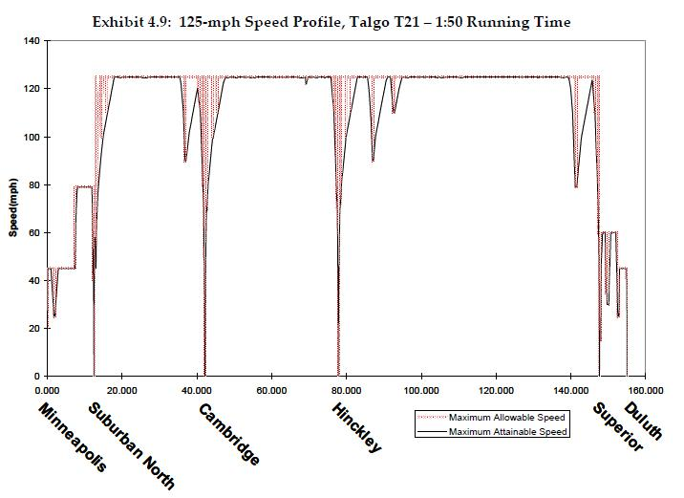

Figure C – 125 mph Speed/Distance – (TEMS, Inc. SRF Consulting Group Inc. 2007)

The graph above charts the speed of a 125 mph train against the distance of its route. In this case, due to the full grade separation of the tracks, the train is able to cruise at its top speed over more miles of the route. However, there are many costs involved with installing the full grade of separation which would not necessarily make it a feasible option.

1. **Station Dwell Time:** Each time the train stops at a station, it must wait for passengers to get on and off. For safety reasons, this process cannot be rushed too much. Short dwell time entrance ways are special train entry and exit systems that allow for faster boarding. There is an extra cost associated with these entrance ways and several stations may need to be upgraded to be compatible with them. A diesel train using a 1.25 mile stop distance would have a time savings of 5.4% if special short dwell time entrance ways were installed. This calculation is for a 20 mile trip; however it could be extrapolated out for a longer trip. The percent savings would decrease because the dwell time would represent a smaller fraction of the overall travel time. Having several stops along its route, the Northern Lights Express needs to start and stop. Slowing to a stop over a several mile distance decreases the average speed of the train. A train on a 20 mile run uses only is at top speed for about half the total travel time. This percentage would increase over a longer distance however.

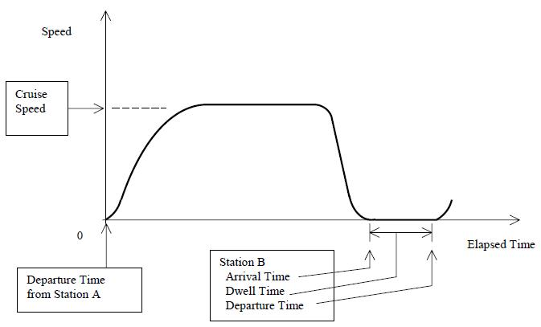

Figure D – Station Dwell Time– (Edward K. Morlok and Bradley F. Nitzberg, 2003)

The graph above shows that the station dwell time accounts for approximately one third of the overall transit time for a twenty mile trip. The route from Minneapolis to Cambridge is approximately 40 miles. The train will therefore spend about 20% of its trip at the station. The Northern Lights Express has at least six stops. Each of these stops will contribute to an extended transit time. When compared to an automobile that can drive non-stop to its destination, a train with several stops will be at a disadvantage.

**Fuel Efficiency**

Global warming and diminishing supplies of non-renewable energy are beginning to become a real problem in the world. The demand for fossil fuels is increasing as the supply continues to decline. The Northern Lights Express project is a design of the future, intended to be a long-term financial and ecological solution to these problems. It is imperative for us to be concerned with reducing fuel consumption and emissions.

Passenger trains consume an average of 2.43 gallons per mile. This immediately seems to be a *bad* alternative to personal cars and trucks; many are known for getting 30 or more miles per gallon. We must remember that many passengers can ride in a single train. The US department of energy has released some numbers concerning the comparison on a per-passenger basis. Here is a table that gives a perspective of how many passengers ride in each form of transportation.

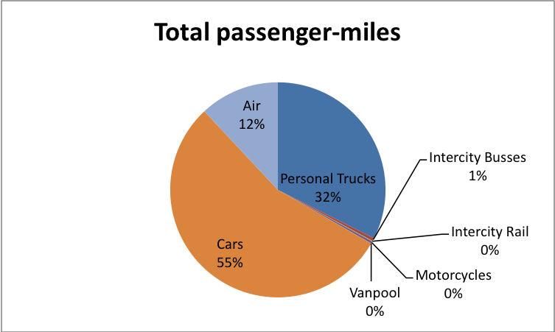

Figure E. – Total Passenger Miles – (U.S. Department of Energy 2008)

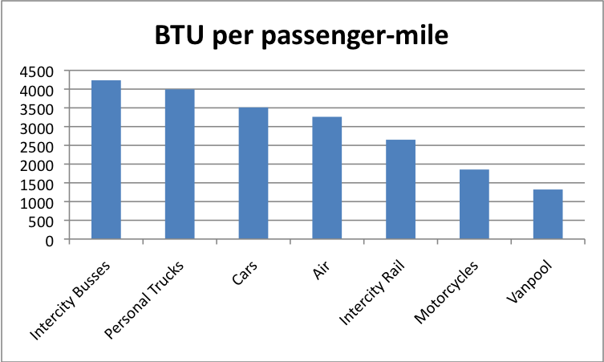

Figure F. - BTUs per Passenger Mile – (U.S. Department of Energy 2008)

BTU per passenger-mile is when you take the average total number of BTUs consumed by a type of vehicle and divide it by the average number of passengers at any given time. This gives you the average BTUs consumed by each passenger.

We can notice two important things right away about these two charts. Personal cars, trucks, and air travel are overwhelmingly the most popular forms of transportation. Intercity rail, intercity busses, motorcycles and vanpool are used by less than 1% of people. We also see that these three also happen to be the most efficient forms of transportation. The primary goal of the Northern Lights Express project is to shift people from less efficient forms of transportation into the intercity rail form of transportation. This will reduce pollution, fuel consumption, and dependence on foreign oil. It will offer a cost-effective, safer alternative to people who may otherwise not be able to commute. Even though intercity rail is not the most efficient form of transportation available, beaten by both motorcycles and vanpools, it provides the most stable alternative to the more common transportation methods. The savings in fuel and no need to invest in a vehicle make the switch desirable to potential riders.

Alternative energy is also a consideration for the train in an attempt to shift toward renewable fuels, or at least reduce consumption of non-renewable fuels. Hybrid trains and other vehicles have been very successful in Japan by reducing fuel consumption and emissions. These savings have proven to be greater than the initial cost after some amount of time, which varies between vehicles. Applying hybrid power to trains is expected to result in similar savings. Trains have been built in Japan and the engines have proven to cost twice as much as a standard train engine at $1.7 million. The savings in fuel is what directly affects the cost of operation due to efficiency. Over time, this savings will pay for the investment in technology and even beyond. We are reducing our effect on the environment and ultimately becoming more cost-effective at the same time.

**Conclusion**

For this study of the proposed Northern Lights Express rail line, we focused on two important points. These were transit time and fuel efficiency. Each of these points comprised 50% of the final recommendation.

The total recommendation was calculated using the following formula:

*Recommendation (out of 100%) = Transit Time Score (out of 100) x 50% + Fuel Efficiency Score (out of 100) x 50%*

We will not assign a meaning to the value calculated with this formula. Instead we will make our recommendation in a manner seeking to maximize this number.

For transit time, this study focused on the benefits and shortcomings of three general categories, cruising speed, acceleration, and dwell time. These are three significant factors that contribute to the transit time of a rail line trip.

The transit time score shall be awarded 80 points if:

* A full grade separation is made to allow for train speeds up to 150 mph.

The score shall be awarded 60 points if:

* The tracks are upgraded to allow for train speeds up to 110 mph.

The score shall be awarded 40 points if:

* The tracks only allow train speeds of 79 mph

An additional 20 points will be awarded to the score if:

* Special short dwell time entrance ways are installed at all of the train stops.

For fuel efficiency, the study is focused on the benefits of using intercity rail over other forms of transportation. We will automatically award the fuel efficiency score 50 points based on the fact that intercity rail uses less energy per passenger-mile than automobiles do. The other 50 points will be awarded on a basis of the efficiency of the train itself. 25 points will be given for an upgraded diesel locomotive. 50 points will be given if the locomotive uses some additional form of energy conservation such as regenerative braking and hybrid power. Regenerative braking would allow the train to channel its kinetic energy into an electric battery when it breaks to slow down.

The Northern Lights Express is a train of the future. We think it is important to be as modern as possible. It is not worth spending millions of dollars on technology of the twentieth century for a twenty-first century project.

**Recommendations**

The Northern Lights Express is a rail line that would serve the state of Minnesota for many years to come. It would cost millions of dollars to install. We conducted this study to investigate the factors that would make this a popular rail line. With more ridership the rail line will prosper to the point that it can be considered a success. Our main points of transit time and fuel efficiency are two factors that will maximize ridership by saving passengers time and money. If the taxpayers of this state are going to invest the money to build this massive project, they should in return save when they ride the line. These are our recommendations:

1. Build a full grade separation between the tracks and roads and use trains that would travel at cruising speeds of 150 mph. This will allow the train to easily be faster than automobile traffic even though it must make intermediate stops. A fast train will lure more riders.
2. Install trains that use modern technology like regenerative braking and hybrid drive systems. This would make for a modern rail line that could compete on a 21st century level.

With both of these recommendations are combined, an added environmental benefit will be increased. The energy consumption of the train will be divided across more passengers and the carbon footprint of all the riders will be reduced.

We do not recommend that a 79 mph train be built that uses old technology. We realize it will cost more initially to install our recommendations, but it will be worth it since the train will run for many years. A rail line that uses old technology will still sink many dollars in development but will not give us the benefits that a modern train would. It would be better not to build any line at all than to invest in a substandard line that is not modern. We recommend that the people of Minnesota install a high speed modern rail line that will benefit everyone.

**References**

[1] Transportation Economics & Management Systems, Inc., *Restoration of Intercity Passenger Rail Service in the Minneapolis-Duluth/Superior Corridor* *Chapters 1&2,* 2007.[Online] Available: http://www.northernlightsexpress.org/joomla/images/documents/TEMS_C_1_2.pdf

[2] Transportation Economics & Management Systems, Inc., *Restoration of Intercity Passenger Rail Service in the Minneapolis-Duluth/Superior Corridor* *Chapters 4-10,* 2007.[Online] Available: http://www.northernlightsexpress.org/joomla/images/documents/TEMS_C_4_10.pdf

[3] Edward K. Morlok and Bradley F. Nitzberg, *Speeding up Commuter Rail Service: Comparative Actual Performance of Different Train and Station Platform Designs* , 2003. [Online] Available: http://www.seas.upenn.edu/~morlok/morlokpage/SpeedPaper.pdf

[4] Y. Kageyama, *Japan hybrid train fights global warming*, Jul. 29, 2007. [Online]. Available: http://www.hybrid-rental-car.com/japan-hybrid-train-fights-global-warming/42. [Accessed: Mar. 5, 2009].

[5] Transportation Economics & Management Systems, Inc., *Restoration of Intercity Passenger Rail Service: Comprehensive Feasibility Study and Business Plan*, Dec. 2007, pg. 5-4. [Online]. Available: http://www.northernlightsexpress.org/. [Accessed: Mar. 5, 2009].

[6] U.S. Department of Energy, “Energy,” in *Transportation Energy Data Book*, 27th ed., 2008. [Online]. Available: http://cta.ornl.gov/data/tedb27/Edition27_Chapter02.pdf. [Accessed: Mar. 5, 2009].

**Appendix**

This is the table we used to generate figures E and F.

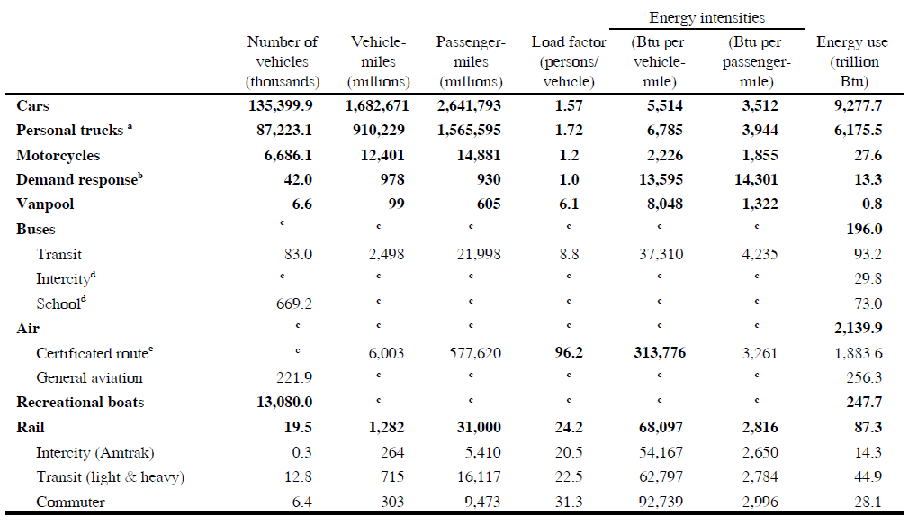

Reference: – (U.S. Department of Energy 2008)