Abstract
Forecasting the future of kelp forests requires models that can capture complex, nonlinear relationships between biological and physical drivers, particularly with large geographic extent. Using dynamically downscaled Earth System Models (ESMs), we forecasted giant kelp abundance to 2100 using boosted regression trees (BRTs) and generalized additive mixed models (GAMs), comparing their ability to predict giant kelp abundance on the Channel Islands to 2100 using six drivers: along and cross shore wind stress, nitrate, depth, urchin density, and temperature. The two methods converged on spatial patterns, identifying hotspots of likely kelp persistence, but diverged on the magnitude and timing of responses. The difference is represented best by the difference in how each model creates the relationship between kelp abundance and the drivers. Our findings show that projections of kelp persistence and loss are highly sensitive to the modelling framework employed, with each model holding particular strengths. The comparison of both models allows cross-validation for the reasonableness of the relationships between drivers and kelps, with agreement between the models strengthening model confidence.

BRT
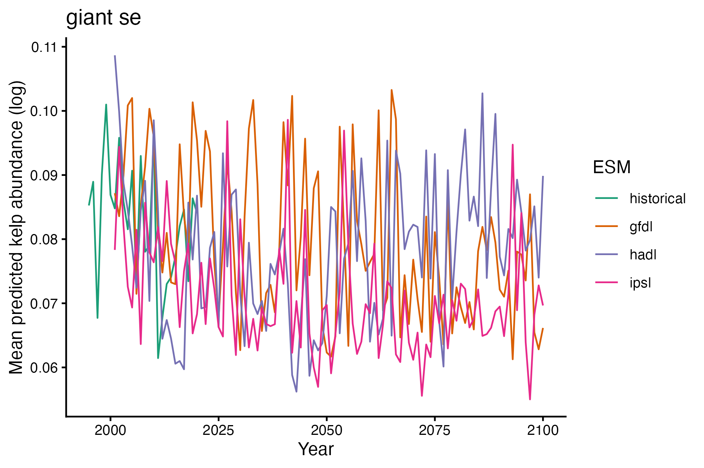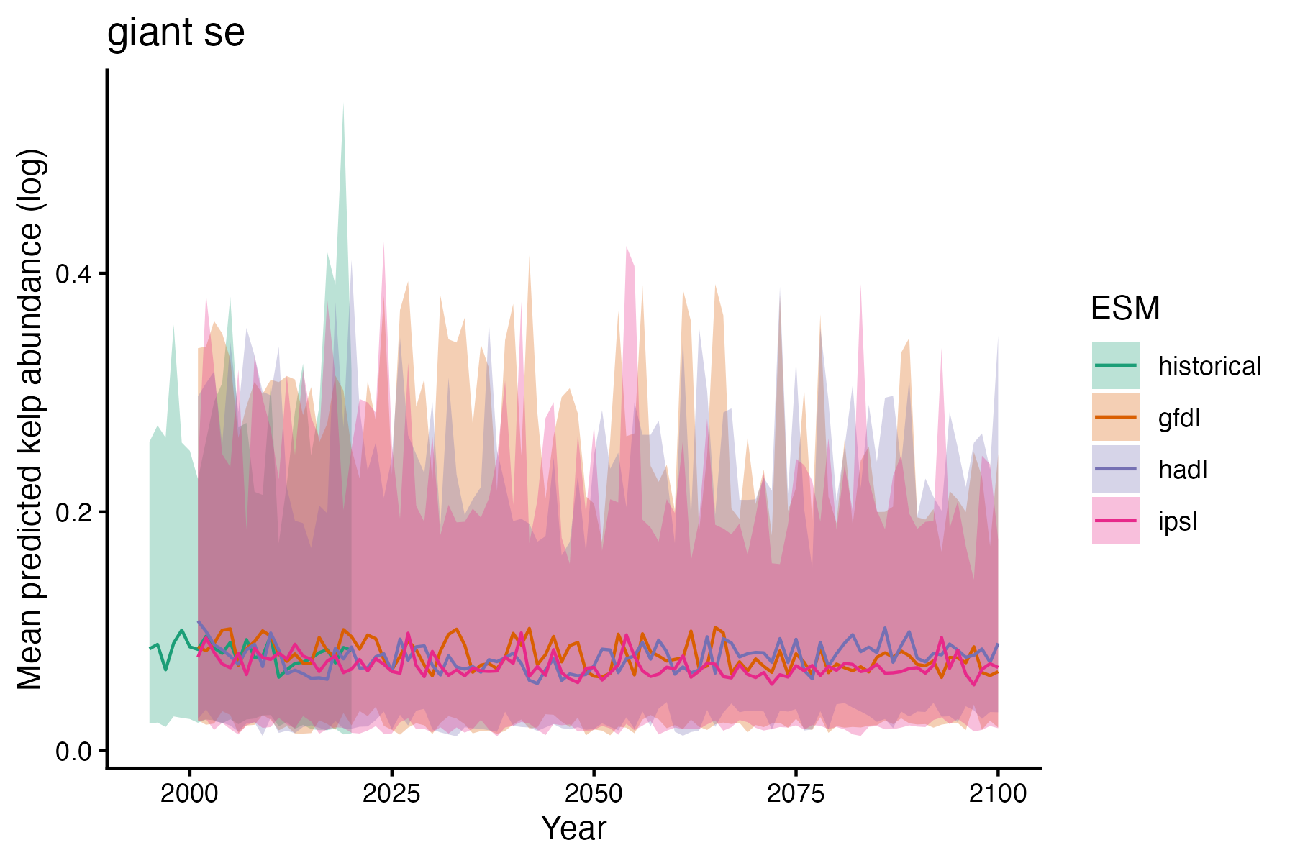
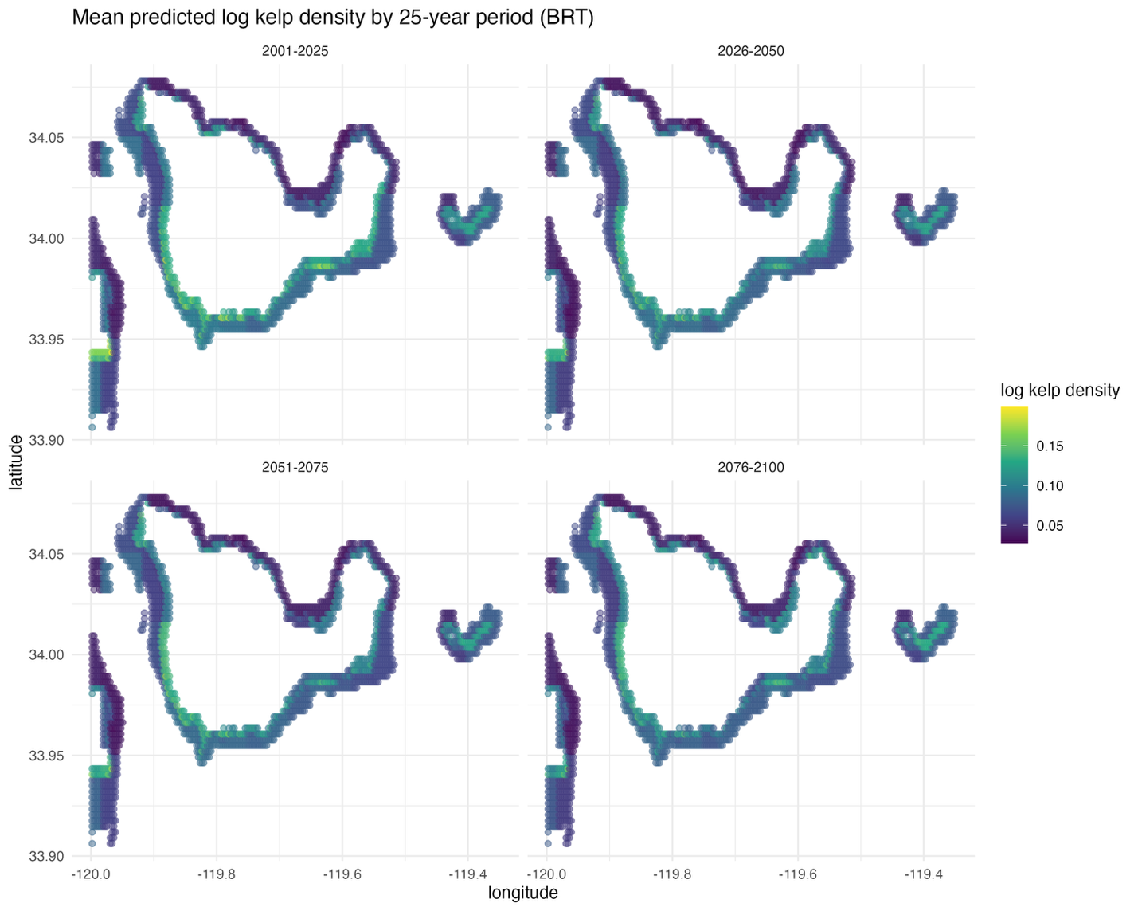

GAM
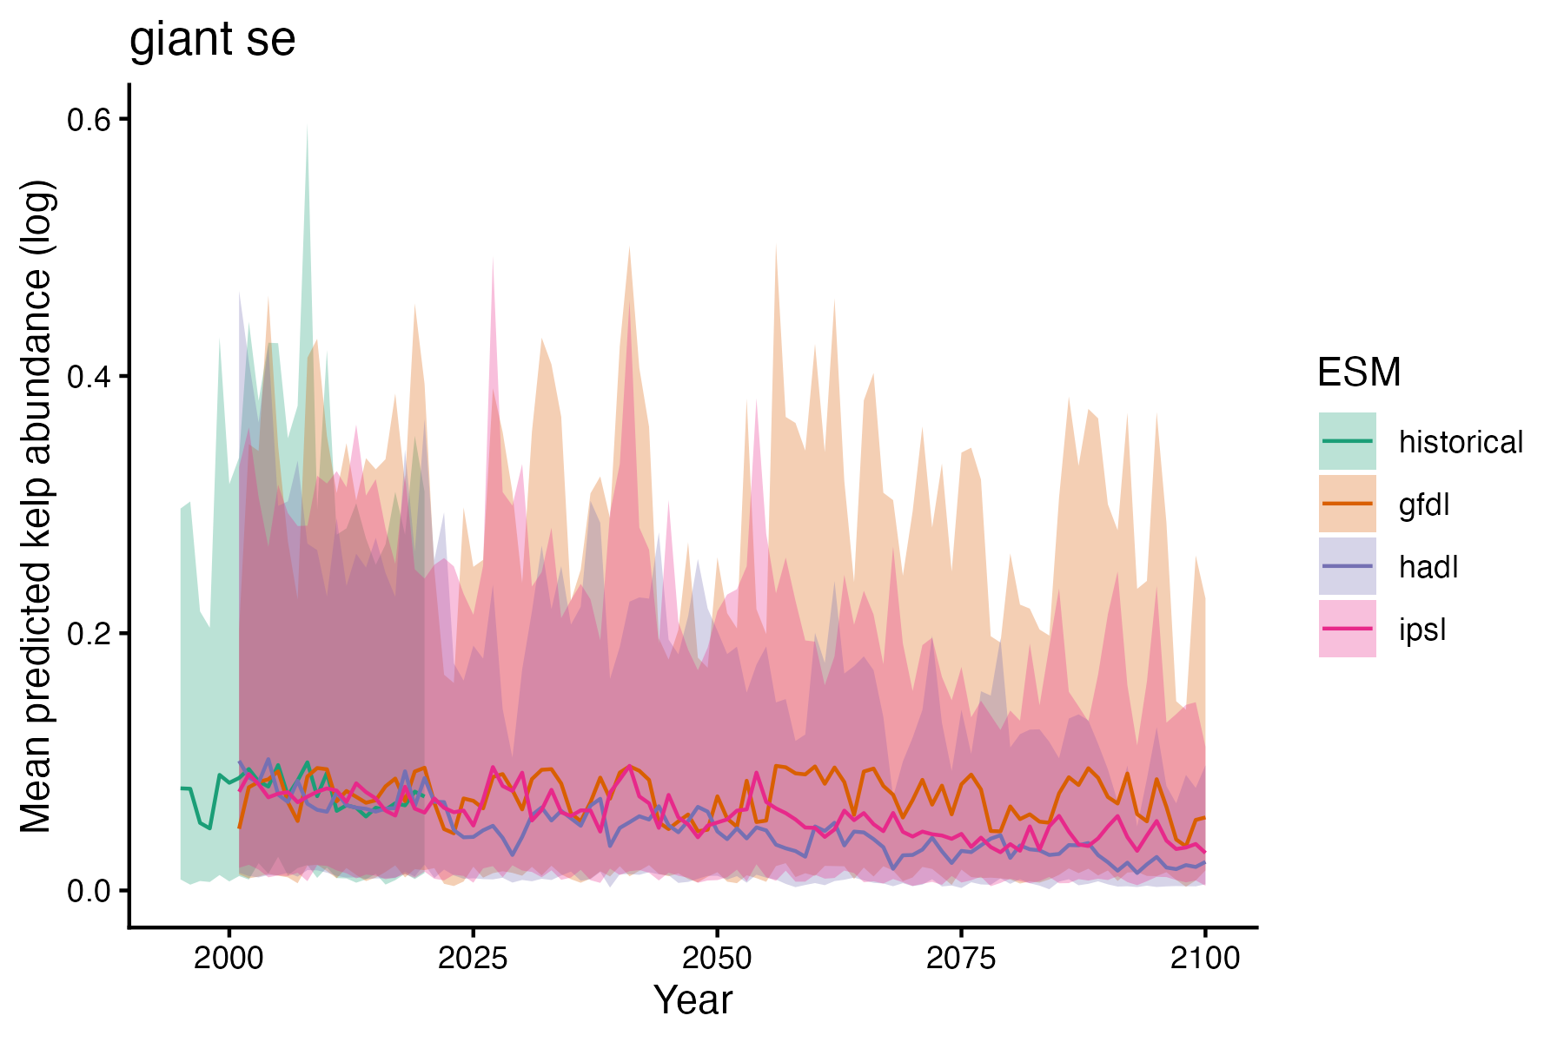
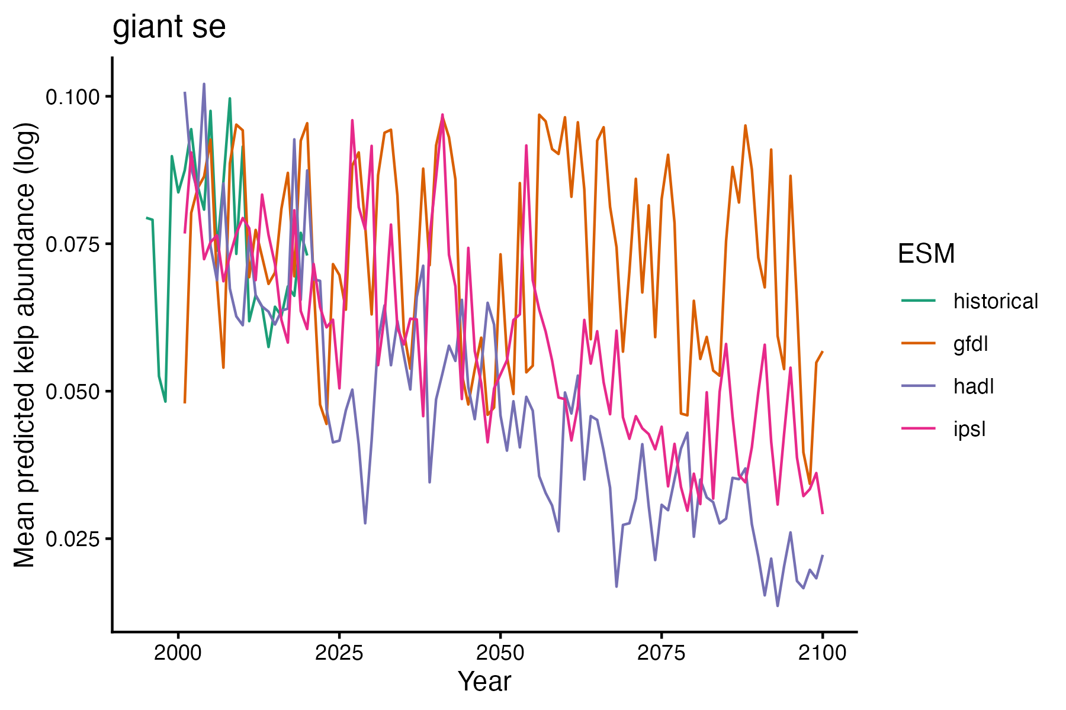
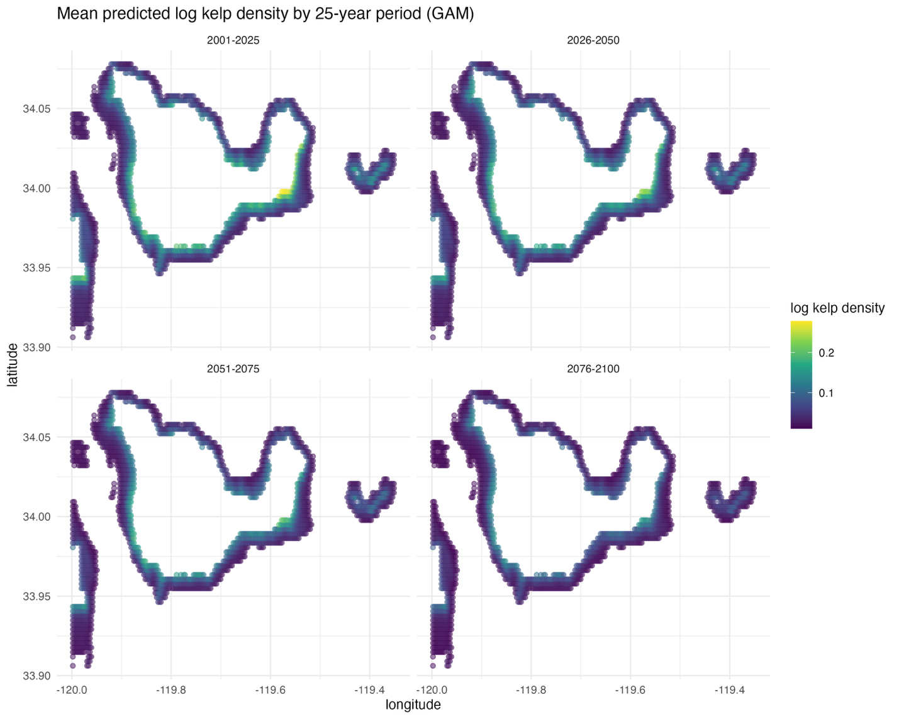
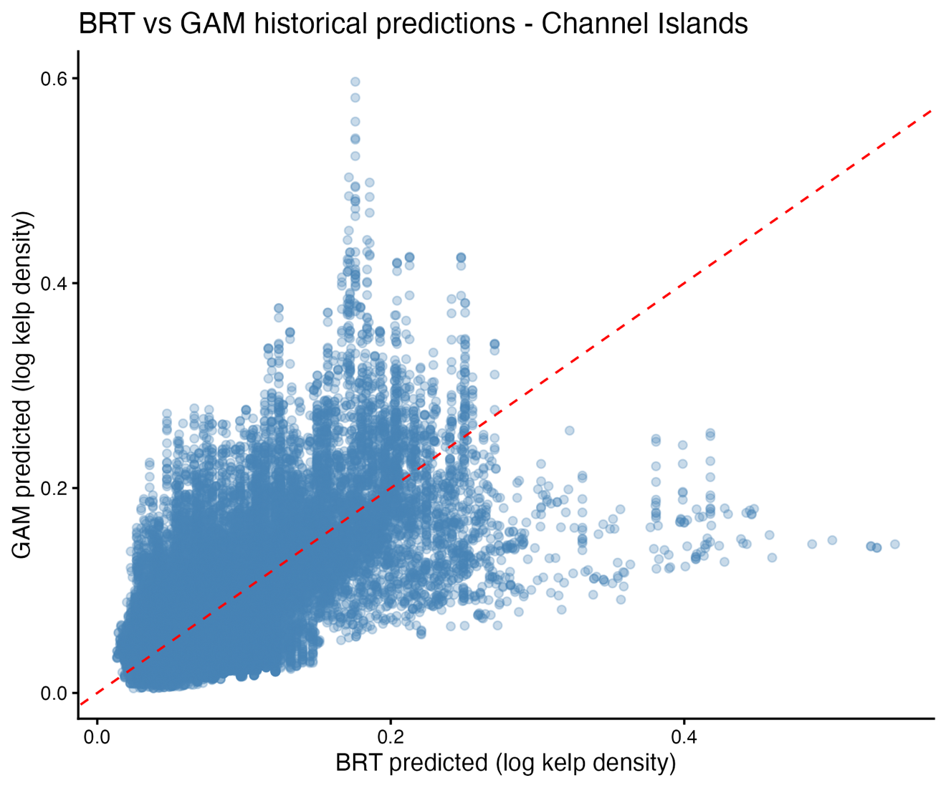
Are the relationships between drivers and kelp being played out in different ways, is there a spatial temporal response difference between the two

