Benjamin Bunk

CMIS 141 6980 Introductory Programming (2142)

Homework1 (Area of a Circle)

February 7, 2014

BenjaminBunkhw1 – Compute the area of a circle.

# Compiler OutputMacintosh HD:Users:ben:Dropbox:School:UMUC:CMIS141:Homework1:images:CompilerOut.png

# Program Output

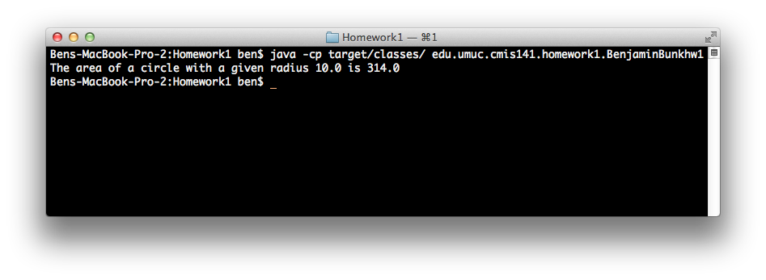

# Test Plan

|  |  |  |  |  |
| --- | --- | --- | --- | --- |
| Test Case | Possible Inputs | Expected Output | Reason | Result |
|  | Radius |  |  |  |
| 1 | 10 | The area of a circle given a radius of 10.0 is 314.0 | Normal test case | Pass |
| 2 | 0 | The area of a circle given a radius of 0.0 is 0.0 | Lower boundary case | Pass |
| 3 | .01 | The area of a circle given a radius of 0.01 is 0.000314 | Normal case with least possible nonzero radius | Pass |
| 4 | 10000000 | The area of a circle given a radius of 1.0E7 is 3.14E14 | Upper boundary case | Pass |
| 5 | -1 | The radius must be a positive decimal number only. | Error-checking | Pass |