Author: Benjamin Bunk

Class: CMIS 141 6980 Introductory Programming (2142)

Assignment: Homework2

February 18, 2014

BenjaminBunkhw2

# Compiler Output

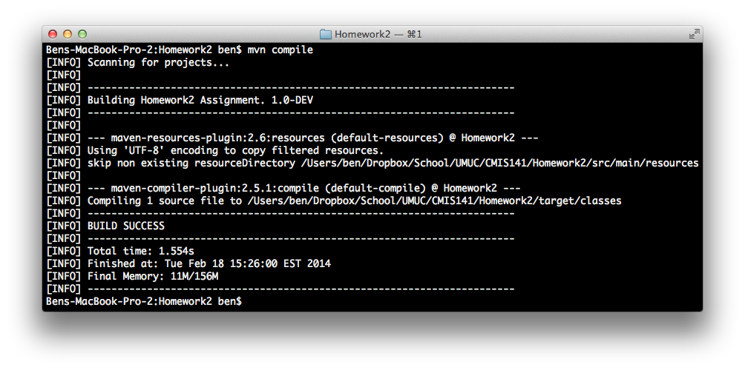

# Program OutputMacintosh HD:Users:ben:Dropbox:School:UMUC:CMIS141:Homework2:images:hw2_output1.pngMacintosh HD:Users:ben:Dropbox:School:UMUC:CMIS141:Homework2:images:hw2_output2.png

# Test Plan

|  |  |  |  |  |  |
| --- | --- | --- | --- | --- | --- |
| Test Case | Possible Inputs | Expected Output | Actual Output | Reason | Result |
|  | Int |  |  |  |  |
| 1 | 161  085  277  486  812  235  778  457  844  055  755  125  850  042  888  402  128  780  580  902  799  074  207  290  153  617  215  918  345  598  652  547  875  159  936  045  798  631  794  166  466  038  107  666  699  450  035  286  673  361  208  330  499  454  949  929  411  754  469  339  709  427  730  007  143  179  194  525  195  526  991  983  816  982  149  705  521  560  376  814  396  857  580  581  496  372  706  061  290  665  734  085  350  395  645  280  179  304  969  421 | Sum of all numbers = 48482 | Sum of all numbers = 48482 | Normal test case | Pass |