Author: Benjamin Bunk

Class: CMIS 141 6980 Introductory Programming (2142)

Assignment: Homework3

March 7th, 2014

BenjaminBunkhw3

# Compiler Output

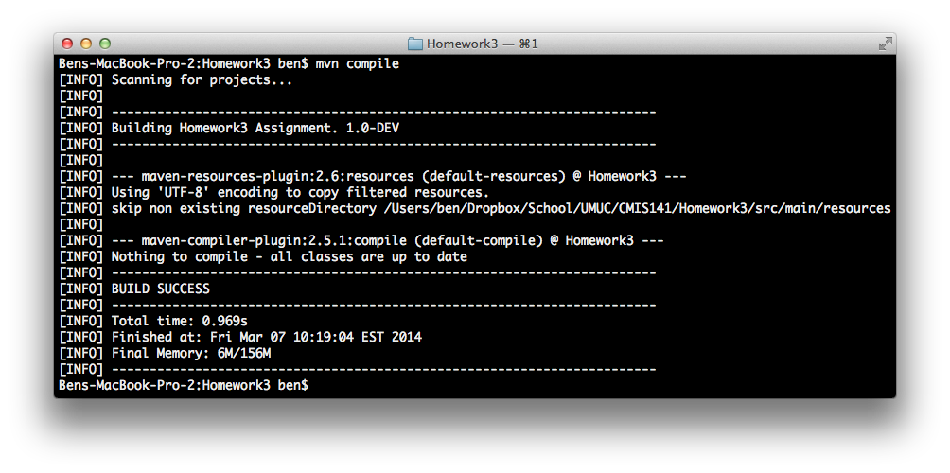

# Program Output

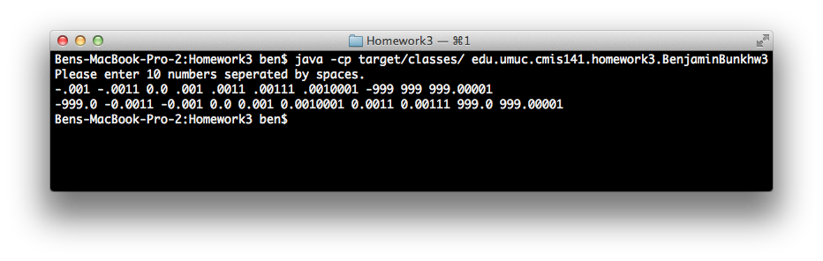

# Test Plan

|  |  |  |  |  |  |
| --- | --- | --- | --- | --- | --- |
| Test Case | Possible Inputs | Expected Output | Actual Output | Reason | Result |
|  | Double |  |  |  |  |
| 1. | -.001 -.0011 0.0 .001 .0011 .00111 .0010001 -999 999 999.00001 | -999.0 -0.0011 -0.001 0.0 0.001 0.0010001 0.0011 0.00111 999.0 999.00001 | -999.0 -0.0011 -0.001 0.0 0.001 0.0010001 0.0011 0.00111 999.0 999.00001 | Normal Test Case | Pass |
| 2. | 999.00001 999 -999 .0010001 .00111 .0011 .001 0.0 -.0011 -.001 | -999.0 -0.0011 -0.001 0.0 0.001 0.0010001 0.0011 0.00111 999.0 999.00001 | -999.0 -0.0011 -0.001 0.0 0.001 0.0010001 0.0011 0.00111 999.0 999.00001 | Normal Test Case | Pass |