Author: Benjamin Bunk

Class: CMIS 141 6980 Introductory Programming (2142)

Assignment: Homework4

March 16th, 2014

BenjaminBunkhw4

# Compiler Output

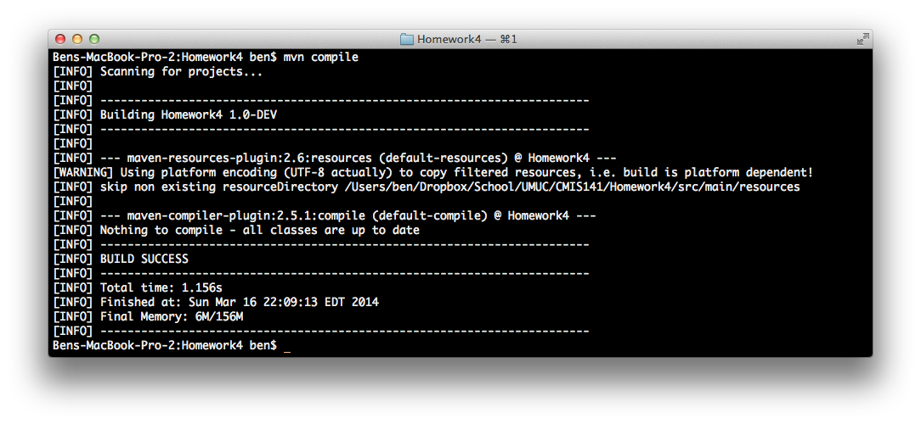

# Program Output

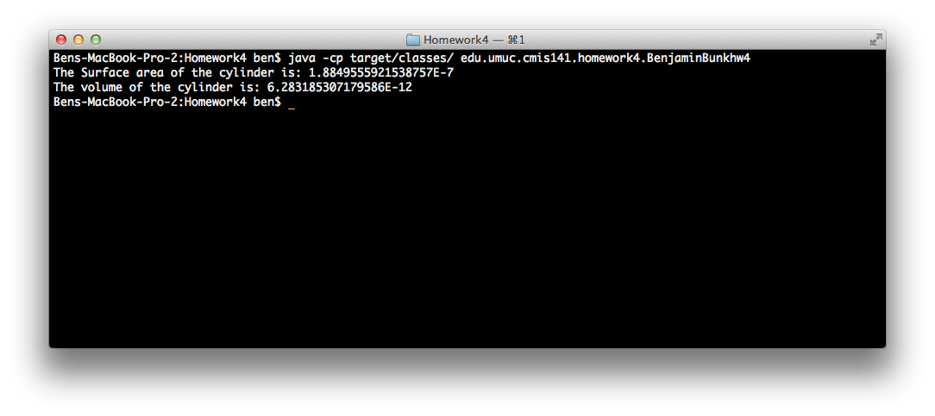

# Test Plan

|  |  |  |  |  |  |
| --- | --- | --- | --- | --- | --- |
| Test Case | Possible Inputs | Expected Output | Actual Output | Reason | Result |
|  |  |  |  |  |  |
| 1. | R = 2, H = 5 | The Surface area of the cylinder is: 87.96459430051421  The volume of the cylinder is: 62.83185307179586 | The Surface area of the cylinder is: 87.96459430051421  The volume of the cylinder is: 62.83185307179586 | Normal Test Case | Pass |
| 2. | R = 1, H = 1 | The Surface area of the cylinder is: 12.566370614359172  The volume of the cylinder is: 3.141592653589793 | The Surface area of the cylinder is: 12.566370614359172  The volume of the cylinder is: 3.141592653589793 | Normal Test Case | Pass |
| 3. | R = .0001, H = .0002 | The Surface area of the cylinder is: 1.8849555921538757E-7  The volume of the cylinder is: 6.283185307179586E-12 | The Surface area of the cylinder is: 1.8849555921538757E-7  The volume of the cylinder is: 6.283185307179586E-12 | Lower Boundary Test Case | Pass |