Author: Benjamin Bunk

Class: CMIS 141 6980 Introductory Programming (2142)

Assignment: Project1

February 12, 2014

BenjaminBunkp1

# Compiler OutputMacintosh HD:Users:ben:Desktop:p1_compile.png

# Program OutputMacintosh HD:Users:ben:Desktop:p1_run1.pngMacintosh HD:Users:ben:Dropbox:School:UMUC:CMIS141:Project1:images:p1_run2.png

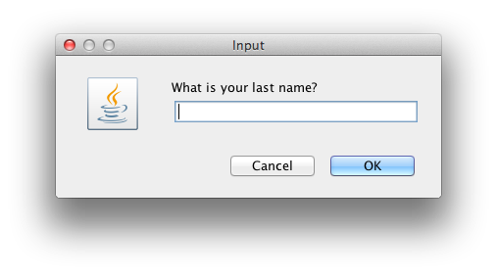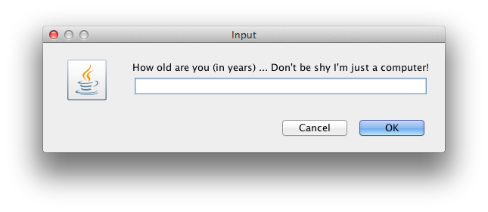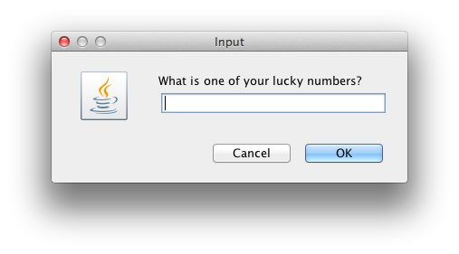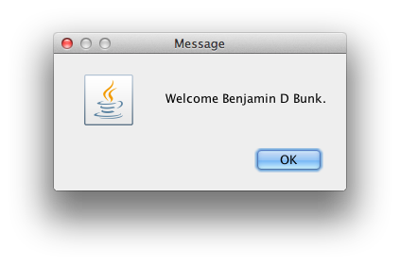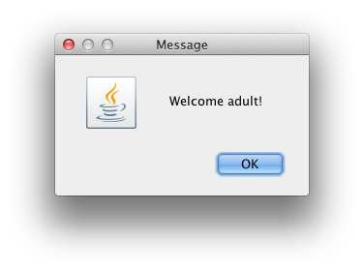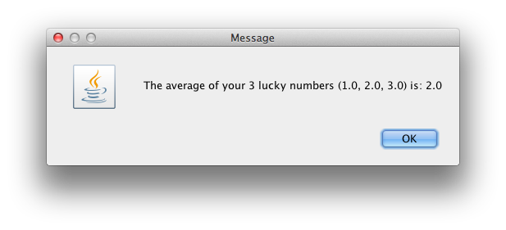

# Test Plan

|  |  |  |  |  |  |
| --- | --- | --- | --- | --- | --- |
| Test Case | Possible Inputs | Expected Output | Actual Output | Reason | Result |
|  | String |  |  |  |  |
| 1 | First: Benjamin  Middle: David  Last: Bunk | Welcome Benjamin D Bunk. | Welcome Benjamin D Bunk. | Normal test case | Pass |
| 2 | First:  Middle:  Last: | Welcome . | Welcome . | Lower boundary case | Pass |
| 3 | Age: 7 | You are just a kid! | You are just a kid! | Normal Case | Pass |
| 4 | Age: 15 | Welcome teenager! | Welcome teenager! | Normal Case | Pass |
| 5 | Age: 20 | Welcome almost adult! | Welcome almost adult! | Normal Case | Pass |
| 6 | Age: 25 | Welcome adult! | Welcome adult! | Normal Case | Pass |
| 7 | Age: 1 | You are just a kid! | You are just a kid! | Lower Boundary Case | Pass |
| 8 | Age: 12 | You are just a kid! | You are just a kid! | Upper Boundary case | Pass |
| 9 | Age: 19 | Welcome teenager! | Welcome teenager! | Upper Boundary case | Pass |
| 10 | Age: 21 | Welcome adult! | Welcome adult! | Lower Boundary case | Pass |
| 11 | Age: -1 | Age must be a positive non-zero number.  Please re-run this application and try again. | Age must be a positive non-zero number.  Please re-run this application and try again. | Error Checking | Pass |
| 12 | Age: Hello | You must only enter a number for the lucky numbers and age questions.  Please re-run this application and try again. | You must only enter a number for the lucky numbers and age questions.  Please re-run this application and try again. | Error Checking | Pass |
| 13 | Num1: -1  Num2: -1  Num3: -1 | The average of your 3 lucky numbers (-1.0, -1.0, -1.0) is: -1.0 | The average of your 3 lucky numbers (-1.0, -1.0, -1.0) is: -1.0 | Lower Boundary Case | Pass |
| 14 | Num1: 1  Num2: 2  Num3: 3 | The average of your 3 lucky numbers (1.0, 2.0, 3.0) is: 2.0 | The average of your 3 lucky numbers (1.0, 2.0, 3.0) is: 2.0 | Normal Case | Pass |
| 15 | Num:  Num:  Num: | You must only enter a number for the lucky numbers and age questions.  Please re-run this application and try again. | You must only enter a number for the lucky numbers and age questions.  Please re-run this application and try again. | Error Checking | Pass |