Author: Benjamin Bunk

Class: CMIS 141 6980 Introductory Programming (2142)

Assignment: Project2

March 1, 2014

BenjaminBunkp2

# Compiler Output

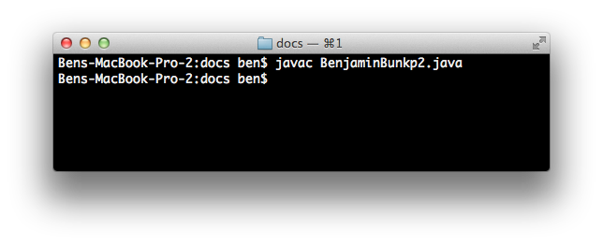

# Program Output

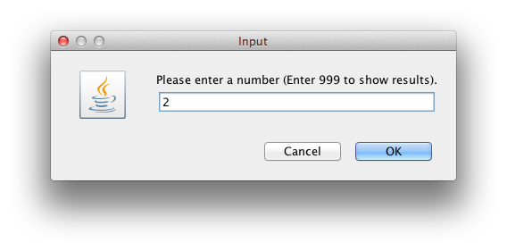

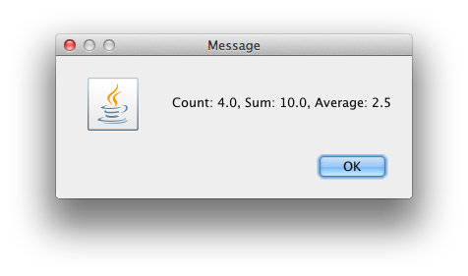

# Test Plan

|  |  |  |  |  |  |
| --- | --- | --- | --- | --- | --- |
| Test Case | Possible Inputs | Expected Output | Actual Output | Reason | Result |
|  | String |  |  |  |  |
| 1. | 2, 2, 3, 3, 999 | Count: 4.0, Sum: 10.0, Average: 2.5 | Count: 4.0, Sum: 10.0, Average: 2.5 | Normal Test Case | Pass |
| 2. | -1, -1, 0, 1, 1, 999 | Count: 5.0, Sum: 0.0, Average: 0.0 | Count: 5.0, Sum: 0.0, Average: 0.0 | Lower Boundary Test | Pass |
| 3. | 50, 25, 25, 999 | Count: 3.0, Sum: 100.0, Average: 33. 333333333333336 | Count: 3.0, Sum: 100.0, Average: 33. 333333333333336 | Upper Boundary Test | Pass |
| 4. | 998, 998, 998, 999 | Values have exceeded a sum of 100. | Values have exceeded a sum of 100. | Error-Checking Test | Pass |
|  |  |  |  |  |  |