Author: Benjamin Bunk

Class: CMIS 141 6980 Introductory Programming (2142)

Assignment: Week 4 Discussion

February 18, 2014

UniqueMethod

# Compiler Output

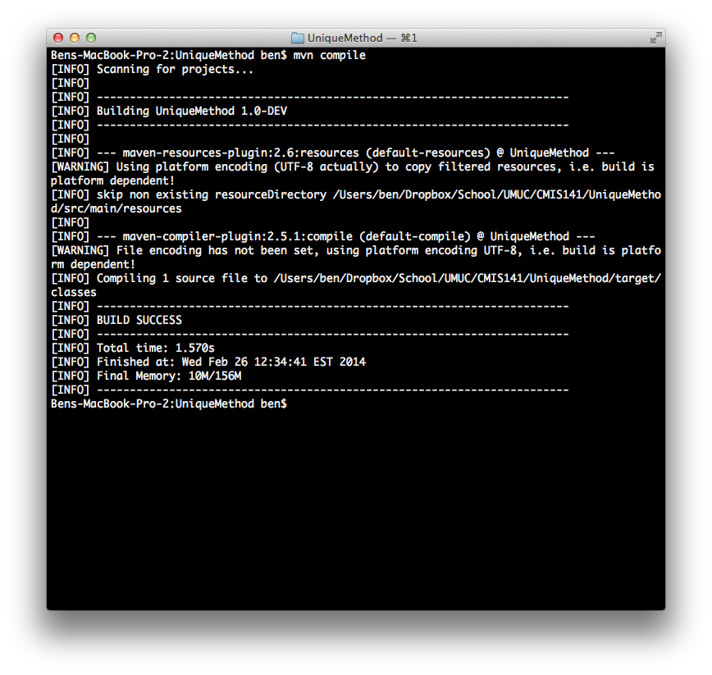

# Program Output

