Author: Benjamin Bunk

Class: CMIS 141 6980 Introductory Programming (2142)

Assignment: Week 3 Discussion

February 18, 2014

WaterCount

# Compiler Output

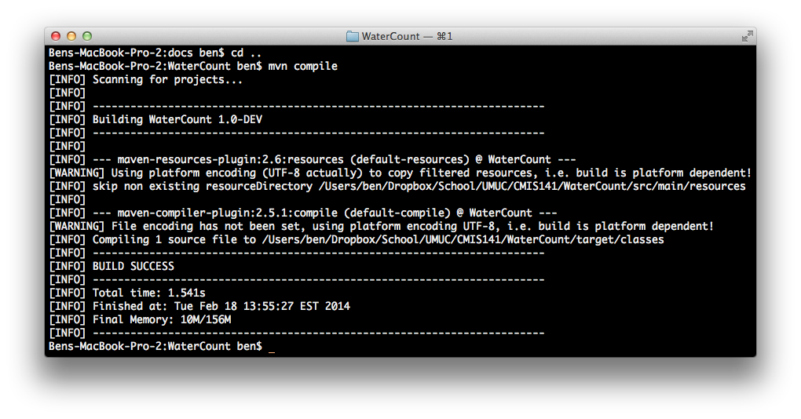

# Program Output

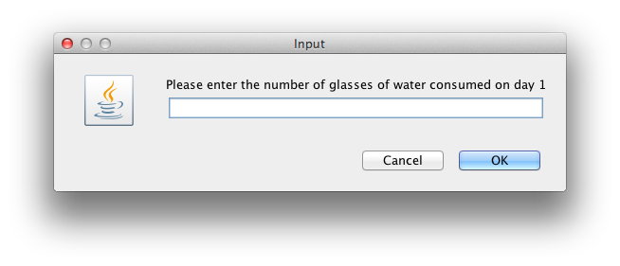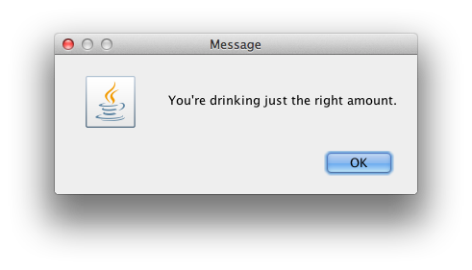

# Test Plan

|  |  |  |  |  |  |
| --- | --- | --- | --- | --- | --- |
| Test Case | Possible Inputs | Expected Output | Actual Output | Reason | Result |
|  | String |  |  |  |  |
| 1 | 7 7 7 7 7 7 7 | You're drinking too much (6 a day is good). | You're drinking too much (6 a day is good). | Upper boundary test case | Pass |
| 2 | 1 1 1 1 1 1 1 | You're drinking too little (6 a day is good). | You're drinking too little (6 a day is good). | Lower boundary case | Pass |
| 3 | 6 6 6 6 6 6 6 | You're drinking just the right amount. | You're drinking just the right amount. | Normal Case | Pass |
| 4 | 17.5 | Input a positive whole number please. | Input a positive whole number please. | Error Checking | Pass |
| 5 | -1 | Input a positive whole number please. | Input a positive whole number please. | Error Checking | Pass |