Notes Parallel Metaheuristics
Edited by E.E. Alba,
ISBN 13 978-0-471-67806-9
- Focuses on discrete optimization problems (e.g. no PSO et al)
- Why read it : measurements, convergence measures, ideas

Classes of heuristics:
Constructive: build a solution

Local Search: pick a solution, improve in neighbourhood

P7
Metaheuristic : <upper level/beyond> <to find>
- Process that guides the search process
- Non deterministic, approximating
- Untrap
- Domain agnostic
- Can use domain specific knowledge as a guide (opt)
- Use memory obtained in process as a guide (opt)

Exploration v Exploitation (Diversification/Intensification)
Identify regions of search space with good/optimal solutions
Exploit discovered region (by search process/memory) for optimal solutions

Classifications
Memory[less|based]
Dynamic|Static objective function
Nature/NonNature inspired
Single point / Population based

Trajectory (sp)
Trajectory in search space, but with additional measures to escape local mimima (e.g. termination criteria)
SA
Memory less (only based on previous state)
Start (rand or heur)
From state s
Select s’
If s’ > s
S <- s’
Else
p(s’ | Tk, s) = e ^ - [ (f(s’) - f(s)) / Tk]
Cooling schedule is critical

Old, useful, used in hybrid

Tabu Search
Keep a cache of visited solutions, do not pick any from neighbourhood if it is in the list

Improve : store solution components

Explorative Local Search
GRASP :
VNS
GLS: use dynamic objective function to make found minima less desirable
ILS : perturb best found

Population Based
Deal with a set, not a single solution
Evolutionary Algorithms
Mutation and crossover
Recombine
Mutate
Evaluate
Select
Memetic algorithm : use local search to improve solution as mutation step
- 2 distinct operations in mutate:
  - Add noise (information), random
  - Improve sample (guided)
- Selection (replacement)
  - Elitist
    - Generational Overlap, some are replaced, not all
  - Steady State
    - Only few are replaced
  - Variable size population is possible

Scatter search, path relinking
Seed solutions, Reference solutions, Diversification solutions (generate differing as much as possible from seed)

EDA : estimation of distribution algorithms
Problem with EC : crossover breaks good building blocks
Generate Popi
Select from Popi subpop p
Generate PDist from p
Sample from p to generate Popi+1
Very Promising, but still young field
ACO : Ant colony optimization
Constructive heuristic used in a population
Using pheromone (param…) model, construct solution using prob
Bias future by previous iteration results
Add local search if needed
Pheromone update:
Evaporate : untrap
Learn from previous
Best known : MaxMin, ACS, MMAS

Decentralized Metaheuristics
Parallel implementations
Better coverage/sampling of search space
-> diversity increases, coverage increases, species formation
Panmictic : random mating
{c|d}EA better than panmictic
Evaluations reduced
Cellular EA, distributed EA
dEA : island EA using sparse exchange
Parameter problem : when to migrate...
cEA : neighbourhoods
Individual has pool of mates (in grid)
But 1 individual is member of several (all) pools
→ diffusion of good solutions across grid
Panmictic : random mating

Hybridization
Algs A, B
B member of A
A cooperates with B
Combine A with AI/operation research
Component exchange
Combine trajectory search with population methods
Population based methods have risk of ‘missing’ good solutions in promising area, local search will improve until found
Cooperative
A exchange info B
In parallel or local, info can be state, information, solutions etc
Tree search, Constraint programming
Combine TS with meta
Add/combine with CP : reduce search space

Measuring performance of (parallel) metaheuristics
NP hard problem space
Parallel is not only optimization (distribution), but actually different search process
Cite A Survey of Parallel Distributed Genetic Algorithms
→ better than sum of parts

2 measures :
How fast is a solution obtained
How accurate is the solution (as it is an approximation)
Theoretical (worst case)
Next to unfeasible, especially given the large number of algorithms
Experimental
: set of problem instances, set of algorithms, compare results (time, accuracy)
Need for framework
Feature Article—Toward an Experimental Method for Algorithm Simulation

Parallel performance measures
Speedup
Ratio between sequential and parallel
# define time
Use wall clock time, need to include overhead
Since alg is non deterministic:
Speedup = E{serial}/E{parallel} for m processors
sub/lin/super : s<m, s=m, s>m
What is Tserial, Tparallel
Strong speedup
Parallel version against best known serial
-> best known is unknown, so don’t use
“How fast does parallel solve the problem, given choice of serial?
Weak speedup
“How fast is my parallelized version of my serial?”

Speedup with sol stop
Vs panmixia (vs random breeding, island approach)
-> serial v parallel
Orthodox
-> parallel on 1 vs parallel on m
Speedup with predefined effort (effort is not related to quality, so don’t do this)

Superlinear speedup may exist, but is highly controversial
Causes:
Implementation is serially inefficient (e.g. pipeline instructions)
E.g. population = 1e6 list, divided by 6 processors is faster data structure
Numerical: Order of search space discover is different, serial can have more difficulty
Physical : Shared cache, subpopulation fits in cache (distributed computing)

Other metrics
Efficiency
Em = sm/ m normalized speedup, em =1 is linear
Incremental
Fraction of time improvement for adding single processor
Used when single processor times are ?
Generalized : n -> m
Iem = [(m-1) E[T_m -1]] / [m E[T_m]]
Gie_n,m = [n E[T_n] ] / [m E[T_m]]

TIme on single : what if problem does not halt, does not fit in memory
Scaled speedup
Ssm = Estimated time to solve serial problem of size nm
/
Actual time to solve problem of sive nm on m procs
N = size of largest problem dealt with by serial

Estimate is difficult

Scaleup
Su_m,n = Time to solve k problems on m processors
/
Time to solve nk problems on nm processors
Linear with sumn = 1

Serial fraction of algorithm
Fm = [1/sm - 1/m] / [ 1- 1/m]
Karp, Flatt
Measuring parallel processor performance
Superlinear = negative
F smooth increasing : granularity of tasks in too fine (e.g. too much overhead)
F constant = ideal. Fconstant can occur with loss of efficiency due to poor parallelism of algorithm, not implementation. (e.g. n or m is irrelevant)

Reporting of results
Fair comparison is hard : depending on metrics, different conclusions can be drawn from same results
Goal of experiment
- Optimzation
  - A > B, AND why
- Understanding algo

Problem instances : variety, interesting results
Real world instances
True test, but hard to find, if possible perturb small existing set
Standard instances
Standardized problem set
Random instances
Controversial, what do you test?

Set up experiment:
Fractional factorial design

Measure performance
Good solution in reasonable time
Independent experiments (since probabilistic)

Quality of soln
Ideally, how many time is solution found (hitrate)
→ Do not know solution
Approximate within distance
Robustness : take into account edge cases, mean, avg
Statistical analysis is needed

Computational effort
If superior soln is result, this is clearly better algo
Time (wall clock), but also evaluations (e.g. python vs c++)
Evaluations : what if f(x) >> f(y) ?
Examples:
Average evaluations/time to solution (if ending)
Average evaluations/time to halting
-> problematic, evals to soln of different accuracy is not good metric
Predefined time/effort, then measure result is correct
Incorrect :
Using runtimes to compare algorithms (e.g. speedup of efficiency)

Analysis:
Comparing two algorithms is tricky
Mean A <> Mean B , but from same distribution ?
Decision process:

Data sets:
Normality (Kolmogorov-Smirnov)
Y N
Normal Vars
Parametric tests
2 data >2
Student -t ANOVA
Levene test Post hoc mean comp
Equality of variance (Levene)
Y N
Duncan Tamhane
SNK

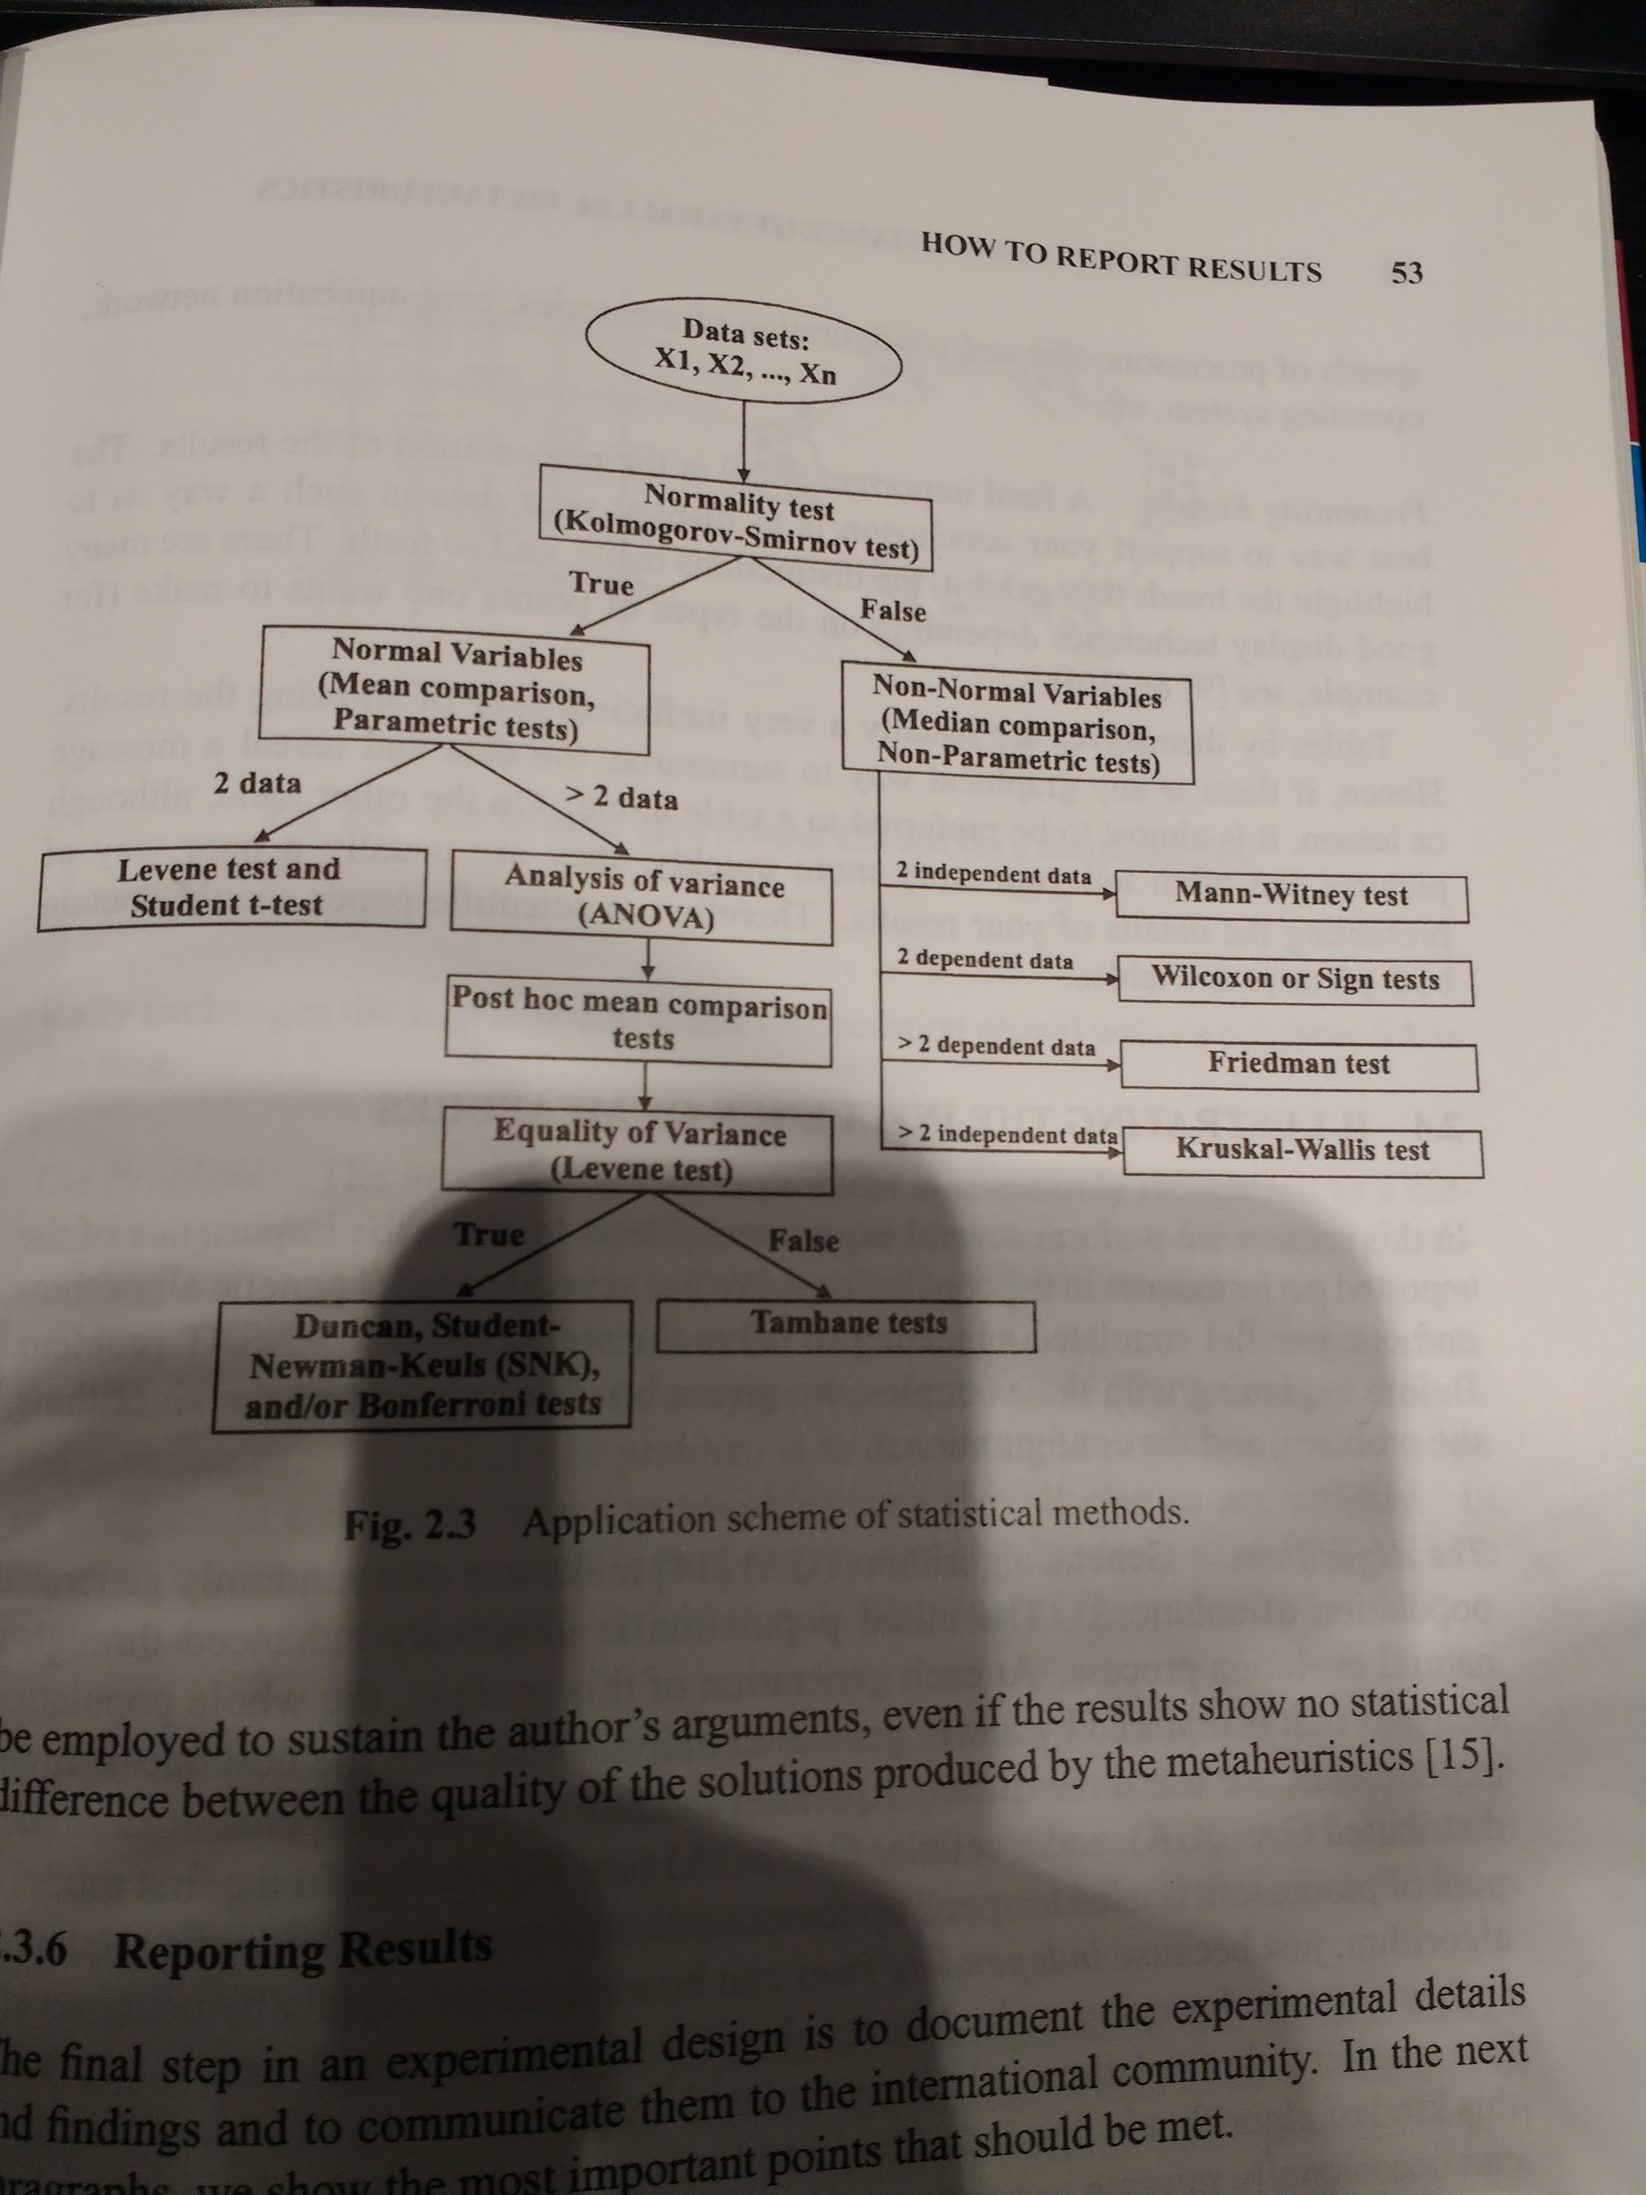

Reporting results
Reproducibility
Machine, code, setup should be repeatable
Presentation
Pictures and tables
cite
Visual Display of quantative data
Elements of Graphing data
Final notes:
Take care : sequential process may be different from parallel (in solutions found), DO NOT COMPARE speed up like this

Parallel technologies
Why it won’t work in CSRM : need explicit sharing of data, neither Julia nor Python is designed to do this, so parallelizing evaluation function is a no go
Key difference, no longer unique control flow
Shared memory
Distributed programming : based on message passing (no shared memory)
Load balancing
Heterogenity
Distributed shared memory : (DSM)

Shared Memory:
No copying of data, no heterogenicity
Still load balancing
→ 3 approaches : parallel compiler, libraires (openmp), own code

COW : cluster of workstations
MP libraries
Layer on top of sockets
Primitives for IPC and syncing
Object based
RPC-like : Corba, Avro, ... , remote callable objects
Middleware
Grid computing
Hard to develop
Large scale, heterogenic
→ multiple structure (network, software, hardware)
→ latency, disruption, rule of 2 out of 3
Web based
SOAP, WSDL
Platform independent (need only browser)
Combine web and grid

Shared memory tools
Pthreads
→ thread: independent flow on control inside a process
Ict multiple processes:
Faster context switching
OpenMP
Compiler directives

Dist memory tools
Sockets
Full duplex channels between processes
PVM : discarded
MPI:
SPMD style : single program, multiple data
P <> Q <> R <> S
CORBA et al
Condor, Globus : grid

Conclusion : Python : Global lock → not threads, so MPI → no grid, so pyMPI

Metaheuristics and parallelism
Exact vs Metaheuristic (approximation)
MTH : NP hard problem space
→ LSM (local search)
exploitation
→ EA (evolutionary algorithms)
Exploration
LSM and EA have differing parallelization approaches

pLSM
Course-grained to fine-grained
Parallel multistart
Launch several instances
Cooperative multistart is typically best model
Parallel moves
Heuristic behaviour is not changed
farmer - worker model, with central management
→ solutions are shared F<>workers
Move acceleration
Accelerate evaluation function, quality of move is parallelized
!!! may influence each other, e.g. as in SA
Note : load balancing : dynamic is optimal, with work stealing
pEA
Recap of why/when EA
Epistatic : x influences y (in genotype), --Need-- evolution
Multimodal : multiple target solutions desired
Multiobjective : several objectives require maximization
Constraints
2 high computational parts:
Fitness function
Reproduction

Parallelization of computation
→ e.g. fitness function : parallel for x in pop : x’=f(x)
Master - Slave:
Identical to sequential, but faster
No sum > +parts
Master does selection, slaves do fitness and reproduction
Parallelization of instances
Run algorithm n times on n processors, no coordination
Parallelization of population
Spatial split: distributed/cellular approach
→ split(pop, proccount)
Distributed: create islands, subpopulations that run the algorithm and only very sparsely comunicate ‘best of’ solutions to untrap from local optima
Cellular : every specimen has a set of mates M, every s belongs to multiple sets of M a
x (y (z) (c) d)
b e
Z can mate with e,c,y, c can mate with d, z, …
Provides quasi ideal combination of exploration with exploitation
If y is local optima, it will diffuse slowly to others, while not preventing other candidates from influencing proces.
Hybrid:
Lowest level : cea, higher level dea

Parallel GP :
Difficult to do, since samples vary in size (load balancing)
This makes cell based approach more difficult (also in mapping topology)
→ approach : make a tree based island topology
Root sends best/2 to children, replaces with random
(seeding)
Non leaf : send best/2 to children, keep
Leaf : receive, send best/2 to sibling
Receiving nodes : replace worst with received samples
Pop:
[ best | mid | worst]
Eval distance only on best|mid
Given 16 datapoints, evaluate on striping: ratio k/x
E.g. 15 processors :
Each uses 15/16 datapoints → avoid overfitting, keep prediction
At end:
Pop = best of {best {procs}

Parallel ACO
Best result : loos coupled dACO, or run x runs and collect best (with better result)
!! SEED

Parallel EDA
Recap:
EDA : try to create distribution from sample points
Then predict new points
Typically learning stage is paralleized

Parallel heterogeneous metaheuristics
- Vary parameter configuration between algorithms (p = ½, p=⅓)
- Differing operators (crossover + mutator)
- Encoding (bit + tree)
- Algorithm (e.g. Gp+ PSO)

Typically with distributed model, each model having its own config

Parallel multiobjective optimization
Typically fitness function becomes most expensive part, reducing it by parallelization

Cooperative multistart :
Islands with exchanging instances is ‘best’

