Documentation

THERMA-FLOW

an automated passive house concept

TEAM MEMBERS

Balogh Árpád Mátyás

Barcza Bende

Fábián Kálmán

Vass Bence

BUDAPEST, 2022.

Tartalomjegyzék

1 Introduction 3

2 Saving 4

3 Ease of use 8

4 Hardware 9

5 BLUENRG-234 9

6 Amphenol CS 10118193-0001LF 10

7 SCD40-D-R1 | SENSIRION 10

8 BMP280 10

9 SGP30 10

10 ESP8266 10

11 AMS1117-3.3 LM1117 10

12 CR2032 Battery Holder 11

13 ASAIR AHT20 11

14 3V CR2032 Primary lithium button battery 11

# Introduction

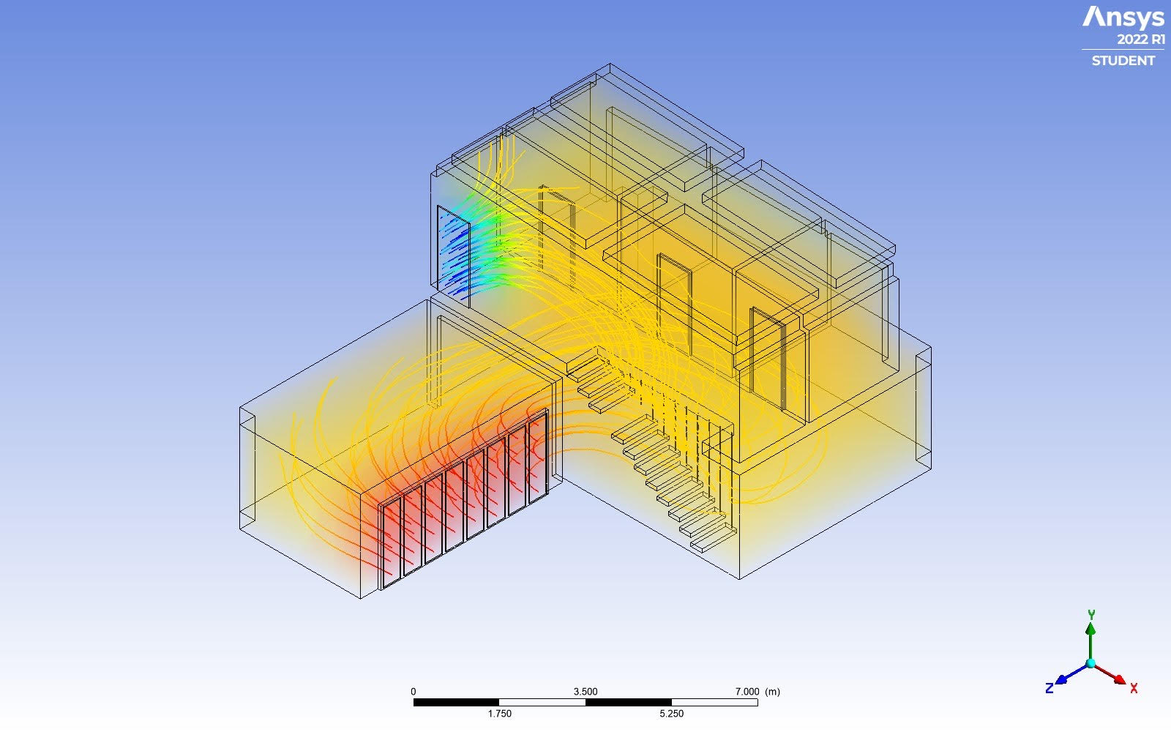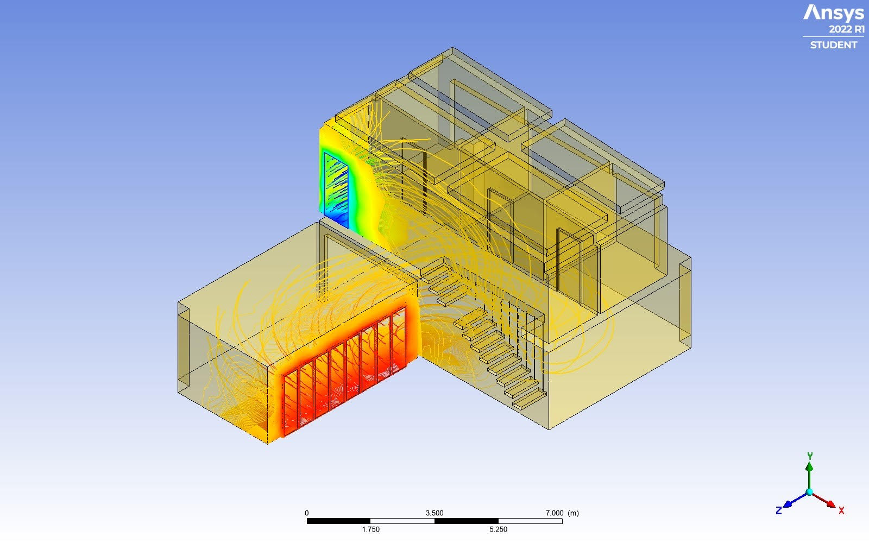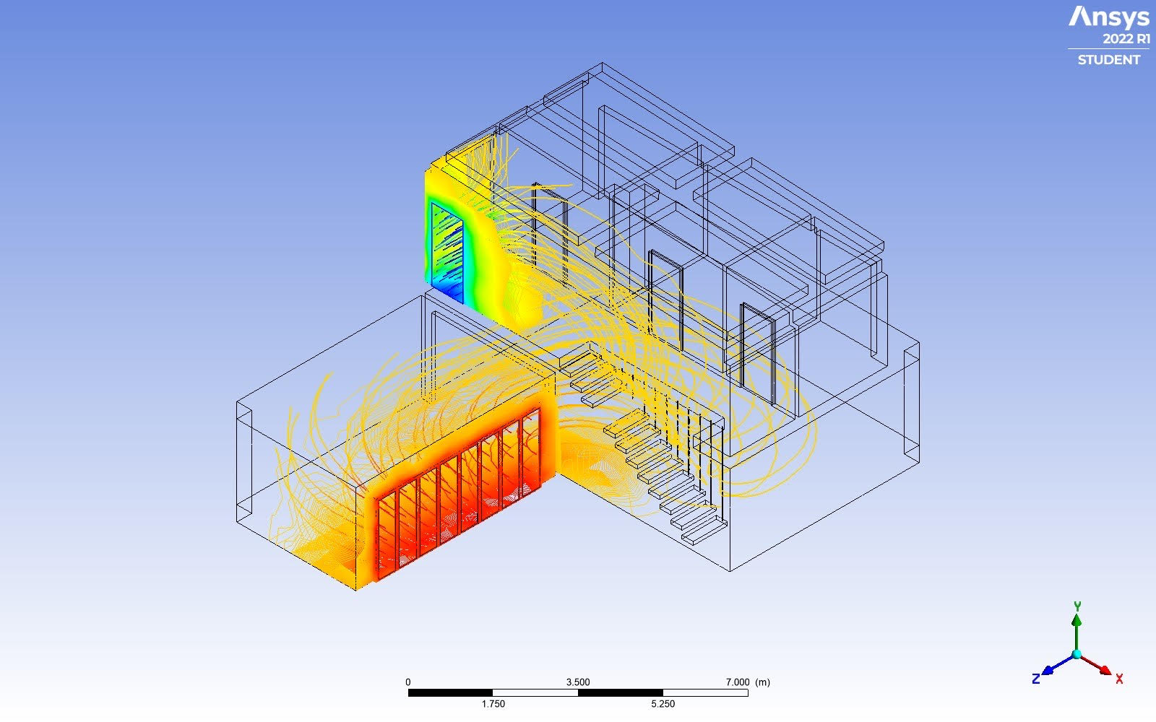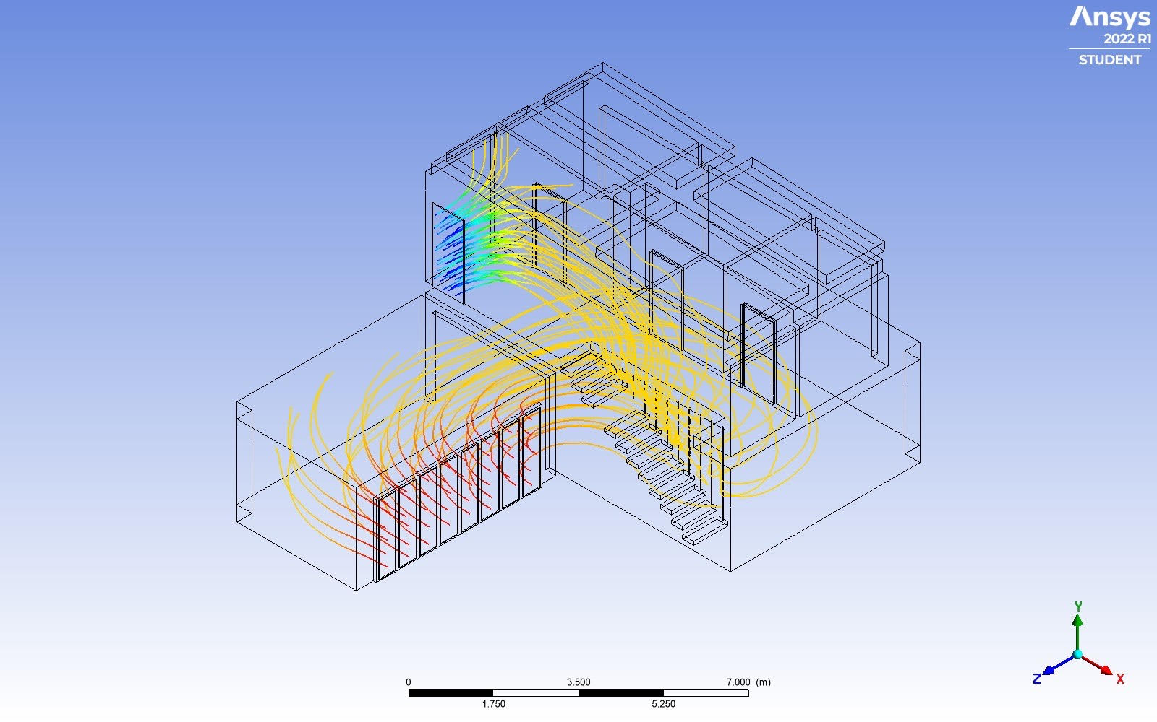We created an automated air ventillation system to reduce heating costs, achieving health benefits and having a better comfort in your home. We designed an IoT device network with diverse sensors to measure air quality. The system is able to work on its own to pull down weights from your shoulders financially and physically too. The financial return will come after 3 years.

# Saving

Based on researches on passsiv houses and their temperature managment, we were able to estimate a possible amount, that could be saved thanks to our solution. The actual measured values could differ in every region due to the annual duration of sunshine, nebulosity, orientation and location of the house and the angle of the sun. Based on a study (<https://marmottenergies.com/much-sun-heat-house/>) we made a rough estimation, if it is possible to have a greener home. In our example we used the provide date from the study to measure the heating enery of the sun,which is sensible in a house.

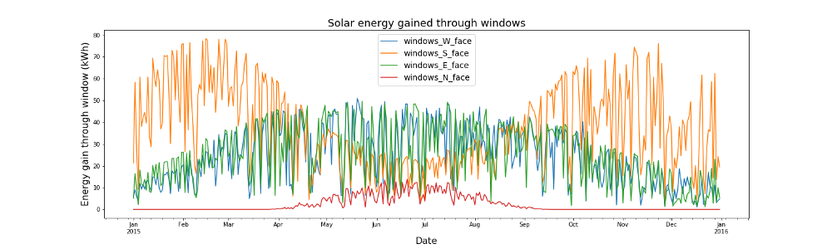

We than set a a reasable room temparture, that we would like to reach depending ont the outside conditions. We drawns the following conclsions, if the outside temperature is lower then 25 Celsius (= 21,5 + 4) then our goal is to reach 21,5 Celsius, otherwise the outside tempeature minus 4 Celsius, which is a comfortable room temperature in the summer time.

We found that in 2021 at Budapest (https://meteostat.net/en/place/hu/budapest?s=12840&t=2021-01-01/2021-12-31), out of the 365 days on 248 days should be a heating device operated accoring to our goals, and on 67 days should be cooled.

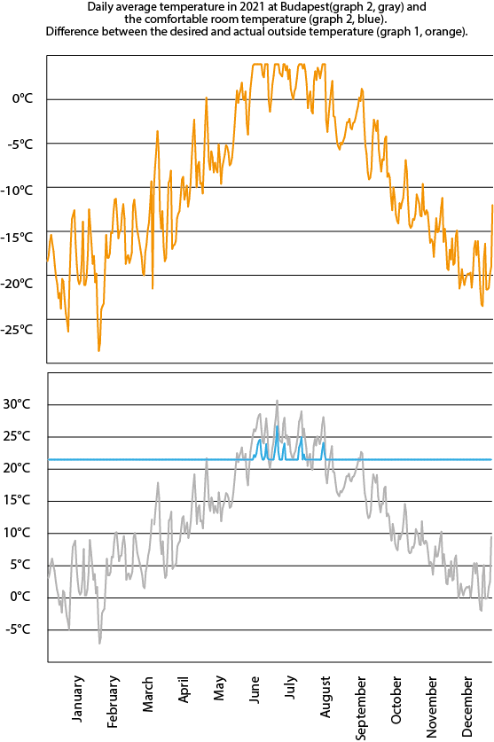

This data could be merged with data from the study about the heat of the sun, so that we could calculate an estimated energy surpluss due to the solar radiation. (Later on the effectivnes of our air flow system) Which is now comperable with a houshold annualy costs in each energy class. We made a few exmaple with different sizes in each class (<https://otk.hu/blog/osszesitett-energetikai-jellemzo>). Calcualting with the 2021 annual avarge price of electicity in Europa,which is EUR 0.1515 kWh (https://ec.europa.eu/eurostat/databrowser/view/nrg_pc_204/default/table?lang=en) , we could give an estimate of annual costs in each cases.

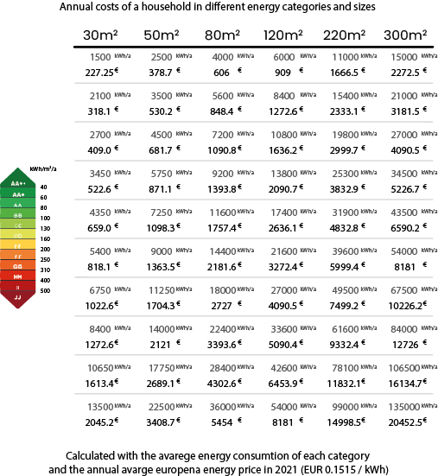

For the seak of realisem we aggrerd on a 10% effiecnt on the capturable solar energy, that could be utilzed in the heating of our house. Of course it is a negative value in cases we woudl liek to cool down the inner envierment. Based on this pricnciple, we have estiamted a maximum possible return on this investment, with regard the size of the windows of the property. These may also varie there for we would like to emphises that it is an rough estiamte.

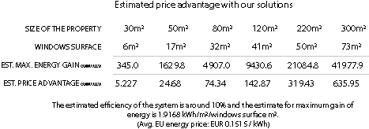

As it is seem our system most efficent for family houses with the minimum area of 200 squaremater. There for our system would be recommended mostly for bigger houses with a larger surface of windows. Based on that we set our ossbile target group to take alook on the return on investment. In our example we have calucalted with a hosue with an are of 220 squaremater and 50 sqrarmater of windows surface.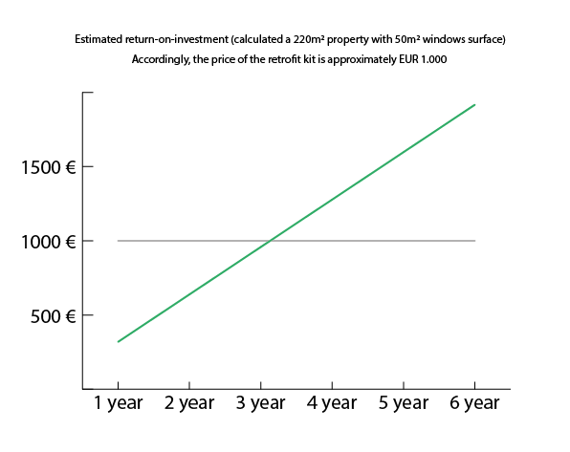

Dispite the loss of date due to the tranformations of energy prices and fairly low effciency level of our system it is still posible to save on the energy. **For our ideal target group the return on investment would around 3 years.**

# Ease of use

The whole sensor kit is ready-to-go, you just have to place them in proper positions and connect them to supply via usb. To equip the windows with the actuators, you will need some basic tools and you can find a step-by-step guide in the package. To wake up your new IoT network, you just have to download the application to your phone and enjoy the benefits. It’s that easy.

During designing process, we took into account all the modularity wishes customers have nowadays. With our modular design, it’s easy to upgrade and expand your system.

No matter what kind of house you live in, the devices can be easily implemented into any of them, you can even live out your retrofitting preferencies.

# Hardware

We placed down a temperature+pressure+CO2+CO sensor in every room close to the floor. We need an other temperature+pressure sensor in the middle of the room and outside the window for more precise measuring. We placed dowm VoC+humidity sensors in the kitchen and the bathroom. We have 1 radon sensor in the most popular place. And we have shutter and window openers on every window possible. For all of theese purposes we put together a few different sensor packs.

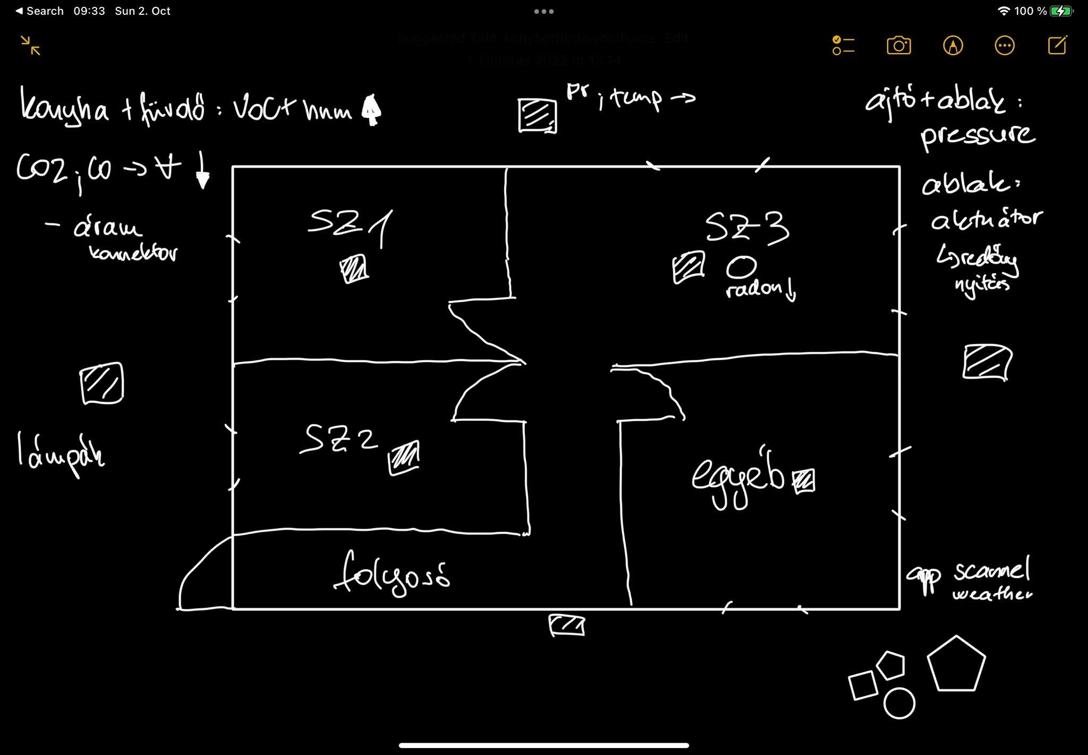

For hardware, we are using ESP8266 modulated developer board. It is typically used in smart homes because it is Wi-Fi ready, low energy and small. We made 3 sensors for our purpose of making of creating Therma-Flow. We are using the same Bluetooth Low Energy (BLE) module for all the PCBs ([link](https://www.alibaba.com/product-detail/Ble-Module-Wearable-Smart-Home-Low_1600550992880.html?spm=a2700.7735675.normal_offer.d_image.555365c5UeNcxm&s=p)). It is a tiny module. It has Bluetooth 5.0 protocol. We choose BLE because of it’s efficiency. For voltage regulation, LM1117-3.3V is used in every device ([link](https://pdf1.alldatasheet.com/datasheet-pdf/view/659331/TGS/LMT1117-3.3.html)). The Github repo for the schematics and board files can be seen here: ([link](https://github.com/bence-vass/CodeLikeABosch)).

The bill-of-materials:

|  |  |  |  |
| --- | --- | --- | --- |
|  | Module name | Price (1000pcs ) |  |
|  | BLUENRG-234 | $3.89 |  |
|  | Amphenol CS 10118193-0001LF | $0.32100 |  |
|  | SCD40-D-R1 | SENSIRION | $24.72 |  |
|  | BMP280 | $1.9375 |  |
|  | SGP30 |  |  |
|  | ESP8266 |  |  |
|  | AMS1117-3.3 LM1117 | $1.88 |  |
|  | CR2032 Battery Holder | $0.05 |  |
|  | ASAIR AHT20 | $0.58 |  |
|  | 3V CR2032 Primary lithium button battery | $0.08 |  |

The first board is a humidity and carbon-monoxide sensor. The created PCB can be seen below:

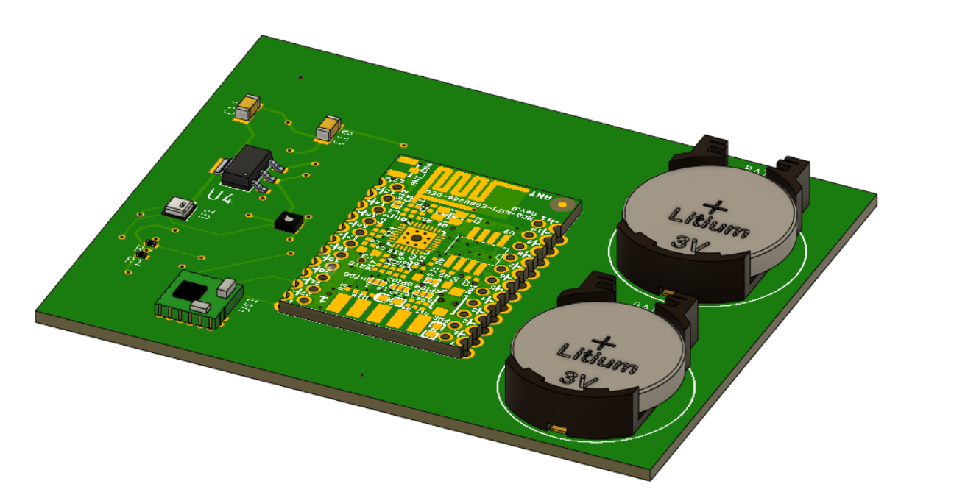

The carbon-monoxide sensing, we use the AHT20 sensor. The datasheet can be seen here: [link](https://files.seeedstudio.com/wiki/Grove-AHT20_I2C_Industrial_Grade_Temperature_and_Humidity_Sensor/AHT20-datasheet-2020-4-16.pdf). For humidity sensing, SGP30 is in use ([link](https://www.soselectronic.hu/products/sensirion/sgp30-sgp30-2-5k-260028)). For power supply we chose button batteries, because they are easy to replace, and for this small PCB, it can last for very long times.

The second sensor is a pressure sensor with a BMP280. It can be seen below.

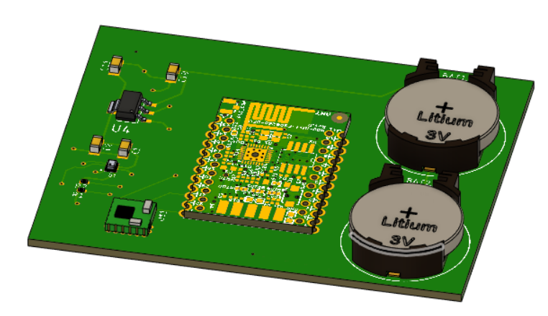

BMP280 is a very small, low energy sensor, with these specs: ([link](https://pdf1.alldatasheet.com/datasheet-pdf/view/1132069/BOSCH/BMP280.html)). Everything else is the same as on the one above.

The third sensor measures pressure, CO2and humidity.

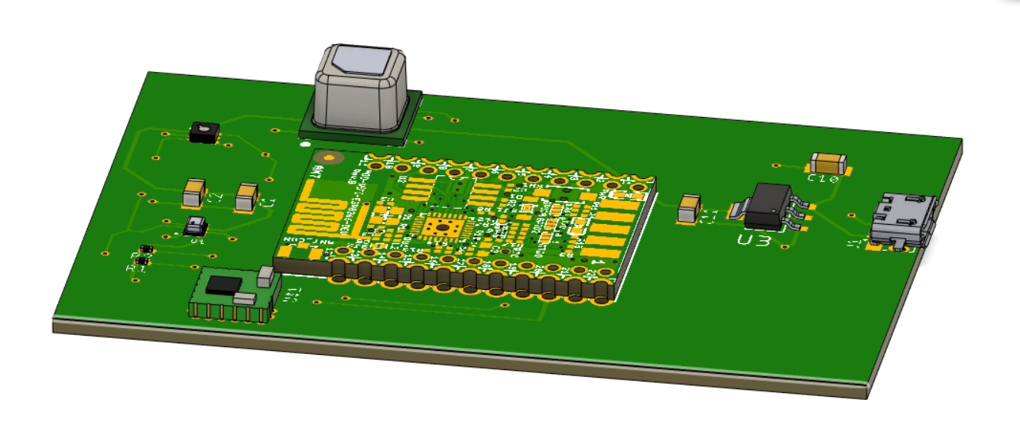

It’s power supply is a micro-usb connector. The CO2 is a SCD40 measuring device ([link](https://cdn.sos.sk/productdata/fe/f6/5759c208/scd40-d-r1.pdf)).

For the window and shutter automating problem, we decided to go with an off-shelf solution. We choose a [motorized shutter](https://www.overgate.hu/ablakmozgatas/kapcsolos-redonymotorok/am35-1017-premium-kapcsolos-redonymotor-10nm) with a 433MHz rf receiver built into it and designed a [transmitter](https://www.rfsolutions.co.uk/radio-modules-c10/alpha-tx-low-cost-high-performance-transmitter-module-p323) for it with the ESP8266 board. We did similarly with the window opener.