1.Group No (state your group number here):
14

2.Group Members
Member No | Student Email | FirstName | Surname | Present (Y/N)
1 | s1295504@live.hkmu.edu.hk | Shing Kit | Lui | Y
2 | s1318885@live.hkmu.edu.hk | On Tai | Hung | Y
3 | s1318886@live.hkmu.edu.hk | Ching Hong | Chan | Y
4 | s1324424@live.hkmu.edu.hk | Holly Lei | Stephenson | Y
5 | s1402940@live.hkmu.edu.hk | Siu Hin | Chak | Y
6 | s1403099@live.hkmu.edu.hk | Kai Ho | Wan | Y
7 | s1410340@live.hkmu.edu.hk | Tsz Fung | Wong | Y
8 | s1410394@live.hkmu.edu.hk | Ching | Lo | Y
9 | s1411205@live.hkmu.edu.hk | Ho Him | Cheung | Y
10 | s1414286@live.hkmu.edu.hk | Ho Ching | Yu | Y

3.Submit the Use Case Diagram
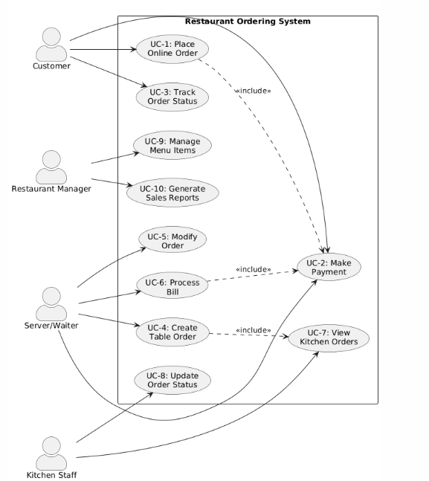

Actors and Use Cases

Customer (End User):
• UC-1: Place Online Order
• UC-2: Make Payment
• UC-3: Track Order Status

Server/Waiter:
• UC-4: Create Table Order
• UC-5: Modify Order
• UC-6: Process Bill

Kitchen Staff:
• UC-7: View Kitchen Orders
• UC-8: Update Order Status

Restaurant Manager:
• UC-9: Manage Menu Items
• UC-10: Generate Sales Reports

UC-1: Place Online Order
Actor: Customer
A customer accesses the restaurant's online ordering platform (web or mobile app) to browse the menu, select food items, customize their order (depends on each disk. Like add special instructions, select level, remove ingredients), specify delivery or pickup preferences, and submit the order. After the order submitted, the system should verify the order, which will include calculates the total amount including delivery fees, lists it to the customer, and confirms the order. Then transmitted to the restaurant's kitchen display system for food preparation. This allows customers to order remotely without having to visit the restaurant.

UC-2: Make Payment
Actor: Customer/Server
Support payment for completed orders. It calculates the final payment total to capture the cost of food, taxes, service charges, and any discounts or promo codes (if have). The system has the ability to accept multiple modes of payment, including card, Apple Pay, Google Pay or cash, as well as secure payment processing is integrated into the system. When the payment is satisfactory, the receipt is printed, the order status is updated to paid, and the transaction information is sent to the accounting system for reconciliation. If the payment is unsuccessful, an error message is generated and provides an opportunity to process another payment.

UC-3: Track Order Status
Actor: Customer
Customers can monitor the status of their orders in real time. The Purchase Status stage shows whether the order is Order Received, Ready, Ready for Pickup/Delivery, or Completed. Where appropriate, we will give customers an estimated delivery time and/or location of the delivery order. Provide regular text messages or push alerts about the status of your order, so, customers don’t have to check all the time.

UC-4: Create Table Order
Actor: Server/Waiter
The server creates a new order using the point-of-sale terminal. In addition to choosing a table number or creating a customer ID, servers read menus, add items to orders and apply customizations, such as no onions, no cheese and other questions. Special notes for the kitchen can be added by the waiter. Once confirmed, the order is sent directly to the kitchen display system where one’s order ID is assigned. Orders remain “active” on the kitchen display system until payment is received. Reduces errors caused by manually written orders.

UC-5: Modify Order
Actor: Server/Waiter
Before any order goes into the kitchen, or while an order is being prepared, the server has the ability to change existing orders per the customers requests. Modifications include adding line items, removing line items, changing the quantities, changing customizations, or correcting for mistakes. The system will check to confirm the modifications based on the order status and will only allow modifications to the order if the menu item has not been prepared yet. Any modified orders are distinctly marked on the kitchen display system to notify the kitchen staff that modifications have been made. The system will also retain an audit trail for modified orders including timestamps and user IDs for individual accountability and tracking the quality and service of each order.
UC-6: Process Bill
Actor: Server/Waiter
When customers are ready to pay, the server retrieves the order using the table number or order ID. The system displays all ordered items with individual and total costs. The server can apply discounts (manager-approved), split bills among multiple customers, or combine multiple orders. The system calculates taxes, service charges, and displays the final amount. The server selects the payment method and processes payment. For cash payments, the system calculates change. Upon completion, the system prints or emails receipts, marks the order as closed, and makes the table available for new customers.

UC-7: View Kitchen Orders
Actor: Kitchen Staff
The individuals preparing food will be able to see the orders in real time through a noted system. Orders are prioritized and displayed based on the timing of order and type (dine-in, takeout, delivery). Each order has the table number/customer number, dishes ordered, detailed preparation instructions, dietary restrictions, and a timestamp. The display will also use color based on the timing of the order (e.g., an order that has a long wait will be in red). Staff will also be able to filter the orders by type of food.

UC-8: Update Order Status
Actor: Kitchen Staff
As the kitchen team processes orders, they manage order status in the noted system interface using a set of touch-controlled buttons. The status will go from 'Received' to 'Preparing' to 'Ready to Pick Up,' to 'Done.' Each status change will generally trigger a notification to the associated parties: servers will be alerted when an order is ready, and customers will receive updates on their online orders as well. The system will also timestamp every status change for later performance analysis. In case of any delays, a staff member can also add an estimated time for completion. By updating statuses, visibility is maintained throughout the restaurant process, and intra-restaurant staff communication and coordination are improved.

UC-9: Manage Menu Items
Actor: Restaurant Manager
Restaurant managers can control the menu. They can add new items that come with descriptions, pricing, pictures, ingredients, allergens, and availability. Item editing is supported for menu items, such as price updating, marking items as temporarily out of stock, and recipe editing. Items can be organized into categories (meat, vegetables, or desserts). The restaurant system has tiered pricing options (lunch/dinner). All menu edits will take effect on all ordering interfaces immediately.

UC-10: Generate Sales Reports
Actor: Restaurant Manager
Managers create detailed operational reports to assist in both business analysis and decision-making. Reports could integrate many types and include sales report summaries (daily sales totals), menu item popularity summaries, revenue summaries (by payment type), server statistics, peak hours analysis, inventory usage, and reports comparing periods (e.g. week-over-week, month-over-month). During these reports, managers can specify date range, filtering criteria, and how they would like to receive the report (PDF, Excel, screen output). The system then queries the database, compiles transaction data, performs calculations, and outputs results in charts and reports. Reports can be scheduled to generate automatically and can be emailed to the manager. The reports and dashboards provide the business with data-driven insights for decision making, including menu optimization, staffing needs, inventory purchasing decisions, and marketing campaigns.

4.Submit the evidence from your system modeling
Link:
https://drive.google.com/file/d/1pKiQJRnb3DsKnsb0UQcewPCRxVaf51Dc/view?usp=sharing

5. Individual Members' Activity
UC-1: Place Online Order
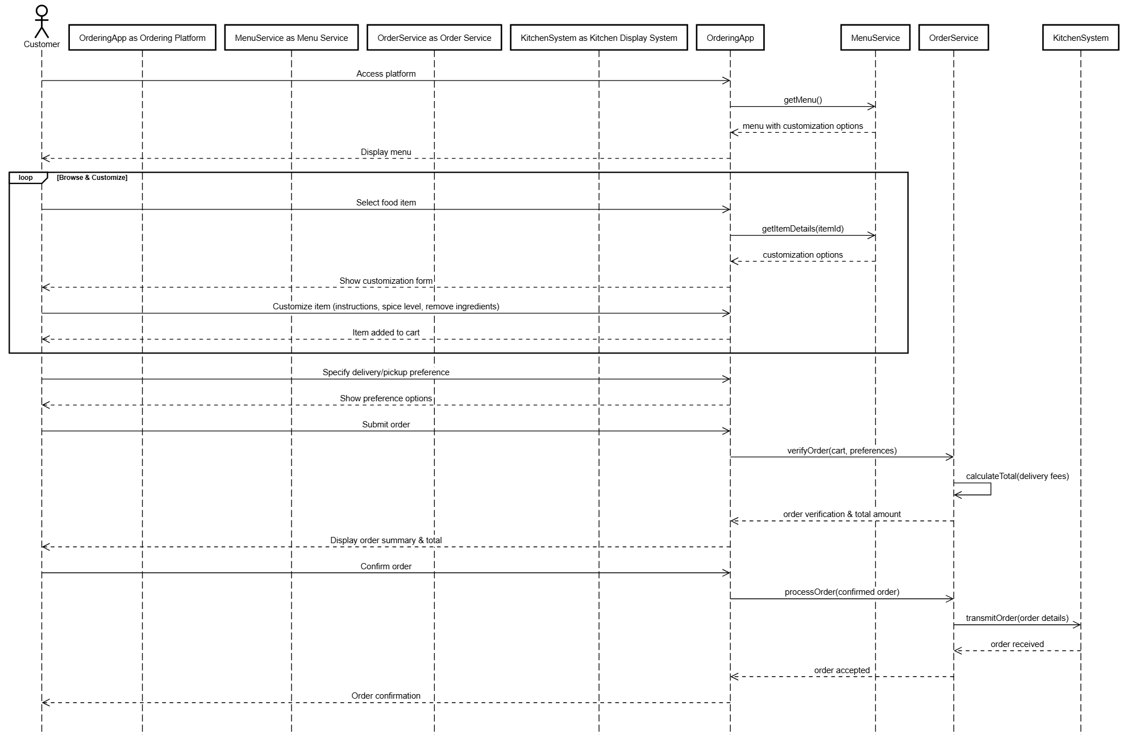
The UC-1: Place online order illustrates the online ordering process for a restaurant. The customers will access the online ordering platform, mostly using the QR code or application. After that, customers can browse the menu to order, and if there are any specific requirements for the food, they can modify the order. The online system receives the order based on the customer specifying delivery or takeaway, and the system will confirm the order and provide the order summary and confirmation. Therefore, the system will send the order to the restaurant’s kitchen for food preparation. This workflow enables online ordering to be more efficient.

UC-3: Track Order Status
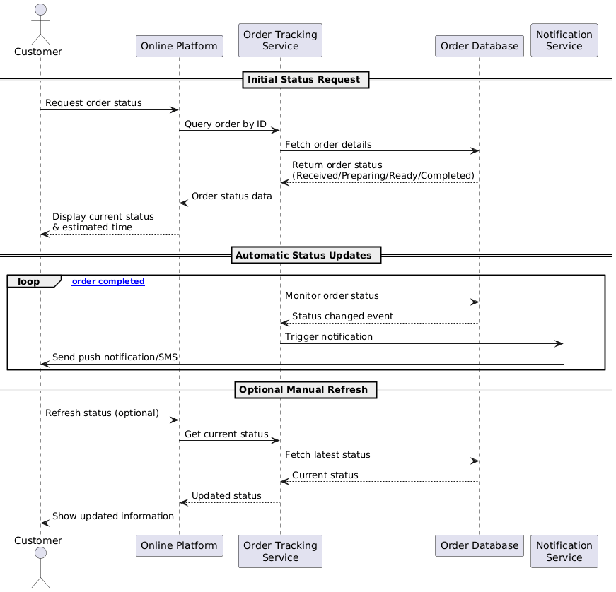
It shows how a customer can track an order's status through four interactions: Online Platform, Order Tracking Service, Order Database, and Notification Service. Status Request: The Customer requests the Online Platform for status on the order. The Platform sends the orderId to the Order Tracking Service. The Service queries the Order Database. The Database returns the status (e.g., Received, Preparing, Ready, Completed). The Order Tracking Service sends the status back to the Online Platform, which displays the status and ETA to the Customer. This is a synchronous/request–response path. Event-driven loop of automatic status updates: The Tracking Service monitors the Database for status changes. On change, the Service notifies the Notification Service, which send a push/SMS notification to the Customer. This continues until the order is completed. Optional manual refresh: At any time, the Customer can refresh in the Platform. The Platform send a request to the Order Tracking Service for updated status. The Order Tracking Service re-queries the Order Database and returns the status for the Platform to show.
UC-4: Create Table Order
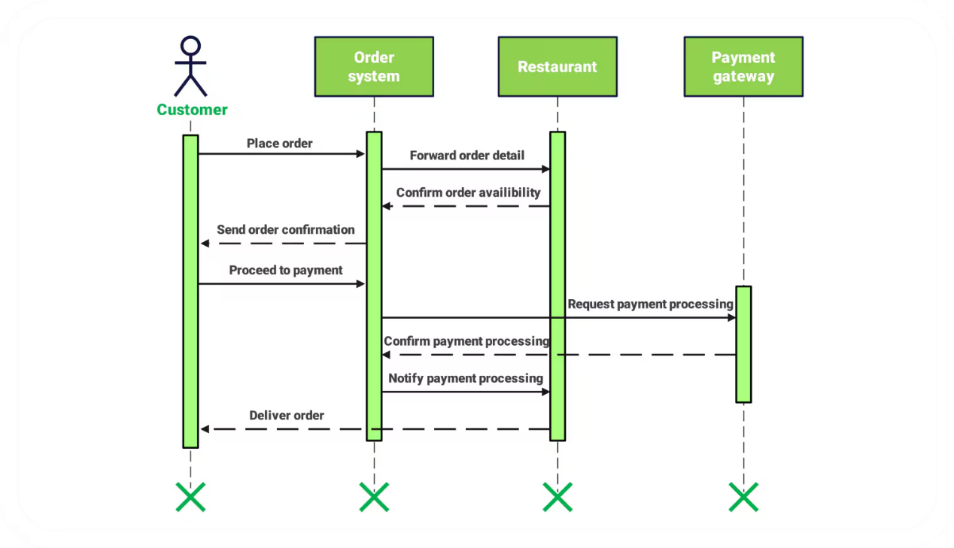

The "View Kitchen Orders" feature allows kitchen staff to monitor received orders in real time through the Kitchen Display System (KDS). When they login, the system displays the details of order, like customer descriptions, dietary notes, timestamps, and priorities (e.g. color-coded urgency). Staff can filter by workstation (e.g. appetizer or main) or order type. The system shows messages for new orders or order delays. This feature supports not only order creation but also order status updates, ensuring efficient kitchen operation, coordination, and minimizing wait times and errors.

UC-6: Process Bill
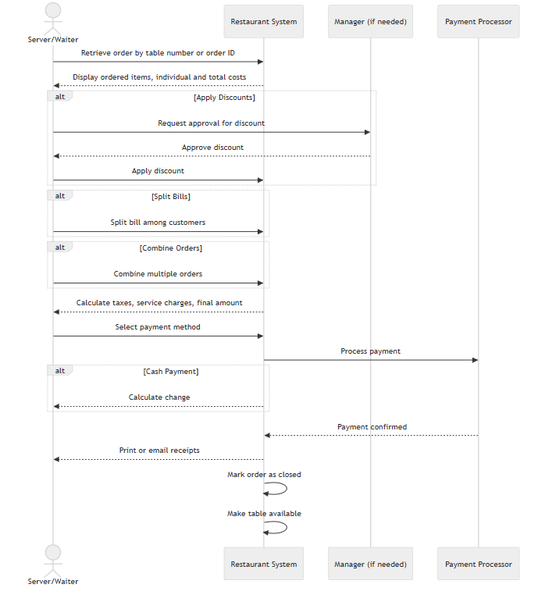
For the use case 6, Process Bill sequence diagram shows the interactions between the server/waiter, restaurant system, manager (if needed), and payment processor to finalize payment for dine-in orders.
The server begins by getting the order using the table number or order ID from the system. This shows all items with their costs. If there are any discounts, the server asks the manager for approval, applies the discount in the system once approved.
The server tells the system how to split the bill among customers and merge orders. The system then figures out taxes, service charges, and shows the total. The server picks the payment method, and the system sends it to the payment processor for processing.
If cash is used, the system makes the change for the server. Once payment is confirmed by the processor, the system sends receipts (print or email) to the server, closes the order, and frees up the table for new use. This flow ensures efficient, flexible bill processing with secure payment integration and minimal errors..

UC-7: View Kitchen Orders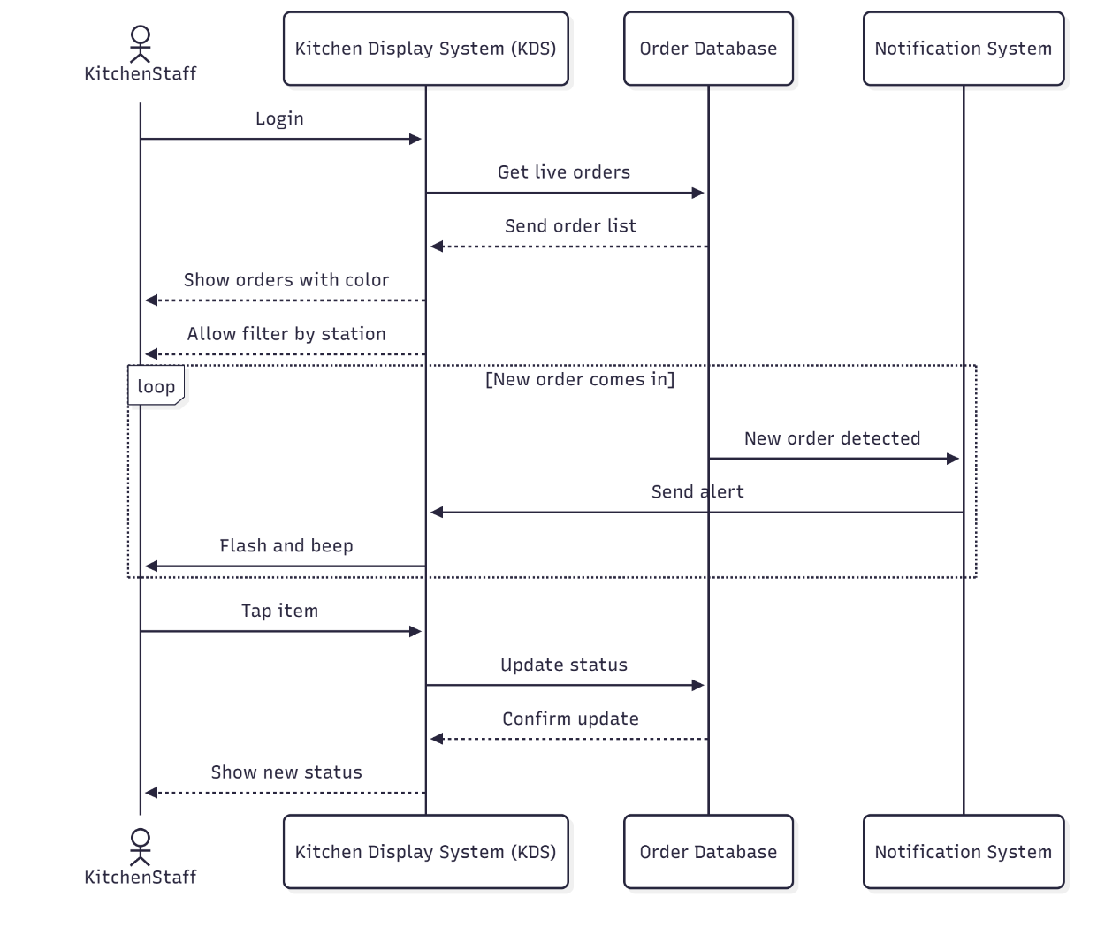
The sequence diagram shows how Kitchen Staff use the Kitchen Display System (KDS) to monitor orders in real time. After login, the KDS requests all active orders from the Order Database. The database returns complete details: table or customer number, dishes ordered, preparation instructions, dietary restrictions, timestamp, and order type (dine-in, takeout, delivery). Orders appear sorted by submission time and priority.
The KDS displays orders with clear color coding: green for on-time, yellow when nearing delay, and red for orders with long wait times. Staff can filter by food type so each station sees only relevant tasks. A background loop runs continuously. When the Order Database detects a new order, it signals the Notification System. The Notification System sends an alert to the KDS, which flashes the new order and plays a loud beep so staff notice instantly.
Staff interact directly by tapping any item. This opens options to mark it as “Cooking” or “Ready.” The KDS sends the update to the Order Database, which saves it and confirms success. The screen refreshes immediately, and the change syncs to the waiter’s tablet. Auto-refresh every 10 seconds ensures the latest data from waiters or managers.

UC-8: Update Order Status
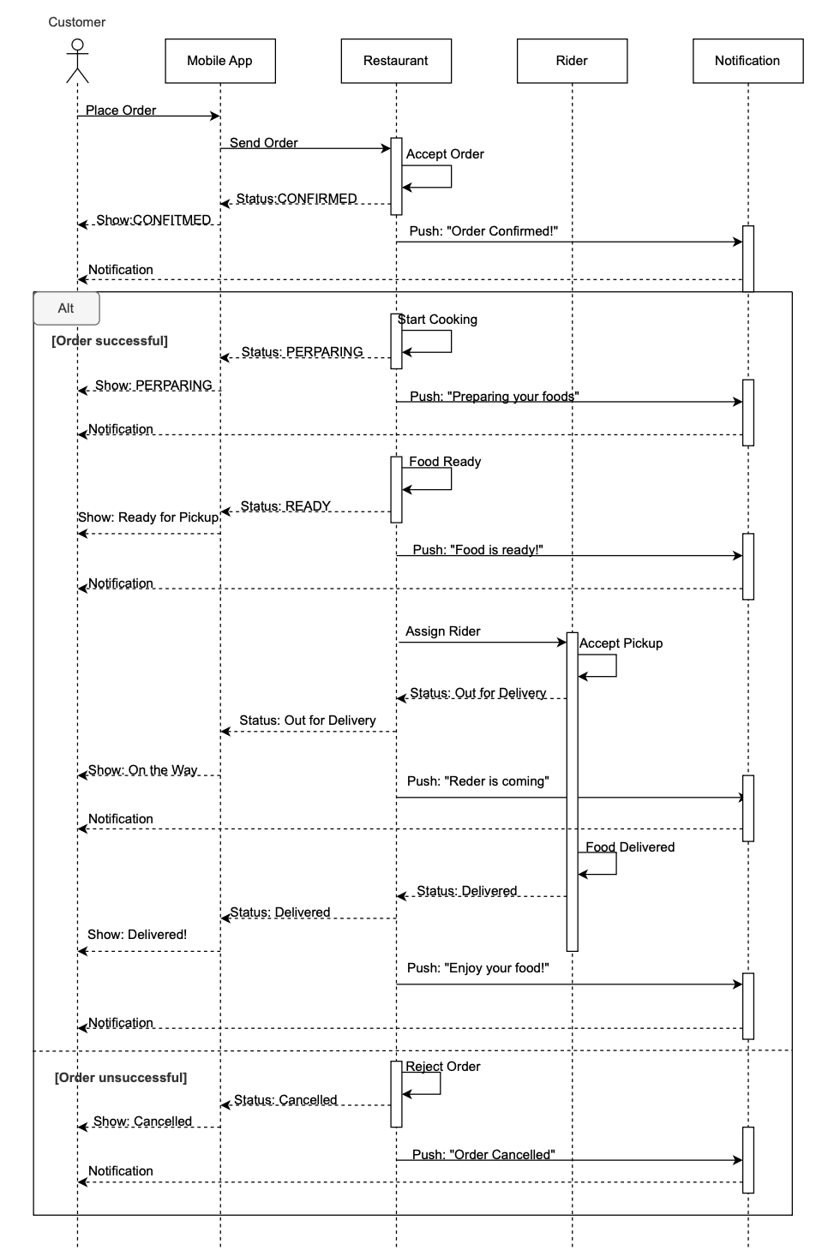
This sequence diagram shows a food ordering system. Customer places order via Mobile App, which sends it to Restaurant. If accepted, status updates to CONFIRMED, then PREPARING (start cooking), READY (food done), and OUT FOR DELIVERY (rider assigned). Rider delivers, ending in DELIVERED. App shows updates to customer; Notification sends pushes like "Order Confirmed!" or "Rider is coming." Alt box splits: [Order successful] for full flow, [Order unsuccessful] for reject (CANCELLED with "Order Cancelled" push).

UC-9: Manage Menu Items
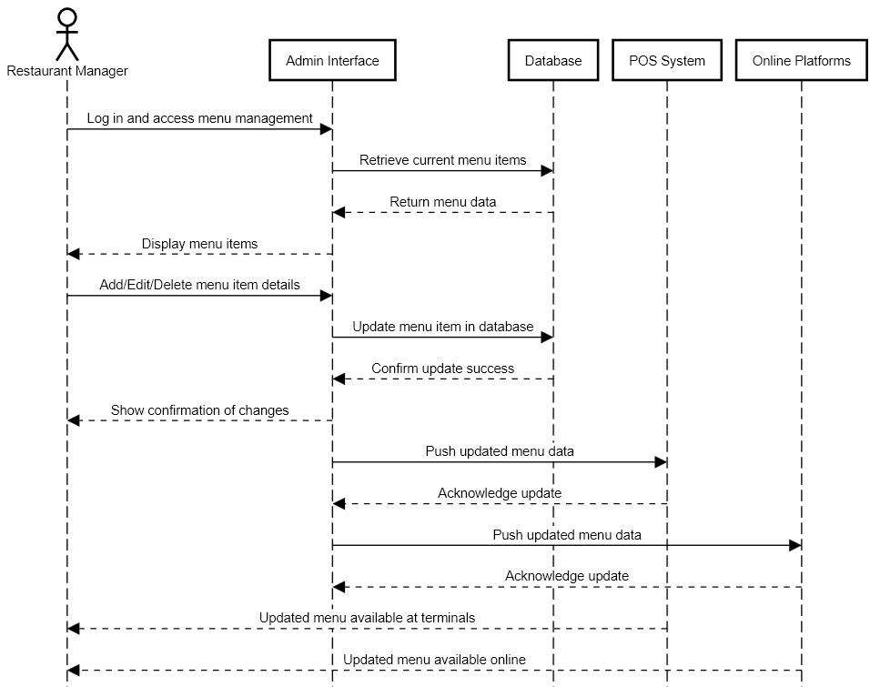
With this system, Restaurant Manager only needs to interact with the Admin Interface while editing the menu.
Restaurant Manager (RM) can perform different operations on the menu:
Read: RM can see all the items inside the menu through database, including unavailable dishes.
Create, Edit & Delete: RM can make a new dish, edit them and delete them. All changes will be committed to the Database. Also, RM can change the dish’s availability. Once a dish is marked unavailable, customers would not be able to purchase the said dish.
The Admin Interface handles all operations on the Database. Once updates are confirmed, the Admin Interface pushes changes to both POS System and Online Platforms, so that updates can take effect immediately across all ordering channels.

UC-10: Generate Sales Reports
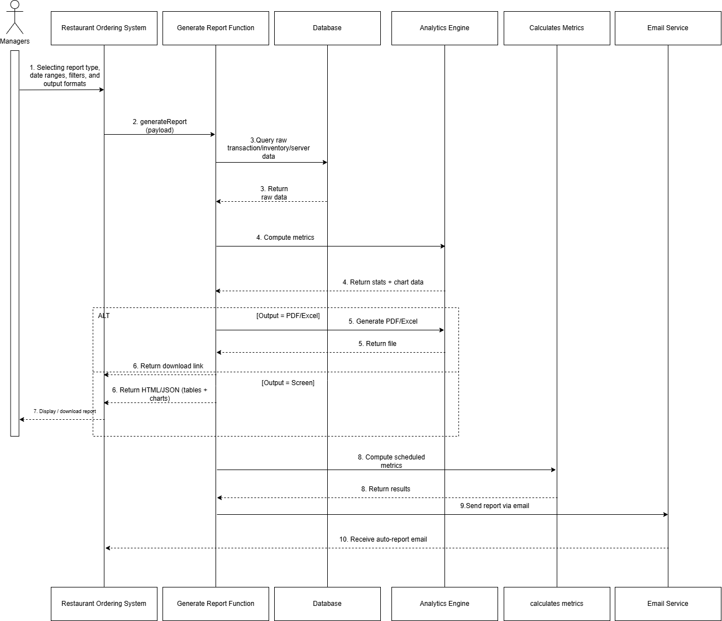
This diagram outlines “Generate Sales Report Functions,” from a manager’s simple request to send it to their inbox. Managers require information about sales figures or inventory levels. The person begins by selecting the type of report and the type of file format, which is mentioned in UC-10.
Once they click "generate." It is like a project manager acting on behalf of the user; asking the database first for every transaction, the database will send the raw data. If the manager selected the type of the output, like peak hours analysis and inventory usage. This raw information will be sent to the analytics engine.
Finally, the report has been generated. The system created a download link for files in PDF or Excel formats. If the user selected that the report display on the screen, the system should use HTML/JSON for the chart or the table. Also, there is the option that the report will be sent to the specified email address.

