# Vestas AME Tower Bolt App Documentation

**README** **Instructions**

This document covers required user information for the VAME Tower Bolt App.

The app is a tool to automate the generation of tower flange bolt tension reports and reduce the amount of manual analysis work performed by engineers for flange tensioning TSLs.

For concerns regarding flange bolt tensioning, please contact the technical specialist.

For concerns regarding the application software, please contact the tool developer.

|  |  |
| --- | --- |
| **Technical Specialist** | **Tool Developer** |
| GEOBE | TOBHI |

Contents

Vestas AME Tower Bolt App Documentation 1

A. Installation Instructions 2

B. Folder Structure Requirements 3

C. General Operation Instructions 5

D. Running Multiple Flange Reports 9

E. Selecting the output location 9

F. Changing the parent folder 10

G. Building a Project Folder 11

## Installation Instructions

1. Install Anaconda through Software Central

* 1. Once installed, make sure that you have access to “Anaconda Prompt” from the start menu.

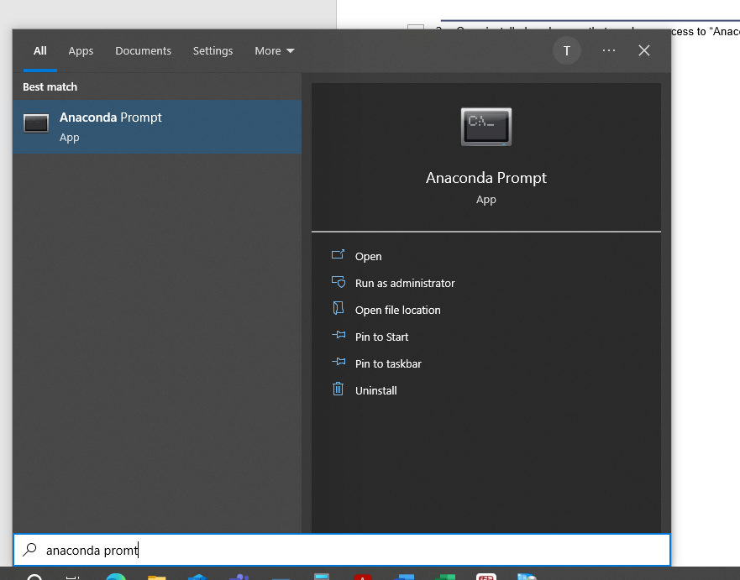

1. Download the tower_bolt_app.py file and the tower_bolt_package folder from this link onto your own computer.
   1. It is required that these two items remain in the same folder.
   2. Typically, this will be placed in the folder hosting all the project folders, as shown.

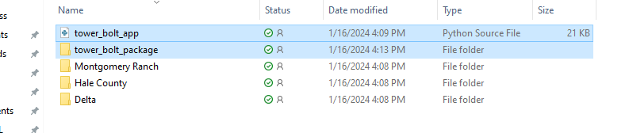

## Folder Structure Requirements

The Tower Bolt App requires that the Xml files be stored in the following folder hierarchy:

Parent Folder

Tower Name

Flange Name

2 Xml Files

Project/Site Name

*Example Folder Structure as a File Tree*

Parent Folder

├───tower_bolt_package

├───tower_bolt_app.py

└───Montgomery Ranch

├───C01

│ ├───B-M1

│ │ ├─── 1698959365000_MGR-C01-Base-M1 Second Round.xml

│ │ └─── FirSt.xml

│ ├───M1-M2

│ ├───M2-M3

│ └───M3-T

└───D04

└───M2-M3

├─── 1700257567000_MGR-D04-M2-M3 First Round.xml

└─── seconD.xml

*Example Folder Structure in File Explorer*

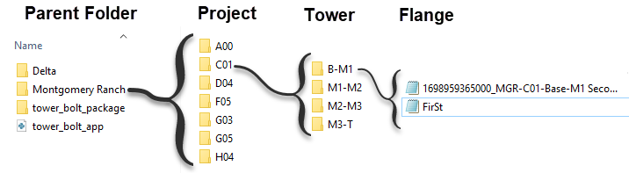

***Naming Requirements***

* Tower folder names should be the pad location name of a similar format to “A00” or “T03”.
* Flange folders must have the shown names.
* Xml files must have the round in either the file name or the ProgramID field.

## General Operation Instructions

1. Open Anaconda Prompt

1. Change the active directory to the folder with the Tower Bolt App files.
   1. It is easiest to copy the file path from File Explorer with **Ctrl+C**.

* 1. Then, in Anaconda Prompt, write “**cd**” and then paste with **Ctrl+V**.

* 1. Press **Enter**.

1. Run the Python script.
   1. In Anaconda Prompt, write “**python tower_bolt_app.py**”.

* 1. Press **Enter**.
  2. This should open the Tower Bolt App. If it opens behind other windows, it can be found with **Alt+Tab.**

1. Select the wind farm project from the drop down selector.

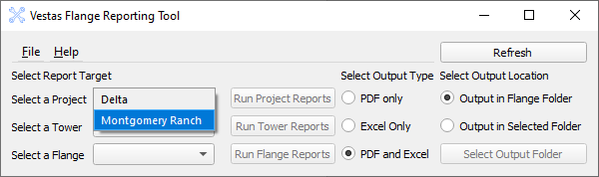

1. Select the tower from the drop down selector.

1. Select the flange from the drop down selector.

1. Click on the **Run Flange Reports** button and wait for it to complete.

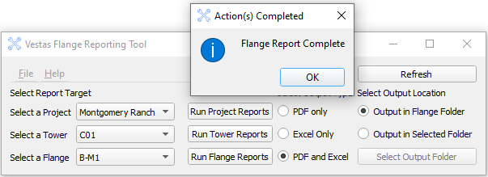

1. Click **OK** to return to the main tool.
2. Navigate to the selected output folder to find the created reports.

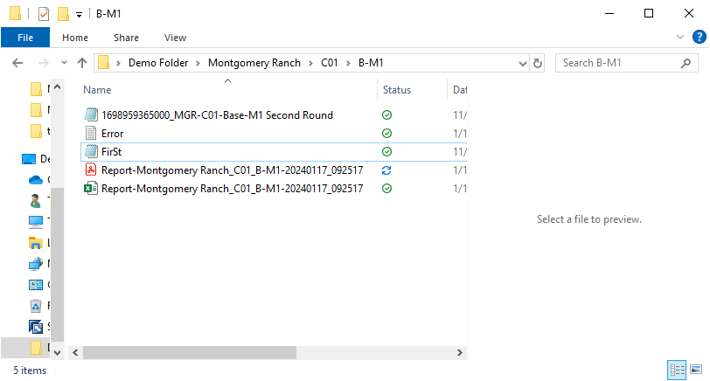

* 1. An “Error.txt” file will be created if there are any known errors or alerts during report generation.

## Running Multiple Flange Reports

The app allows the user to run reports for multiple flanges with one click. The two provided options are to run reports on all the flanges in each tower or to run reports for all of the flanges in every tower in a wind project.

1. Running reports for all flanges in a tower.
   1. Select the tower as discussed in section C.
   2. Click **Run Tower Reports**.
   3. This will loop through the available flanges in that tower, creating the report for each.
2. Running reports for all tower in a project.
   1. Select the project as discussed in section C.
   2. Click **Run Project Reports**.
   3. This will loop through the available towers in that project. In each tower, it will then loop through the available flanges to create each report.

## Selecting the output location

Under default settings, the reports for each flange will be generated and stored within the flange folder. This is beneficial for organization, but when creating many reports at the same time, it may save some time to have the reports for all flanges saved in a single separate folder. It is possible to set this in the app by changing the output location selection.

1. Under **Select Output Location**, click “**Output in Selected Folder**”.
   1. This should bring up a folder selection window. If it does not, click the **Select Output Folder** button.
2. Select the output location with the folder selector.
3. To change back to saving in the flange folders, click “**Output in Flange Folder**”.

*A Note on Report File Naming*

The generated reports have names in the following format:



The generalized format is:

“Report-Project Name_Tower_Flange-DATE_TIME.extension”

|  |  |
| --- | --- |
| **Filename Substring Formatting** | |
| DATE | YYYYMMDD |
| TIME | HHMMSS |
| extension | .pdf or .xlsx |

## Changing the parent folder

The parent folder is the top level folder housing the directories for each wind farm project. In the example above, the parent folder would be “Demo Folder”.

It is recommended to include the application files in the parent folder, but this is not required.

The parent folder can be changed in the app by selecting it in the file menu.

1. Under the **File** menu, select “**Change Parent Folder**”.

* 1. This will open a Windows file selector.

1. Navigate to and select the new parent folder.
2. Click the **Refresh** button in the app to load the projects in the new parent folder.
   1. Note: The “**Reset Options**” button under the **File** menu will reset the parent folder to the default location. Do not use this if you have changed the parent folder.

## Building a Project Folder

Building the multi-level folder structure required for this tool can be time-consuming. The application is able to build empty folder structures for whole project semi-automatically.

1. Under the **File** menu, select “**Build Project Folder Tree**”.

1. Fill out the input fields.
   1. Select the parent folder for the project.
   2. Write the project name into the “Input Project Name” line.
   3. Write the tower names into the third line, separated by commas as shown.

1. Click **Build Directory**.
   1. Each tower folder will be generated with 4 empty flange subfolders.
   2. If a folder has already been made, it will not overwrite the data in this category. Thus, this can also be used to add new towers to an existing project folder.