DIY3 and DIY4 Pressure Transducer User Manual
Ben Chittle
chittle5@uwindsor.ca

Table of Contents
DIY3 and DIY4 Pressure Transducer User Manual 1
1. Capabilities 2
1.1. Sampling 2
1.2. Accuracy 2
1.3. Battery Life 2
1.4. Durability 2
2. Pre-Deployment Checklist 3
2.1. Check Main Batteries 4
2.2. Check microSD Card 4
2.3. Try Powering On the Transducer 4
2.4. Change Coin Cell Battery 5
3. Deployment 6
4. Diagnosing Errors 8
5. Downloading and Unpacking Data 10
6. Processing Data 11

DIY3 and DIY4 Pressure Transducer User Manual
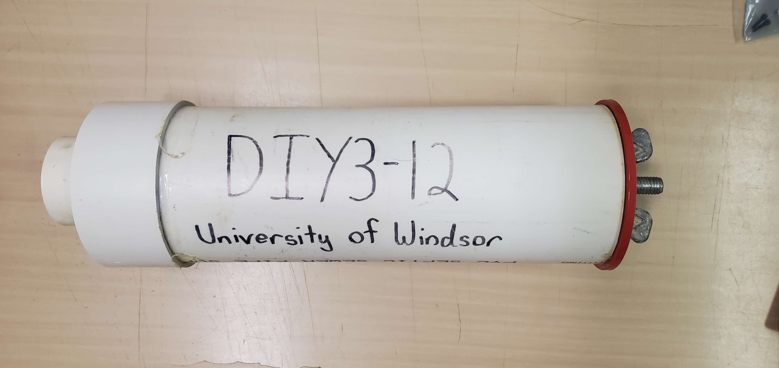
This guide explains how to prepare and deploy a DIY3 or DIY4 pressure transducer. It also gives details on capabilities, downloading data, and processing data. It does not include details on assembly of the electronics/housing or reprogramming the transducer.
Feel free to direct any questions to Ben Chittle (chittle5@uwindsor.ca).

1. Capabilities

1.1. Sampling
The transducers sample at a rate of 1 Hz continuously for as long as they are powered on. Each sample consists of an absolute pressure reading (millibar) and a temperature reading (degrees Celsius) from the sensor module exposed at the top of the transducer. Timestamps are also recorded.
Data is stored on a microSD card in a custom raw binary format. A Python script is needed to unpack the data. See Section 5.

1.2. Accuracy
The transducers have been tested against a commercial RBR TWR-2050 pressure transducer in the lab and on several paired field deployments. Depths ranged from 0 m (atmospheric pressure) to 2 m of fresh water.
- Pressure error observed: < 1 millibar
- Temperature error observed: < 1 degree Celsius
See the Data Sheet for the sensor module used by the transducer for more information.
Note: Accuracy may drift over time and require recalibration. This has not been tested.

1.3. Battery Life
Each transducer requires 3 AA batteries and 1 CR2032 coin cell battery.
The transducers have been tested to run continuously for at least 4 months on fresh batteries, and could likely continue for much longer (perhaps close to a year, though this has not been tested, and durability would likely be an issue).
Not all battery brands are equal. Duracell and Energizer brand batteries have worked well for testing and deployment in the past.

1.4. Durability
The transducers are prone to degrading during deployment. Regular check-ups are a good idea when deployed in the field to avoid data loss.
The most common issue is when the sensor module exposed at the top of the transducer becomes damaged and stops working. Existing data can still be recovered in this case, but the transducer housing will need to be replaced.

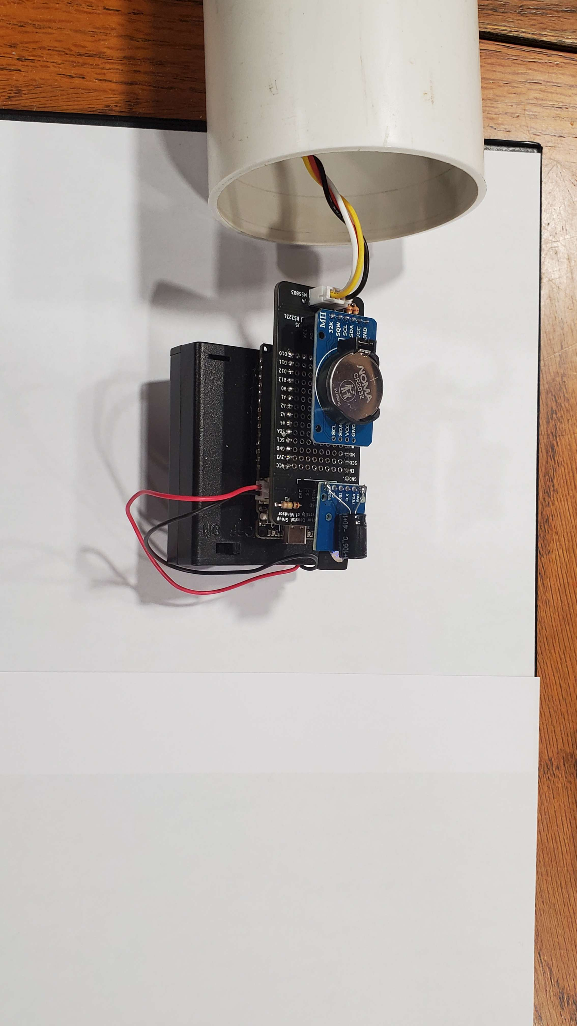
2. Pre-Deployment Checklist
CR2032 Coin Cell
microSD Card
On/Off Switch
Main Battery Holder
Indicator LED
(to the right of USB-C)
These checks should be done in the lab in the order shown below for each sensor before deployment.
- Check if main batteries need to be changed.
- Check microSD card for old data.
- Try powering on the transducer and see if any errors are reported.
- Check if coin cell battery needs to be changed.

See details below.

2.1. Check Main Batteries
- Ensure the On/Off Switch is switched off.
- Open the battery case:
  - On the opposite side of the Main Battery Holder (as shown in the image above), locate and remove the screw.
  - Slide off the cover.
- You can now test the batteries (if you have a battery tester or multimeter) or replace them. Ensure they are replaced in the same orientation.
  - If testing the batteries, ensure each one has a voltage of at least 1.2 V. The nominal voltage would be closer to 1.5 V. Anything under 1 V should be considered “dead” for this device.

2.2. Check microSD Card
- Ensure the On/Off Switch is switched off.
- Pull the card straight out from the slot. Don’t worry about touching any exposed electronics, they won’t be damaged as long as the device is off.
- Plug the card into a computer (use an adapter if needed) and open it.
- There should be a file called “config.txt.” Do not delete this file. If it is missing, it will need to be properly replaced.
- Feel free to clear any other files on the card.
- Eject the card from the computer and put it back in the slot on the transducer.

2.3. Try Powering On the Transducer
- Flip the On/Off Switch to on.
- A light next to the USB-C port should flash.
  - A solid 3 second flash followed by nothing means the device is working.
  - Otherwise, wait until a stable flash pattern is established (it may attempt to restart several times) and then see the section on diagnosing errors.
- Turn the device off at any time by switching the On/Off Switch to off.
- Repeat if needed.
- After testing, check the contents of the microSD card.
  - A file should have been created with a name like
“DIY3-02_20230604-1527” where “DIY3-02” is the name of the sensor (as written on the housing), “20230604” is the current date in YYYYMMDD format and “1527” is the time when the file was created by the transducer in 24-hour HHMM format.
    - The file will be empty unless the transducer was able to run for more than 2 minutes (data is only saved to the card every two minutes).
    - If data was collected, you will need a Python script to unpack it. See Section 5.
  - If the date in the file name is incorrect, see the next section to change the coin cell battery. Otherwise, the transducer is ready for deployment.

2.4. Change Coin Cell Battery
This step is only needed if files created during the previous test did not have the correct current date (e.g. if the date is in the year 2000).
In this case, the clock will need to be reset. Please reach out to Ben (chittle5@uwindsor.ca) to resolve this.

3. Deployment
The following is needed for deploying a transducer:
- Pool noodle slice and desiccant should already be in the transducer housing. (Desiccant to absorb any small amounts of moisture, pool noodle to hold the electronics in place).
- Wrench or pliers to tighten red gripper cap.
- Something to mount the transducer to and an optional buoy marker (assuming underwater deployment).

The steps to deploy a transducer follow.
- Power on the transducer by flipping the On/Off switch to on.
  - It can also be a good idea to record the exact time (within a couple seconds) when the transducer was powered on if it becomes necessary to adjust for clock drift later.
- Make sure you see the indicator LED next to the USB-C port turn on for 3 seconds. If any other flashing is seen, this indicates a warning or error. Try powering the device off and on again. If it continues, see Section 4.
- Place the electronics in the PVC housing.
- Shove the pool noodle slice above the electronics to secure them in place.
- Place some desiccant packets on top of the pool noodle.
- Place the red gripper cap onto the end of the housing and begin to hand-tighten it closed. Ensure the cap is flush with the housing.
- Use a wrench or pliers to finish tightening the cap. Avoid over-tightening it! A good rule of thumb is to tighten it just until you can no longer easily loosen it by hand.
- Deploy the transducer. Try not to jostle it around too much while mounting it.
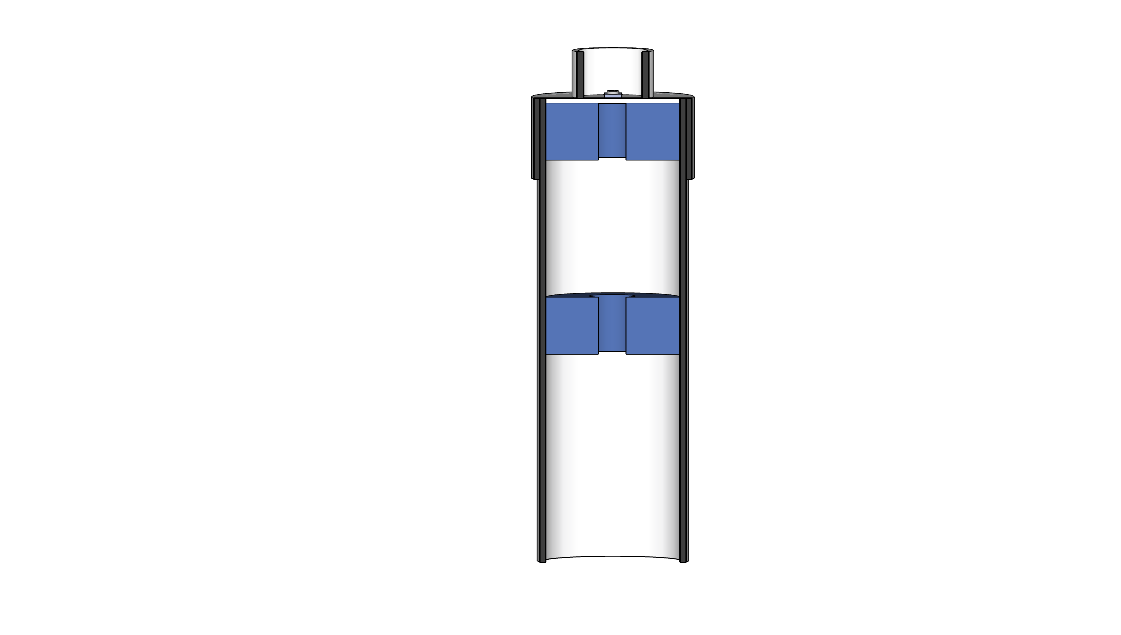
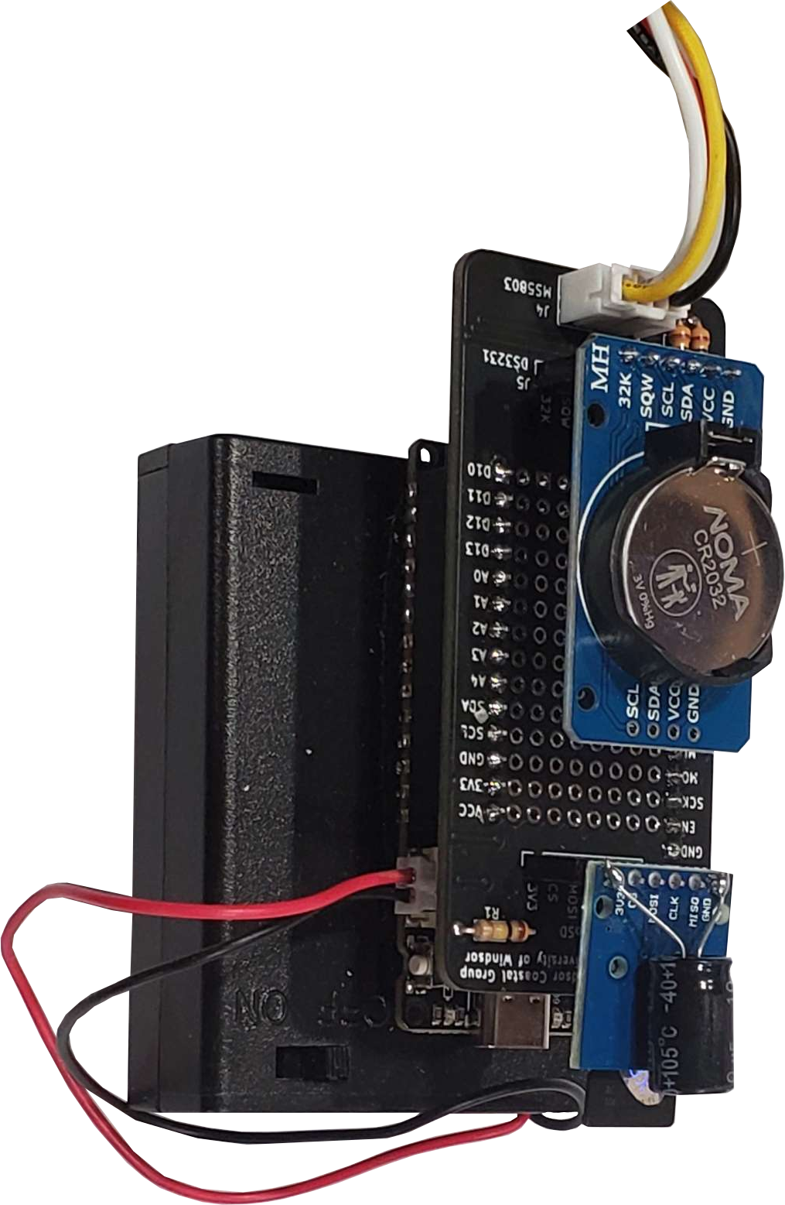
Space for desiccant (does not need to be filled)
Pressure sensor
module
Pool noodle to secure electronics
Space for electronics
Red gripper cap goes here to seal the inside

4. Diagnosing Errors
When the transducer malfunctions or otherwise encounters an error, it will endlessly flash a repeating pattern on the LED to the right of the USB-C port. This pattern consists of some number of flashes followed by a longer pause.
The number of flashes indicates the error:
- Error communicating with the clock module
- Error communicating with microSD card
- (Single instance of 3 flashes, not repeating) Unable to find “config.txt” file on microSD card or the file is formatted incorrectly.
  - Will cause the device to use a generic name for files instead of naming them after the device itself
  - e.g. “DIY3-XX_20240520-1200.data” instead of “DIY3-12_20240520-1200.data”.
  - Not a fatal error, but it will make it hard to identify which transducer produced the data when combined with others.
- Unable to create a new file on the microSD card
- Error communicating with the pressure sensor module
- General malfunction
- General malfunction

If restarting the device does not resolve an error, try the following:
- Look for any loose wires or components and set them in properly
- Ensure the microSD card is properly inserted, has a “config.txt” file in the top level directory, and is not full
- Ensure batteries are not near empty

When an error is encountered, the device will attempt to restart itself up to 3 times. If the error persists, it will continue flashing the pattern until the batteries run out. This usually means a malfunctioning transducer will be out of power by the time it is recovered in the field. The error will also be logged in a “log.txt” file on the microSD card, unless of course the error was regarding the card itself.

The most common error during / after deployment is 5 flashes if the pressure sensor module is damaged. It is possible that the pressure sensor module malfunctions, but the transducer is unable to detect it. In this case, it will simply record junk data, which is easily recognized and filtered out later, but not able to be recovered into useful data.

5. Downloading and Unpacking Data
For each day the transducer is active, it will create a new “.data” file on the microSD card at midnight. These files store the collected data in a raw binary format that must be unpacked by a custom Python script.
Before you can unpack the data, you will need a computer with Python installed, as well as the Python packages pandas and matplotlib. The scripts were last tested on Python 3.12.3, pandas 1.5.3, and matplotlib 3.8.3.
To download and unpack data:
- Ensure the transducer is switched off.
- Remove the microSD card and plug it into a computer. An adapter might be needed here.
- Copy or move all of the desired “.data” files into a new folder. Give the folder a name like “raw” and remember the file path to this folder.
- Create another empty folder with a name like “unpacked”.
- Create a third empty folder with a name like “scripts”.
- Download the following two Python scripts and put them in the “scripts” folder: processing_tools.py and unpack_raw.py
- Open the unpack_raw.py script. Modify lines 11 and 12 to contain the full paths to the “raw” and “unpacked” folders you created previously.
- Save and run the unpack_raw.py script.
- You should see a .csv file created in the “unpacked” folder for each of the .data files in the “raw” folder.
- You can now open these .csv files in a program like Excel or your data processing tool of choice.

Note: Data from multiple transducers can be copied into the same “raw” folder before running the script i.e. you don’t need to create separate “raw”, “unpacked”, and “scripts” folders for each transducer.

6. Processing Data
I have a number of scripts for cleaning up data, though they are somewhat customized to each deployment. Feel free to reach out, or look at some of the other functions in processing_tools.py from the previous step.
Visualizing the data is very helpful as a first step.
Common things to watch out for:
- Occasional duplicate or missing timestamps in the data are possible and are not indicative of any faulty electronics unless they are very common.
- Random outlier spikes in pressure and/or temperature can be indicative of a faulty sensor. Any more than one or two spikes in a single data file should be investigated.
- Be aware of clock drift when comparing data from multiple sensors. Depending on when they were last calibrated, drift of several seconds to several minutes can be expected.
  - This can be countered by recording the exact time when the transducer was powered on before deployment or recovered after deployment, and adjusting all timestamps by the offset accordingly.

