Network Topology and Architecture Specification
Meridian Financial Services — Current State Network Documentation
Version: 2.4 | Last Updated: October 2024 | Author: Network Engineering Team

1. WAN Circuit Inventory
Circuit ID | Purpose | Provider | Path | Capacity | Committed | Monthly Cost | SLA | Contract End
CKT-001 | MPLS Primary | Lumen | Newark — Stamford | 10 Gbps | 10 Gbps | $8,500/mo | 99.99% | Feb 2026
CKT-002 | MPLS Secondary | Zayo | Newark — Stamford | 10 Gbps | 10 Gbps | $7,800/mo | 99.99% | Mar 2026
CKT-003 | Internet Primary (NWK) | Cogent | Newark — Internet | 10 Gbps | 5 Gbps commit | $4,200/mo | 99.95% | Dec 2025
CKT-004 | Internet Secondary (NWK) | GTT | Newark — Internet | 1 Gbps | 500 Mbps commit | $1,800/mo | 99.95% | Dec 2025
CKT-005 | Internet Primary (STM) | Comcast | Stamford — Internet | 1 Gbps | 1 Gbps | $2,400/mo | 99.90% | Jun 2026
CKT-006 | Market Data Feed | NYSE Arca | Newark — Exchange | 1 Gbps | Dedicated | $12,000/mo | 99.999% | Rolling
CKT-007 | Payment Network | FIS | Newark — Payment Proc | 1 Gbps | Dedicated | $5,500/mo | 99.999% | Rolling
CKT-008 | Regulatory Reporting | FINRA Gateway | Newark — FINRA | 100 Mbps | Dedicated | $2,200/mo | 99.99% | Rolling
CKT-009 | DR Replication | Crown Castle | Newark — Stamford | 10 Gbps | 10 Gbps | $6,800/mo | 99.99% | Mar 2026
CKT-010 | Cloud Interconnect | Equinix Fabric | Newark — AWS/Azure | 10 Gbps | Burstable | $3,200/mo | 99.95% | Dec 2025

2. VLAN Configuration
VLAN ID | Name | Subnet | Gateway | DHCP Scope | ACL | Purpose
10 | Management | 10.1.10.0/24 | 10.1.10.1 | — | ACL-MGMT | Infrastructure management
20 | Production-DB | 10.1.20.0/24 | 10.1.20.1 | — | ACL-PROD-DB | Production database tier
21 | Production-App | 10.1.21.0/24 | 10.1.21.1 | — | ACL-PROD-APP | Production application tier
22 | Production-Web | 10.1.22.0/24 | 10.1.22.1 | — | ACL-PROD-WEB | Production web tier
30 | DMZ-External | 10.1.30.0/24 | 10.1.30.1 | — | ACL-DMZ-EXT | External-facing DMZ
31 | DMZ-Internal | 10.1.31.0/24 | 10.1.31.1 | — | ACL-DMZ-INT | Internal DMZ services
40 | Storage-SAN | 10.1.40.0/24 | 10.1.40.1 | — | ACL-SAN | iSCSI/FCoE storage network
41 | Storage-NAS | 10.1.41.0/24 | 10.1.41.1 | — | ACL-NAS | NFS/CIFS file services
50 | vMotion | 10.1.50.0/24 | — | — | ACL-VMOT | VM live migration traffic
51 | vSAN | 10.1.51.0/24 | — | — | ACL-VSAN | vSAN cluster communication
60 | Backup | 10.1.60.0/24 | 10.1.60.1 | — | ACL-BKUP | Backup infrastructure
70 | Monitoring | 10.1.70.0/24 | 10.1.70.1 | 10.1.70.100-200 | ACL-MON | SNMP, syslog, monitoring
80 | Development | 10.1.80.0/24 | 10.1.80.1 | 10.1.80.50-200 | ACL-DEV | Development environment
81 | Test/QA | 10.1.81.0/24 | 10.1.81.1 | 10.1.81.50-200 | ACL-QA | Test and QA environment
90 | Trading | 10.1.90.0/24 | 10.1.90.1 | — | ACL-TRADE | Trading platform network
91 | Market Data | 10.1.91.0/24 | 10.1.91.1 | — | ACL-MKTDATA | Market data feed ingestion
100 | Guest/Wireless | 10.1.100.0/24 | 10.1.100.1 | 10.1.100.10-200 | ACL-GUEST | Guest and wireless access
110 | IPMI/iDRAC | 10.1.110.0/24 | 10.1.110.1 | — | ACL-OOB | Out-of-band management
120 | Voice | 10.1.120.0/24 | 10.1.120.1 | 10.1.120.10-100 | ACL-VOICE | VoIP infrastructure
130 | Printer/IoT | 10.1.130.0/24 | 10.1.130.1 | 10.1.130.10-100 | ACL-IOT | Printers, environmental sensors
200 | STM-Production-DB | 10.2.20.0/24 | 10.2.20.1 | — | ACL-STM-DB | Stamford production DB
201 | STM-Production-App | 10.2.21.0/24 | 10.2.21.1 | — | ACL-STM-APP | Stamford production app
210 | STM-DR-Active | 10.2.30.0/24 | 10.2.30.1 | — | ACL-STM-DR | Stamford DR active systems
211 | STM-DR-Standby | 10.2.31.0/24 | 10.2.31.1 | — | ACL-STM-DRS | Stamford DR standby
220 | STM-Storage | 10.2.40.0/24 | 10.2.40.1 | — | ACL-STM-SAN | Stamford storage network
230 | STM-Management | 10.2.10.0/24 | 10.2.10.1 | — | ACL-STM-MGMT | Stamford management
240 | STM-Backup | 10.2.60.0/24 | 10.2.60.1 | — | ACL-STM-BKUP | Stamford backup
250 | STM-DevTest | 10.2.80.0/24 | 10.2.80.1 | 10.2.80.50-200 | ACL-STM-DEV | Stamford dev/test

3. Firewall Rule Matrix
Rule ID | Source Zone | Dest Zone | Source Net | Dest Net | Protocol/Port | Action | Description | Last Review
FW-001 | DMZ-EXT | Production | 10.1.30.0/24 | 10.1.22.0/24 | TCP/443 | Allow | HTTPS to web tier | 2024-08
FW-002 | DMZ-EXT | Production | 10.1.30.0/24 | 10.1.22.0/24 | TCP/80 | Allow | HTTP redirect to HTTPS | 2024-08
FW-003 | Production-Web | Production-App | 10.1.22.0/24 | 10.1.21.0/24 | TCP/8080-8089 | Allow | App server communication | 2024-08
FW-004 | Production-App | Production-DB | 10.1.21.0/24 | 10.1.20.0/24 | TCP/1521 | Allow | Oracle database | 2024-08
FW-005 | Production-App | Production-DB | 10.1.21.0/24 | 10.1.20.0/24 | TCP/1433 | Allow | SQL Server | 2024-08
FW-006 | Production-App | Production-DB | 10.1.21.0/24 | 10.1.20.0/24 | TCP/5432 | Allow | PostgreSQL | 2024-08
FW-007 | Trading | Market Data | 10.1.90.0/24 | 10.1.91.0/24 | TCP/9001-9010 | Allow | Market data feeds | 2024-08
FW-008 | Trading | Production-DB | 10.1.90.0/24 | 10.1.20.0/24 | TCP/1521 | Allow | Trade execution DB | 2024-08
FW-009 | Any | Management | Any | 10.1.10.0/24 | Any | Deny | Block direct mgmt access | 2024-08
FW-010 | Management | Any | 10.1.10.0/24 | Any | TCP/22,3389 | Allow | Admin SSH/RDP | 2024-08
FW-011 | DMZ-INT | Production-DB | 10.1.49.0/24 | 10.1.22.0/24 | TCP/161 | Allow | Allow TCP from DMZ-INT to Production-DB | 2024-02
FW-012 | Trading | Production-DB | 10.1.21.0/24 | 10.1.53.0/24 | TCP/445 | Allow | Allow TCP from Trading to Production-DB | 2024-06
FW-013 | Backup | Development | 10.1.30.0/24 | 10.1.31.0/24 | TCP/25 | Allow | Allow TCP from Backup to Development | 2024-01
FW-014 | DMZ-EXT | Management | 10.1.52.0/24 | 10.1.57.0/24 | TCP/8443 | Allow | Allow TCP from DMZ-EXT to Management | 2024-01
FW-015 | DMZ-INT | Trading | 10.1.55.0/24 | 10.1.40.0/24 | TCP/161 | Allow | Allow TCP from DMZ-INT to Trading | 2024-04
FW-016 | DMZ-EXT | Production-Web | 10.1.76.0/24 | 10.1.75.0/24 | TCP/9200 | Allow | Allow TCP from DMZ-EXT to Production-Web | 2024-04
FW-017 | Monitoring | Development | 10.1.80.0/24 | 10.1.59.0/24 | TCP/636 | Allow | Allow TCP from Monitoring to Development | 2024-03
FW-018 | DMZ-INT | Monitoring | 10.1.11.0/24 | 10.1.53.0/24 | TCP/389 | Allow | Allow TCP from DMZ-INT to Monitoring | 2024-05
FW-019 | Backup | Production-DB | 10.1.76.0/24 | 10.1.57.0/24 | TCP/5044 | Allow | Allow TCP from Backup to Production-DB | 2024-01
FW-020 | Trading | DMZ-EXT | 10.1.89.0/24 | 10.1.31.0/24 | TCP/5044 | Allow | Allow TCP from Trading to DMZ-EXT | 2024-07
FW-021 | DMZ-EXT | Production-App | 10.1.68.0/24 | 10.1.87.0/24 | TCP/9200 | Allow | Allow TCP from DMZ-EXT to Production-App | 2024-04
FW-022 | Production-Web | Development | 10.1.55.0/24 | 10.1.20.0/24 | TCP/445 | Allow | Allow TCP from Production-Web to Development | 2024-05
FW-023 | Production-DB | Monitoring | 10.1.32.0/24 | 10.1.79.0/24 | TCP/8443 | Allow | Allow TCP from Production-DB to Monitoring | 2024-09
FW-024 | Development | DMZ-INT | 10.1.23.0/24 | 10.1.51.0/24 | TCP/25 | Allow | Allow TCP from Development to DMZ-INT | 2024-01
FW-025 | DMZ-EXT | Production-Web | 10.1.84.0/24 | 10.1.23.0/24 | TCP/587 | Allow | Allow TCP from DMZ-EXT to Production-Web | 2024-04
FW-026 | Trading | Backup | 10.1.35.0/24 | 10.1.73.0/24 | TCP/3306 | Deny | Block TCP from Trading to Backup | 2024-01
FW-027 | Production-Web | DMZ-EXT | 10.1.18.0/24 | 10.1.43.0/24 | TCP/636 | Allow | Allow TCP from Production-Web to DMZ-EXT | 2024-06
FW-028 | Production-Web | Production-App | 10.1.27.0/24 | 10.1.53.0/24 | TCP/993 | Allow | Allow TCP from Production-Web to Production-App | 2024-07
FW-029 | Production-DB | Production-App | 10.1.12.0/24 | 10.1.71.0/24 | TCP/135 | Allow | Allow TCP from Production-DB to Production-App | 2024-04
FW-030 | Development | Backup | 10.1.28.0/24 | 10.1.20.0/24 | ICMP | Allow | Allow ICMP from Development to Backup | 2024-05
FW-031 | Monitoring | Production-Web | 10.1.80.0/24 | 10.1.37.0/24 | TCP/445 | Allow | Allow TCP from Monitoring to Production-Web | 2024-06
FW-032 | DMZ-EXT | Development | 10.1.51.0/24 | 10.1.20.0/24 | TCP/993 | Allow | Allow TCP from DMZ-EXT to Development | 2024-01
FW-033 | Production-App | Backup | 10.1.42.0/24 | 10.1.82.0/24 | TCP/161 | Allow | Allow TCP from Production-App to Backup | 2024-01
FW-034 | DMZ-EXT | Production-DB | 10.1.75.0/24 | 10.1.10.0/24 | TCP/8443 | Deny | Block TCP from DMZ-EXT to Production-DB | 2024-06
FW-035 | Monitoring | Backup | 10.1.47.0/24 | 10.1.39.0/24 | TCP/27017 | Allow | Allow TCP from Monitoring to Backup | 2024-07
FW-036 | Development | DMZ-EXT | 10.1.71.0/24 | 10.1.77.0/24 | TCP/22 | Allow | Allow TCP from Development to DMZ-EXT | 2024-03
FW-037 | DMZ-EXT | Monitoring | 10.1.12.0/24 | 10.1.25.0/24 | TCP/389 | Allow | Allow TCP from DMZ-EXT to Monitoring | 2024-02
FW-038 | Monitoring | Production-Web | 10.1.56.0/24 | 10.1.34.0/24 | TCP/6379 | Allow | Allow TCP from Monitoring to Production-Web | 2024-05
FW-039 | Production-Web | Trading | 10.1.15.0/24 | 10.1.42.0/24 | UDP/514 | Allow | Allow UDP from Production-Web to Trading | 2024-02
FW-040 | DMZ-EXT | Monitoring | 10.1.23.0/24 | 10.1.23.0/24 | ICMP | Allow | Allow ICMP from DMZ-EXT to Monitoring | 2024-06
FW-041 | Backup | Monitoring | 10.1.64.0/24 | 10.1.12.0/24 | TCP/27017 | Allow | Allow TCP from Backup to Monitoring | 2024-06
FW-042 | Trading | DMZ-EXT | 10.1.53.0/24 | 10.1.86.0/24 | TCP/22 | Allow | Allow TCP from Trading to DMZ-EXT | 2024-04
FW-043 | DMZ-EXT | DMZ-INT | 10.1.51.0/24 | 10.1.11.0/24 | TCP/445 | Deny | Block TCP from DMZ-EXT to DMZ-INT | 2024-04
FW-044 | Backup | Management | 10.1.20.0/24 | 10.1.31.0/24 | TCP/636 | Allow | Allow TCP from Backup to Management | 2024-08
FW-045 | Development | Trading | 10.1.42.0/24 | 10.1.10.0/24 | UDP/514 | Allow | Allow UDP from Development to Trading | 2024-05
FW-046 | Production-Web | Monitoring | 10.1.73.0/24 | 10.1.50.0/24 | TCP/9200 | Allow | Allow TCP from Production-Web to Monitoring | 2024-03
FW-047 | Management | Monitoring | 10.1.24.0/24 | 10.1.33.0/24 | TCP/6379 | Allow | Allow TCP from Management to Monitoring | 2024-09
FW-048 | Management | Backup | 10.1.88.0/24 | 10.1.69.0/24 | TCP/9200 | Allow | Allow TCP from Management to Backup | 2024-09
FW-049 | DMZ-INT | Production-Web | 10.1.40.0/24 | 10.1.79.0/24 | TCP/9200 | Allow | Allow TCP from DMZ-INT to Production-Web | 2024-08
FW-050 | Development | Trading | 10.1.63.0/24 | 10.1.28.0/24 | TCP/389 | Allow | Allow TCP from Development to Trading | 2024-08
FW-051 | Production-Web | Production-DB | 10.1.76.0/24 | 10.1.47.0/24 | TCP/443 | Allow | Allow TCP from Production-Web to Production-DB | 2024-03
FW-052 | Monitoring | DMZ-EXT | 10.1.55.0/24 | 10.1.46.0/24 | TCP/9200 | Allow | Allow TCP from Monitoring to DMZ-EXT | 2024-08
FW-053 | DMZ-INT | Production-DB | 10.1.11.0/24 | 10.1.44.0/24 | TCP/161 | Deny | Block TCP from DMZ-INT to Production-DB | 2024-03
FW-054 | Production-Web | DMZ-EXT | 10.1.62.0/24 | 10.1.79.0/24 | TCP/3306 | Allow | Allow TCP from Production-Web to DMZ-EXT | 2024-08
FW-055 | DMZ-INT | Development | 10.1.19.0/24 | 10.1.79.0/24 | TCP/445 | Allow | Allow TCP from DMZ-INT to Development | 2024-07
FW-056 | Monitoring | DMZ-INT | 10.1.81.0/24 | 10.1.59.0/24 | TCP/5044 | Allow | Allow TCP from Monitoring to DMZ-INT | 2024-02
FW-057 | Production-Web | Management | 10.1.74.0/24 | 10.1.41.0/24 | TCP/6379 | Allow | Allow TCP from Production-Web to Management | 2024-08
FW-058 | DMZ-EXT | Backup | 10.1.73.0/24 | 10.1.11.0/24 | TCP/389 | Allow | Allow TCP from DMZ-EXT to Backup | 2024-09
FW-059 | Management | Production-Web | 10.1.30.0/24 | 10.1.31.0/24 | ICMP | Allow | Allow ICMP from Management to Production-Web | 2024-03
FW-060 | Backup | Trading | 10.1.34.0/24 | 10.1.53.0/24 | TCP/25 | Allow | Allow TCP from Backup to Trading | 2024-06

4. Load Balancer Configuration
VIP ID | Service | VIP Address | Port | Algorithm | Health Check | Interval | Persistence | State
VIP-001 | Client Portal | 10.1.30.10 | TCP/443 | Round Robin | HTTPS GET /health | 30s | Cookie (JSESSIONID) | Active
VIP-002 | Trading API | 10.1.30.20 | TCP/443 | Least Connections | TCP Connect | 10s | Source IP | Active
VIP-003 | Market Data WS | 10.1.30.30 | TCP/8443 | Round Robin | WebSocket Ping | 15s | Source IP | Active
VIP-004 | Internal API Gateway | 10.1.21.100 | TCP/8080 | Weighted RR | HTTP GET /status | 30s | None | Active
VIP-005 | Email Gateway | 10.1.30.40 | TCP/25,587 | Round Robin | SMTP HELO | 60s | None | Active
VIP-006 | Data Warehouse | 10.1.20.100 | TCP/1521 | Active-Passive | TCP Connect :1521 | 30s | None | Active
VIP-007 | Risk Engine API | 10.1.21.110 | TCP/8443 | Least Connections | HTTPS GET /health | 20s | Cookie | Active
VIP-008 | Admin Portal | 10.1.31.10 | TCP/443 | Round Robin | HTTPS GET /login | 30s | Cookie | Active
VIP-009 | SFTP Gateway | 10.1.30.50 | TCP/22 | Active-Passive | TCP Connect :22 | 60s | Source IP | Active
VIP-010 | DNS (Internal) | 10.1.10.53 | UDP/53 | Round Robin | DNS Query | 10s | None | Active
VIP-011 | Monitoring Dashboard | 10.1.70.10 | TCP/443 | Round Robin | HTTPS GET / | 30s | None | Active
VIP-012 | Log Aggregation | 10.1.70.20 | TCP/5044 | Round Robin | TCP Connect | 30s | None | Active
VIP-013 | Backup Server | 10.1.60.10 | TCP/9392 | Active-Passive | TCP Connect | 60s | None | Active
VIP-014 | Client Portal (STM DR) | 10.2.30.10 | TCP/443 | Round Robin | HTTPS GET /health | 30s | Cookie | Standby
VIP-015 | Trading API (STM DR) | 10.2.30.20 | TCP/443 | Least Connections | TCP Connect | 10s | Source IP | Standby

5. QoS Policy Configuration
Policy ID | Traffic Class | DSCP | Queue | BW Allocation | Max Latency | Max Loss | Description
QOS-01 | Trading/Market Data | EF (46) | Strict Priority | 10% | < 1ms | < 0.01% | Real-time trading traffic
QOS-02 | Voice/Video | EF (46) | Priority Queue | 5% | < 2ms | < 0.1% | VoIP and video conferencing
QOS-03 | Database Replication | AF41 (34) | Weighted Fair | 20% | < 5ms | < 0.01% | DB sync and replication
QOS-04 | Production Applications | AF31 (26) | Weighted Fair | 25% | < 10ms | < 0.1% | General production apps
QOS-05 | Backup Traffic | AF21 (18) | Weighted Fair | 15% | < 50ms | < 1% | Scheduled backup jobs
QOS-06 | Monitoring/Management | AF11 (10) | Best Effort+ | 5% | < 20ms | < 0.5% | SNMP, syslog, management
QOS-07 | Email | AF11 (10) | Best Effort+ | 5% | < 100ms | < 1% | SMTP traffic
QOS-08 | Development/Test | BE (0) | Best Effort | 10% | No guarantee | No guarantee | Dev/test environments
QOS-09 | Guest/Internet | BE (0) | Best Effort | 5% | No guarantee | No guarantee | Guest and internet browsing
QOS-10 | Bulk Transfer | CS1 (8) | Scavenger | Remaining | No guarantee | No guarantee | Large file transfers, ETL

Appendix A: Circuit Utilization
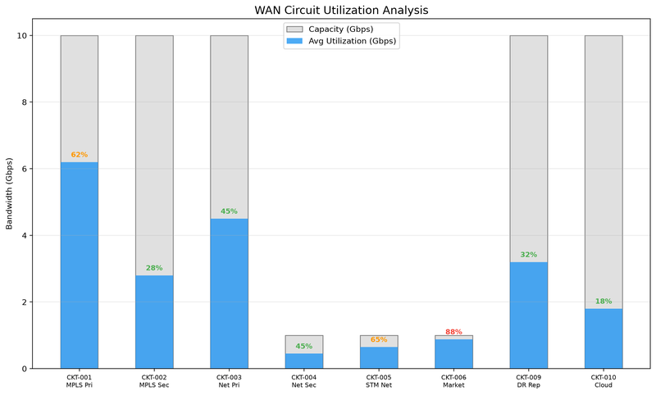

Appendix B: Traffic Distribution
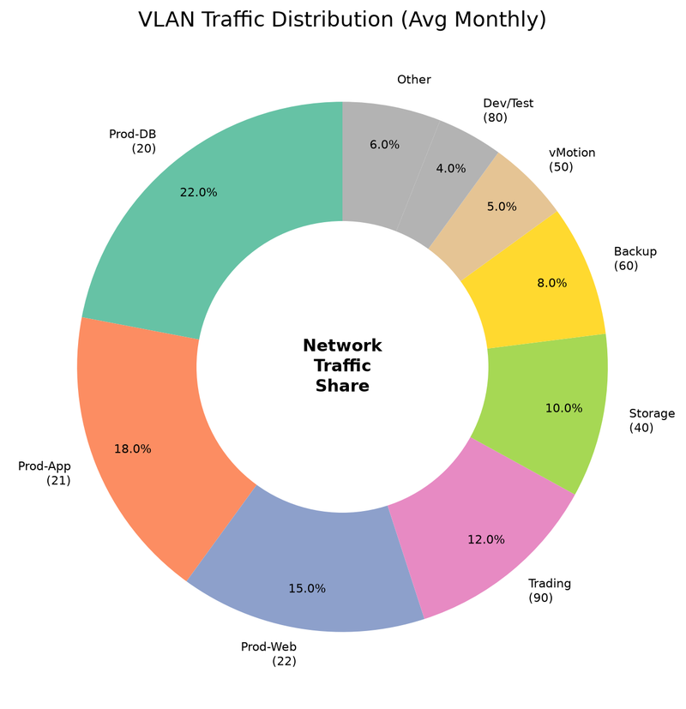

Appendix C: Firewall Rule Audit
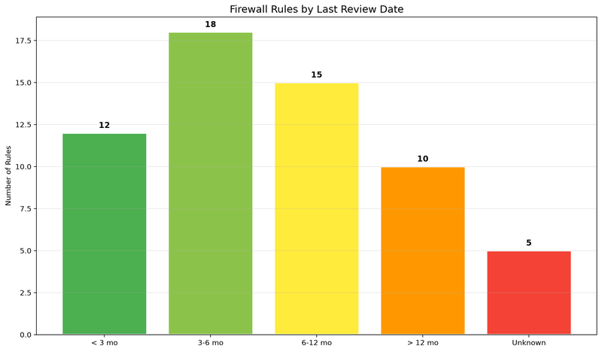

Appendix D: VLAN Traffic Distribution Analysis
The following chart summarizes average and peak inter-VLAN throughput across both facilities. VLAN 40 (Storage) consistently shows the highest sustained throughput at 6.7 Gbps average, with peaks approaching 9.8 Gbps on the dedicated 10G storage fabric. The VLAN 20 (Database) tier exhibits bursty traffic patterns with a 1.93x peak-to-average ratio, primarily driven by Oracle RAC heartbeat traffic and bulk ETL operations during the 02:00-04:00 processing window. Cross-facility replication traffic between Facility A VLAN 40 and Facility B VLAN 240 averages 3.2 Gbps, consuming 32% of the dedicated MPLS circuit capacity (2x10 Gbps LACP bundle).
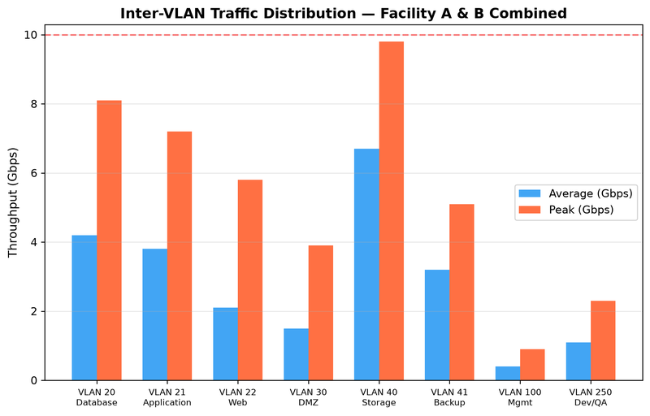

Appendix E: Routing Protocol Convergence Testing
Convergence time measurements were taken during controlled failover testing on 2024-09-15. OSPF Area 0 (backbone) achieved sub-3-second convergence in both facilities, meeting the <5-second target for Tier 1 workloads. However, eBGP convergence times of 45.2s (Facility A) and 52.8s (Facility B) significantly exceed the 30-second target specified in the network SLA. The extended BGP convergence is attributed to conservative timer settings (keepalive=60s, hold=180s) on the Cogent and GTT peering sessions. BFD (Bidirectional Forwarding Detection) is configured on OSPF adjacencies but NOT on BGP sessions, which is a known gap. VRRP failover between the redundant Core-A01/A02 pair measured 0.8 seconds, within the <1-second requirement for the trading floor VLAN 22.
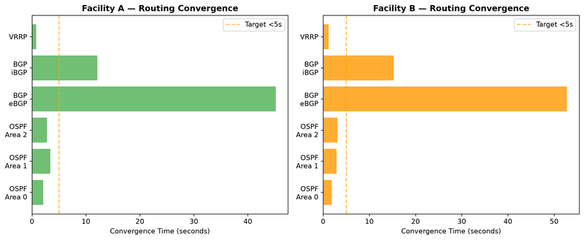

Appendix F: Firewall Rule Hit Analysis
Analysis of firewall ACL hit counters over a 30-day sample period (2024-08-01 to 2024-08-30). DNS traffic (Port 53) generates the highest rule hit count at 1.12M daily hits, followed by Web-to-Application HTTPS traffic at 847K daily hits. The API Gateway rule (port 8443) handles 568K daily hits, reflecting the growing REST API workload from the mobile banking platform. Rules with fewer than 1,000 daily hits (not shown) are candidates for cleanup and should be reviewed during the pre-migration firewall rule audit. Currently 2,847 ACL rules are configured across FW-NWK-01 and FW-NWK-02, of which approximately 340 (12%) show zero hits in the last 90 days and are candidates for decommissioning prior to migration.
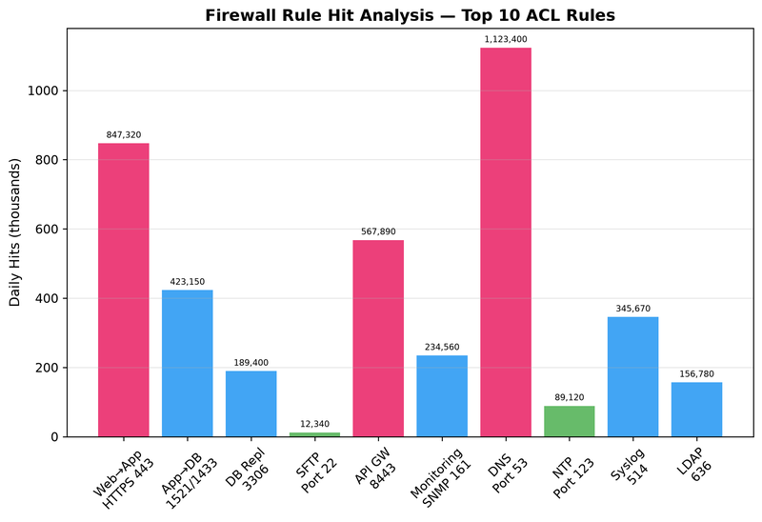

Appendix G: Switch Port Utilization Assessment
Port utilization heatmap across all network switches in both facilities. Values above 85% are flagged as capacity risks during migration. Core-A01 100G QSFP28 ports are at 94% utilization, indicating that additional migration traffic cannot be accommodated without provisioning new uplink capacity. Acc-A01 1G copper ports are at 97% utilization with only 1 spare port available, which constrains the ability to add temporary migration staging servers. Facility B switches generally show lower utilization due to the smaller footprint (42 racks vs. 68 racks), but Core-B01 40G ports at 89% are approaching the planning threshold. MTU configuration is standardized at 9000 bytes (jumbo frames) on all storage VLANs but remains at 1500 bytes on the DMZ and management VLANs.
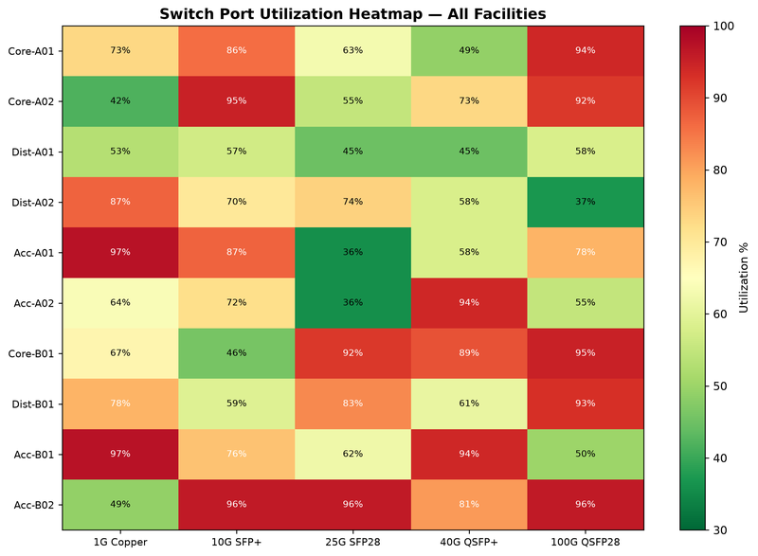

Appendix D: Cross-Facility VLAN Allocation Matrix
The following table documents the current VLAN allocation across both facilities. VLANs are assigned by the Network Engineering team and tracked in the IPAM system. Migration planning should reference this table for network segmentation decisions.
VLAN ID | Name | Facility A (Newark) | Facility B (Stamford) | Subnet
10 | Management | Switch/Router Mgmt | Switch/Router Mgmt | 10.0.0.0/24
20 | Database | Production DB Tier | Production DB Tier | 10.10.20.0/22
30 | Application | App Server Tier | App Server Tier | 10.10.30.0/22
40 | Web/DMZ | External-facing services | External-facing services | 10.10.40.0/24
50 | Storage | iSCSI/NFS Traffic | iSCSI/NFS Traffic | 10.30.0.0/22
60 | Backup | Backup Network | Backup Network | 10.40.0.0/22
100 | Trading Systems | Trading Core (Low-latency) | DR-CoreBanking (Standby) | 10.10.100.0/24
110 | Risk Analytics | Real-time Risk Engine | Risk Analytics Batch | 10.10.110.0/24
120 | Compliance | Regulatory Reporting | Audit Log Aggregation | 10.10.120.0/24
130 | Client Services | Client Portal Frontend | Client Portal DR | 10.10.130.0/24
140 | Development | Dev/Test Environment | Staging Environment | 10.20.140.0/22
150 | QA | QA Testing | Pre-production QA | 10.20.150.0/24
200 | Out-of-Band Mgmt | iLO/iDRAC Network | iLO/iDRAC Network | 10.100.0.0/22
210 | Monitoring | Nagios/Zabbix | Monitoring Agents | 10.100.10.0/24
250 | IoT/Sensors | Environmental Sensors | Environmental Sensors | 10.250.0.0/24
300 | Storage Mgmt | SAN Management | SAN Management | 10.30.100.0/24
400 | VoIP | Telephony | Telephony | 10.50.0.0/24
500 | Guest | Guest WiFi | Guest WiFi | 172.16.0.0/24
666 | Quarantine | Isolated/Compromised | Isolated/Compromised | 192.168.66.0/24
900 | Transit | WAN Transit | WAN Transit | 10.90.0.0/30
999 | Native/Untagged | Trunk Native | Trunk Native | N/A
Note: VLAN 100 serves different functions at each facility. Any Layer 2 extension or VLAN stretching during migration would create a broadcast domain conflict. The network team has documented this in the IPAM system as a known configuration.

Appendix E: BGP Routing Policy and AS Path Configuration
Meridian Financial Services operates AS 65001 (private) for internal routing and peers with the following external autonomous systems via eBGP:
Peer AS | Provider | Circuit ID | Capacity | Facility | Convergence Time (s)
AS 7018 | AT&T MPLS | ATT-MFS-NWK-001 | 10 Gbps | Newark | 45.2
AS 7018 | AT&T MPLS | ATT-MFS-STM-001 | 10 Gbps | Stamford | 52.8
AS 3356 | Lumen DIA | LMN-MFS-NWK-001 | 1 Gbps | Newark | 38.1
AS 6461 | Zayo DIA | ZAY-MFS-STM-001 | 1 Gbps | Stamford | 41.7
AS 174 | Cogent (Backup) | COG-MFS-NWK-001 | 1 Gbps | Newark | 65.3
AS 22394 | Verizon Business | VZ-MFS-NWK-002 | 10 Gbps | Newark | 42.9
AS 22394 | Verizon Business | VZ-MFS-STM-002 | 10 Gbps | Stamford | 48.1
AS 16509 | AWS Direct Connect | AWS-MFS-NWK-DX1 | 10 Gbps | Newark | 3.2

Appendix: Network Architecture Diagrams

Network Topology Overview
The following diagram illustrates the current network topology across both facilities, including VLAN assignments, inter-facility links, and core switching architecture.
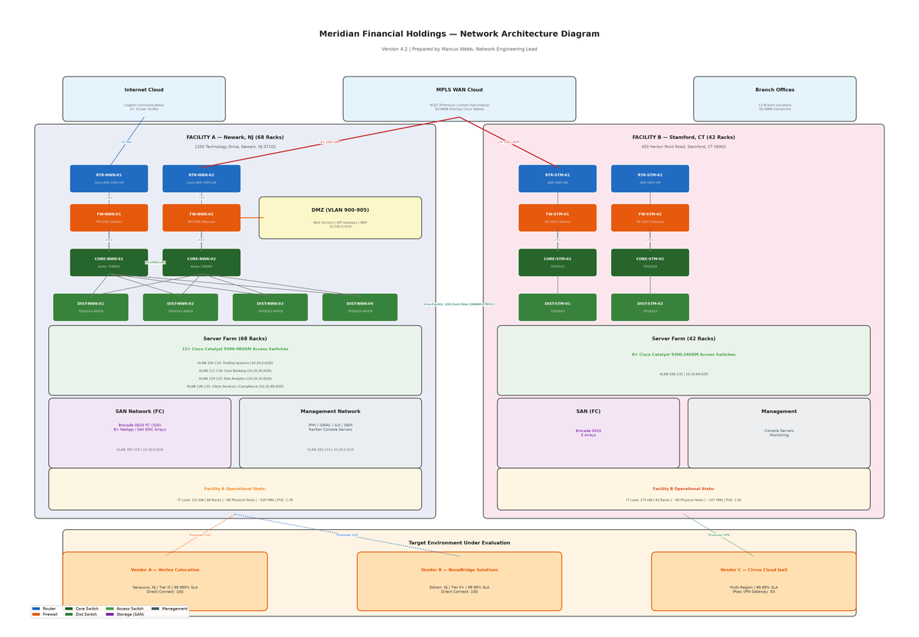

Security Zone Architecture
The security architecture diagram below maps trust zones, firewall boundaries, and VLAN-to-zone assignments across the production environment.
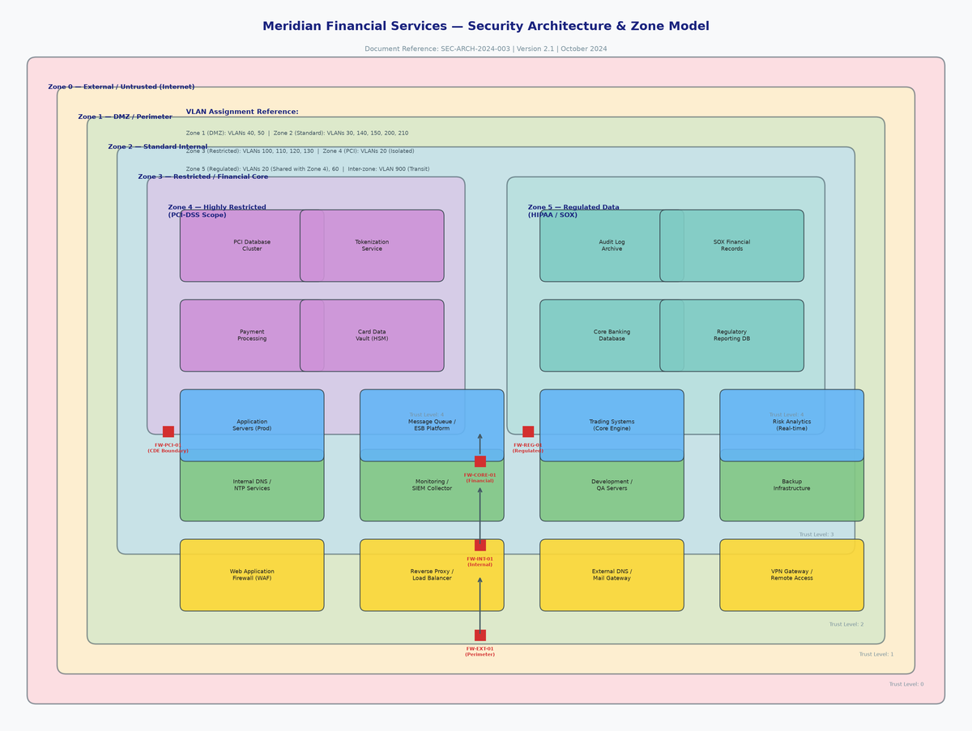

Inter-Facility Bandwidth Allocation Model
The bandwidth allocation model below shows committed traffic reservations and available capacity across the inter-facility WAN links.
