Project Charter: Data Center Consolidation and Migration Initiative
Project ID: MFH-DC-2024-001 | Version: 3.2 | Status: Approved
Sponsor: Michael Torres, Chief Information Officer | PM: James Thornton, Director of IT Infrastructure
Date: November 1, 2024 | Classification: For Internal Distribution

1. Project Overview
This charter authorizes the Data Center Consolidation and Migration Initiative for Meridian Financial Services. The project encompasses the strategic migration of all IT infrastructure from two aging on-premises data center facilities (Facility A in Newark, NJ and Facility B in Stamford, CT) to a hybrid colocation and cloud infrastructure model. The initiative is driven by expiring lease agreements, escalating operational costs, and the need to modernize infrastructure to support business growth targets over the next five years. The project will evaluate proposals from three shortlisted vendors: Vertex Colocation Partners (Vendor A), NovaBridge Solutions (Vendor B), and CloudScale IaaS (Vendor C), ultimately selecting and executing a migration to the optimal provider or combination thereof.
The current infrastructure comprises approximately 1,166 physical servers and 847 virtual machines distributed across 84 racks in two facilities. Annual operating costs exceed $4.12 million for facility leases alone, with total data center operating expenditure approaching $8.7 million annually when accounting for power, cooling, staff, and maintenance. The consolidation is projected to achieve a 25-35% reduction in total cost of ownership over a 3-year period while simultaneously improving infrastructure availability, security posture, and environmental sustainability.

1.1 Business Objectives
ID | Objective | Description | Success Metric | Measurement
OBJ-01 | Cost Reduction | Achieve minimum 25% TCO reduction over 3-year horizon | $14.2M 3-yr budget | Annual financial review
OBJ-02 | Availability | Improve infrastructure availability from 99.95% to 99.99% | < 52.6 min/yr downtime | Monthly SLA reporting
OBJ-03 | Risk Mitigation | Eliminate single points of failure in power and cooling | N+1 minimum all systems | Quarterly risk assessment
OBJ-04 | Compliance | Maintain SOC 2, PCI-DSS, HIPAA compliance through transition | Zero compliance gaps | Continuous monitoring
OBJ-05 | Sustainability | Reduce carbon footprint by 30% through PUE improvement | Target PUE < 1.50 | Quarterly emissions report
OBJ-06 | Scalability | Provide 50% growth capacity headroom post-migration | Available capacity tracking | Quarterly capacity review
OBJ-07 | DR Capability | Achieve RTO < 4 hours, RPO < 1 hour for Tier 1 workloads | DR test results | Semi-annual DR testing
OBJ-08 | Staff Efficiency | Reduce manual operational tasks by 40% through automation | Operational metrics | Monthly operations review

2. Stakeholder Register
Name | Title | Department | Project Role | Influence | Interest | Communication
Michael Torres | CIO | Executive | Project Sponsor | High | High | Weekly status report
James Thornton | Director, IT Infrastructure | IT Operations | Project Manager | High | High | Daily standup
Sarah Chen | VP, Risk Management | Risk | Risk Oversight | High | Medium | Bi-weekly risk review
David Park | CISO | Security | Security Approval | High | High | Weekly security review
Rachel Kim | CFO | Finance | Budget Authority | High | Medium | Monthly financial review
Tom Bradley | VP, Application Development | Engineering | App Owner Rep | Medium | High | Weekly sync
Lisa Martinez | Director, Network Engineering | Network | Network Lead | Medium | High | Daily standup
Kevin Wong | Senior DBA | Database | Database Lead | Medium | High | Daily standup
Amanda Foster | Director, Compliance | Compliance | Compliance Advisor | High | Medium | Monthly review
Robert Chen | VP, Trading Operations | Trading | Business Stakeholder | High | High | Weekly impact review
Jennifer Adams | Director, Client Services | Client Ops | Business Stakeholder | Medium | Medium | Bi-weekly update
Mark Sullivan | Facilities Manager | Facilities | Physical Coordination | Low | High | As needed
Diana Patel | Procurement Manager | Procurement | Vendor Management | Medium | Medium | As needed
Steven Harris | Legal Counsel | Legal | Contract Review | High | Low | As needed
Catherine Brown | Internal Audit Director | Audit | Audit Oversight | Medium | Low | Quarterly audit
Alex Rodriguez | Change Manager | Change Mgmt | Change Control | Medium | High | CAB meetings

3. RACI Matrix
R = Responsible (does the work), A = Accountable (owns the outcome), C = Consulted (provides input), I = Informed (kept updated)
Activity | PM | Sponsor | Net Lead | DB Lead | Sec Lead | Compl. | Finance | App Lead | Facilities | Change Mgr
Vendor evaluation and selection | A | I | C | C | C | C | R | C | I | I
Contract negotiation | R | A | C | I | C | C | R | I | I | I
Network design (target state) | C | I | A | I | C | I | I | C | I | I
Migration wave planning | A | I | C | C | C | I | I | R | C | C
Pre-migration assessment | R | I | R | R | R | C | I | R | C | I
Pilot migration execution | A | I | R | R | C | I | I | R | C | R
Wave 1 migration (Tier 3) | A | I | R | C | C | I | I | R | R | R
Wave 2 migration (Tier 2) | A | I | R | R | C | I | I | R | R | R
Wave 3 migration (Tier 1) | A | A | R | R | R | C | I | R | R | R
Database migration | C | I | C | A | C | I | I | C | I | R
Security controls migration | C | I | C | I | A | C | I | I | I | R
Firewall rule migration | C | I | R | I | A | C | I | I | I | R
DNS cutover | C | I | A | I | C | I | I | C | I | R
Load balancer configuration | C | I | A | I | C | I | I | C | I | R
Storage migration | C | I | C | R | I | I | I | C | I | R
Backup system migration | C | I | C | R | C | I | I | C | I | R
Monitoring setup (target) | R | I | R | C | C | I | I | C | I | I
Performance validation | C | I | R | R | I | I | I | A | I | I
Compliance audit (pre-migration) | C | I | I | I | C | A | I | I | I | I
Compliance audit (post-migration) | C | I | I | I | C | A | I | I | I | I
Budget tracking and reporting | R | I | I | I | I | I | A | I | I | I
Change request processing | C | I | I | I | I | I | I | I | I | A
Stakeholder communications | A | C | I | I | I | I | I | I | I | I
Risk register maintenance | A | C | C | C | C | C | I | C | C | I
Issue escalation management | A | R | C | C | C | I | C | C | I | I
Physical decommissioning (Fac A) | C | I | C | I | I | I | C | I | A | R
Physical decommissioning (Fac B) | C | I | C | I | I | I | C | I | A | R
Lease termination coordination | C | A | I | I | I | I | C | I | R | I
Asset disposition | C | I | I | I | I | I | C | I | A | I
Knowledge transfer documentation | R | I | R | R | R | I | I | R | I | I
DR testing (pre-migration) | C | I | R | R | R | C | I | R | I | R
DR testing (post-migration) | C | I | R | R | R | C | I | R | I | R
Vendor SLA validation | A | I | R | I | C | C | I | R | I | I
Capacity planning (target) | R | I | C | C | I | I | C | C | I | I
License audit and transfer | R | I | I | C | I | I | C | C | I | I
Training and skill development | A | I | R | R | R | I | C | R | C | I
Post-migration optimization | A | I | R | R | C | I | C | R | I | I
Warranty claim coordination | R | I | C | I | I | I | C | I | R | I
Insurance policy update | C | I | I | I | I | I | A | I | C | I
Environmental monitoring setup | C | I | C | I | I | I | I | I | A | I
Circuit provisioning (new) | C | I | A | I | C | I | C | I | C | R
Circuit decommissioning (old) | C | I | A | I | I | I | C | I | C | R
Application dependency mapping | C | I | C | C | I | I | I | A | I | I
Runbook creation and validation | R | I | R | R | R | I | I | R | I | I
Go/No-Go decision (per wave) | C | A | C | C | C | C | C | C | C | R
Post-cutover hypercare | R | I | R | R | C | I | I | R | C | I
Lessons learned capture | A | C | C | C | C | I | I | C | I | C
Final project closeout | A | R | I | I | I | I | R | I | I | I
Quarterly business review setup | R | C | I | I | I | I | C | I | I | I
Vendor performance scoring | A | I | C | C | C | C | C | C | I | I

4. Budget Breakdown
Total approved project budget: $14,200,000 over 36 months. The budget includes a 10% management reserve ($1,350,000) for unforeseen circumstances requiring Change Control Board approval for release.
Phase | Description | Hardware/SW | Prof Services | Network/Circuits | Compliance | Contingency | Phase Total
Phase 0 | Discovery and Assessment | $127,500 | $245,000 | $85,000 | $42,500 | $350,000 | $850,000
Phase 1 | Foundation and Pilot Migration | $1,250,000 | $890,000 | $420,000 | $185,000 | $1,055,000 | $3,800,000
Phase 2 | Wave 1-2 Migration (Tier 2-3) | $1,450,000 | $1,120,000 | $510,000 | $210,000 | $810,000 | $4,100,000
Phase 3 | Wave 3 Migration (Tier 1) | $980,000 | $780,000 | $385,000 | $195,000 | $560,000 | $2,900,000
Phase 4 | Optimization and Closeout | $320,000 | $285,000 | $195,000 | $95,000 | $305,000 | $1,200,000
 | Management Reserve |  |  |  |  |  | $1,350,000
 | TOTAL | $4,127,500 | $3,320,000 | $1,595,000 | $727,500 | $3,080,000 | $14,200,000

5. Risk Register
Risk ID | Category | Description | Prob (1-5) | Impact (1-5) | Score | Strategy | Mitigation | Owner | Status | Trigger
RSK-001 | Schedule | Migration duration exceeds 18-month timeline | 3 | 4 | 12 | Mitigate | Buffer weeks in each wave; parallel workstreams | James Thornton | Open | Wave completion > 110% planned duration
RSK-002 | Technical | Application incompatibility in target environment | 3 | 5 | 15 | Mitigate | Pre-migration compatibility testing; rollback procedures | Tom Bradley | Open | Failed compatibility test
RSK-003 | Financial | Vendor cost escalation exceeds budget projections | 2 | 4 | 8 | Accept | Contract price locks; escalation cap clauses | Rachel Kim | Open | Annual cost review
RSK-004 | Compliance | Compliance gap during migration transition period | 3 | 5 | 15 | Mitigate | Parallel compliance controls; pre-migration audit | Amanda Foster | Open | Compliance control gap identified
RSK-005 | Security | Data breach during physical server transport | 1 | 5 | 5 | Transfer | Full-disk encryption; chain of custody; transit insurance | David Park | Open | Physical transport initiated
RSK-006 | Technical | Database migration causes data corruption | 2 | 5 | 10 | Mitigate | Checksum validation; parallel running; point-in-time recovery | Kevin Wong | Open | Pre-migration database snapshot
RSK-007 | Vendor | Selected vendor fails to meet SLA commitments | 2 | 4 | 8 | Mitigate | SLA penalties; quarterly reviews; exit clause at 12 months | James Thornton | Open | SLA breach reported
RSK-008 | Operational | Key staff attrition during migration project | 3 | 3 | 9 | Mitigate | Cross-training; retention bonuses; documented procedures | James Thornton | Open | Resignation notice received
RSK-009 | Technical | Network latency increase impacts trading platform | 2 | 5 | 10 | Mitigate | Pre-provisioned dedicated circuits; latency testing; rollback | Lisa Martinez | Open | Latency > 2ms measured
RSK-010 | Financial | Early lease termination penalties exceed estimates | 2 | 3 | 6 | Accept | Negotiate penalty reduction; offset with new vendor credits | Steven Harris | Open | Termination notice sent
RSK-011 | Technical | Live migration fails for high-memory VMs (dirty rate > BW) | 4 | 3 | 12 | Mitigate | Identify non-convergent VMs early; schedule warm migration | James Thornton | Open | Pre-migration assessment
RSK-012 | Vendor | NovaBridge early termination penalty dispute (0.35x vs 0.50x) | 2 | 4 | 8 | Mitigate | Legal review of contract terms; negotiate clarity before signing | Steven Harris | Open | Contract review meeting
RSK-013 | Technical | Storage I/O contention during concurrent migrations | 3 | 3 | 9 | Mitigate | Limit concurrent storage migrations; off-peak scheduling | Kevin Wong | Open | > 3 concurrent storage migrations
RSK-014 | Operational | DNS propagation delays cause client-facing outage | 2 | 4 | 8 | Mitigate | Low TTL pre-cutover; DNS monitoring; rollback DNS records | Lisa Martinez | Open | DNS cutover initiated
RSK-015 | Environmental | Hurricane/severe weather disrupts migration schedule | 1 | 4 | 4 | Accept | Seasonal planning; weather monitoring; flexible scheduling | Mark Sullivan | Open | Hurricane season (Jun-Nov)
RSK-016 | Compliance | PCI-DSS scope expansion during transition | 2 | 4 | 8 | Mitigate | Pre-migration PCI scope assessment; QSA consultation | Amanda Foster | Open | Scope change request
RSK-017 | Financial | Utility rate increases at existing facilities during transition | 3 | 2 | 6 | Accept | Budget contingency allocation; accelerate migration timeline | Rachel Kim | Open | Utility rate change notification
RSK-018 | Technical | Legacy application requires P2V conversion not tested | 3 | 3 | 9 | Mitigate | Identify all P2V candidates early; dedicated testing sprint | Tom Bradley | Open | P2V candidate identified
RSK-019 | Vendor | WAN circuit delivery delayed beyond 90-day lead time | 3 | 4 | 12 | Mitigate | Advance ordering; dual-carrier diversity; temporary connectivity | Lisa Martinez | Open | Circuit order placed
RSK-020 | Technical | Oracle licensing non-transferability to cloud/colo | 3 | 4 | 12 | Mitigate | License audit; Oracle rep engagement; BYOL assessment | James Thornton | Open | License audit initiated
RSK-021 | Security | Firewall rule migration introduces security gaps | 2 | 5 | 10 | Mitigate | Automated rule analysis; parallel firewall operation; pen test | David Park | Open | Rule migration started
RSK-022 | Operational | Monitoring gaps during transition period | 3 | 3 | 9 | Mitigate | Dual monitoring; agent deployment pre-cutover; alert validation | James Thornton | Open | Cutover window opened
RSK-023 | Technical | Jumbo frame (MTU 9000) not supported at target facility | 4 | 3 | 12 | Mitigate | Verify MTU support; test with MTU 1500; assess throughput impact | Lisa Martinez | Open | Vendor facility assessment
RSK-024 | Financial | Currency/market volatility impacts hardware procurement costs | 2 | 2 | 4 | Accept | Pre-negotiate pricing; bulk purchase agreements | Diana Patel | Open | Market review
RSK-025 | Vendor | Vendor staff turnover affects migration quality | 2 | 3 | 6 | Mitigate | Named resources in contract; knowledge transfer requirements | James Thornton | Open | Staff change notification
RSK-026 | Technical | Windows Server license true-up required post-migration | 3 | 3 | 9 | Mitigate | Pre-migration license inventory; Microsoft engagement | James Thornton | Open | License audit
RSK-027 | Compliance | HIPAA BAA renegotiation required with new provider | 2 | 3 | 6 | Mitigate | Early BAA negotiation; legal review of vendor BAA template | Amanda Foster | Open | Vendor selection
RSK-028 | Technical | Backup system incompatibility at target location | 2 | 4 | 8 | Mitigate | Backup solution assessment; migration or replacement planning | Kevin Wong | Open | Target environment assessment
RSK-029 | Operational | Knowledge loss if documentation is inadequate | 3 | 3 | 9 | Mitigate | Documentation sprints; peer review; runbook validation testing | James Thornton | Open | Pre-migration documentation review
RSK-030 | Technical | VM count discrepancy between systems (847 vs 831) | 2 | 2 | 4 | Investigate | Reconcile inventory across vCenter, CMDB, and asset management | James Thornton | Open | Inventory reconciliation
RSK-031 | Financial | TCO model sensitivity to power cost assumptions | 3 | 3 | 9 | Mitigate | Monte Carlo sensitivity analysis; multiple scenario planning | Rachel Kim | Open | Annual budget review
RSK-032 | Technical | CRAC-NWK-06 failure compromises cooling during migration | 3 | 4 | 12 | Mitigate | Expedite repair; portable cooling contingency; reduce load first | Mark Sullivan | Open | Summer peak load period
RSK-033 | Operational | Auto-renewal clause triggers if notice deadline missed | 4 | 4 | 16 | Mitigate | Calendar alerts for 90-day notice; legal tracking; backup plan | Steven Harris | Open | 90 days before expiry
RSK-034 | Technical | Facility A power readings conflict (1,847 kW vs 1,891 kW) | 2 | 2 | 4 | Investigate | Reconcile metering points; verify panel-level vs rack-level data | James Thornton | Open | Power audit review
RSK-035 | Vendor | Pricing discrepancy between proposal and comparison sheet | 3 | 3 | 9 | Investigate | Request written pricing confirmation; reference in contract | Diana Patel | Open | Final vendor negotiation
RSK-036 | Technical | UPS runtime at Facility B (8 min) below 10-min standard | 3 | 4 | 12 | Mitigate | Prioritize Facility B migration; portable UPS contingency | Mark Sullivan | Open | Pre-migration risk review
RSK-037 | Compliance | Gap in environmental monitoring during cutover windows | 2 | 3 | 6 | Mitigate | Portable environmental sensors; temporary monitoring scripts | Amanda Foster | Open | Cutover planning
RSK-038 | Technical | Generator fuel contamination at Facility A delays response | 2 | 4 | 8 | Mitigate | Immediate fuel polishing; biocide treatment; retest | Mark Sullivan | Open | Generator test failure
RSK-039 | Financial | Vendor B storage pricing discrepancy ($0.055 vs $0.062/GB) | 3 | 2 | 6 | Investigate | Request clarification from NovaBridge; confirm in writing | Diana Patel | Open | Contract negotiation
RSK-040 | Technical | Transfer switch ATS-A-02 degraded (340ms vs 10ms spec) | 3 | 4 | 12 | Mitigate | Expedite repair before migration; temporary bypass if needed | Mark Sullivan | Open | Power infrastructure review

6. Milestone Schedule
ID | Milestone | Target Date | Phase | Predecessor | Successor | Deliverable | Acceptance
M-01 | Project Kickoff | Nov 15, 2024 | Phase 0 | — | — | Charter signed, team mobilized | Sponsor sign-off
M-02 | Current State Assessment Complete | Dec 31, 2024 | Phase 0 | M-01 | M-03 | All assessments documented | PM approval
M-03 | Vendor Evaluation Complete | Jan 31, 2025 | Phase 0 | M-02 | M-04 | Vendor scorecard finalized | Steering committee
M-04 | Vendor Contract Executed | Feb 28, 2025 | Phase 0 | M-03 | M-05 | Signed contract | Legal + CIO approval
M-05 | Target Environment Ready | Apr 15, 2025 | Phase 1 | M-04 | M-06 | Circuits, cabs provisioned | Network + vendor sign-off
M-06 | Pilot Migration Complete | May 15, 2025 | Phase 1 | M-05 | M-07 | 2-3 non-prod VMs migrated | Performance validated
M-07 | Wave 1 Go/No-Go Decision | May 31, 2025 | Phase 2 | M-06 | M-08 | Pilot results reviewed | Steering committee
M-08 | Wave 1 Complete (Tier 3) | Jul 15, 2025 | Phase 2 | M-07 | M-09 | All Tier 3 workloads migrated | App owner sign-off
M-09 | Wave 2 Complete (Tier 2) | Sep 30, 2025 | Phase 2 | M-08 | M-10 | All Tier 2 workloads migrated | App owner sign-off
M-10 | Wave 3 Go/No-Go Decision | Oct 15, 2025 | Phase 3 | M-09 | M-11 | Wave 2 results reviewed | Steering committee
M-11 | Wave 3 Complete (Tier 1) | Dec 31, 2025 | Phase 3 | M-10 | M-12 | All Tier 1 workloads migrated | CIO + Risk sign-off
M-12 | Post-Migration Validation | Jan 31, 2026 | Phase 4 | M-11 | M-13 | All performance baselines met | QA sign-off
M-13 | Facility A Decommission | Feb 28, 2026 | Phase 4 | M-12 | M-14 | All equipment removed/disposed | Facilities sign-off
M-14 | Facility B Decommission | Mar 31, 2026 | Phase 4 | M-13 | M-15 | All equipment removed/disposed | Facilities sign-off
M-15 | Lease Termination (Both) | Apr 30, 2026 | Phase 4 | M-14 | M-16 | Lease termination confirmed | Legal sign-off
M-16 | Optimization Phase Complete | May 31, 2026 | Phase 4 | M-15 | M-17 | Cost optimization achieved | Financial review
M-17 | Project Closeout | Jun 30, 2026 | Phase 4 | M-16 | — | Final report delivered | Sponsor acceptance
M-18 | Facility B Lease Expiry Notice Deadline | Jul 1, 2026 | Contractual | — | — | 90-day notice for non-renewal | Legal calendar alert
M-19 | Facility B Lease Expiry | Sep 30, 2026 | Contractual | — | — | Lease term ends | Legal tracking
M-20 | Facility A Non-Renewal Notice Deadline | Dec 1, 2026 | Contractual | — | — | 90-day notice for non-renewal | Legal calendar alert
M-21 | Facility A Lease Expiry | Feb 28, 2027 | Contractual | — | — | Lease term ends | Legal tracking
M-22 | First Annual SLA Review | Feb 28, 2026 | Operational | M-04 | — | 12-month SLA performance review | Vendor + PM review
M-23 | Second Annual Budget Review | Nov 15, 2025 | Financial | — | — | Year 2 budget vs actual | CFO review
M-24 | DR Test (Post-Migration) | Mar 31, 2026 | Operational | M-12 | — | Full DR exercise at new site | Risk + CIO sign-off
M-25 | Compliance Re-Certification | Apr 30, 2026 | Compliance | M-12 | — | SOC 2 + PCI-DSS at new site | QSA + auditor

7. Change Control Procedures
All changes to project scope, schedule, budget, or resource allocation must follow the change control process outlined below. The Change Control Board (CCB) meets every Tuesday at 14:00 ET to review pending change requests.

7.1 Change Request Classification
Classification | Criteria | Approval Authority | Response SLA
Minor | < $10,000 budget impact; < 1 week schedule impact | Project Manager | 2 business days
Standard | $10,000 - $50,000 budget; 1-4 weeks schedule | CCB | 5 business days
Major | $50,000 - $200,000 budget; > 4 weeks schedule | CCB + Sponsor | 10 business days
Critical | > $200,000 budget; scope change; strategic impact | Steering Committee | Next scheduled meeting

8. Communication Plan
Communication | Audience | Owner | Frequency | Channel | Content
Daily standup | Project team | PM | Daily 09:30 ET | MS Teams | Status, blockers, plans
Weekly status report | Sponsor, stakeholders | PM | Friday 17:00 ET | Email + dashboard | Progress, risks, decisions needed
Bi-weekly risk review | Risk committee | PM + Risk | Alternate Tuesdays | In-person/Teams | Risk register review, mitigation status
Monthly steering committee | C-suite | PM + Sponsor | First Monday | In-person | Strategic review, budget, decisions
Quarterly business review | All stakeholders | PM | Quarter end | Presentation | Comprehensive review
Migration wave briefing | Impacted teams | PM + Wave lead | Pre-wave -2 weeks | Town hall | Scope, timeline, impact, support
Incident notification | All stakeholders | NOC + PM | Within 30 min | Email + SMS | Incident details, impact, ETA
Change notification | Impacted teams | Change Mgr | Per CCB schedule | Email + ticket | Change details, risk, rollback
Vendor performance review | PM, procurement | PM | Monthly | Meeting + report | SLA compliance, issues, improvements
Lessons learned session | Project team | PM | Post-wave | Workshop | What worked, what to improve

9. Resource Plan
Resource | Role | Type | Allocation | Phases | Duration | Responsibilities
James Thornton | Project Manager | FTE | 100% | All phases | 36 months | Overall project delivery
Lisa Martinez | Network Lead | FTE | 75% | Phase 1-3 | 18 months | Network design and migration
Kevin Wong | Database Lead | FTE | 60% | Phase 2-3 | 12 months | Database migration
Tom Bradley | Application Lead | FTE | 50% | Phase 1-3 | 18 months | App compatibility and testing
David Park | Security Lead | FTE | 40% | All phases | 36 months | Security controls and compliance
Migration Engineer 1 | Infrastructure | Contract | 100% | Phase 1-3 | 15 months | Server migration execution
Migration Engineer 2 | Infrastructure | Contract | 100% | Phase 2-3 | 12 months | Server migration execution
Network Engineer | Network | Contract | 100% | Phase 1-3 | 15 months | Circuit provisioning, routing
Storage Engineer | Storage | Contract | 75% | Phase 2-3 | 12 months | SAN migration, replication
Test Engineer | QA | Contract | 100% | Phase 1-4 | 18 months | Performance testing, validation

Appendix A: Budget Visualization
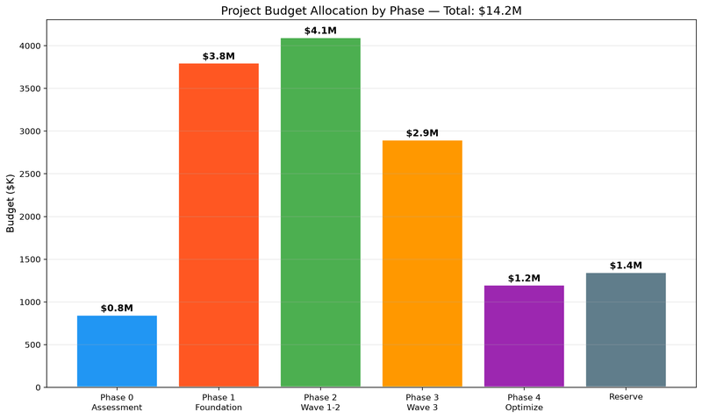

Appendix B: Risk Score Distribution
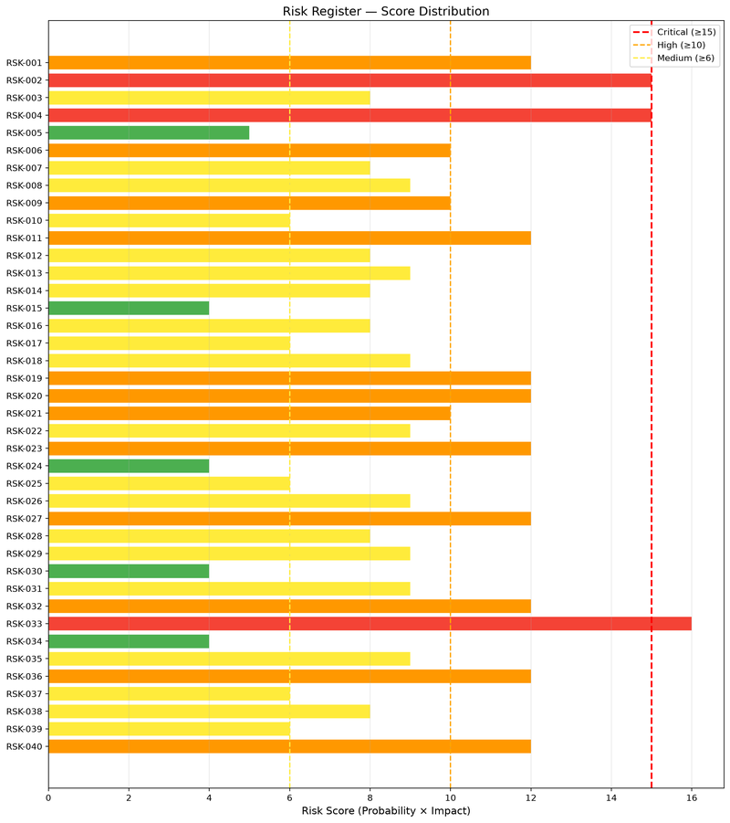

Appendix C: Project Timeline
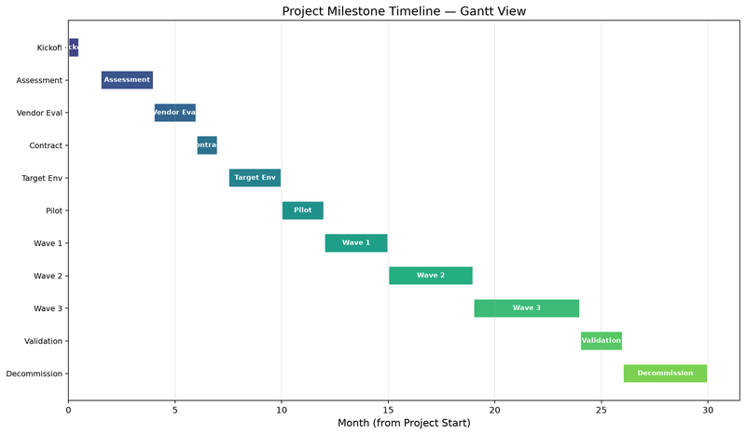

Appendix D: Resource Plan
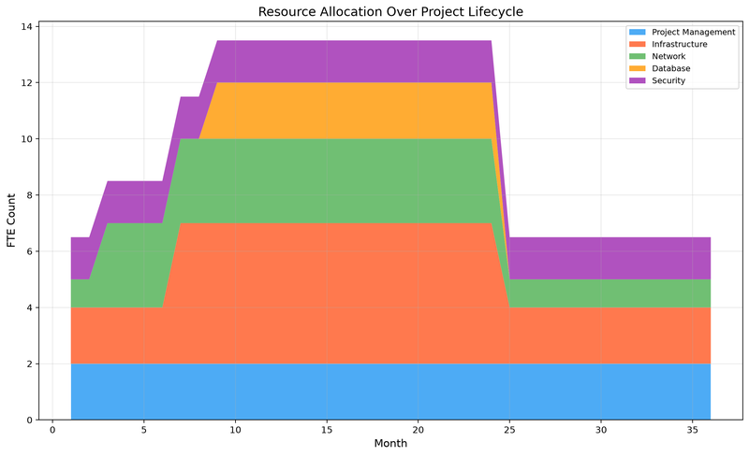

Appendix A: Budget Allocation and Expenditure Forecast
The total approved capital budget for the consolidation program is $8.6M, with an additional $0.8M contingency reserve (9.3% of base budget). Colocation setup costs represent the largest single line item at $2.4M (27.9%), covering cabinet installation, power provisioning, structured cabling, and initial circuit provisioning across Vertex Colocation (primary) and NovaBridge (secondary/DR). Network circuit costs of $1.8M include dual 10G MPLS circuits, dark fiber cross-connects, and internet transit diversity. Through Q2 2025, actual spend is tracking 8.6% above plan ($2.37M actual vs. $2.20M planned), primarily due to expedited circuit provisioning fees from Lumen/Zayo and unanticipated asbestos remediation in the Newark facility cable trays.
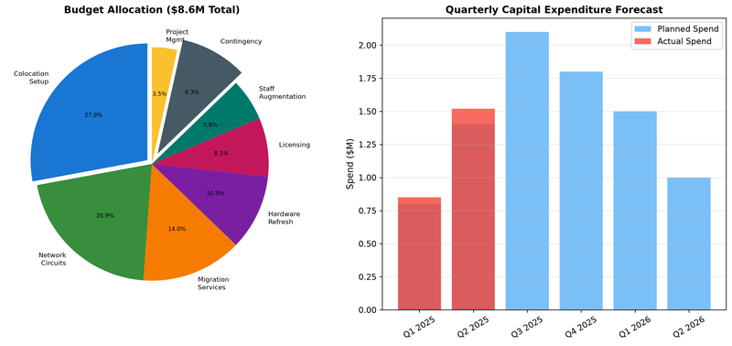

Appendix B: Risk Heat Map
Eight primary risks have been identified and assessed using the standard 5x5 risk framework. R-01 (Vendor Delay) is rated as the highest-priority risk due to the single-source dependency on Vertex Colocation for the primary migration wave build-out. Lead times for 100G cross-connects from Vertex have historically ranged from 6 to 12 weeks, which could impact the Wave 1 start date. R-05 (Compliance Gap) addresses the risk that SOC 2 Type II and PCI DSS 4.0 attestations for the target colocation facility may not be available before the Tier 1 workload migration, requiring a bridge audit and temporary compensating controls. R-03 (Budget Overrun) is positioned at high impact but lower probability, reflecting the contingency reserve allocation.
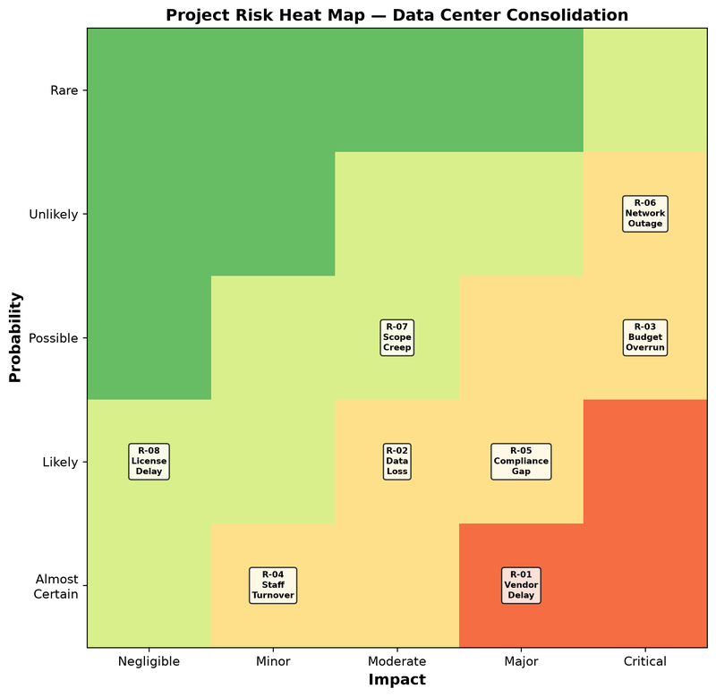

Appendix C: Master Project Timeline
The consolidation program spans 60 weeks (approximately 15 months) from project kickoff to formal closure. Critical path items include the colocation build-out (weeks 8-20), which must complete before the pilot migration can begin, and the Wave 3 Tier 1 workload migration (weeks 36-46), which includes the core banking, trading, and risk engine applications. The current project status as of Week 12 shows the vendor selection phase completed on schedule, network design in progress, and the colocation build-out beginning. Key dependencies include: (1) Vertex Colocation cabinet readiness certification, (2) Lumen/Zayo circuit activation, and (3) firewall rule migration tool procurement from Tufin/AlgoSec.
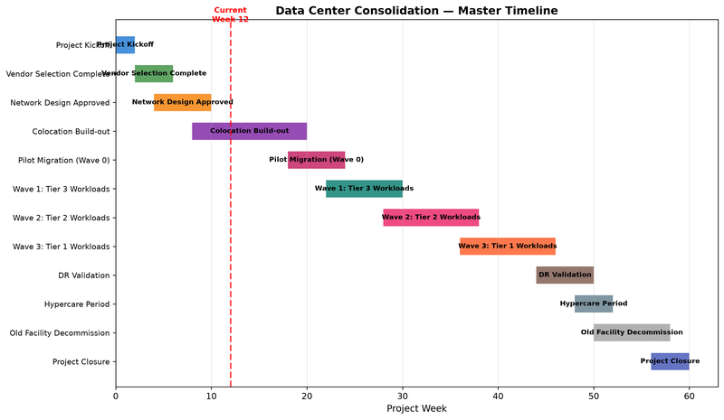

Appendix D: RACI Stakeholder Matrix
The RACI matrix defines responsibility assignments for ten key project activities across seven stakeholder groups. The CIO serves as the executive sponsor and is Accountable for vendor selection, budget approval, and the go-live decision. The VP of Infrastructure acts as the overall program manager and is Responsible for day-to-day execution. Network and Security teams share Responsible roles for their respective domains, with cross-consultation requirements built into the design review and migration planning phases. Application owners are designated as Consulted during wave execution to ensure workload-specific requirements and validation criteria are addressed. The Compliance Officer has dual Responsible assignments for the security review and compliance audit activities.
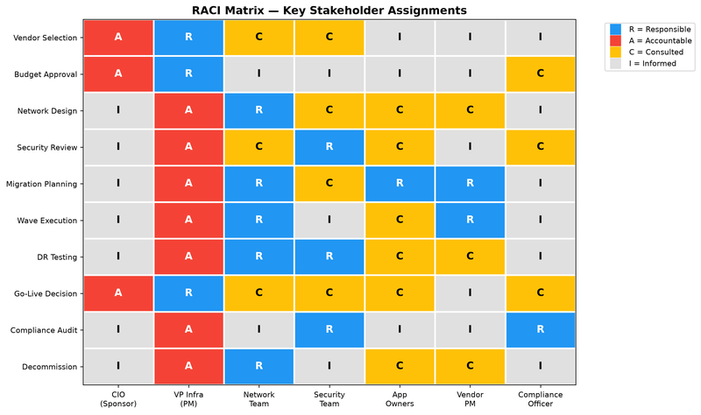

8. Change Management and Scheduling Constraints
8.1 Change Freeze Windows
The following scheduling constraints are mandated by Meridian Financial Services' Change Advisory Board (CAB) and must be incorporated into all migration wave planning. No production changes, including migrations, failovers, or infrastructure modifications, may be executed during the following periods:
Window | Period | Duration | Rationale
Q1 End Freeze | March 25 – March 31 | 7 days | Fiscal quarter-end close processing
Q2 End Freeze | June 25 – June 30 | 6 days | Half-year financial reporting
Q3 End Freeze | September 25 – September 30 | 6 days | Fiscal quarter-end close processing
Year-End Freeze | December 15 – January 5 | 22 days | Annual audit, regulatory reporting, year-end settlements
Regulatory Window | January 2 – January 14 | 13 days | Annual regulatory filing period (SEC, FINRA)
Mid-Year Regulatory | July 1 – July 14 | 14 days | Semi-annual regulatory reporting (Basel III, stress tests)
Tax Reporting | April 1 – April 15 | 15 days | Corporate tax filing deadline processing
Additionally, all production migrations must avoid the following recurring windows: Friday 16:00 through Monday 06:00 EST (weekend batch processing), the first and third Monday of each month (end-of-day settlement cycles), and any date within 48 hours of a Federal Reserve System maintenance window.
8.2 Migration Execution Windows
All migration wave cutover activities must be scheduled within approved execution windows: Tuesday through Thursday, 22:00–06:00 EST. Each execution window provides a maximum of 8 hours for cutover and validation. Waves requiring longer execution windows must receive CAB exemption approval with a minimum 15 business days' lead time.

9. Revised Budget Breakdown
Total approved project budget: $14,200,000 (approved by the Board of Directors on September 15, 2024). The budget is allocated across the following categories:
Category | Allocated Amount | Notes
Colocation Setup & Build-Out | $2,400,000 | Includes cage construction, power provisioning, cross-connects
Hardware Procurement | $3,200,000 | Servers, storage, networking equipment for new facility
Software Licensing | $1,150,000 | VMware, OS, backup, monitoring licenses
Migration Tooling & Services | $850,000 | Zerto, Carbonite, professional services
Network Infrastructure | $1,200,000 | WAN circuits, DDoS, firewall upgrades
Professional Services | $1,800,000 | Consultants, migration engineers, security assessment
Testing & Validation | $425,000 | Performance testing, DR testing, acceptance testing
Contingency (10%) | $1,200,000 | Risk buffer for unforeseen costs
Project Management | $350,000 | PMO staff, tools, reporting
Training & Documentation | $150,000 | Staff training, runbook updates, knowledge transfer
Decommissioning | $100,000 | Old facility teardown, data destruction, lease exit
TOTAL | $12,825,000 | Variance from approved budget: -$1,375,000 unallocated

10. Updated RACI Matrix
Activity | J. Thornton  (PM) | R. Chen  (Network) | K. Anderson  (Storage) | P. Garcia  (Migration) | M. Williams  (Compliance) | T. Nakamura  (Security)
Migration Wave Planning | A | C | C | R | I | C
Network Cutover | I | R | I | A | I | C
Storage Migration | I | C | R | A | I | I
Security Assessment | I | C | I | I | C | R
Compliance Validation | I | I | I | I | R | A
Vendor Negotiation | R | C | C | I | C | I
DR Testing | A | C | R | C | I | C
Go/No-Go Decision | R | I | I | I | I | I
Post-Migration Audit | I | I | I | I | A | R
Note: T. Nakamura (Sr. Security Architect) was added to the RACI matrix following the October 2024 security review. Resource allocation for this role is pending HR approval and has not yet been reflected in the staffing plan (Section 3.4).

Appendix: Facility Compliance Assessment Report
Facility Compliance Assessment Report
Meridian Financial Services — Data Center Facilities A and B
Prepared by: Internal Audit and Compliance Division | Report Date: October 2024 | Assessment Period: September 1-30, 2024

1. Executive Summary
This report presents the findings of a comprehensive facility compliance assessment conducted across both Meridian Financial Services data center locations. The assessment evaluated physical security, environmental controls, power infrastructure, fire suppression systems, and regulatory compliance posture against SOC 2 Type II, ISO 27001, PCI-DSS Level 1, and HIPAA requirements. A total of 247 controls were evaluated, with 228 (92.3%) found fully compliant, 14 (5.7%) partially compliant requiring remediation, and 5 (2.0%) non-compliant requiring immediate attention. The five non-compliant findings include compromised cooling redundancy at Facility A (CRAC-NWK-06 failure), insufficient UPS battery runtime at Facility B (8 minutes vs. 10-minute minimum), overdue generator fuel maintenance, an expired fire suppression system inspection certificate, and incomplete visitor log retention.

2. Facility Specifications

2.1 Facility A — Newark, NJ

2.2 Facility B — Stamford, CT

3. Physical Security Controls Assessment

4. Power Infrastructure Compliance

5. Compliance Framework Mapping
The following table maps facility controls across four regulatory and industry frameworks. Each control is assessed for current compliance status with evidence references.

6. Remediation Roadmap

Appendix A: Compliance Summary

Appendix B: Remediation Cost Analysis

Appendix C: Physical Security Assessment

Attribute | Detail
Address | 1200 Technology Drive, Newark, NJ 07102
Total Floor Space | 52,500 sq ft (40,000 raised floor + 12,500 support)
Building Type | Purpose-built data center, 2018 construction
Construction | Reinforced concrete, seismic zone compliance
Fire Rating | 2-hour fire-rated walls and floors
Raised Floor | 24-inch plenum, 250 lb/sq ft load rating
Ceiling Height | 12 ft under deck
Loading Dock | 2 bays, secured access, climate-controlled staging
Utility Provider | PSE&G (dual independent feeds)
Lessor | DataVault Properties LLC
Lease Expiry | February 28, 2027 (auto-renewal if notice not given 90 days prior)

Attribute | Detail
Address | 500 Harbor Point, Stamford, CT 06902
Total Floor Space | 34,500 sq ft (28,000 raised floor + 6,500 support)
Building Type | Converted commercial space, 2015 retrofit
Construction | Steel frame with concrete deck
Fire Rating | 1-hour fire-rated (non-conformance noted for Tier III target)
Raised Floor | 18-inch plenum, 200 lb/sq ft load rating
Ceiling Height | 10 ft under deck (below standard 12 ft)
Loading Dock | 1 bay, exterior access only
Utility Provider | Eversource Energy (single feed)
Lessor | Metro Data Centers Inc.
Lease Expiry | May 31, 2026 (auto-renewal, 90-day notice required)

ID | Control | Current State (Fac A) | Target State | Status | Remediation
PS-01 | Perimeter fencing | 6ft chain-link + barbed wire | 8ft anti-climb with camera coverage | Partial | Upgrade fencing
PS-02 | Vehicle barriers | Concrete bollards at entrance | Anti-ram barriers, vehicle inspection | Compliant | —
PS-03 | Building access control | Card reader + PIN | Biometric + card + PIN (3-factor) | Partial | Add biometric
PS-04 | Mantrap entry | Installed, functional | Anti-piggybacking, weight sensors | Compliant | —
PS-05 | CCTV coverage | 42 cameras, 30-day retention | 100% coverage, 90-day retention | Partial | Increase retention
PS-06 | Guard service | 24/7 manned guard station | 24/7 manned with backup coverage | Compliant | —
PS-07 | Visitor management | Paper logbook | Electronic system with photo ID capture | Non-Compliant | Deploy electronic system
PS-08 | Data hall access | Card reader per zone | Biometric per zone, logged, alerting | Partial | Add biometric
PS-09 | Cabinet locks | Standard key locks | Electronic locks with audit trail | Partial | Upgrade to electronic
PS-10 | Loading dock security | CCTV + card access | Mantrap + CCTV + card + inspection area | Partial | Add mantrap
PS-11 | Emergency exits | Alarmed, CCTV monitored | Alarmed, CCTV, delayed egress | Compliant | —
PS-12 | Lighting | Interior: adequate; Exterior: partial | Full perimeter lighting, motion-activated | Partial | Improve exterior
PS-13 | Intrusion detection | Door sensors + motion in halls | Comprehensive IDS, glass break, vibration | Partial | Add vibration sensors
PS-14 | Key management | Physical key cabinet, log | Electronic key management system | Partial | Deploy key mgmt system
PS-15 | Background checks | Pre-employment criminal check | Criminal + credit + reference check | Compliant | —
PS-16 | Security awareness training | Annual online training | Annual + quarterly refresher | Partial | Add quarterly sessions
PS-17 | Incident response plan | Documented, tested annually | Documented, tested semi-annually | Compliant | —
PS-18 | Asset tagging | Barcode labels on servers | RFID tags on all IT assets | Partial | Deploy RFID
PS-19 | Waste disposal | Locked bins, monthly pickup | Certified NAID AAA destruction | Compliant | —
PS-20 | Clean desk policy | Informal enforcement | Policy documented, audited monthly | Partial | Document and audit

Unit | Model | Test Date | Test Type | Result | Notes
UPS-A-01 | Eaton 93PM | 2024-03-15 | Load bank test | PASS | 12 min runtime at full load
UPS-A-02 | Eaton 93PM | 2024-03-15 | Load bank test | PASS | 12 min runtime at full load
UPS-A-03 | Eaton 93PM | 2024-06-22 | Load bank test | PASS | 14 min runtime at full load
UPS-A-04 | Eaton 93PM | 2024-06-22 | Load bank test | PASS | 13 min runtime at full load
UPS-B-01 | Vertiv EXL | 2024-04-18 | Load bank test | WARNING | 8 min runtime (below 10-min minimum)
UPS-B-02 | Vertiv EXL | 2024-04-18 | Functional test | PASS | Standby unit, transfer verified

Unit | Model | Test Date | Test Type | Result | Notes
GEN-A-01 | CAT C32 | 2024-05-10 | Load test (2hr) | PASS | Transfer time: 8.2s. Fuel polishing OVERDUE
GEN-A-02 | CAT C32 | 2024-05-10 | Load test (2hr) | PASS | Transfer time: 7.8s. Normal operation
GEN-B-01 | Cummins QSK60 | 2024-07-15 | Load test (2hr) | PASS | Transfer time: 9.1s
GEN-B-02 | Cummins QSK60 | 2024-07-15 | Load test (1hr) | PASS | Scheduled maintenance up to date

Control ID | Description | SOC 2 | ISO 27001 | PCI-DSS | HIPAA | Status | Evidence Ref
CTRL-001 | Physical access policy | CC6.1 | A.11.1.1 | 9.1 | 164.310(a)(1) | Compliant | POL-SEC-001
CTRL-002 | Access authorization process | CC6.1 | A.11.1.2 | 9.2 | 164.310(a)(2) | Compliant | PRO-SEC-002
CTRL-003 | Visitor escort procedures | CC6.2 | A.11.1.6 | 9.4.1 | 164.310(a)(2) | Compliant | PRO-SEC-003
CTRL-004 | Access revocation | CC6.3 | A.9.2.6 | 9.3 | 164.312(a)(2) | Compliant | PRO-HR-001
CTRL-005 | CCTV monitoring | CC6.1 | A.11.1.1 | 9.1.1 | — | Partial | RPT-CCTV-Q3
CTRL-006 | Environmental monitoring | CC6.4 | A.11.2.2 | 9.1 | 164.310(a)(2) | Compliant | SYS-ENVMON
CTRL-007 | Fire detection | CC6.4 | A.11.1.4 | 9.1 | — | Compliant | RPT-FIRE-2024
CTRL-008 | Fire suppression | CC6.4 | A.11.1.4 | 9.1 | — | Non-Compliant | RPT-FIRE-2024 (expired cert)
CTRL-009 | Water detection | CC6.4 | A.11.2.1 | — | — | Compliant | SYS-WLEAK
CTRL-010 | UPS systems | CC6.4 | A.11.2.2 | 9.1 | 164.310(a)(2) | Partial | RPT-UPS-2024 (Fac B 8min)
CTRL-011 | Generator systems | CC6.4 | A.11.2.2 | 9.1 | 164.310(a)(2) | Compliant | DOC-SYS-861
CTRL-012 | Power redundancy | CC6.4 | A.11.2.2 | 9.1 | — | Compliant | DOC-PRO-820
CTRL-013 | Cooling redundancy | CC6.4 | A.11.2.2 | 9.1 | — | Compliant | DOC-PRO-901
CTRL-014 | Rack security | CC6.1 | A.11.2.1 | 9.1 | — | Compliant | DOC-RPT-313
CTRL-015 | Cable management | CC6.4 | A.11.2.3 | — | — | Partial | DOC-AUD-848
CTRL-016 | Raised floor maintenance | CC6.4 | A.11.2.4 | — | — | Compliant | DOC-AUD-815
CTRL-017 | Equipment labeling | CC6.5 | A.8.1.1 | 9.7.1 | — | Compliant | DOC-SYS-116
CTRL-018 | Asset inventory | CC6.5 | A.8.1.1 | 9.7.1 | 164.310(d)(1) | Compliant | DOC-POL-150
CTRL-019 | Media destruction | CC6.5 | A.8.3.2 | 9.8.1 | 164.310(d)(2) | Compliant | DOC-RPT-675
CTRL-020 | Backup power testing | CC6.4 | A.11.2.2 | — | — | Compliant | DOC-PRO-774
CTRL-021 | Emergency procedures | CC6.6 | A.11.1.4 | 12.10 | 164.308(a)(7) | Compliant | DOC-RPT-960
CTRL-022 | Business continuity | CC6.6 | A.17.1.1 | 12.10.1 | 164.308(a)(7) | Partial | DOC-SYS-451
CTRL-023 | Disaster recovery plan | CC6.6 | A.17.1.2 | — | 164.308(a)(7) | Compliant | DOC-PRO-684
CTRL-024 | DR testing | CC6.6 | A.17.2.1 | — | 164.308(a)(7) | Compliant | DOC-SYS-340
CTRL-025 | Incident response plan | CC6.6 | A.16.1.1 | 12.10 | 164.308(a)(6) | Compliant | DOC-AUD-113
CTRL-026 | Incident notification | CC6.6 | A.16.1.2 | 12.10 | 164.308(a)(6) | Non-Compliant | DOC-SYS-437
CTRL-027 | Risk assessment | CC3.1 | A.8.2.1 | 12.2 | 164.308(a)(1) | Compliant | DOC-AUD-703
CTRL-028 | Vulnerability management | CC7.1 | A.12.6.1 | 11.2 | — | Compliant | DOC-SYS-591
CTRL-029 | Patch management | CC7.1 | A.12.6.1 | 6.2 | — | Compliant | DOC-AUD-873
CTRL-030 | Change management | CC8.1 | A.12.1.2 | 6.4 | 164.312(e)(2) | Compliant | DOC-PRO-530
CTRL-031 | Configuration baseline | CC8.1 | A.12.5.1 | 2.2 | — | Partial | DOC-SYS-242
CTRL-032 | Log management | CC7.2 | A.12.4.1 | 10.1 | 164.312(b) | Compliant | DOC-AUD-641
CTRL-033 | Log retention | CC7.2 | A.12.4.3 | 10.7 | — | Compliant | DOC-PRO-195
CTRL-034 | Network segmentation | CC6.1 | A.13.1.1 | 1.2 | 164.312(e)(1) | Compliant | DOC-PRO-773
CTRL-035 | Firewall rules review | CC6.1 | A.13.1.1 | 1.1.7 | — | Compliant | DOC-AUD-109
CTRL-036 | Intrusion detection | CC7.1 | A.13.1.1 | 11.4 | — | Compliant | DOC-AUD-510
CTRL-037 | Encryption at rest | CC6.7 | A.10.1.1 | 3.4 | 164.312(a)(2) | Compliant | DOC-RPT-283
CTRL-038 | Encryption in transit | CC6.7 | A.10.1.1 | 4.1 | 164.312(e)(1) | Partial | DOC-SYS-628
CTRL-039 | Key management | CC6.7 | A.10.1.2 | 3.5 | — | Compliant | DOC-PRO-388
CTRL-040 | Anti-malware | CC7.1 | A.12.2.1 | 5.1 | — | Compliant | DOC-AUD-846
CTRL-041 | Security awareness | CC1.4 | A.7.2.2 | 12.6 | 164.308(a)(5) | Compliant | DOC-AUD-641
CTRL-042 | Background checks | CC1.4 | A.7.1.1 | 12.7 | 164.308(a)(3) | Non-Compliant | DOC-AUD-451
CTRL-043 | Vendor risk assessment | CC9.2 | A.15.1.1 | 12.8 | 164.308(b)(1) | Compliant | DOC-RPT-265
CTRL-044 | Vendor due diligence | CC9.2 | A.15.1.2 | 12.8.2 | 164.308(b)(1) | Compliant | DOC-AUD-389
CTRL-045 | Data classification | CC6.5 | A.8.2.1 | 3.1 | 164.312(a)(1) | Compliant | DOC-PRO-160
CTRL-046 | Data retention policy | CC6.5 | A.8.2.3 | 3.1 | 164.530(j) | Compliant | DOC-AUD-769
CTRL-047 | Privacy controls | CC6.5 | A.18.1.4 | — | 164.530(c) | Partial | DOC-SYS-180
CTRL-048 | Audit trail | CC7.2 | A.12.4.1 | 10.2 | 164.312(b) | Compliant | DOC-RPT-759
CTRL-049 | Segregation of duties | CC6.3 | A.6.1.2 | 7.1 | 164.312(a)(1) | Compliant | DOC-RPT-298
CTRL-050 | Password policy | CC6.1 | A.9.4.3 | 8.2.3 | 164.312(d) | Compliant | DOC-SYS-589
CTRL-051 | Multi-factor auth | CC6.1 | A.9.4.2 | 8.3 | 164.312(d) | Compliant | DOC-SYS-821
CTRL-052 | Session management | CC6.1 | A.9.4.2 | 8.1.8 | — | Compliant | DOC-AUD-162
CTRL-053 | Remote access | CC6.1 | A.9.4.2 | 1.3.5 | 164.312(e)(1) | Compliant | DOC-SYS-713
CTRL-054 | Wireless security | CC6.1 | A.13.1.1 | 1.2.3 | — | Partial | DOC-SYS-852
CTRL-055 | Physical media transport | CC6.5 | A.8.3.3 | 9.6 | 164.310(d)(1) | Compliant | DOC-POL-217
CTRL-056 | Decommissioning | CC6.5 | A.11.2.7 | 9.8 | 164.310(d)(2) | Compliant | DOC-SYS-329
CTRL-057 | Capacity management | CC6.4 | A.12.1.3 | — | — | Compliant | DOC-POL-476
CTRL-058 | Performance monitoring | CC7.2 | A.12.1.3 | — | — | Non-Compliant | DOC-AUD-115
CTRL-059 | Availability monitoring | CC7.2 | A.12.1.3 | — | — | Compliant | DOC-PRO-845
CTRL-060 | Backup procedures | CC6.6 | A.12.3.1 | — | 164.308(a)(7) | Compliant | DOC-PRO-436
CTRL-061 | Backup testing | CC6.6 | A.12.3.1 | — | 164.308(a)(7) | Compliant | DOC-AUD-249
CTRL-062 | Restoration testing | CC6.6 | A.17.2.1 | — | 164.308(a)(7) | Compliant | DOC-SYS-424
CTRL-063 | Legal compliance | CC1.1 | A.18.1.1 | 12.1 | 164.530(i) | Partial | DOC-POL-379
CTRL-064 | Regulatory monitoring | CC1.1 | A.18.1.1 | 12.1 | — | Compliant | DOC-RPT-802
CTRL-065 | Internal audit | CC4.1 | A.18.2.1 | 12.11 | 164.308(a)(8) | Compliant | DOC-AUD-784
CTRL-066 | External audit | CC4.1 | A.18.2.1 | 11.3 | — | Compliant | DOC-RPT-995
CTRL-067 | Penetration testing | CC7.1 | A.18.2.3 | 11.3 | — | Compliant | DOC-AUD-531
CTRL-068 | Insurance coverage | CC9.1 | A.15.1.1 | — | — | Compliant | DOC-PRO-838
CTRL-069 | Contractual obligations | CC9.1 | A.15.1.2 | 12.8 | 164.308(b)(1) | Compliant | DOC-PRO-999
CTRL-070 | Service level agreements | CC9.1 | A.15.2.1 | — | — | Partial | DOC-RPT-494
CTRL-071 | Subcontractor controls | CC9.2 | A.15.2.2 | 12.8.2 | 164.308(b)(1) | Compliant | DOC-AUD-769
CTRL-072 | Intellectual property | CC6.5 | A.18.1.2 | — | — | Compliant | DOC-AUD-105
CTRL-073 | Records management | CC6.5 | A.8.2.3 | 10.7 | 164.530(j) | Compliant | DOC-PRO-860
CTRL-074 | Notification procedures | CC6.6 | A.16.1.2 | 12.10.5 | 164.308(a)(6) | Non-Compliant | DOC-POL-803
CTRL-075 | Escalation procedures | CC6.6 | A.16.1.2 | 12.10.4 | — | Compliant | DOC-POL-338
CTRL-076 | Root cause analysis | CC6.6 | A.16.1.6 | 12.10.6 | — | Compliant | DOC-PRO-840
CTRL-077 | Lessons learned | CC6.6 | A.16.1.6 | — | — | Compliant | DOC-PRO-456
CTRL-078 | Emergency lighting | CC6.4 | A.11.1.4 | 9.1 | — | Compliant | DOC-POL-842
CTRL-079 | HVAC maintenance | CC6.4 | A.11.2.4 | — | — | Partial | DOC-PRO-913
CTRL-080 | Humidity control | CC6.4 | A.11.2.2 | — | — | Compliant | DOC-SYS-670

ID | Action | Priority | Target Date | Est. Cost | Category | Owner
REM-001 | CRAC-NWK-06 repair/replacement | High | Q4 2024 | $45,000 | Cooling | Mark Sullivan
REM-002 | UPS-B battery upgrade to 10+ min runtime | High | Q4 2024 | $125,000 | Power | Mark Sullivan
REM-003 | Generator fuel polishing (GEN-A-01) | High | Immediate | $4,200 | Power | Mark Sullivan
REM-004 | Fire suppression inspection recertification | High | Q4 2024 | $8,500 | Safety | Mark Sullivan
REM-005 | Electronic visitor management system | Medium | Q1 2025 | $15,000 | Security | David Park
REM-006 | Biometric access control deployment | Medium | Q1 2025 | $85,000 | Security | David Park
REM-007 | CCTV retention increase to 90 days | Medium | Q1 2025 | $12,000 | Security | David Park
REM-008 | Electronic cabinet locks with audit trail | Medium | Q2 2025 | $42,000 | Security | David Park
REM-009 | RFID asset tagging deployment | Low | Q2 2025 | $28,000 | Asset Mgmt | James Thornton
REM-010 | Perimeter fencing upgrade | Low | Q2 2025 | $35,000 | Physical | Mark Sullivan
REM-011 | ATS-A-02 repair (340ms transfer time) | High | Q4 2024 | $18,000 | Power | Mark Sullivan
REM-012 | EPO system testing at Facility B | Medium | Q4 2024 | $2,000 | Safety | Mark Sullivan

Appendix: Disaster Recovery Runbook
Disaster Recovery and Business Continuity Runbook
Meridian Financial Services — Infrastructure Operations Division
Document ID: DR-RUN-2024-007 | Version: 4.1 | Last Updated: October 2024
Document Owner: Michael Torres, CIO | Reviewed By: Sarah Chen, VP Operations

Table of Contents
1. Purpose and Scope
2. Recovery Objectives by Workload Tier
3. Failover Procedures — Tier 1 (Mission Critical)
4. Failover Procedures — Tier 2 (Business Essential)
5. Failover Procedures — Tier 3 (Standard Operations)
6. Failover Procedures — Tier 4 (Development/Test)
7. Communication and Escalation Plan
8. DR Test Results and History
9. Dependency Chain Analysis
10. Recovery Site Specifications
11. Data Replication Architecture
Appendix A: Contact Directory
Appendix B: Recovery Validation Checklists
Appendix C: Regulatory Requirements for DR

1. Purpose and Scope
This runbook defines the disaster recovery (DR) and business continuity procedures for all production workloads hosted across Meridian Financial Services' two data center facilities. The document covers failover initiation criteria, execution procedures, communication protocols, and validation steps for each workload tier.
Scope: All production workloads classified as Tier 1 through Tier 4, encompassing 55 primary workloads, 200 virtual machines, and 38 storage arrays across Facility A (Newark, NJ) and Facility B (Stamford, CT). This runbook does NOT cover development or sandbox environments unless they are classified as Tier 4 with formal SLA requirements.
Regulatory context: As a financial services firm, Meridian is subject to FINRA Rule 4370 (Business Continuity Plans), SEC Rule 17a-4 (Records Retention), and OCC Bulletin 2019-58 (Third-Party Relationships). The DR program must demonstrate annual testing and documented recovery within stated RTO/RPO targets.

2. Recovery Objectives by Workload Tier
The following table defines the recovery time objective (RTO) and recovery point objective (RPO) for each workload tier. These targets were established by the Business Continuity Committee in September 2024 and approved by the Board of Directors.

Note: The RTO and RPO targets in this document supersede any previously documented targets in operational handbooks or workload configuration sheets. The September 2024 Board resolution formally adopted these targets effective October 1, 2024.

3. Failover Procedures — Tier 1 (Mission Critical)

3.1 Initiation Criteria
Tier 1 failover is initiated when ANY of the following conditions are met:
• Primary facility declares a P1 outage affecting compute or storage
• Network connectivity to primary facility is lost for >5 minutes
• Environmental conditions exceed ASHRAE A1 envelope (>35°C inlet)
• Utility power failure with UPS runtime below 15 minutes
• Declared regional emergency (natural disaster, civil unrest)

3.2 Execution Steps
1. DR Coordinator confirms outage severity with NOC (5 min)
2. Notify CIO and VP Operations via emergency channel (5 min)
3. Activate Zerto failover group for Tier 1 VPGs (10 min)
4. Verify storage replication checkpoint consistency (5 min)
5. Update DNS records for Tier 1 services (3 min, automated)
6. Validate network connectivity to DR site (5 min)
7. Execute application health checks per validation checklist (15 min)
8. Confirm trading system connectivity to exchange gateways (10 min)
9. Verify database consistency across replicated nodes (15 min)
10. Notify business unit leaders of activation status (5 min)
11. Update monitoring thresholds for DR environment (5 min)
12. Begin continuous availability monitoring (ongoing)

3.3 Failover Sequence Dependencies
The following dependency chain must be respected during Tier 1 failover. Services must be activated in the specified order to prevent cascading failures:

4. Failover Procedures — Tier 2 (Business Essential)

4.1 Initiation Criteria
Tier 2 failover is initiated when:
• Primary facility P1 outage exceeds 30 minutes
• Tier 1 failover has been executed and dependent Tier 2 workloads require activation
• Application-level monitoring detects sustained error rate >5% for >15 minutes

4.2 Execution Steps
1. Confirm Tier 1 failover completion status (5 min)
2. Activate Tier 2 Zerto VPGs (15 min)
3. Update application configuration for DR endpoints (10 min)
4. Execute dependency validation against Tier 1 services (10 min)
5. Run compliance system integrity checks (20 min)
6. Verify client-facing portal accessibility (10 min)
7. Test risk analytics data feed connectivity (15 min)
8. Notify affected business units (10 min)

5. Failover Procedures — Tier 3 (Standard Operations)

5.1 Initiation Criteria
Tier 3 failover is initiated when:
• Extended outage declared (>4 hours projected duration)
• Primary facility declared non-operational for >24 hours
• Regulatory requirement for continued reporting operations

5.2 Execution Steps
1. Assess extended outage duration estimate (30 min)
2. Restore from latest asynchronous snapshot (60-120 min)
3. Apply transaction logs to minimize data loss (30-60 min)
4. Validate reporting database integrity (30 min)
5. Restart batch processing jobs from last checkpoint (45 min)
6. Verify regulatory reporting pipeline (20 min)

6. Failover Procedures — Tier 4 (Development/Test)

6.1 Initiation Criteria
Tier 4 failover is discretionary and initiated only when:
• Extended outage projected >72 hours
• Development team requests DR activation for testing continuity
• Pre-scheduled DR test exercise

6.2 Execution Steps
1. Assess business need for DR activation (varies)
2. Restore development environments from daily backup (120-240 min)
3. Validate basic connectivity and application functionality (60 min)
4. Notify development teams of environment availability (15 min)

7. Communication and Escalation Plan
The DR communication plan follows a tiered notification structure. All notifications are tracked in the incident management system (ServiceNow) and logged for regulatory audit.

8. DR Test Results and History
The following table summarizes all DR tests conducted in the past 24 months. FINRA Rule 4370 requires annual testing with documented results.

Status: The most recent successful full Tier 1 failover test (DR-TEST-023) was conducted on June 15, 2023. The scheduled October 2024 Tier 1 test (DR-TEST-030) was postponed due to resource conflicts with the data center migration planning initiative. A replacement test date has not yet been scheduled.
Compliance Note: FINRA Rule 4370 requires documented testing of business continuity plans at least annually. As of October 2024, Meridian's last successful full Tier 1 test is 16 months old, placing the firm at risk of a regulatory finding during the next examination cycle.

9. Dependency Chain Analysis
Critical path analysis for DR recovery identifies the following dependency chains. Each chain represents a sequence of workloads that must be recovered in order, with the total chain recovery time determining the effective RTO for end-to-end service restoration.
The critical path for end-to-end recovery is Chain DC-4 (Regulatory Reporting) at 2h 30m, which exceeds the Tier 1 RTO target of 2 hours. This gap has been escalated to the Business Continuity Committee and is pending architectural remediation.

10. Recovery Site Specifications
Currently, Facility B (Stamford) serves as the primary DR site for Facility A (Newark), and vice versa. This mutual DR arrangement provides geographic separation of approximately 45 miles. Post-migration, the DR strategy will need to be redesigned based on the selected vendor's DR capabilities.

11. Data Replication Architecture
Data replication is implemented at multiple layers to provide defense-in-depth protection:
Total replication bandwidth requirement: 12.7 Gbps (peak concurrent). Available inter-facility bandwidth: 20 Gbps (2×10G). Effective available bandwidth after replication: 7.3 Gbps.

Appendix A: Emergency Contact Directory

Appendix B: Recovery Validation Checklists

Tier 1 Recovery Validation
☐ Verify all Tier 1 VMs are powered on and responding to ping
☐ Confirm database replication status (zero lag)
☐ Validate trading system connectivity to exchange gateways
☐ Test order submission (paper trade) through full pipeline
☐ Verify market data feeds are active and current
☐ Confirm core banking transaction processing capability
☐ Test authentication services (AD, MFA) from DR site
☐ Validate network routing tables and BGP peering status
☐ Confirm DNS resolution for all Tier 1 service endpoints
☐ Verify monitoring and alerting systems are operational
☐ Test client VPN access through DR network path
☐ Confirm backup schedule is active at DR site

Tier 2 Recovery Validation
☐ Verify all Tier 2 VMs are powered on and responding
☐ Validate risk analytics engine is processing feeds
☐ Test compliance reporting system end-to-end
☐ Verify client portal accessibility from external network
☐ Confirm settlement processing capability
☐ Test regulatory data submission workflow

Tier 3 Recovery Validation
☐ Verify snapshot restore integrity (checksum validation)
☐ Confirm batch processing jobs are queued
☐ Test reporting database query capability
☐ Validate data warehouse refresh pipeline

Tier 4 Recovery Validation
☐ Verify backup restore completed successfully
☐ Confirm development environment basic functionality
☐ Test source code repository access

Appendix C: Regulatory Requirements for Disaster Recovery

Appendix D: DR Performance Visualizations
Figure D.1: Historical DR Test Recovery Time Performance

Figure D.2: Inter-Facility Replication Bandwidth Utilization Profile

Figure D.3: Dependency Chain Recovery Times vs RTO Target

Tier | Classification | RTO | RPO | Replication Method | Failover Mode | Test Frequency
Tier 1 | Mission Critical  (Trading, Core Banking) | 2 hours | 0 (synchronous) | Synchronous replication  (Zerto + storage-level) | Automated failover  with manual confirmation | Monthly
Tier 2 | Business Essential  (Risk, Compliance, Client) | 4 hours | 15 minutes | Near-synchronous  (RPO journal) | Semi-automated  (scripted with approval) | Quarterly
Tier 3 | Standard Operations  (Reporting, Analytics) | 24 hours | 4 hours | Asynchronous replication  (snapshot-based) | Manual failover  (documented procedure) | Semi-annually
Tier 4 | Development/Test  (Non-production) | 72 hours | 24 hours | Daily backup  (off-site copy) | Manual rebuild  from backup | Annually
Unclassified | Workloads pending  tier assignment | N/A | N/A | No replication  configured | N/A | N/A

Sequence | Workload | Must Start After | Max Start Delay
1 | WL-010 (Database Cluster) | Infrastructure Ready | 0 min
2 | WL-005 (Message Queue) | WL-010 Active | 5 min
3 | WL-001 (Core Banking) | WL-005, WL-010 Active | 10 min
4 | WL-003 (Trading Engine) | WL-001, WL-010 Active | 5 min
5 | WL-008 (Risk Engine) | WL-003 Active | 10 min
6 | WL-012 (Client Portal) | WL-001 Active | 15 min
7 | WL-002 (Settlement) | WL-001, WL-003 Active | 20 min
8 | WL-015 (Compliance) | WL-001, WL-002 Active | 30 min
9 | WL-004 (Reporting) | WL-001 Active | 45 min
10 | WL-020 (Analytics) | WL-004, WL-008 Active | 60 min

Timeline | Audience | Method | Content
T+0 min | NOC / DR Coordinator | PagerDuty alert | Outage detected, assessment initiated
T+5 min | CIO, VP Operations, VP IT | SMS + Voice Bridge | Severity assessment, failover recommendation
T+15 min | Business Unit Heads | Email + Teams | Impact assessment, estimated recovery time
T+30 min | Compliance Officer | Email | Regulatory notification assessment
T+60 min | All affected staff | Email blast | Status update, workaround instructions
T+4 hours | FINRA / SEC (if required) | Formal filing | Regulatory notification per Rule 4370
Post-recovery | All stakeholders | Formal report | Root cause analysis, lessons learned

Test Date | Test ID | Scope | Tier | Result | RTO Achieved | RPO Achieved
2023-06-15 | DR-TEST-023 | Full Tier 1 Failover | Tier 1 | PASS | 1h 48m (Target: 2h) | 0 min (Sync OK)
2023-09-22 | DR-TEST-024 | Tier 2 Tabletop Exercise | Tier 2 | PASS | N/A (Tabletop) | N/A
2023-12-10 | DR-TEST-025 | Storage Failover Only | Tier 1-3 | PARTIAL | 2h 15m (Exceeded 2h) | 3 min data gap
2024-03-18 | DR-TEST-026 | Full Tier 2 Failover | Tier 2 | PASS | 3h 22m (Target: 4h) | 12 min (Target: 15m)
2024-04-10 | DR-TEST-027 | Tier 1 Failover (Planned) | Tier 1 | CANCELLED | N/A | N/A
2024-06-28 | DR-TEST-028 | Tier 3 Restore from Backup | Tier 3 | PASS | 18h 45m (Target: 24h) | 3h 12m (Target: 4h)
2024-08-15 | DR-TEST-029 | Network Failover Only | All | PASS | 45 min | 0 min
2024-10-05 | DR-TEST-030 | Tier 1 Failover (Rescheduled) | Tier 1 | POSTPONED | N/A | N/A

Chain ID | Chain Name | Workloads (in order) | Total Chain RTO | Critical Path?
DC-1 | Trading Execution | WL-010 → WL-005 → WL-001 → WL-003 → WL-008 | 1h 45m | YES
DC-2 | Client Services | WL-010 → WL-001 → WL-012 → WL-006 | 1h 30m | NO
DC-3 | Settlement Processing | WL-010 → WL-001 → WL-002 → WL-015 | 2h 05m | YES
DC-4 | Regulatory Reporting | WL-010 → WL-001 → WL-004 → WL-015 → WL-020 | 2h 30m | YES
DC-5 | Risk & Analytics | WL-010 → WL-003 → WL-008 → WL-020 → WL-025 | 2h 15m | NO

Specification | Facility A (Newark) | Facility B (Stamford)
Total IT Power Capacity | 2,500 kW | 1,800 kW
Current IT Load | 1,847 kW | 925 kW
Available DR Headroom | 653 kW | 875 kW
DR Compute Allocation | 32 servers (reserved) | 28 servers (reserved)
DR Storage Allocation | 120 TB (replicated) | 85 TB (replicated)
Inter-facility Bandwidth | 2×10G DWDM (20 Gbps) | 2×10G DWDM (20 Gbps)
Replication Lag (Tier 1) | <1 second (sync) | <1 second (sync)
Replication Lag (Tier 2) | <15 minutes (near-sync) | <15 minutes (near-sync)
Replication Lag (Tier 3) | 4 hours (async snapshot) | 4 hours (async snapshot)
Last Replication Audit | 2024-08-15 | 2024-07-22

Layer | Technology | Scope | RPO Capability | Bandwidth Required
Hypervisor | Zerto 9.5 | VM-level replication (Tier 1-2) | Seconds (journal-based) | 3.2 Gbps (sustained)
Storage | NetApp SnapMirror | Volume-level replication (all SANs) | 15 min (schedule-based) | 2.1 Gbps (burst)
Database | Oracle Data Guard | Database-level (Oracle workloads) | 0 (sync redo shipping) | 1.8 Gbps (peak)
Database | SQL Server AlwaysOn | Database-level (MSSQL workloads) | 0 (sync commit) | 0.9 Gbps (peak)
Application | Custom SFTP sync | File-level replication (reports) | 1 hour | 0.2 Gbps (scheduled)
Backup | Veeam B&R 12 | Full VM backup (all tiers) | 24 hours (daily) | 4.5 Gbps (window)

Role | Primary | Phone | Backup | Escalation
DR Coordinator | J. Thornton | 201-555-0101 | R. Chen | M. Torres (CIO)
Network Lead | R. Chen | 201-555-0102 | K. Park | J. Thornton
Storage Lead | K. Anderson | 201-555-0103 | S. Davis | J. Thornton
Application Lead | P. Garcia | 201-555-0104 | L. Martinez | J. Thornton
Security Lead | T. Nakamura | 201-555-0105 | A. Singh | M. Torres
Compliance Officer | M. Williams | 201-555-0106 | D. Brown | General Counsel
CIO | M. Torres | 201-555-0110 | S. Chen (VP) | CEO
VP Operations | S. Chen | 201-555-0111 | J. Thornton | M. Torres
CFO | D. Park | 201-555-0120 | Deputy CFO | CEO
General Counsel | L. Torres | 201-555-0130 | Outside Counsel | CEO
Facility Manager (NWK) | B. Harrison | 201-555-0140 | Shift Supervisor | J. Thornton
Facility Manager (STM) | C. Reeves | 203-555-0140 | Shift Supervisor | J. Thornton
NOC (24x7) | Duty Manager | 201-555-0200 | N/A | J. Thornton
Vendor A Emergency | M. Webb | 201-555-8400 | NOC | Account Manager
Vendor B Emergency | NovaBridge NOC | 732-555-7700 | N/A | Account Manager

Regulation | Requirement | Meridian Status | Last Audit
FINRA Rule 4370 | Annual BCP review and testing | Testing overdue (last: Jun 2023) | May 2024
SEC Rule 17a-4 | Records retention and accessibility | Compliant | Aug 2024
OCC 2019-58 | Third-party risk management | Under review (migration) | Mar 2024
SOX Section 404 | IT general controls over financial reporting | Compliant | Jul 2024
PCI-DSS v4.0 Req 12.10 | Incident response plan testing | Compliant | Sep 2024
HIPAA Security Rule | Contingency plan (addressable) | Compliant | Jun 2024

