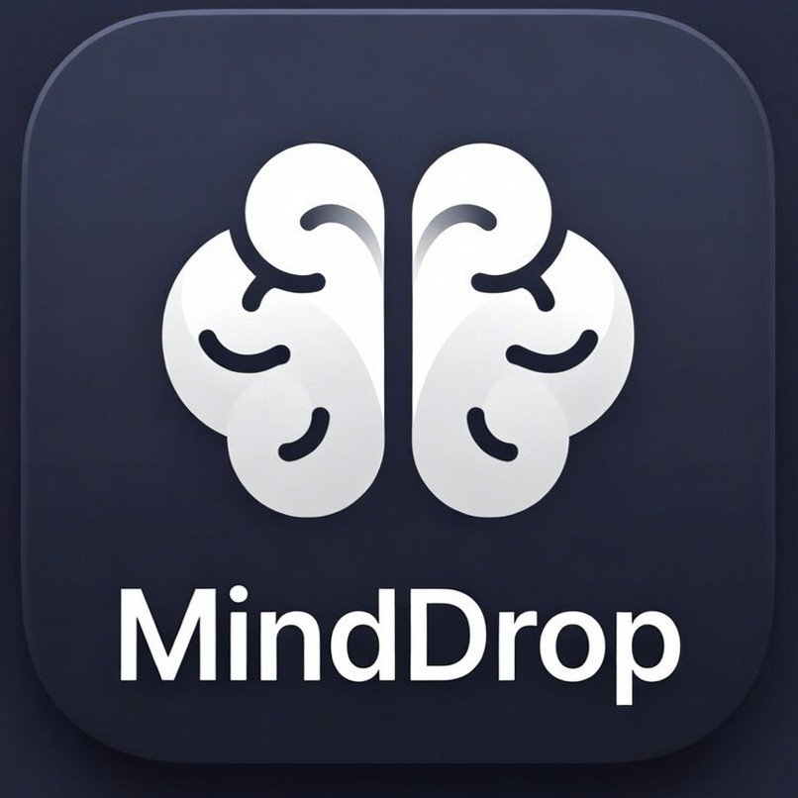
MindDrop
Smart To-Do List with AI
Elite Productivity Workspace

User Guide
Version 1.0

Table of Contents

1. Introduction 3
2. Getting Started 3
2.1 Account Creation & Authentication 3
2.2 Installation Options 4
3. Core Features 4
3.1 Task Management 4
3.2 AI-Powered Task Analysis 5
3.3 Kanban Board View 6
3.4 Timeline/Planning View 6
3.5 Meeting Studio 7
3.6 Focus Mode (Pomodoro) 7
3.7 Voice Assistant 8
3.8 AI Image Generation 8
4. Advanced Features 9
4.1 Tags & Organization 9
4.2 Keyboard Shortcuts 9
4.3 Filters & Search 10
4.4 Theme Customization 10
5. Data & Privacy 10
6. Tips & Best Practices 11

1. Introduction
MindDrop is an intelligent task management application powered by Google's Gemini AI. It goes beyond traditional to-do lists by automatically analyzing your tasks, breaking them into actionable subtasks, suggesting priorities, and even generating unique workspace themes.

Key Features
🤖 AI-Powered Task Analysis - Automatically prioritizes and breaks down tasks
📋 Kanban Board & Timeline Views - Organize tasks your way
🎤 Voice Assistant - Hands-free task creation with Gemini Live
⏱️ Focus Mode - Pomodoro timer for deep work
📝 Meeting Studio - Convert meeting notes into actionable tasks
🎨 AI Image Generation - Create custom workspace backgrounds
🏷️ Smart Tagging - Organize with hashtags and AI-suggested tags
📱 Cross-Platform - Works on web and mobile (via Capacitor)

2. Getting Started
2.1 Account Creation & Authentication
When you first launch MindDrop, you'll see the authentication screen. You have several options to get started:

• Google Sign-In: Sign in with your Google account for seamless access
• Email/Password: Create an account using your email address
• Continue as Guest: Try MindDrop without an account (data stored locally)
[ Screenshot Placeholder ]
Figure 1: MindDrop Authentication Screen

Note: Guest mode stores your data locally in the browser. For cross-device access, sign in with Google or create an account.
2.2 Installation Options
MindDrop is a web application that can also be installed as a native mobile app:

• Web App: Access at minddrop.app from any browser
• PWA: Install as a Progressive Web App for offline access
• Android APK: Build using Capacitor for native Android experience

3. Core Features
3.1 Task Management
Creating tasks in MindDrop is intuitive and powerful. The AI assistant analyzes your input to provide smart suggestions:

1. Click the task input field or press 'N' on your keyboard
2. Type your task naturally (e.g., 'Write a report about Q4 sales by Friday')
3. Optionally add details or upload an image for context
4. Press Enter - MindDrop will automatically:
• Analyze and set priority level (Critical, High, Medium, Low)
• Break the task into actionable subtasks
• Suggest time estimates for each subtask
• Extract relevant tags and deadlines
[ Screenshot Placeholder ]
Figure 2: Creating a New Task with AI Analysis

Task Properties
Property | Description
Title | The main task description
Description | Additional context and details
Priority | AI-suggested: Critical, High, Medium, or Low
Subtasks | AI-generated actionable steps with time estimates
Deadline | Extracted deadline with smart reminders
Tags | AI-suggested and manual hashtags for organization

3.2 AI-Powered Task Analysis
MindDrop uses Google's Gemini AI to analyze your tasks and provide intelligent insights:

Smart Prioritization: AI evaluates urgency and importance to suggest the right priority level
Subtask Generation: Automatically breaks complex tasks into manageable steps
Time Estimation: AI estimates how long each subtask will take
Context Awareness: Understands deadlines, attachments, and natural language
AI Coach: Chat with AI about any task for guidance and suggestions
3.3 Kanban Board View
The Kanban board provides a visual overview of all your tasks organized into three columns:

📋 To Do: Tasks waiting to be started
🚀 In Progress: Tasks you're currently working on
✅ Done: Completed tasks

Tip: Click on any task to open the detailed task view where you can edit, add comments, or use AI features.
[ Screenshot Placeholder ]
Figure 3: Kanban Board View with Task Cards

3.4 Timeline/Planning View
Switch to Timeline view (press Alt+2) for a calendar-based perspective on your tasks:

📅 Day/Week/Month views for different planning horizons
🖱️ Drag and drop tasks to reschedule them
📊 Color-coded by priority for quick scanning
➕ Click any time slot to create a new task with that deadline
3.5 Meeting Studio
Transform meeting notes into actionable tasks automatically:

1. Switch to Meeting Studio view (Alt+3)
2. Paste your meeting notes or transcription
3. Click 'Process' to let AI analyze the content
4. Review the structured minutes and extracted tasks
5. Sync individual tasks directly to your board
[ Screenshot Placeholder ]
Figure 4: Meeting Studio - Converting Notes to Tasks
3.6 Focus Mode (Pomodoro)
Enter Focus Mode for distraction-free work sessions. Press 'F' or click the wand icon to let AI select your most important task:

⏱️ 25-minute work sessions with 5-minute breaks
🤖 AI automatically picks your highest-priority task
📝 Tick off subtasks as you complete them
🔔 Browser notifications when sessions end
🌙 Ambient background that adjusts to your theme

Tip: Focus Mode works best with headphones on for audio cues!
[ Screenshot Placeholder ]
Figure 5: Focus Mode with Pomodoro Timer
3.7 Voice Assistant
Use hands-free task entry with Gemini Live voice recognition (press 'V'):

🎤 Natural voice input for creating multiple tasks
📝 Real-time transcription as you speak
🤖 AI processes your spoken tasks automatically
✅ Review and confirm extracted tasks before adding
3.8 AI Image Generation
Customize your workspace with AI-generated backgrounds using Gemini:

1. Open the Theme customization
2. Describe your desired atmosphere (e.g., 'A futuristic city with neon lights')
3. Click 'Generate' to create a unique 4K background
4. Apply to instantly transform your workspace

4. Advanced Features
4.1 Tags & Organization
MindDrop uses a powerful tagging system to organize your tasks:

🏷️ Use #hashtags directly in task titles (e.g., 'Finish report #work #q4')
🎨 Tags are auto-assigned colors for visual distinction
🔍 Filter tasks by single or multiple tags
🤖 AI suggests relevant tags based on task content
4.2 Keyboard Shortcuts
Master these shortcuts to boost your productivity:

Shortcut | Action | Description
N | New Task | Open task input
V | Voice Assistant | Open voice input
F | Focus Mode | AI-select task & start timer
/ | Search/Filter | Open filter panel
Esc | Close Modal | Close any open modal
Alt+1 | Board View | Switch to Kanban board
Alt+2 | Timeline View | Switch to calendar view
Alt+3 | Meeting Studio | Switch to meeting notes

4.3 Filters & Search
Quickly find what you need with powerful filtering:

🔤 Search by task title or description
🚩 Filter by priority level (Critical, High, Medium, Low)
🏷️ Filter by tags
📅 Filter by urgency (Today, Overdue, This Week)
🔄 Combine multiple filters for precise results
4.4 Theme Customization
Personalize your MindDrop experience:

🌙 Dark/Light mode toggle
🎨 AI-generated backgrounds with Magic Theme
🖼️ Custom workspace backgrounds
📱 Responsive design adapts to any screen size

5. Data & Privacy
Your data security and privacy are our top priorities:

🔐 Authentication: Secure Firebase authentication with Google or email
💾 Data Storage: Firestore database for cloud sync, localStorage for guests
🤖 AI Processing: Tasks processed by Google's Gemini AI for analysis
📜 Data Ownership: You own your data - export/backup anytime
🔒 Privacy: AI analysis happens securely - no data shared with third parties

Backup & Export: Your data can be exported as JSON at any time from the settings menu.
6. Tips & Best Practices
Get the most out of MindDrop with these recommendations:

💡 Start Small: Begin with 3-5 tasks to build the habit
🎯 Daily Review: Spend 5 minutes each morning reviewing your board
🤖 Trust the AI: Let Gemini suggest priorities - it learns your patterns
⏰ Use Deadlines: Set realistic deadlines for accountability
🏷️ Tag Everything: Consistent tagging makes filtering powerful
🎤 Speak Naturally: Voice input works best with clear, complete sentences
🍅 Pomodoro Power: Use Focus Mode for deep work sessions
📝 Meeting Prep: Use Meeting Studio right after calls while context is fresh

Appendix: Quick Reference

Priority Color Coding
Priority | Color
Critical | 🔴 Red
High | 🟠 Orange
Medium | 🟡 Amber/Yellow
Low | 🟢 Green

Troubleshooting Common Issues
• Voice not working: Check microphone permissions in browser settings
• AI not analyzing: Ensure you have an active internet connection
• Tasks not saving: Try logging out and back in, or use a registered account
• Slow performance: Clear browser cache or try incognito mode
• Missing features: Some features require sign-in for full access

Need Help?
For additional support, feature requests, or feedback, please reach out through our official channels.

© 2024 MindDrop. All rights reserved.

