Dignity Is a Baseline: Welfare Institutions and the Asymmetric Politics of Economic Disruption
Ben Smart
University of Copenhagen, Department of Economics
Welfare State Seminar — Spring 2026
"The goal of social policy, in these times of change and anxiety, is to help people absorb the shocks that affect them without allowing those shocks to affect their sense of themselves."

Banerjee and Duflo (2019)
Abstract
Why does economic disruption so often produce the wrong politics? Workers exposed to automation turn against immigrants rather than toward the welfare state, and more generous spending has done little to stop them; compensation often fails, sometimes backfires, and is frequently refused (Gingrich 2019; Stutzmann 2025; Pelc 2025). The standard answer, descended from Ruggie's (1982) embedded liberalism, treats welfare as a buffer: compensate the losers of economic change, and the backlash recedes. The operative variable is quantity. Spend more, get less populism. This paper argues the buffering account measures the wrong thing. Welfare shapes the direction of the political response, not only its intensity, and it does so through what it communicates to vulnerable workers about their worth and their standing, not through how much it spends; in Banerjee and Duflo's (2019) terms, whether it lets them absorb economic shocks without those shocks reaching their sense of themselves. The European Social Survey (rounds 6–9, 34 countries, N=188,764) shows the gap: automation exposure turns into anti-immigration sentiment far more strongly where welfare is less decommodifying. Spending effort misses the pattern entirely; active labour market expenditure is uncorrelated with the cross-national variation (r=0.01, N=15). Decommodification (Esping-Andersen 1990) tracks it strongly across these countries (r=−0.855, p<0.001, N=15), and the more defensible individual-level interaction holds (β=−0.059, p=0.015, N=81,885). The welfare state's signature is clearest on the damage side. Where welfare is more decommodifying, vulnerability turns into exclusion less readily; the same welfare shows no comparable pull toward solidarity, consistent with dignity-preserving welfare clearing the ground for a solidarity it does not by itself produce. The paper reads that asymmetry cautiously, since the redistributive outcome is measured far more coarsely than the exclusionary one. Decommodification, not spending, is the dimension along which the politics of economic disruption becomes visible.
I. Introduction
Workers in routine-task-intensive occupations across Europe support the populist radical right at strikingly high rates (Gingrich 2019; Kurer 2020; Im et al. 2019; Autor et al. 2020; Gallego and Kurer 2022), and they do so most where welfare provision is weakest (Vlandas and Halikiopoulou 2022; Caselli et al. 2021). The pattern is by now well established. The question this paper takes up is not whether it exists but why it takes the form it does: why economic disruption turns into hostility toward immigrants rather than demand for redistribution, and why people facing genuine vulnerability turn against the welfare state rather than toward it. This is the wrong politics, the response that fails the people experiencing the disruption.
The conventional answer treats the welfare state as a buffer. In Ruggie's (1982) account of embedded liberalism, generous provision compensates the losers of open markets, and compensation dampens their resentment; the operative variable is quantity. Spend more, get less populism. Posing the problem as how much welfare states spend, however, obscures what they communicate. This paper argues that welfare shapes the direction of the political response to disruption, not only its intensity, and that the dimension doing the work is decommodification rather than spending effort: what the welfare state says to vulnerable workers about their worth and their citizenship, not how much it transfers to them.
The evidence is harder on the buffering account than this allows. Compensation often does not work; in the one careful cross-national test, automation-exposed workers are no less likely to vote populist where early retirement, in-kind spending, and labour protection are more generous (Gingrich 2019). It sometimes backfires. Germany compensated the communities hit by its coal phase-out, and those communities abstained and abandoned the party that represented them anyway (Stutzmann 2025), while austerity predicted Brexit through lost trust rather than lost income (Fetzer 2019). And it is often refused: workers prefer reduced hours to compensated unemployment, and employer provision to the identical transfer from the state (Pelc 2025). Kurer (2020, p.1801) names the tension directly:
"When relative societal decline rather than material hardship are at the heart of socially conservative resentment, traditional welfare policy may be an insufficient response to satisfy exposed workers and hence an ineffective remedy to counter the ascent of right-wing populist movements."
The mechanism runs through what welfare communicates, not what it spends. Welfare is the one domain where economic vulnerability and institutional judgement meet at the same moment; when a worker reaches the welfare state, it allocates resources and renders a verdict on the worker's claim to them in a single act. Banerjee and Duflo (2019) cast the task of social policy as helping people absorb economic shocks without letting those shocks reach their sense of themselves, and this paper takes the formulation literally. Where welfare preserves that sense of self, communicating that disruption is a structural problem calling for a collective answer, workers read their vulnerability through class and press for redistribution. Where it damages that sense of self, through means-testing, surveillance, and the message that need reflects failure, the same vulnerability sets off a cascade of identity switching (Bonomi, Gennaioli and Tabellini 2021), misattribution (Gallego and Kurer 2022), and defensive othering (Wagner 2022). Institutional design communicates worth, citizenship, and belonging, and those communications carry political weight the generosity literature has missed.
This is why spending and decommodification come apart. Redistribution and recognition are not the same good, and they do not substitute: right-populist voters "care as much, or even more, about recognition as about redistribution" (Gidron and Hall 2017), and what routine workers demand is economic and cultural protection at once, the second of which no transfer can supply (Kurer and Palier 2019). A welfare state can spend heavily through punitive, conditional channels that register as generous while communicating suspicion, or it can decommodify, in Esping-Andersen's (1990) sense letting a person "maintain a livelihood without reliance on the market", and so communicate standing. Collapse welfare onto a spending axis, and the two become impossible to tell apart.
The paper's empirical task is to identify the dimension that does the work, and to show that it is decommodification, not spending. In the European Social Survey (rounds 6–9, 34 countries, N=188,764), automation exposure turns into anti-immigration sentiment far more strongly in liberal welfare regimes than in Nordic ones (β=0.127, p=0.003). Active labour market spending, on a matched 15-country sample, tracks none of this cross-national variation (r=0.01, N=15); decommodification tracks it strongly (r=−0.855, p<0.001), though that correlation rests on 15 country-level points, which makes the individual-level interaction the firmer test; that interaction survives at the individual level and under macroeconomic controls (β=−0.059, p=0.015, N=81,885). The welfare state's signature is clearest on the damage side. Where welfare is more decommodifying, vulnerability turns into exclusion less readily; the same welfare shows no comparable pull toward solidarity. The paper reads that asymmetry as dignity-preserving welfare clearing the ground for a solidarity it does not by itself produce, and reads it cautiously, since the redistributive outcome is measured far more coarsely than the exclusionary one and the within-individual test belongs to the register-based design sketched in §V.G.
The contribution is twofold. The paper connects mechanisms that have been studied apart, identity switching, misattribution, and defensive othering, into a single chain, and locates the decommodifying quality of the welfare state as the condition under which the chain fires. And it shows that the moderation vanishes under spending measures and sharpens under decommodification, displacing the buffering model's reliance on generosity as the variable that matters. Section II makes the case against buffering; §III sets out the mechanism; §IV bounds its scope; §V presents the analysis; §VI concludes.
II. The Limits of the Buffering Model
The buffering framework introduced in §I treats the welfare state as a compensatory buffer against political extremism. Its contemporary applications test whether welfare generosity reduces radical right support (Vlandas and Halikiopoulou 2022; Halikiopoulou and Vlandas 2016; Ennser-Jedenastik et al. 2019). The operative variable is quantity.
But the evidence is harder on the framework than this account allows.
Compensation that does not work. Gallego and Kurer (2022) flag what they call a "concerning finding" from Gingrich's (2019) comparative study, the only careful cross-national analysis testing whether public policies aimed at alleviating labour market risks for automation-exposed workers prevent the political turn to protest voting. Gingrich finds that workers highly exposed to automation are not less likely to vote for populist parties in countries with more generous early retirement policies, more in-kind spending, or more protective labour market regulation. If the buffering model were correct, more generous welfare states should show weaker automation-to-populism effects. They do not; as Kurer (2020, p.1826) puts it, "the reverse mechanism (more spending, less populism) is not borne out by Gingrich's data."
Compensation that backfires. Stutzmann (2025) examines Germany's coal phase-out, a case where affected communities received substantial compensatory investment and where both compensation and interest group representation were fulfilled. Material conditions held; affected municipalities nonetheless showed higher abstention rates and lower support for the issue-owning party. Bergman (2022) theorises "self-undermining" policy feedback effects, whereby welfare interventions visibly benefiting groups that potential radical right voters view unfavourably can catalyse greater support for the radical right. Fetzer's (2019) analysis of Brexit makes the channel explicit: welfare cuts predicted Leave support through the erosion of political trust and efficacy, rather than through material deprivation. The institutional channel is doing the political work.
Compensation that is resisted. Pelc (2025) shows that a sizeable portion of workers resist being compensated out of work even when the compensation fully replaces their income, preferring reduced hours over unemployment at the same pay, and compensation from employers over identical compensation from government. The form, source, and meaning of compensation carry political weight independently of its material content. As Guriev and Papaioannou (2022) observe, compensating the losers of economic transformation has proven much harder than economists assumed, not because of insufficient resources, but because of political and institutional constraints the buffering framework does not theorise. Kuziemko et al. (2023) make the complementary point on the demand side. Less-educated voters in the United States prefer predistribution (wage protection, work supports) over redistribution as such, suggesting the resistance Pelc documents is characteristic rather than anomalous.
Burgoon and Schakel (2022) provide the most careful recent empirical case for the buffering account, and the apparent contradiction with this paper's null on welfare spending is worth resolving directly. They find welfare generosity associated with reduced anti-globalization nationalism in European party platforms. Their result is real and their measurement careful. The contradiction dissolves once the units of analysis are kept distinct: Burgoon and Schakel measure platform language at the party level, while the analysis here measures attitudinal slopes at the individual level conditional on automation exposure. The mechanisms that translate aggregate welfare effort into party platforms (elite incentives, coalition arithmetic, electoral targeting) differ from the mechanisms that translate institutional encounter into individual self-concept and exclusionary attitudes. Both findings can be true. Welfare generosity at scale may dampen the supply of anti-globalization rhetoric in party systems while the demand for exclusionary attitudes among vulnerable workers responds to a different welfare dimension entirely. The contribution of this paper is to identify that dimension as decommodification rather than spending effort, and to locate it at the individual rather than party level.
The buffering model is not entirely wrong. Albanese, Barone and de Blasio (2022) find that EU structural fund disbursements reduce populist voting in recipient regions, suggesting visible, tangible local investment can work where individualised transfers cannot. The finding cuts the same way as the asymmetric argument developed below. What the spending says about recipients, and about their relationship to the political community, is what does the work. Spending effort alone is too coarse.
III. The Mechanism: Welfare and the Self-Concept
A. What the Evidence Demands
The central empirical pattern of §V is asymmetric. The theoretical argument that follows in this section is the falsifiable form of the central hypothesis stated in §I; §V.D tests its decommodification-versus-spending half, and §V.F tests the asymmetry on the solidarity side. The data test the moderating dimension, not the mechanism: decommodification rather than spending conditions how disruption converts into exclusion. The cascade developed below is theorised, not tested; its links are supported citation by citation, and the within-individual design of the thesis is built to test them. Welfare institutional context moderates the conversion of automation exposure into anti-immigration sentiment: the slope is significantly steeper in Liberal regimes than in Nordic ones, and the moderation tracks decommodification rather than spending. It does not detectably moderate the conversion of the same exposure into redistributive solidarity. RTI predicts slightly higher redistribution support across all regimes, but the cross-regime interaction is small and non-significant, and a supplementary ISSP analysis (Appendix C) returns the same null on a different sample and outcome variable. The damage mechanism is legible. The protective one is not.
However, the natural response is to treat the solidarity null as a measurement problem. The supplementary analysis suggests the null survives a few obvious alternatives, and it is also robust to the more defensible interpretation: the pattern itself appears asymmetric. Welfare institutions can fail politically in a specific, cumulative way; the protective converse, actively manufacturing solidarity, is weaker and harder to detect, for reasons partly substantive and partly of measurement.
Indeed, the recognition literature has been working toward this claim for some time. Gidron and Hall (2017, p.26) find that right-populist voters "care as much, or even more, about recognition as about redistribution," and that compensation "is not what these people are looking for." Kurer and Palier (2019) make the complementary point in the routine-worker context: what routine workers demand is "economic and cultural protection," and the second of those cannot be supplied through transfer payments. Redistribution and recognition are not fungible. The asymmetric mechanism takes that non-fungibility as its starting point.
B. Why Welfare, and Not Something Else
The obvious objection is that many institutions shape identity. Media environments construct group boundaries; religious traditions supply moral narratives; class structures generate interest coalitions. Why isolate welfare?
The answer is that welfare is the single state domain where economic vulnerability and institutional treatment meet. When a worker encounters the welfare state, the institution allocates resources and renders a judgement about that worker's claim to them, in the same act. Other identity-shaping institutions cannot match the combination. Courts render judgement but rarely allocate resources to the individual judged; markets allocate without judgement, or pretend to; religious institutions render judgement but cannot compel. Only welfare does both, and at the point of a person's maximum material dependence.
Wagner's (2022) finding that recipients learn and mirror the recognition norms the state enacts on them is intelligible only under these conditions. Because the encounter is materially consequential and judgement-laden, recipients cannot dismiss the signal as one view among many; they have to metabolise it. Soss (1999) documents the specific learning. Programmes with respectful implementation foster civic engagement; programmes characterised by surveillance and conditionality generate alienation, and the alienation persists. De Blok and Kumlin (2022) extend the point: procedural fairness preserves institutional trust most strongly for those whose outcomes are unfavourable, which means implementation quality matters most precisely for those who are most economically vulnerable. What the welfare state says about you, when you encounter it, is part of what you know about yourself.
Furthermore, the mechanism scales beyond direct recipients through three channels. Workers anticipating future dependency factor present welfare treatment into present self-understanding. Public discourse mirrors recipient-level recognition norms (Wagner 2022). And routine-task-intensive workers are over-represented in welfare caseloads over the life-course, even though most are employed at any given moment; the bridge therefore runs as much through anticipated dependency and public discourse as through current receipt, which is why the cross-national pattern is detectable in ESS data. A structurally distinct fourth channel runs through Mettler's (2011) "submerged state": tax expenditures and indirect benefits serving middle and upper-income groups that remain invisible as government assistance. Recipients of submerged welfare attribute their security to personal merit; recipients of visible welfare are marked as dependents. The two groups look at the same welfare state but see different institutions, producing a political identity fracture in which a large share of the population benefits from the welfare state without recognising it.
C. The Damage Cascade
When welfare institutions damage the self-concept, three responses follow, each harder to reverse than the one before.
The first is identity. Bonomi, Gennaioli, and Tabellini (2021) model how individuals move from class to cultural identity when class identity is degraded by economic disruption, and under cultural identity redistribution demand decreases while cultural conservatism intensifies. The welfare state enters at a specific point: stigmatising implementation degrades class identity directly. A worker entering a system that treats retraining as a citizenship right retains class identity; a worker entering a system of means-testing and surveillance has it doubly damaged, by the disruption and by the system's response to him. Ballard-Rosa, Jensen, and Scheve (2022) provide the downstream evidence: economic decline activates social identity processes producing authoritarian values through group status threat. Welfare institutional mediation, this paper argues, is the missing upstream variable. Im et al. (2023) confirm in Finnish panel data that expected status decline, not material hardship as such, drives the radical right shift among routine workers, and expectations are themselves shaped by what workers observe of how the state treats people in their position.
Once cultural identity is in charge, grievances misattribute. Economic frustration gets pointed at cognitively available scapegoats. Wu (2022) confirms the misdirection empirically: workers at higher automation risk oppose immigration but show no different technology preferences. There is no analogue on the protective side; no condition under which structural attribution emerges as a substitute for the cultural attribution workers would otherwise have made. Alesina and Angeletos (2005) provide the institutional anchor: conditional welfare systems produce individual rather than structural attributions.
The third move is defensive othering. Patrick (2016) documents what this looks like at the recipient level: UK benefit claimants shoring up their own deservingness through critique of those below them, using the same criteria the welfare system applied to them. Wagner (2022) calls it "kicking down" and documents its institutional origins. Im and Komp-Leukkunen (2021) connect it to automation: routine workers support strict conditionality because it maintains status distance from groups below them, not because strict conditionality is in their material interest.
D. The Recursive Loop
The cascade forms a self-sustaining system. Conditional welfare damages self-concepts. Damaged self-concepts produce othering. Othering generates public attitudes supporting further conditionality. Political entrepreneurs respond with welfare chauvinism. Further conditionality deepens the damage. The loop runs into a population that has forgotten the position it now defends was constructed for it.
Haugsgjerd and Kumlin (2020) demonstrate the dynamic with panel data: poor welfare performance reduces political trust, and reduced trust makes future evaluations more negative; a "downbound spiral." Van Hootegem, Abts, and Meuleman (2021) name the attitudinal contradiction the loop produces: the most vulnerable simultaneously support redistribution in principle and distrust the welfare state in practice. This gap is the political space the radical right occupies, and it is constructed by the loop rather than discovered by it.
The loop makes the damage self-concealing. Because the welfare state produces the attitudes that legitimate its own retrenchment, each iteration appears more natural than the last. Preferences that are outputs of policy appear as inputs. This is policy feedback running backwards; not Pierson's (1994) positive feedback constructing supportive constituencies, but the reverse, with constituencies generated against the mechanisms that would serve their material interests. The cascade ends in the configuration Busemeyer, Rathgeb, and Sahm (2022) name precisely: the "particularistic-authoritarian" welfare preference (pro-workfare, anti-poor, anti-social-investment), the programme of the radical right, generated in part by the welfare institutions it claims to oppose. On the evidence, its supporters "strongly support policies that promote new social divisions and the further exclusion of the unemployed and the poor" (Busemeyer, Rathgeb, and Sahm 2022, p.96).
E. Why the Protective Pathway Is Weaker
The symmetric account would predict that welfare institutions which preserve the self-concept produce solidarity through a mirror-image cascade: stable identity, structural attribution, inclusive deservingness. The paper's empirical null on the solidarity side says otherwise, and on the reading developed here the null is what the mechanism actually predicts.
Indeed, three different things are wrong with the symmetric picture. Loss aversion comes first. Kahneman and Tversky's (1979) finding, that losses loom larger than equivalent gains in evaluation, applies directly to dignity shocks. A stigmatising welfare encounter registers as a status loss; a dignity-preserving encounter does not register as a status gain of equivalent magnitude. What it produces is the absence of damage, which has a different psychological signature and a different political one. Damage mobilises; the absence of damage tends not to. Kurer and van Staalduinen (2022) document the closely related asymmetry in intergenerational status discordance: voters whose expectations are unmet show large political shifts, while voters whose expectations are exceeded show much weaker ones.
Second, status is positional. There is no quantity of status one person can have without another person having less. Gidron and Hall (2017) make the point exactly: what right-populist voters want is recognition in the relational sense, not redistribution in the material sense, and relational goods cannot be redistributed without losses to the currently-recognised. Dignity-preserving welfare removes an obstacle to inclusive solidarity; it does not, by itself, construct the inclusion. The distinction is between care and connection: welfare design as currently constituted delivers material care across the Esping-Andersen regimes, but solidarity is a connection-thick political achievement; it requires the shared workplaces, organising work, and relational practices that decommodification can clear the ground for but cannot construct (Iversen and Soskice 2001; Rothstein 2001; Larsen 2008). Welfare provides permission, not propulsion.
Third, defensive othering, once committed to, is costly to reverse. A worker who has built their own deservingness on critique of those below them has made an identity investment, and identity investments are not undone by changing the institutional environment alone; they require the un-doing of identity work that has already happened. This is the structural reason the recursive loop developed in §III.D, once initiated, is so difficult to interrupt by institutional reform alone. The asymmetry runs through the individual as well as the system: dignity damaged is harder to restore than dignity preserved is to maintain.
Three asymmetries, each with a far weaker mirror image. Dignity is a baseline good. Its absence damages. Its presence clears the ground for a solidarity that has to be built on top, by other means.
F. What the Theory Predicts
A theory of this shape has to be testable. The asymmetry generates five predictions sharp enough to fail.
(P1) Cross-national variation in exclusion should track dimensions of welfare design that bear on dignity (decommodification, conditionality, the punitive-enabling balance of ALMP; see Meuleman et al. 2025) but not welfare spending effort, because spending is orthogonal to dignity. Tested in §V.D.
(P2) Cross-national variation in solidarity should not track the same welfare design variables with anything like the same strength, because solidarity requires supply-side construction (political entrepreneurship, coalitional framing, electoral system affordances) that welfare quality alone cannot provide. Tested in §V.F.
(P3) What makes Nordic welfare states distinctive should be the absence of steep exclusion slopes, not the presence of redistributive uplift. The data behaves accordingly: among the Western European welfare-state genealogies in scope, Nordic RTI→exclusion slopes are the flattest (§V.C; the negative Eastern interaction is treated as a scope condition in §IV).
Two further predictions live within rather than across countries and motivate the registry-based follow-up.
(P4) Welfare reform introducing conditionality should show damage effects, while welfare reform expanding generosity should show weaker or null protective effects.
(P5) Panel data should detect path-dependence in individual attitudes, with workers who experience a stigmatising encounter showing elevated exclusionary attitudes years later.
Three of the five predictions are tested in this paper; two are written so that, in the thesis, they can be falsified.
IV. Scope Conditions and Limits
The asymmetric mechanism claims something narrower than its symmetric cousin: welfare institutions are the institutional condition under which the damage cascade fires, while the protective converse, a symmetric condition producing a mirror-image solidarity cascade, is weaker and harder to detect. Three limits bound the claim.
The absence of damage is necessary but not sufficient for solidarity. Universal programmes build social trust (Rothstein 2001) and produce inclusive deservingness narratives (Larsen 2008); extensive universal provision conveys recognition beyond material security (Kurer et al. 2019); Nordic welfare states show consistently lower populist support despite globalisation pressures (Norris and Inglehart 2019). All real. On the asymmetric reading, what these findings record is the baseline dignity-preserving welfare provides, not the active uplift the buffering model assumes. The political work that converts baseline dignity into active solidarity (Bornschier et al. 2024; Jeffrey 2020) is out of scope here. Welfare design's role in that construction is permissive, not productive.
Welfare institutions also do not operate on a blank moral slate. Pelc's (2025) finding that Protestant work ethic predicts compensation resistance independently of material incentives suggests some attitudes exist prior to institutional contact. The welfare state shapes moral frameworks, but it also inherits them.
The loss aversion claim in §III.E borrows from behavioural economics by analogy. Supporting empirical work (Kurer and van Staalduinen 2022; Kurer et al. 2019) is consistent with the claim but does not test it directly. The within-individual test belongs to the registry-based follow-up. The cross-sectional finding here is large, robust, and predicted by the theory; it remains provisional in a way the asymmetric framing itself acknowledges.
A scope condition worth naming concerns Eastern Europe. Table 2 shows RTI × Eastern is negative and significant (β=−0.132, p<0.001); the conversion of automation exposure into anti-immigration sentiment is flatter in low-decommodification Eastern European regimes than in Nordic ones, the opposite of what a CWED-based theory predicts at face value. On the institutional-encounter reading developed above, this is consistent rather than disconfirming: the asymmetric-encounter mechanism presupposes the welfare-citizenship norms inherited from the Esping-Andersen genealogy, which post-communist regimes have not had time to develop in the same form (Vachudova 2020; Bustikova 2019). CEE welfare states carry different fiscal commitments to dignity-as-baseline, different inheritance from socialist-era universalism, and different supply-side radical-right structures. The 15-country CWED-matched sample is therefore not just a data constraint but a scope condition: the asymmetric mechanism is bounded to Western European welfare-state genealogies, and the negative Eastern interaction is consistent with that boundary rather than evidence against the mechanism inside it.
V. Empirical Analysis
A. Data and Measurement
The cross-national test that follows identifies the environment channel delimited in §IV. The analysis uses the European Social Survey (ESS), rounds 6–9 (fieldwork 2012–2018), covering 34 countries and 188,764 observations.
Automation exposure is measured by routine task intensity (RTI) scores mapped to three-digit ISCO-08 occupation codes following Autor, Levy, and Murnane (2003) and Goos, Manning, and Salomons (2014). Match rate: 87.8% (N=165,667).
Exclusionary attitudes are measured by a three-item anti-immigration index (whether immigrants make the country worse, undermine cultural life, or are bad for the economy; reverse-coded 0–10; Cronbach's α=0.864).
Welfare institutional context is operationalised in three ways. Countries are classified into welfare regimes following Esping-Andersen (1990) and Ferrera (1996): Nordic (DK, SE, NO, FI, IS), Continental (DE, FR, AT, BE, NL, CH), Liberal (GB, IE), Southern (ES, IT, PT, CY), and Eastern (CZ, PL, HU, SK, SI, EE, LT, LV, BG, HR). Country-level ALMP spending (% of GDP) is drawn from the CPDS (22 countries). Total welfare generosity from the Comparative Welfare Entitlements Dataset (CWED), measured as the mean decommodification score across unemployment, sickness, and pension programmes for 2005–2011 (15 Western European countries).
Controls include age, age squared, gender, education (ES-ISCED), household income decile, and urban/rural residence.
B. Empirical Strategy
The core test is a cross-level interaction:
Y_ij = β₀ + β₁(RTI_i) + β₂(Welfare_j) + β₃(RTI_i × Welfare_j) + γ(X_i) + u_j + ε_ij
where β₃ tests whether the conversion of automation exposure into exclusionary attitudes depends on welfare institutional context. The analysis estimates mixed models with country-wave random slopes for RTI (1 + RTI | country-wave), confirmed over random intercepts alone by likelihood ratio test. Models 1–5 use this random-slopes specification; the radical-right-vote model (Model 6) and the Appendix A robustness battery retain the earlier random-intercept estimator. OLS with country-wave fixed effects and clustered standard errors serves as a robustness check; results are directionally identical. The cross-sectional design cannot establish causality. The test is whether the pattern is consistent with the asymmetric mechanism developed in §III and inconsistent with the symmetric "more spending = less backlash" alternative.
C. Descriptive Results
Figure 1 presents the central descriptive finding. Across all welfare regimes, higher RTI is associated with more anti-immigration attitudes; the relationship is positive and significant everywhere. The slope is steepest in Liberal regimes (β=0.512), followed by Southern (β=0.462), Continental (β=0.443), Nordic (β=0.413), and Eastern (β=0.263). These are descriptive slopes; the regime interactions in Table 2 are expressed relative to the Nordic baseline, so Eastern, positive here but the flattest, enters Table 2 with a negative sign. The marginal effects plot (Figure 2) makes the comparison precise: a one-standard-deviation increase in RTI is associated with approximately 0.32 additional scale points of anti-immigration sentiment in Liberal regimes, compared to 0.20 in Nordic regimes. The gap is statistically significant and substantively meaningful.
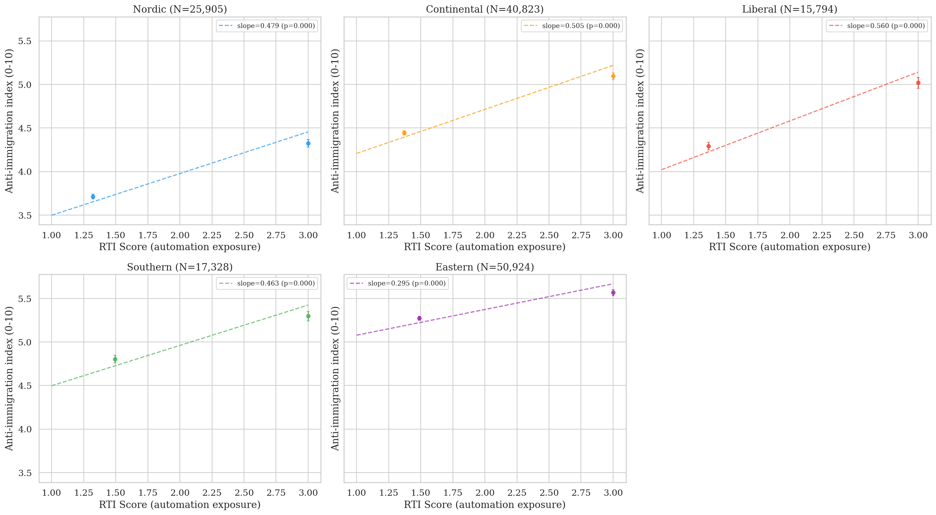
Figure 1. RTI vs. anti-immigration by welfare regime. Five-panel binned scatter.
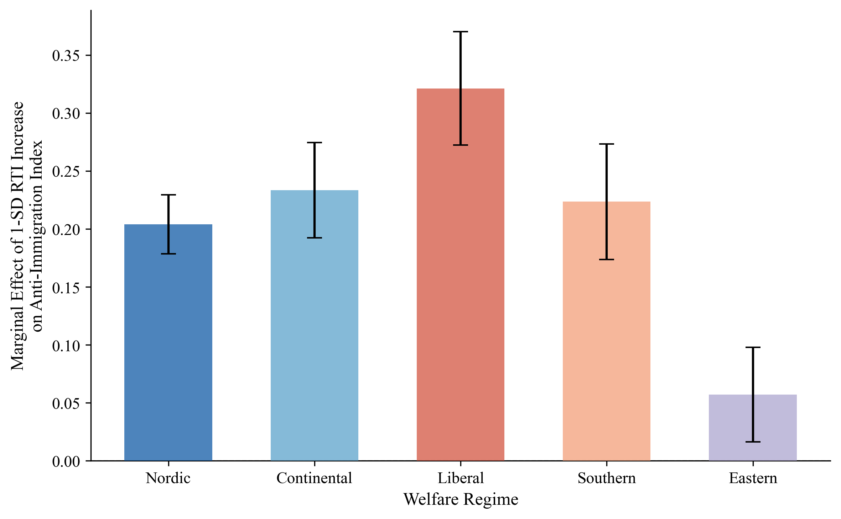
Figure 2. Marginal effect of 1-SD RTI increase by welfare regime.
D. The CWED Finding: Decommodification as the Operative Variable
Comparing two welfare measures produces the paper's most important finding.
When individual countries' RTI→anti-immigration slopes are plotted against their ALMP spending levels (restricting to the same 15 Western European countries used in the CWED analysis), the correlation is near-zero (r=0.01, p=0.97, N=15). Countries spending more on active labour market policies show no systematically flatter or steeper vulnerability-to-exclusion slopes. Spending effort, holding sample constant, is unrelated to the exclusion pattern.
The picture changes dramatically when welfare is measured by its decommodifying quality. Figure 3 plots the same country-level slopes against CWED total generosity, the composite score capturing how effectively welfare systems enable workers to sustain living standards without employment. The correlation is strongly negative: r=−0.855, p<0.001, N=15 countries. Welfare generosity measured as decommodification is associated with 73 per cent of the cross-country variation in how strongly automation exposure co-varies with exclusionary attitudes. The United Kingdom, lowest in CWED generosity, shows the steepest slope. Norway, highest in generosity, shows the flattest.
These country-level slopes are extracted as best linear unbiased predictors (BLUPs) from a random-slopes mixed model with individual-level controls (age, age², gender, education, income, urban residence); this specification partials out within-country covariation between RTI and demographics that would otherwise contaminate a bivariate slope estimate, while letting each country's slope estimate borrow strength from the cross-country variance structure. The simpler bivariate per-country OLS alternative (no controls, no information sharing across countries) gives a directionally identical but weaker correlation with CWED (r=−0.625, p=0.013, N=15) and is reported in the replication appendix.
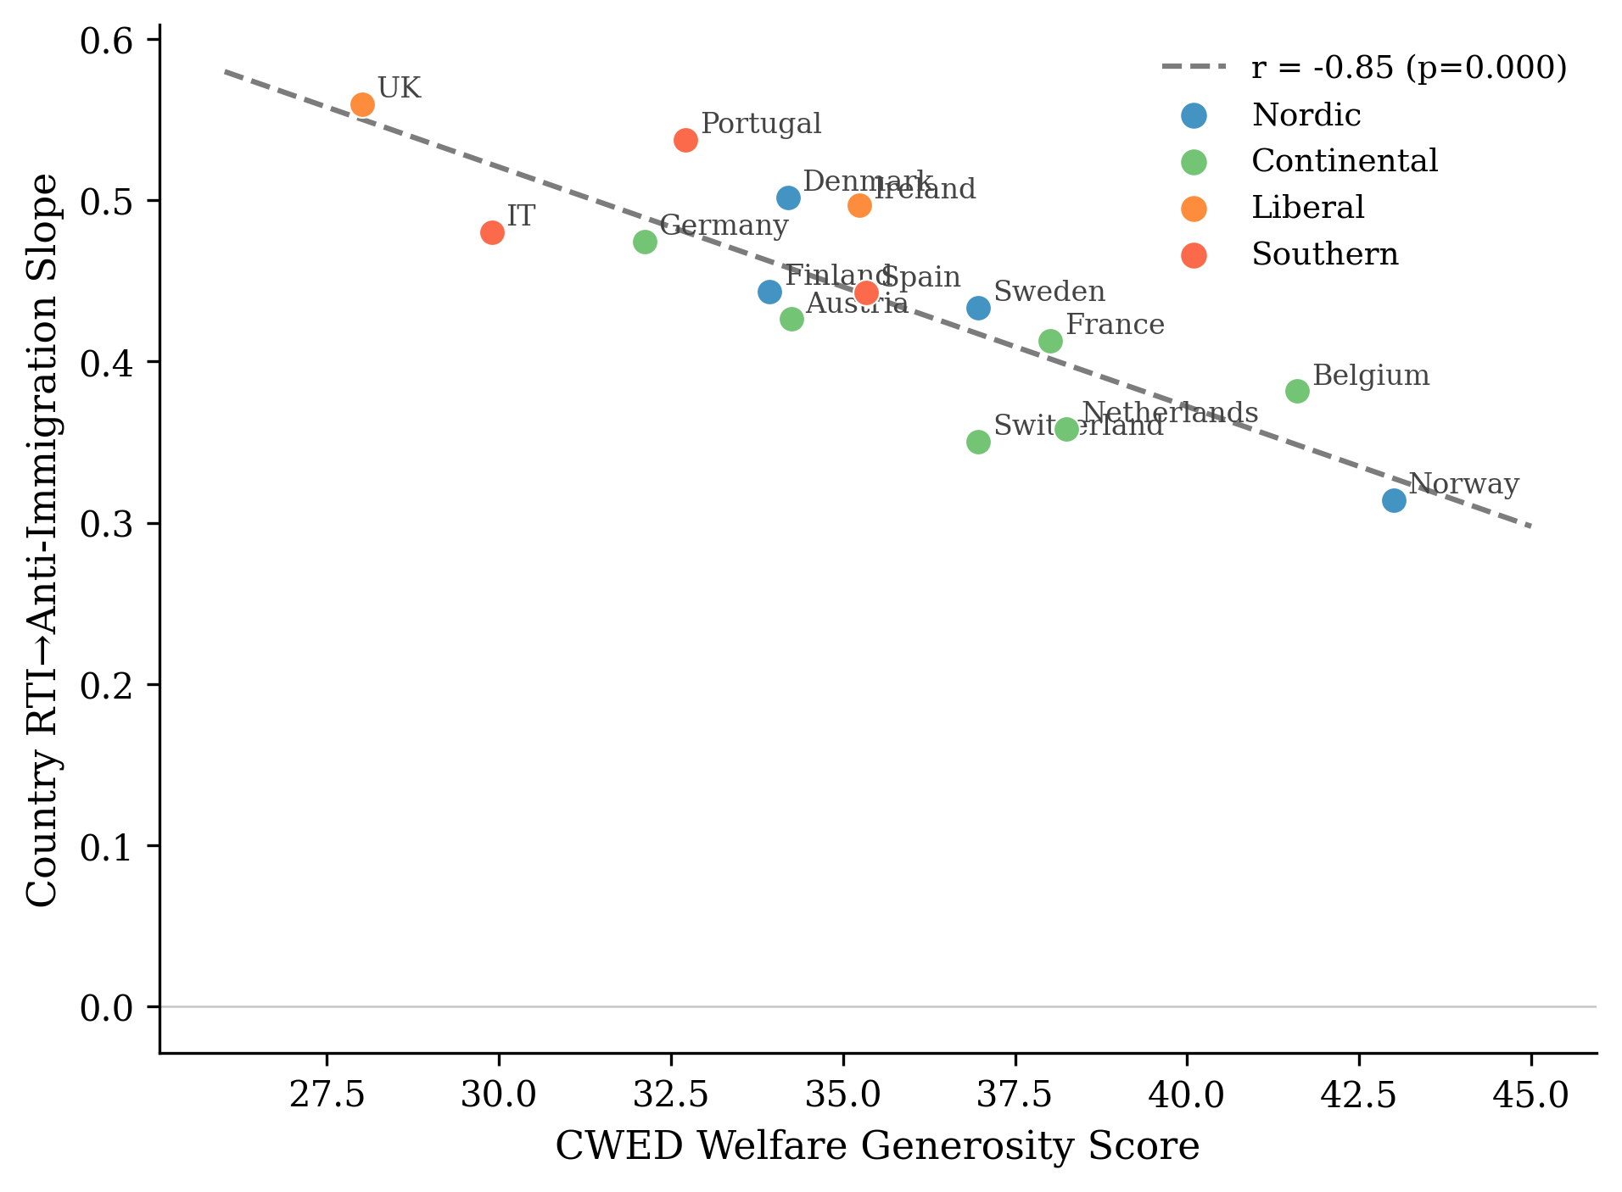
Figure 3. CWED generosity vs. country-level RTI→anti-immigration slopes.
At the individual level, Model 3 confirms this with the cross-level interaction (Table 1):
Table 1. Cross-level interaction of RTI and CWED generosity (Model 3; random slopes; N=81,885).
Variable | β | SE | p
RTI | 0.215 | 0.025 | <0.001
CWED generosity | -0.069 | 0.064 | 0.281
RTI × CWED generosity | -0.059 | 0.024 | 0.015
The interaction is negative and significant (β=−0.059, p=0.015, N=81,885): a one-standard-deviation increase in welfare generosity reduces the marginal effect of RTI on anti-immigration attitudes by 0.059 scale points. The larger standard error relative to earlier specifications reflects the conservative random-slopes estimator, which absorbs cross-national slope heterogeneity. The finding is robust to country-level GDP growth and Gini controls (β=−0.066, p<0.001), arguing against the concern that decommodification proxies for broader economic conditions.
The ALMP/CWED contrast is the paper's central empirical argument, and it maps directly onto the theoretical distinction in §III. Bonoli's (2013) typology and the more recent treatment in Meuleman et al. (2025) explain why: ALMP aggregates across enabling programmes (upskilling, employment counselling) and punitive ones (benefit sanctions, behavioural conditionality), so the political signature of the punitive subset cancels out against the enabling subset. CWED measures what the welfare state provides rather than what it demands, which is the asymmetric mechanism's exact prediction.
Denmark presents an instructive complication. Despite high CWED generosity, Denmark shows a relatively steep RTI→exclusion slope (β=0.24, a control-adjusted BLUP, on a different and lower scale than the descriptive regime slopes of §V.C), higher than Finland, Sweden, or Norway. Danish "flexicurity" combines generous benefits with high labour market flexibility and active job search requirements, creating a system generous in transfers but demanding in activation. On the asymmetric reading, this is not an anomaly but an additional piece of evidence: conditionality and surveillance damage the self-concept even when transfer levels are high. Decommodification is the best available cross-national proxy for what welfare provides and communicates, not a direct measure of the texture of the encounter; Denmark is therefore read here as suggestive rather than confirmatory. The activation-introducing reforms of 2003, 2006, and 2013 are exactly the kind of within-country shock the asymmetric theory predicts should produce damage signatures with decommodification held constant. The country-level finding is robust to all single-country exclusions: excluding the United Kingdom (lowest CWED) gives r=−0.808; excluding Norway (highest CWED) gives r=−0.793; excluding both simultaneously gives r=−0.700 (p=0.008). Across the full set of 105 two-country BLUPs jackknife pairs the correlation ranges from r=−0.700 to r=−0.922, no pair flips sign, and 105 of 105 retain significance at p<0.05; the result does not depend on any single case or any pair of cases jointly.
E. Main Models
Table 2 presents the multilevel results. Model 1 confirms that RTI predicts anti-immigration attitudes after controls (β=0.168, p<0.001, N=133,016). Model 2 introduces regime interactions with Nordic as reference:
Table 2. Multilevel models of anti-immigration attitudes (Models 1–2; random slopes; Nordic baseline).
Interaction | β | SE | p
RTI (Nordic baseline) | 0.194 | 0.025 | <0.001
RTI × Continental | 0.034 | 0.032 | 0.288
RTI × Liberal | 0.127 | 0.043 | 0.003
RTI × Southern | 0.029 | 0.039 | 0.454
RTI × Eastern | -0.132 | 0.031 | <0.001
Automation exposure is associated with anti-immigration sentiment significantly more strongly in Liberal welfare regimes than in Nordic ones (β=0.127, p=0.003). A one-standard-deviation increase in RTI is associated with 0.127 additional scale points of anti-immigration sentiment in Liberal compared to Nordic contexts, after controlling for individual characteristics. The larger standard errors compared to fixed-effects specifications reflect the random-slopes estimator; the substantive pattern is unchanged.
F. The Asymmetric Confirmation
Importantly, the redistribution models confirm the asymmetric prediction set out in §III, and they do so in the place where the symmetric account most needed them to fail. RTI predicts slightly more redistribution support across all regimes (β=0.041, p<0.001). The cross-regime variation that drives the exclusion finding does not appear on the solidarity side: the RTI × Liberal coefficient is small and non-significant (β=0.013, SE=0.019, p=0.488). Welfare institutional context cleanly attenuates the conversion of vulnerability into exclusion. It does not detectably moderate the conversion of the same vulnerability into redistributive solidarity. That is the asymmetry. It is consistent with what the theory predicted in §III.F (P2), though it should be read cautiously.
The ISSP 2006 Role of Government module (N=10,216, 12 countries) provides a second test on a different sample, outcome, and time period. The result: no interaction between automation exposure and welfare generosity on unemployment spending support (β=+0.010, SE=0.016, p=0.55). A second null. The 2006 data predate the automation discourse of Frey and Osborne (2017) by several years; the protective pathway, on the reading developed here, requires automation exposure to register as a salient class-level threat in public discourse before solidarity can be politically organised around it, while the damage pathway carries no such contextual requirement. The asymmetry is detectable across temporal contexts in which the underlying material vulnerabilities are themselves shifting.
A measurement-problem reading of the redistribution null is available, but it does not survive a positive test: against smallest-effect thresholds anchored in comparable interaction magnitudes from the redistribution-attitudes literature (Margalit 2013; Rehm 2009), a two-one-sided-tests procedure places the RTI × welfare interaction on redistribution statistically equivalent to zero (p_TOST < 0.001 at a 0.10 standardised-effect threshold; p = 0.028 at 0.05). The substantive reading, consistent with the asymmetric theory, is that welfare design's political effects are real and mediated by decommodification rather than spending; whether they run more reliably toward damage than toward repair is harder to settle, since the two outcomes are measured very differently.
The two pathways are not measured with equal fidelity. The anti-immigration outcome is a three-item composite (α=0.864) with broad dispersion (3.0% of respondents at the ceiling), whereas redistribution support is a single item with a pronounced ceiling (31.3% at the maximum). A more compressed, ceiling-bound outcome will tend to yield weaker estimated moderation regardless of the underlying mechanism. The asymmetry reported here is therefore partly substantive and partly a feature of measurement; the contrast between the damage and protective pathways should be read as provisional, and adjudicating it requires an outcome measured with comparable fidelity and the within-individual design discussed in §V.G.
The radical right voting models (Model 6) require honest treatment. RTI predicts radical right voting in Nordic countries (β=0.220, p<0.001) but the RTI × Liberal interaction is negative and significant (β=−0.123, p=0.032), opposite in direction to the attitudinal finding. This is not a contradiction of the mechanism; it is what happens when supply-side institutions intervene between attitudes and votes (see §VI). The behavioural models are descriptive of electoral systems' translation of attitudes into votes, not tests of the asymmetric mechanism itself.
G. Limitations
Ultimately, several limits matter for how to read these findings. The cross-sectional design cannot establish temporal ordering, though the welfare measure does at least precede the outcome: CWED is drawn from 2005–2011, the ESS attitudes from 2012–2018, which lends the ordering weak empirical support rather than none. Country-level welfare indicators are confounded with other institutional differences; Nordic countries with high CWED generosity also tend to have higher social trust, stronger unions, proportional electoral systems, and lower ethnic heterogeneity, and the macro-controls robustness check (GDP growth, Gini) addresses macroeconomic confounders but not these deeper institutional correlates. The CWED finding, while striking (r=−0.855), rests on 15 country-level observations. The individual-level Model 3 interaction provides a more defensible test, but full identification requires within-country variation in welfare generosity over time, exploiting CWED changes following benefit reforms. A within-country sanity check using NUTS-2 regional aggregates (Milner 2021) does not reproduce the country-level pattern: the meta-correlation of regional RTI→radical-right vote share with CWED is r=+0.15 (p=0.66), and 8 of 12 within-country regional slopes are negative. This divergence is consistent with a classical ecological-individual mismatch rather than a refutation of the finding; the thesis follow-up therefore exploits within-individual register linkage rather than regional aggregates, since aggregation level matters and country-level slopes are not redeemed by a regional pattern in the same direction. The Danish activation reforms of 2003, 2006, 2010, and 2013 (and the within-individual administrative-register linkage they make tractable) are the design indicated by these limitations, and will be pursued in subsequent work.
VI. Discussion and Conclusion
The evidence supports the asymmetric account theorised in §III. Welfare design shapes how economic disruption turns into exclusion. It does not equivalently shape how the same disruption turns into solidarity. Disruption processed through welfare institutions that preserve the self-concept does not, in this data, produce detectably stronger redistributive demand than disruption processed through institutions that damage it. Disruption processed through institutions that damage the self-concept does produce detectably stronger exclusionary attitudes. The damage mechanism is legible across every specification. The protective pathway is not detectable here, on a redistribution measure this coarse.
The ALMP/CWED contrast bears directly on the theoretical argument. The buffering model asks how much the welfare state spends. The asymmetric mechanism asks what the welfare state communicates. A country can spend heavily on active labour market policies that are punitive, conditional, and dignity-stripping, and the spending will register as "generous" in conventional measures while communicating suspicion to the people on the receiving end. Decommodification captures what spending alone cannot: the degree to which the welfare state enables citizens to maintain their living standards and their sense of themselves without dependence on market employment. This is the institutional quality Banerjee and Duflo (2019) identify as the goal of social policy. It is what Kurer and Palier (2019) mean by the economic and cultural protection routine workers demand, and what Gidron and Hall (2017) capture in their account of recognition mattering to right-populist voters as much as redistribution. Three vocabularies, one institutional dimension.
The findings change the long-running debate about whether radical right support has "economic" or "cultural" roots. Ciccolini (2025, p.12) argues the distinction is "flawed" because "voters give a cultural reading to economic phenomena, namely those that they experience firsthand," and the present paper pushes that argument in an institutional direction. Welfare design is part of what shapes whether economic disruption receives a cultural reading in the first place. Cultural backlash is not a rival explanation to the economic one; it is what economic disruption looks like, cross-nationally, where welfare institutions are less decommodifying. The cultural reading has no symmetric counterpart on the protective side.
The argument is about attitudinal sorting, not vote translation. The behavioural results in §V.F are better read as confirmation of that distinction than as a puzzle. Attitudes sort; supply-side institutions then determine whether attitudes become votes. Ireland has no electorally significant radical right party in this period. The UK's first-past-the-post system suppresses radical right seat conversion despite substantial UKIP vote shares; high-RTI Liberal-regime voters channelled exclusionary preferences into Brexit. A full account of how sorted attitudes become exclusionary politics is a separate paper.
The "dignity dividend" is a property of how welfare is experienced, of whether the encounter leaves a person feeling like a citizen or a supplicant. Standard generosity measures cannot capture it. The Danish 2003, 2006, and 2013 activation reforms introduced conditionality of exactly the kind the asymmetric theory predicts should produce damage signatures, with underlying decommodification levels held relatively constant; that is as close to a quasi-experimental setting on the dignity margin as the available data permits, and it is where the test the present paper cannot run will have to be run.
Decommodification, not spending, is the dimension of welfare design along which the political consequences of economic disruption are visible. The consequences themselves appear asymmetric, clearly toward damage and far less reliably toward repair, though the solidarity side is measured more coarsely. The buffering model's instinct, that welfare design matters politically, is correct. Its specific account of how (symmetric, quantity-based) is wrong in a way the data and the theory now make legible together. Dignity is a baseline good. The buffering model has been treating it as a quantity.

References
Alesina, A. and Angeletos, G.-M. (2005). 'Fairness and Redistribution.' American Economic Review, 95(4), pp. 960–980.
Albanese, G., Barone, G. and de Blasio, G. (2022). 'Populist Voting and Losers' Discontent: Does Redistribution Matter?' European Economic Review, 141, 104315.
Autor, D. H., Dorn, D., Hanson, G. and Majlesi, K. (2020). 'Importing Political Polarization?' American Economic Review, 110(10), pp. 3139–3183.
Autor, D. H., Levy, F. and Murnane, R. J. (2003). 'The Skill Content of Recent Technological Change.' Quarterly Journal of Economics, 118(4), pp. 1279–1333.
Ballard-Rosa, C., Jensen, A. and Scheve, K. (2022). 'Economic Decline, Social Identity, and Authoritarian Values.' International Studies Quarterly, 66(1), sqab027.
Banerjee, A. and Duflo, E. (2019). Good Economics for Hard Times. PublicAffairs.
Bergman, M. E. (2022). 'Labour Market Policies and Support for Populist Radical Right Parties: The Role of Nostalgic Producerism, Occupational Risk, and Feedback Effects.' European Political Science Review, 14(4), pp. 520–543.
Bonoli, G. (2013). The Origins of Active Social Policy. Oxford University Press.
Bonomi, G., Gennaioli, N. and Tabellini, G. (2021). 'Identity, Beliefs, and Political Conflict.' Quarterly Journal of Economics, 136(4), pp. 2371–2411.
Bornschier, S., Haffert, L., Häusermann, S., Steenbergen, M. and Zollinger, D. (2024). Cleavage Formation in the 21st Century: How Social Identities Shape Voting Behavior in Contexts of Electoral Realignment. Cambridge University Press.
Burgoon, B. and Schakel, W. (2022). 'Embedded Liberalism or Embedded Nationalism? How Welfare States Affect Anti-Globalisation Nationalism in Party Platforms.' West European Politics, 45(1), pp. 50–76.
Busemeyer, M. R., Rathgeb, P. and Sahm, A. H. J. (2022). 'Authoritarian Values and the Welfare State: The Social Policy Preferences of Radical Right Voters.' West European Politics, 45(1), pp. 77–101.
Bustikova, L. (2019). Extreme Reactions: Radical Right Mobilization in Eastern Europe. Cambridge University Press.
Caselli, M., Fracasso, A. and Traverso, S. (2021). 'Globalization, Robotization and Electoral Outcomes: Evidence from Spatial Regressions in Italy.' Journal of Regional Science, 61(1), pp. 86–111.
Ciccolini, G. (2025). 'Who Is Left Behind? Economic Status Loss and Populist Radical Right Voting.' Perspectives on Politics.
Colantone, I. and Stanig, P. (2018). 'The Trade Origins of Economic Nationalism.' American Journal of Political Science, 62(4), pp. 936–953.
De Blok, L. and Kumlin, S. (2022). 'Losers' Consent in Changing Welfare States: Output Dissatisfaction, Experienced Voice and Political Distrust.' Political Studies, 70(4), pp. 867–886.
Ennser-Jedenastik, L., Köppl-Turyna, M. and others (2019). 'Cushion or Catalyst? Welfare State Generosity and Radical Right Voting.' European Political Science Review, 11(4).
Esping-Andersen, G. (1990). The Three Worlds of Welfare Capitalism. Princeton University Press.
Ferrera, M. (1996). 'The "Southern Model" of Welfare.' Journal of European Social Policy, 6(1), pp. 17–37.
Fetzer, T. (2019). 'Did Austerity Cause Brexit?' American Economic Review, 109(11), pp. 3849–3886.
Frey, C. B. and Osborne, M. A. (2017). 'The Future of Employment: How Susceptible Are Jobs to Computerisation?' Technological Forecasting and Social Change, 114, pp. 254–280.
Gallego, A. and Kurer, T. (2022). 'Automation, Digitalization, and Artificial Intelligence in the Workplace.' Annual Review of Political Science, 25, pp. 463–484.
Gidron, N. and Hall, P. A. (2017). 'The Politics of Social Status.' British Journal of Sociology, 68(S1), pp. S57–S84.
Gingrich, J. (2019). 'Did State Responses to Automation Matter for Voters?' Research and Politics, 6(1).
Goos, M., Manning, A. and Salomons, A. (2014). 'Explaining Job Polarization: Routine-Biased Technological Change and Offshoring.' American Economic Review, 104(8), pp. 2509–2526.
Guriev, S. and Papaioannou, E. (2022). 'The Political Economy of Populism.' Journal of Economic Literature, 60(3), pp. 753–832.
Halikiopoulou, D. and Vlandas, T. (2016). 'Risks, Costs and Labour Markets: Explaining Cross-National Patterns of Far Right Party Success in European Parliament Elections.' Journal of Common Market Studies, 54(3), pp. 636–655.
Haugsgjerd, A. and Kumlin, S. (2020). 'Downbound Spiral?' West European Politics, 43(4), pp. 969–990.
Im, Z. J., Wass, H., Kantola, A. and Kauppinen, T. M. (2023). 'With Status Decline in Sight, Voters Turn Radical Right: How Do Experience and Expectation of Status Decline Shape Electoral Behaviour?' European Political Science Review, 15(1), pp. 116–135.
Im, Z. J. and Komp-Leukkunen, K. (2021). 'Automation and Public Support for Workfare.' Journal of European Social Policy, 31(4), pp. 457–472.
Im, Z. J., Mayer, N., Palier, B. and Rovny, J. (2019). 'The "Losers of Automation".' Research and Politics, 6(1).
Iversen, T. and Soskice, D. (2001). 'An Asset Theory of Social Policy Preferences.' American Political Science Review, 95(4), pp. 875–893.
Jeffrey, K. (2020). 'Automation and the Future of Work: How Rhetoric Shapes the Response in Policy Preferences.' Working Paper.
Kahneman, D. and Tversky, A. (1979). 'Prospect Theory: An Analysis of Decision under Risk.' Econometrica, 47(2), pp. 263–291.
Kurer, T. (2020). 'The Declining Middle.' Comparative Political Studies, 53(10–11), pp. 1798–1835.
Kurer, T., Häusermann, S., Wüest, B. and Enggist, M. (2019). 'Economic Grievances and Political Protest.' European Journal of Political Research.
Kurer, T. and Palier, B. (2019). 'Shrinking and Shouting: The Political Revolt of the Declining Middle in Times of Employment Polarization.' Research and Politics, 6(1).
Kurer, T. and van Staalduinen, B. (2022). 'Disappointed Expectations: Downward Mobility and Electoral Change.' American Political Science Review, 116(4), pp. 1340–1356.
Kuziemko, I., Longuet-Marx, N. and Naidu, S. (2023). 'Compensate the Losers? Economic Policy and the Origins of U.S. Partisan Realignment.' NBER Working Paper 31794 (forthcoming, Quarterly Journal of Economics).
Larsen, C. A. (2008). 'The Institutional Logic of Welfare Attitudes.' Comparative Political Studies, 41(2), pp. 145–168.
Margalit, Y. (2013). 'Explaining Social Policy Preferences: Evidence from the Great Recession.' American Political Science Review, 107(1), pp. 80–103.
Mettler, S. (2011). The Submerged State. University of Chicago Press.
Meuleman, B., Van Hootegem, A., Rossetti, F. and Abts, K. (2025). 'Two Faces of Activation Attitudes: Explaining Citizens' Diverging Views on Demanding versus Enabling Activation Policies.' Social Policy & Administration, 59(1), pp. 174–191.
Milner, H. V. (2021). 'Voting for Populism in Europe.' Comparative Political Studies, 54(13).
Norris, P. and Inglehart, R. (2019). Cultural Backlash. Cambridge University Press.
Patrick, R. (2016). 'Living with and Responding to the "Scrounger" Narrative.' Journal of Poverty and Social Justice, 24(3), pp. 245–259.
Pelc, K. (2025). 'On Paying Workers to Stop Working: Public Attitudes toward "Wage Buyouts".' Perspectives on Politics.
Pierson, P. (1994). Dismantling the Welfare State? Cambridge University Press.
Rehm, P. (2009). 'Risks and Redistribution: An Individual-Level Analysis.' Comparative Political Studies, 42(7), pp. 855–881.
Rothstein, B. (2001). 'The Universal Welfare State as a Social Dilemma.' Rationality and Society, 13(2), pp. 213–233.
Ruggie, J. G. (1982). 'International Regimes, Transactions, and Change.' International Organization, 36(2), pp. 379–415.
Soss, J. (1999). 'Lessons of Welfare.' American Political Science Review, 93(2), pp. 363–380.
Stutzmann, S. (2025). 'Asymmetric Backlash against Structural Economic Change: The Electoral Consequences of the Coal Phase-Out in Germany.' European Journal of Political Research.
Vachudova, M. A. (2020). 'Ethnopopulism and Democratic Backsliding in Central Europe.' East European Politics, 36(3), pp. 318–340.
Van Hootegem, A., Abts, K. and Meuleman, B. (2021). 'The Welfare State Criticism of the Losers of Modernization: How Social Experiences of Resentment Shape Populist Welfare Critique.' Acta Sociologica, 64(2), pp. 125–143.
Vlandas, T. and Halikiopoulou, D. (2022). 'Welfare State Policies and Far Right Party Support: Moderating "Insecurity Effects" Among Different Social Groups.' West European Politics, 45(1), pp. 24–49.
Wagner, P. (2022). 'Kicking Down on the Ladder of Deservingness: Attitudinal Reactions to Experiences with Welfare Conditionality.' Working Paper. doi:10.31235/osf.io/arvh5
Wu, N. (2022). 'Misattributed Blame?' Political Science Research and Methods, 10(3), pp. 470–487.
Appendix A: Robustness Checks
Figure A1 presents a coefficient stability plot for the RTI × Liberal interaction across specifications. The coefficient ranges from 0.073 (jackknife excluding GB) to 0.161 (jackknife excluding IE), with a jackknife mean of 0.117 and standard deviation of 0.013. The result survives exclusion of Eastern European countries (β=0.128), removal of the income control (β=0.132), and inclusion of left-right self-placement (β=0.116). The 95% confidence interval never includes zero in any specification.
The CWED×RTI interaction is similarly robust. Adding country-level GDP growth and post-fiscal Gini as macro controls (sourced from the Comparative Political Data Set over 2012–2018) leaves the buffering coefficient essentially unchanged (β=−0.066, p<0.001), arguing against the concern that decommodification proxies for broader economic conditions rather than welfare quality per se.
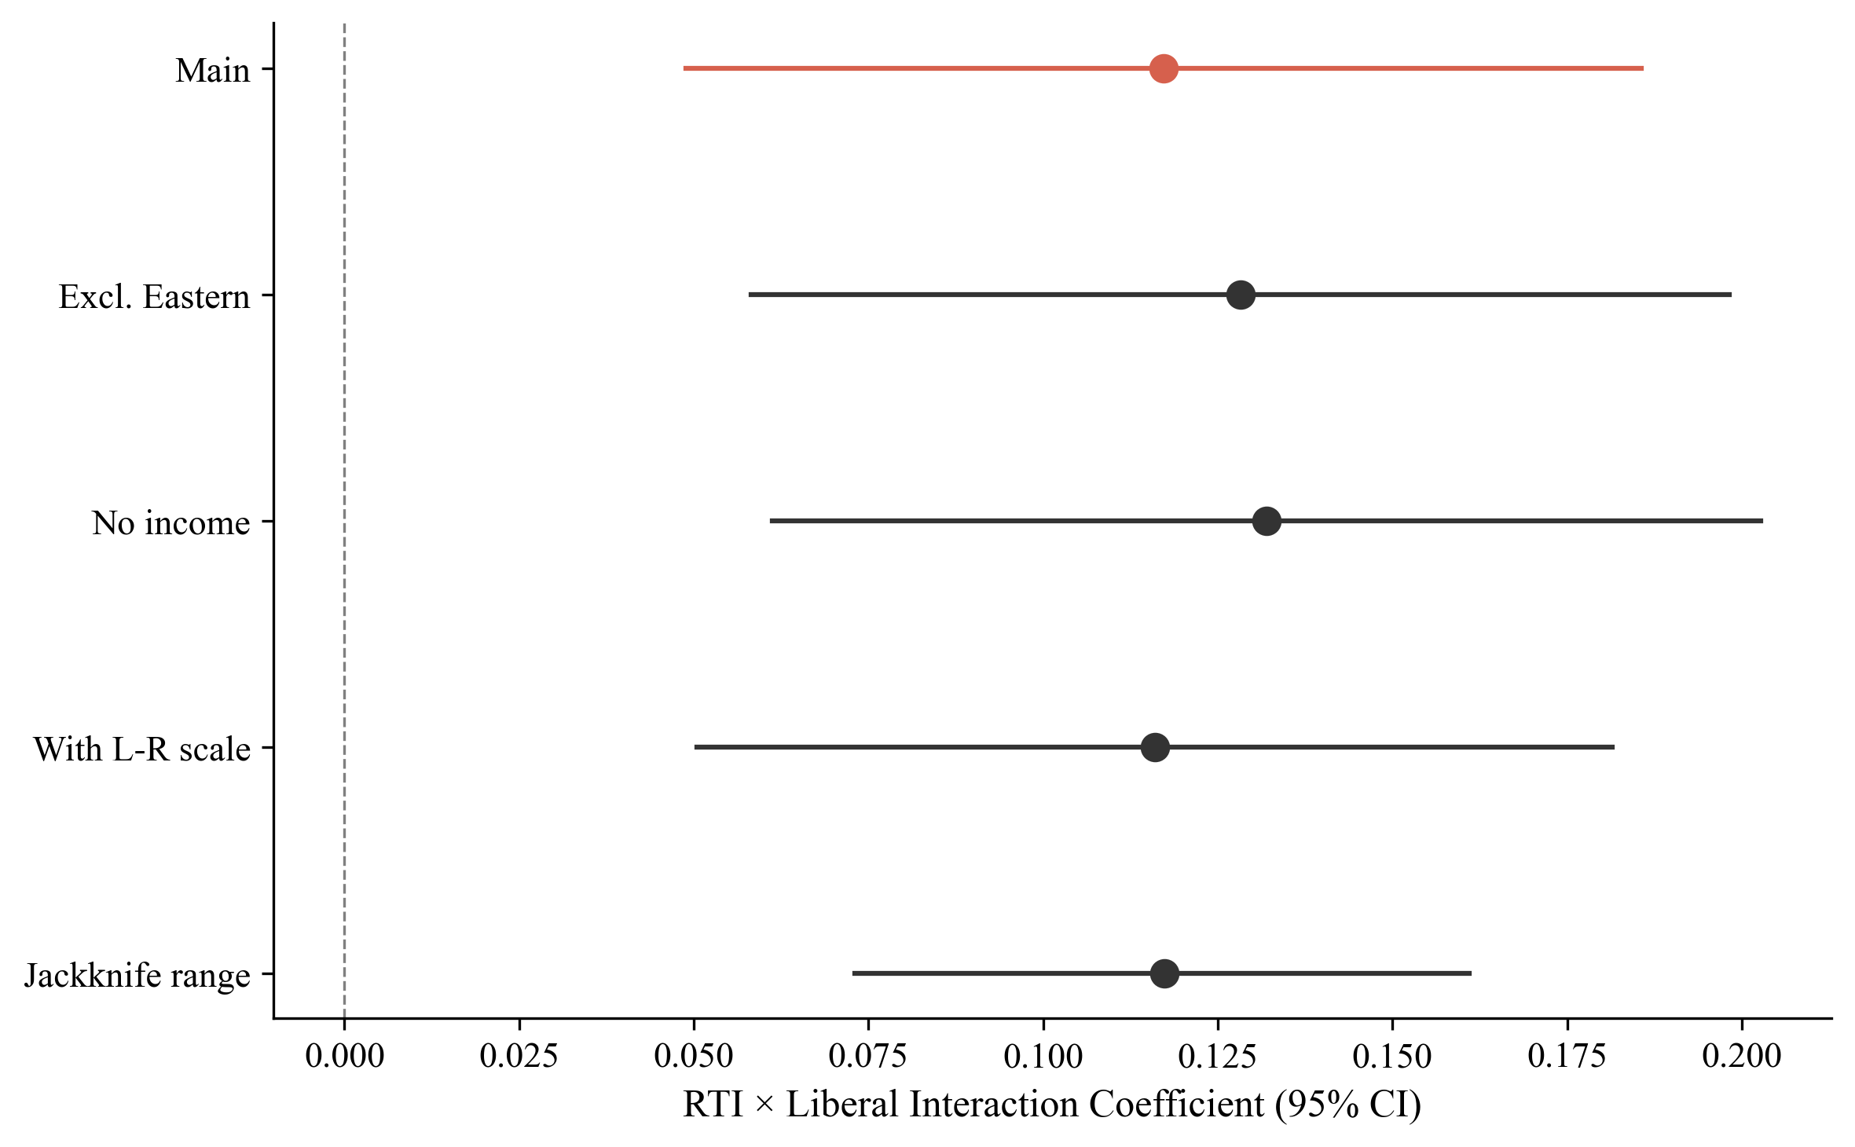
Figure A1. Coefficient stability across robustness specifications.
Appendix B: Education Moderation
The descriptive analysis reveals that the RTI→anti-immigration relationship is steeper for non-college workers in all regimes. In Liberal regimes, the bivariate slope drops from 0.280 (non-college) to 0.128 (college), a 54 per cent reduction. This pattern is consistent with the theoretical prediction that education provides alternative identity resources buffering the switch from class to cultural identity.
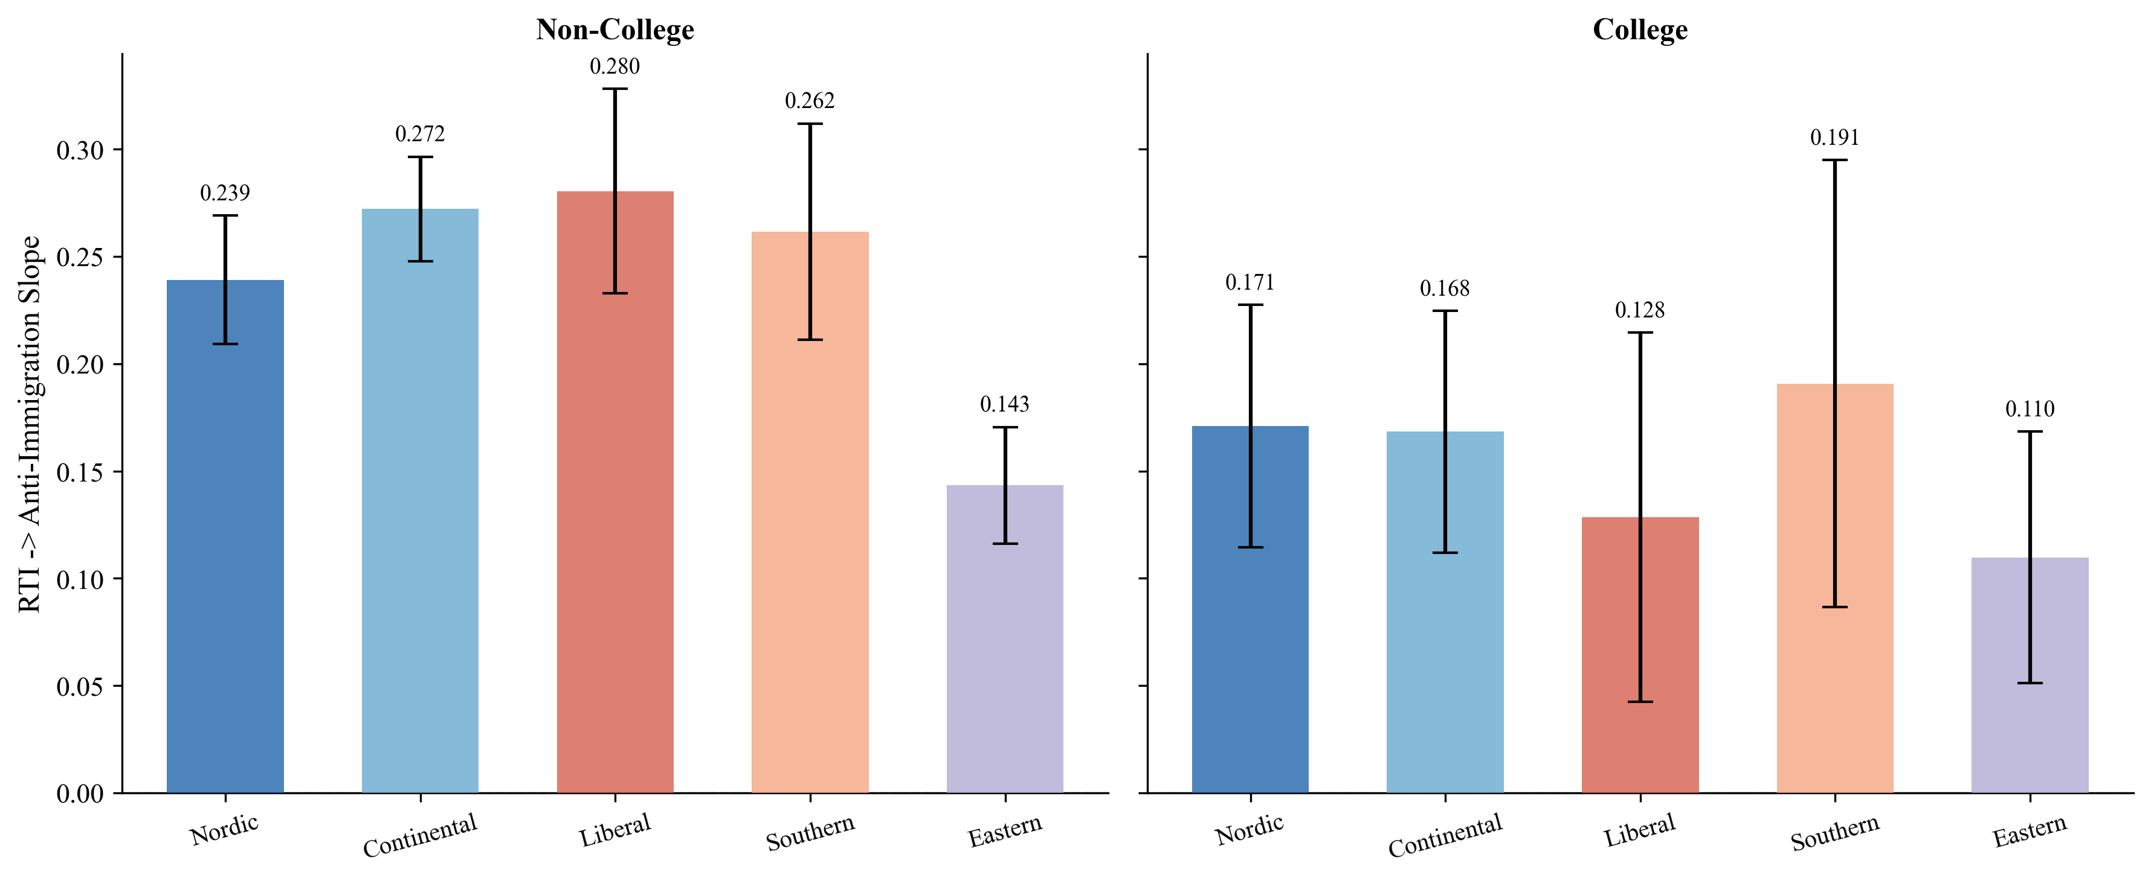
Figure B1. RTI→anti-immigration slopes by education and welfare regime.
The formal three-way interaction (Model 4: RTI × regime × non-college) shows a positive but non-significant coefficient for the RTI × Liberal × non-college term (β=0.037, p=0.542). The formal test does not reach conventional significance thresholds. The descriptive pattern is consistent with the theoretical prediction, and parallels the finding of Ballard-Rosa, Jensen, and Scheve (2022) that education buffers the economic decline → authoritarian values pathway; it should be treated as exploratory pending a design with adequate statistical power for three-way interactions.
Appendix C: The Solidarity Pathway: Supplementary ISSP Test
Model 5 (redistribution support, gincdif reverse-coded 1–5) shows RTI predicting slightly more redistribution support everywhere (β=0.041, p<0.001), but the cross-regime interaction does not match symmetric predictions: the RTI × Liberal coefficient is small and non-significant (β=0.013, SE=0.019, p=0.488). The institutional moderation of the vulnerability→solidarity pathway is not detectable in the ESS data; this is a result the asymmetric theory of §III predicts and the empirical analysis of §V.F treats as confirmation rather than limitation.
The supplementary test using the ISSP 2006 Role of Government module (N=10,216, 12 countries) reported in §V.F provides further detail. Model: solidarity ~ task_z * cwed_z + controls + (1 + task_z | country). RTI × CWED interaction: β=+0.010, SE=0.016, p=0.55. OLS cross-check: β=−0.012, p=0.77 (opposite sign). Main RTI effect: β=−0.109; routine workers in 2006 wanted less spending, before the automation discourse of Frey and Osborne (2017) reshaped how these workers' material position was being culturally framed. The temporal scope condition matters for the asymmetric theory: it suggests the protective pathway requires automation exposure to register as a salient class threat, not merely as individual occupational risk, while the damage pathway is detectable without similar contextual scaffolding because conditional welfare encounters carry their own salience.
The redistribution asymmetry (clear exclusion effects against no detectable solidarity effects) is consistent across the ESS Model 5 null and the ISSP Model 5 null. Distinguishing residual measurement limitations from the substantive theoretical asymmetry developed in §III requires panel data tracking individuals across periods of welfare reform; a design to be pursued in subsequent work.

