Billzone.eu Online invoice System
BILLGATE INTERFACE
SETTINGS

version number: 2.1
date: 2014.10.30.

Created by:


N-Ware Informatics and Advisor Ltd.

Document History
Modified by | Date | Changes | Version
2011.02.21 | Zoltán Szlaukó | Document creation | 1.0
2013.07.25 | Andrea Katona | Document redesign according to the new design | 2.0
2014.10.30 | Szabolcs Bakos | Update of available environments | 2.1

Table of Contents
1. Introduction 4
1.1. Summary 4
2. Available environments 5
2.1. Sandbox environment 5
2.2. Production environment 5
3. Design of test environment 6
3.1. Starting integration 6

- Introduction
  - Summary
The goal of this document is to describe the method of connecting Billzone.eu to Billgate service.

- Available environments
The automated invoice creator interface of Billzone.eu online invoicer is currently available in 2 public environments. The production environment means the current Billzone.eu production system, while sandbox environment is the test system for integration testing.
  - Sandbox environment
Web interface url: https://sandbox.billzone.eu
Billgate url: https://sandbox.billzone.eu/billgate
Note: Signature and time stamp of invoices created in sandbox environment originate from non-validated issuer, invoices issued this way are invalid e-invoices.

  - Production environment
Web interface url: https://www.billzone.eu
Billgate url: https://www.billzone.eu/billgate
- Design of test environment
To activate the testing environment, you have to register a test company in sandbox environment. Following this, our colleagues activate the created company, top up your account and create test data required for testing.
  - Starting integration
In order to make an external system create invoices in Billzone.eu system the integration in the created test company has to be enabled. You can perform this as follows:
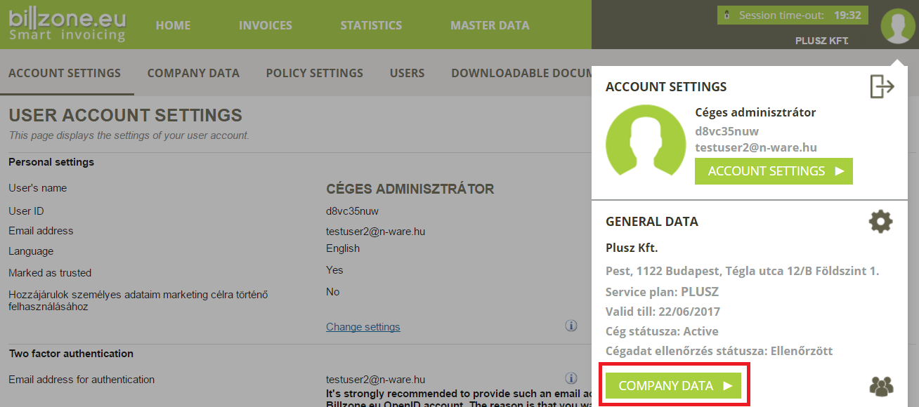
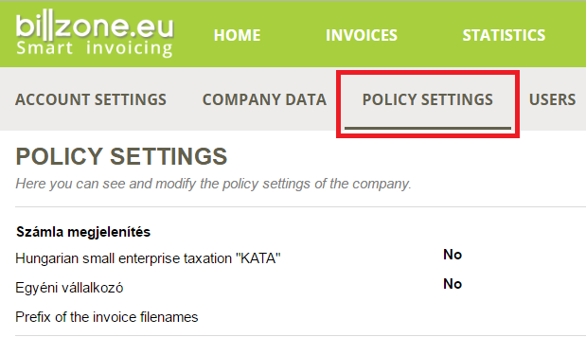
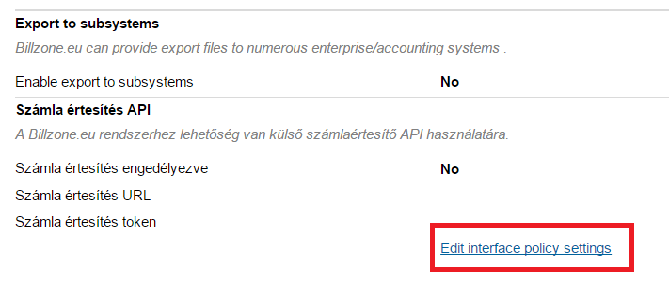
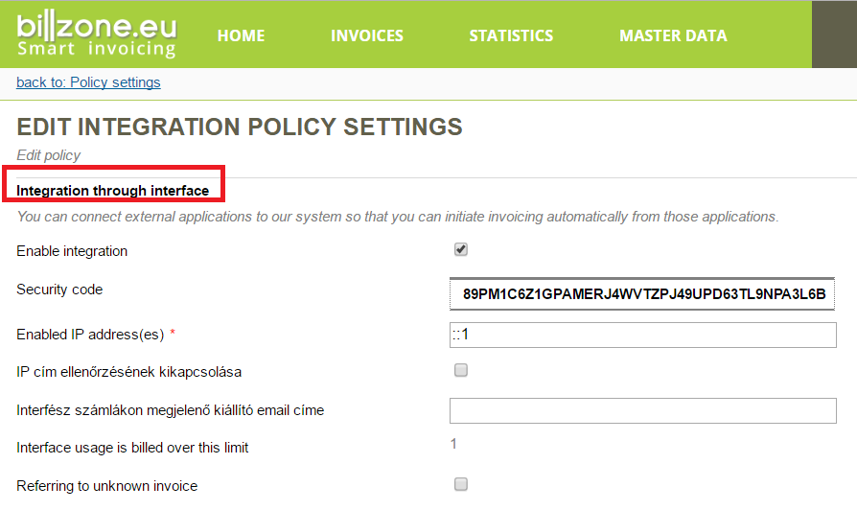
Enabling integration
The image above shows, that after enabling the integration, the system generates a security ID and requires an IP address.
In the „Enabled IP address” field the address of the device must be provided which you wish to use automated invoice creation service from.
In the „Security identifier” field you find the token generated by the system which has to be presented in all Web Service calls.

