Download the Arduino IDE from <https://www.arduino.cc/en/Main/Software>

And choose you’r operating system from the list 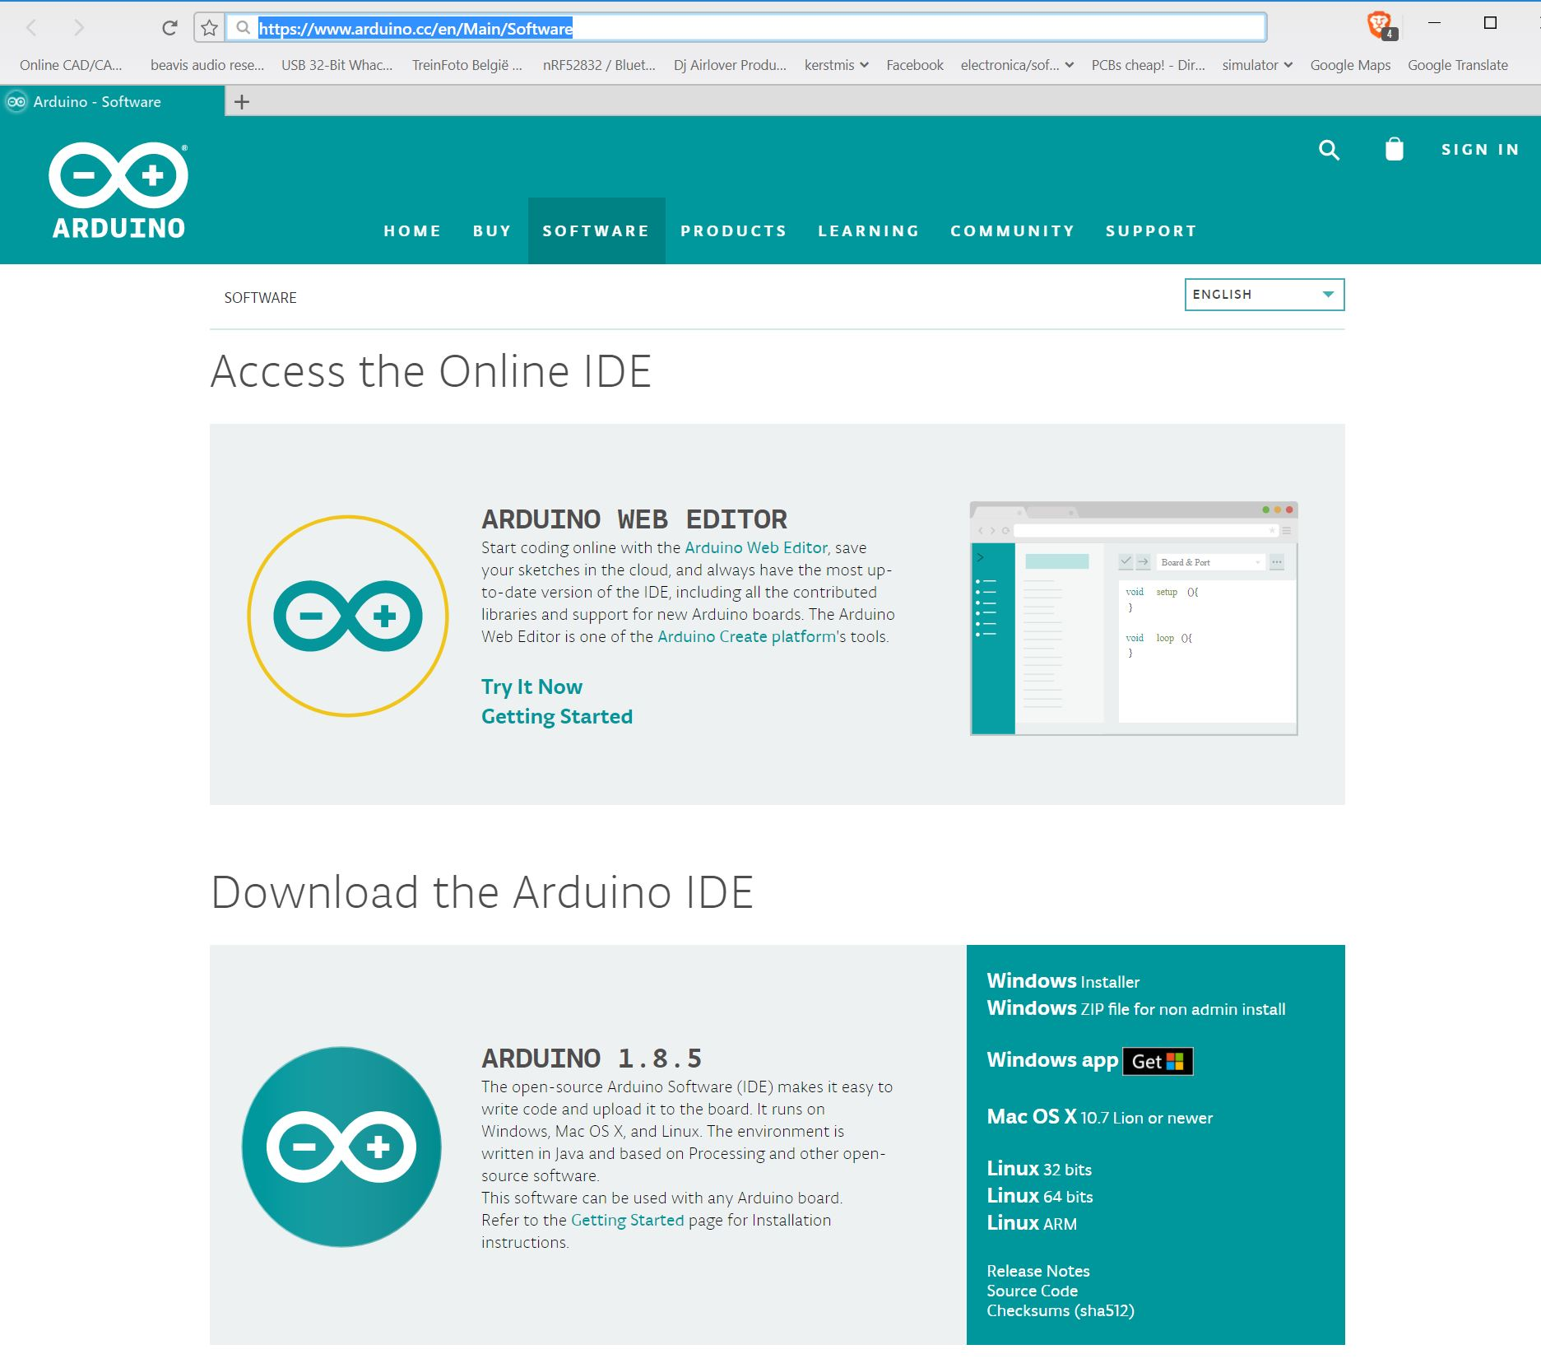

Go to <https://wiki.wemos.cc/tutorials:get_started:get_started_in_arduino>

And copy the link <http://arduino.esp8266.com/versions/2.3.0/package_esp8266com_index.jsonin> the additiona board manager url (witch can be found under files -> preferences )

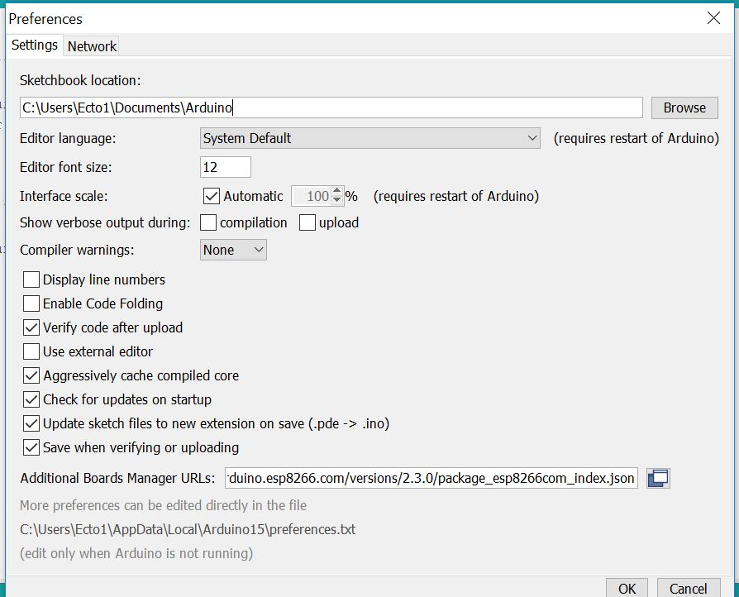

The requird libary’s fount in the arduno libary maneger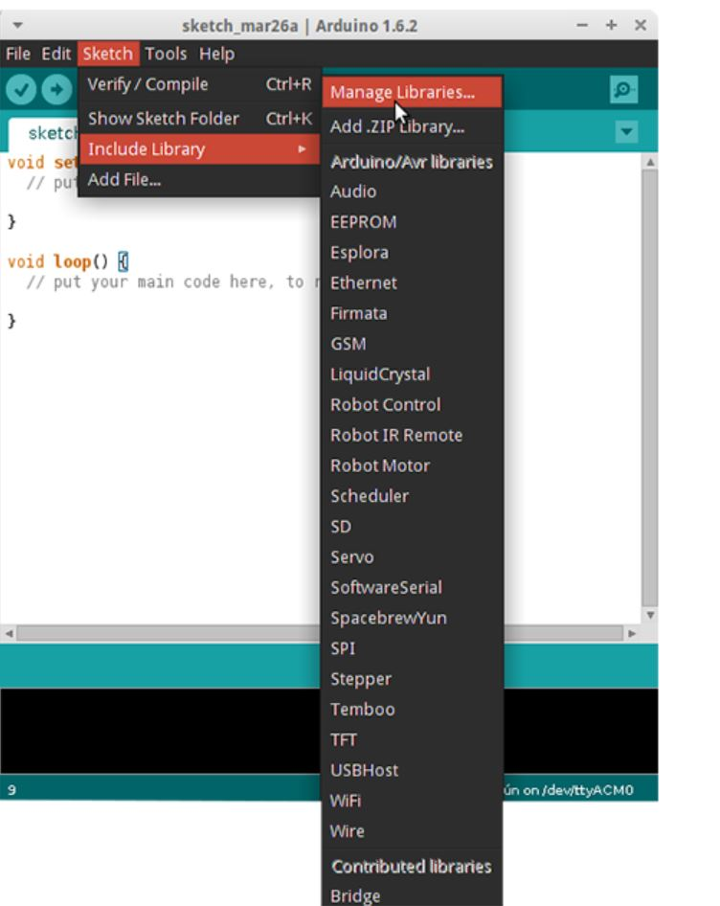

Adafruit IO arduino

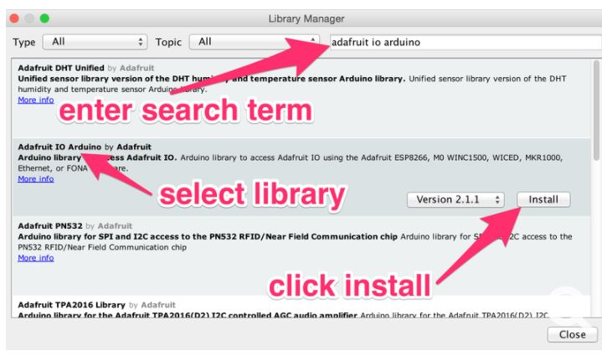

Adafruit MQTT

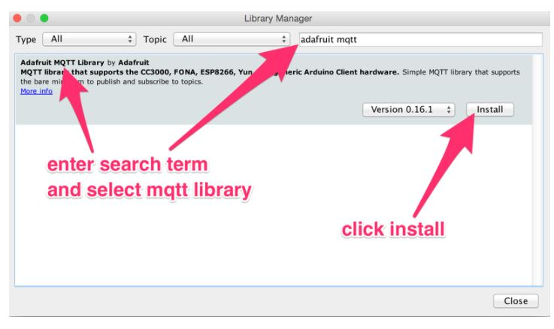

Arduino http client

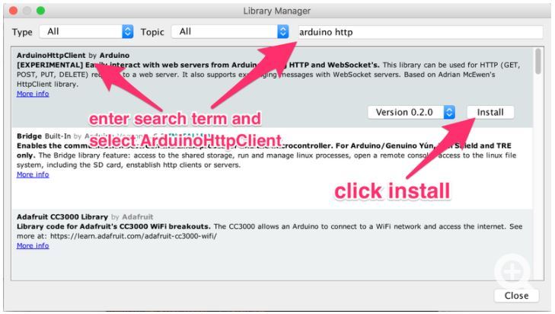

How to create tan adafruit account:

Go to : <https://accounts.adafruit.com/users/sign_up> and singe up for a free account 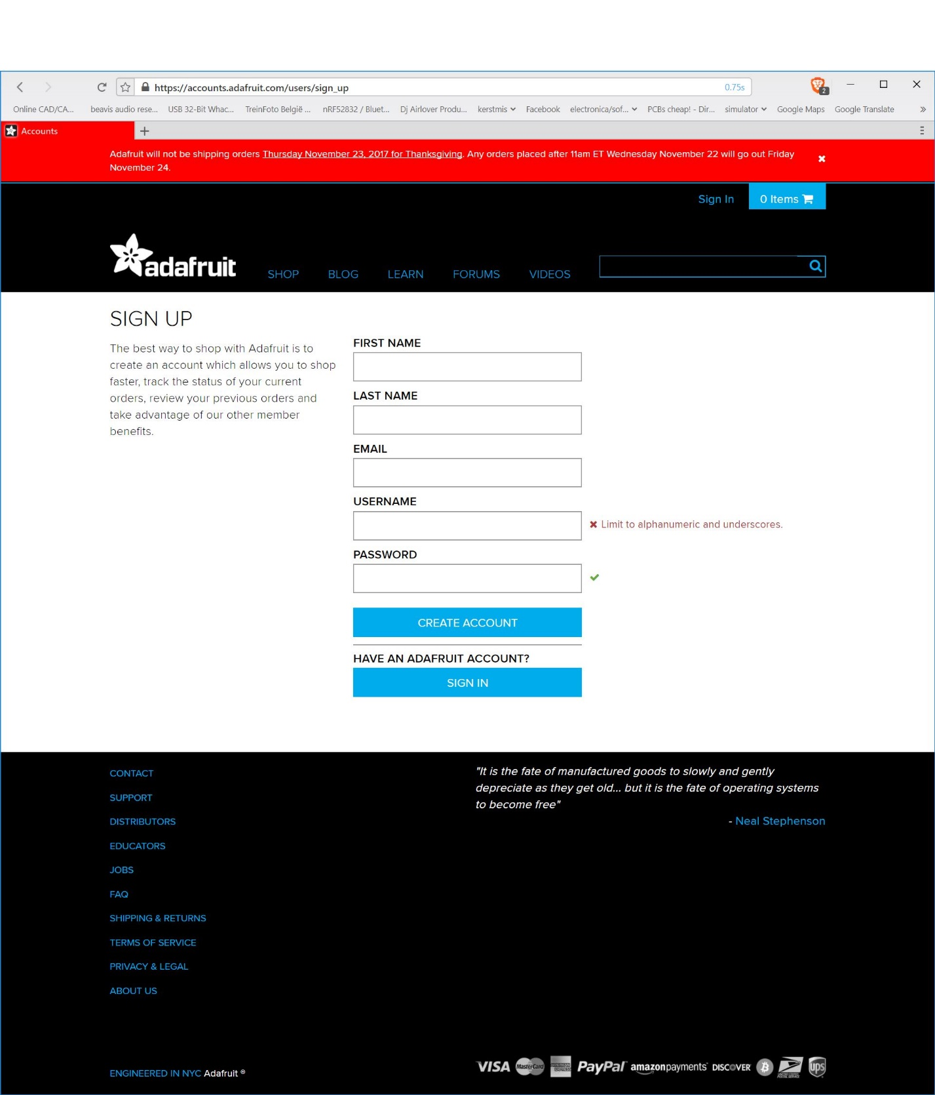

Then go to io.adafruit.com and singe in with the account created in the previous step 

After you singed in to adafruit IO go to the dasboards tab and creat a new one and name it temperature for example 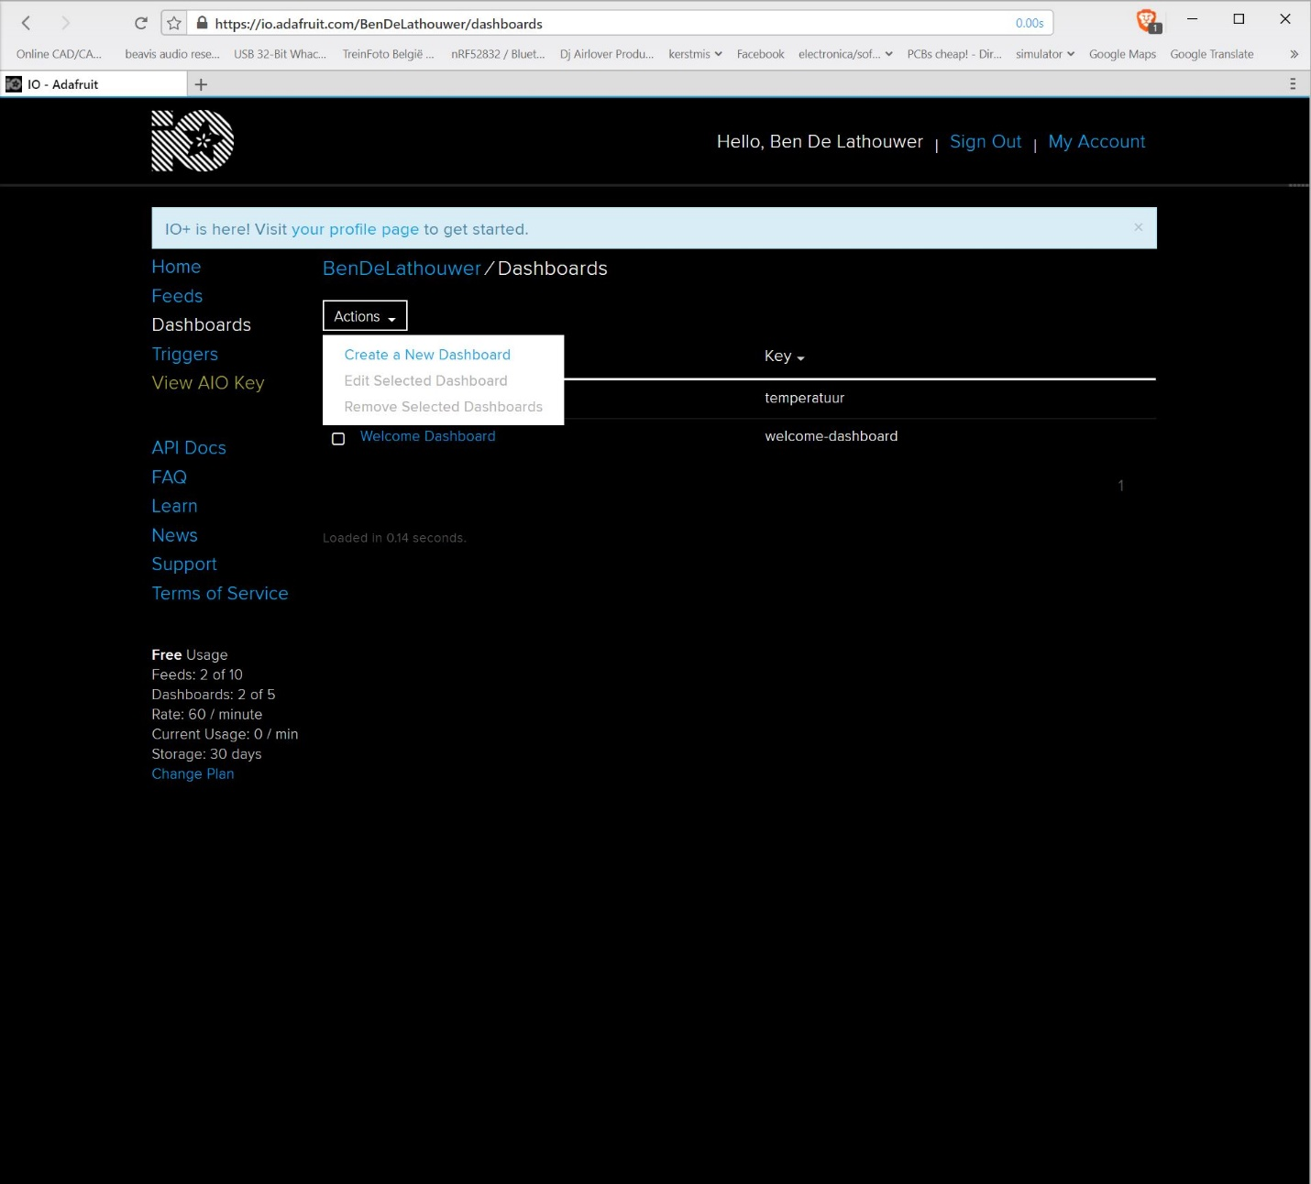

After you created you’r new dashboard click on the name and add a graph and a stream by clicking on add new block 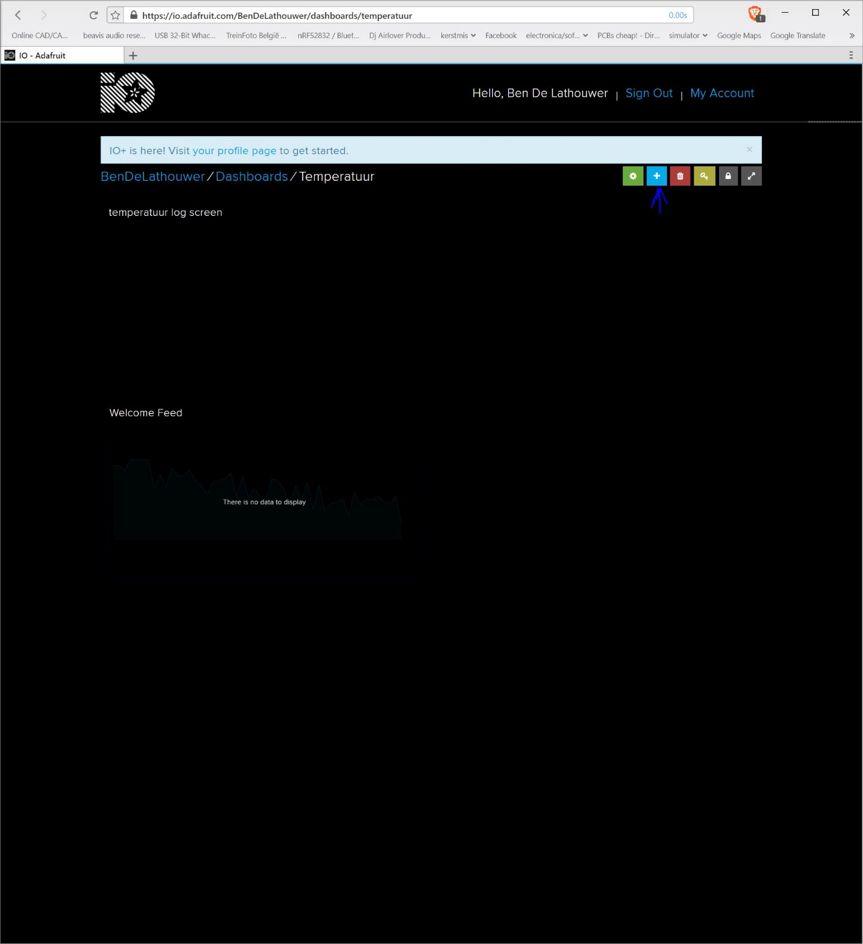

After you created you’r dashboard you need to generate a key for you’r code to acsess the service by clicking on the key symbol and take note of it and also take note of you’r user name 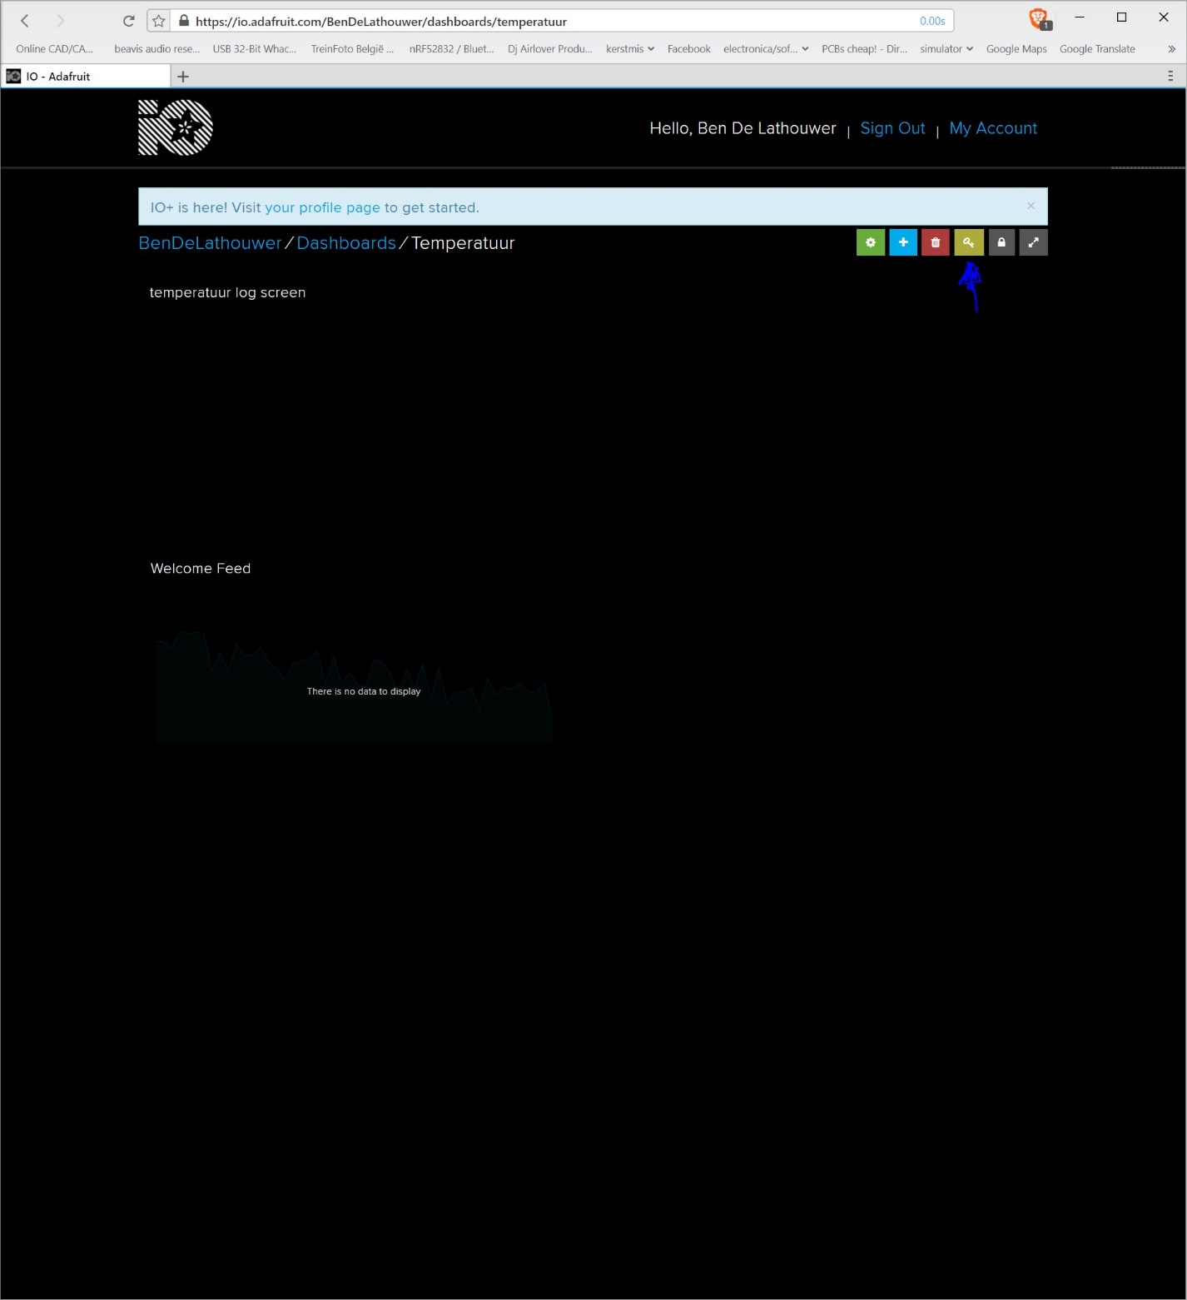

After that go to <https://github.com/bendelathouwer/arduino_Wifi_Datastream>

And press the green download button and download the zip file and unzip the file 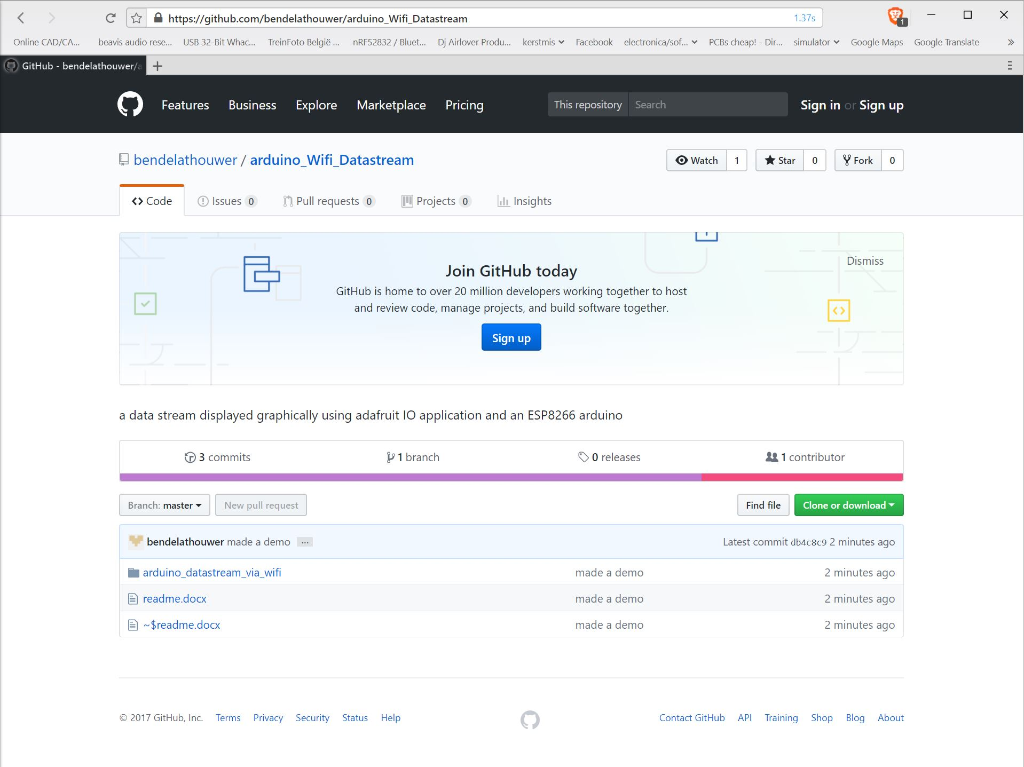

Open the Arduino file

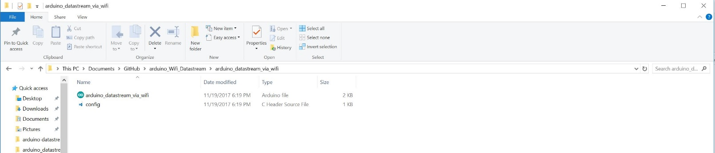

The you need to go to the config.h file and fill in you’r Adafruit IO username and key also you need to fill in you’r WIFI’s ssid and password

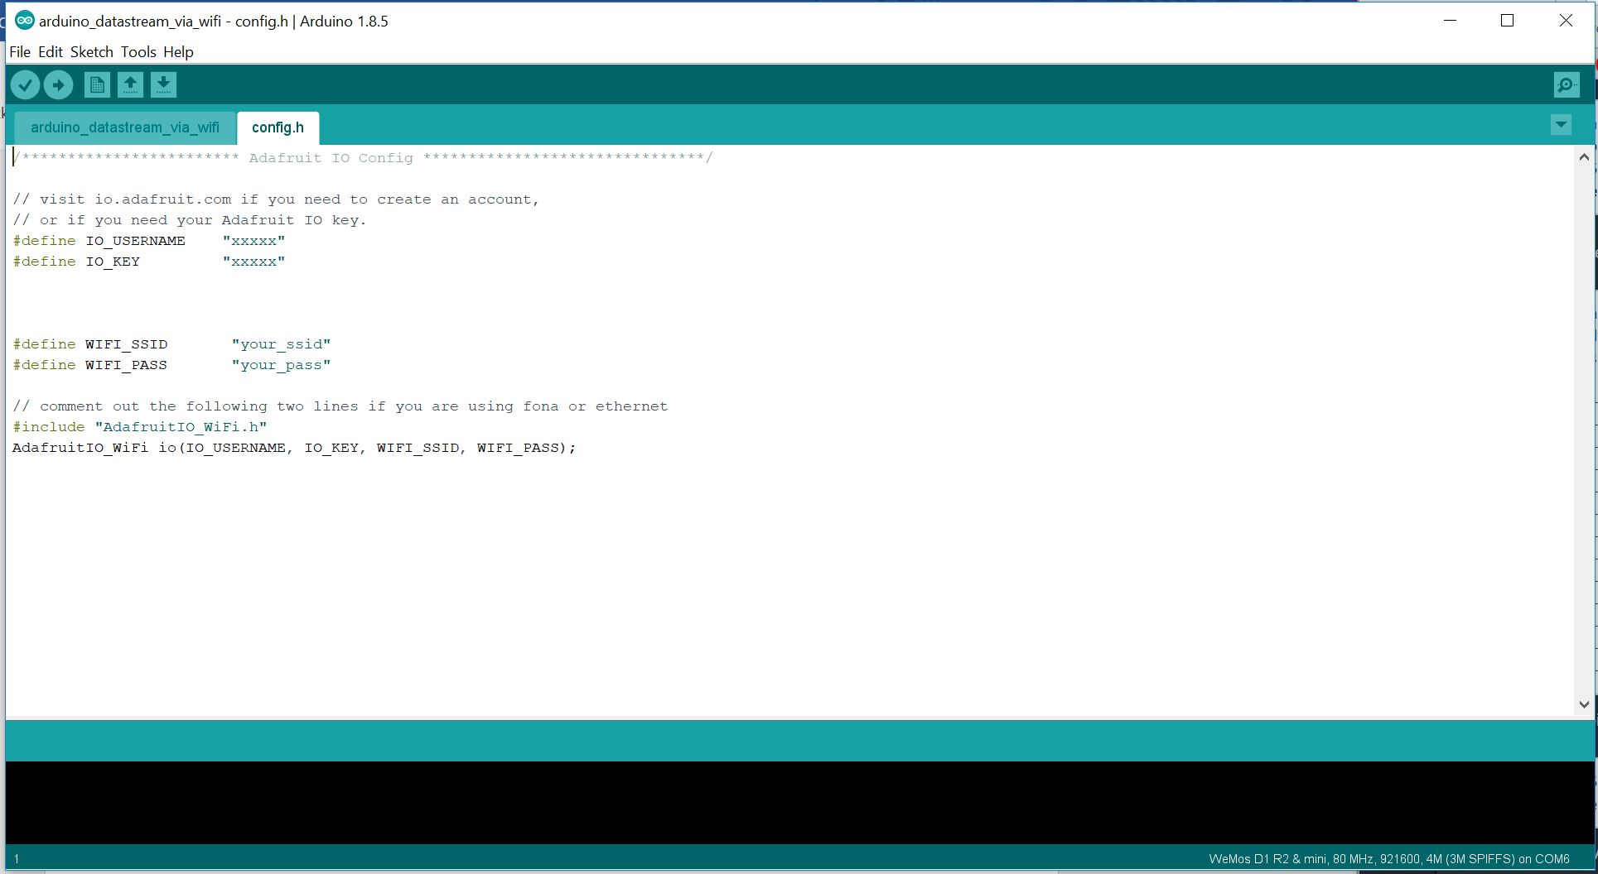

Go to the board selector and choose you’r WEEMOS D1 R2 board and hit compile and upload

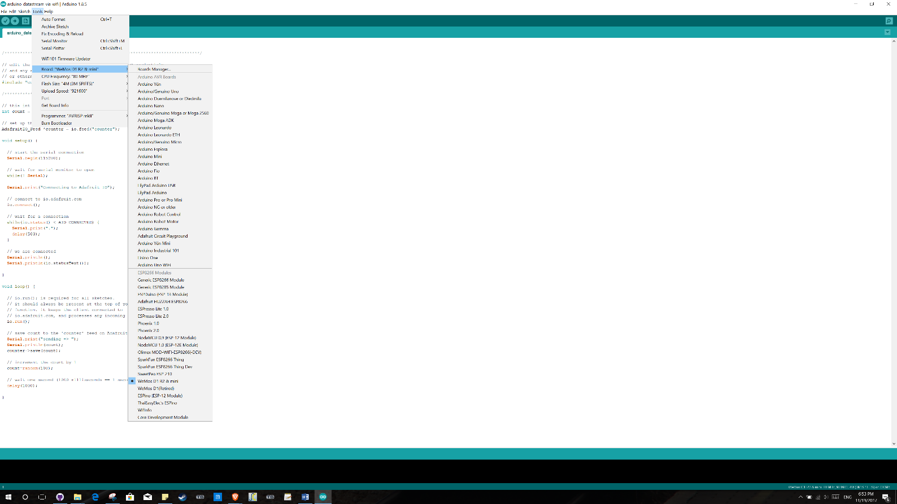

Enjoy you’r result 😊