Nick Pohl

CSC 445

Final Documentation

May 3, 2016

My app is a sliding tile game where you are presented with board filled with numbered tiles except for one empty slot. The point of the game is to slide the tiles around until you get the tiles in numerical order.

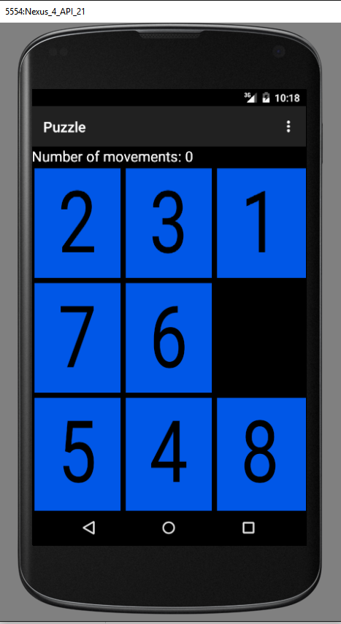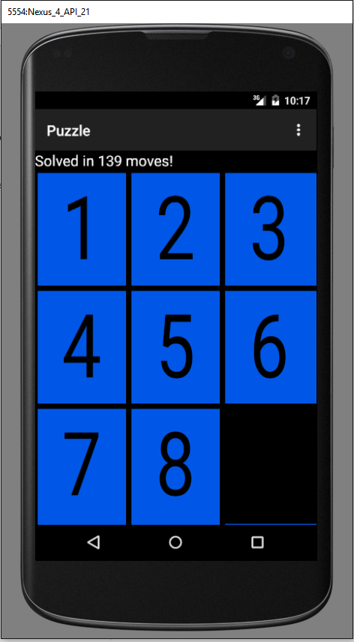

In the top right hand corner there is a menu where you can start a new game, get a brief description of the application, and change the number of tiles in the game.

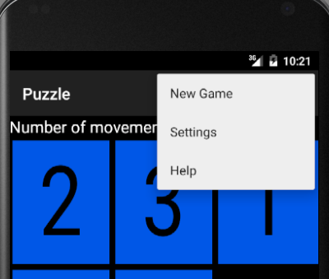

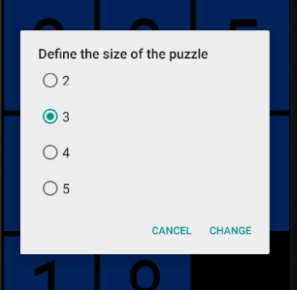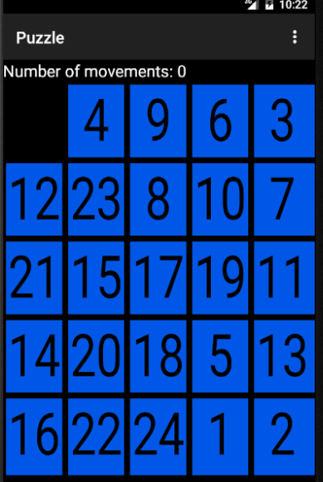

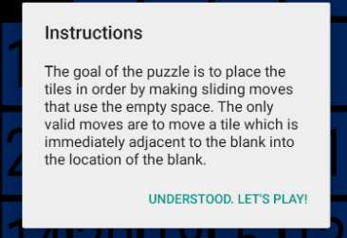

I have a MainActivity, BoardView, Tile, Place, and Board class.

The MainActivity does many things including setting the default value for the board size, creates new games, inflates the menu, and many other things. The boardview displays the puzzle board. Tile creates tiles and gives them unique numbers. Place places the tiles where they need to be on the board. Board creates the board and makes sure the board is solvable. I found the algorithm for this from [*http://www.cs.bham.ac.uk/~mdr/teaching/modules04/java2/TilesSolvability.html*](http://www.cs.bham.ac.uk/~mdr/teaching/modules04/java2/TilesSolvability.html)

I do want to mention my friend Jacob Singleton who helped me analyze my code and helped me with some of the more complicated aspects on this application.

<https://github.com/benderbot2004/hello-world.git>