Murder in the Midwest

Group Write-up

Project 1 April 12 2019

The project team had three goals in this analysis: To understand demographics and relationships of murder offenders and victims in the Midwest; explore social and political climates that may influence murder counts over time; and call attention to the evolution of murder solve rates by state and over time in the Midwest. In order to explore these topics, we asked the following questions.

What gender were the victims and the offenders?

From the analysis it was determined that about 60% of the offenders were male and about 77% of victims were also male.

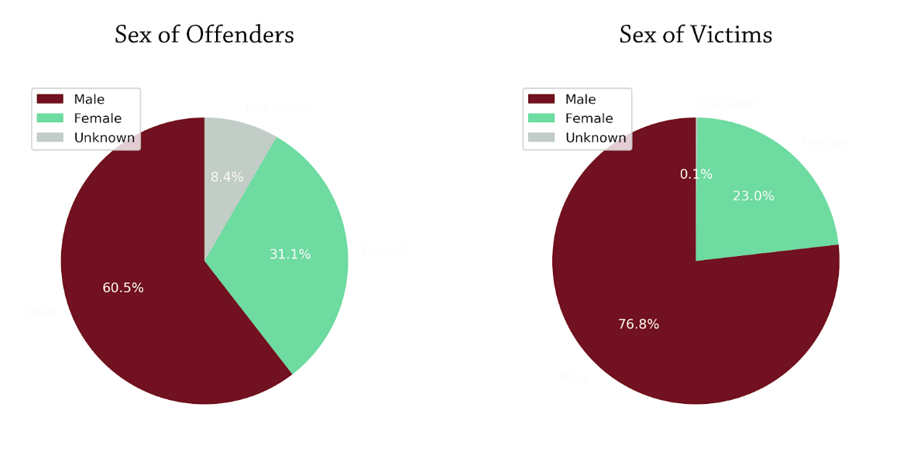

How old are murder victims?

Most of the murder victims fell in the 20-30 years age group, followed by 30-40 year group. The age of offenders was excluded from this analysis as almost 9% of data was missing or unknown.

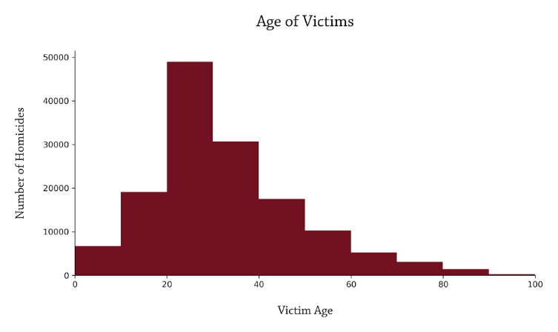

Do some states in the region have higher victim counts than others and does the time of the year affect the number of murders?

The analysis over here showed that states like Missouri and Illinois had higher crime rates and it also showed that there were about 35 times more homicides between the lowest and the highest state.

The breakdown by months did not show any significant differences throughout the year. It closely tracked the number of days in the month

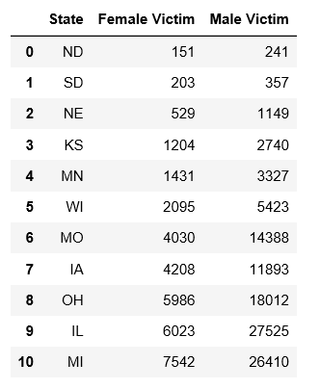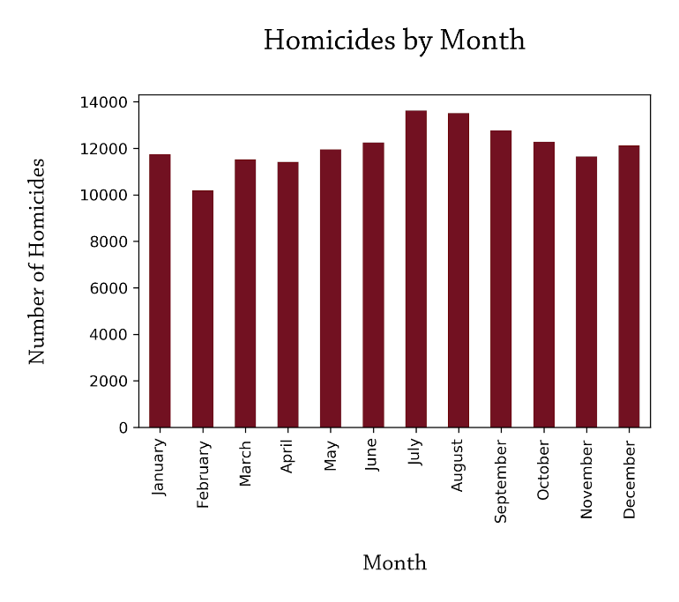

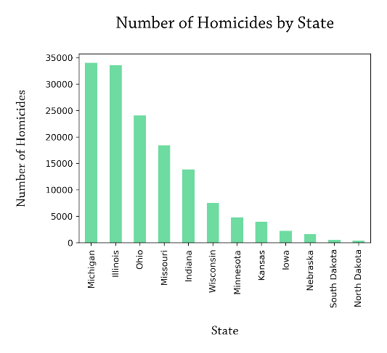 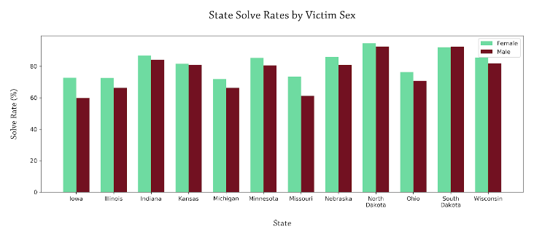

In the Midwest, are female victims more often murdered by someone they know?

The raw data from the Murder Accountability project lists 29 victim relationship types, including *Relationship not Determined*. This list was re-grouped into 9 main categories: *Acquaintance, Spouse, Partner, Other – known to victim, Stranger, Child, Parent, Other Family, Sibling.* A table of the consolidated categories is below.

For the purposes of this analysis, the *Relationship not determined* category was excluded. However, it is important to note that 42.6 % (47,540) of total Male victim entries (111,465), and 28.7% (9,592) of total Female victim entries (33,402), were listed as *Relationship not Determined*.

There were three victim gender categories available from the Murder Accountability project: *Male*, *Female*, and *Unknown*. For the purposes of this analysis, category type *Unknown* was excluded.

Top 5 Relationships for Female Victims:

22% Acquaintance, 21% Spouse, 17% Partner, 12% Other (known to victim), 11% Stranger.

Top 5 Relationships for Male Victims:

40% Acquaintance, 26% Stranger, 16% Other (known to victim), 4% Partner, 4% Child.

|  |  |
| --- | --- |
|  |  |

This data shows that almost half of female victims (47%) with relationships defined were murdered by a spouse or partner. On the other hand, male victims were murdered by a spouse or partner in 8% of cases. **Conclusion: female victims during 1976-2016 were killed by people close to them more often than male victims.**

|  |  |
| --- | --- |
| **Relationship** | **Includes** |
| Acquaintance | * Acquaintance |
| Spouse | * Ex-Husband * Ex-Wife * Husband * Wife |
| Partner | * Boyfriend * Girlfriend * Common-law Husband * Common-law Wife * Homosexual Relationship |
| Other – Known to Victim | * Other(known to victim) * Friend * Neighbor * Employee * Employer * In-law |
| Stranger | * Stranger |
| Child | * Son * Daughter * Stepson * Stepdaughter |
| Parent | * Mother * Father * Stepfather * Stepmother |
| Other Family | * Other Family |
| Sibling | * Brother * Sister |

Are there differences in murder method based on the relationship of the offender and the victim?

The raw data from the Murder Accountability project lists 18 weapon types, including *Other or Type Unknown.* Weapons categorized as *Other or Type Unknown* were excluded from this analysis. Weapon types were re-organized into two types: Close Contact or No/Little Contact. Close Contact weapons are those in which the offender had direct hands-on or intimate contact with the victim, such as beating, stabbing, or strangling. No/Little contact weapons are those in which the offender did not need direct hands-on or intimate contact with the victim, such as guns, poison, or explosives. A full breakdown of weapon categories is listed in the table below.

For this analysis, victim relationship categories from above were further grouped into 4 categories based on intimacy: *Stranger, Acquaintance, Family Member, and Romantic Partner.* Categories *Relationship not Determined* and *Other – known to victim* were excluded from these groupings, as we cannot determine what level of intimacy these victims had with their offenders.

From this grouping, 31% (22,216) of total murders (71,493) used close contact methods. 68.9% of total murders in this set used no/little contact methods.

Of note, 43.9% of close contact murders were by a spouse or romantic partner as opposed to 27% of no/little contact murders.

On the other end of the spectrum, 16.3% of close contact murders were by a stranger as opposed to 30% of no/little contact murders.

We could infer from these findings that the level of intimacy between a victim and offender may influence the way in which a murder is performed. It may be easier to gain close contact to a victim known to the offender than not. However, the number of victims in each relationship grouping is different, which skews our results. In addition, no statistical analysis was done on these groupings, so we cannot confirm any sort of statistical significance in these findings.

|  |
| --- |
|  |

|  |  |
| --- | --- |
| Close Contact Weapons | Little or No Contact Weapons |
| * Knife or cutting instrument * Personal weapons, including beating * Blunt object – hammer, club, etc. * Asphyxiation – includes death by gas * Drowning | * Handgun – pistol, revolver, etc. * Shotgun * Strangulation -hanging * Rifle * Firearm, type not stated * Other gun * Fire * Pushed or thrown out window * Narcotics or drugs, sleeping pills * Explosives * Poison – does not include gas |

Are guns used significantly more in homicides than any other weapon?

We performed a t-test on two groups – the total number of homicides committed with a gun each year since 1976 and the total number of homicides committed using all other weapons each year. The test gave us significant results, with a p-value of p = 0.000000000000000000000008.601757949810224. In the graph below, you can see that the histograms of the two groups do not even overlap.

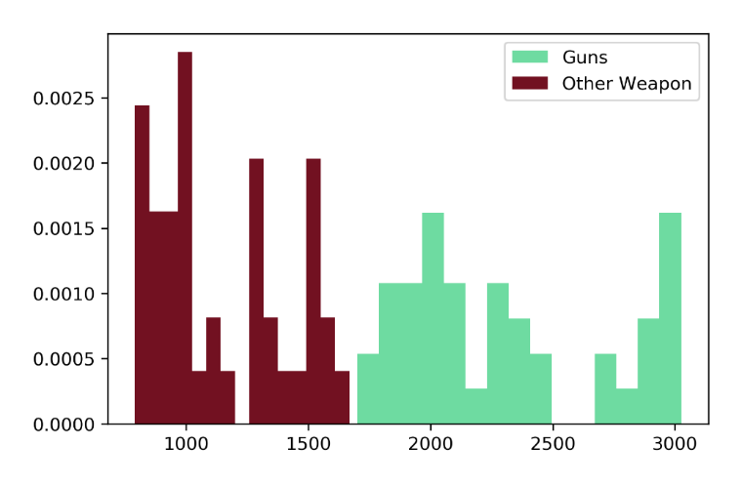

Have murder solve rates increased or decreased over time?

The group came into this project assuming homicide clearance rates would have increased with the improving forensic sciences and growing interest in true crime. We were proven wrong. The overall clearance rate in the Midwest has decreased by about 15% since 1976.

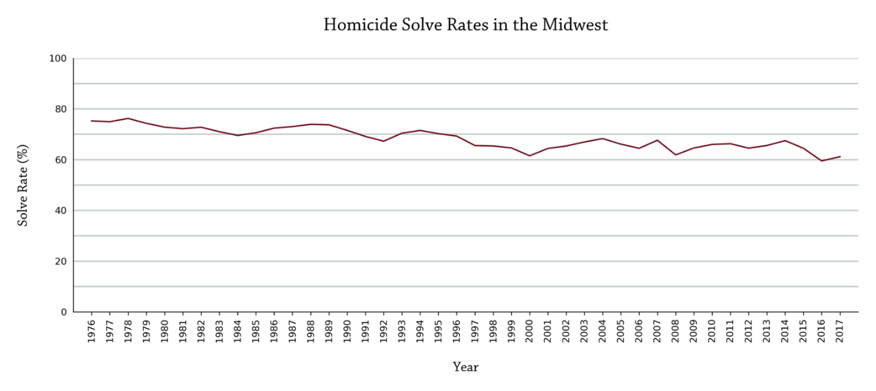

Some cities, particularly Chicago, have even lower clearance rates, which has been under 50% for the past 14 years.

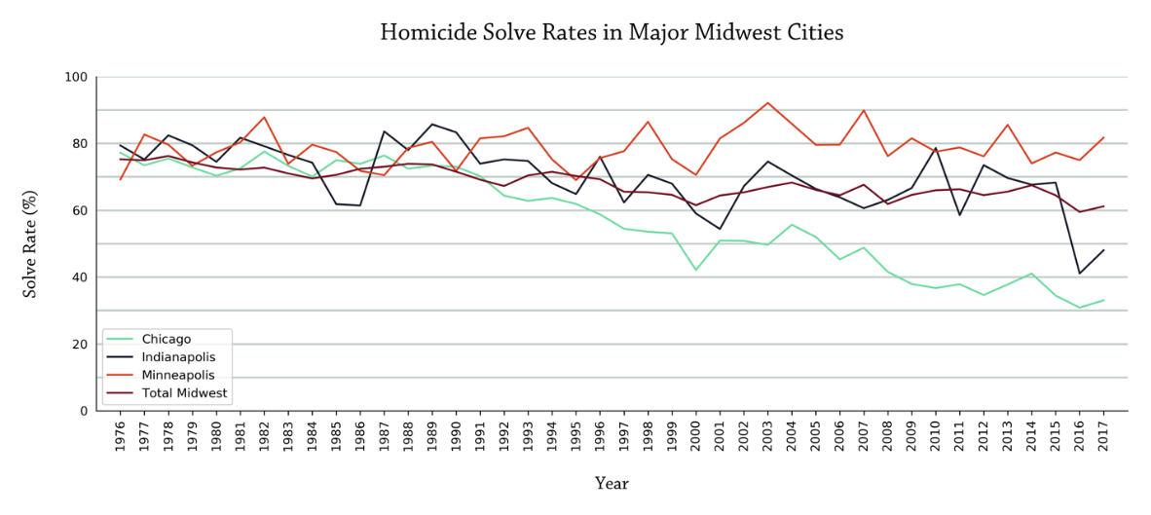

More research and analysis needs to be done, but some possible reasons for the decrease are insufficient personnel for solving homicides, murders are increasingly committed by strangers to the victims, drug and gang activity and witnesses are now more reluctant to speak with police officers.

There are currently more than 45,000 unsolved homicides in the Midwest and more than 220,000 unsolved homicides in the entire U.S. since 1976.

Question: Has the political climate impacted the murder counts over time?

Looking for murder trends through a political angle, I decided to look at murder counts along side the political affiliation of the executive branch. Although a proper investigation of the question would be complex, I figured this would make a good jumping point to dive deeper into any spotted trend.

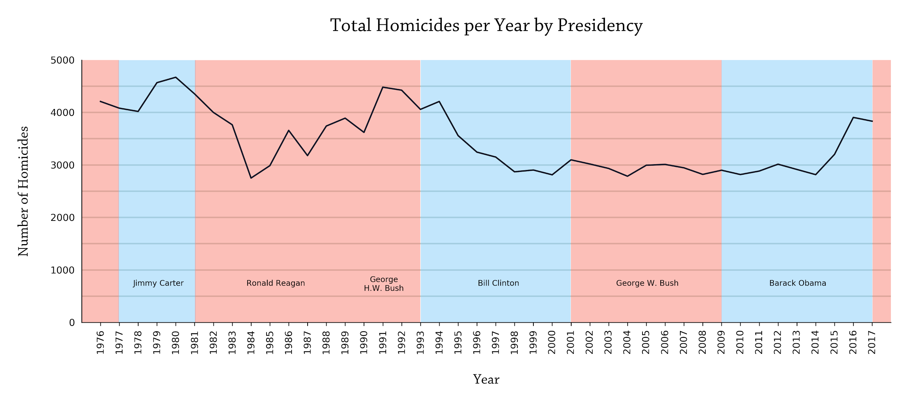

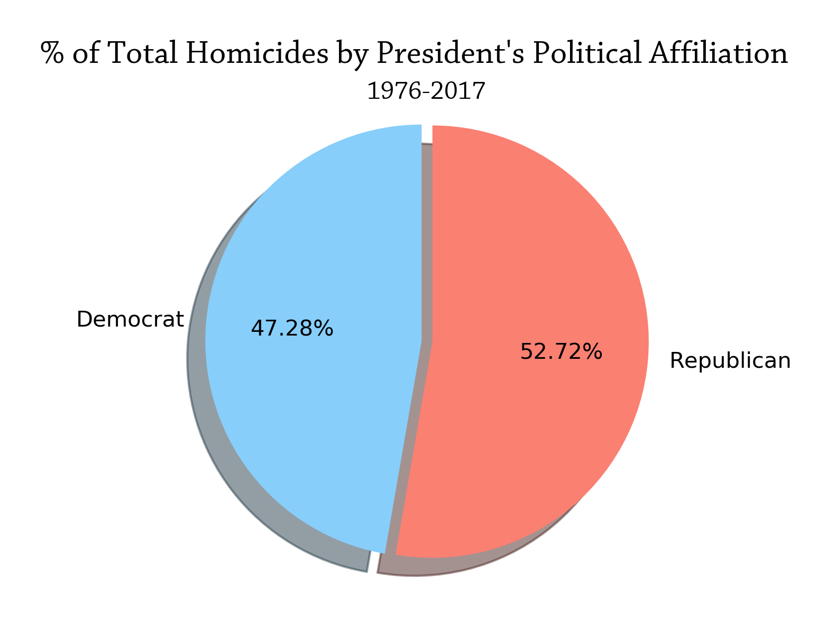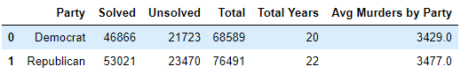

Comparing the two parties, we see a difference of 5.44% with Republicans representing 57.72% of the murder count and Democrats representing 47.28%.

Since our dataset starts in 1976 and ends in 2017, both Ford and Trump only had one year of presidency in the data. Because of this, we made a separate dataset, excluding them as potential outliers. Whether or not they were included in the statistical analysis made little difference. Using a Student’s T-test, we found no statistically significant difference in the number of murders when comparing the political parties.

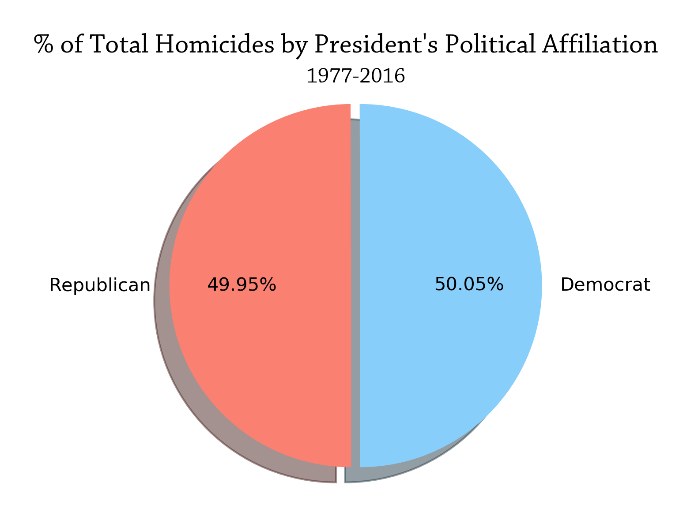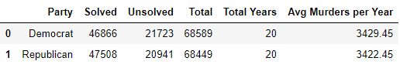

When the potential outliers are removed, we are left with 20 years for each party. The results are nearly split down the middle with Democrats having 50.05% of the total murders compared to 49.95% under an executive branch with Republican affiliation.

Things that could be looked at more closely in relation to the questions are the political affiliation of congress during these times along with whether or not there were policies passed that could have impacted resources used to fight crime. One interesting thing to look into based on the graphs is the potential effect 9/11 had on the number of murders and murder rate. It appears George W. Bush had the lowest average number of homicides per year of presidency, and that could be a part of the explanation.

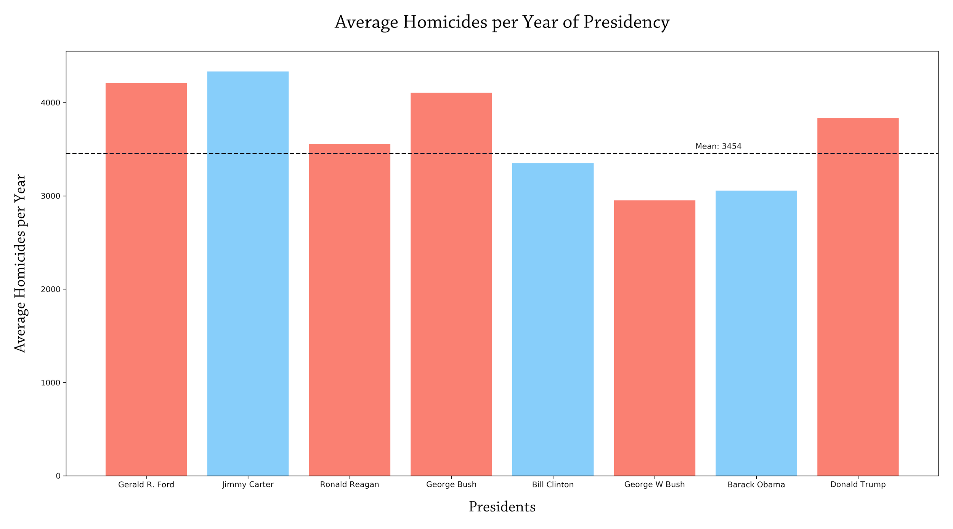

# Do murder rates per capita really increase in denser populations?

This project set out to find the answer to this question by combining data from the Murder Accountability Project (MAP) with population estimates for metropolitan statistical areas (MSA) taken from the Census Bureau API. From those datasets we calculated the murder rates per capita by multiplying metro area murders in a time period that matched that which our population estimates were taken by 100,000, then dividing by the populations for each city.

The challenges of combining the two data sets by merging on common MSA values were far more numerous than anticipated. The key issue was that MAP had not updated its MSA code-label pairings since 2009, and only published the labels for MSAs, many of which were now outdated. The upshot of this was that this project had to use 2009 Census populations, taken from the 5-year estimates in the ACS5 2009 census, in order to match with metro areas in the MAP data. Thus, our murder samples line up with the years from which the census 5-year estimates were taken: 2005 through 2009.

The results of this analysis suggested a weak to null relationship between population density and per capita murder rates, as the scatter plot below shows.

That said, the best evidence for a relationship between population density and per capita murders exists in the fact that none of the cities with one million or more had below 10 murders per capita between 2005 and 2009.

So which cities did have the most murders per capita in the Midwest in those years? The answer dispelled some of the myths about big cities being more violent. Chicago, the poster child in modern America for gun violence and out of control big city murder rates, came in at just No. 10 on our list of the most violent cities, with much smaller cities posting much higher murder rates in those years. The most violent city in the Midwest was Flint, MI, a city with fewer than one million inhabitants.

Conclusion

Victims of murder in the Midwest tend to be between 20-30 years of age. There are more male victims than female victims. There is no significant difference in the number of murders committed from month to month. Missouri and Illinois had higher victim counts. Females were more often killed by their spouse or romantic partner than males. Close contact methods of murder may be more popular among family or romantic partners. There is significant statistical evidence that supports the use of guns is preferred over all other weapons in the Midwest. The clearance rate of homicide cases in the region has decreased 15% since 1976. In Chicago, the clearance rate has decreased 50% over the past 14 years. Overall, there are 45000 unsolved homicides in the Midwest. There are no statistically significant differences between murder counts during Republican or Democrat administrations.