ENTERPRISE NETWORK DESIGN
Multi-Floor Campus Network with Dual-ISP Redundancy,
Segmented VLANs, Unified Communications & Wireless
Cisco Packet Tracer Case Study
Network Design & Implementation Portfolio Project
July 2026

1. Executive Summary
This project is a full-scale simulation of an enterprise campus network built in Cisco Packet Tracer, designed to reflect the architecture a mid-size organization would deploy across a multi-floor office building. The design integrates redundant Internet edge connectivity, a segmented internal network, a hardened DMZ, dual perimeter firewalls running dynamic routing, an on-premise IP telephony system, and centrally managed enterprise wireless.
The goal was not just to make devices ping one another, but to replicate real design decisions that engineers make in production networks: high availability at every tier, security zoning between trust levels, and services (DHCP, DNS, VoIP, wireless) delivered per-segment rather than as a flat network.

Key Capabilities Demonstrated
- Dual-ISP internet edge with redundant perimeter firewalls (ASA-style) and OSPF-based dynamic routing to the internal core
- Layer 3 core switching with HSRP for gateway redundancy across VLANs
- Security segmentation via VLANs (Management, Data/LAN, Wireless, VoIP, Server, Black Hole) across 3 floors and 5 departments
- DMZ / server farm hosting FTP, Web, Email, Application, and internal services servers, isolated behind ACLs
- Cisco IOS-based Call Manager Express (CME) VoIP deployment with working extension-to-extension calling
- Centrally managed enterprise Wi-Fi via a Cisco 2500-series Wireless LAN Controller (WLC)
- Access-list based traffic filtering enforced at the firewall inside/outside boundaries
- DHCP services scoped per VLAN (management, LAN, wireless, VoIP) rather than a single flat pool
- Switch and firewall hardening: enable/console password protection, service password-encryption, login banners
- End-to-end connectivity verified via ping and live VoIP call testing

2. Network Topology
The topology below is the logical diagram of the full network. It shows two internet-facing users connecting through a redundant cloud/router pair into two perimeter firewalls (5506-X), which in turn connect to a dual-core switch layer (CORE1/CORE2). The core distributes to a DMZ/server farm and to three access-layer floors, each with its own VLAN-segmented switch, PCs, IP phones, laptops, smartphones, and printers. A dedicated Wireless LAN Controller (WLC 2504) manages access points across the building.
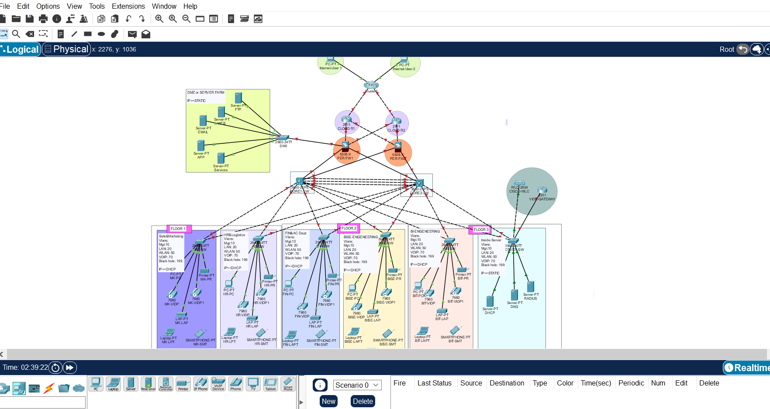
Figure 1 – Full logical topology: Internet edge, dual firewalls, redundant core, DMZ, and 3-floor access layer

3. Design Objectives
- Eliminate single points of failure at the internet edge, firewall tier, and core switching tier
- Contain broadcast domains and enforce least-privilege access between departments using VLANs and ACLs
- Provide a secure DMZ for externally reachable services (FTP, Web, Email, App servers) isolated from internal LAN traffic
- Deliver internal voice services without relying on external SIP trunking (self-contained CME deployment)
- Provide managed, centrally authenticated Wi-Fi access rather than autonomous per-floor access points
- Automate address assignment per VLAN via scoped DHCP pools instead of static addressing on end devices

4. IP Addressing & VLAN Plan
Each floor uses an identical VLAN template so the design is repeatable across departments (Sales & Marketing, HR & Logistics, Finance & Accounts, BI & Engineering). This keeps troubleshooting and future floor additions straightforward — a new floor is a copy of an existing VLAN/ACL/DHCP template rather than a bespoke design.
VLAN ID | Segment | Subnet Role | Example Subnet | Redundancy
10 | Management | Device/OOB mgmt | 192.168.10.0/24 | HSRP
20 | LAN (Data) | PCs / staff data | 172.16.0.0/16 | HSRP
50 | WLAN (Wireless) | Wireless clients / WLC mgmt | 10.20.0.0/16 | HSRP (standby 50)
70 | VOIP | IP phones | 172.30.0.0/16 (CME pool) | N/A
90 | Server/Uplink | Inter-switch / server uplink | 10.11.11.32/27 | HSRP (standby 90)
199 | Black Hole | Unused ports / security | N/A | N/A

Core switches (CORE1/CORE2) own the VLAN 50 and VLAN 90 SVIs and share gateway redundancy using HSRP, so a core switch failure does not take down client default gateways.
interface Vlan50
mac-address 0001.63e2.4803
ip address 10.20.0.2 255.255.0.0
ip helper-address 10.11.11.38
standby 50 ip 10.20.0.1
!
interface Vlan90
mac-address 0001.63e2.4804
ip address 10.11.11.34 255.255.255.224
standby 90 ip 10.11.11.33
Figure 2 – Core switch SVI configuration with HSRP standby gateways
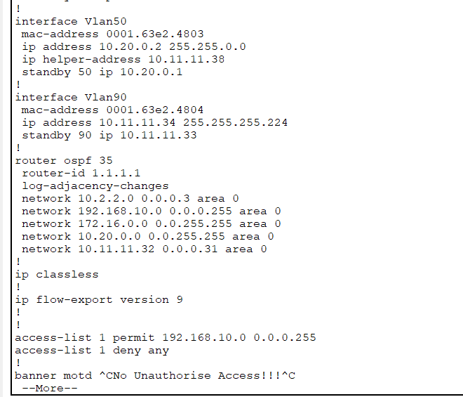
Figure 3 – OSPF process 35 on the core, redistributing VLAN and DMZ subnets, plus a management ACL restricting Telnet/SSH sourcing

5. Perimeter Security – Dual Firewalls & Dynamic Routing
Two firewalls (FWL1 and FWL2) front the network, each dual-homed to a different upstream ISP path (OUTSIDE1 / OUTSIDE2) and to the internal core (INSIDE). This gives the network two independent exit paths and lets OSPF converge around a failed firewall or ISP link rather than relying on static failover alone.
Interface | Name | IP Address | Security Level
Gig1/3 | INSIDE2 | 10.2.2.6/30 | 100
Gig1/1 | OUTSIDE1 | 105.100.50.6/30 | 0
Gig1/2 | OUTSIDE2 | 197.200.100.6/30 | 0

Default routes point out each ISP-facing interface, with a floating (higher administrative distance) route toward OUTSIDE2 so OUTSIDE1 is preferred under normal conditions. OSPF then advertises the internal DMZ and transit subnets so the core always has a path out, even if one firewall's link fails.
route OUTSIDE1 0.0.0.0 0.0.0.0 105.100.50.1
route OUTSIDE2 0.0.0.0 0.0.0.0 197.200.100.1 70
!
router ospf 35
router-id 1.1.8.1
network 105.100.50.0 255.255.255.252 area 0
network 197.200.100.0 255.255.255.252 area 0
network 10.11.11.0 255.255.255.224 area 0
network 10.2.2.8 255.255.255.252 area 0
network 10.2.2.0 255.255.255.252 area 0
Figure 4 – FWL1 default routing (dual ISP with floating route) and OSPF advertising transit networks
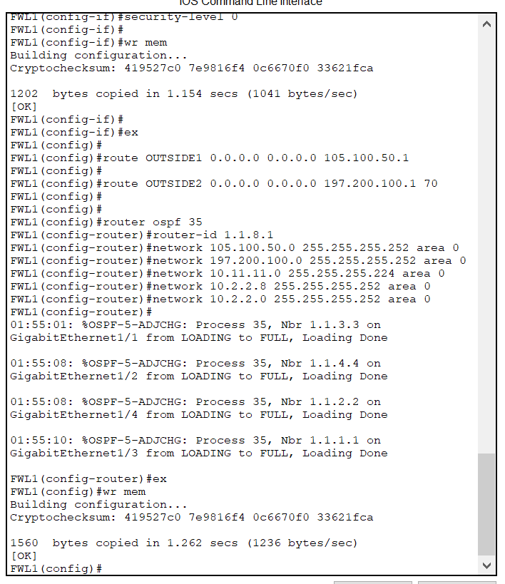
Figure 5 – OSPF adjacencies reaching FULL state with all four core/firewall neighbors after configuration
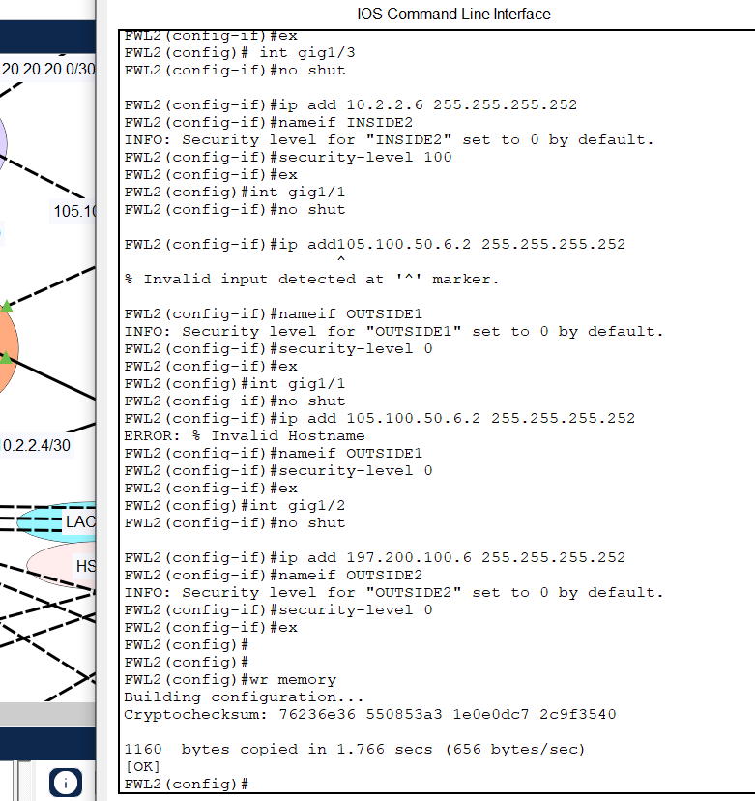
Figure 6 – FWL2 interface configuration mirroring FWL1 (INSIDE2, OUTSIDE1, OUTSIDE2) for firewall redundancy

6. Access Control Lists – Traffic Filtering
An extended ACL named INNET is applied inbound on the DMZ, OUTSIDE1, and OUTSIDE2 interfaces of each firewall. It explicitly permits ICMP (for reachability testing/diagnostics), HTTP (TCP/80) for the web server, and DNS (TCP/UDP 53), while implicitly denying everything else by the ACL's default deny-all. This keeps the DMZ servers reachable only for the protocols they are meant to serve.
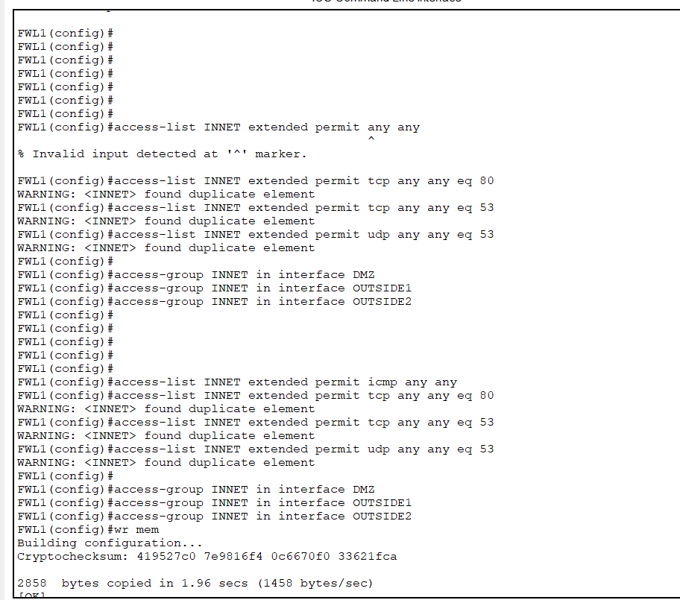
Figure 7 – Extended ACL (INNET) permitting ICMP, HTTP, and DNS, applied to DMZ, OUTSIDE1, and OUTSIDE2
Note: Cisco IOS reported duplicate-element warnings when the same permit statement was re-entered — expected behavior confirming the ACL entries were already present rather than a configuration error.

7. DHCP Services
Rather than one flat DHCP scope, address assignment is scoped per VLAN so each segment gets the correct default gateway, subnet mask, and (for wireless) WLC address automatically. This mirrors how production networks tie IP addressing to VLAN membership.
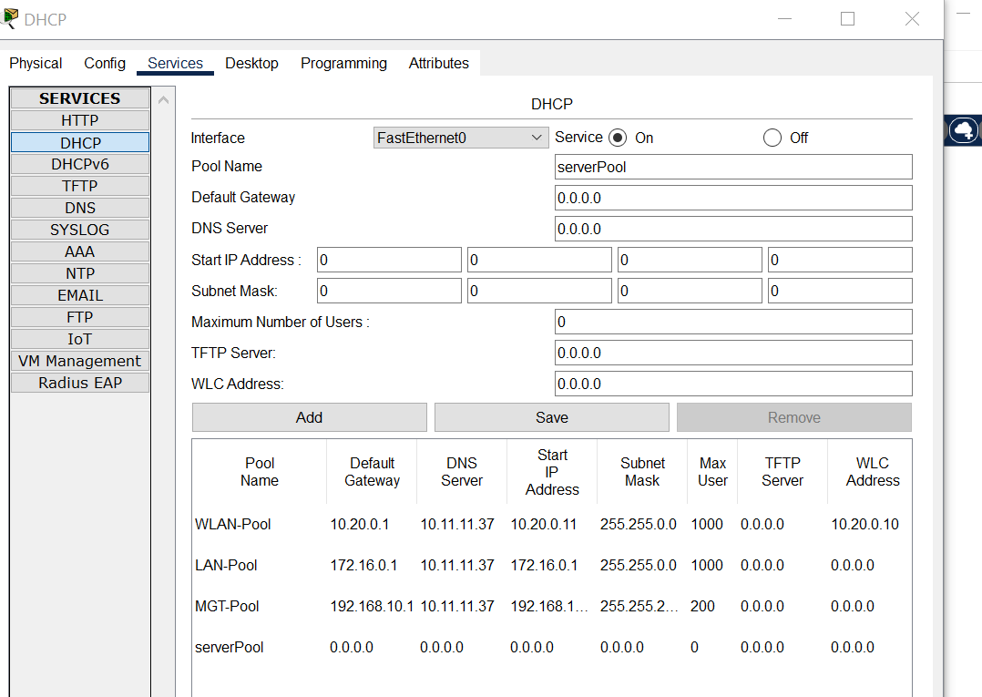
Figure 8 – Per-VLAN DHCP pools (WLAN, LAN, Management) each with distinct gateway, mask, and scale
Pool Name | Default Gateway | Start IP | Subnet Mask | Max Users
WLAN-Pool | 10.20.0.1 | 10.20.0.11 | 255.255.0.0 | 1000
LAN-Pool | 172.16.0.1 | 172.16.0.1 | 255.255.0.0 | 1000
MGT-Pool | 192.168.10.1 | 192.168.1.x | 255.255.2xx | 200
VOIP-POOL | 172.30.0.1 | 172.30.0.0 | 255.255.0.0 | Option 150 → 172.30.0.1

8. Unified Communications – VoIP (Cisco CME)
Voice services are delivered by Cisco IOS Telephony Service (CME) running on the internal router. A dedicated VOIP-POOL DHCP scope hands out addresses in 172.30.0.0/16 and advertises Option 150 (TFTP/Call Manager address) so Cisco 7960 IP phones can auto-register without manual configuration.
ip dhcp pool VOIP-POOL
network 172.30.0.0 255.255.0.0
default-router 172.30.0.1
option 150 ip 172.30.0.1
!
telephony-service
max-ephones 30
max-dn 30
ip source-address 172.30.0.1 port 2000
auto assign 1 to 30
!
ephone-dn 1
number 4 01
Figure 9 – VOIP DHCP scope with Option 150, and telephony-service configuration for up to 30 phones/extensions
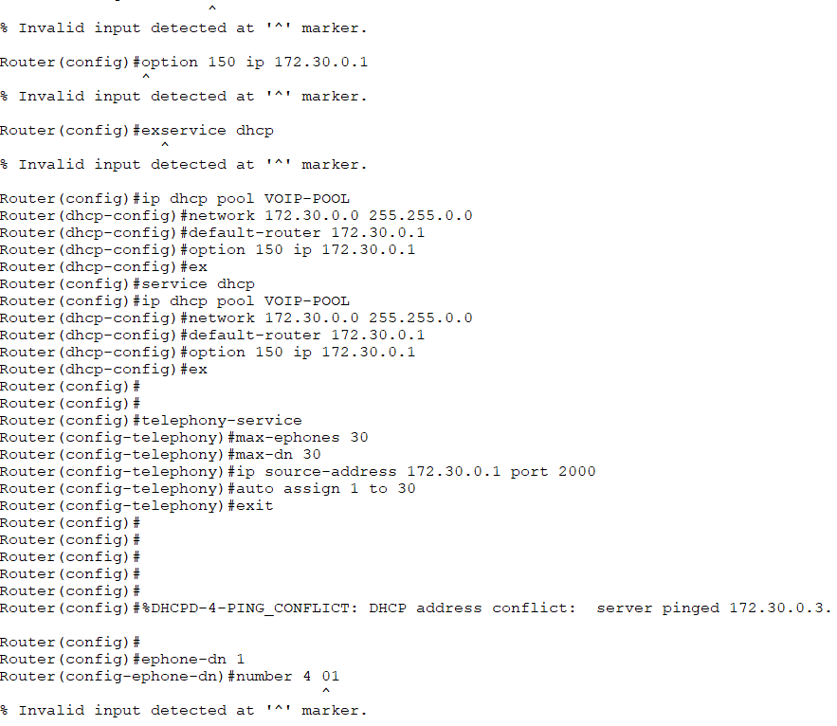
The design was validated with a live call test between extension 402 and extension 410 — both phones show a Connected state, confirming CME registration, dial-plan, and RTP path all function correctly end to end.
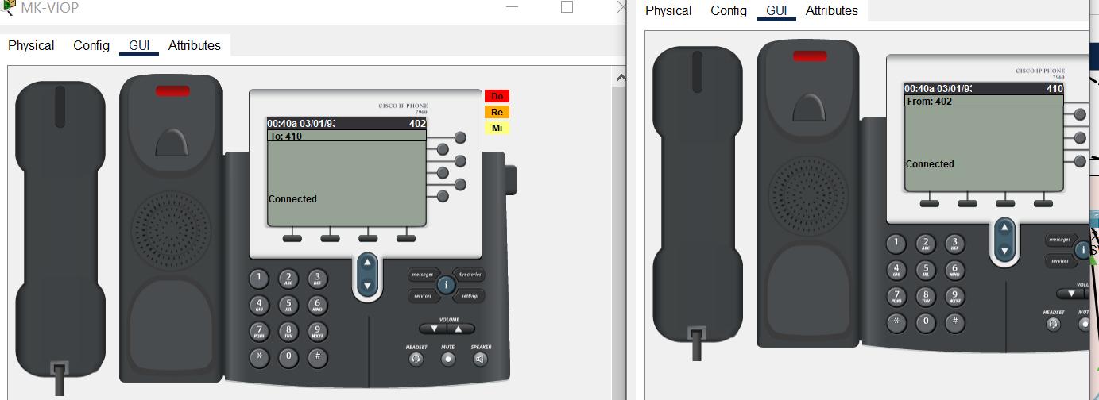
Figure 10 – Live call test: extension 402 ↔ extension 410 shown as Connected on both handsets

9. Enterprise Wireless – WLC-Managed Wi-Fi
Wireless is centrally managed by a Cisco 2504 Wireless LAN Controller rather than standalone autonomous access points. The WLC's management interface sits in the WLAN-Pool subnet (10.20.0.10), and the initial setup wizard defines the corporate SSID, security mode, and VLAN mapping in one place — so every access point in the building inherits the same policy.
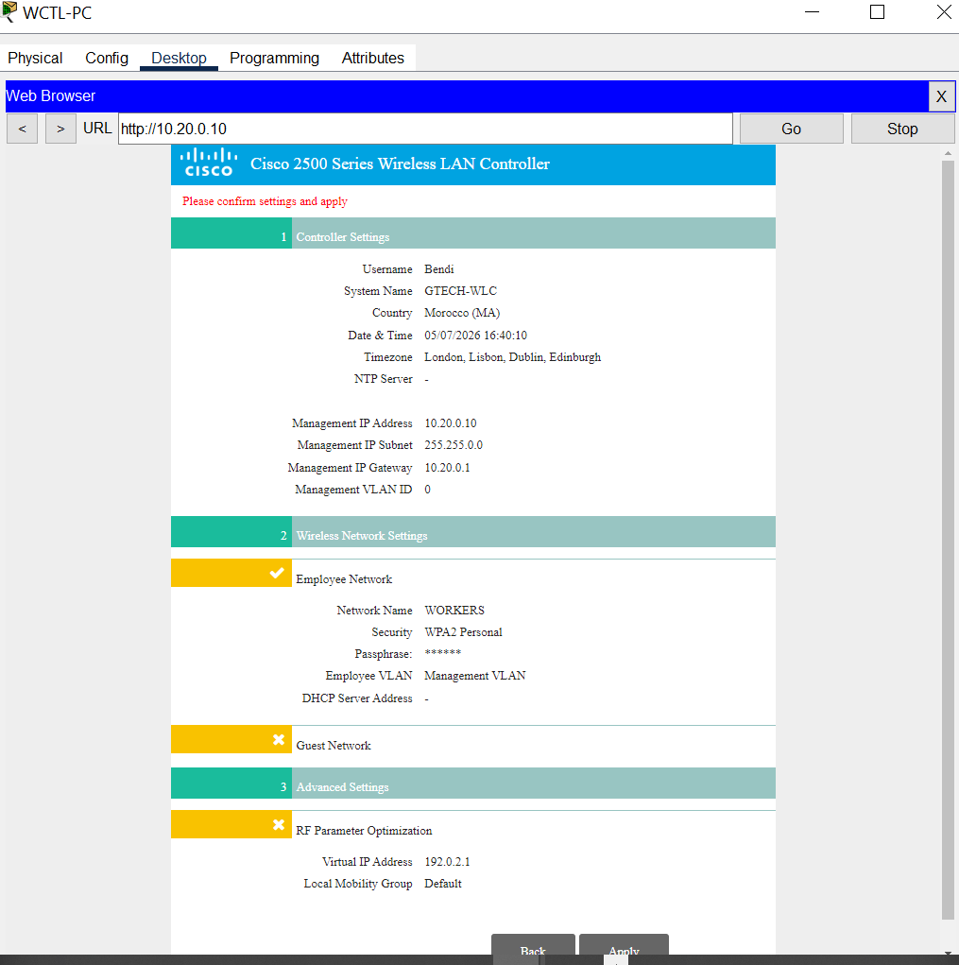
Figure 11 – WLC initial configuration: management IP, employee SSID (WORKERS) on WPA2-Personal, mapped to the management VLAN

10. Access & Device Hardening
Access-layer switches and firewalls were hardened with standard best practices: console and enable password protection, password encryption service (so passwords aren't stored in plaintext in the running config), and a login banner warning against unauthorized access — small details that a hiring manager will recognize as production-network hygiene rather than lab shortcuts.
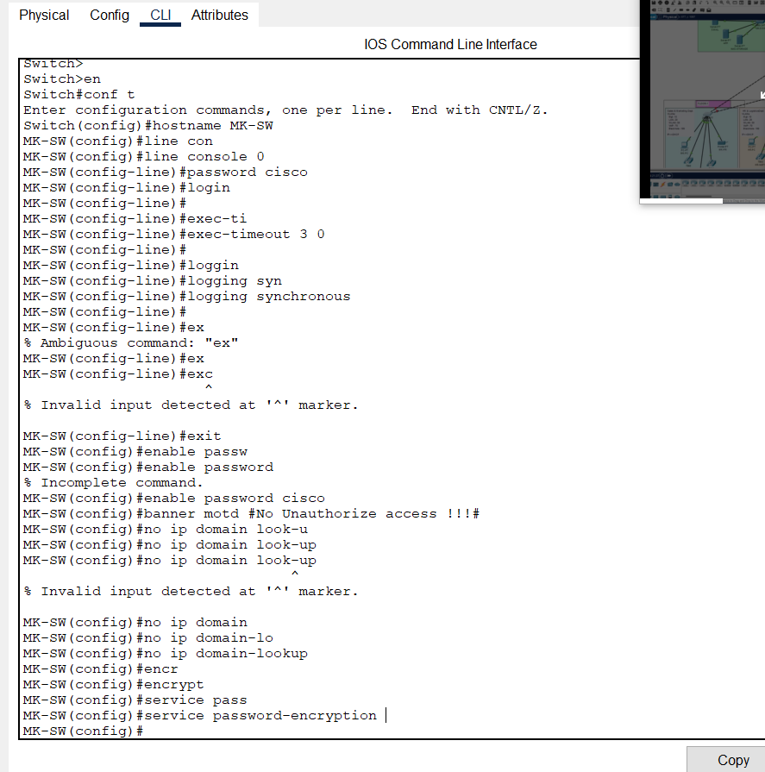
Figure 12 – Switch hardening: console password, exec-timeout, banner motd, and service password-encryption

11. Network Address Translation (NAT)
Internal hosts use dynamic PAT (Port Address Translation) rather than public addressing, so traffic leaving either firewall is translated to the outbound interface's address. Separate NAT rules exist for the LAN (172.16.0.0/16) and Wireless (10.20.0.0/16) subnets, and for each firewall's pair of outside interfaces, so a host is correctly translated regardless of which ISP path or which firewall its traffic egresses through.
object network INSIDE1-OUTSIDE1
subnet 172.16.0.0 255.255.0.0
nat (INSIDE1,OUTSIDE1) dynamic interface
!
object network INSIDEw1-OUTSIDEw1
subnet 10.20.0.0 255.255.0.0
nat (INSIDE1,OUTSIDE1) dynamic interface
!
object network INSIDE1-OUTSIDE2
subnet 172.16.0.0 255.255.0.0
nat (INSIDE1,OUTSIDE2) dynamic interface
!
object network INSIDE2-OUTSIDE2
subnet 172.16.0.0 255.255.0.0
nat (INSIDE2,OUTSIDE2) dynamic interface
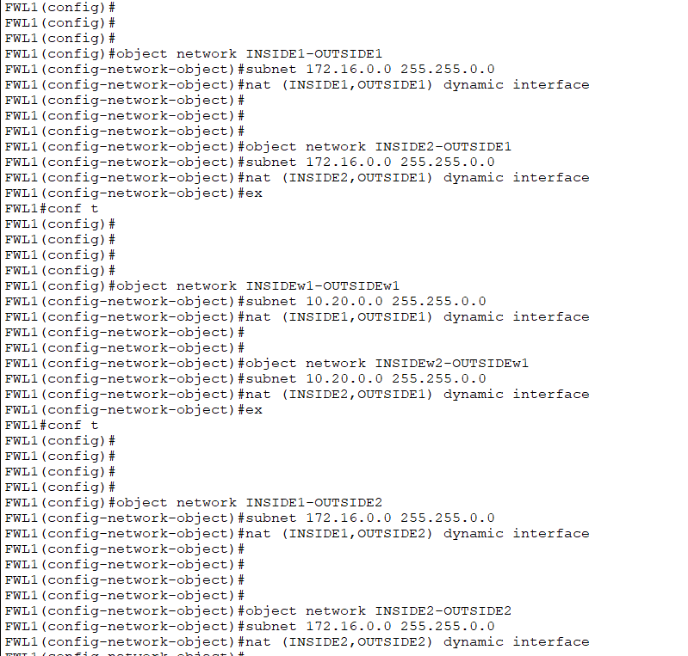
Figure 14 – Dynamic PAT rules covering LAN and Wireless subnets across both firewalls and both outside interfaces
Configuring NAT per interface pair (rather than one blanket rule) means either firewall can independently translate and forward traffic for any internal subnet, which keeps address translation consistent no matter which path OSPF selects at a given moment.

12. Firewall Load Sharing & Path Preference
FWL1 and FWL2 are configured as mirror images of each other but with opposite default-route preference, so each firewall prefers a different upstream ISP under normal conditions while remaining able to fail over to the other path. FWL1 prefers OUTSIDE1 with OUTSIDE2 as a floating backup; FWL2 prefers OUTSIDE2 with OUTSIDE1 as its floating backup. This spreads outbound traffic across both ISP links instead of leaving one completely idle, while OSPF between the firewalls and core keeps both paths converged and ready to absorb the other's traffic on failure.
! FWL2 routing (mirrors FWL1 with reversed preference)
route OUTSIDE1 0.0.0.0 0.0.0.0 197.200.100.5
route OUTSIDE2 0.0.0.0 0.0.0.0 105.100.50.5 20
!
router ospf 35
router-id 1.1.8.2
network 197.200.100.4 255.255.255.252 area 0
network 105.100.50.4 255.255.255.252 area 0
network 10.2.2.4 255.255.255.252 area 0
network 10.2.2.12 255.255.255.252 area 0
Figure 15 – FWL2 default routing and OSPF, configured as the active/backup counterpart to FWL1

13. Core Switch Link Aggregation (EtherChannel)
The link between CORE1 and CORE2 is bundled into a single logical EtherChannel (Port-Channel 1) using LACP passive mode across three physical Gigabit links (Gi1/0/9–11). Bundling the redundant core-to-core links this way increases available bandwidth between the cores and, more importantly, means the loss of any single physical link does not tear down the trunk or force a spanning-tree recalculation — the remaining member links simply absorb the traffic.
interface range GigabitEthernet1/0/9-11
channel-group 1 mode passive
exit
!
interface Port-channel 1
switchport mode trunk
exit
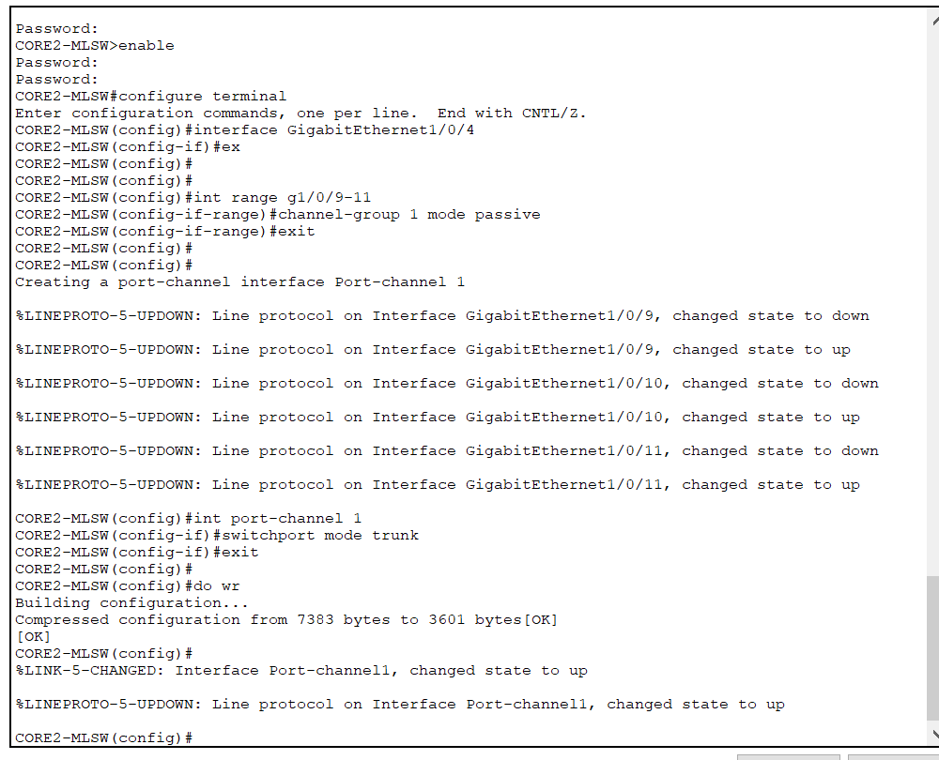
Figure 16 – LACP EtherChannel formation on CORE2: member links bundle into Port-channel1, which comes up as a trunk
The %LINEPROTO and %LINK-5-CHANGED messages confirm each member interface flapped briefly while joining the bundle, then the Port-channel1 interface itself came up as a trunk — the expected behavior when EtherChannel negotiation completes successfully.

14. Access-Layer Switch Configuration & Hardening
Each floor/access switch carries a consistent build so the design scales cleanly across departments: an uplink trunk to the core, VLANs matching the addressing plan, a dedicated voice VLAN for IP phones, and all unused ports shut down and parked in the black-hole VLAN so an unauthorized device cannot get network access simply by plugging into an empty jack.
interface range fa0/1-2
switchport mode trunk
exit
vlan 10
name MGT
vlan 20
name LAN
vlan 50
name WLAN
vlan 70
name VOIP
vlan 199
name BLACKHOLE
exit
interface range fa0/3-4
switchport mode access
switchport access vlan 20
exit
interface range fa0/5-6
switchport mode access
switchport voice vlan 70
exit
interface fa0/7
switchport mode access
switchport access vlan 50
exit
interface range fa0/8-24, gig0/1-2
switchport mode access
switchport access vlan 199
shutdown
exit
Figure 17 – Standard access-switch template: trunk uplink, VLAN plan, dedicated voice VLAN, unused ports shut in VLAN 199
Every access port also has PortFast and BPDU Guard enabled, since end-user/phone ports should transition straight to forwarding without waiting through STP listening/learning, and should never legitimately receive a BPDU — if one appears, it is almost certainly a misconfigured or unauthorized device, so the port is automatically error-disabled.
interface range fa0/3-24
spanning-tree portfast
spanning-tree bpduguard enable
exit
The DMZ switch and the server/WLC switch use the same PortFast + BPDU Guard treatment on their server-facing and access ports, keeping the hardening approach consistent across every switch in the topology rather than only on the user-facing floors.

15. Verification & Testing
Connectivity was validated end-to-end rather than assumed. A PC on the HR VLAN (HR-PC) was used to ping a remote target (8.0.0.20) across the firewall/OSPF path, confirming both the routing design and the ACL permit rules were working correctly — the first ping attempt shows expected initial ARP/OSPF convergence loss, followed by 100% success on the retry.
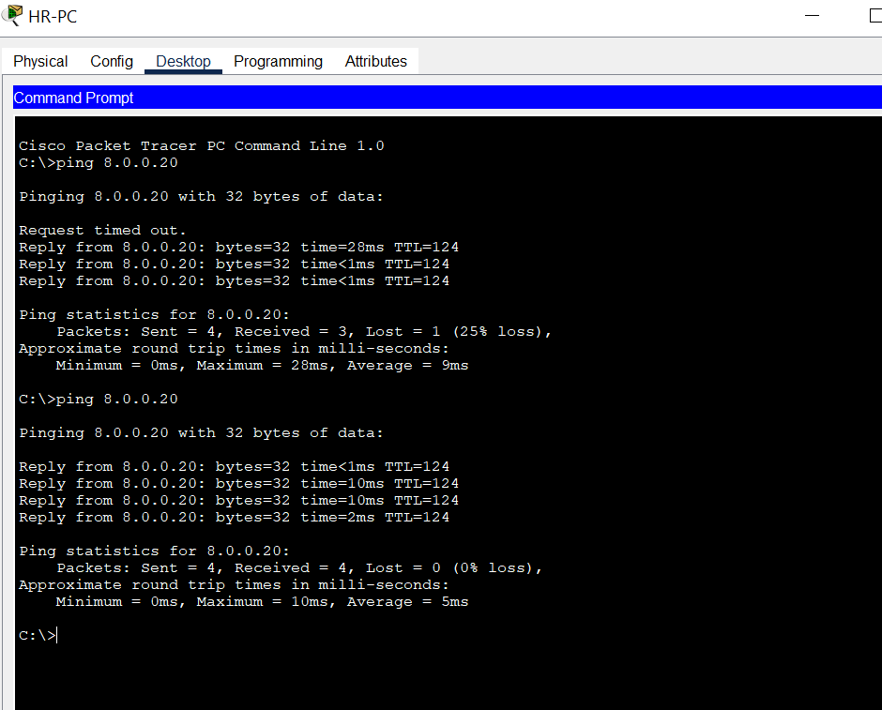
Figure 18 – End-to-end reachability test from HR-PC across the WAN/firewall path, confirming routing and ACL correctness
Additional verification performed:
- OSPF neighbor states confirmed FULL across all firewall–core adjacencies (Figure 5)
- Live VoIP call test between two IP phones on different ephone-dns (Figure 10)
- DHCP scope assignment confirmed per VLAN (correct gateway/mask handed out to clients)
- WLC management page reachable and wireless SSID broadcasting per configured policy

16. Challenges & Troubleshooting
Several real configuration issues were encountered and resolved during the build, which is worth highlighting because troubleshooting ability is often more valuable to employers than a clean first-try config:
- Invalid IP address syntax when typed without a space (e.g. "ip add105.100.50.6") — corrected by re-entering the command with proper spacing
- Duplicate ACL element warnings when re-applying existing access-list entries — confirmed as non-fatal and left in place since the entries already existed
- Ambiguous/incomplete IOS commands during switch hardening (e.g. "ex" matching multiple commands) — resolved by using the fully qualified command ("exit")
- DHCP address conflict detected on the VoIP pool via IOS's built-in ping-before-assign feature, confirming the DHCP conflict-detection mechanism was functioning as intended
- EtherChannel member ports briefly flapped (down/up) while LACP negotiated the bundle — expected transient behavior, resolved once Port-channel1 came up and was set to trunk mode

17. Skills Demonstrated
- Enterprise LAN/WAN design: hierarchical core–distribution–access architecture
- Routing: OSPF multi-area-capable configuration, route redistribution, floating static routes
- High availability: HSRP gateway redundancy, dual-ISP/dual-firewall edge design
- Security: DMZ design, extended ACLs, firewall security levels, dynamic PAT/NAT, device hardening
- Switching: LACP EtherChannel link aggregation, PortFast + BPDU Guard STP hardening, voice VLAN and blackhole VLAN design
- Services: per-VLAN DHCP scoping, DNS/HTTP service exposure via ACL
- Unified Communications: Cisco CME VoIP deployment and dial-plan configuration
- Wireless: WLC-based centralized enterprise Wi-Fi management
- Verification-driven engineering: testing and validating every layer rather than assuming success

18. Conclusion
This project demonstrates the ability to design, build, and validate a complete enterprise network from the internet edge down to the end-user device — covering routing, redundancy, security, voice, and wireless in a single cohesive architecture. It reflects the kind of layered thinking (availability, segmentation, least privilege, and service delivery) expected of a network engineer working on real campus or branch deployments.
Project files (Packet Tracer .pkt topology and configuration exports) are available on request / in the accompanying repository.

