SECURITY OPERATIONS HOME LAB
Reconnaissance, Detection, Analysis & Human-Layer Testing
Across a Self-Hosted Blue-Team Toolchain
Security Portfolio Case Study
Analyst: Bendi Caleb Yonli
July 2026

1. Executive Summary
This project documents a self-built security operations home lab used to practice the full blue-team lifecycle — reconnaissance, detection, analysis, and human-layer (phishing) testing — using a self-hosted toolchain rather than only completing guided training exercises. The lab is designed to mirror the workflow of a junior SOC analyst: scan and assess an environment, identify and prioritize risk, and produce a client-ready report a manager or client could act on directly.
The first completed deliverable is a full internal vulnerability assessment of a 24-host lab subnet using Nmap, presented below in the same format used for professional penetration-testing engagements: scope, methodology, findings with CVE references, a management-facing risk dashboard, and a prioritized remediation roadmap.

2. Lab Environment & Toolchain
The lab combines prevention, detection, analysis, and offensive-simulation tooling so that each stage of a real security operation can be practiced end-to-end rather than in isolation.
Tool | Function in Lab | Stage
Nmap | Host/service discovery, OS detection, vulnerability scripts | Reconnaissance / Scanning
pfSense | Perimeter firewall, network segmentation | Prevention
Wireshark | Packet capture and protocol-level traffic analysis | Analysis
Snort | Signature-based intrusion detection | Detection
Splunk | Log aggregation, correlation, and dashboarding | Detection / Analysis
GoPhish | Simulated phishing campaigns for awareness testing | Human-Layer Testing

This case study currently documents the Nmap-based reconnaissance and vulnerability assessment phase in full. The pfSense, Snort, Wireshark, Splunk, and GoPhish components of the lab are operational and will be documented as dedicated sections (Section 8) as each engagement is completed and captured.

3. Engagement: Internal Network Vulnerability Assessment

3.1 Assessment Details
- Client (lab designation): Internal Lab Network
- Scope: 192.168.100.0/24
- Assessment Type: Internal Reconnaissance & Vulnerability Scan
- Tool: Nmap (Advanced Scan)
- Analyst: Bendi Caleb Yonli

3.2 Scope & Methodology
The assessment followed a standard internal vulnerability-scanning methodology: an initial SYN scan to identify live hosts, a full port scan to avoid missing services on non-default ports, service/version detection, OS fingerprinting, and finally Nmap's scripting engine vulnerability scans to flag known CVEs against detected service versions.
nmap -sS <target> # SYN scan - host/port discovery
nmap -p- <target> # full 65535-port scan
nmap -sV <target> # service/version detection
nmap -O <target> # OS detection
nmap --script vuln <target> # NSE vulnerability scripts
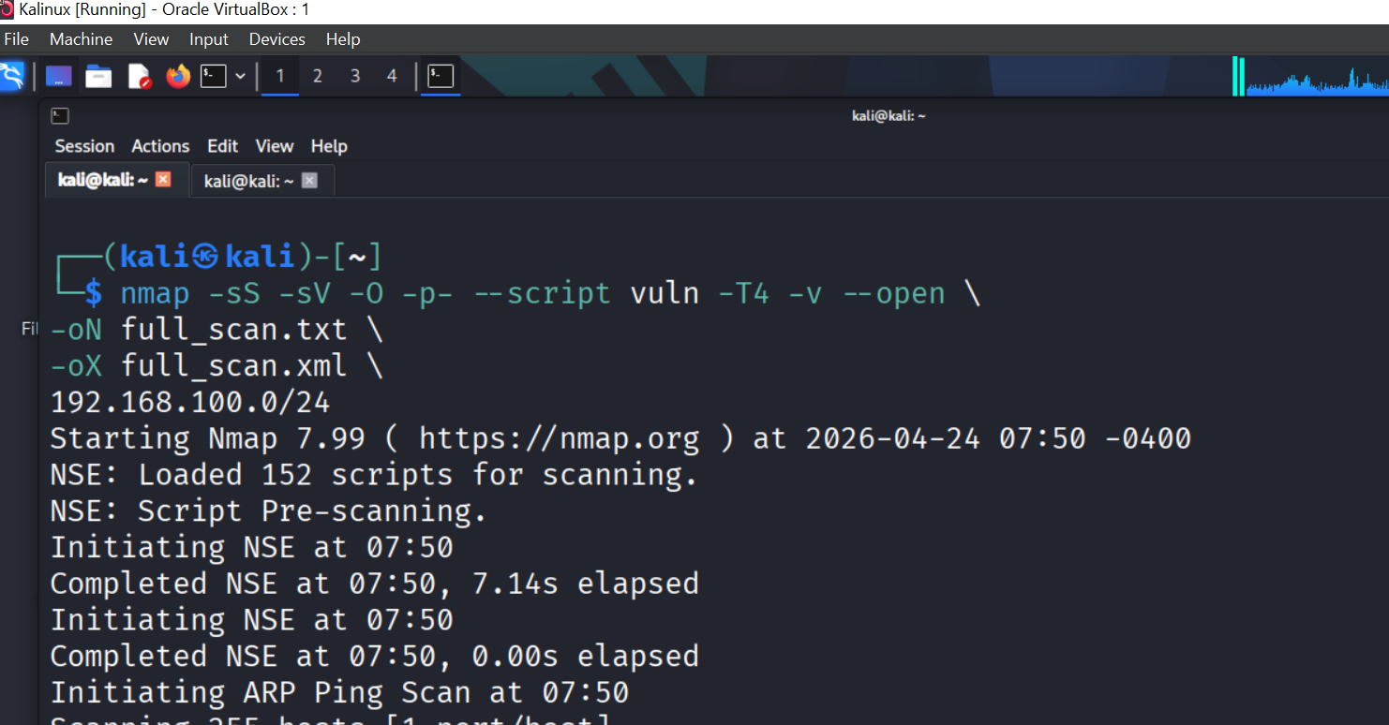
Figure 1 – Nmap scan configuration and scope against the 192.168.100.0/24 lab subnet

3.3 Asset Summary
Category | Count | Risk Level
Servers | 2 | Medium
Windows Hosts | 3 | High
IoT Devices | 10+ | High
Network Device | 1 | High
Printers | 1 | Medium

3.4 Key Findings
Finding 1 – Vulnerable Web Server (HIGH)
- Host: 192.168.100.25
- Service: thttpd 2.25b
- CVEs: CVE-2017-17663, CVE-2009-4491
- Impact: Remote code execution possible
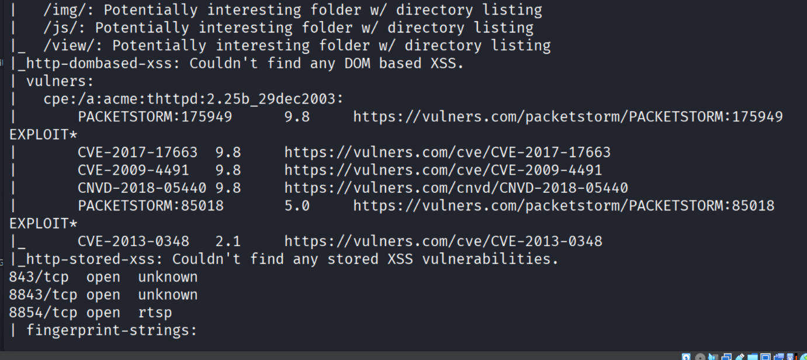
Figure 2 – Nmap NSE output identifying the outdated thttpd version and associated CVEs
Finding 2 – Slowloris Vulnerability (HIGH)
- Host: 192.168.100.1
- Service: HTTP
- Impact: Denial of Service (DoS) via slow HTTP connection exhaustion
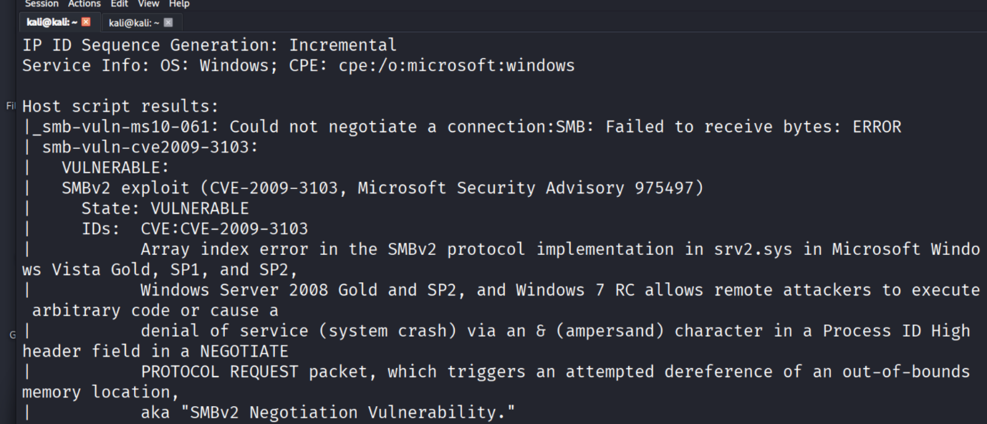
Figure 3 – Nmap vulnerability script flagging Slowloris DoS exposure on the HTTP service
Finding 3 – SMB Exposure (HIGH)
- Host: 192.168.100.12
- Ports: 139, 445
- Impact: Lateral movement risk, credential theft potential
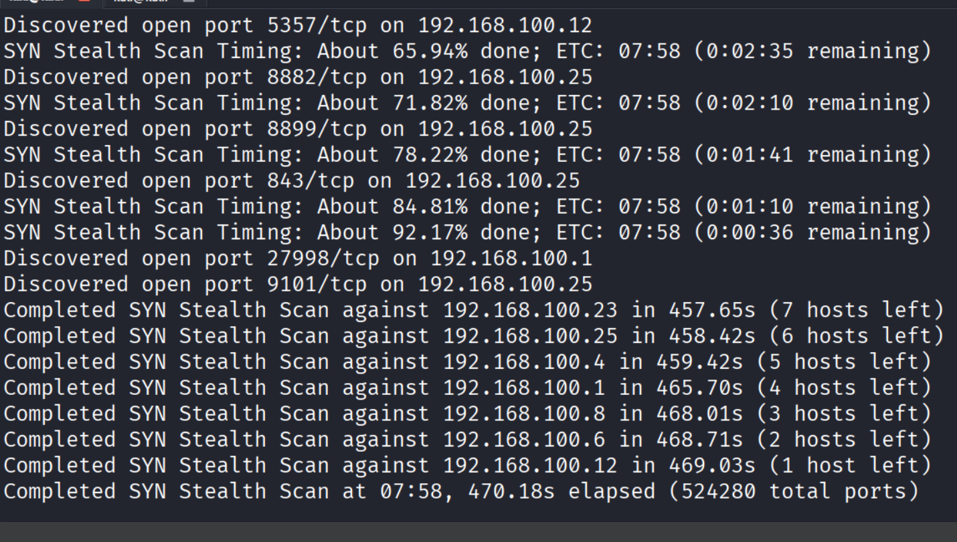
Figure 4 – Nmap SMB enumeration showing exposed NetBIOS/SMB ports
Finding 4 – RDP Exposure (HIGH)
- Host: 192.168.100.168
- Port: 3389
- Impact: Exposed RDP is a common target for remote brute-force attacks
Finding 5 – IoT Surveillance Exposure (MEDIUM–HIGH)
- Host: 192.168.100.25
- Services: RTSP, DVR
- Impact: Camera stream leakage; IoT devices frequently ship with weak default credentials and infrequent patching

4. Risk Dashboard (Management View)
A one-glance risk summary was produced alongside the technical findings so a non-technical stakeholder can quickly understand overall exposure without reading the full technical detail.

Risk Distribution
HIGH ██████████ 6
MEDIUM █████ 3
LOW ██ 2

Top Exposed Services
Service | Count | Risk
HTTP | 6 | High
SMB | 2 | High
SSH | 2 | Medium
RDP | 1 | High
RTSP | 2 | Medium

Threat Overview
- Internal attack surface is wide — many hosts respond on more services than expected
- IoT devices materially increase exposure and are the least-patched category on the network
- Multiple outdated / end-of-support services detected (e.g., thttpd 2.25b)

Critical Alerts
- Outdated web server (thttpd) vulnerable to known CVEs
- SMB exposed on the internal network
- RDP accessible without apparent network-level restriction
- IoT devices are not network-segmented from core assets

5. Recommendations & Remediation Roadmap
Findings were translated into a prioritized action plan rather than a flat list, since a client or manager needs to know what to fix first, not just what is wrong.

Immediate (0–7 days)
- Patch vulnerable web servers (replace/upgrade thttpd)
- Disable unused/unnecessary services on all scanned hosts
- Restrict SMB and RDP access to only the hosts/users that require it

Short Term (1–4 weeks)
- Implement VLAN segmentation to separate servers, workstations, and IoT devices
- Isolate IoT/surveillance devices onto their own restricted segment
- Enforce strong authentication (disable default credentials, enforce MFA where possible)

Long Term (1–3 months)
- Deploy a SIEM (Wazuh or Splunk) for centralized log visibility
- Implement IDS/IPS (Snort) at the network perimeter and key internal chokepoints
- Establish a continuous/recurring vulnerability scanning cadence rather than a one-time assessment

6. Why This Report Is Structured This Way
The report deliberately separates an Executive Summary (for managers) from the technical Key Findings (for engineers), because that is how real vulnerability assessments and pentest reports are consumed in practice — a manager needs the risk rating and required actions in 30 seconds, while an engineer needs the host, port, CVE, and technical impact to actually remediate it. Producing both audiences correctly in one document is itself a skill assessed in security interviews.

7. Skills Demonstrated
- Reconnaissance & enumeration: Nmap SYN/full-port/service/OS scans and NSE vulnerability scripting
- Vulnerability analysis: mapping discovered services/versions to CVEs and assessing real-world impact
- Risk communication: producing both an executive summary and a technical findings section for different audiences
- Remediation planning: prioritizing fixes into immediate / short-term / long-term action tiers
- Security fundamentals: exposure analysis across web, SMB, RDP, and IoT/RTSP attack surfaces
- Report writing: structuring findings the way a client-facing vulnerability assessment or pentest report is expected to read

8. Roadmap – Additional Lab Modules (In Progress)
The following modules are built and operational in the lab and will be documented with the same evidence-based format once screenshots/logs are captured:
- pfSense: firewall rule set and network segmentation policy protecting the lab subnet
- Snort: signature-based detection of the same reconnaissance/exploitation activity identified by Nmap above (full detect-the-attacker loop)
- Wireshark: packet-level analysis of a captured attack or scan for protocol-level verification
- Splunk: log ingestion and a correlation search/dashboard tying Snort alerts to source IP and timeline
- GoPhish: a documented phishing simulation campaign with click-rate/credential-submission metrics and an awareness recommendation
Together, these will complete the full detect → analyze → respond → educate cycle, giving this lab the same breadth as a junior SOC analyst's day-to-day workflow.

9. Conclusion
This engagement demonstrates the ability to plan and execute a real vulnerability assessment, correctly interpret and prioritize findings by risk, and communicate results to both technical and non-technical audiences — the core responsibilities of a Tier 1 SOC Analyst or junior security engineer. Combined with the accompanying Enterprise Network Design portfolio (VLAN segmentation, ACLs, dual-firewall NAT/OSPF, and EtherChannel redundancy), this project shows both the ability to build a secure network and the ability to assess and defend one.

