Pentesting: SOC Report (client-ready)

FINAL REPORT
Network Security Assessment Report
Client: Internal Lab Network
Scope: 192.168.100.0/24
Assessment Type: Internal Reconnaissance & Vulnerability Scan
Tool: Nmap (Advanced Scan)
Date: April 2026
Analyst: BENDI CALEB YONLI
Tel: +226 71782891/0557230269

1. Executive Summary (FOR MANAGERS)
The internal network assessment identified multiple high-risk exposures, including:
- Vulnerable web services (outdated software)
- Exposed Windows SMB services
- Remote access services (RDP, SSH)
- IoT and surveillance devices with weak security
Overall Risk Rating:
HIGH
Immediate Actions Required:
- Patch vulnerable web servers
- Restrict SMB and RDP access
- Isolate IoT devices

2. Scope & Methodology

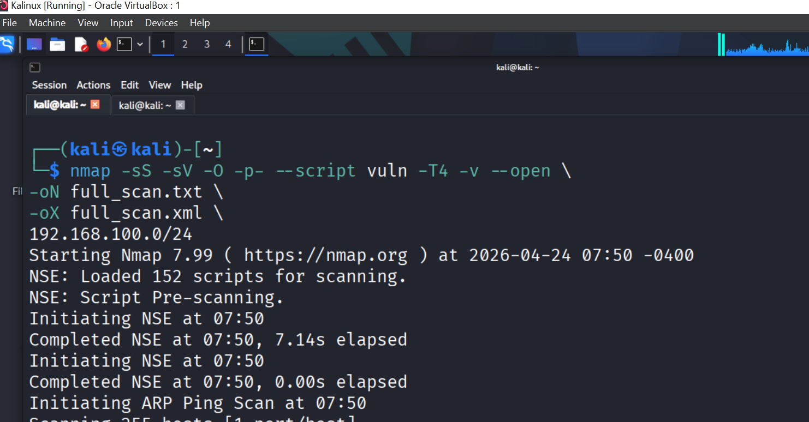
Scope:
- Network: 192.168.100.0/24
Methodology:
- SYN scan (-sS)
- Full port scan (-p-)
- Service detection (-sV)
- OS detection (-O)
- Vulnerability scan (--script vuln)

3. Asset Summary
Category | Count | Risk Level
Servers | 2 | Medium
Windows Hosts | 3 | High
IoT Devices | 10+ | High
Network Device | 1 | High
Printers | 1 | Medium

4. Key Findings
Finding 1: Vulnerable Web Server
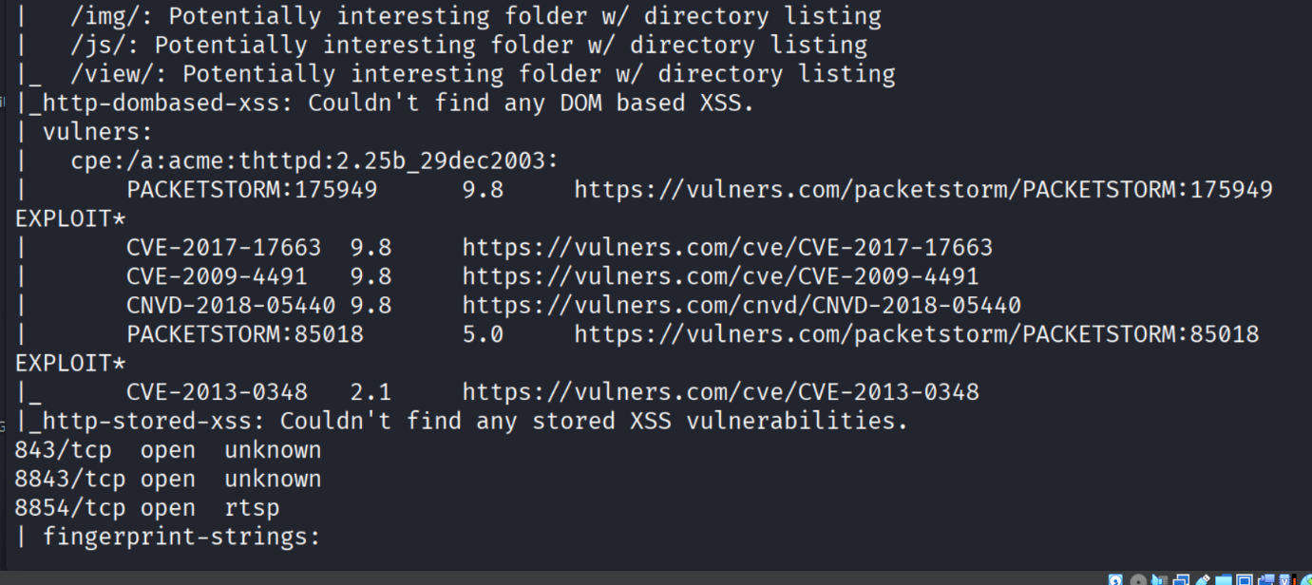
- Host: 192.168.100.25
- Service: thttpd 2.25b
- CVEs: CVE-2017-17663, CVE-2009-4491
- Risk: HIGH
Reason: Publicly exposed service with known exploitable vulnerabilities
Impact:
- Remote code execution possible

Finding 2: Slowloris Vulnerability
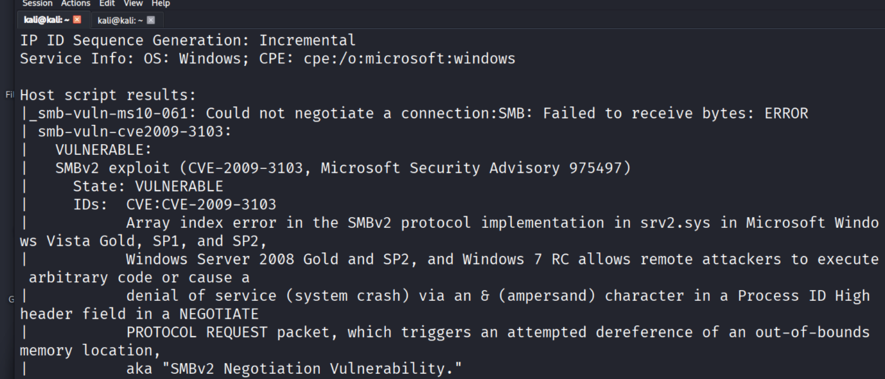
- Host: 192.168.100.1
- Service: HTTP
- Risk: HIGH
Impact:
- Denial of Service (DoS)

Finding 3: SMB Exposure
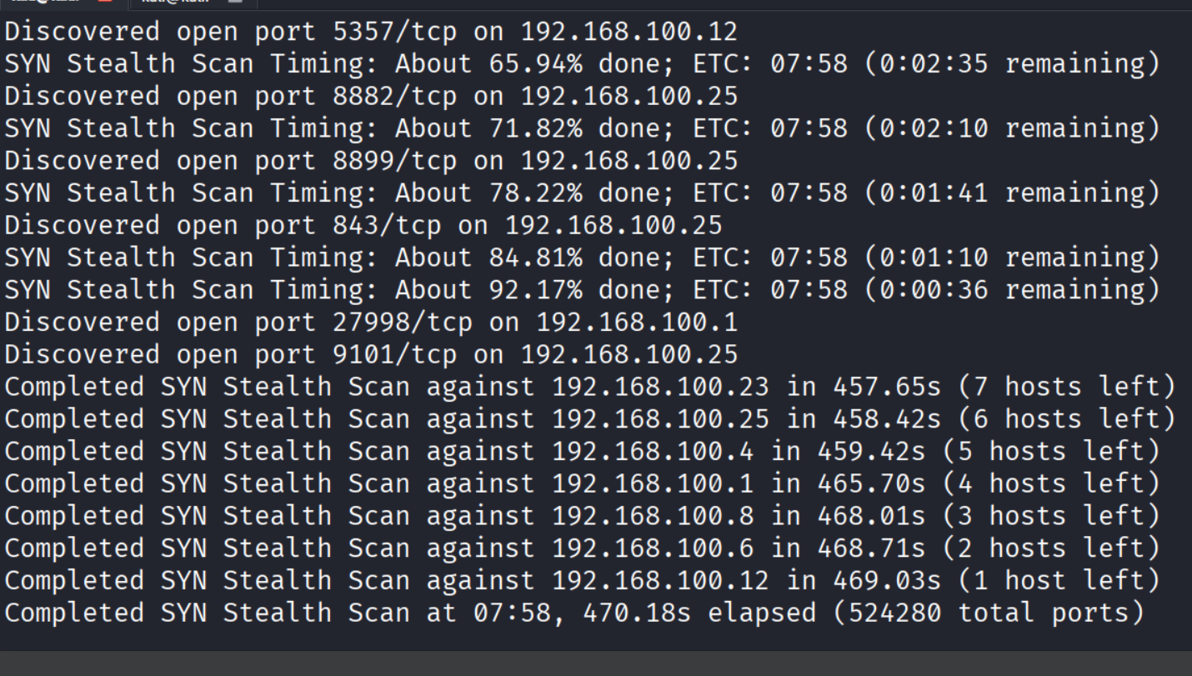

- Host: 192.168.100.12
- Ports: 139, 445
- Risk: HIGH
Reason: Publicly exposed service with known exploitable vulnerabilities
Impact:
- Lateral movement
- Credential theft

Finding 4: RDP Exposure
- Host: 192.168.100.168
- Port: 3389
- Risk: HIGH
Reason: Publicly exposed service with known exploitable vulnerabilities
Impact:
- Remote brute-force attacks

Finding 5: IoT Surveillance Exposure
- Host: 192.168.100.25
- Services: RTSP, DVR
Impact:
- Camera stream leakage

5. DASHBOARD (MANAGEMENT VIEW)
Risk Distribution
HIGH ██████████ 6
MEDIUM █████ 3
LOW ██ 2

Top Exposed Services
Service | Count | Risk
HTTP | 6 | High
SMB | 2 | High
SSH | 2 | Medium
RDP | 1 | High
RTSP | 2 | Medium

Threat Overview
- Internal attack surface is wide
- IoT devices increase exposure significantly
- Multiple outdated services detected

Critical Alerts
- Outdated web server (thttpd)
- SMB exposed internally
- RDP accessible
- IoT devices unsegmented

6. RECOMMENDATIONS

- Immediate (0–7 days)
- Patch vulnerable web servers
- Disable unused services
- Restrict SMB and RDP

- Short Term (1–4 weeks)
- Implement VLAN segmentation
- Isolate IoT devices
- Enforce strong authentication

- Long Term (1–3 months)
- Deploy SIEM (Wazuh / Splunk)
- Implement IDS/IPS
- Continuous vulnerability scanning

----------------------------------------
Report Prepared by:
BENDI CALEB YONLI
Cybersecurity Analyst

Confidential – For Internal Use Only

