**Web Tech Assignment 2 Report**

**GitHub Link** <https://github.com/bendicko12/WebTechAssignment>

Activity Diagrams

To start of any Javascript project it is good practice to create activity diagrams before hand in the design of a flow chart. This highlights the main functions and processes that will be needed to be performed by the code. Below are the activity diagrams for both the Theatre Ticket page and the Slot Machine page.

**Theatre Tickets** –

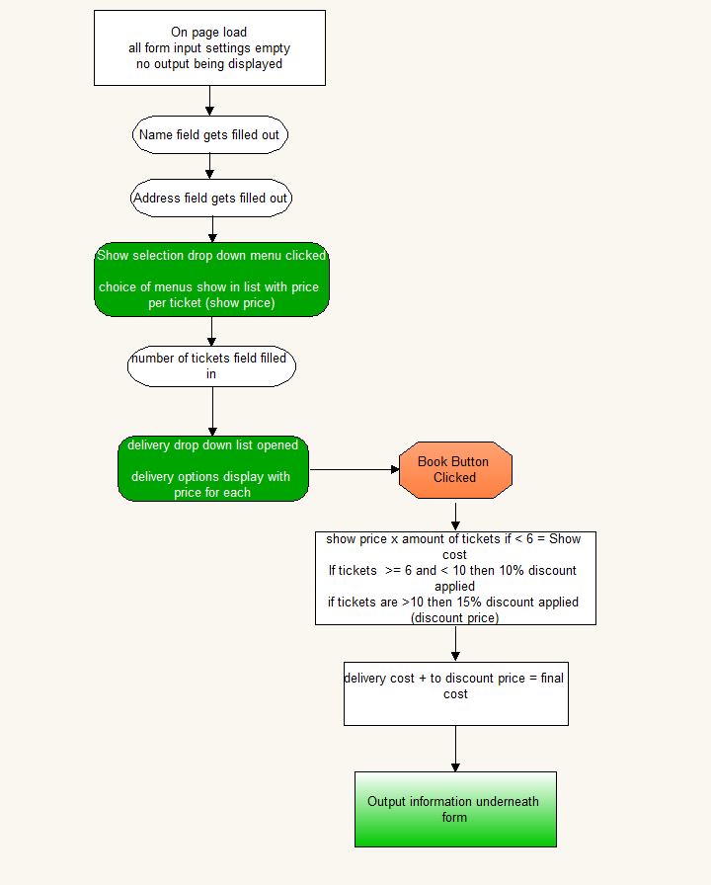

**Slot Machine –**

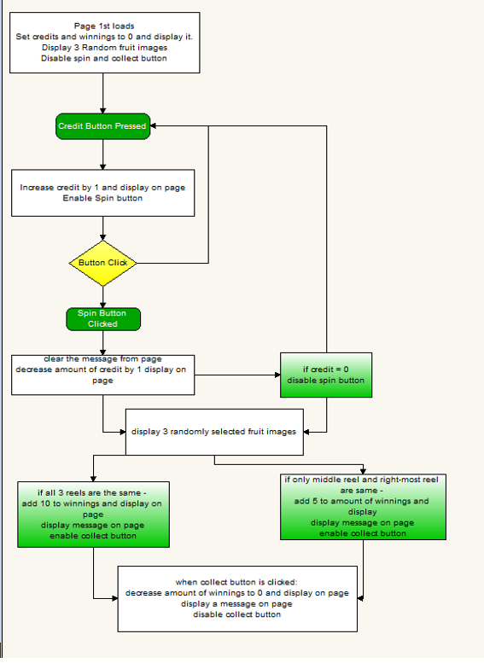

**Testing**

After the coding was completed it was time to test the product to see if it was functional. Test tables were created to guide the testing results and have been documented below.

Theatre Tickets Testing

|  |  |
| --- | --- |
| Test | Test form with less than 6 tickets and check output |
| Reason | To see if form without discount is functional |
| Expected Outcome | Functional website and output |
| Actual Outcome | No output was displayed |
| Fix (if necessary) | Issue with the code based around ‘eTicket’, code was fixed and output then displayed |

|  |  |
| --- | --- |
| Test | Test form with between 6 and 9 tickets |
| Reason | To see if form with 10% discount is functional |
| Expected Outcome | Functional form and output showing discount value and total after discount |
| Actual Outcome | Test was successful |
| Fix (if necessary) |  |

|  |  |
| --- | --- |
| Test | Test form with between 10 or more tickets |
| Reason | To see if form with 15% discount is functional |
| Expected Outcome | Functional form and output showing discount value and total after discount |
| Actual Outcome | Test was successful |
| Fix (if necessary) |  |
| Test | Test different delivery methods on booking |
| Reason | To make sure the different delivery methods are displaying and calculating properly |
| Expected Outcome | Each delivery method displayed and added to total cost. |
| Actual Outcome | All delivery options displayed and calculated perfectly. |
| Fix (if necessary) |  |

Slot Machine Testing

|  |  |
| --- | --- |
| Test | Test add credit button |
| Reason | Make sure credit button adds 1 credit and enables spin button |
| Expected Outcome | +1 to credit, spin button enabled and message displayed |
| Actual Outcome | Test Succesful |
| Fix (if necessary) |  |

|  |  |
| --- | --- |
| Test | Test spin button |
| Reason | Make sure spin reduces credit by 1 and if hits 0 spin button becomes disabled, 3 random images display |
| Expected Outcome | 3 random images, credit – 1 and spin button disabled when 0 credit |
| Actual Outcome | Test Succesful |
| Fix (if necessary) |  |

|  |  |
| --- | --- |
| Test | Test spin button |
| Reason | Test spin button until 2 right most pictures display same image |
| Expected Outcome | Credits -1 each time, when 2 right images the same – add 5 to winnings and display win message. Collect button enabled |
| Actual Outcome | Test Succesful |
| Fix (if necessary) |  |

|  |  |
| --- | --- |
| Test | Test spin button |
| Reason | Test spin button until all 3 images are the same |
| Expected Outcome | Credits -1 each time, when all images the same – add 10 to winnings and display win message. Collect button enabled |
| Actual Outcome | Test Succesful |
| Fix (if necessary) |  |

|  |  |
| --- | --- |
| Test | Test collect Button |
| Reason | Make sure winnings can be collected |
| Expected Outcome | Winnings go to 0, winnings collect message displayed, collect button disabled |
| Actual Outcome | Test Succesful |
| Fix (if necessary) |  |

|  |  |
| --- | --- |
| Test | Reload Page |
| Reason | On page load make sure everything is refreshed |
| Expected Outcome | 3 random images appear, credit and winnings = 0, spin and collect button disabled. |
| Actual Outcome | Test Succesful |
| Fix (if necessary) |  |