DIFUSE Data Science Module

EEE 350: Random Signal Analysis

Professor Chao Wang

Arizona State University

## Intended Deployment:

* Institution: Arizona State University (ASU)
* Course: EEE350: Random Signal Analysis
* Semester/Term: Spring 2023
* Instructor: Dr. Chao Wang
* Duration: Two Class Periods, including group work outside of class time
* Platforms: MATLAB, Canvas LTI, Google Drive

### 

## Logistics:

### Folder Organization. (each indentation is a subfolder in the directory)

F22-EEE-350/

* Completed Module/
  + README_Instructor_Guide.pdf
  + Student Module Materials/*
    - Part 1/*
      * DIFUSE_Stats_Module_Part_1_Assignment.doc*
      * DIFUSE_Stats_Module_Part_1.mlx*
    - Part 2/*
      * DIFUSE_Stats_Module_Part_2_Assignment.doc*
      * DIFUSE_Stats_Module_Part_2.mlx*
    - Data/*
      * airline_delay_analysis.csv*
  + Instructor Module Solutions/
    - DIFUSE_Stats_Module_Part_1_Solution.mlx
    - DIFUSE_Stats_Module_Part_2_Solution.mlx
    - SamplePresentation.pdf
    - SamplePresentation.pptx
    - SampleInterpretations.doc
    - How_To_Import_Canvas_Quiz.mp4
  + Module Data/
    - airline_delay_analysis.csv

\***-**Module materials that should be distributed to students. Other materials are meant to help with deployment of the module in the classroom, and can be shared at your discretion.

### **Description of Module Materials.**

The “Module Assignment(s) and Instructions” folder will serve as the primary folder for distributing materials to students. Inside you’ll find materials for Part 1 and Part 2, and their respective Solutions, in similarly named folders. The Canvas quiz (to be completed in tandem with Part 1) is in the Module Components folder, and can be uploaded to Canvas directly (as a .zip file). Module Data houses the principal dataset for the module, **airline_delay_analysis.csv**.

| **File Name** | **Description** |
| --- | --- |
| **DIFUSE_Stats_Module_Part_1_Assignment.pdf** | Includes an introduction to the learning objectives for the module; a description of the dataset and a codebook for the dataset; a briefing to prepare students to answer questions in **DIFUSE_Stats_Module_Part_1.mlx.** |
| **DIFUSE_Stats_Module_Part_1.mlx** | 10 questions that ask students to perform exploratory analysis on the provided dataset; provides justification for different types of analysis (measures of center, measures of spread); used to complete the Canvas quiz. |
| **DIFUSE_Stats_Module_Part_2_Assignment.pdf** | Includes an introduction to the “case” for Part 2, students are hired as consultants to recommend a course of action to Phoenix Sky Harbor International Airport; includes rubric for presentation and resource links. |
| **DIFUSE_Stats_Module_Part_2.mlx** | Asks students to perform exploratory analysis for 2 airlines of their choosing; guides students through the use of supervised ML models in MATLAB; used to produce the graphs and visualizations that will populate their final presentation. |
| **DIFUSE_Stats_Module_Part_1_Solution.mlx** | Solutions to Part 1 of the module, including sample function calls and visualizations. |
| **SamplePresentation.pdf** | Solution to Part 2 of the module, a sample presentation that provides an idea of what the final product may look like. (in PDF and .pptx format for ease of use) |
| **Canvas Quiz** | For students to complete alongside Part 1 of the Module |

### **Platform.**

This module was developed inside MATLAB version R2022b. MATLAB offers an online interface as well as a desktop application, either of which can be used to complete the module. Even if students have MATLAB Desktop on their computer, we highly recommend the online interface as it contains the required toolboxes pre-installed into MATLAB.

**Students using MATLAB Online.** MATLAB offers an online interface that allows students to keep the module documents in MATLAB Drive and access MATLAB in a browser window.

Provide the entire **Module Assignment(s) and Instructions** folder (extracted from the module .zip file) and students will download this folder to their machines in an appropriately-named directory (i.e. C:\Users\username\Desktop\module_materials).

Students then log in to their MATLAB Drive using this link <https://drive.matlab.com/login> using their standard MathWorks login information, and upload the **Module Assignment(s) and Instructions** folder into their MATLAB Drive.

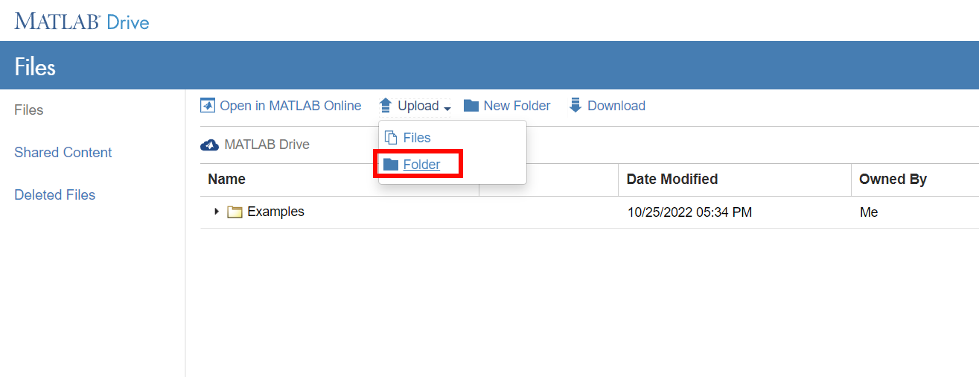

The uploaded folder should look something like this in MATLAB Drive:

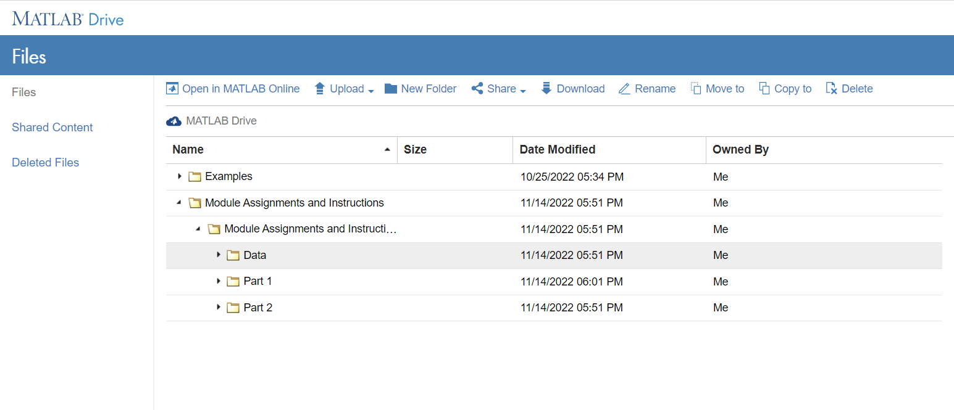

When students next log into MATLAB Online using this link <https://matlab.mathworks.com/> they will be able to see the **Module Assignments and Instructions** folder in their MATLAB Online instance.

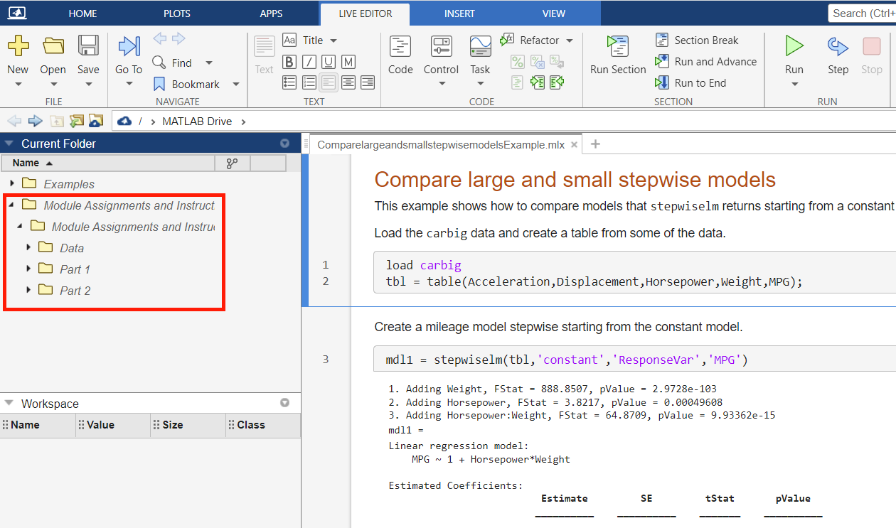

MATLAB Online has most MATLAB-provided toolboxes (including the Statistical and Machine Learning Toolbox) available without the time-consuming need to install them as an Add-On.

**Students using MATLAB Desktop.** Provide the entire **Module Assignments and Instructions** folder (extracted from the module .zip folder) and have students download this folder to their machines in an appropriately-named directory (i.e. C:\Users\username\Desktop\module_materials). They will open this folder inside of MATLAB.

Students must also download the Statistical and Machine Learning Toolbox, an Add-On from MATLAB including functions for visualization and statistical analysis in the Module. Students should be asked to complete this step before coming to class as the download and install is time consuming.

To install the toolbox, students should click Add-Ons → Get Add-Ons → Search “Statistical and Machine Learning Toolbox” → Install the Toolbox.

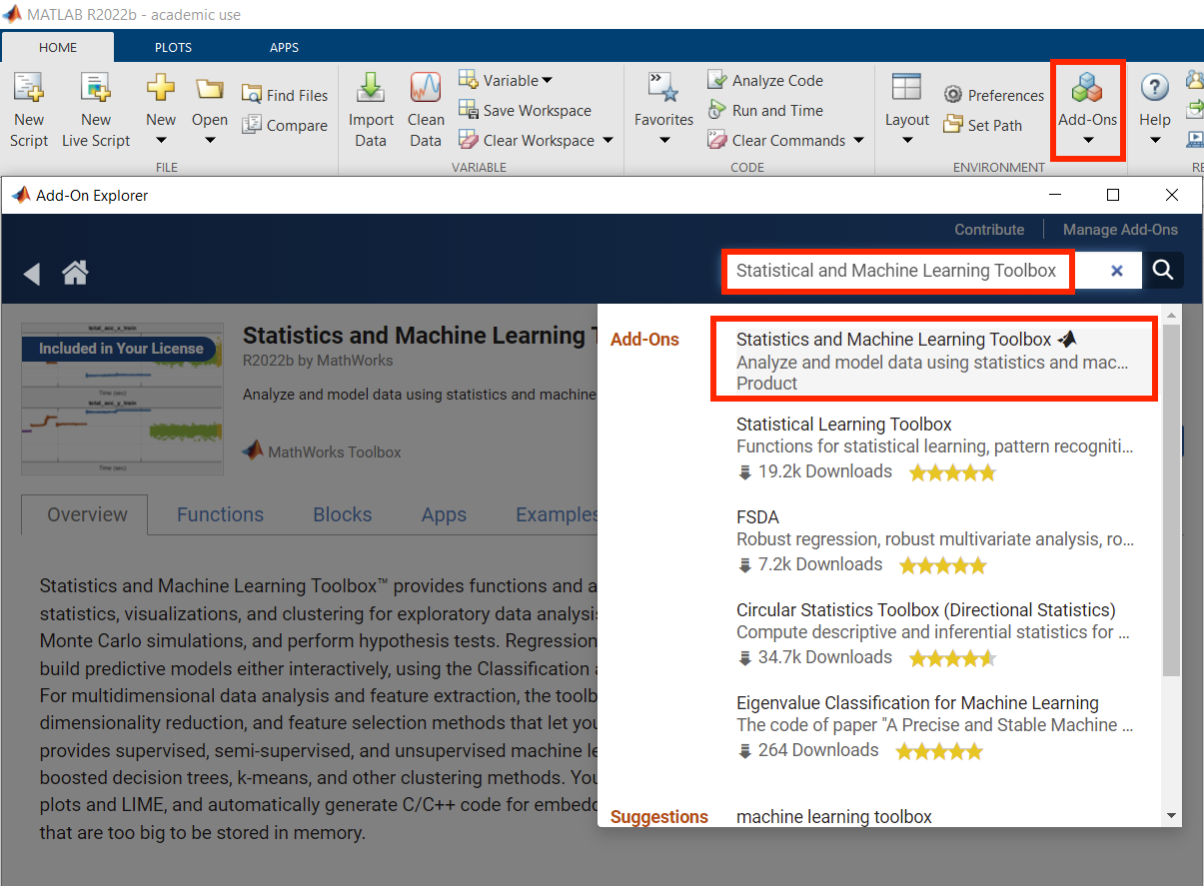

The student now has all requisite files to begin work on the Module.

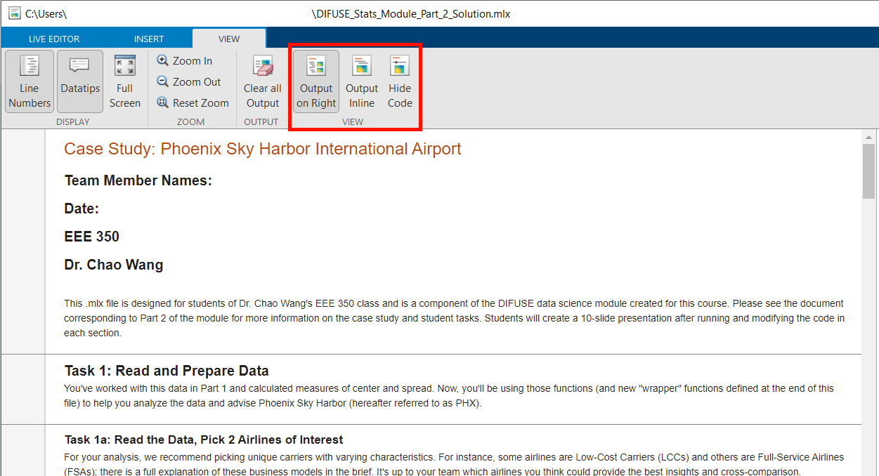

Note: You can change the output style of MATLAB in the “View” tab, above picture highlights the available viewing options.

### Canvas Grading.

Part 1 of the module includes a Canvas component, which can be used as the sole evaluation tool for the contents of part 1. The quiz consists of mainly multiple choice and matching questions, so the Canvas Quiz tool will automatically grade these questions upon completion.

The first question asks students to upload a copy of their completed live script (in PDF form), and the last question asks students to make hypotheses about the first module to prepare them for the second module (as a bonus).

The instructor should manually examine responses to the first question to ensure students are uploading unique work corresponding to the answers in the quiz, and can choose to award points for the last question according to the quality of the response. The instructor can also manually change the weighting of each question as they see fit.

Note: The Canvas quiz was initially created on a Dartmouth-supported Canvas sandbox and uploaded to Canvas Commons for instructors from other institutions to use. The quiz is titled “DIFUSE Stats Module Quiz”. For a walkthrough of how to import the quiz into your personal Canvas page, see “*How_To_Import_Canvas_Quiz.mp4*” within the “Instructor Module Solutions” subfolder.

### 

## Reminders:

1. This module was designed to be implemented **over two class sessions** and for students to complete the majority of the module in class, with collaborative group work taking place outside of class after the second session
2. **For Part 1**, students should first read through the PDF document for the assignment (*DIFUSE_Stats_Module_Part_1_Assignment.pdf)*, that provides information on the dataset and task at hand. They should then complete the exercises in the *DIFUSE_Stats_Module_Part_1.mlx* file and record their answers to the exercises in the corresponding quiz on Canvas
   1. Students will need ample time in class to complete the MATLAB exercises. The corresponding suggested answers document (*DIFUSE_Stats_Module_Part_1_Solution.mlx*) can be used by instructors and TAs to assist students with any questions related to code.
   2. Instruct students to finish the assignment outside of class if they could not finish it in class.
   3. Spend the beginning of the next class to review the assignment from Part 1
3. **For Part 2**, students should first read through the PDF document for the assignment (*DIFUSE_Stats_Module_Part_2_Assignment.pdf)*, which provides information on the task at hand. They should then complete the exercises in the *DIFUSE_Stats_Module_Part_2.mlx* file. Once completed, the students should collaborate in groups (likely outside of class) to make a short slidedeck (rubric in the Part 2 description) to summarize their findings and upload the presentation to Canvas.
   1. Depending on the size of the class, ensure students are split into groups of 2-3. Groups larger than 3 may make it more difficult for students to individually engage in the module.
   2. Students can work through the MATLAB assignment collaboratively in their groups, but each student should run the script on their own device and be able to interpret the findings individually. Groups will be primarily used for students to develop a slidedeck summarizing their results—each group should submit one slide deck in line with the rubric discussed in the module assignment.
4. The final piece of Part 2 is for students to turn in a slidedeck prepared in groups.
   1. If desired, the instructor can highlight a few presentations at the beginning of a future class to show students what they felt was an optimal product

| **Date** | **Materials** | **Activity** |
| --- | --- | --- |
| Day 1 | All Part 1 Materials | Introduce Module, have students start Part 1 MatLab activity, complete for homework |
| Day 2 | All Part 2 Materials  Sample Presentation of Part 2 | Introduce Part 2 of Module, have students start Part 2 MatLab activity in groups of 3-4 |
| Outside of class |  | Students are expected to collaborate in groups to develop a presentation that will be uploaded to Canvas. |