
  - Illustrative research report

Tide sensor pilot

Overview
Synthetic measurements for illustration; not operational or clinical results.

Observed counts
The trial covers two stations. Counts are observations, not percentages.
Station | Observed count
North | 12
South | 18

The total remains unresolved
The reported total is 31; the component values sum to 30. The difference of one observation remains unresolved.
Reliability is unavailable.
Total | Value
Reported | 31
Computed | 30
Difference | 1 observation, unresolved
Report: pilot.docx. Count data: observations.csv.

The review path
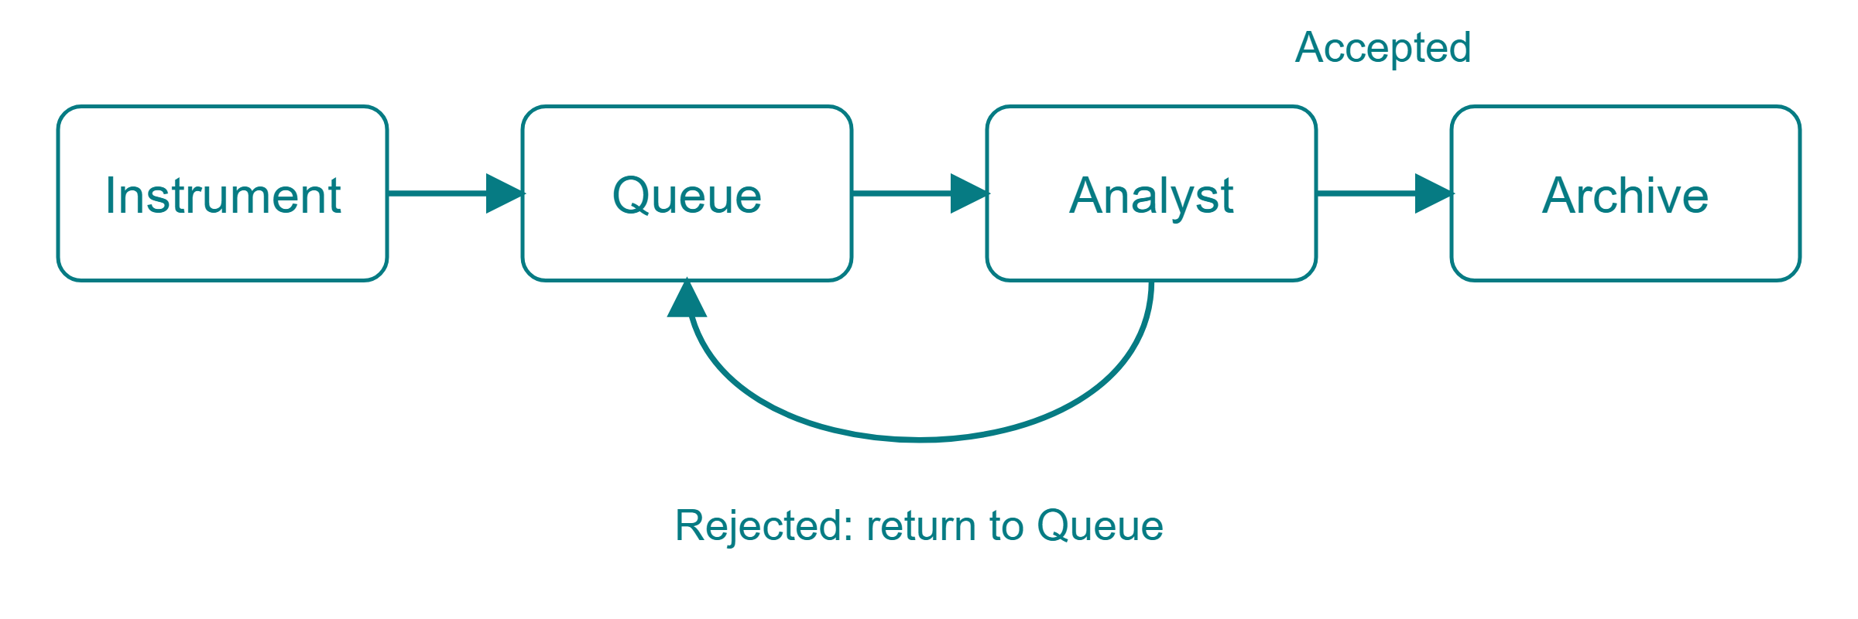
Accepted records continue to Archive. Rejected records return to Queue.
Instrument sends observations to Queue; Queue sends them to Analyst; Analyst sends accepted records to Archive. Rejected records return from Analyst to Queue.

Scope and uncertainty
The trial covers two stations. Counts are observations, not percentages. No error bars or confidence intervals were provided.
Item | Status
Stations covered | Two
Measure | Observation counts, not percentages
Error bars | Not provided
Confidence intervals | Not provided
Reliability | Unavailable
Materials: pilot.docx, observations.csv and review-path.svg. Tide Research branding: brand.json and brand.svg.

