**Lab Report Unit 2**

**Lab 3**

1. In Step 4 of the Apache Web Server Lab, you must login as superuser (root) before performing or entering any commands. If the command

**service start httpd**

fails, what is the most likely the problem.

Not logged in as root user

1. You will also get a warning message when you type in that command in #1 of this report. What is the message and why is it displaying?

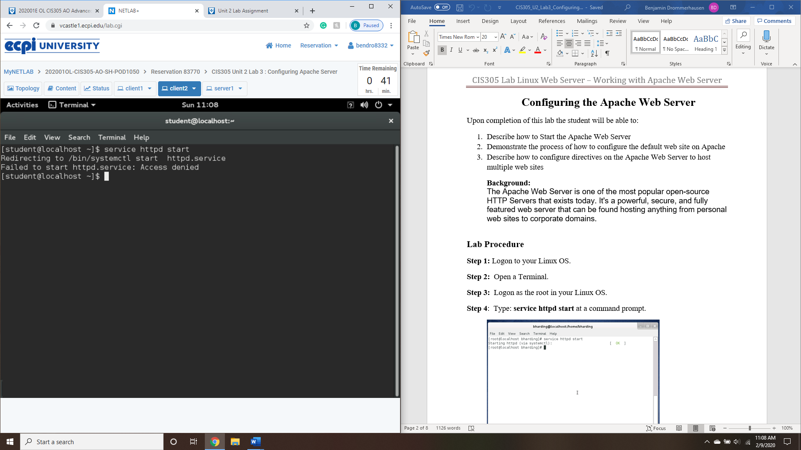

Either lacking permission to run command or in my case I opted not to verify process with my user password

1. If the Default Apache Web page fails to display in Step 6, what might be the problem.?

Could be the service isn’t running, make sure you follow step 4 (part2) and check status of service with **service httpd status or systemctl status httpd** to verify that the service has started.

If service isn’t started, follow step 5 to reintall/install web server

1. Take a screenshot of the **Apache Default web page** by using the Snipping tool in Windows from Step 6?

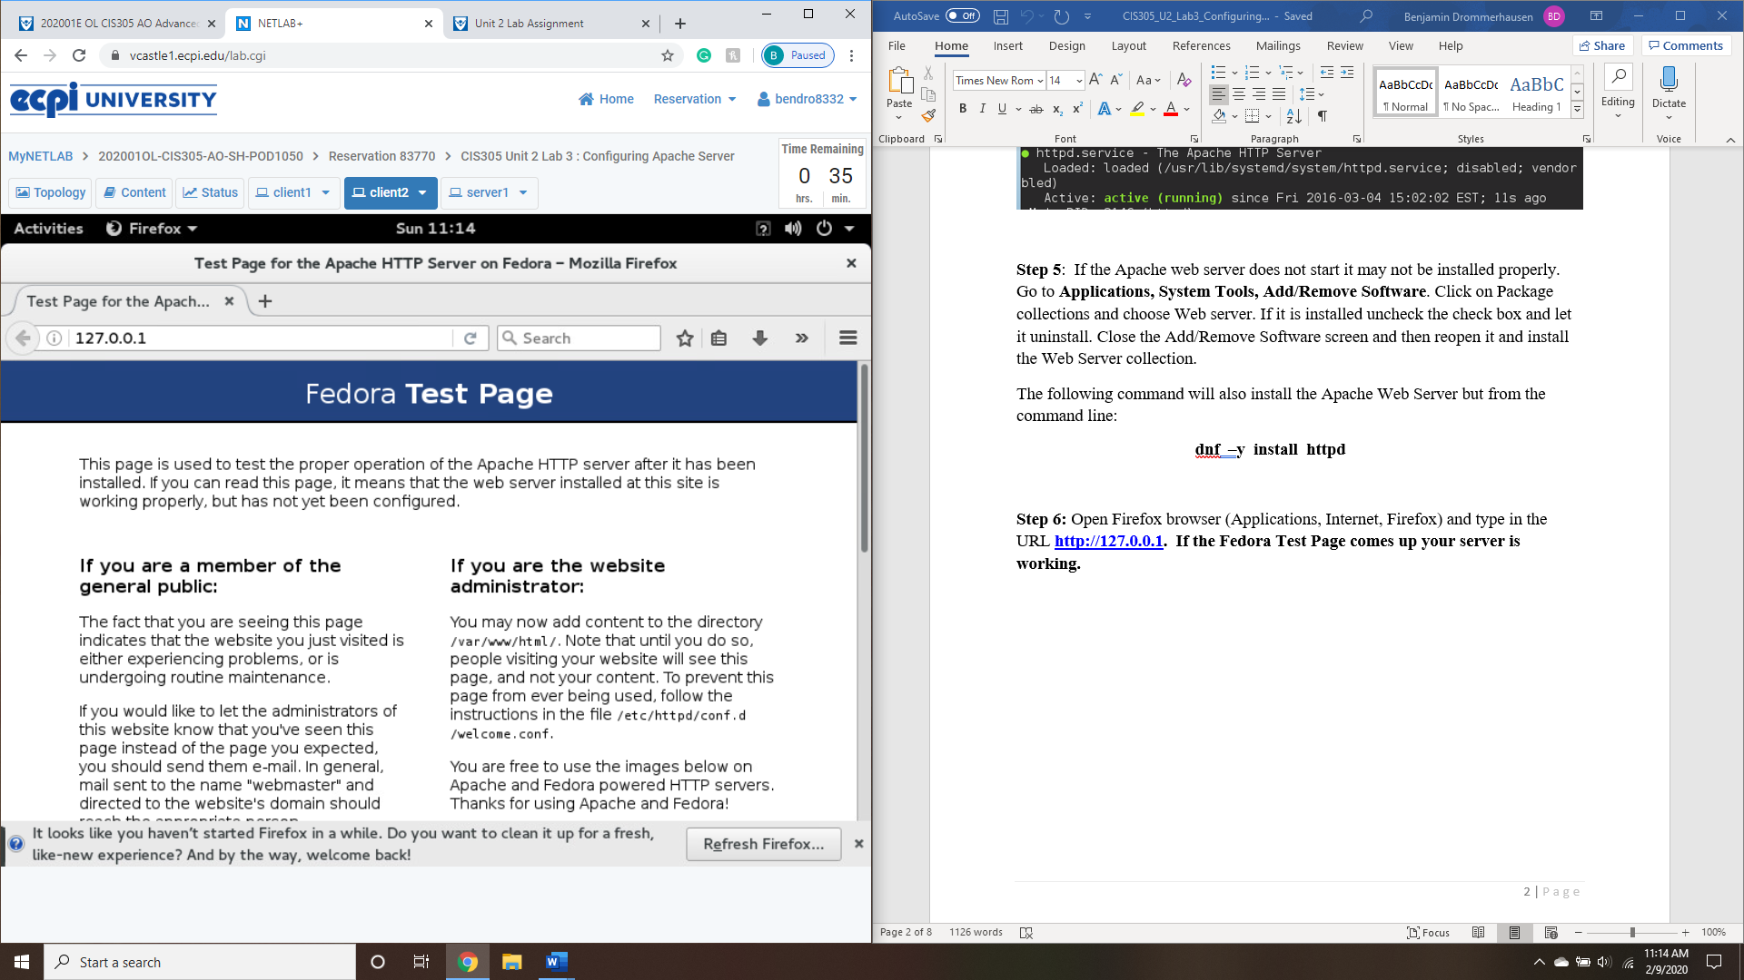

1. In Step 7 , take a screenshot of your Default web page.

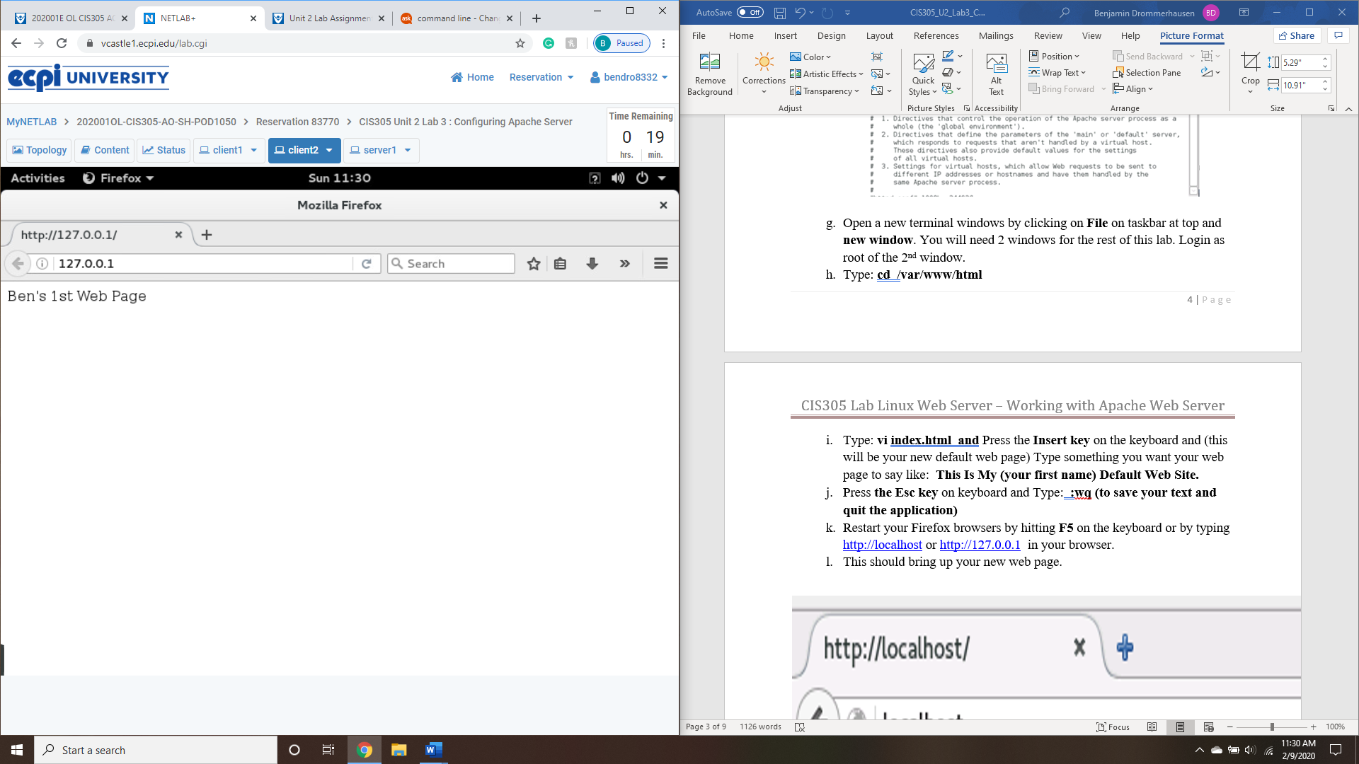

1. In Step8, take a screenshot of your completed configuration file with your new URLs under Virtual Hosts.?

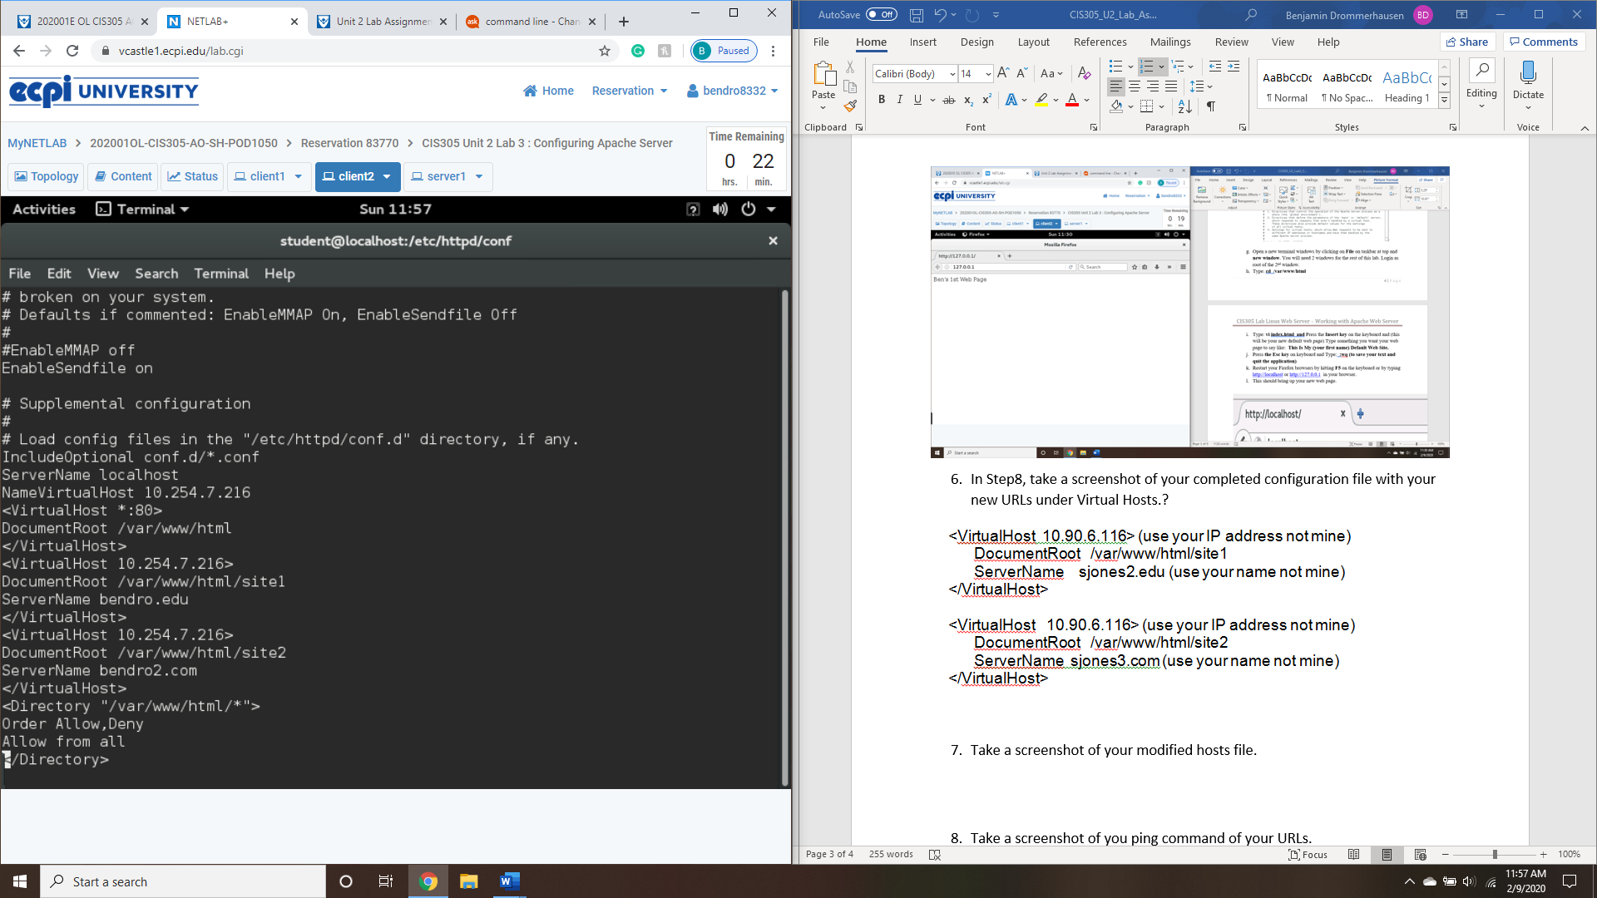

1. Take a screenshot of your modified hosts file. 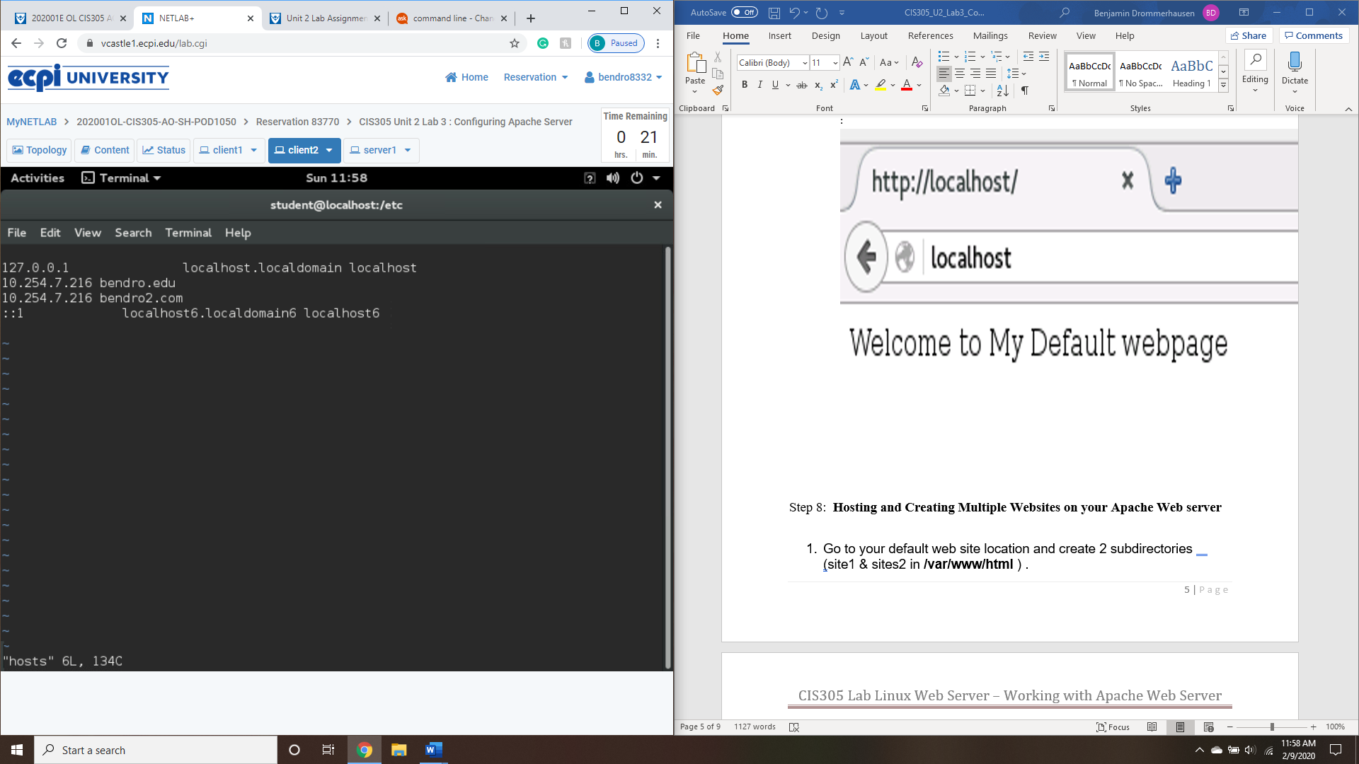
2. Take a screenshot of you ping command of your URLs.

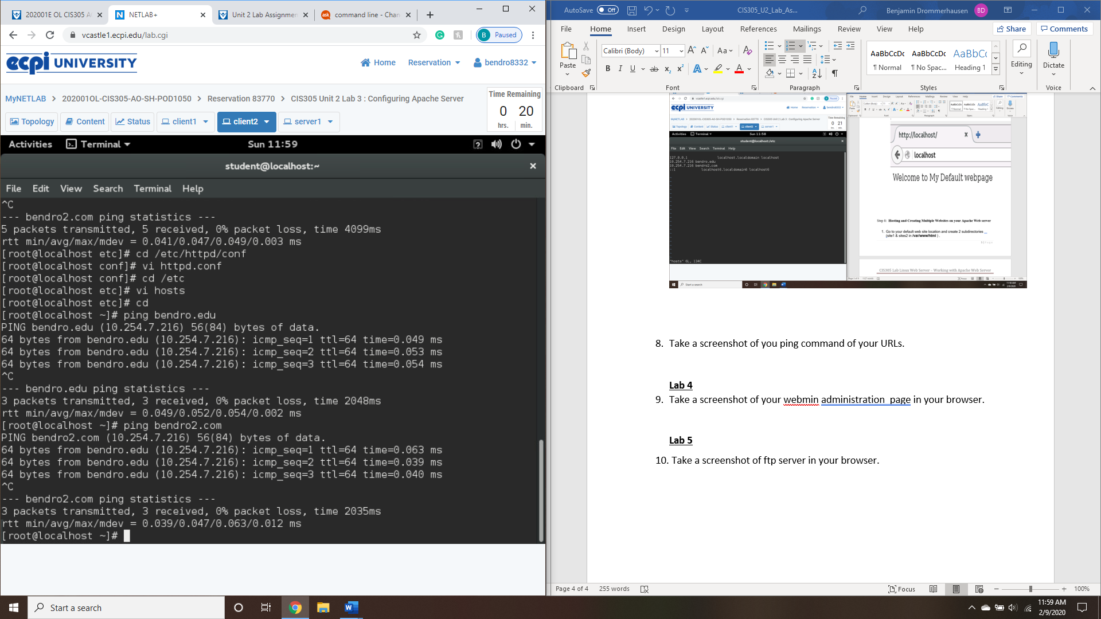

**Lab 4**

1. Take a screenshot of your webmin administration page in your browser.

Tried multiple different troubleshooting methods, keep getting error screen. No connection available to complete this portion.

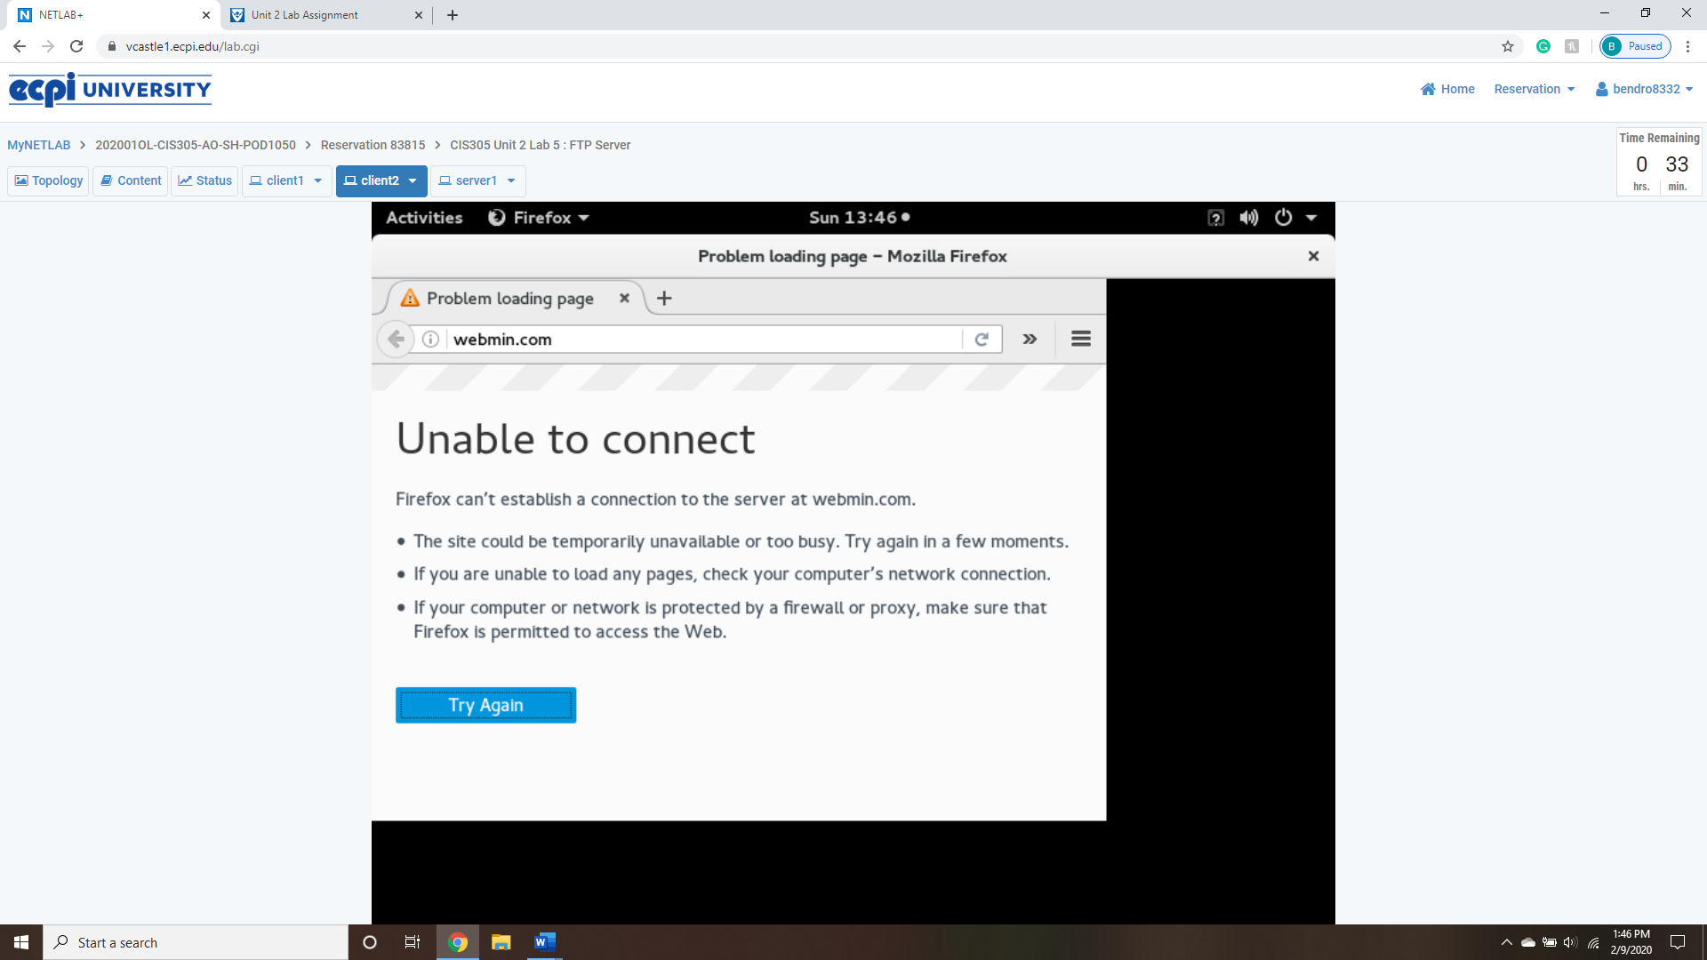

**Lab 5**

1. Take a screenshot of ftp server in your browser.

Continuously keep getting this error whenever trying to install or start ftp server 