**Lab Report Unit 4**

**Lab 8 Samba**

1. In Step 4 of the Lab, what does the **–y** do when entering an install command (**dnf –y install samba**)?

.

Answers the prompt before installation with yes, when entering this command the computer skips this prompt since the answer is essentially built into the command. This prompt is for security reasons, as certain programs can/do add packages/tools to your PC, very similar to the windows firewall tool prompt.

1. What does the –q mean in the command **rpm –q samba**?

If not mistaken, it does a similar job to command: systemctl status (*example)

Where rpm -q doesn’t check the working status, it verifies the version of targeted service.

Where each are used to check the integrity and presence of targeted service.

1. What do any commands that start with **system-config-XXXXX (example – system-config-samba)** used for?

Opening a GUI-related to service targeted, such as the firewall or samba setup GUIs in the Lab.

1. In Step 7 you installed the **GUI tool** for Samba. Is it easier to use the GUI tool or to do it from the command line?

The GUI is easier to navigate and confirm changes, where the command is the faster of the two (normally), since it is the more direct route.

1. In Step 15 you configured the Firewall, take a screenshot of your Firewall configuration page.

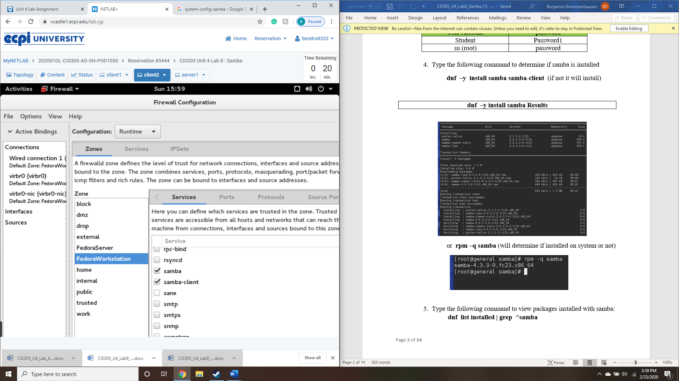

1. In Step 16, take a screenshot of the status of your samba service (use the status command).

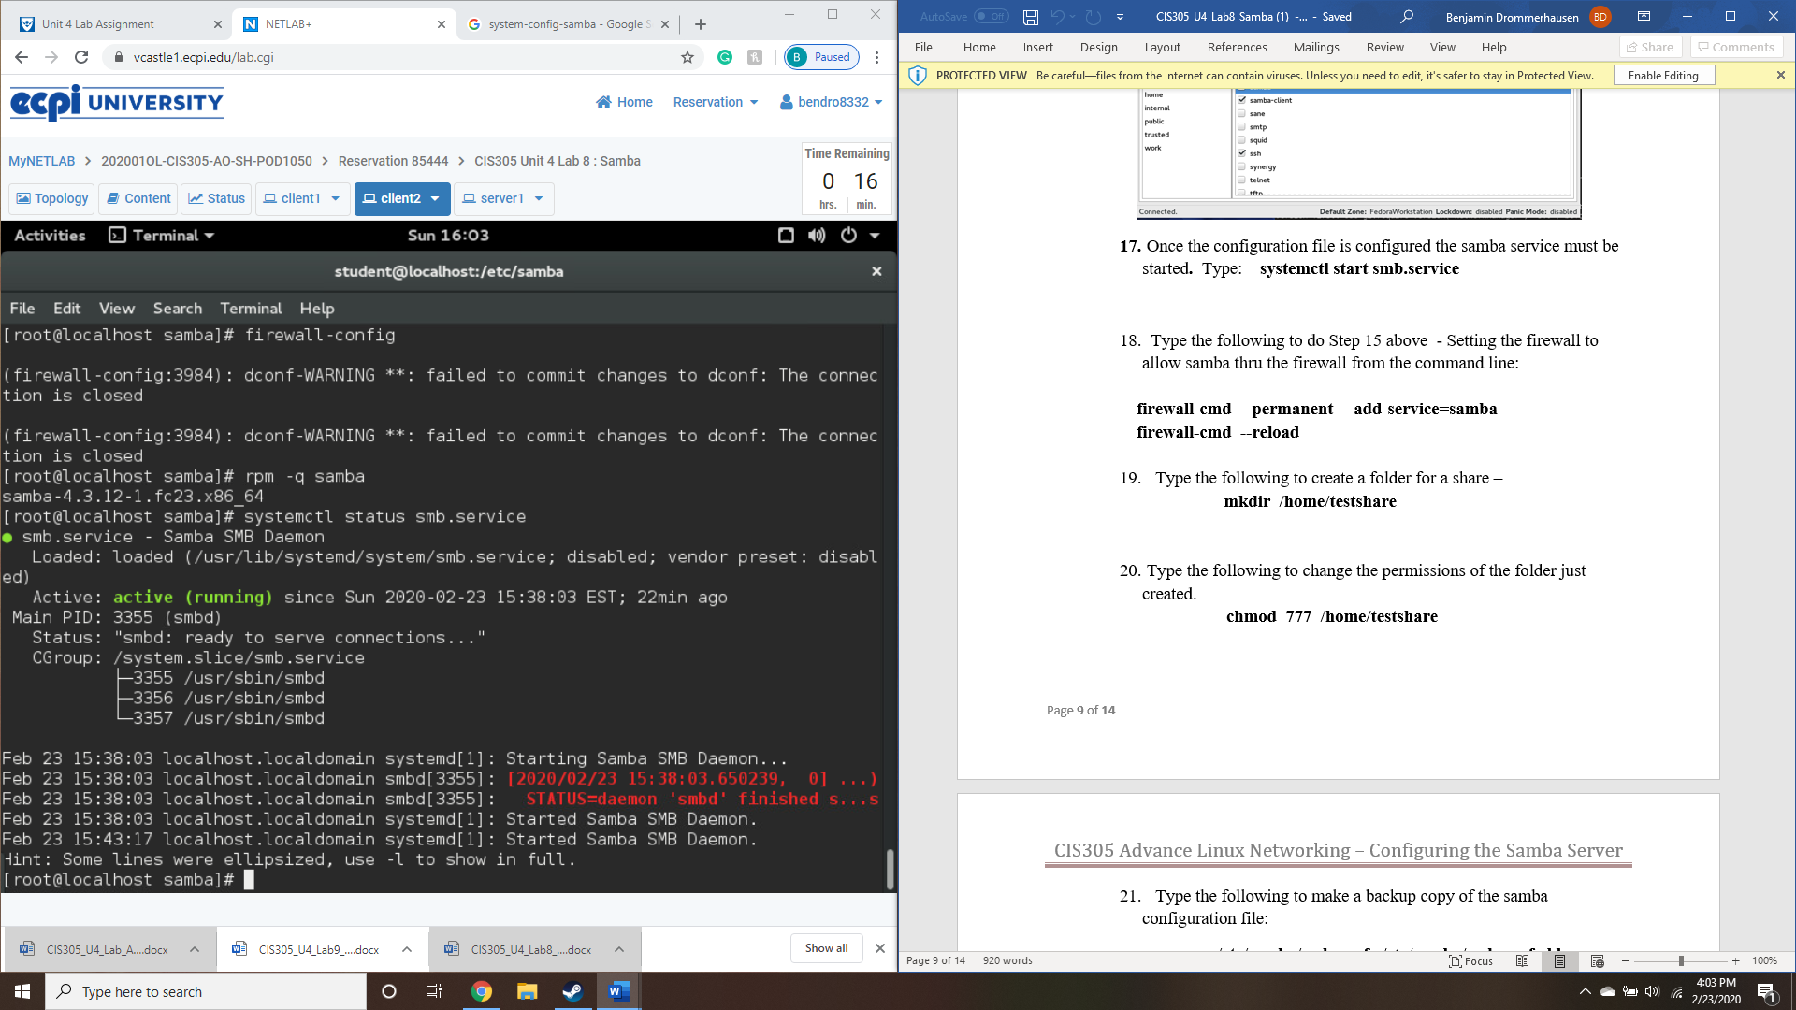

1. Take a screenshot of step 23 of your modified smb file.

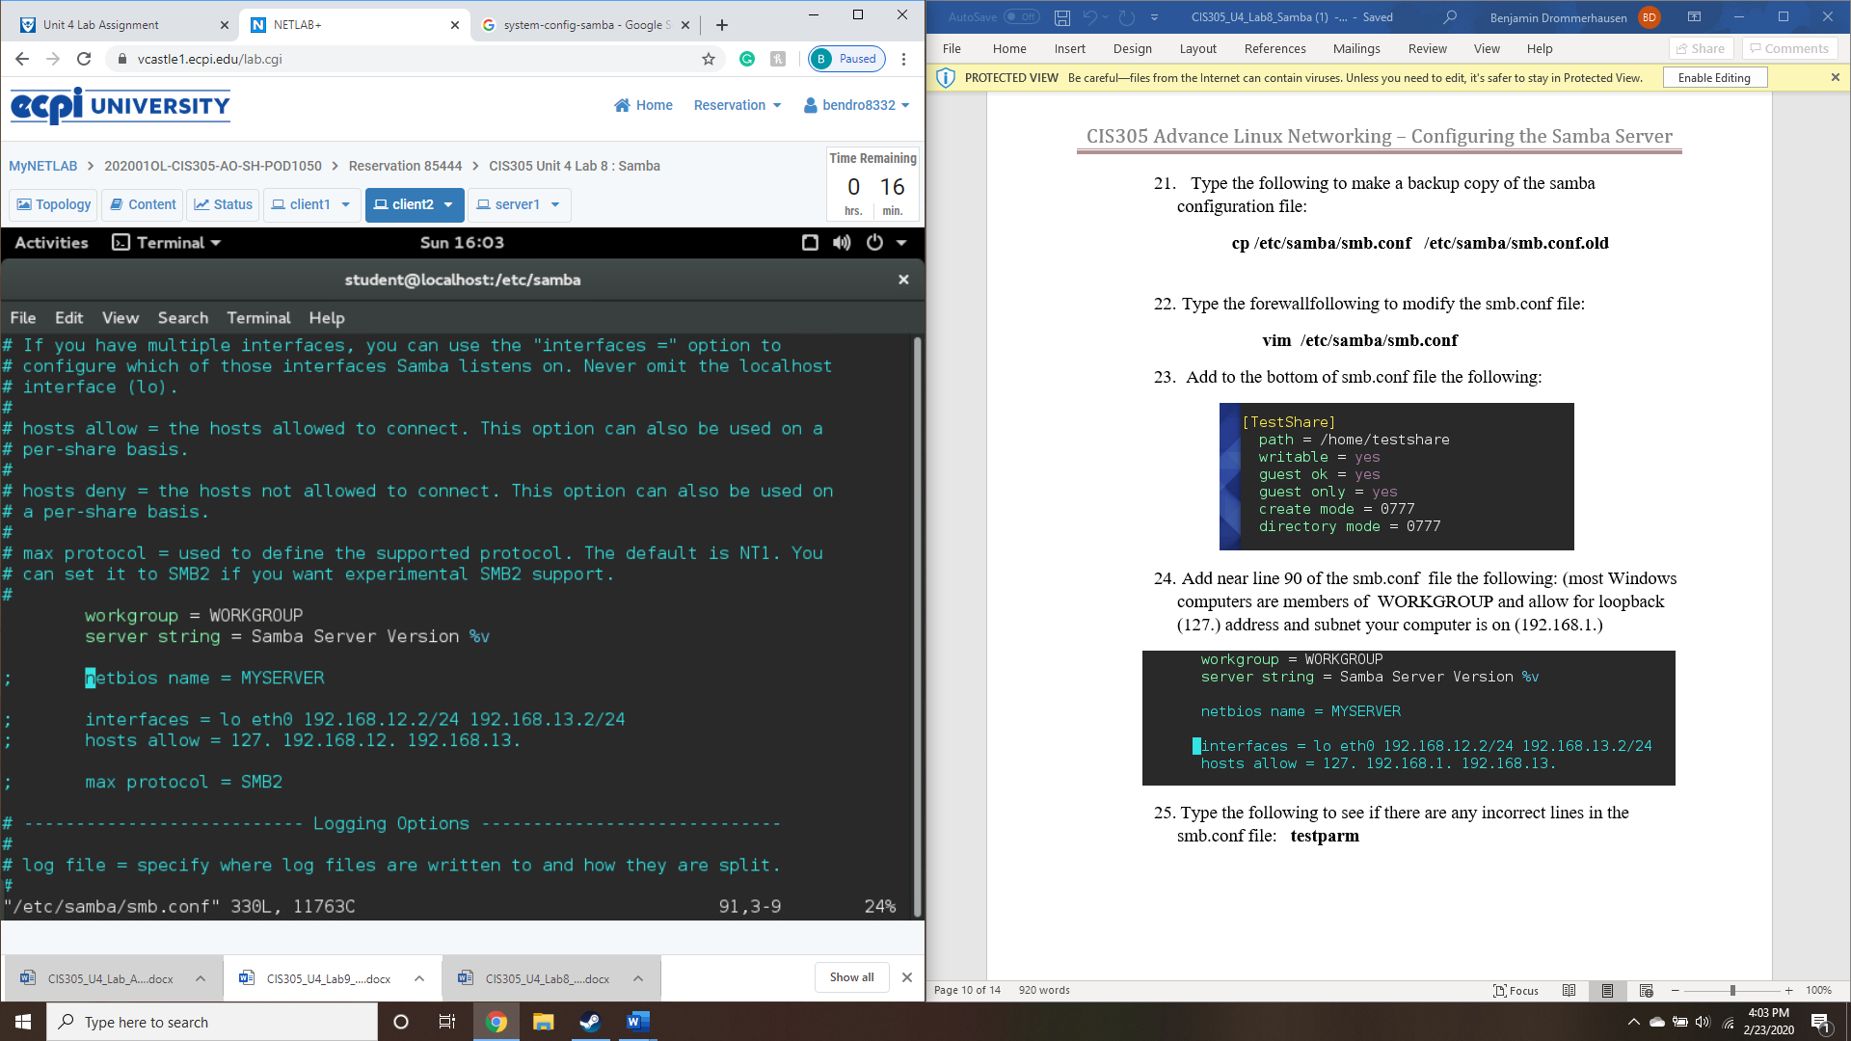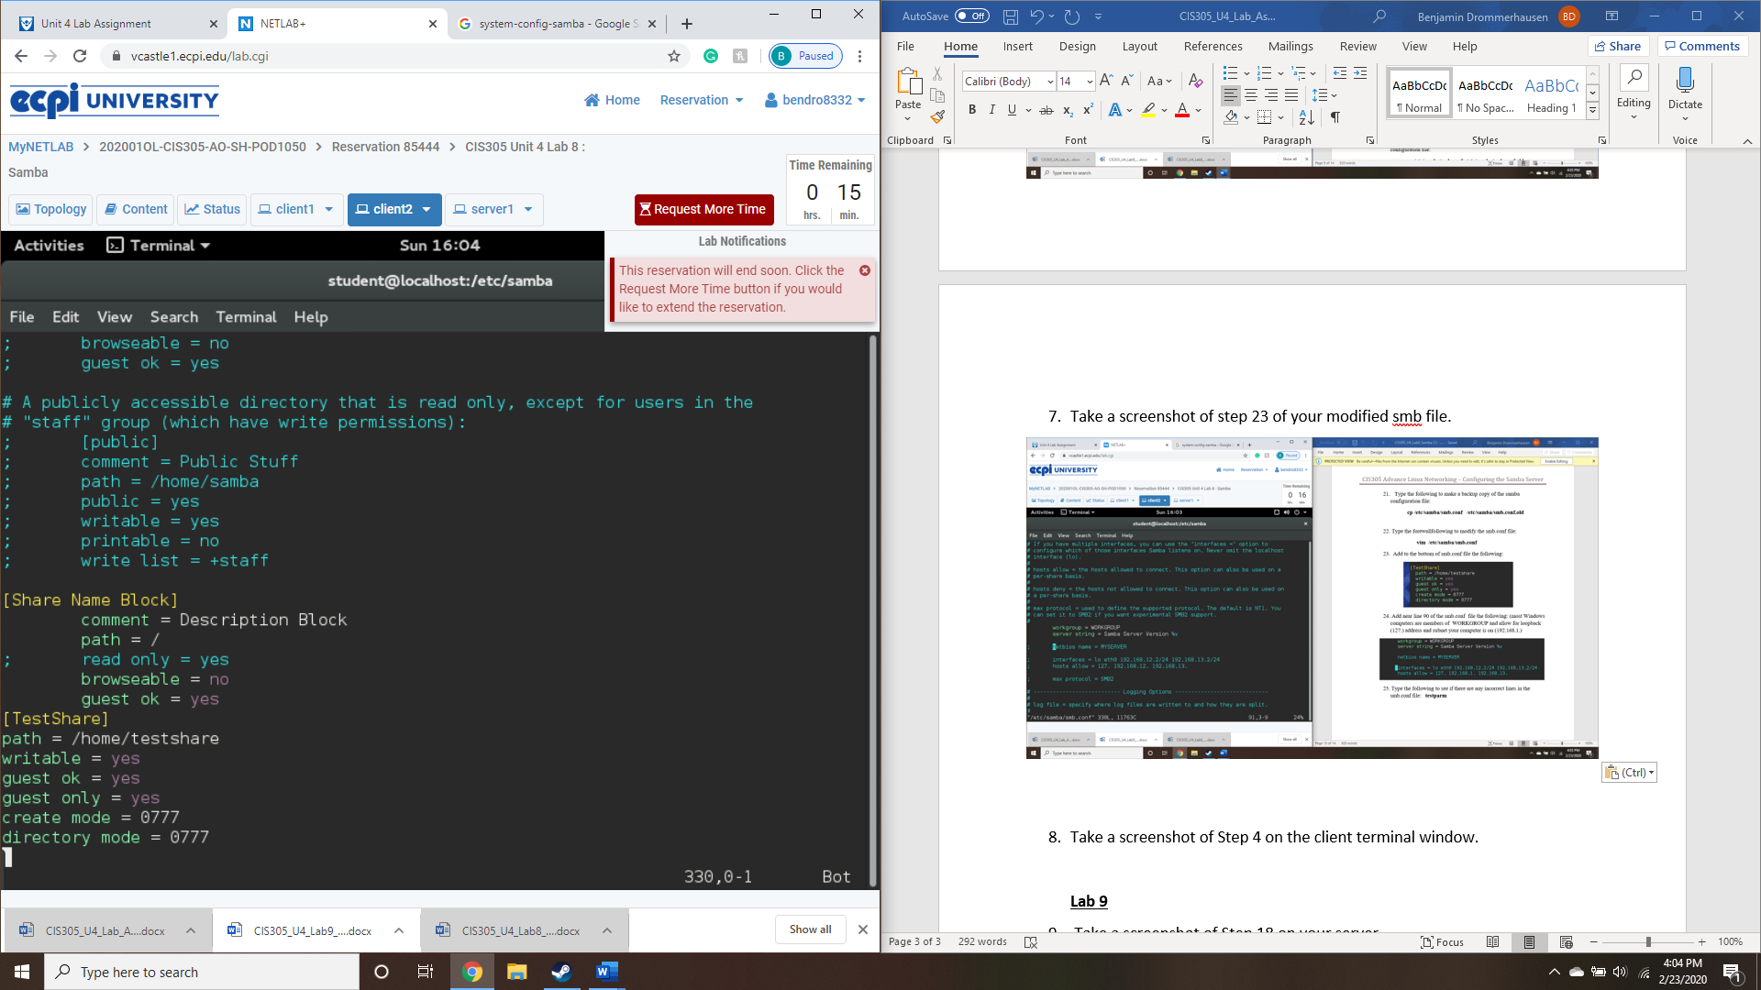

**Lab 9**

1. Take a screenshot of Step 4 on the client terminal window.

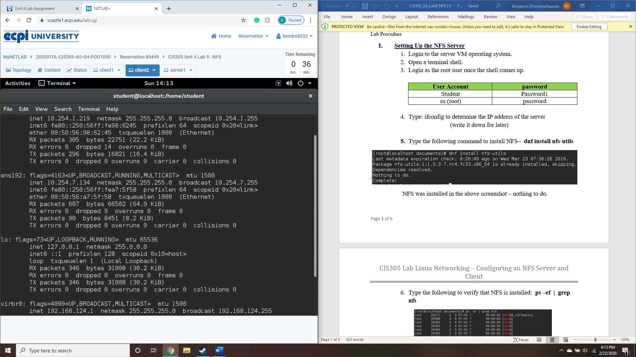

1. Take a screenshot of Step 18 on your server.

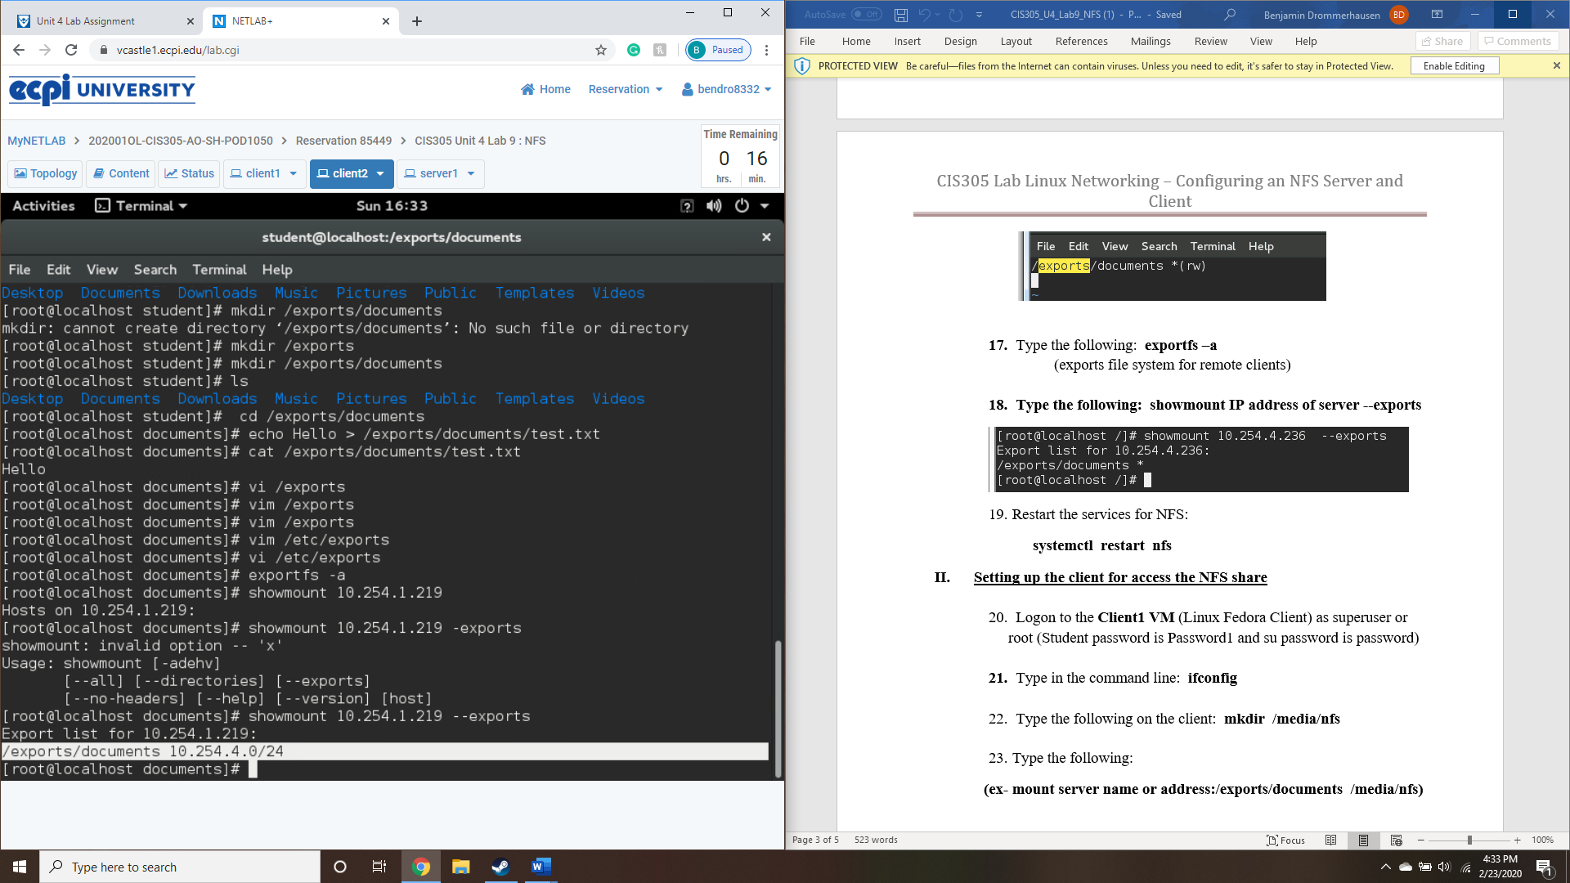

1. Take a screenshot of Step 25 showing the

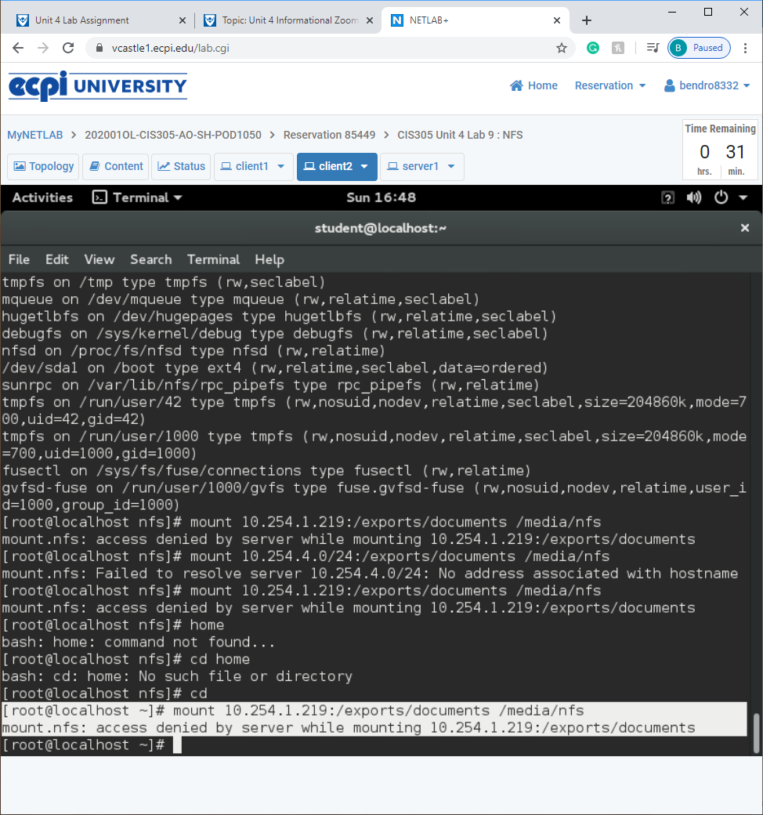

I’m not sure if I missed a step or have an improper setup, but after following the lab twice, I’m still getting an access denied by server message. I am logged in as rootuser.